**COMMONWEALTH OF MASSACHUSETTS**

**SUFFOLK, ss. Building Code Appeals Board Docket No. 10-859**

**­­­­­­­­­­­­­­­­­­­­­­­­­­­­___________________________________**

)

James Sheehan, )

Appellant )

)

v. )

)

Board of Building Regulations )

and Standards, )

Appellee )

___________________________________ )

**Board’s ruling on Appeal**

**Procedural History**

This matter came before the State Building Code Appeals Board ("Board") on the Appellant’s petition filed on January 20, 2010 pursuant to 780 CMR 122.1. In accordance with 780 CMR 122.3, the Appellant requested that the Board grant the Appellant a six-month extension pursuant to 7th Edition 780 CMR 110.R7.2.5 for completion of Inspector of Buildings certification that was denied by the Building Official Certification Committee ("Committee".)

In accordance with GL c. 30A, §§10 & 11; GL c. 143. §100; 801 CMR 1.02 *et. seq.*; and 780 CMR 122.3.4, the Board convened a public hearing on April 1, 2010 where all interested parties were provided with an opportunity to testify and present evidence to the Board. Appellant appeared on his own behalf. For the following reasons, this appeal is hereby **DENIED**.

**Exhibits in Evidence**

The following Exhibits were entered into evidence without objection:

|  |  |
| --- | --- |
| Exhibit 1 | State Building Code Appeals Board appeal application form with attachments, dated January 20, 2010. |
| Exhibit 2 | Undated letter from J. Sheehan to Certification Board Members. |

**Findings of Fact**

The following findings of fact are supported by substantial evidence based upon review of the exhibits marked and presented at the hearing as well as witness testimony. The Board finds the testimony of all witnesses to be credible and by and large uncontroverted as it pertains to the relevant facts. The relevant facts are as follows:

1. The Appellant is James Sheehan ("Sheehan") (See Exhibit 1, 01/20/10.)
2. The Appellant is requesting a 6 month extension to complete obligations for complete certification. (See Exhibit 2.)
3. The Appellant has previously been granted a 6-month extension by the Committee.
4. The Appellant has been working as Inspector of Buildings without proper certification for the City of Everett for 38 months.
5. The Appellant is certified as a local inspector. (See Exhibit 2.)
6. The Appellant has endured several personal hardships, including the death of Appellant's mother.
7. The Appellant's position with City of Everett position as Inspector of Buildings was terminated prior to the Appellant appearing before the Board.

**Discussion**

The Appellant is appealing a decision by the Committee to take No Action on the Appellant's request that the Committee reopen Appellant's request for an extension of time to complete the Inspector of Buildings certification process. Pursuant to M.G.L. c. 143, § 100, the Board has the authority to decide appeals by those "aggrieved by an interpretation, order, requirement, direction or failure to act by any state or local agency or any person or state or local agency charged with the administration or enforcement of the state building code." Accordingly, the Board has the authority to decide this appeal.

The issue before the Board is whether to grant the Appellant an extension pursuant to 7th Edition 780 CMR 110.R7.2.5 to allow the Appellant more time to complete the certification required to work as an Inspector of Buildings. 7th Edition 780 CMR 110.R7.2.5.1 states, in pertinent part: "All candidates shall meet or exceed the qualifications for the position of local inspector…prior to any examinations. The Board of Building Regulations and Standards via the certification committee shall approve all candidates prior to taking any examinations." In addition, 7th Edition 780 CMR 110.R7.2.5.4 states: "No candidate shall be allowed to take said examinations without prior approval of the Board of Building Regulations and Standards or the certification committee at the Board's discretion."

The Appellant has been given 38 months (including extensions), to complete all obligations required for completion of Inspector of Buildings certification. The Board states that the Appellant has been given ample time to pass the five exams to complete certification. Further, the Board states that since the Appellant is certified as a Local Inspector, the Appellant can find gainful employment as a Local Inspector and start the process for Inspector of Buildings certification from the beginning.

**Conclusion**

A motion was made by Sandy Macleod and seconded by Douglas Semple to **AFFIRM** the decision by the Committee not to grant the Appellant an extension. The Board voted 2-0 in favor of the motion, with Jacob Nunnemacher abstaining.

The decision by the Committee not to grant the Appellant an extension of time pursuant to 7th Edition 780 CMR 110.R7.2.5 for completion of Inspector of Buildings certification is hereby **AFFIRMED** as described in the discussion above.

**SO ORDERED.**

By The Board:

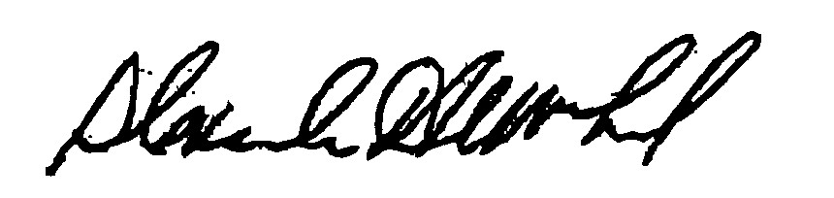

**_______________________ ________________________ ______________________**

Sandy MacLeod Douglas Semple Jacob Nunnemacher

Chair

DATED: August 5, 2010

*In accordance with M.G.L. c. 30A, §14, any person aggrieved by this decision may appeal to the Superior Court within 30 days of receipt of notice of this decision.*