COMMONWEALTH OF MASSACHUSETTS

SUFFOLK, ss. Building Code Appeals Board Docket No. 10-860

___________________________________
)
In re Edward Sobolweski, )
Appellant )
___________________________________ )

Board’s ruling on Appeal

Procedural History

This matter came before the State Building Code Appeals Board ("Board") on the Appellant’s petition filed on March 18, 2010 pursuant to 780 CMR 122.1 In accordance with 780 CMR 122.3, the Appellant requested that the Board grant the Appellant a six-month extension pursuant to 7th Edition 780 CMR 110.R7.2.4 for completion of local inspector certification that was denied by the Building Official Certification Committee ("Committee".)

In accordance with GL c. 30A, §§10 & 11; GL c. 143. §100; 801 CMR 1.02 et. seq.; and 780 CMR 122.3.4, the Board convened a public hearing on April 1, 2010 where all interested parties were provided with an opportunity to testify and present evidence to the Board. The Appellant appeared on his own behalf. For the following reasons, this appeal is hereby GRANTED.

Exhibits in Evidence

The following Exhibits were entered into evidence without objection:

Exhibit 1 | State Building Code Appeals Board appeal application form with attachments, dated March 18, 2010.
Exhibit 2 | Fax from Appellant to K. Spencer dated April 28, 2010 attaching medical documentation.
Exhibit 3 | Committee Minutes dated May 4, 2010.
Exhibit 4 | Letter from Committee to Appellant dated May 20, 2010 granting extension

Findings of Fact

The following findings of fact are supported by substantial evidence based upon facts presented at the hearing as well as witness testimony. The Board finds the testimony of all witnesses to be credible and by and large uncontroverted as it pertains to the relevant facts. The relevant facts are as follows:

- The Appellant is Edward Sobolweski ("Sobolweski".)
- Appellant is requesting a six-month extension to complete local inspector certification. (See Exhibit 1.)
- Appellant has previously been granted three 6-month extensions by the Committee.
- Appellant has passed one of the three exams necessary for certification. (See Exhibit 1.)
- Appellant has experienced medical issues, including an eye operation and treatment for a recurrence of cancer.
- The Committee was unaware of the Appellant's medical issues.
- Appellant is currently employed by the City of Everett.
- As directed by the Board, the Appellant submitted documentation to the Committee detailing medical conditions. (See Exhibit 2.)

Discussion

The Appellant is appealing a decision by the Committee to deny the Appellant's request for an extension of time to complete the local inspector certification exams. Pursuant to M.G.L. c. 143, § 100, the Board has the authority to decide appeals by those "aggrieved by an interpretation, order, requirement, direction or failure to act by any state or local agency or any person or state or local agency charged with the administration or enforcement of the state building code." Accordingly, the Board has the authority to decide this appeal.

The issue before the Board is whether to grant the Appellant an extension pursuant to 7th Edition 780 CMR 110.R7.2.4 to allow the Appellant more time to complete the certification required to work as a local inspector. 7th Edition 780 CMR 110.R7.2.4.1 states, in pertinent part: "All candidates shall meet or exceed the qualifications for the position of local inspector…prior to any examinations. The Board of Building Regulations and Standards via the certification committee shall approve all candidates prior to taking any examinations." In addition, 7th Edition 780 CMR 110.R7.2.4.3 states: "No candidate shall be allowed to take said examinations without prior approval of the Board of Building Regulations and Standards or the certification committee at the Board's discretion."

The Appellant has been given 32 months (including the three extensions) to pass the three exams necessary for local inspector certification. The Board stated that since the Committee was not aware of the Appellant's medical condition, if the Appellant could provide medical documentation to the Committee and the Committee feels that an extension is justified, the Board would grant the Appellant a six-month extension as requested.

Conclusion

A motion was made by Jacob Nunnemacher and seconded by Sandy MacLeod to conditionally GRANT the Appellant a six-month extension, contingent on the following:

- The Appellant must provide by April 27, 2010, medical documentation from his doctor to the Committee;
- The Appellant must also provide all documentation of passing scores to the Committee as required by the Code.

If the information provided to the Committee does not meet their approval for the six-month extension, this motion by the Board will be then denied and voided.

Addendum

As directed by the Board, the Appellant submitted documentation to the Committee detailing his medical conditions. As a result, the Committee decided to grant the Appellant an extension which shall expire on November 30, 2010.

The decision by the Committee not to grant the Appellant an extension of time pursuant to 7th Edition 780 CMR 110.R7.2.4 for completion of local inspector certification is hereby REVERSED as described in the discussion above.

SO ORDERED.

By The Board:

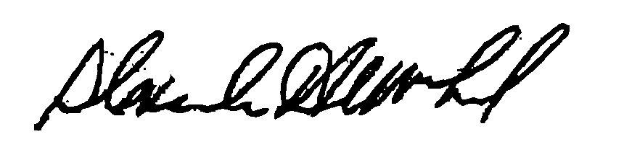
_______________________ ________________________ ______________________
Sandy MacLeod Douglas Semple Jacob Nunnemacher
Chair

DATED: August 16, 2010

In accordance with M.G.L. c. 30A, §14, any person aggrieved by this decision may appeal to the Superior Court within 30 days of receipt of notice of this decision.

