**COMMONWEALTH OF MASSACHUSETTS**

**SUFFOLK, ss. Building Code Appeals Board**

**Docket #10-871**

__________________________________________

)

University of Massachusetts Medical School, )

Appellant )

)

v. )

)

City of Worcester, )

Appellee )

__________________________________________ )

**BOARD’S RULING ON APPEAL**

**Procedural History**

This matter came before the State Building Code Appeals Board (“Board”) on the Appellant’s appeal filed pursuant to 780 CMR 122.1. In accordance with 780 CMR 122.3, the Appellant requested that the Board grant a variance from 7th edition 780 CMR 404.0 and 707.2 Exception 7 for the property at 55 Lake Avenue North, Worcester, MA. In accordance with G.L. c. 30A, §§ 10 and 11; G.L c. 143, §100; 801 CMR 1.02 *et. seq*; and 780 CMR 122.3.4, the Board convened a public hearing on April 20, 2010 where all interested parties were provided with an opportunity to testify and present evidence to the Board. Representatives of the Appellant Mark Daly, Kevin Hastings, and Mark Armington and building official Joe McEvoy appeared for the hearing as noted on the sign in sheet which is on file at the Department of Public Safety.

**Exhibits**

1. State Building Code Appeals Board Appeal Application Form
2. ICC-ES Evaluation Report issued March 1, 2009 evaluating Model WS – 5.6 K-Factor Specific Application Window Sprinklers, Horizontal Sidewall and Pendant Vertical Sidewall

**Findings of Fact**

1. The Appellant’s property (“Property”) is located at the UMass Medical School Albert Sherman Center, 55 Lake Avenue North, Worcester, MA 01655-0002.
2. The Property is a nine story business occupancy research building containing both research facilities and offices.
3. The Appellant is seeking to add a three story atrium wing to the current building. While the proposed atrium wing will reach a three story height, the open space of the atrium wing rises only to two floors with the third floor enclosure separated from the two floor space below by two-hour fire barriers, 90-minute fire shutters, and sprinkler protected glass. (Exhibit 1)
4. The sprinkler protected glass constituting the separation between the atrium wing’s lower two levels and the third level enclosure will be designed and installed in accordance with International Code Council Legacy Report NER-516 to achieve the equivalent of a 2 hour wall assembly. (Exhibit 2)
5. As an additional safety measure, the building’s HVAC equipment serving the top of the floor opening at Level 3 will provide the Fire Department with the ability to vent smoke and heat from the space if necessary. Controls for this system will be provided at the fire command center at Level 3. This is an additional safeguard and the smoke exhaust capability does not conform to 780 CMR 909.0. (Exhibit 1)
6. Neither Captain Metterville from the Worcester Fire Department or the building official Joe McEvoy has a problem with the relief requested provided that the aforementioned safety equivalencies are provided.

**Discussion**

The issue in this case is whether or not a variance should be granted for the construction of an atrium wing that would otherwise require a mechanical smoke control system under 780 CMR 404.0 and a shaft enclosure under 780 CMR 707.2 Exception 7. The proposed atrium wing’s lower two levels are completely separated from the third thereby operating as the functional equivalent of a two story space and will incorporate safety features intended to conform the space to the Building Code’s intent. Neither Captain Metterville of the Worcester Fire Department nor the inspecting Building Official has any objection to the design as proposed.

780 CMR 404.0 defines an atrium as “[a]n opening connecting two or more stories” in which “[a] smoke control system shall be installed in accordance with 780 CMR 909.0.” The proposed atrium wing would not have a smoke control system that conforms to 780 CMR 909.0 but will be equipped with alternate safety measures. The third floor space of the three story atrium wing will be completely separated from the bottom levels by two-hour fire barriers, sprinkler-protected glass, and 90-minute fire shutters. In addition, a smoke exhaust system will be provided although it will not conform to 780 CMR 909.0. This system will provide the Fire Department with the ability to vent smoke and heat from the space if necessary.

The Appellant would also like the Board to grant a variance bringing Appellant’s three-story atrium wing to be considered the equivalent of a floor opening regulated by 780 CMR 707.2 Exception 7 which provides that in buildings “other than Groups I-2 and I-3, a shaft enclosure is not required for a floor opening that … [d]oes not connect more than two stories.” Due to the separation between the third level of the atrium and the lower two levels by 2-hour fire barriers, a 90-minute fire shutter, and sprinkler protected glass, the atrium wing operates as the functional equivalent of a two-story opening.

Based on the provision of alternate safety measures, a motion was made to grant Appellant variances to 780 CMR 404.0 and 707.2 Exception 7. A second on the motion was made and a Board vote was taken which was unanimous.

**Conclusion**

The Appellant’s requests for variances from 780 CMR 404.0 and 707.2 Exception 7 as described in the Discussion are hereby **ALLOWED** under the condition that the atrium is built in accordance with the designs as discussed above and presented to the Board.

SO ORDERED.

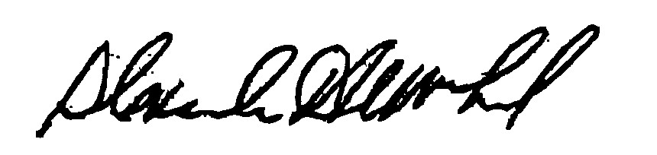

______________________ _________________________ _______________________

Alexander MacLeod Douglas Semple Jacob Nunnemacher

DATED: August 19, 2010

*In accordance with M.G.L. c. 30, §14, any person aggrieved by this decision may appeal to the Superior Court within 30 days of receipt of notice of this decision.*