**COMMONWEALTH OF MASSACHUSETTS**

**SUFFOLK, ss. BUILDING CODE APPEALS BOARD**

**DOCKET NO.: 10-910**

**­­­­­­­­­­­­­­­­­­­­­­­­­­­­______________________________**

New England Group Management, )

Appellant, )

)

v. )

)

City of Fall River, )

Appellee )

______________________________)

**BOARD’S DECISION[1]**

**Procedural History**

This matter came before the State Building Code Appeals Board (“Board”) on July 20, 2010 relative to the Appellant’s appeal of a decision made by the Appellee. The Appellee denied issuance of a permit due to the lack of sprinklers installed in the property. In accordance with 780 CMR 122.3, the Appellant petitioned the Board to grant an interpretation or variance from 7th Edition 780 CMR 3401.0 of the Massachusetts State Building Code (“MSBC”) for 1246 North Main Street, Fall River, MA (“Property”).

In accordance with G.L. c. 30A, §§ 10 and 11; G.L. c. 143, §100; 801 CMR 1.02 *et. seq*.; and 780 CMR 122.3.4, the Board convened a public hearing at which all interested parties were provided with notice and an opportunity to testify and present evidence to the Board.

The Appellant appeared at the hearing and was represented by Mark Levin, Esq.. Present and representing the City of Fall River Building Department was Building Inspector Joseph M. Biszko.

**Exhibits in Evidence**

The following Exhibits were entered into evidence without objection:

Exhibit 1: State Building Code Appeals Board appeal application form, dated June 15, 2010, including supporting documents.

Exhibit 2: Proposals/Bids from various companies to install a fire protection system at the property

Exhibit 3: Assessment of property by Patriot Properties, Inc., printed May 11, 2010.

Exhibit 4: Calculations made by Building Inspector Joseph M. Biszko, dated July 20, 2010.

**Findings of Fact**

The following findings of fact are supported by substantial evidence based upon review of the exhibits marked and presented at the hearing as well as witness testimony. The Board finds the testimony to be credible and by and large uncontroverted. The relevant facts are as follows:

1. The Appellant is New England Group Management, LLC (“Management”), represented by Mark Levin, Esq. (See Exhibit 1).
2. The Appellant wishes to renovate 5 of the 16 units in the property that was directly and indirectly damaged by a fire in one of the units and to repair exterior parts of the property that was also damaged. (See Exhibit 1; Testimony).
3. Mr. Levin deemed the work that his client was electing to be done to be ordinary improvements and repairs for the purpose of 780 CMR 3401, which would not require the building inspector to make any determination regarding fire. (Testimony).
4. 780 CMR 3401.0 was interpreted by Mr. Levin to mean that sprinklers would not have to be added to the premises when the value of the repairs and renovations are less than 15% of the value of the work to be performed. (See Exhibit 1).
5. The Appellant obtained three estimates for fire suppression systems. (See Exhibit 2).
6. The price quoted for the sprinklers compared to the price of the job is greater than 15%. (See Exhibit 1).
7. Inspector Joseph Biszko disagreed with Mr. Levin’s interpretation of 780 CMR 3401.0 and refused to issue a permit to the Appellant until sprinklers are installed in the property. (See Exhibit 1).
8. Appellant now seeks relief from the Board to grant a variance from 7th Edition 780 CMR 3401.0 for the property, and/or to clarify the interpretation of 780 CMR 3401.0.

**Discussion**

Pursuant to M.G.L. c. 143, § 100, the Board has the authority to decide appeals by those “aggrieved by an interpretation, order, requirement, direction or failure to act by any state or local agency or any person or state or local agency charged with the administration or enforcement of the state building code.” The Appellant is appealing a decision by Inspector Joseph Biszko to deny the Appellant a permit until sprinklers have been installed in the property despite Appellant’s argument that sprinklers are not required for the property under 780 CMR 3401.0; therefore, the Board has jurisdiction over this matter.

The issue to be considered here by the Board is whether the Appellant must install sprinklers or not in the property before obtaining a permit. Inspector Biszko claims that “because of the size of the building, the number of apartments and the closeness of the lowest sprinkler bid (1.4%) to the 15% required,” he must deny the Appellant a permit until sprinklers are installed in the property. (Exhibit 1) However, Appellant states that the contract price is not inclusive of the architect cost; thus, the prices contained in the bids do not reflect the real cost of installing the sprinklers, which are significantly higher than that stated in the bids.

A motion was made by Jake Nunnemacher to overturn the building official’s ruler of 780 CMR 3401.1 due to the fact that all the documentation is in order, that this is going to exceed the 15% that is required in the definition of substantial renovation or substantial alteration, contingent on the Appellant first going to the Fall River Fire Department prior to the start of construction to check with them on the applicability of MGL 148, §261. However, the board does strongly recommend that sprinklers be installed.

**Conclusion**

The Appellant’s request for a variance from 780 CMR 3401.0 is hereby **granted.**

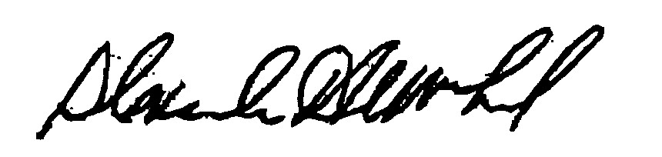

**_______________________ _______________________ ________________________**

Jacob Nunnemacher Douglas Semple (Chairman) Alexander MacLeod

DATED: October 18, 2010

*\* In accordance with G.L. c. 30A § 14, any person aggrieved by this decision may*

*appeal to the Superior Court within 30 days after receipt of this decision.*

1. This is a summary version of the Board’s decision. You may request a full written decision within 30 days of the date of this decision. Requests must be in writing and addressed to: Department of Public Safety, State Building Code Appeals Board, Program Coordinator, One Ashburton Place, Room 1301, Boston, MA 02108.