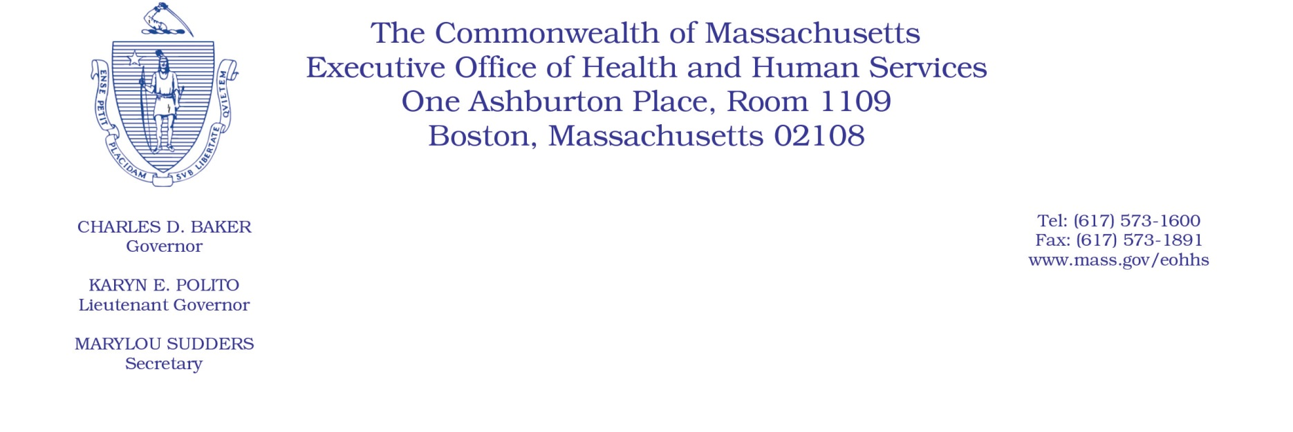

101 CMR 414.00: Rates for Family Stabilization Services

The Executive Office of Health and Human Services previously issued an administrative bulletin under the authority of 101 CMR 414.01(5) to clarify certain family stabilization services rates in 101 CMR 414.03(5). Administrative Bulletin 20-04, Clarification to Certain Family Stabilization Services Rates, effective January 1, 2020.

The unit of service for the rates for family training, peer support, and respite services in 101 CMR 414.03(5) are being updated from an hour unit to a 15-minute unit to align with claiming practices. The chart below reflects the 15-minute unit rate for these services, effective January 1, 2020. These rates below are formally being incorporated into regulation 101 CMR 414.00: Rates for Family Stabilizations Services. No other rates within this regulation are being updated at this time.

Service | Center Size | Unit of Service | Agency Rate
Family Training |  | 15 minutes | $8.74
Family Training Group of 2 |  | 15 minutes | $4.37
Family Training Group of 5 |  | 15 minutes | $1.76
…
Peer Support |  | 15 minutes | $7.59
Peer Support Group of 2 |  | 15 minutes | $3.80
Peer Support Group of 5 |  | 15 minutes | $1.53
…
Respite in Recipient’s Home, 1:1 |  | 15 minutes | $6.82
Respite in Recipient’s Home, 1:2 |  | 15 minutes | $3.41
Respite in Recipient’s Home, 1:3 |  | 15 minutes | $2.28

