Commonwealth of Massachusetts
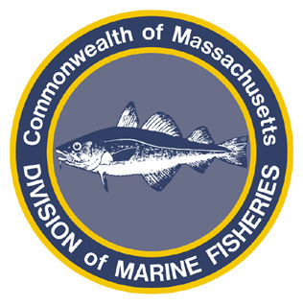
Paul J. Diodati
Director

Deval Patrick
Governor
Timothy P. Murray
Lt. Governor
Richard K. Sullivan, Jr.
Secretary
Mary B. Griffin
Commissioner

Division of Marine Fisheries
251 Causeway Street, Suite 400
Boston, Massachusetts 02114
(617)626-1520
fax (617)626-1509

October 19, 2011
MarineFisheries Advisory

MARINE FISHERIES ADVISORY COMMISSION APPROVES
STATE WATERS SEA SCALLOP DREDGE MEASURES

With the support of the Marine Fisheries Advisory Commission, the Division of Marine Fisheries (MarineFisheries) has created new restrictions to constrain daily catches of sea scallops within the state waters fishery and require gear modifications to reduce bycatch.

All vessels fishing in state waters under the authority of the Coastal Access Permit (CAP) will be subject to the following permit conditions:

- Trip Limit.
  - Effective November 1, 2011 all CAP holders may not retain or possess more than 200 lbs. of sea scallop meats or 2,000 lbs. of whole (shell-on) sea scallops per 24-hour day or per trip, whichever is longer;
  - In those instances when a vessel has both shucked meats and whole scallops, the weight of the whole scallops will be multiplied by 0.10 to determine its equivalency in meats;
  - Exceptions: i) Federally permitted scallop vessels that hold a CAP, may fish in state waters but must adhere to the state trip limit while fishing in state waters.
ii) Federally permitted scallop vessels are allowed to transit state waters and land larger amounts of scallops in state ports provided they comply with the federal plan and their gear is stowed.

- Gear Modifications to reduce by catch.
  - Effective January 1, 2012, it shall be unlawful to fish with or have aboard a sea scallop dredge with rings less than 4 inches in inside diameter;
  - Also effective on January 1, 2012, it shall be unlawful to fish with or have aboard a sea scallop dredge with twine top that has mesh openings smaller than 10 inches; no additional material is allowed to cover the twine top to restrict the mesh openings to less than 10 inches in diameter.

For more information, contact MarineFisheries at 617-626-1520 or online at www.mass.gov/marinefisheries.

