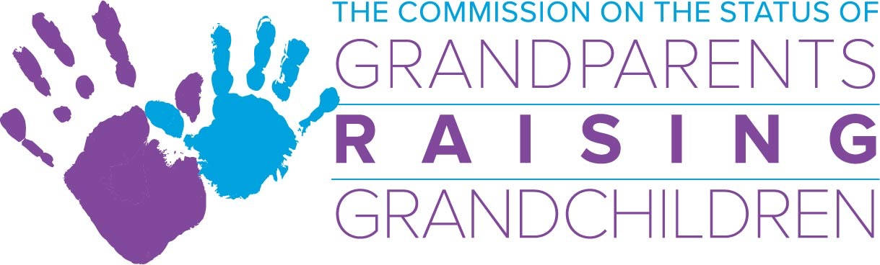

October 10, 2018 Commission Meeting, 2-4 p.m. .
One Ashburton Place 5th Floor Boston, Ma.
**New**Commission Bridge Number: 240-454-0887
Meeting Access Code: 731860817

Agenda

- Acceptance of August meeting minutes
*Action required

- Guest Speaker: 2:15 -2:35 Andrea Weaver, Bridges Together
- Guest Speaker: 2:35- 2:50 Matthew Lashof-Sullivan, Attorney General’s Office

- Financial Report/Budget
- FY’19 Budget
- MCOA budget
- Study: Ilene and Rachel to present proposal, updates
- FY’20 Budget proposal to request funding for additional staff
*Action Required

- Sub-Committee Updates:
- Information and Referral Sub-Committee: Skip
- Support Group Sub-Committee: Margo/Deb
- Legal Sub-Committee: Lynn
- Resource Development Sub-Committee: Ilene

- Directors Report

- Chairwoman’s Report

- Other Business:

- Kerry’s family and collection for donation

