Commonwealth of Massachusetts
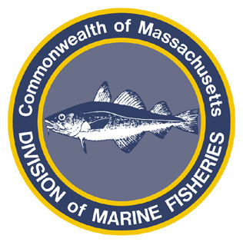
Paul J. Diodati
Director

Deval Patrick
Governor
Timothy P. Murray
Lt. Governor
Richard K. Sullivan, Jr.
Secretary
Mary B. Griffin
Commissioner

Division of Marine Fisheries
251 Causeway Street, Suite 400
Boston, Massachusetts 02114
(617)626-1520
fax (617)626-1509

October 20, 2011
MarineFisheries Advisory

COMMERCIAL SCUP AND FLUKE NO FISHING DAYS LIFTED
EFFECTIVE FRIDAY, OCTOBER 21, 2011

As of October 19, 2011 dealer reports indicate the Commonwealth has landed 71% of the 1,285,325 pound commercial summer (May – October) scup quota and 94% of its 1,156,952 pound commercial Period II (June 1 – Quota) fluke quota. To improve the probability of landing the remainder of these available seasonal fishery quotas, the Division of Marine Fisheries (MarineFisheries) is eliminating no fishing days (Fridays and Saturdays) in the commercial scup and fluke fisheries.

More information can be found on the agency’s website (www.mass.gov/marinefisheries) or by contacting the agency by phone (617-626-1520) or email (marine.fisheries @state.ma.us).

