Commonwealth of Massachusetts
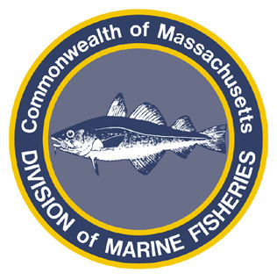Paul J. Diodati
Director

Deval Patrick
Governor
Ian A. Bowles
Secretary
Mary B. Griffin
Commissioner

Division of Marine Fisheries
251 Causeway Street, Suite 400
Boston, Massachusetts 02114
(617)626-1520
fax (617)626-1509

October 25, 2011
MarineFisheries Advisory
EFFECTIVE OCTOBER 27, MANAGEMENT AREA 1A ATLANTIC SEA HERRING DIRECTED FISHERY TO CLOSE
Consistent with federal and interstate action and 322 CMR 9.00, the Division of Marine Fisheries (MarineFisheries) is closing the directed Management Area 1A Atlantic sea herring fishery. This closure is effective at 0001 hours on October 27, 2011. By this date, the National Marine Fisheries Service projects the fishery will land 95% of the 2011 Area 1A Total Allowable (TAC). From October 27, 2011 through December 31, 2011, vessels may continue to retain and land an incidental catch of Atlantic sea herring from Management Area 1A provided it does not exceed 2,000 lb. per day or trip, whichever is longer. This action does not affect the catch, retention and landing of sea herring caught from other management areas.
For further information please visit our website at: www.mass.gov/marinefisheries

