Commonwealth of Massachusetts
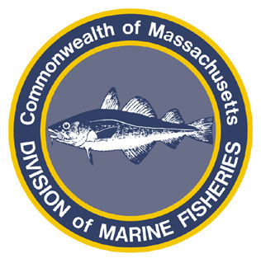
Paul J. Diodati
Director

Deval Patrick
Governor
Timothy P. Murray
Lt. Governor
Richard K. Sullivan, Jr.
Secretary
Mary B. Griffin
Commissioner

Division of Marine Fisheries
251 Causeway Street, Suite 400
Boston, Massachusetts 02114
(617)626-1520
fax (617)626-1509

October 4, 2011
MarineFisheries Advisory

REMINDER OF SEA SCALLOP SCOPING MEETINGS
OCTOBER 4th and 5th, 2011

SPECIAL FISHERY PERMIT FOR 2012:
STATE WATERS SEA SCALLOP DREDGE ENDORSEMENT
AND PERMIT CONDITIONS PERTAINING TO SCALLOP DREDGE GEAR
AND SEA SCALLOP TRIP LIMITS

Pursuant to M.G.L. c. 130 § 17A and 80 and 322 CMR 7.01(4), for the 2012 fishing year, the Division of Marine Fisheries (MarineFisheries) is considering implementing a regulated fishery special permit endorsement authorizing Coastal Access Permit (CAP) holders to take sea scallops by dredge in state waters; this permit endorsement will be known as the State Waters Sea Scallop Endorsement (SE). The SE will only be made available to CAP holders who do not also hold a federal sea scallop permit. This will not prevent federal scallop permit holders from fishing in state waters.

MarineFisheries is also recommending the following conditions to the SE:
- all permitted vessels are authorized to retain and land no more than 200 lbs of sea scallop meats or 2,000 lbs of in-shell sea scallops per trip or 24 hour period, whichever is longer;
- all permitted vessels must use at minimum a 10” twine top net mesh; and
- all permitted vessels must use at minimum a 4” dredge ring.

Two public scoping meetings have been scheduled to take comment on the proposed permit and permit conditions:
Tuesday, October 4, 2011 – 6:00 to 9:00 PM – Falmouth Public High School, 874 Gifford Street Ext, Falmouth, MA 02540.
Wednesday, October 5, 2011 – 6:00 to 9:00 PM –Annisquam River Station, 30 Emerson Ave, Gloucester, MA 01930.

MarineFisheries is accepting written comments through 5:00 PM on Friday, October 7, 2011. Interested parties may submit comments to MarineFisheries via e-mail (marine.fish@state.ma.us or jared.silva@state.ma.us), fax (617-626-1509) or mail (Jared Silva, 251 Causeway Street, Suite 400, Boston, MA 02114).

For additional information regarding the meetings or proposal please contact Jared Silva by phone (617-626-1534) or e-mail (jared.silva@state.ma.us).

