Commonwealth of Massachusetts
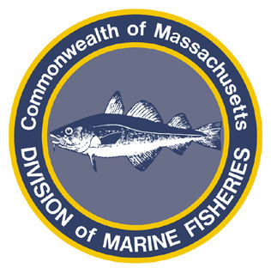
Paul J. Diodati
Director

Deval Patrick
Governor
Timothy P. Murray
Lt. Governor
Richard K. Sullivan, Jr.
Secretary
Mary B. Griffin
Commissioner

Division of Marine Fisheries
251 Causeway Street, Suite 400
Boston, Massachusetts 02114
(617)626-1520
fax (617)626-1509

October 4, 2011
MarineFisheries Advisory

ADJUSTMENTS TO GROUNDFISH RULES TO COMPLIMENT ASPECTS OF AMENDMENT 16

The Division of Marine Fisheries (MarineFisheries) has promulgated rules pertaining to commercial and recreational groundfish that adjust 322 CMR 6.03, 6.41 and 7.01. These actions compliment aspects of the federal groundfish management plan.

Commercial and recreational fishermen should be advised that the following changes the 322 CMR have been made and are now in effect:

Recreational Gulf of Maine Cod Season Changes
The season when private recreational fishermen may keep only two cod per angler per day not exceeding 75 lbs. of cod per vessel has been extended by 15 days and is now November 1 – April 15.
The season when for-hire recreational fishermen may not possess cod has been extended by 15 days and is now November 1 – April 15.

Halibut Minimum Size Increase
Both the recreational and commercial minimum size for halibut has increased from 37” to 41”.

Prohibitions on Ocean Pout, Wolffish and Windowpane Flounder
Commercial fishermen are now prohibited from retaining or landing wolfish, ocean pout and windowpane flounder. Recreational fishermen are now prohibited from retaining or landing wolfish.

Restrictions on the Possession of Groundfish Filets
Recreational fishermen are allowed to land filets of groundfish provided each filet has 2 square inches of skin attached for species identification purposes and the filets do not exceed two times the bag limit for that species.

Conversion for Groundfish Filets and Parts
Commercial fishermen may land filets and parts of groundfish provided the weight of these parts and filets will be multiplied by three to determine compliance with commercial trip limits. This provision does not apply to the possession of cod parts.

For further information please contact Jared Silva by phone (617-626-1534) or through e-mail (jared.silva@state.ma.us), or visit our website to view the full text of these regulations (www.mass.gov/marinefisheries).

