105 CMR 726.000: Temporary placement of Kratom in schedule 1 pursuant to M.G.L. c. 94C, § 2A

726.001: Findings

- The Commissioner has considered kratom’s actual or relative potential for abuse and its history and current patterns of abuse and has found that kratom is an imminent hazard to the public safety.
- The Commissioner has found:
  - The order stated in 105 CMR 726.004 is necessary:
    - to avoid an imminent hazard to the public safety; and,
    - for the preservation of the public health, safety or general welfare.
  - Kratom is not listed in any other schedule identified in section 3 of M.G.L. c. 94C.
  - No exception is in effect for kratom pursuant to section 4 of M.G.L. c. 94C.
  - Kratom is not excluded under subsection (c) of section 2 of M.G.L. c. 94C.
- Based on the foregoing, the Commissioner has found that the immediate adoption of this regulation is necessary for the preservation of the public health, safety, and general welfare.

726.002: Purpose

The purpose of 105 CMR 726.000 is to place Kratom in schedule 1 of M.G.L. c. 94C: Controlled Substances Act.

726.003: Definitions

Commissioner: The Commissioner of Public Health.

Kratom: The plant mitragyna speciosa, mitragynine, 7-hydroxymitragynine (also known as 7-OH), mitragynine pseudoindoxyl (also known as MP), dihydro-7-hydroxymitragynine (also known as MGM-15), 9-fluoro-7-hydroxymitragynine (also known as MGM-16), including their isomers, esters, ethers, salts, and salts of isomers, esters, and ethers, whenever the existence of such isomers, esters, ethers, and salts is possible. Kratom includes any product held out or holding itself out to be kratom.

Board of Health or Local Board of Health or Regional Board of Health: the appropriate and legally designated health authority of the city, town, or other legally constituted governmental unit within the Commonwealth having the usual powers and duties of the board of health or health department of a city or town.

Schedule: As defined in M.G.L. c. 94C, § 1.

726.004: Order

Kratom is hereby placed in schedule 1 in accordance with M.G.L. c. 94C, § 2A.

726.005: Effective date

The effective date of this regulation shall be August 28, 2026. This regulation shall remain in effect for 1 year from its effective date unless the Commissioner finds during the intervening period that the order stated in 105 CMR 726.004 is no longer necessary.

726.006: Guidance to all Local and Regional Boards of Health

Possession or distribution of kratom by any food, retail or other commercial establishment shall constitute an imminent health hazard. While the order stated in 105 CMR 726.004 is in effect, a board of health or an authorized agent, the local inspection department or the equivalent, or a municipal government or its agent may, pursuant to section 30 of chapter 111 and any regulation promulgated pursuant thereto, take any enforcement action consistent with a finding of an imminent health hazard, up to and including summary suspension of a municipal license or permit held by the establishment including, but not limited to, a permit to operate.

The Commissioner may issue other guidance under this section as may be necessary.

Authority: G.L. c. 94C, § 2A

ORDER OF THE COMMISSIONER PURSUANT TO G.L. c. 94C, § 2A PLACING KRATOM IN SCHEDULE I

Statutory Authority
The Commissioner of the Department of Public Health has the authority under G.L. c. 94C, § 2A to order the placement of an unscheduled substance in schedule I on a temporary basis if the Commissioner finds that it is necessary to avoid an imminent hazard to the public safety and that it is necessary for the preservation of the public health, safety or general welfare as well as other procedural prerequisites. The statute requires a 14-day notice period and the order is an emergency regulation in effect for up to 1 year.
For the reasons stated below, I find that the conditions of section 2A have been met regarding the use, sale and distribution of kratom, and therefore order the placement of kratom on schedule I on a temporary basis as provided in section 2A. (Attached)
Prior to issuing this Order, I have considered the public safety hazard posed by kratom’s actual or relative potential for abuse and its history and current patterns of abuse, as discussed below:

Kratom Background
Kratom (Mitragyna speciosa) is a plant native to Southeast Asia. Depending on the amount used, kratom may produce stimulant-like effects, such as increased alertness, or opioid-like effects, such as pain relief and sedation. While individuals may use kratom recreationally, it is also used to self-treat conditions such as anxiety, depression, opioid use disorder and opioid withdrawal. According to data form the Substance Abuse and Mental Health Services Administration’s National Survey on Drug Use and Health an estimated 1.7 million Americans aged 12 and older used kratom in 2021. Kratom is not well researched for efficacy in treatment of psychiatric and substance use disorders, nor for any other medical condition.
Synthesized products typically contain higher concentrations of the naturally occurring substance, 7-hydroxymitagynine (7-OH), or synthetic derivatives of mitragynine. The contents of kratom products, both “natural” and “synthetic”, vary widely in their ingredients, strength, and purity, and are difficult to distinguish from one another. Consumers have no reliable way of knowing what compounds a specific product contains or how potent it may be. As a relatively new product in the United States and given current marketing methods, many individuals may consume kratom without being aware of its presence in a product and/or without understanding of potential harmful side effects and risk of dependence.
Some kratom products are manufactured as gelatin-based “gummy” candies with flavors that reflect those found in popular candy (e.g. “blue raspberry”, “sour apple”). Packaging resembles that of popular candy brands and does not carry warning labels. These products appeal to youth who may consume them without knowledge or understanding of their psychoactive nature (see “Appendix A”). Products are often marketed as a “sober alternative,” branded as “all-natural” or “plant-based” herbal supplements, exploiting the health-halo effect, which is the tendency to associate such labels with safety and wellness. Such marketing obscures the fact that kratom use can lead to tolerance, withdrawal, and misuse.
According to the FDA, there are no prescription or over-the-counter drug products containing kratom or its known alkaloids that are legally on the market in the U.S.

Risks of Kratom Use
The FDA has warned consumers not to use kratom because of the risk of serious adverse events, including liver toxicity, seizures, and substance use disorder (SUD). The active alkaloids in kratom act upon opioid receptors. As such, kratom products carry substantial risks of dependence, acute toxicity, overdose, and organ failure. Additional risks of use include delusional thinking, psychosis, seizures, and dehydration resulting from excessive urination and sweating. Overdose can occur, including fatal overdose, particularly when using highly potent products, using kratom products mixed with unknown substances, and/or using other substances alongside kratom products, especially opioids, alcohol, benzodiazepines, or other sedatives.
Overdose can occur, particularly when:
- Using highly potent products with 7-OH or other synthetic kratom derivatives alone;
- Using highly potent products that are mixed with unknown substances; and
- Using other substances with kratom, especially opioids (like fentanyl, heroin, oxycodone, or methadone), alcohol, benzodiazepines, or sedatives.

Although rare, kratom-involved deaths have been reported. Patients are especially at risk when combining with other substances and/or when they have a chronic health condition. While overdose deaths from some of the synthetic kratom derivatives like MGM-15 and MGM-16 have not yet been reported and confirmed, they have caused respiratory depression and overdose in laboratory experiments.
Physical dependence develops when an individual takes kratom products often and consistently so that when they stop taking it, they experience unpleasant withdrawal symptoms. Many people take kratom products and don’t realize that it could be harmful or that dependence can occur.
Withdrawal can occur when regular or daily use of kratom products is stopped. People can experience symptoms similar to opioid withdrawal, such as anxiety, agitation, muscle spasms, runny nose, hot flashes, loss of appetite, diarrhea, restlessness, and fever.
Kratom use disorder (addiction) can occur when people using kratom products compulsively use and crave these products despite adverse consequences, like overdose, withdrawal, or disruptions in their relationships and ability to work, go to school, or take care of their family.

Commercial Availability and Vulnerability of Minors
Because these products are widely sold over the counter at retail locations in Massachusetts including gas stations, convenience stores, and smoke shops, consumers, including minors, can easily acquire them without age verification or understanding of potential dangers. Kratom products are not required to carry warning labels and are often stocked in areas in front of counters and accessible to all customers. This leaves the public unaware of severe health risks, including potentially dangerous drug interactions, undisclosed adulterants, and other risks. Further, manufacturers frequently use colorful packaging and target marketing that obscures the drug’s effects and addictive qualities, placing children and consumers at risk of accidental ingestion, dependency, overdose, and acute toxicity.

Massachusetts Usage and Impact Data
Massachusetts health data demonstrate that kratom is an acute public health safety hazard in Massachusetts. Since 2020, there have been approximately 100 deaths reported in Massachusetts to be associated with kratom or related substances. Deaths may be underreported as no ICD codes (clinical modification for diagnosis coding in U.S. healthcare settings) currently relate to kratom or related substances.
From July 2025 through July 28, 2026, the Electronic Surveillance System for the Early Notification of Community-Based Epidemics (ESSENCE) has records of 314 visits in MA where kratom was mentioned in either the “triage notes” or “chief complaint” field.
Additionally, the Massachusetts and Rhode Island Poison Center has reported 127 kratom-related calls from January 2021 through July 29, 2026, including 10 calls for children aged 5 years or less, half of which were for children aged 1 year or less. Of the 127 calls received, approximately 46% were categorized as “moderate” or “major” effect. Calls for kratom exposure from Jan 1, 2026, through July 29, 2026 are approximately equal to the total number of calls for kratom exposure received in all of calendar year 2025.
Currently, mitragynine and 7-OH are routinely tested for upon overdose death and DPH is actively monitoring counts and trends of kratom-involved overdose. Death records contain the names of substances that contributed to death. From 2020-2026, kratom, mitragynine, and/or 7-hydroxymitragynine (7-OH) were listed as the “cause of death” fields in the following number of DPH’s Registry of Vital Records (RVRS) death records, by year:
Table 1: RVRS death records: Deaths associated with Kratom use in MA
Year | Number of Records
2020 | 15
2021 | 10
2022 | 16
2023 | 19*
2024 | 18*
2025 | 21*
2026 | 8†
*preliminary data
† data as reported 1/1/2026-7/28/2026

Appendix A
Examples of kratom products currently on the market in Massachusetts.
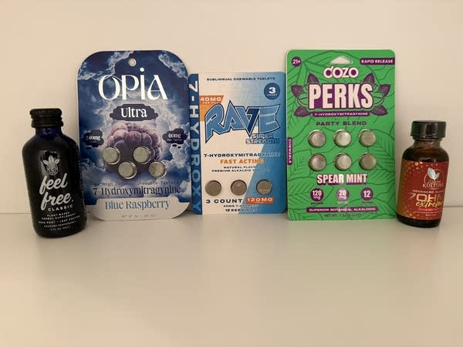
The above photo is from Minnesota Public Radio News with all products confirmed as being available in Massachusetts by Brookline’s Massachusetts Tobacco Cessation and Prevention (MTCP) Board of Health program.
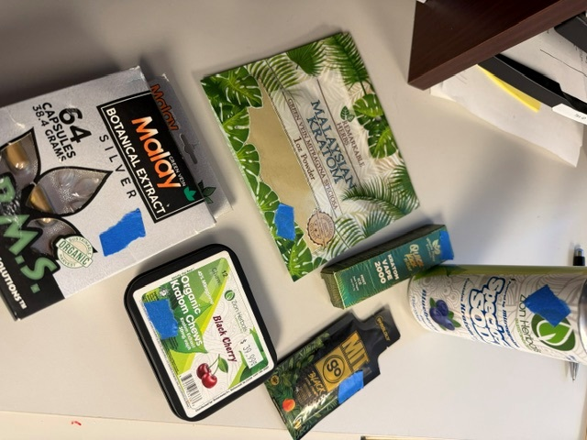
The above photo has been provided by Melrose’s MTCP Board of Health program.

FDA and Kratom | FDA
Perry T, Chin S. The Unregulated Rise of Kratom Drinks: Emerging Challenges and Policy Recommendations. Public Health Rep. 2026 May-Jun;141(3):329-334. doi: 10.1177/00333549251403378. Epub 2026 Jan 12. PMID: 41527301; PMCID: PMC12799471.
Perry T, Chin S. The Unregulated Rise of Kratom Drinks: Emerging Challenges and Policy Recommendations. Public Health Rep. 2026 May-Jun;141(3):329-334. doi: 10.1177/00333549251403378. Epub 2026 Jan 12. PMID: 41527301; PMCID: PMC12799471.
FDA and Kratom | FDA
Smallets S, Litvin S, Abele G, Kirsh S, Paustenbach D. The acute adverse health effects of kratom: an evaluation of case reports. Front Pharmacol. 2025 Aug 29;16:1620601. doi: 10.3389/fphar.2025.1620601. PMID: 40949154; PMCID: PMC12425911.

