**COMMONWEALTH OF MASSACHUSETTS**

**SUFFOLK, ss. BUILDING CODE APPEALS BOARD DOCKET NO. 11-1013**

**­­­­­­­­­­­­­­­­­­­­­­­­­­­­**______________________________

)

PPC Land Ventures Inc., )

Appellant )

)

v. )

)

City of Boston, )

Appellee )

______________________________)

**BOARD’S DECISION ON APPEAL**

**Introduction**

This matter came before the State Building Code Appeals Board (“Board”) on Appellant’s appeal application filed pursuant to G.L. c.143, §100 and 780 CMR 122.1 (“Application”). Appellant sought relief from the requirements of 780 CMR 1015.1 (8th Edition) with respect to a building located at 291 Saint Botolph Street, Boston, MA 02115 (a project developed for Northeastern University).

**Procedural History**

On or about June 3, 2011, the Inspectional Services Department for the City of Boston issued a Building Code Refusal regarding a project involving the demolition of an existing gymnasium building and the construction of a new 17-story mixed used building with one story below grade consisting of Group R-2 (Dorms), Group B (Offices), University classrooms), and Group A-3 (Multipurpose rooms) located at 291 Saint Botolph Street, Boston, MA. The Refusal cited violation comments regarding 780 CMR 403.6.1 and 1015.1. The Board convened a public hearing on July 7, 2011, in accordance with G.L.c. 30A, §§10 & 11; G.L.c. 143, §100; 801 CMR 1.02; and 780 CMR 122.3. All interested parties were provided an opportunity to testify and present evidence to the Board.

The following exhibits were entered into evidence:

Exhibit 1: The Application including: a copy of the City’s Building Code Refusal; a memorandum dated June 9, 2011 from R. W. Sullivan Engineering to the Board regarding Northeastern Residential Tower (Grandmarc); a letter dated April 29, 2011 from the International Code Council to Jeff. D. Perras, P.E. of R. W. Sullivan Engineering; and a copy of a floor plan for Levels 13-15, dated June 9, 2011, prepared by R. W. Sullivan Engineering.

Exhibit 2: A copy of a letter, dated June 28, 2011, from the International Code Council (“ICC”) to Jeff D. Perras, P.E. of R. W. Sullivan Engineering.

**Conclusion**

The Board considered a motion to withdraw Appellant’s request for relief with respect to 780 CMR 403.6.1 (“Motion One”). Motion One was allowed and was approved by a unanimous vote. The Board considered a motion to overturn the City’s decision regarding 780 CMR 1015.1, based on the interpretation of the ICC set forth in Exhibit 2 (indicating that the proposed design meets the intent of the Code, 780 CMR 1015.1, Exception 1) (“Motion Two”). Motion Two was **approved** by a unanimous vote.

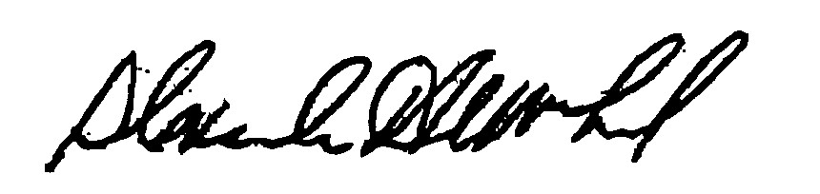

_______________________ _______________________ __________________

H. Jacob Nunnemacher Douglas A. Semple, Chair Alexander MacLeod

*Any person aggrieved by a decision of the State Building Code Appeals Board may appeal to Superior Court in accordance with G.L. c.30A, §14 within 30 days of receipt of this decision.*

DATED: November 7, 2011