COMMONWEALTH OF MASSACHUSETTS

SUFFOLK, ss. BUILDING CODE APPEALS BOARD DOCKET NO. 11-1036
______________________________
)
7-41 Charlton, LLC, )
Appellant )
)
v. )
)
City of Everett, )
Appellee )
______________________________ )

BOARD’S DECISION ON APPEAL

Introduction

This matter came before the State Building Code Appeals Board (“Board”) on Appellant’s appeal application filed pursuant to G.L. c.143, §100 and 780 CMR 122.1 (“Application”). Appellant sought variances from 780 CMR 111.7 and 111.8 with respect to a determination by the Building Inspector for the City of Everett that a building permit had expired for developing 180 housing units in a building located at 27-41 Charlton Street, Everett, MA.

Procedural History

On or about June 30, 2011, the Director of Inspectional Services and Inspector of Buildings for the City of Everett issued the following decision to Appellant:

It is my opinion that you have failed to prosecute the building permit scope of work in a continuous manner, in good faith, as required by State Building Code 780 CMR 111.8. As such, please consider the building permit BP 2005-0255 invalid. (“Decision”)

The Board convened a public hearing on September 1, 2011, in accordance with G.L.c. 30A, §§10 & 11; G.L.c. 143, §100; 801 CMR 1.02; and 780 CMR 122.3. All interested parties were provided an opportunity to testify and present evidence to the Board.

Discussion

By way of background, the Application continues the story set forth in the Board’s Ruling in Docket No. 11-962 (dated January 25, 2011). The intention, according to Appellant, is to develop 180 apartment, rather than condominium, units in the building in issue (because, among other reasons, Appellant cannot obtain financing for a condominium). Appellant testified that it is working with Fairfield Residential, which has experience in developing multi-family apartment complexes, to bring in a partner to help provide financing (possibly equity or otherwise). Since the Ruling in Docket No. 11-962, Appellant has expended $5,800 to, in general, frame out a single, one-bedroom, unit as a model for further development of the building. Appellant has also had some environmental site investigation work performed. Appellant also asserted that tens of thousands of other costs have been incurred (for various engineering and site investigation activities) since January 2011.

Appellant estimated that it would require three to six months (from the date of the hearing) to complete financing, after which (approximately two more months) construction activities could get underway “full bore.” If those things occurred, completing the build-out would take approximately 15 to 18 months. Appellant estimated that the costs, going forward, would range from $15 million to $25 million to complete the project.

Appellant represented that, within the next six months, construction activities could take place, costing approximately $250,000. Appellant asserted that, if financing were in place, it would be overly aggressive to believe that $2.5 million worth of worth would take place within the next 6 months.

The Board also discussed and considered the possible consequences if Appellant were not given additional time to make progress in construction activities pursuant to the building permit.

Conclusion

The Board considered a motion to allow a variance from 780 CMR 111.8, on the conditions that “substantial work” is done within six (6) months of the hearing, “substantial work” must include: (1) demolition of two separate buildings located on the site (as indicated by Appellant); (2) completion of DEP environmental remediation requirements; (3) the sealing of the exterior of the building, as Appellant has stated; (4) providing a report each month, on the first of the month, to the building official, which contains: (a) a description of the physical work that has taken place on site to that month; and (b) the work that has taken place “behind the scenes.” If substantial work, as set forth above, is not accomplished by March 1, 2012, then the building permit will be null and void (“Motion”). The Motion was approved by unanimous vote.

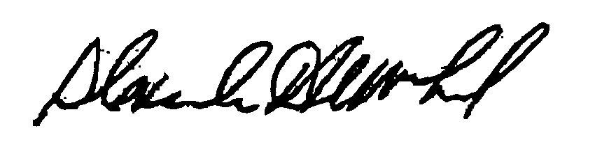
_______________________ ___________________ __________________
H. Jacob Nunnemacher Brian Gale, Chair Alexander MacLeod

Any person aggrieved by a decision of the State Building Code Appeals Board may appeal to Superior Court in accordance with G.L. c.30A, §14 within 30 days of receipt of this decision.

DATED: December 27, 2011

