COMMONWEALTH OF MASSACHUSETTS

SUFFOLK, ss. BUILDING CODE APPEALS BOARD DOCKET NO. 11-1050
______________________________
)
Massachusetts Bay Transportation )
Authority, )
Appellant )
)
v. )
)
Commonwealth of Massachusetts, )
Department of Public Safety, )
Appellee )
______________________________ )

BOARD’S DECISION ON APPEAL

Introduction

This matter came before the State Building Code Appeals Board (“Appeals Board”) on Appellant’s appeal application filed pursuant to G.L. c.143, §100 and 780 CMR 122.1 (“Application”). Appellant (“MBTA”) sought review of its decision not to staff the Science Park Station as part of the installation of a new automated fare collection system.

Procedural History

A State Building Inspector issued a decision, dated September 16, 2011, which pointed out that the MBTA’s decision not to staff the Science Park Station deviated from a prior agreement between the MBTA and the Board of Building Regulations and Standards. The Appeals Board convened a public hearing on October 18, 2011, in accordance with G.L.c. 30A, §§10 & 11; G.L.c. 143, §100; 801 CMR 1.02; and 780 CMR 122.3. All interested parties were provided an opportunity to testify and present evidence to the Appeals Board. The following materials were accepted into evidence: (1) The Application, including background documentation; (2) copy of a set of photographs and plans entitled “Accessibility Improvements at Science Park Station,” dated October 17, 2011, prepared by AECOM for the MBTA.

Discussion

The MBTA represented that its long-term plan was always to have the Science Park Station unstaffed; staff had been assigned there only to assist riders during the implementation of a new fare collection system. As described in more detail in Exhibits 1, 2 and the testimony, a Board of Building Regulations and Standards decision in 2004 under the 6th Edition of the State Building Code had required the Science Park Station to be staffed. But the Appeals Board concluded that the 6th Edition of the Code would no longer apply in these circumstances and that the installation as the Science Park Station met the requirements of NFPA 130, Section 5.5.6.3.5.3.

Conclusion

The Appeals Board considered a motion to allow a variance at the Science Park Station site, allowing the site to be unstaffed, because the installation at that location met the requirements of NFPA 130, Section 5.5.6.3.5.3 (“Motion”). The Motion was approved by unanimous vote.

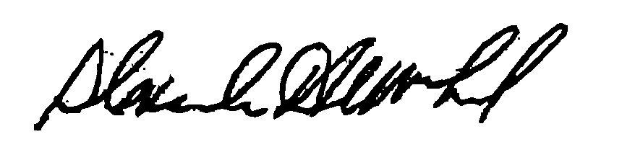
_______________________ ___________________ __________________
H. Jacob Nunnemacher Douglas Semple, Chair Alexander MacLeod

Any person aggrieved by a decision of the State Building Code Appeals Board may appeal to Superior Court in accordance with G.L. c.30A, §14 within 30 days of receipt of this decision.

DATED: December 19, 2011

