**COMMONWEALTH OF MASSACHUSETTS**

**SUFFOLK, ss. BUILDING CODE APPEALS BOARD DOCKET NO. 11-1054**

**­­­­­­­­­­­­­­­­­­­­­­­­­­­­**______________________________

)

Watch City Ventures, LLC, )

Appellant )

)

v. )

)

City of Waltham, )

Appellee )

______________________________ )

**BOARD’S DECISION ON APPEAL**

**Introduction**

This matter came before the State Building Code Appeals Board (“Board”) on Appellant’s appeal application filed pursuant to G.L. c.143, §100 and 780 CMR 122.1 (“Application”). Appellant sought variances from 780 CMR Table 503 and 780 CMR 506.3 (8th Edition) with respect to buildings located at 221-257 Crescent Street, Waltham, MA, and where the tallest building is seven stories in height.

**Procedural History**

On or about September 15, 2011, the Building Inspector for the City of Waltham issued the following:

The Building Permit . . . is denied for non-compliance with 780 CMR (Table 503, as referenced in the 2009 IBC, Table 503, Allowable Building Height and Areas). A type 3B fully sprinklered building cannot exceed 5 stories for R-2 use.

The Board convened a public hearing on October 18, 2011, in accordance with G.L.c. 30A, §§10 & 11; G.L.c. 143, §100; 801 CMR 1.02; and 780 CMR 122.3. All interested parties were provided an opportunity to testify and present evidence to the Board. The following were admitted into evidence: (1) State Building Code Appeals Board Appeal Application Form with ; (2) copy of a document entitled “Watch City Ventures – Waltham Watch Factory Lofts – Phase 3,” which describes facts relevant to variance request concerning 780 CMR Table 503.

**Discussion**

The project consists of approximately 500,000 square feet of former mill spaces, developed over three phases. The third phase (which is in issue in the Application) involves changing the use from business (B) to residential (R-2). The City’s Building Department did not object to granting relief. The Fire Department did not so object. The seven-story building has been in existence, is historically significant (and protected), and had been vacant for some time. Further, it would have been a hardship to remove two stories as part of building renovations. Finally, the Board noted that Appellant shall comply with high-rise fire protection requirements in the project.

**Conclusion**

The Board considered a motion to allow variances from 780 CMR Table 503 and 780 CMR 506.3, based on the facts described above and discussed during the hearing (“Motion”). The Motion was **approved** by unanimous vote.

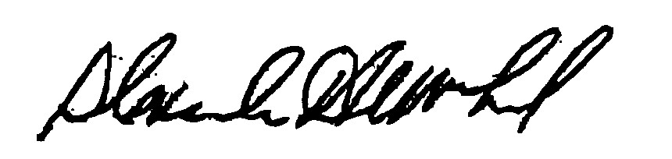

_______________________ ___________________ __________________

H. Jacob Nunnemacher Douglas Semple, Chair Alexander MacLeod

*Any person aggrieved by a decision of the State Building Code Appeals Board may appeal to Superior Court in accordance with G.L. c.30A, §14 within 30 days of receipt of this decision.*

DATED: December 19, 2011