**COMMONWEALTH OF MASSACHUSETTS**

**SUFFOLK, ss. BUILDING CODE APPEALS BOARD DOCKET NO. 11-1067**

**­­­­­­­­­­­­­­­­­­­­­­­­­­­­**______________________________

)

John Cole (d/b/a Riva Pizzeria), )

Appellant )

)

v. )

)

Town of Scituate, )

Appellee )

______________________________ )

**BOARD’S DECISION ON APPEAL**

**Introduction**

This matter came before the State Building Code Appeals Board (“Board”) on Appellant’s appeal application filed pursuant to G.L. c.143, §100 and 780 CMR 122.1 (“Application”). Appellant sought review of the Town of Scituate’s decision about the installation of an exhaust hood in a pizzeria located at 673 Country Way.

**Procedural History**

On or about October 14, 2011, the Building Commissioner/Zoning Enforcement Officer for the Town of Scituate issued the following. He ordered Appellant to install a Type I exhaust hood over pizza ovens in accordance with IMC 2009, Section 507.2.1 (Commercial Kitchen Hoods).

The Board convened a public hearing on November 15, 2011, in accordance with G.L.c. 30A, §§10 & 11; G.L.c. 143, §100; 801 CMR 1.02; and 780 CMR 122.3. All interested parties were provided an opportunity to testify and present evidence to the Board.

**Discussion**

Appellant installed two-deck electric pizza ovens in June 2011. Appellant believed that the ovens were exempt from the requirements of IMC 2009, Section 507 because the ovens did not produce grease or smoke, and the kitchen area was ventilated by a roof exhaust fan with a capacity of 1083 cubic feet per minute.

The Building Commissioner, however, observed that the ovens do emit grease, which led him to conclude that a Type I exhaust must be installed.

**Conclusion**

The Board considered a motion to agree with the Building Commissioner’s conclusion that a Type I hood must be installed and allowed Appellant 90 days from December 1, 2011 in order to complete the installation (“Motion”). The Motion was **approved** by unanimous vote.

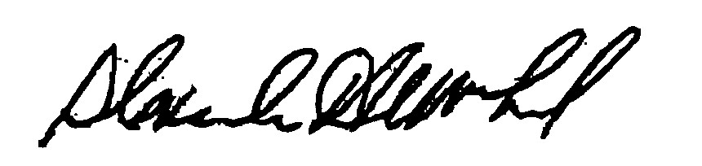

_______________________ ___________________ __________________

Dana Haagensen Douglas Semple, Chair Alexander MacLeod

*Any person aggrieved by a decision of the State Building Code Appeals Board may appeal to Superior Court in accordance with G.L. c.30A, §14 within 30 days of receipt of this decision.*

DATED: January 18, 2012