**COMMONWEALTH OF MASSACHUSETTS**

**SUFFOLK, ss. BUILDING CODE APPEALS BOARD DOCKET NO.: 11-960**

**­­­­­­­­­­­­­­­­­­­­­­­­­­­­**______________________________

)

Harvard Vanguard Medical, )

Appellant )

)

v. )

)

City of Boston, )

Appellees )

______________________________)

**BOARD’S RULING ON APPEAL**

**Introduction**

This matter came before the State Building Code Appeals Board (“Board”) on appellant’s appeal filed pursuant to G.L. c.143, §100 and 780 CMR 122.1. In accordance with 780 CMR 122.3 the appellant petitioned the Board to grant a variance based on the Eighth Edition of the Massachusetts State Building Code (“Code”). For the following reasons, the variance is hereby **GRANTED**.

The appellant requested that the Board grant a variance from 780 CMR Section 1018.1. Kevin Hastings of R.W. Sullivan and Mike Reith of Steffian Bradley Architects appeared on behalf of the appellant. No building official was present. All witnesses were duly sworn.

**Procedural History**

The Board convened a public hearing on January 6, 2011, in accordance with G.L.c. 30A, §§10 & 11; G.L.c. 143, §100; 801 CMR 1.02; and 780 CMR 122.3. All interested parties were provided with an opportunity to testify and present evidence to the Board.

**Findings of Fact**

The facts of this matter are largely not in dispute. Instead, this matter turns on the review of the applicable provisions of the State Building Code. The Board bases the following findings upon the testimony presented at the hearing. There is substantial evidence to support the following findings:

1. The property at issue is located at 165 Dartmouth St., Boston, MA.
2. The project involves a partial renovation of 1 floor of an existing building.
3. The renovation is on the first floor which is at grade.
4. The property is an outpatient medical facility.
5. There are 6 floors above the facility that are all an open parking structure.
6. A variance was granted for this issue in the same space in 2005.
7. The floor in question is fully sprinklered.

**Exhibits**

The following Exhibits were entered into evidence at the hearing on this matter and reviewed by the Board:

Exhibit 1: Application for Appeal.

Exhibit 2: Floor Plan

**Analysis**

1. Jurisdiction of the Board

There is no question that the Board has jurisdiction to hear this case. The governing statute provides that:

Whoever is aggrieved by an interpretation, order, requirement, direction or failure to act by any state or local agency or any person or state or local agency charged with the administration or enforcement of the state building code or any of its rules and regulations, except any specialized codes as described in section ninety-six, may within forty-five days after the service of notice thereof appeal from such interpretation, order, requirement, direction, or failure to act to the appeals board. G.L. c.143, §100.

The issues giving rise to this matter directly implicate provisions of the Code. As such, this Board has jurisdiction to decide this case pursuant to G.L. c. 143, §100.

1. State Building Code requirements

The issue is whether to grant a variance to 780 CMR 1018. 1 to allow the corridor walls not to be fire-resistance rated. The appellant testified that this is a continuation of the corridor and that in 2005 this Board granted a variance to not fire rate the corridors. The appellant asserted that the facility is outpatient only and that it is fully sprinklered.

Because nothing has changed since the variance was granted in 2005 and because the floor is fully sprinklered, the variance may be granted.

**Conclusion**

A motion was made by Alexander MacLeod and seconded by Jacob Nunnemacher to **GRANT** the variance to 780 CMR 1016.1 for making the corridor walls non-rated based on the fact that there was a variance for this issue on the same property in 2005 and there is no difference, the floor was fully sprinklered and there is no evidence of any fires since 2005.

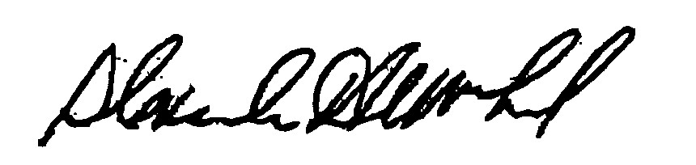

_______________________ _______________________ __________________

Jacob Nunnemacher Alexander MacLeod Doug Semple

*Any person aggrieved by a decision of the State Building Code Appeals Board may appeal to Superior Court in accordance with G.L. c.30A, §14 within 30 days of receipt of this decision.*

DATED: February 8, 2011