**COMMONWEALTH OF MASSACHUSETTS**

**SUFFOLK, ss. BUILDING CODE APPEALS BOARD DOCKET NO.: 11-974**

**­­­­­­­­­­­­­­­­­­­­­­­­­­­­**______________________________

)

Donald Rushford, )

Appellant )

)

v. )

)

Town of Ashland, )

Appellees )

______________________________)

**BOARD’S RULING ON APPEAL**

**Introduction**

This matter came before the State Building Code Appeals Board (“Board”) on appellant’s appeal filed pursuant to G.L. c.143, §100 and 780 CMR 122.1. In accordance with 780 CMR 122.3 the appellant petitioned the Board to grant a variance based on the Seventh Edition of the Massachusetts State Building Code (“Code”).

The appellant requested that the Board grant a variance to 780 CMR Chapter 7, Section 904.7. The appellant appeared for the hearing *pro se*. Ed Morini, Building Commissioner for the Town of Ashland, appeared on behalf of the appellees. All witnesses were duly sworn.

**Procedural History**

The Board convened a public hearing on March 3, 2011, in accordance with G.L.c. 30A, §§10 & 11; G.L.c. 143, §100; 801 CMR 1.02; and 780 CMR 122.3. All interested parties were provided with an opportunity to testify and present evidence to the Board.

**Findings of Fact**

This matter turns on the review of the applicable provisions of the State Building Code. The Board bases the following findings upon the testimony presented at the hearing. There is substantial evidence to support the following findings:

1. The property at issue is located at 48 Cherry St., Ashland, MA.
2. The appellant/owner is remodeling the garage space into living space.
3. The appellant currently lives on the second story of the garage space.
4. The second story of the garage space was built pursuant to a variance granted by the local Zoning board.
5. The appellant applied for and received a building permit for the renovation.

**Analysis**

1. Jurisdiction of the Board

There is no question that the Board has jurisdiction to hear this case. The governing statute provides that:

Whoever is aggrieved by an interpretation, order, requirement, direction or failure to act by any state or local agency or any person or state or local agency charged with the administration or enforcement of the state building code or any of its rules and regulations, except any specialized codes as described in section ninety-six, may within forty-five days after the service of notice thereof appeal from such interpretation, order, requirement, direction, or failure to act to the appeals board. G.L. c.143, §100.

The issues giving rise to this matter directly implicate provisions of the Code. As such, this Board has jurisdiction to decide this case pursuant to G.L. c. 143, §100.

1. State Building Code requirements

The issue in this case is whether or not the appellant must sprinkler the entire property. The appellant testified that he received a building permit with the stipulation that he would sprinkler the 2 rooms being renovated and provide a fire separation between the 5th unit and the rest of the units.

The Building Commissioner testified that the renovation and the change to an R2 use group does require that the entire property meet the Code, meaning the entire property should be sprinklered. However, the Building Commissioner testified that when the appellant bought the property it had already been converted into a 4 family unit and that it was allowed by the prior building officials, zoning board, and fire officials without that requirement. Therefore, the Building Commissioner testified that when he received the permit for this renovation he stated that at a minimum he would require a fire separation between the new 5th unit and the 4th unit and that those units be sprinklered.

Both the appellant and the Building Commissioner testified that this was agreeable and that it was at the time the fire department got involved, after the project was ¾ completed that they stated the entire building must be sprinklered. The appellant and the Building Commissioner testified that by coming to this Board they were seeking relief and that although they understand that even if this Board grants a variance that the fire department still has the authority to impose additional requirements if they so choose.

**Conclusion**

A motion was made by Alexander MacLeod and seconded by Jeff Putnam that based on the testimony presented that the appellant must comply with what the building commissioner has stated is agreeable-that he must sprinkler the 5th unit and make a fire separation wall between the existing unit and the fifth unit this is allowed due to the hardship and the fact that the whole house is up to code with carbon monoxide detectors and hardwired smoke detectors.

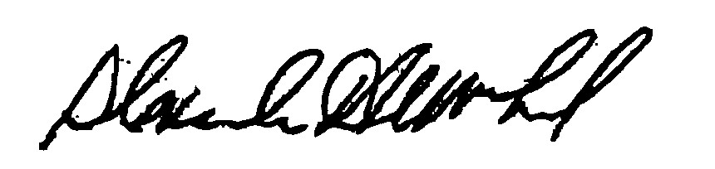

_______________________ _______________________ __________________

Jeff Putnam Alexander MacLeod Doug Semple

*Any person aggrieved by a decision of the State Building Code Appeals Board may appeal to Superior Court in accordance with G.L. c.30A, §14 within 30 days of receipt of this decision.*

DATED: March 17, 2011