COMMONWEALTH OF MASSACHUSETTS

SUFFOLK, ss. BUILDING CODE APPEALS BOARD DOCKET NO.: 11-975
______________________________
)
Richard Martelli, Jr., )
Appellant )
)
v. )
)
Town of Northborough, )
Appellees )
______________________________)

BOARD’S RULING ON APPEAL

Introduction

This matter came before the State Building Code Appeals Board (“Board”) on appellant’s appeal filed pursuant to G.L. c.143, §100 and 780 CMR 122.1. In accordance with 780 CMR 122.3 the appellant petitioned the Board to grant a variance based on the Seventh Edition of the Massachusetts State Building Code (“Code”).

The appellant requested that the Board grant a variance to 780 CMR Sections 5305, 5310.1.1, and 9304.8. The appellant appeared for the hearing pro se. William Farnsworth, Building Commissioner for the Town of Northborough, appeared on behalf of the appellees. All witnesses were duly sworn.

Procedural History

The Board convened a public hearing on March 3, 2011, in accordance with G.L.c. 30A, §§10 & 11; G.L.c. 143, §100; 801 CMR 1.02; and 780 CMR 122.3. All interested parties were provided with an opportunity to testify and present evidence to the Board.

Findings of Fact

This matter turns on the review of the applicable provisions of the State Building Code. The Board bases the following findings upon the testimony presented at the hearing. There is substantial evidence to support the following findings:

- The property at issue is located at 13 Assabet Drive, Northborough, MA.
- The appellant purchased the subject property in October of 2006.
- The property is a 2 story Cape.
- Upon purchasing the property the appellant was told that the second floor had been used as a bedroom since it was built in 1947.
- Since 2006 the appellant has made renovations to the second floor.
- The appellant’s renovations included the addition of sheetrock, some electrical wiring and insulating the building.
- The appellant has sold the property.
- The new owner requested building permits for all work that has been done as a condition of sale.
- The Town Building Department could not provide permits because in 2006 the second floor was listed as a walkup attic and in 2011 it is listed as a bedroom.
- The second floor bedroom does not meet current Code requirements for ceiling height and window height.

Analysis

- Jurisdiction of the Board

There is no question that the Board has jurisdiction to hear this case. The governing statute provides that:

Whoever is aggrieved by an interpretation, order, requirement, direction or failure to act by any state or local agency or any person or state or local agency charged with the administration or enforcement of the state building code or any of its rules and regulations, except any specialized codes as described in section ninety-six, may within forty-five days after the service of notice thereof appeal from such interpretation, order, requirement, direction, or failure to act to the appeals board. G.L. c.143, §100.

The issues giving rise to this matter directly implicate provisions of the Code. As such, this Board has jurisdiction to decide this case pursuant to G.L. c. 143, §100.

- State Building Code requirements

The issue in this case is whether to grant variances to 780 CMR 5305 and 5310.1.1 and allow the current ceiling height and window height on the second floor bedroom. The Code requires the bedroom height to be a minimum of 7 feet. The appellant testified that the ceiling is 6 feet 10 inches and that the footprint of the second floor has remained the same and that it has always been used as a bedroom. The appellant also testified that the window meets the width requirements of the Code but not the height requirements. He stated that it would be a hardship to replace the windows as it would involve work to the exterior of the building.

The Building official testified that he could not provide the permit as requested but was not opposed to granting the variance so that the permits could be provided so long as the appellant would be willing to increase the life safety of the house by updating the carbon monoxide and smoke detectors to meet current standards of the Code.

Conclusion

A motion was made by Alexander MacLeod and seconded by Jacob Nunnemacher to GRANT a variance to 780 CMR 5305 to allow the ceiling height of 6 feet 10 inches and to GRANT a variance to 780 CMR 5310.1.1 to allow the existing window in the second floor bedroom to remain at 18 inches high by 24 inches wide with the condition that the appellant must put in a smoke and carbon monoxide detection system that is compatible with today’s edition of the Code.

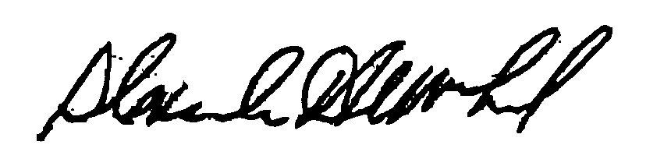
_______________________ _______________________ __________________
Jacob Nunnemacher Alexander MacLeod Doug Semple

Any person aggrieved by a decision of the State Building Code Appeals Board may appeal to Superior Court in accordance with G.L. c.30A, §14 within 30 days of receipt of this decision.

DATED: March 28, 2011

