**COMMONWEALTH OF MASSACHUSETTS**

**SUFFOLK, ss. BUILDING CODE APPEALS BOARD DOCKET NO. 11-990**

**­­­­­­­­­­­­­­­­­­­­­­­­­­­­**______________________________

)

The Coca Cola Company, )

Appellant )

)

v. )

)

City of Northampton, )

Appellee )

______________________________)

**BOARD’S DECISION ON APPEAL**

**Introduction**

This matter came before the State Building Code Appeals Board (“Board”) on Appellant’s appeal application filed pursuant to G.L. c.143, §100 and 780 CMR 122.1 (“Application”). Appellant owns a beverage manufacturing and warehouse facility located at 45 Industrial Drive, Northampton, MA. Appellant seeks approval, pursuant to 780 CMR 901.7.2.1 (7th Edition) for an alternate fire protection design methodology – independent engineering review to install a Tyco Quell fire protection system.

**Procedural History**

The Board convened a public hearing on April 19, 2011, in accordance with G.L.c. 30A, §§10 & 11; G.L.c. 143, §100; 801 CMR 1.02; and 780 CMR 122.3. All interested parties were provided an opportunity to testify and present evidence to the Board. The City reviewed a proposed fire protection system in the freezer and 35 degree cooler at the Coca Cola facility. As a result, the Building Commissioner for the City of Northampton issued a letter, dated March 18, 2011, which stated, “While I agree that the Tyco Quell fire protection system will provide more than adequate protection, it does not meet the prescriptive requirements of the Massachusetts State Building Code or NFPA 13. I cannot approve installation of this system. I will support the installation of this system if you elect to appeal my decision to the State Building Code Appeals Board.”

**Discussion**

Existing warehouse space at the Coca Cola facility is being converted to freezer and storage uses, to store non-combustible liquid filled plastic bottles. Environmental Fire Protection, Inc, on behalf of the building owner (The Coca Cola Company) submitted the Application.

The Tyco Quell fire protection system is being proposed as an alternative to in-rack sprinkler systems because, among other things, sprinkler systems are more difficult to maintain in a freezer and cold storage spaces, according to Appellant. The third party engineer (involved as part of the process pursuant to 780 CMR 901.7.2.1) also noted that the Tyco Quell system has been thoroughly tested and has been shown to provide better protection than in-rack systems.

A third party engineer agreed with the proposal and the City’s Department of Building Inspection and its Fire Department both supported the granting of a variance.

**Conclusion**

Accordingly, the Board made a motion to **grant** a variance from 780 CMR 901.7.2.1 (“Motion”). The Motion was approved unanimously.

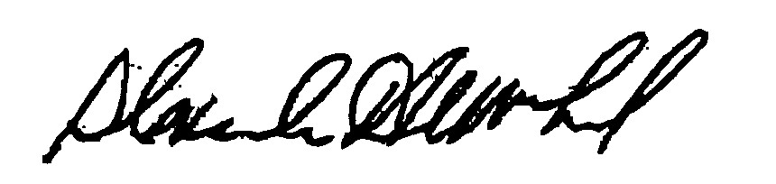

_______________________ _______________________ __________________

Ralph Cirelli Douglas A. Semple, Chair Alexander MacLeod

*Any person aggrieved by a decision of the State Building Code Appeals Board may appeal to Superior Court in accordance with G.L. c.30A, §14 within 30 days of receipt of this decision.*

DATED: April 27, 2011