**November 5, 2019**

**PUBLIC NOTICE TO MARINERS AND FISHERMEN**

**CHARACTER OF WORK**: Woods Hole Group notifies all interested parties that it will collect bottom sediment samples at discrete locations along a pre-determined route that follows the “Route to be Surveyed” depicted on the attached figure. Given the equipment and techniques used to collect small bottom samples, the survey is not expected to impact local fisheries or fishing gear. As such, no action is required of fishermen. These data will be used to meet some of the state and federal permit requirements.

Please note that the more comprehensive bottom survey using geophysical equipment for a future subsea telecommunication cable network that was originally planned to commence in late September and extend into October 2019 was delayed until January 2020 due to the extensive fishing effort occurring coincident with the previous survey schedule. A notice of the confirmed date of the future survey will be provided.

**WATERWAY AND LOCATION**: The survey vessel collecting the sediment samples will be operating within a 500 m corridor of the vessel route which extends from Lynn, Massachusetts to the shores off Rockport, Massachusetts (*See Figure*).

**DURATION OF WORK**: The survey is expected to last approximately 3 days, subject to weather conditions. The survey could begin as early as November 15, 2019 and end on or around November 18, 2019 (assuming weather delays). The survey will only occur during the day.

**COMMUNICATION**: Alcatel Submarine Networks (ASN) and its Partners are committed to communicating and working with the local fishermen in the region during all stages of development of the proposed undersea cable. On the day of operations, the vessel Captain can be contacted via VHF Channel 13 or 16.

If you have any questions, please contact Mr. Tom Hill, water-based Fishery Liaison for ASN, at 978-697-5821. Juan C. Levesque, land-based Fishery Liaison, can be contacted via email at Juan.Levesque@erm.com or cell phone at 813-928-6381.

**Vessel:** M/V Karoline Marie

**LOA:** 44 ft.

**Flag:** USA

**Standing by on VHF Channel:** 13 & 16

**Vessel Means of Communication:**

Tom Hill: cell phone (978) 697-5821

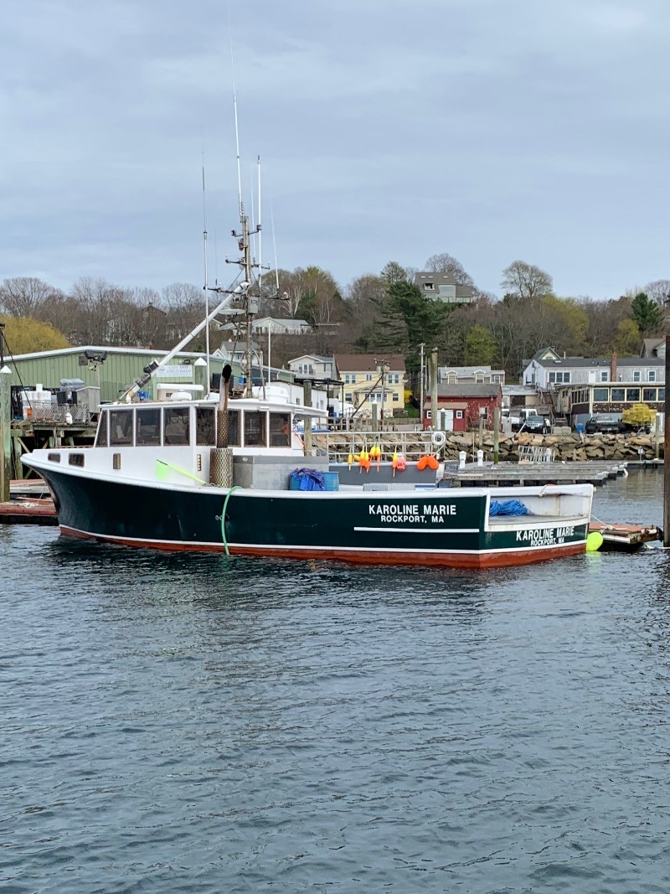

Figure 1: M/V Karoline Marie



Figure 2. M/V Karoline Marie operations route.