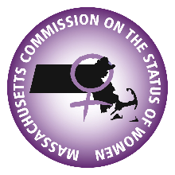

**Massachusetts Commission on the Status of Women**

**Finance Committee Agenda**

**DATE:** 11/10/2022 3:00pm-4:00pm

Web Meeting Link: <https://us06web.zoom.us/j/82328240464>

1. Call to Order
2. [10.13.2022 Fiancne Committee Minutes](https://acrobat.adobe.com/link/review?uri=urn:aaid:scds:US:1c09883f-2aaa-3af9-8b27-ed2eeca2ca50)
3. Policy & Procedure
   1. Sponsorship/Donation Policy



1. FY24 Budget [MCSW FY24 Planning Budget.xlsx (sharepoint.com)](https://massgov.sharepoint.com/:x:/r/sites/CSW-GFS-SharedFiles/_layouts/15/Doc.aspx?sourcedoc=%7BD177F7A9-D4D3-491E-AF29-44CB3E6BE54D%7D&file=MCSW%20FY24%20Planning%20Budget.xlsx&action=default&mobileredirect=true)
   1. Line Item
   2. Vote on Budget by December
2. Questions & Next steps
   1. Next Meeting: December 8th, 2022 3:00pm

**Voting Members:**

Nina Liang, Committee Chair

Marianne Fleckner, Committee Vice Chair

**Associate Members:**

Sarah Glenn-Smith

Jean Fox

Audrey Hall

Denella Clark