MassHealth 1115 Demonstration Waiver and Delivery System Restructuring Progress

Executive Office of Health & Human Services

Public Meeting March 1, 2024

## Guidance for meeting participants

* This meeting is open to the public
* All participants will automatically be on mute for the first part of the presentation.
* We will then open up the forum for questions and comments. To share, you may:
  + Type your comments in the chat
  + Use the ‘raise hand’ feature to indicate that you would like to be called on
* Please remember to state your **first and last name** & your **organization name** (if applicable) if you are sharing questions or comments.
* Slides will be posted on the MassHealth website
* This meeting will not be recorded
* For IT issues, or for feedback on session logistics, please use the Q&A feature to message us or email Olivia Obrien at [Olivia.OBrien@umassmed.edu](mailto:Olivia.OBrien@umassmed.edu)

## MassHealth Delivery System Restructuring: Background and Context

* In 2018, Massachusetts implemented its most **significant Medicaid restructuring* in 20 years to move away from a fee-for-service model** by creating:
  + **Accountable Care Organizations (ACOs)**
  + **Community Partners (CPs),** serving members with complex needs
  + **Delivery System Reform Incentive Payment (DSRIP) Program,** investing in statewide infrastructure
* This is the **fourth public report** on the MassHealth delivery system restructuring; **it primarily covers its fourth calendar year (2021),** in comparison to 2019 and 2020 which are covered in prior reports. **
* During 2021, MassHealth had 17 ACOs providing care for **~1.1M members** with a composite expense of **~$6.3B.**
* **The COVID-19 pandemic continued to have a significant impact** on health care delivery and outcomes in 2021, and also impacted **performance data**:
  + **MassHealth caseload and ACO enrollment significantly increased** due to Medicaid coverage protections during the federal Public Health Emergency (PHE), and as a result **total spend increased** even though per member spend and utilization was lower in 2021 compared to 2019.
  + In response to concerns over the pandemic’s impact on individual quality measures, MassHealth and CMS agreed to certain **benchmark reductions** for ACO/CP measures.
  + **This report is focused on the 2017-2022 1115 demonstration's performance data**. At the time of this report’s release, MassHealth is implementing the 2022-2027 1115 demonstration extension. This report does not cover this extension.

**Reports are available at: <https://www.mass.gov/info-details/massachusetts-delivery-system-reform-incentive-payment-program>

## ACO Caseload Increased Significantly throughout 2021

**2021 weekly snapshots**

Average # of members in ACOs

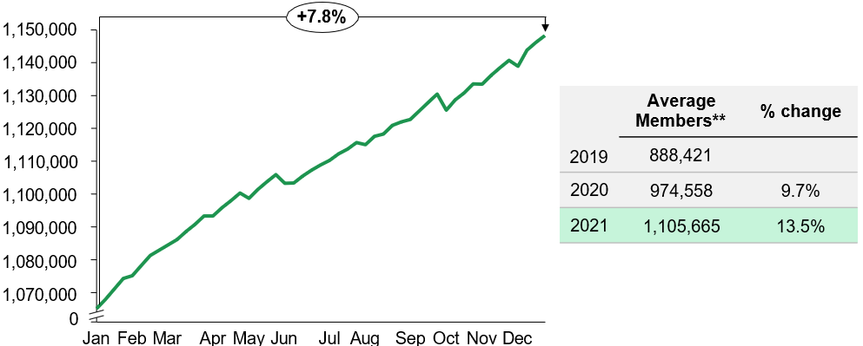

Alt Text: Key Takeaways below summarize the graph on ACO caseload increase through 2021.

|  |  |  |
| --- | --- | --- |
|  | Average Members** | % change |
| 2019 | 888,421 |  |
| 2020 | 974,558 | 9.7% |
| 2021 | 1,105,665 | 13.5% |

**Key takeaways:**

* Redeterminations paused in March 2020 and remained paused throughout 2021 due to the federal PHE
* Growth of 7.8% from January 2021 to December 2021;
* Average annual membership growth of 13.5% over 2020
* Growth was concentrated in non-disabled groups

*Includes 13 Accountable Care Partnership Plans (ACPPs), which are partnerships between ACOs and managed care plans, and three Primary Care ACOs (PCACOs),

which are provider ACOs contracted directly with MassHealth. Excludes MCO-Administered ACOs.

**January – December 2021 average member months for ACPP and PCACO models. Excludes MCO-Administered ACOs with an average membership of 9,565. Year-over-year % change is restricted to the ACPP and PCACO population.

## Even in the Context of the COVID-19 Pandemic, MassHealth’s Restructuring Efforts Were Already Showing Early Promising Results in 2021

**Key examples of progress**

* **ACOs strengthened member connection to primary care**. PCP visits were 11% higher

for ACOs than non-ACOs on average from 2019 to 2021.

* **ACO members saw greater declines in inpatient admissions\*** from 2019 to 2021 where ACOs saw a 16% decline versus a 5% decline for non-ACO members**.**
* **ACOs improved clinical quality.** In 2021, ACOs already showed a rebounding of some

quality metrics post-2020

* **CPs succeeded at engaging the hardest-to-reach members** with complex BH and LTSS needs

– CPs enrolled ~44,000 unique members in 2021, increased engagement rates over pre- pandemic levels, and sustained improvement on members’ cost and outcomes including trends that pre-dated the pandemic’s impact on care patterns.

* The **Flexible Services Program**, which provides nutrition and housing support to certain members, saw rapid and substantial growth **increasing the number of unique members served by 70% from 2020**.

*Physical health inpatient admissions, excluding BH admissions

## Contents

* MassHealth Restructuring Update: Background and Context

### *Delivery system reform updates*

### *ACOs*

* Flexible Services
* CPs
* DSRIP
* Quality and member experience data: updates and trends
  + Quality
  + Member Experience
  + Cost data: update and trends
* Current 1115 Demonstration and Opportunity for Feedback and Questions

## Delivery System Reform: ACOs

**In 2021, ACOs continued to deal with impacts of the COVID-19 pandemic** which brought with it increased enrollments, efforts to re-engage members in normal care, and the launch of the COVID vaccine. A few themes emerged during this period:

1. ACOs retained members and **increased enrollment over the course of 2021,**

growing to a total average enrollment of 1,115,230 (13% growth over year-end 2020).

1. The ACO program **continued to see utilization declines from 2019 to 2021** driven by ongoing impacts of the pandemic. However, some utilization increases from 2020, including in ED, outpatient hospital, and primary care, demonstrated the **return of some more typical care patterns as the pandemic continued**.
2. **ACOs continued pivoting programs in response to the evolving impacts of the pandemic.** In particular, ACOs rolled out initiatives to vaccinate members for COVID and to address BH ED boarding.
3. With DSRIP dollars declining (as planned in the fourth of five years of the DSRIP program), ACOs further adapted their population health strategies and made ongoing **funding decisions based on demonstrated outcomes and experience of their DSRIP programs.**
4. ACOs made **rapid and substantial growth in the second year of the Flexible Services Program**. Flexible Services quickly became a significant part of ACOs’ COVID and population health strategies, with **services provided more than doubling from 2020.**

## There Were Significant Market-Level Utilization Shifts When Comparing 2019 to 2021

1. Most services continue to see utilization declines from 2019, ranging from -4% to -25%.
2. Urgent Care saw a 61% increase due to removal of referral requirements for certain plans and overall changes in patterns of care.
3. The utilization rates below reflect ongoing pandemic impacts (e.g., holds on elective procedures during COVID spikes and overall lower acuity of the population).
4. While rates are generally down from 2019, some services are seeing increases over 2020 including ED, Outpatient Hospital, and Primary Care with increases of 5%, 24%, and 9%, respectively. This indicates a return of some normal care as the impact of the pandemic lessened.

**2019-2021 Market-Level Utilization Trends**

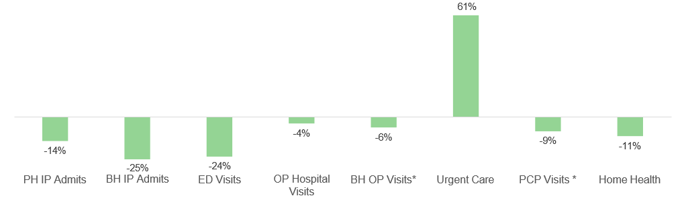

Alt text: See #1-4 above summarizing the key takeaways from the graph on 2019-2021 Market-Level Utilization Trends.

*Includes in-person visits and visits delivered via telehealth. Includes ACO, MCO and PCC Plan utilization.

Note: Utilization trends do not reflect the impact of temporary rate increases implemented in response to the COVID-19 PHE

## Members in ACOs Have Retained Higher Rates of Primary Care and Achieved Sharper Declines in Physical Health Inpatient Admissions

**2019-2021 PCP Visits**

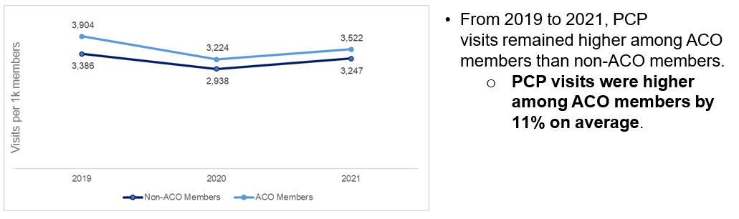

**Alt text: Graph on PCP Visits from 2019-2021. From 2019-2021, PCP visits remained higher among ACO members than non-ACO members. PCP visits were higher among ACO members by 11% on average.**

**2019-2021 Physical Health Inpatient Admissions**

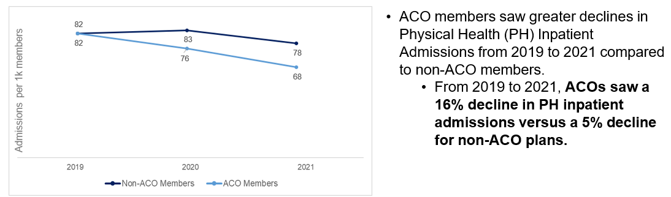

**Alt text: Graph on Physical Health Inpatient Admissions from 2019-2021. ACO members saw greater declines in Physical Health Inpatient Admissions from 2019-2021 compared to non-ACO members. From 2019 to 2021, ACOs saw a 16% decline in Physical Health Inpatient admissions versus a 5% decline for non-ACO plans.**

## Telehealth Utilization for Outpatient BH Services Remained Consistent while Telehealth Utilization for PCP and Other Services Declined from 2020 to 2021 for ACO and Non-ACO Members

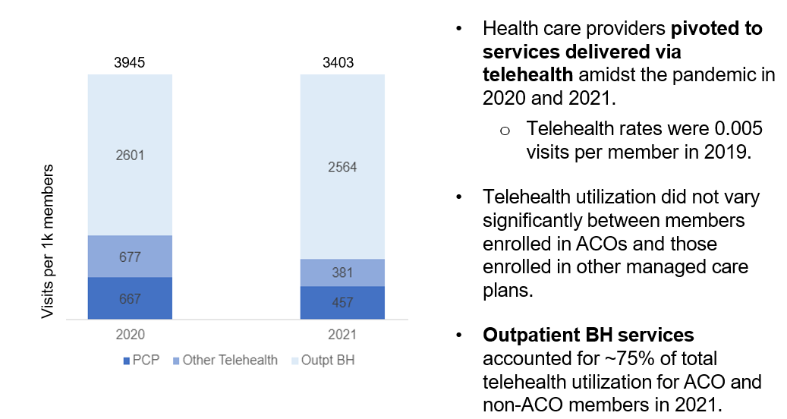

**Alt text: Graph on Telehealth Utilization including number of telehealth PCP, Outpatient BH, and other telehealth visits per 1k members, comparing 2020 to 2021. Key takeaways included below.**

Key Takeaways:

* Health care providers pivoted to services delivered via telehealth amidst the pandemic in 2020 and 2021.
  + Telehealth rates were 0.005 visits per member in 2019.
* Telehealth utilization did not vary significantly between members enrolled in ACOs and those enrolled in other managed care plans.
* Outpatient BH services accounted for ~75% of total telehealth utilization for ACO and non-ACO members in 2021.

## ACOs Continued to Focus on COVID Response Efforts and Rolled Out Many Initiatives to Drive Vaccination Efforts

ACOs developed robust outreach and engagement strategies for vaccination, with ~47% of ACO members fully vaccinated for COVID-19 in 2021. *

* **Vaccination Clinics**
  + ACOs stood up various types of vaccination clinics to best serve their unique populations.
  + These included pop-up clinics at community events, ambulatory vaccination clinics and key community sites such as schools and churches.
  + Example - Tufts Cambridge Health Alliance: Leveraged internal data to identify clusters of un- vaccinated individuals and set up community-based vaccination clinics twice per week.
* **Community Engagement**
  + Through strategic partnerships, ACOs engaged community organizations to address vaccine hesitancy by connecting members to trusted community members.
  + Example - My Care Family: Regularly met with a vaccination coalition in Lawrence consisting of medical practitioners, health plan representatives, public health officials and others. This led to coordinated and comprehensive vaccination efforts across the Lawrence area.
* **Direct Member Outreach**
  + ACOs and their partners **continued to engage in direct member outreach** to encourage vaccination uptake and inform members of their options.
  + **Example - Fallon Health:** Implemented communication campaigns (including text campaigns and direct phone calls) targeted at un-vaccinated members in high-risk locations. This was coupled with outreach efforts from member care teams and case workers.

## Flexible Services Program: Summary of 2021 Progress

* The Flexible Services Program allows ACOs to pilot innovative programs to provide nutritional and housing supports, with the goal of improving overall member health and outcomes
* The Flexible Services Program was **one of 2021’s key successes.** In its second year, the program experienced **rapid and substantial growth, became more efficient,** and demonstrated **promising early outcomes**
* The Flexible Services Program **grew faster in 2021 when compared to 2020, providing more services to more members.**
  + **Services* provided more than doubled** (2020: 9,673; 2021: 21,051) along with a **70% increase in unique members** served (2020: 6,133; 2021: 10,466)
  + In 2021, the **cumulative dollars spent on Flexible Services supports doubled** from $3.4M in Q1 to $7.1M in Q4
* Despite being early in implementing the Flexible Services Program, preliminary analyses of individual Flexible Services programs had already begun to show **improvements for members with diabetes (reductions in A1c) and total cost of care**

*MH defines Flexible Services in terms of member-quarters or number of quarters members have received services. A unique member that received services across 4 quarters would count towards 4 services provided.

## ACOs Partnered with SSOs to Offer 76 Flexible Services Programs in 2021

* In 2021, ACOs partnered with community-based Social Services Organizations (SSOs) to offer **76 Flexible Services programs** focused on nutrition and housing support services and goods.
* Compared to 2020, both the number of available programs and partnerships between ACOs and SSOs **increased by approximately 25%.**

| **ACOs and SSOs launched 76 programs** in the following domains in 2021: | ACOs partnered with **38 SSO partners**  to deliver Flexible Services in 2021,  including: |
| --- | --- |
| * 37 Housing * 38 Nutrition * 1 Housing/Nutrition | * 22 Housing SSOs * 13 Nutrition SSOs * 3 Housing/Nutrition SSOs |

All **17 ACOs offered at least 1 Flexible Services program** in calendar year (CY) 2021.

## In 2020 and 2021, there was continuous growth in Flexible Services uptake each quarter

* **Flexible Services expenditures more than tripled** from CY20 to CY21 ($6.8M to $22.6M), corresponding to a **70% increase in unique members served** (6,133 to 10,466).
* Cumulatively across CY20 and CY21, almost **31,000 Flexible Services were provided to almost 14,400 unique members.** *

| **Flexible Services** | **# of Members Served CY20** | **# of Members Served CY21** | **$ Spent**  CY20 | **$ Spent**  CY21 |
| --- | --- | --- | --- | --- |
| **# of Unique Members / $ Spent per year** | **6,133** | **10,466** | **$6.8M** | **$22.6M** |
| **# of Unique Members / $**  **Spent Across All Quarters** | Total Members Served CY20 and CY21  14,397 | Total Members Served CY20 and CY21  14,397 | Total Money Spent CY20 and CY21  $29.4M | Total Money Spent CY20 and CY21  $29.4M |

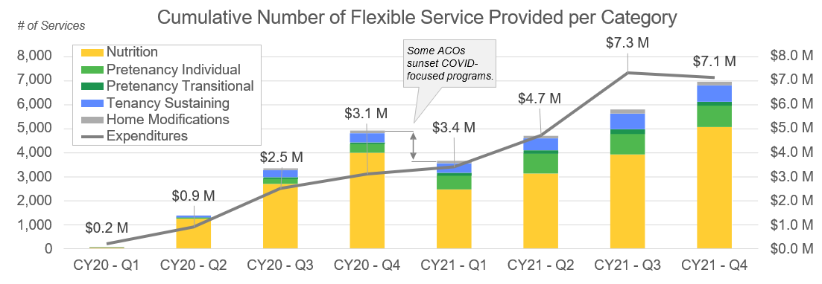

* MH defines Flexible Services in terms of member-quarters or number of quarters members have received services. A unique member that received services across 4 quarters would count towards 4 services provided.

Alt Text: Graph shows number of flexible services provided per category (i.e., nutrition, pre-tenancy individual, pre-tenancy transitional, tenancy sustaining, and home modifications) by quarter from calendar year 2020 Q1 to calendar year 2021 Q4. Overall findings are summarized in table above.

## Flexible Services: Early Promising Results

**In 2021, individual ACOs and SSOs were already seeing early improvements** in clinical and social outcomes, costs, and utilization. As the Flexible Services Program progresses, MassHealth will closely track results and evaluate if specific interventions/models are more impactful than others.

***ACO Highlight: Community Care Cooperative*** *observed encouraging initial impacts on health outcomes, cost, and utilization based on their CY2021 members served.*

* **Clinical Improvements**: members receiving home-delivered medically-tailored meals (MTM) in first half CY21 saw positive trends including:
  + **Average reduction in hemoglobin A1c levels (HbA1c) of 0.9%,** from 9.3% to 8.4% (p=.001)
  + More members achieved goal of reduced HbA1c: **71% of members had HbA1c >9.0% prior to receiving MTM vs 38% of members after 7 months**
  + Members with HbA1c >9.0% prior to enrollment had greatest improvement: **49% saw a reduction in their HbA1c to achieve goal of <9.0% within 7 months of starting MTM**. The average decline in HbA1c for those members was 2.4%
* **TCOC Reduction: $5,552 reduction in annualized TCOC** for members who received nutrition supports (p<0.001).

***SSO Highlight: Project Bread*** *observed positive initial impacts on food security and fruit and vegetable consumption based on their CY2021 members served.*

* **Social Improvements**
  + **25.1% decrease in member reported food insecurity (p<.001)** for members receiving nutrition services (N = 486) for 6 months, (services include nutrition education, food vouchers, coordination, transportation)
  + **29.2% increase in the availability of appropriate/healthy food (p<.001)** reported by members receiving services for 6 months (N= 466)

Note: different “N’s” result from variations in survey completeness for initial and 6-month assessments.

| **Increased fruit and vegetable consumption** | N | ***Change after 6 months*** |
| --- | --- | --- |
| **Fruit**  **consumption** | 483 | 1/3 serving increase |
| **Vegetable consumption** | 481 | 1/4 serving increase |

## Community Partners: Summary of 2021 progress

* CPs contract with ACOs to provide **care coordination expertise and support for behavioral health (BH) services and long-term services and supports (LTSS)**
* In 2021, the CP program continued to see positive trends in utilization and cost measures, including:
  + Between 2018 and 2021, there was a 25% reduction in ED visits and a 40% reduction in BH inpatient admissions among members enrolled in the BH CP program*
  + Data also show that reductions in ED and BH inpatient utilization rates correlate with longer enrollment in the CP program
  + Risk-adjusted TCOC was 19% lower for BH CP members following graduation from the CP program vs. members in the 12 months preceding enrollment
  + However, these observed reductions may be confounded by overall utilization declines driven by the pandemic and changes in the CP population over time.
  + 2021 continued to present **many of the same COVID-19 related challenges** of 2020, including:
  + Transitioning care coordination relationships to telehealth modalities
  + Increased health and social needs among members
  + Staffing challenges
  + New barriers to communication with providers (e.g., accessing PCPs)
  + In spite of these challenges, CPs continued to make **gains in member outreach and engagement**. During 2021, CPs:
  + Enrolled ~44,000 unique members
  + Increased the annual engagement rate** of actively enrolled members from 53% to 58%
  + Reduced the statewide average days to a complete care plan (a key indicator of successful coordination with PCPs) from 176 to 152 days (14% reduction)

*Comparing ED utilization and BH inpatient admissions of members enrolled in BH CP in Q3 of 2018 to members enrolled in BH CP in Q4 of 2021

**Engagement rate represents the % of members enrolled at least 1 day in that month who had a Care Plan completed within the past 12 months

## ED visits among BH CP members continued to decline since the start of the program

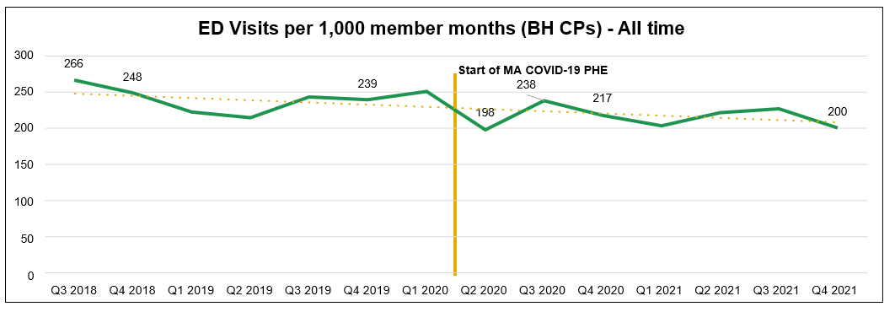

Source: Mathematica, data pulled on 8/29/2023 reflecting the ED utilization of members receiving BH CP services by quarter.

**Alt Text: Graph shows ED Visits per 1,000 member months for BH CPs. Findings are summarized in key takeaways below.**

Key Takeaways:

* **ED visits have continued to decline among BH CP members** since the start of the program, from 266 ED visits per 1,000 member months in Q3 of 2018 to 200 ED visits by Q4 of 2021.
* Since the start of the program (from Q3 of 2018 to Q4 of 2021), the BH CP Program saw a **25% reduction** in ED visit utilization among BH CP members.*
* In 2021 (from Q4 of 2020 to Q4 of 2021), the BH CP Program saw an **8% reduction** in ED visit utilization among BH CP members enrolled in 2021.

*Comparing ED utilization of members enrolled in BH CP in Q3 of 2018 to members enrolled in BH CP in Q4 of 2021

## In 2021, there was a 12% reduction in ED Utilization from the start of their enrollment to 13 months or more after a Care Plan among BH CP members

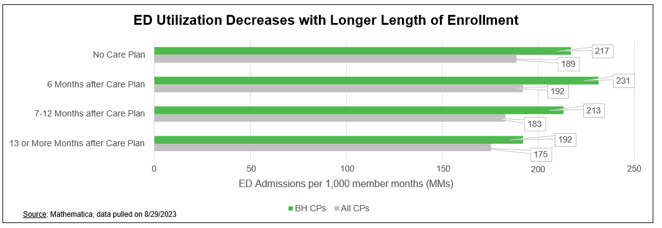

**Alt Text: Graph shows ED utilization decreases with longer length of enrollment in BH CP program. Key takeaways summarized below.**

Key Takeaways:

* In 2021, there was a **17% reduction in ED utilization** among BH CP members between 6 months after a Care Plan (231 admissions/1K MMs) and 13 or more months after a Care Plan (192 admissions/1K MMs).
* There was also a **12% reduction in ED utilization** from the time a BH CP member was enrolled (217 admissions/1K MMs) to when the member reached 13 months or more after a Care Plan (192 admissions/1K MMs).
* Overall, **the longer a member is enrolled in the CP Program, the less utilization of the ED** they had, despite an initial increase in ED usage at the beginning of their enrollment.

## In 2021, BH inpatient admissions continued to decline among BH CP members, reaching a 24% reduction correlated with length of enrollment in BH CPs

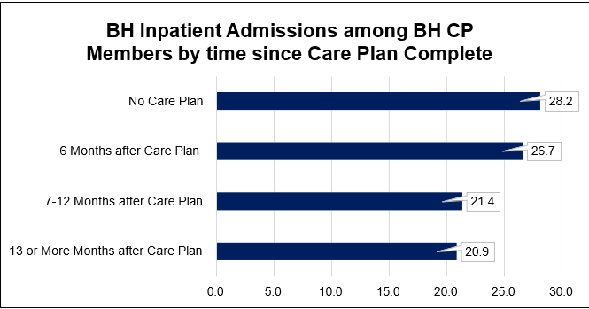

Source: Mathematica, data pulled on 8/29/2023

Alt Text: Graph shows BH Inpatient Admissions among BH CP members by time since Care Plan Complete. CP members have a significant decrease in inpatient admissions once they have reached 7 months of enrollment and have a completed care plan. **In 2021, BH CP members had a 24% reduction in BH inpatient admissions from the time they were enrolled to reaching 7-12 months after a Care Plan.** This is maintained the longer CP members remain enrolled with the CP Program.

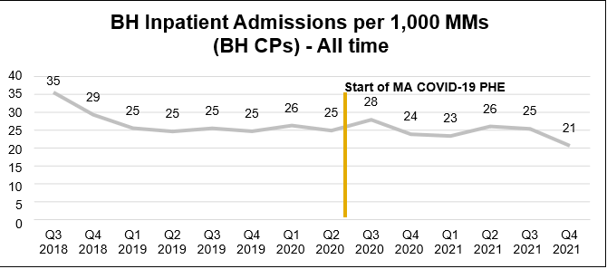

Source: Mathematica, data pulled on 8/29/2023 reflecting the BH inpatient admissions of members receiving BH CP services by quarter.

**Alt Text: Graph shows BH Inpatient admissions per 1,000 member months (MMs) among BH CPs. Key takeaways summarized below.**

Key Takeaways:

* In 2021, **BH inpatient admissions among BH CP members declined by 9%,** from 23 admissions per 1,000 MMs in Q1 to 21 admissions per 1,000 MMs in Q4.
* Since the start of the program (Q3 2018 to Q4 2021), there was a **40% decline in BH inpatient admissions among BH CP members**

## Risk-Adjusted Total Cost of Care (rTCOC) continued to decline in 2021 the longer CP Members are engaged in the CP Program

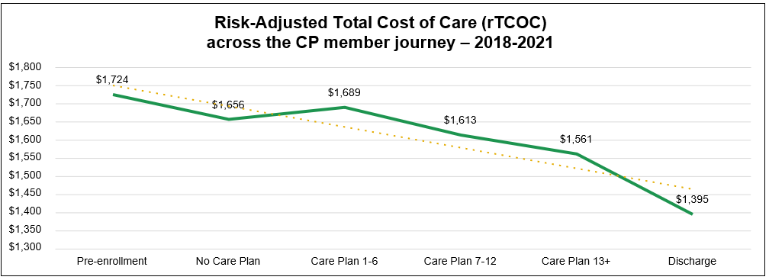

Source: Mathematica, data pulled on 8/29/2023

Alt Text: Graph shows rTCOC across the CP member journey from 2018 to 2021. Key takeaways are summarized below.

Key Takeaways:

* rTCOC is the average amount paid on claims by Medicaid and ACOs/MCOs per CP member per month, risk adjusted within the CP population and excluding members who are dually- eligible for Medicaid and Medicare.
* This graph represents all CP members enrolled in the program between 2018 – 2021 and shows the change in rTCOC throughout their time enrolled in the program.
* Overall, **rTCOC decreases throughout the time that CP members are engaged with a CP**
  + On average, CP members have a **19% lower rTCOC** upon discharge compared to CP members in the 12 months prior to enrollment ($1,395 vs. $1,724).

## CP member engagement continued to improve during 2021

A line chart representing Engagement Rates for BH and LTSS CPs*


Source: Data Warehouse, April 3, 2023

Alt Text: Graph shows engagement rates for BH and LTSS CPs. Key takeaways are summarized below.

Key Takeaways:

* As of December 2021, **58% of members enrolled in CPs were engaged\***
* This is an **increase from 53%** in December 2020, 47% in December 2019, and 6% in

December 2018, the year the CP program launched.

*Engagement rate represents the % of members enrolled at least 1 day in that month in a CP, who had a Care Plan completed within the past 12 months. Members who have been disenrolled from the program in a given month are not included in the denominator for that month.

## Overview of DSRIP Program

* The **Delivery System Reform Incentive Payment (DSRIP)** program is a **$1.8 billion**, five-year investment program authorized through MassHealth’s 1115 demonstration to support MassHealth’s restructuring efforts
* ACOs and CPs used DSRIP funds to **design and test innovative programs**, with the expectation that they measure those programs’ outcomes, **and to stand up infrastructure required for population health management**
* In CY2021, **ACOs and CPs spent $205.4M** in DSRIP funding:
  + **$110.1M** by ACOs (Startup/Ongoing: $87.5M; and Flexible Services: $22.6M)*
  + **$95.3M** by CPs (Infrastructure and Care Coordination)
  + The most common type of DSRIP-funded ACO program in CY2021 was **care coordination and care management programs** (338 programs costing $49M; e.g., embedding community health workers in EDs to help members navigate the health care system and share resources upon ED departure)**
* From 7/1/18 to 12/31/21, ACOs and CPs cumulatively spent **$962.8M** in DSRIP funding:
  + **$673.4M** by ACOs (Startup/Ongoing and Flexible Services)
  + **$289.4M** by CPs (Infrastructure and Care Coordination)
  + Additionally, **$5.2M of DSRIP funding was used for Statewide Investments in 2021** to support workforce development (training, hiring, retention), technical assistance for ACOs and CPs, and related initiatives.

## 2021 DSRIP Investments: by the Numbers

**778 different ACO investments/programs** supported by DSRIP

* Initiatives implemented by ACOs to improve quality of member care and lower total cost of care

**$65.5M spent on personnel/staff** by ACOs

* Significant investment in workforce (e.g., care coordinators,

community health workers, IT staff) to support ACO efforts

**$14.56M spent on infrastructure** by CPs

* Build out infrastructure to implement CP program, such as establishing workflows, integrating electronic systems, purchasing tablets to facilitate in-person connections, etc.

**$80.9M paid to CPs for care coordination supports**

* Payments for outreach, assessing needs, care planning,

care coordination, etc.

## Statewide Investments: by the Numbers – Workforce

| **Cumulative through CY20** | **CY21** | Descriptor |
| --- | --- | --- |
| 216 | 91 | **# student loans repaid for community-based clinicians** |
| $8.4M | $2.7M | **$ in student loan repayment** |
| 90% | 90% | **% of BH and primary care providers who received student loan repayment awards from 2018-2021 that are honoring their multi-year service commitment**   * Empowers and incentivizes clinicians to work at and remain in   safety net provider organizations |
| 732 | 295 | **# community health workers and peer specialists trained**   * Key members of the extended care team, who help engage members in their care |
| 26 | 8 | **# community health center-based Family Medicine and Family Nurse Practitioner residency training slots supported**   * **Clinicians trained in community-based residency programs more**   **likely to remain in community upon training completion** |
| 167 | 16 | **# technical assistance (TA) projects funded at**  **ACOs/CPs** |
| $15.3M | $6.5M | **$ of technical assistance support**   * **ACOs and CPs were given funds to purchase TA support from a curated catalog of 47 TA vendors with expertise in 9 different domains (e.g., population health management, care coordination/integration, performance improvement)** |
| 2,013 | 2,453 | **# average monthly active users of** [**DSRIP TA**](https://www.ma-dsrip-ta.com/)[**website**](https://www.ma-dsrip-ta.com/)**\***   * **High interest from ACOs and CPs since program launch** |

DSRIP funding per Statewide Investments program included in appendix

* MA DSRIP TA Marketplace: <https://www.ma-dsrip-ta.com/>

## Overview of 2021 Quality Data and Performance

### **ACO and CP quality score performance**

* The varying impact of the pandemic across ACO and CP quality measures, as well as the addition of various COVID-based scoring modifications in 2020 and 2021, **makes the comparison of year over year overall quality performance difficult.**
* However, at a high-level, **clinical quality performance improved for ACOs** (73.90% vs. 61.24%) and CPs (70.64% vs. 36.92%) **when comparing 2021 to 2020 performance**
  + In 2021, of the measures that showed substantial declines in performance from 2019 to 2020, five of six ACO measures and all four CP measures demonstrated partial recovery from their respective previous declines.
  + Despite these improvements, **many measures did not reach their pre-pandemic performance levels**\*
  + **Member experience results were similar to 2019-2020**, and demonstrated strong levels of satisfaction with providers, and ongoing opportunities for increased care coordination
* *Note: Despite the ongoing PHE, MassHealth and CMS determined 2021 data was usable for official quality scoring. This is in contrast to 2020 when data was deemed unusable due to the pandemic. In response to concerns over the pandemic’s impact on individual quality measures, MassHealth and CMS agreed to certain benchmark reductions for ACO/CP measures demonstrating 2019-2020 performance declines.

## ACO Clinical Quality: 2021 Measures with Substantial Performance Drop

* In 2020, six ACO quality measures demonstrated substantial drops in performance from 2019 to 2020 (likely due to COVID) and were deemed priority measures for monitoring in 2021
* In 2021, five of these measures demonstrated partial recovery from their 2019-2020 declines. The table below demonstrates the percentage of initial performance drops in 2020 recovered by the end of 2021

| **Measure** | **Performance Monitoring**  **(2019-2020 Perf. Drop)** | **Performance Monitoring**  **(2019-2021**  **Perf. Drop)** | | | Performance Monitoring (Recovery) | Performance Monitoring  (Recovery %) | |
| --- | --- | --- | --- | --- | --- | --- | --- |
| Metabolic monitoring for children using antipsychotics | -7.35 | | -5.56 | +1.79 | | | 24% |
| Diabetes care: a1c poor control | -11.03 | | -3.88 | +7.15 | | | 65% |
| Controlling high blood pressure | -12.64 | | -6.07 | +6.57 | | | 52% |
| Oral health evaluation | -16.72 | | -7.44 | +9.28 | | | 56% |
| Screening for depression and follow-up plan | -8.98 | | -3.66 | +5.32 | | | 60% |
| ED Visits for individuals with mental illness and/or addiction (observed/expected ratio) | -0.40 | | -0.48 | - | | | - |

## Clinical Quality: Overview of ACO and CP Performance in 2019, 2020, and 2021

* **ACO/CP clinical quality performance improved for ACOs (61.24% vs. 73.90%) and CPs (36.92% vs. 70.64%)** when comparing 2020 performance data to 2021 performance data
* **Improvements above reflect both measure level increases as well as benchmarks reductions implemented in 2021**. However, the expansion of measures in pay-for-performance status and differences in scoring methodologies (as a result of COVID-19) place limitations on year-over-year comparisons

**ACO Quality Scores**

| **ACO** | **2019 Official Quality Score (based on actual 2019 data)** | **2020 Official Quality Score**  **(based on 2019 data + COVID allowances)\*** | **2020 Actual Quality Score**  **(based on actual 2020 data)** | **2021 Actual Quality Score**  **(based on actual 2021 data)** |
| --- | --- | --- | --- | --- |
| **Measures where median ACO passed Attainment Threshold** | 14/16 (87.5%) | 14/16 (87.5%) – *note:*  *mirrors 2019 by definition* | 10/16 (62.5%) | 16/18 (88.9%) |
| **Median ACO quality**  **score** | 75.71% | 97.14% | 61.24%  (proxy score) | 73.90% |

**CP Quality Scores**

| **CP** | **2019 Official Quality Score (based on actual 2019 data)** | **2020 Official Quality Score**  **(based on 2019 data + COVID allowances)\*** | **2020 Actual Quality Score**  **(based on actual 2020 data)** | **2021 Actual Quality Score**  **(based on actual 2021 data)** |
| --- | --- | --- | --- | --- |
| **Measures where median CP passed Attainment Threshold** | 15/15 (100.0%) | 15/15 (100.0%) - note:  mirrors 2019 by definition | 11/15 (73.3%) | 20/20 (100.0%) |
| **Median CP quality**  **score** | 34.96% | 55.53% | 36.92%  (proxy score) | *70.64%* |

*Official Quality Scores from 2020 utilized data from 2019 plus scoring modifications to help mitigate the impact of the PHE on quality accountability.

## CP Clinical Quality: 2020 Measures with Substantial Performance Drop

* In 2020, four of the 13 measures demonstrated substantial drops in performance from 2019 to 2020 (likely due to COVID) and were deemed priority measures for monitoring in 2021
* In 2021, all measures demonstrated partial to near full recovery from 2019-2020 declines. The table below demonstrates the percentage of initial performance drops in 2020 recovered by the end of 2021

| **Measure** | **CP Type** | **Performance Monitoring**  **(2019-2020 Perf. Drop)** | **Performance Monitoring**  **(2019-2021**  **Perf. Drop)** | Performance Monitoring (Recovery) | Performance Monitoring  (Recovery %) |
| --- | --- | --- | --- | --- | --- |
| Annual Treatment Plan | BH CP | -7.36 | -0.92 | +6.44 | 88% |
| Diabetes Screening for Individuals w/Bipolar Disorder | BH CP | -5.37 | -4.33 | +1.04 | 19% |
| Oral Health Evaluation | LTSS CP | -15.43 | -1.37 | +14.06 | 91% |
| Hospital  Readmissions (observed/ expected ratio) | LTSS CP | -0.45 | -0.27 | +0.18 | 40% |

## Member Experience: Summary of 2019, 2020, and 2021 Results

* **ACOs are accountable for performance on two-member experience measures**: *
  1. Overall care delivery; and 2) Integration/ coordination of care
     + These measures are based on results from a subset of questions **in the primary care survey**, based on a nationally validated tool
     + As in 2020, members in 2021 expressed **strong levels of satisfaction** with their providers, and **the need for increased coordination managing BH and other specialists and services**
* As with 2019-2020 results, 2021 continues to **identify opportunities for progress**, especially in the **integration and coordination of BH care**, and in the **experience for the LTSS population**

**Member experience aggregate statewide scores**

|  |  |  |  |  |  |
| --- | --- | --- | --- | --- | --- |
| **Performance Measure** | **2019**  **Aggregate Statewide Score** | **2020 Aggregate Statewide Score** | **2021 Aggregate Statewide Score\*** | **Threshold** | **Goal** |
| Overall Care Delivery | 89.9 | 88.6 | 88.9 | 75.0 | 92.0 |
| Integration/ Coordination of Care | 83.2 | 81.8 | 80.8 | 71.25 | 86.25 |

*Measurement Year 2021-member experience scores continue to **likely and variably be impacted by the COVID period** when the surveys were issued in early 2022; MassHealth continued to contract with Massachusetts Health Quality Partners (MHQP) to survey approximately 30,000 members about their 2021 experience of the health care system to build on the 2018-2020 survey results

## Overview of 2021 Cost Data and ACO Financial Performance

**Overall spend**

* In 2021, the ACO program accounted for $6.3B of MassHealth spending, with an average annual total cost of medical services per member of ~$5,700
* ACO medical spend per member declined on average by approximately 3% from 2019 to 2021:
  + Decline concentrated in child population; adult member per year spend was flat
  + Decreases in inpatient and other routine care were offset by increases in pharmacy and temporary provider rate increases

**Financial Performance**

* Most ACOs experienced financial gains in 2021 due to decreased utilization during the PHE and an increase in the number of non-disabled, less acute members

**Variation in spend**

* Among 13 ACPPs, profit/loss performance varied by **up to ~18 percentage points** across ACPPs after applying adjustments
* Among 3 PCACOs, performance varied by **up to ~2 percentage points** across PCACOs after applying adjustments

**New Pricing Policies: Market Adjustment**

* In 2021, MassHealth implemented new pricing policies to adjust for changes that impacted the market as a whole. Through these changes, MassHealth ensures that actual funding (i.e., the rate / benchmark) is adjusted to meet actual costs for the ACO/MCO program overall while continuing to incentivize individual ACOs to perform better than the market. The main changes included:
  + **Concurrent risk score** adjustments which adjust for member acuity throughout the year
  + **Market corridor** which applies a market-wide adjustment in instances of significant profits or losses across all plans

## Total Cost of Care: Comparison across 2019, 2020, & 2021

While **total spend increased** in 2021, **average per member per year spending dropped** compared to 2019, driven by the **child population.** Adult member per year spend increased slightly from 2019 to 2021.

**Overall trend\***

| **2019** | **2020** | **2021** | **Descriptor** |
| --- | --- | --- | --- |
| ~$5.2B | ~$5.5B | ~$6.3B | Total spent on covered services for ACO members |
| ~$5,900 | ~$5,700 | ~$5,700 | Average per member per year (PMPY) spending |

**Trend by population type\*\***

| - **Average PMPY** | **2019** With  disabilities² | **2019** Without  disabilities² | **2020** With  disabilities² | **2020** Without  disabilities² | **2021** With  disabilities² | **2021** Without  disabilities² | **2021 vs 2019 % Change** With  disabilities² | **2021 vs 2019 % Change** Without  disabilities² |
| --- | --- | --- | --- | --- | --- | --- | --- | --- |
| Adults | ~$20,100 | ~$6,600 | ~$20,300 | ~$6,600 | ~$21,100 | ~$6,700 | 5% | 1% |
| Children | ~$10,700 | ~$2,500 | ~$10,100 | ~$2,300 | ~$10,400 | ~$2,200 | -3% | -12% |

*January – December 2020 & 2021 medical expenditures; includes all medical covered services (incl. maternity supplemental and HCD), and excludes ABA, CBHI, and HCV. Excludes MCO-Administered ACOs.

**Non-disabled adults include RC IA, RC IX, RC X; disabled adults include RC IIA; non-disabled children include RC IC; disabled children include RC II C

**Notes:**

* Total spend and PMPY figures are not directly comparable to estimates in previous annual reports
* This 2021 deck utilizes a different data source than the 2019 version. The main differences from 2019 are that this deck utilizes a full year of data (2019 was annualized with data through Sep 2019), the expenses are not price normalized to the MassHealth fee schedule, HCV is excluded, and maternity supplemental is included.

## Total Cost of Care: Category of Service Breakdown, 2019 vs. 2020 vs. 2021

### **Trend by category of service\*** (ACPP & PCACO combined)

* Pharmacy was the only category to consistently trend upwards and saw the largest increase, driven by a shift to a partially unified formulary**\*\***
* All other categories saw a decrease in cost of care during this time period. Inpatient spend saw the largest decrease, down 17% in 2021 compared to 2019
* Total spend in 2021 was impacted by **temporary provider rate increases**

| **Average PMPY** | **2019** | **2020** | **2021** | **2019 vs. 2021**  **% change** |
| --- | --- | --- | --- | --- |
| Inpatient Hospital | 1,249 | 1,222 | 1,033 | -17% |
| Outpatient Hospital | 1,135 | 971 | 1,078 | -5% |
| Inpatient BH | 221 | 243 | 219 | -1% |
| Outpatient BH | 647 | 647 | 632 | -2% |
| Professional services | 971 | 862 | 925 | -5% |
| Pharmacy | 1,381 | 1,472 | 1,579 | 14% |
| All other | 272 | 265 | 259 | -5% |
| **Total** | 5,875 | 5,682 | 5,725 | -3% |

*January – December 2020 & 2021 medical expenditures. Inpatient includes inpatient physical health maternity and non-maternity. Outpatient includes outpatient hospital, emergency room, and lab and radiology (facility). Pharmacy includes high-cost drugs and excludes HCV. All Other includes DME and supplies, emergency transportation, LTC, home health, and other medical services. Excludes MCO-Administered ACOs.

**The partial unified formulary unifies drug coverage across MassHealth plans for certain classes of drugs. This unification simplified prescriber management, streamlined member continuity of care, and maximized savings from rebates received by MassHealth. To maximize these rebates, plans were required to shift to some higher cost drugs driving increases in plan pharmacy spend. This increased spend was fully funded through plans’ rates. Savings accrued to the state are not shown in these figures.

Notes: Total spend and PMPY figures are not directly comparable to estimates in previous annual reports. This 2021 deck utilizes a different data source than the 2019 version. The main differences from 2019 are that this deck utilizes a full year of data (2019 was annualized with data through Sep 2019), the expenses are not price normalized to the MassHealth fee schedule, HCV is excluded, and maternity supplemental is included.

## Financial Performance: Most ACOs saw financial gains in 2021, driven by decreased utilization during the PHE

### *2021 projected performance against capitation rates/benchmark\**

| # of ACOs |  | ACPP | PCACO | Additional Comments |
| --- | --- | --- | --- | --- |
| **>2% gains** |  | 8 | 2 | Due to decreased utilization during the PHE, most ACOs experienced financial gains in 2021 |
| **+/- 2% of breakeven** |  | 2 | 1 | For 2021 and beyond, MassHealth adjusted funding to meet actual costs for the ACO program overall. |
| **>2% losses** |  | 3 | 0 | This is done by adjusting for situations in which the market overall is in savings or losses due to some market-wide trend (e.g., pandemic utilization changes, shifts in acuity of the overall caseload). |
| **TOTALS:** |  | 13 | 3 | Even in the context of these adjustments, individual ACOs remain incented to perform better than the market overall |

*January – December 2021 core medical expenditures. ACPP and PCACO data sourced from the 2021 refresh market corridor report which reflects concurrent risk scores and the market corridor adjustment. Figures subject to final reconciliation (including final concurrent risk scores and market corridor adjustments), all percentages presented are prior to risk-sharing. Excludes MCO-Administered ACOs.

## ACO Financial Performance Varied by Plan

By plan profit/(loss) compared to ACPP and PCACO market profit/loss*

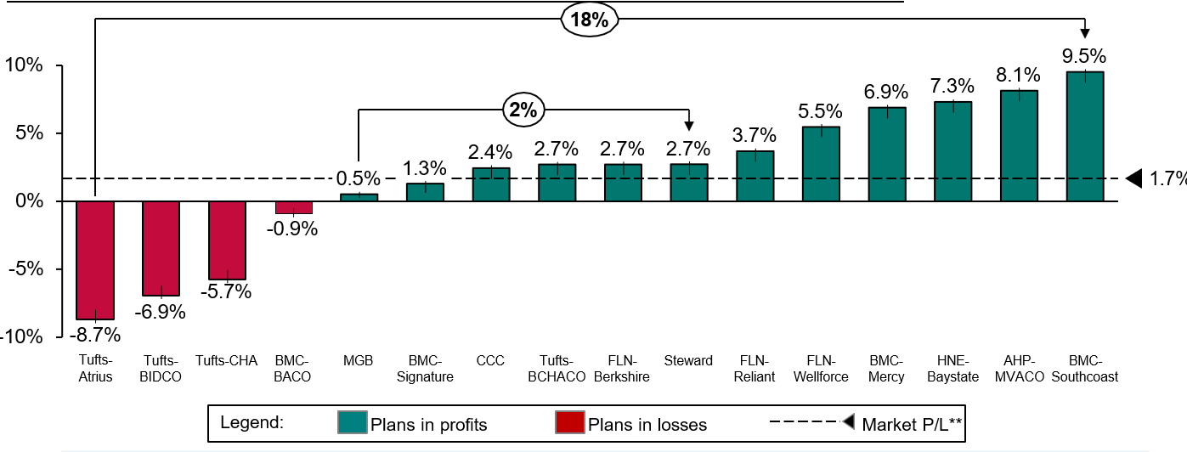

Alt text: Graph shows by plan profit/loss compared to ACPP and PCACO market profit/loss. Key takeaways are summarized below.

Key Takeaways:

* ACPP/PCACO market experienced 1.7% gains after applying concurrent risk scores and the market corridor adjustment
* Across the ACPP market, performance varied by up to ~18 percentage points across ACOs.
* Across the PCACO market, performance varied by up to ~2 percentage points across ACOs.

*January – December 2021 core medical expenditures. ACPP and PCACO data sourced from the 2021 refresh market corridor report which reflects concurrent risk scores and the market corridor adjustments. Figures subject to final reconciliation (including final concurrent risk scores and market corridor adjustments), all percentages presented are prior to risk-sharing. Excludes MCO-Administered ACOs.

**The Market % profit/loss above will not tie out to the 2021 refresh market corridor report because the above data excludes MCO and PCC plans

### *Current 1115 Demonstration and Opportunity for Feedback and Questions*

## MassHealth's 1115 demonstration extension represents a five-year $67.2 billion agreement supporting MassHealth reforms

On September 28th, 2022, CMS approved a five-year extension of the MassHealth Section 1115 demonstration. Since 1997, the 1115 demonstration has been a critical tool in enabling Massachusetts to achieve and maintain near-universal coverage, sustain the Commonwealth’s safety net, expand critical behavioral health services, and implement reforms in the way that care is delivered. The new approval is effective October 1, 2022, through December 31, 2027.

**MassHealth’s new 1115 demonstration (2022-2027)** builds on these reforms by continuing to support integrated, outcomes-based care for MassHealth members and bringing a new focus on advancing health equity by closing disparities in quality and access. Goals for this demonstration include:

1. Continues the path of restructuring and **reaffirms accountable, value-based care**
2. Makes reforms and investments in **primary care, behavioral health and pediatric care**
3. **Advances health equity**, with a focus on initiatives addressing health-related social needs and specific disparities
4. Sustainably **supports the Commonwealth’s safety net,** including level, predictable funding for safety net providers, with a continued linkage to accountable care
5. **Maintains near-universal coverage**, making updates to eligibility policies to support coverage and equity

## The 1115 demonstration provides authority to continue the ACO, Community Partners and Flexible Services programs, and to expand Community Support Programs

### Continuing the path of accountable, value-based care

**Continue the path of restructuring and reaffirm accountable, value-based care**

* **Re-procured the ACO program**, making refinements while maintaining the same core pillars and requirements. As of April 1, 2023, 17 new ACOs are accountable for cost, quality, and member experience
* **Re-procured the Behavioral Health and Long-Term Services and Supports Community Partners (CP)** program, transitioning to sustainable financing and a more accountable structure for 12 BH and 8 LTSS CPs.
* Took lessons learned from successful programs under DSRIP to **transition funding and key principles to core MassHealth operations** (e.g., supports for members with disabilities, embedded community health workers and peers in primary care, CP care coordination).
* **Continued and expanded the Flexible Services Program and Community Supports Programs** to address and integrate health-related social needs.
  + From October 2022 - September 2023, ACOs have delivered services to over 20,000 unique members. This represents an 18% increase from the prior 12 month-period.
* As of 2025, these programs will transition to a new, sustainable HRSN Services Framework that integrates with the ACO Program.

## Investing in primary care, behavioral health, and pediatric care

### The 1115 demonstration authorizes the Primary Care Sub-Capitation program, workforce investments, and continued expansion of behavioral health services

**Make reforms and investments in primary care, behavioral health, and pediatric care**

* Implemented a new **"sub-capitation" payment model that supports enhanced care delivery** expectations (e.g., team-based care, behavioral health integration, specific expectations for members under 21) and more provider flexibility.
  + On track to invest an additional $115M per year in primary care
  + In addition to the $115M, increased group practice rates by 25-35% for 2024
* Implemented loan repayment and nurse practitioner fellowship programs to improve **primary care and behavioral health workforce capacity and diversity.\***
  + Student Loan Repayment programs: $140.9M to 2,935 Primary Care and BH providers and $710K to 30 Nurses providing continuous skilled nursing services
  + Psychiatric Mental Health Nurse Practitioner Fellowship program: 5 CHCs awarded to host 7 graduates and 3 students
  + Additional Student Loan Repayment and Family Nurse Practitioner Residency programs are under way or under development, with anticipated additional ~$140M in workforce investment
* Continued to support **access to behavioral health services**, including **expanding the availability of diversionary behavioral health services** (e.g., Community Support Programs, Structured Outpatient Addiction Program) to members in MassHealth fee-for-service.

* Includes both waiver and non-waiver funded programs

## Advancing health equity

### *The 1115 demonstration authorizes significant investments and policies to advance health equity*

**Advance health equity, with a focus on health- related social needs, maternal health, and justice- involved populations**

* Launched **Health Quality and Equity Incentives Program to incentivize ACO, MCOs, Massachusetts Behavioral Health Vendor, and acute care hospitals to reduce disparities in quality and access**, accounting for members' clinical and social risk (including race, ethnicity, language, disability status, sexual orientation, gender identity, and health-related social needs).
  + All 60 acute care hospitals met The Joint Commission’s new Health Care Equity standards
  + 77 planned Performance Improvement Projects
* **Justice-involved populations:** MassHealth aligned its original proposal to new CMS guidance issued in 2023 and re-submitted the request in an 1115 amendment. CMS approval on the amendment is pending.
* **Members with disabilities**: Through HQEIP, entities evaluated their ability to meet the needs of individuals with disabilities and identified strategic areas for improvement through disability competency training plans.
* **Pregnant/postpartum members**:*
  + Strengthened requirements for ACOs/MCOs to support members with high- risk pregnancies.
  + Expanded Flexible Services for households with high-risk children and pregnant individuals.

*MassHealth also introduced **12-month postpartum coverage and doula services** through non-1115 Waiver authority.

## Supporting the safety net

### *The 1115 demonstration authorizes additional funding to sustainably support the Commonwealth’s safety net providers*

**Sustainably support the Commonwealth’s safety net, including level, predictable funding for safety net providers, with a Continued linkage to accountable care**

* CMS approved the proposed hospital financing package that will generate $600M+ of annual net benefit to hospitals.
* Increased Safety Net Provider funding by $125M per year, expanding eligibility for payments to nine additional hospitals.
* Targeting health equity incentive payments toward ACO- participating, safety net hospitals.
* Preserved other long-time funding for the Commonwealth’s safety net (e.g., the Health Safety Net).
* The hospital assessment has been updated and expanded to help fund these important programs and initiatives.

## Maintaining near-universal coverage

### *The 1115 demonstration authorizes updates to eligibility policies that will maintain and strengthen near-universal coverage and advance equity*

**Maintain near- universal coverage including updates to eligibility policies to support coverage and equity**

* Maintained current coverage expansions, including state insurance subsidies for the Health Connector for individuals with income up to 300% of FPL (ConnectorCare program)
* Implemented targeted updates that expand eligibility to maintain near-
* universal coverage and advance equity, including:*
* **Streamlined access to CommonHealth** to cover all disabled adults under age 65 with sliding scale premiums, without a spend- down, and to cover long-time CommonHealth members over age 65 when they retire
  + Extended retroactive eligibility to 3 months for pregnant individuals and children
  + Continuous eligibility for members who are homeless (24
  + months) or justice-involved (12 months)
  + Expanded access to Medicare Savings Programs for members with MassHealth Standard, consistent with state law expansions

*MassHealth also implemented **12-month continuous coverage for children** through non-1115 Waiver authority

## Q&A and Opportunity for Comments

* To ask questions:
  + Type your comments in the chat
  + Use the ‘raise hand’ feature to indicate that you would like to be called on
* Please remember to state your **first and last name** & your **organization name** (if applicable) if you are sharing questions or comments.