

December 9, 2024

Michael Levine

Assistant Secretary for MassHealth One Ashburton Place 11th Floor Boston, MA 02108

Dear Assistant Secretary Levine:

The Centers for Medicare & Medicaid Services (CMS) is approving Massachusetts’s request to amend its Medicaid section 1115(a) demonstration entitled, “MassHealth Medicaid and Children’s Health Insurance Plan (CHIP) Section 1115 Demonstration” (Project Numbers

11-W-00030/1 and 21-00071/1) (the “demonstration”), which is effective from the date of approval and will remain in effect through the demonstration approval period, which is set to expire December 31, 2027. Approval of this demonstration amendment will provide waiver authority for a limited reason.

# Pre-Release Services under the Reentry Demonstration Initiative

Expenditure authority was approved for Massachusetts to provide limited coverage for a targeted set of services furnished to certain incarcerated individuals immediately prior to the individual’s expected date of release. The state’s proposed approach was approved on April 19, 2024.

*Eligible Juveniles and Targeted Low-Income Children and this Section 1115 Reentry Demonstration Initiative*

Section 5121 of the Consolidated Appropriations Act, 2023 (CAA, 2023; P.L. 117-328) amends the Social Security Act (the Act) and describes a mandatory population (eligible juveniles and targeted low-income children) and a set of pre-release and post-release services. Every state is required to submit Medicaid and CHIP State Plan Amendments (SPAs) attesting to meeting the requirements in section 5121 beginning January 1, 2025.1

To the extent there is overlap between the services required to be covered under sections 1902(a)(84)(D) and 2102(d)(2) of the Act and coverage under this demonstration, we understand that it would be administratively burdensome for states to identify whether each individual service is furnished to a beneficiary under the state plan or demonstration authority.

Accordingly, to eliminate unnecessary administrative burden and ease implementation of statutorily required coverage and this demonstration, we are approving waivers of the otherwise mandatory state plan coverage requirements to permit the state instead to cover at least the same

1 SHO# 24-004, RE: Provision of Medicaid and CHIP Services to Incarcerated Youth. <https://www.medicaid.gov/federal-policy-guidance/downloads/sho24004.pdf>

services for the same beneficiaries under this demonstration. This approach will ease implementation, administration, and claiming, and provide a more coherent approach to

monitoring and evaluation of the state’s reentry coverage under the demonstration. The state will provide coverage under the reentry demonstration initiative to eligible juveniles described in section 1902(nn)(2) in alignment with sections 1902(a)(84)(D) and 2102(d)(2) of the Act, at a level equal to or greater than otherwise would be covered under the state plan. Compliance and state plan submission requirements under sections 5121 of the CAA, 2023 will remain unchanged. Coverage of the population and benefits identified in sections 1902(a)(84)(D) and 2102(d)(2) of the Act, as applicable, will automatically revert to state plan coverage in the event that this demonstration ends or eliminates coverage of beneficiaries or services specified in those provisions.

*Implementation and Reinvestment Plans*

As described in the demonstration special terms and conditions (STCs), Massachusetts is required to submit a Reentry Demonstration Initiative Implementation Plan (implementation plan) and Reinvestment Plan. The operational plan requirement in sections 1902(a)(84)(D) or 2102(d)(2) of the Act is satisfied by the implementation plan only for the population and for the services covered under this demonstration and for which the requirements of section 1902(a)(84)(D) and 2102(d)(2) therefore are waived. The state is still required to create an operational plan, provide coverage, and otherwise meet state plan requirements with respect to any population or service specified in section 1902(a)(84)(D) or 2102(d)(2) of the Act that is not covered under this demonstration. The reinvestment plan may include the services provided to eligible juveniles and targeted low-income children under 1902(nn)(2) and 2102(d)(2) of the Act, respectively, who are covered under this demonstration.

# Budget and Allotment Neutrality

The state already accounted for the population specified in sections 1902(a)(84)(D) and 2102(d)(2) of the Act in making estimates for the previous action approved in April 2024. There is no budgetary or allotment neutrality impact with this action.

# Monitoring and Evaluation

The state is required to include eligible juveniles and targeted low-income children eligible under sections 1902(a)(84)(D) and 2102(d)(2) of the Act, as applicable, as part of the demonstration monitoring and evaluation activities.

# Consideration of Public Comments

Public comments were addressed in the reentry demonstration initiative approval letter on April 19, 2024.

# Other Information

CMS’ approval of this amendment is conditioned upon compliance with the enclosed amended set of waiver and expenditure authorities and the STCs defining the nature, character, and extent of anticipated federal involvement in the demonstration. The award is subject to our receiving your acknowledgement of the award and acceptance of these STCs within 30 days of the date of this letter. Your project officer, Rabia Khan, is available to answer any questions concerning this amendment, and her contact information is as follows:

Centers for Medicare & Medicaid Services Center for Medicaid and CHIP Services Mail Stop S2-25-26

7500 Security Boulevard

Baltimore, Maryland 21244-1850 Email: [Rabia.Khan1@cms.hhs.gov](mailto:Rabia.Khan1@cms.hhs.gov)

If you have any questions regarding this approval, please contact Jacey Cooper, Director, State Demonstrations Group, Center for Medicaid and CHIP Services, at (410) 786-9686.

Sincerely,

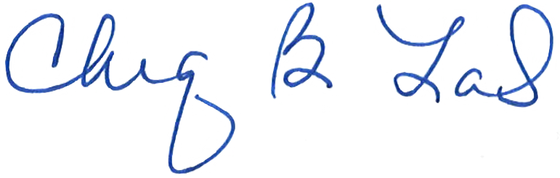

Chiquita Brooks-LaSure

Enclosure

cc: Ambriosa Watts, State Monitoring Lead, Medicaid and CHIP Operations Group