Me.tiimackHealth

Diana Richardson President & CEO

1 General Street
Lawrence, MA 01841
978-683-4000

April 1, 2026 Via Email
Stephen Davis, Director
Division of Health Care Facility Licensure and Certification Department of Public Health
67 Forest Street
Marlborough, MA 01752

Re: Maternity. Neonatology, and Pediatric Beds at LG NewCorp's Merrimack Health Methuen Hospital and Merrimack Health Haverhill Hospital

Dear Mr. Davis:
This letter is submitted on behalf of LG NewCorp, Inc.'s Merrimack Health Methuen and Merrimack Health Haverhill Hospitals (the "Hospitals") with respect to its campuses located at 70 East Street, Methuen, MA O1844 ("Methuen Hospital") and 140 Lincoln Street, Haverhill, MA 01830 ("Haverhill Hospital"). Pursuant to 105 CMR 130.122, the Hospital hereby informs the Department of Public Health (the "Department") that on or about May 1, 2026, it intends to submit a formal Ninety-Day (90) Notice (the "Notice") of the proposed closure of certain services at both Methuen Hospital and Haverhill Hospital.
As Methuen and Haverhill Hospitals are fully integrating into a new system, Merrimack Health, that includes Lawrence Hospital, we are working strategically to invest in and redeploy care and resources in a more thoughtful integrated manner that better meets the needs of its communities. Planning related to this Notice has further been informed by the findings of a comprehensive, collaborative evaluation led by state, regional, and local leaders. This committee, the Eastern Merrimack Valley Work Group, was formed following Lawrence Hospital's October 2024 acquisition of the Hospitals to assess the region's health care needs.
To that end, Methuen Hospital will no longer operate its maternity and neonatology services consisting of 24 obstetric beds, 28 well infant nursery bassinets, 10 special care nursery bassinets. The current daily special care nursery census of 1.2 and obstetrics daily census of 4.4, both at Methuen Hospital, can be served by the Lawrence Hospital campus. Separately, we will be asking for a waiver to transition twenty (20) unused pediatric beds to adult medical/surgical beds.

Additionally, this Notice will also seek to formally notice the closure of Haverhill Hospital's seven
(7) pediatric beds, which were not operational at the time of acquisition. No other services or beds at Haverhill Hospital will be impacted by this notice.
Please note that in compliance with the Department's regulations, Methuen Hospital, through separate correspondence, is sending notice today to the Hospital's Patient and Family Council, each staff member of the Hospital, and every labor organization that represents the Hospital's workforce during the period of the essential services closure process. Notice is also being sent today to the appropriate locally elected officials.
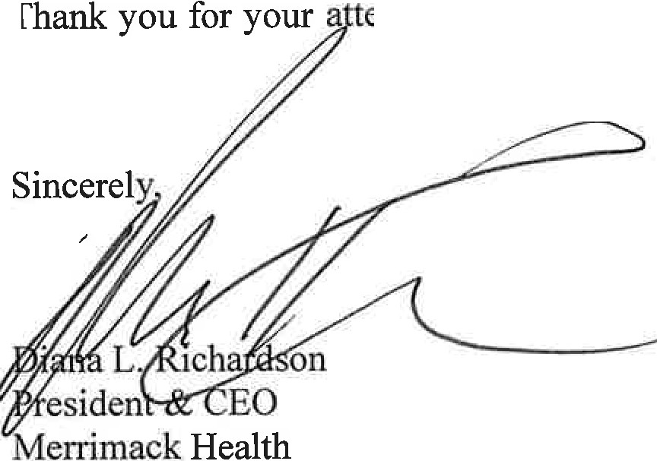
ention to this matter. If you have any questions, please do not hesitate to
contact me.

"\

cc: T. Smith, DPH
W. Mackie, Esq., DPH
J. Gagne, Esq., DPH
J. Bernice, DPH
S. Carlson, DPH

