July 26, 2024

**VIA EMAIL**

Stephen Davis, Director

Division of Health Care Facility Licensure and Certification

Department of Public Health

67 Forest Street

Marlborough, MA 01752

Re: Nashoba Valley Medical Center – Notice of Hospital Closure

Dear Mr. Davis:

This letter is submitted on behalf of Steward Health Care System LLC regarding Nashoba Valley Medical Center, located at 200 Groton Road, MA 01432 (the “Hospital”). Pursuant to 105 CMR 130.122, the Hospital hereby informs the Department of Public Health (“Department”) that the Hospital intends to close and will submit notice of the proposed closure shortly. The proposed closure will include the following: 46 Medical/Surgical beds, 6 Intensive Care Unit beds, 5 Pediatric Service beds, 20 Psychiatric Service beds, and all ambulatory care services at the Hospital.

Please note that in compliance with the Department’s regulations, the Hospital, through separate correspondence, is sending notice to the Hospital’s Patient and Family Council, each staff member of the Hospital, and every labor organization that represents the Hospital’s workforce during the period of the essential services closure process. Notice is also being sent to the members of the General Court, as well as appropriate local elected officials.

Thank you for your attention to this matter. If you have any questions, please do not hesitate to contact Salvatore Perla, President of the Hospital at [salvatore.perla@steward.org](mailto:salvatore.perla@steward.org), or me.

Sincerely,

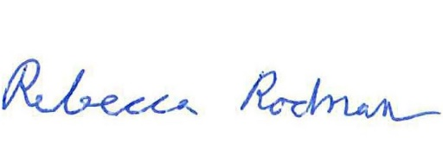

HUSCH BLACKWELL LLP

Rebecca Rodman

cc: Walter Mackie, DPH

Antonio Sousa, DPH

Judy Bernice, DPH

Rebecca Kaye, DPH

Torey McNamara, DPH

Salvatore Perla, Steward