

February 20, 2025

Via Email [(stephen.davis@mass.gov)](mailto:(stephen.davis@mass.gov)

Stephen Davis, Director

Division of Health Care Facility Licensure and Certification Department of Public Health

67 Forest Street

Marlborough, MA 01752

Re: PAM Health Specialty Hospital of Stoughton – Neuro Behavioral Unit Dear Mr. Davis:

This letter is submitted on behalf of PAM Health regarding PAM Health Specialty Hospital of Stoughton, a long-term acute care hospital, located at 909 Sumner Street, Stoughton, MA 02072 (the “Hospital”). Pursuant to 105 CMR 130.122, the Hospital hereby informs the Department of Public Health (“DPH”) that on or about March 22, 2025, it intends to submit a formal ninety-day

(90) notice of the proposed closure of the Neuro Behavioral Unit (“NBU”) at the Hospital. The proposed closure includes 41-inpatient psychiatric beds.

The NBU is a specialized unit for patients with brain injuries and other cognitive impairments as well as other behavioral challenges. The NBU was opened in the 2000s as a dually licensed by the DPH and the Department of Mental Health (“DMH”) unit to address community need; however since that time need for these services has shifted to caring for patients with these diagnoses in non-institutional settings. Today, the NBU is no longer licensed by DMH. It has become a challenge to operate and staff the NBU because it does not align with the Hospital’s primary non-acute, 157 bed- chronic care services which are certified by Medicare as a long-term acute care hospital.

The Hospital intends to close NBU as of June 20, 2025. Please note that in compliance with the Department’s regulations, the Hospital, through separate correspondence, is sending notice to the Hospital’s patients, each staff member of the Hospital, and every labor organization1 that represents the Hospital’s workforce during the period of the essential services closure process. Notice is also being sent to the members of the General Court, as well as appropriate local elected officials

1 The Hospital does not have any labor organization

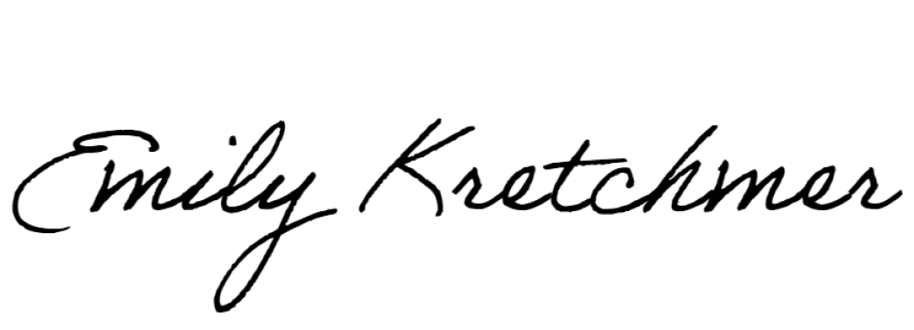Thank you for your attention to this matter. If you have any questions, please do not hesitate to contact me.

Sincerely,

Emily Kretchmer