METROWEST MEDICAL CENTER

♦

**framlngh.un Union Hospltal • Leont1rd *Morse* Hospltcll**

**Framingham Union Hospital 115 Lincoln Street**

**Framingham, MA 01702**

**(508) 383-1000**

**Leonard Morse Hospital 67 Union Street**

**Natick, MA 01760**

**(508) 650-7000**

February 10, 2025

**VIA EMAIL**

Stephen Davis, Director

Division of Health Care Facility Licensure and Certification Department of Public Health

67 Forest Street

Marlborough, MA 01752

Re: VHS AcquisitioL1 Subsidiary Number 9, Inc. (d/b/a MetroWest Medical Center)- Closure of Level II NICU Service at Framingham Union Campus

Dear Mr. Davis:

This letter is submitted on behalf of VHS Acquisition Subsidiary Number 9, Inc. (d/b/a MetroWest Medical Center), which operates a licensed hospital (License No. VL8S) with a campus located at 115 Lincoln Street, Framingham, MA O1702 ("Framingham Union"). Pursuant to 105 CMR 130.122, Framingham Union hereby informs the Department of Public Health ("Department") that on or about March 12, 2025, Framingham Union intends to submit a formal 90-day notice of the proposed closure of the Level II NICU Service at Framingham Union.

Please note that in compliance with the Department's regulations, Framingham Union, through separate correspondence, is sending notice today to Framingham Union's patient and family council, each staff member of Framingham Union, and every labor organization that represents Framingham Union's workforce during the period of the essential service closure process. Notice is being sent today to the members of the General Court who represent the City of Framingham and the Town of Natick, as well as the City of Framingham's Mayor and City Council Chair, and the Town ofNatick's Select Board Chair and Town Administrator.

Thank you for your attention to this matter. If you have any questions, please contact Lianne Ankner, Esq., Ankner & Levy, PC at 617-247-3104 [(kla@anknerlevy.com).](mailto:(kla@anknerlevy.com)

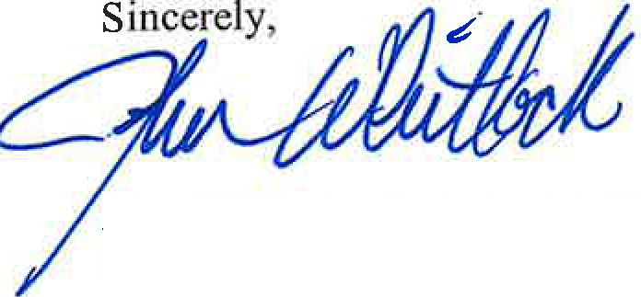

John Whitlock, Jr., CPA, CGMA CEO, MetroWest Medical Center

CC:

Governor Maura Healey Senator Karen E. Spilka Representative Priscila S. Sousa

Representative David Paul Linsky Representative Danielle Gregoire Representative Jack Lewis Representative Kate Donaghue

Charlie Sisitsky, Mayor, City of Framingham

Philip R. Ottaviani, Jr., Chair, City Council, City of Framingham James Errickson, Town Administrator, Town of Natick

Kathryn M. Coughlin, Chair, Select Board, Town of Natick Walter Mackie, DPH

Judy Bernice, DPH

C. Davison, MWMC

L. Domstead, MWMC

C. Jackson, MWMC