|  |
| --- |
| PROPOSED MASSACHUSETTS TAX EXPENDITURES  EVALUATION SUMMARY |
| EVALUATION YEAR: 2020 |

|  |  |
| --- | --- |
|  |  |
| **TAX EXPENDITURE TITLE** | Exemption of Interest on Savings in Massachusetts Banks |
| **TAX EXPENDITURE NUMBER** | 1.413 |
| **TAX EXPENDITURE CATEGORY** | Deduction against taxable income |
| **TAX TYPE** | Personal income tax |
| **LEGAL REFERENCE** | M.G.L. c. 62, § 2(b)(1)(A); M.G.L. c. 62, § 3B(a)(6) |
| **YEAR ENACTED** | 1973, see St. 1973, c. 723, § 2 |
| **REPEAL/EXPIRATION DATE** | None |
| **ANNUAL REVENUE IMPACT** | Tax loss of $4.1 million FY22 |
| **NUMBER OF TAXPAYERS** | 710,000 filers in tax year 2018 |
| **AVERAGE TAXPAYER BENEFIT** | $5 per filer |

|  |  |
| --- | --- |
| **Description of the Tax Expenditure:**  Up to $100 ($200 on a joint return) of interest from savings deposits or savings accounts in Massachusetts banks is deductible from gross income | **Is the purpose defined in the statute?**  The statute does not explicitly state the purpose of this tax expenditure. |
| **What are the policy goals of the expenditure?**  The tax expenditure is designed to encourage taxpayers to open savings accounts with Massachusetts banks, thereby facilitating the growth and development of such banks. | **Are there other states with a similar Tax Expenditure?**  No other bordering states offer a parallel deduction or exemption for in-state bank interest. |

|  |
| --- |
| Incentive Evaluation Results |

**INTRODUCTION**

Massachusetts imposes a personal income tax on the Massachusetts gross income of residents and of income sourced to Massachusetts for non-residents. M.G.L. c. 62, §§ 2; 5A. Massachusetts gross income generally means federal gross income, but is subject to certain modifications. M.G.L. c. 62, § 2. Massachusetts gross income is divided into Part A, Part B, and Part C categories. M.G.L. c. 62, § 2(b). Part A gross income generally consists of interest, dividends, and certain capital gain income, Part C gross income is typically long-term capital gain income, and Part B gross income is gross income not included in either Part A or Part C. M.G.L. c. 62, § 2(b)(1)-(3).

M.G.L. c. 62, § 2(b)(1)(A) excludes Massachusetts bank interest from Part A gross income, thereby classifying it as Part B gross income. M.G.L. c. 62, § 3B(a)(6) allows taxpayers filing singly to deduct up to $100 of such interest, and taxpayers filing jointly to deduct up to $200.

While M.G.L. c. 62, § 3B(a)(6) neither mentions nor defines a Massachusetts bank, the Massachusetts bank requirement and its definition are imputed from M.G.L. c. 62, § 2(b)(1)(A). In particular, a Massachusetts bank for purposes of the deduction is a savings or cooperative bank, trust company or credit union incorporated in or chartered by the commonwealth, any national bank, federal savings and loan association, federal savings bank or federal credit union located in the commonwealth, any banking company or Morris Plan company subject to M.G.L. c. 172A, any savings or loan association or banking partnership under the supervision of the Massachusetts commissioner of banks. Id.

**POLICY GOAL**

This particular tax expenditure encourages savings and deposits in Massachusetts banks by allowing taxpayers a limited deduction for interest received from such banks. This expenditure ultimately supports the banking industry in Massachusetts. In addition, the incentive encourages taxpayers to deposit money in interest-bearing accounts with Massachusetts banks. The amount of the deduction remains unchanged since its enactment in 1973. Neighboring states do not have equivalent tax expenditures. Historically, New Hampshire had a parallel provision, but it was repealed in 1995. See 1995 NH ALS 188, § 3.

**COSTS**

The revenue loss from this tax expenditure is calculated annually as part of the Tax Expenditure Budget (TEB). We estimate the cost of this credit in FY22 will be $4.1 million.

**Actual and Forecast Tax Loss from MA Bank Interest Deduction ($millions)**



**BENEFITS**

**MA Bank Interest Deduction claimed by filers in 2018, by Income level**

*Source: Massachusetts Statistics of Income*



**EVALUATION: COMPARING COSTS AND BENEFITS**

The Massachusetts bank interest deduction costs Massachusetts $3 to $4 million annually. In addition to the direct tax savings to Massachusetts taxpayers, this deduction supports Massachusetts employment in the banking industry.

While the benefits of the deduction are small, they are widely distributed across all income strata in Massachusetts. In theory, the deduction is equitable because as a percentage of income, the benefit is worth more to lower-income filers. However, as actually applied, the deduction has insignificant benefits for most filers for two reasons:

*Minor tax savings:*

The maximum value of the deduction is $100 for single filers and $200 for joint filers. Because the Massachusetts personal income tax is imposed at a rate of 5%, this deduction provides tax savings up to a maximum of either $5 or $10 per filer.

*Significant savings required to reach maximum:*

The Massachusetts bank interest deduction was enacted in 1973. At that time, interest rates were much higher than today, and it was not uncommon for a savings account to generate 5% interest annually. By comparison, the current interest rate on a savings account may be only 0.1%. Even a “high rate savings” account may pay only 1% interest annually. At a 1% interest rate, a taxpayer filing alone would have to have at least $10,000, or $20,000 if filing jointly, deposited in a Massachusetts bank to earn the maximum $100 or $200 in interest annually. These are significant sums to leave in an account bearing such a minor return, even with the tax deduction.

**SIMILAR TAX EXPENDITURES OFFERED BY OTHER STATES**

No other bordering states offer a parallel deduction or exemption for in-state bank interest.

**IS THE INCENTIVE AS DESIGNED ACCOMPLISHING ITS PURPOSE?**

This tax expenditure is designed to encourage taxpayers to open savings accounts with Massachusetts banks, thereby facilitating the growth and development of such banks. However, as the chart below demonstrates, the amount of Massachusetts bank interest deducted annually has generally been in decline for the past two decades:

**Total Massachusetts Bank Interest Deducted**

Actual Massachusetts Bank Interest deducted, 2001 to 2018; projected 2019 to 2021

(in $millions)

*Source: Massachusetts Department of Revenue Statistics of Income*

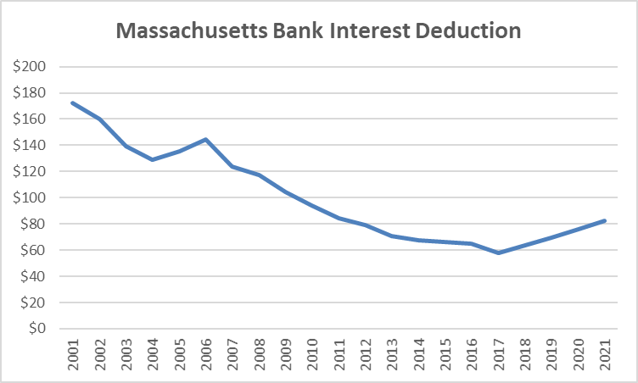

The general decline in the amount of Massachusetts bank interest providing this deduction suggests that the deduction is failing to accomplish its goal. It should be noted that interest rates have been falling steadily during the period depicted, which may have contributed to the decline in claimed deductions. However, an examination of the claims by income level (“Benefits” section above) shows fewer claimants than would be expected. Even among filers with incomes over $500,000, less than half claim *any deduction at all*. It seems unlikely that filers at this income level would have zero Massachusetts bank interest income.

While we cannot be certain why this is so, as noted in the “Benefits” section, the maximum tax benefit is only a savings of $5 for taxpayers filing singly and $10 for taxpayers filing jointly. The relatively low participation rate suggests that this current deduction is too small to have any significant impact on taxpayer behavior.

To be completed further by TERC

Conclusion/Recommendations: [To be Entered by TERC]