The Commonwealth of Massachusetts
Executive Office of Health and Human Services
Department of Public Health
250 Washington Street, Boston, MA 02108-4619

MARYLOU SUDDERS
Secretary
EILEEN M. SULLIVAN
Acting Commissioner

Tel: 617-624-6000
www.mass.gov/dph

CHARLES D. BAKER
Governor
KARYN E. POLITO
Lieutenant Governor

Circular Letter: DHCQ 15-01-626

TO: Providers of Mammography Services
FROM: Eileen Sullivan, Acting Commissioner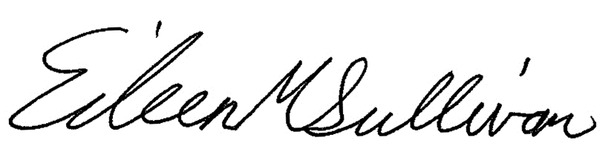
Department of Public Health

CC: Barbara A. Piselli, Acting Director
Board of Registration in Medicine

DATE: January 20, 2015

RE: New Breast Density Notification Statute

The purpose of this Circular Letter is to inform providers of mammography services licensed by the Department of Public Health (Department) pursuant to 105 CMR 127.000, about a new law relating to breast density notification. Information for physicians licensed by the Board of Registration in Medicine (BORIM) pursuant to 243 CMR 2.00, will be provided by BORIM under separate cover.

Chapter 150 of the acts of 2014 amends section 5Q of chapter 111 of the Massachusetts General Laws to add a requirement that all providers of mammography services provide written notification to a patient if an interpreting physician determines, based on standards promulgated by the American College of Radiology, that the patient has dense breast tissue.

The notification must include, at minimum, the following information:

- that the patient’s mammogram shows dense breast tissue;
- the degree of density apparent and an explanation of that degree of density;
- that dense breast tissue is common and not abnormal but that dense breast tissue may increase the risk of breast cancer;
- that dense breast tissue can make it more difficult to find cancer on a mammogram and that additional testing may be needed for reliable breast cancer screening;
- that additional screening may be advisable and that the patient should discuss the results of the mammogram with the patient’s referring physician or primary care physician;
- that the patient has the right to discuss the results of the patient’s mammogram with the interpreting radiologist or the referring physician;
- that a report of the patient’s mammogram has been sent to the referring physician and will become part of the patient’s medical record; and
- where the patient can find additional information about dense breast tissue.

Existing Department regulations also establish the following rights of the patient:

105 CMR 127.021(A)(1)
…
(f) Receive, directly or through her referring physician, a written statement describing the test results and, if results suggest other than routine mammographic follow-up, the next steps for the patient to pursue promptly after undergoing a mammogram at the facility;
(g) Be informed of the patient's right to discuss the results of the mammogram with the Responsible or Interpreting Physician or her referring physician;

The language of the new statute supplements these provisions, clearly outlining the requirements of the written statement of results, follow-up and notice of rights to discuss with a physician. The statute specifically delineates the manner in which to comply with these regulatory provisions.

The above requirements are minimum standards of notification for those patients identified as having dense breast tissue, and should not be interpreted as preventing a provider from including information on breast density in any and all patient communication following a mammogram. Providers may refer patients to the following website, where additional information regarding dense breast tissue, including the levels of breast density, is available: www.mass.gov/dph/mammographyresults

Questions or concerns regarding this information should be directed to Suzanne Cray, Director of Health Care Integration, Department of Public Health, suzanne.cray@state.ma.us

