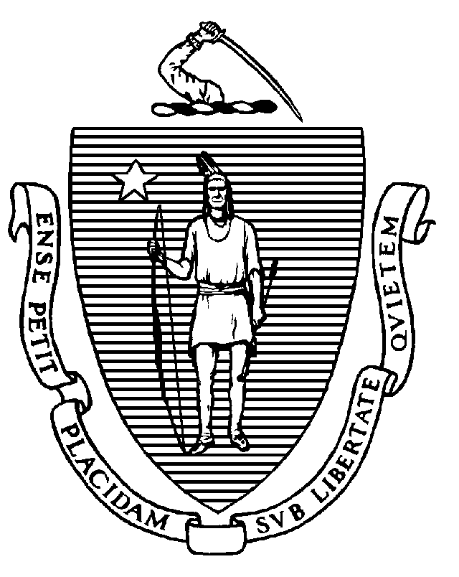
The Commonwealth of Massachusetts
Executive Office of Health and Human Services
Department of Public Health
Bureau of Health Care Safety and Quality
99 Chauncy St., 11th Floor
Boston, MA 02111

CHARLES D. BAKER
Governor
KARYN E. POLITO
Lieutenant Governor

MARYLOU SUDDERS
Secretary
MONICA BHAREL, MD, MPH Commissioner

Tel: 617-624-6000
www.mass.gov/dph

Circular Letter: DHCQ 16-2-654

TO: Hospice Agency Administrators
Nursing Home Administrators
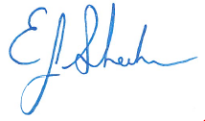
FROM: Eric Sheehan, J.D., Interim Bureau Director
Bureau of Health Care Safety and Quality

Sherman Lohnes, J.D., Director, Division of Health Care Facility Licensure and Certification

DATE: February 1, 2016

RE: Dementia Training Requirements for Hospice Staff Providing Care in Nursing
Homes

In order to ensure appropriate care is provided to all nursing home residents, including those receiving hospice care, the Department of Public Health (Department) has determined that hospice agency staff who provide care in nursing homes and meet the definition of “relevant staff member” must be trained in accordance with 105 CMR 150.024.

The Department is requiring all current hospice workers who meet the definition of relevant staff member to be trained no later than July 31, 2016. New hospice staff members who meet the definition of relevant care workers must, beginning May 1, 2016, be trained prior to being released from orientation. If a hospice agency can clearly identify staff members who will not be providing care in nursing homes, those staff members would be exempt from these training requirements.

Under the training requirements in the standards for dementia care, and as specified in the Department’s Guidelines for Dementia Special Care Units (“Guidelines”) to nursing homes dated May 22, 2014, all relevant staff members must receive eight hours of initial training and four hours of ongoing training each calendar year.

Training conducted to meet the requirements of 105 CMR 150.024 must include, at a minimum, the following topics:

- A basic introduction to the foundations of Alzheimer’s and other related dementias;
- Training on communicating and connecting with residents with Alzheimer’s and other related dementias;
- Training on techniques and approaches to care of persons with Alzheimer’s and dementia;
- Training on person centered care;
- Training on understanding the needs of and working with the families;
- Training on the dietary needs of residents with Alzheimer’s and other related dementia;
- Training on the social needs and appropriate activities in the care of residents with Alzheimer’s and other related dementia;
- Recognizing and responding to caregiver stress; and,
- Preventing, recognizing, and responding to abuse and neglect of residents with Alzheimer’s and other related dementia.

Training conducted to meet the requirements of 105 CMR 150.024 must be at least partially interactive. The Department considers “partially interactive” to be training that does not consist of the presentation of information through reading or lecture alone. Since adult learning styles differ, training should be planned and conducted in a meaningful part with the use of interactive learning techniques such as interactive or experiential exercises, small group discussion or exercises, role-play, and case study. There is no requirement that all eight hours of initial training or four hours of annual training be completed in one day.

As a number of effective training programs exist, including, but not limited to, the Alzheimer’s Association’s “Habilitation Therapy – Caring for People with Dementia”, Hand in Hand, and OASIS (augmented with additional training and focus related to Alzheimer’s and dementia care), the Department will not be requiring or excluding the use of any specific training program at this time. Agencies must ensure that the basic curriculum used incorporates at a minimum the above-mentioned topics.

In addition to training staff members, a hospice agency must train volunteers “appropriately … for the tasks they will be performing” as required under 105 CMR 150.024(B)(6). While agencies may elect to provide volunteers, and others who do not meet the definition “relevant staff member” with eight hours of initial training and four hours of annual training, a hospice agency may elect to provide less than the eight hours of initial training and four hours of annual training should they deem it appropriate.

As has been the case with nursing homes and temporary staffing agencies in regard to training on preventing abuse, the Department will accept language in the agreement between the hospice agency and the nursing home that training has been or will be completed as required above as evidence on the part of the nursing home that the nursing home is in compliance with the dementia training requirement, and will not require a nursing home to produce documentation that an individual hospice worker has been trained.

Hospice agencies or nursing homes with questions regarding this matter should contact Sherman Lohnes at 617-753-8160 or Paul DiNatale at 617-753-8222.

Direct care workers, therapeutic activity directors and supervisors of direct care workers are considered to be “relevant staff members” under 105 CMR 150.023. “Direct care worker” is defined at 105 CMR 150.020 to mean “… a staff member whose work involves extensive patient contact or administrative decisions regarding care…” Relevant to the issue of training hospice agency staff is the second sentence of the definition which provides: “The term "direct care worker" shall not be limited to those workers employed by the nursing home, and shall include contracted workers who provide direct care to residents.”

