|  |
| --- |
| PROPOSED MASSACHUSETTS TAX EXPENDITURES  EVALUATION SUMMARY |
| EVALUATION YEAR: 2020 |

|  |  |
| --- | --- |
|  |  |
| **TAX EXPENDITURE TITLE** | Renewable Energy Source Credit (tax credit) |
| **TAX EXPENDITURE NUMBER** | 1.601 |
| **TAX EXPENDITURE CATEGORY** | Credit against tax |
| **TAX TYPE** | Personal income tax |
| **LEGAL REFERENCE** | M.G.L. c. 62, § 6(d) |
| **YEAR ENACTED** | 1979 |
| **REPEAL/EXPIRATION DATE** | None |
| **ANNUAL REVENUE IMPACT** | Tax loss of $5.2 million in FY22 |
| **NUMBER OF TAXPAYERS** | Estimated 6,000 personal income tax filers |
| **AVERAGE TAXPAYER BENEFIT** | $900 to $1,000 per claimant |

|  |  |
| --- | --- |
| **Description of the Tax Expenditure:**  Provide homeowners and tenants a credit equal to 15% of the net expenditure for renewable energy source property or $1,000, whichever is less. The credit is limited to certain types of equipment used directly for the production of solar or wind energy for residential properties. | **Is the purpose defined in the statute?**  The statute does not explicitly state the purpose of this tax expenditure. We inferred that the purpose is to provide incentives to homeowners and tenants to invest in renewable energy sources to promote energy efficiency, and reduce environmental pollution. |
| **What are the policy goals of the expenditure?**  We infer it is intended to promote energy efficiency, thereby reducing environmental pollution. | **Are there other states with a similar Tax Expenditure?**  All the New England states and New York have renewable energy incentive programs. The programs include, depending on the state, a sales tax, property tax or income tax deduction or exemption, or a combination of these tax incentives. |

|  |
| --- |
| Incentive Evaluation Results |

**INTRODUCTION**

Owners and tenants of residential property located within Massachusetts who are not dependents and who occupy the property as a principal residence are allowed a credit equal to 15% of the net expenditure for renewable energy source property or $1,000, whichever is less.

Unused credits may be carried forward for 3 years. The credit is neither transferable nor refundable and is reduced by any federal tax credits and grants or rebates received from the U. S. Department of Housing and Urban Development.

The credit is limited to the purchase and installation of equipment for solar or wind powered and related equipment.See, 830 CMR 62.6.1.

|  |
| --- |
|  |

|  |
| --- |
|  |

**POLICY GOAL**

While the intent of the tax credit is not explicit, it appears intended to encourage the use of renewable energy by allowing homeowners and tenants a credit for installation of qualifying renewable energy equipment. The goals it works towards are:

* Cleaner Environment
* Support the establishment of the renewables industry in Massachusetts
* Provide jobs/employment

**COSTS**

The revenue loss from this tax expenditures is calculated annually as part of the Tax Expenditure Budget (TEB). We estimate the cost of this credit in FY22 will be $5.2 million.

**Actual and Forecast Tax Loss from Renewable Energy Credit ($millions)**



**BENEFITS**

The table below provides a break-out, by income level, of the $4.359 million in Renewable credits claimed for tax year 2018. Also shown is the percentage of claimants at each income level, and the percentage of total credits they claimed.

**Renewable Energy Credits claimed by filers in 2018, by Income level**

*Source: Massachusetts Statistics of Income*



In Massachusetts, the average cost of a typical 5kWh system is $16,000[1] (2020); a $1,000 credit would represent a 6.25% reduction in the cost of such a system.

**EVALUATION: COMPARING COSTS AND BENEFITS**

This tax credit has direct impacts in the form of lost tax revenue to the state, which reduces state spending. This loss directly benefits certain filers in the form a lower tax burden. The direct benefits lower the tax burden of claimants, which has an economic impact similar to an increase in their disposable income. The net impact on the state’s economy is likely slightly negative, as state spending tends to have a greater local impact than a general increase in disposable income. However, for this particular tax expenditure, a consideration of its broader benefits should be considered, even if difficult to quantify.

More broadly, this tax credit has a jobs-creation effect and an environmental benefit. The jobs creation comes from spending for installing renewables, principally solar. Beyond the direct benefits of the jobs it funds, by increasing the volume of installations the credit likely has contributed to the establishment of the solar industry in Massachusetts.

The use of renewables to produce electricity also displaces fossil fuel use, providing environmental benefits. Although difficult to quantify, achievement of this socially desirable goal is a benefit of the credit.

While the installation of renewables has expanded significantly over the past 10 years, it is difficult to quantify how much of this activity can be attributed to this credit, and how much is due to other factors such as federal tax credits and falling costs in the renewables industry. See “Is the Incentive as Designed Accomplishing its Purpose?” section below for further analysis.

**SIMILAR TAX EXPENDITURES OFFERED BY OTHER STATES**

Most states have some type of energy incentive or income tax deduction, sales tax exemption and/or property tax exemption:

* Maine has a deduction tied to the Federal Tax Credit for Solar Photovoltaics and other renewable energy incentives. It also offers loans, and net metering.
* Vermont has a deduction tied to the Federal Investment Tax Credit and other renewable energy incentives including net metering. (Varies by local utility)
* New Hampshire has a property tax exemption for solar & wind energy installations. Also, any homeowner with a solar system size of 10 kW or less will qualify for the state’s incentive program for small residential solar. The program pays $0.20 per watt **up to $1,000** or half the cost of the system, whichever comes first.
* Connecticut has a sales tax exemption and a property tax exemption and several other incentive programs for renewable energy. Connecticut’s “Residential Solar Investment Program” (administered by the Connecticut Green Bank) provides rebates of $0.463 per watt of solar installed (up to 10kW). That is, a homeowner who invests in a 5-kilowatt system would receive $2,315.
* Rhode Island has a sales tax exemption and a property tax exemption and several other incentive programs for renewable energy. Rhode Island’s “solar grant program” provides new solar owners $0.85 per watt via the installing company, up to $7,000. An average 5-kilowatt roof- system receives $4,250 in cash payments.
* New York has a sales tax exemption and a property tax exemption and several other incentive programs for renewable energy, notably their Solar Equipment Tax Credit. This is a solar tax credit of up to $5**,**000 or 25% of the cost of a solar energy system (whichever is lower). Solar Equipment Tax Credit claimants who rent or lease their system (i.e. solar with a lease or PPA) qualify. Any unused credit may be carried forward into the next year. In addition, New York’s Megawatt Block Incentive is a direct incentive for solar energy available under its NY-Sun Initiative. The program provides an up-front dollars-per-watt ($/W) rebate for both commercial and residential solar panel systems; the size of your subsidy depends on how much solar energy is already being produced in the area, and could be as high as $1/W ($5,000 for a 5-kWh system).

For programs in other states, see:

**Database of State Incentives for Renewables & Efficiency**

[**https://www.dsireusa.org/**](https://www.dsireusa.org/)

**Solar Energy Tax Incentives by State**

<https://www.solar-electric.com/learning-center/solar-energy-tax-incentives.html/>

**IS THE INCENTIVE AS DESIGNED ACCOMPLISHING ITS PURPOSE?**

The renewable energy source credit was introduced in 1979. It was little used during its early years. As the cost of solar photovoltaic installations fell, claims for the credit have increased. This was most pronounced over the past 10 years.

The chart below shows the actual credits claimed by filers (in millions of dollars). Annual claims plateaued at around the $1 million level from 2005 to 2012. We know that the installation costs for solar power have been declining over time. The credit has likely helped make investment in home renewable power more attractive. From 2013 on, credits increased rapidly to the $4 to $5 million dollar range. While the renewables credit is only part of the reason for increased solar installations (see next section), this increase in claims is an indication that the credit is contributing to the goal of expanded use of renewable electric generation.

Note that this credit, as originally conceived, was for any renewable energy source property. As the market for renewables developed, solar power emerged as the most cost-effective renewable source. The credit provided a *renewable* incentive, while the market selected the particular technology (solar in this case) as the principal recipient of the credit.

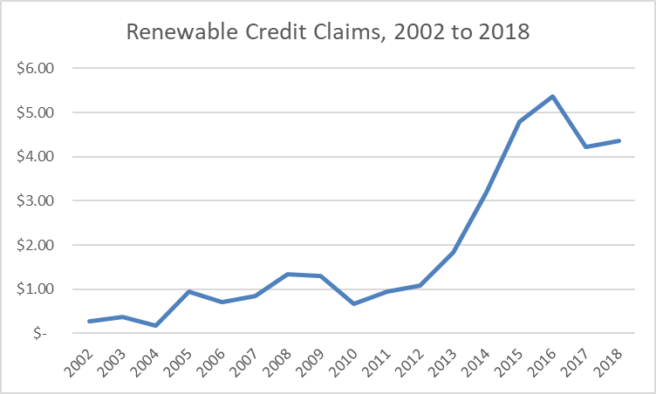

**Other Massachusetts plans that support renewable energy production**

It should be noted that the renewable energy source credit is not the only inducement for the installation of these systems. We believe that the two programs described below, in combination with the credit, have contributed to the expanded use of renewables, particularly solar, in Massachusetts.

*Massachusetts solar tax exemptions*

There are two major tax exemptions for solar homeowners in addition to the income tax exemption: the sales tax and property tax incentives. Both of these tax incentives are attractive as they provide a 100% tax exemption from both sales and property tax payments.

*Mass Solar Loan program*

This new, innovative state-level incentive allows residential homeowners to own a solar photovoltaic system by making fixed, low-interest loan payments. This financing program is a major reason for solar’s rising popularity in Massachusetts where legislators wanted to incentivize homeowners to get the best value out of their solar panel installation - by owning it rather than getting into complex third-party ownership agreements.

To be completed further by TERC

Conclusion/Recommendations: [To be Entered by TERC]

1. <https://www.energysage.com/local-data/solar-panel-cost/ma/>