|  |
| --- |
| PROPOSED MASSACHUSETTS TAX EXPENDITURES  EVALUATION SUMMARY |
| EVALUATION YEAR: 2020 |

|  |  |
| --- | --- |
|  |  |
| **TAX EXPENDITURE TITLE** | Film Production Incentives (tax credit and sales tax exemption) |
| **TAX EXPENDITURE NUMBER** | 1.611, 2.614, 3.004 |
| **TAX EXPENDITURE CATEGORY** | Credit against tax *(personal income tax, corporate and business tax)*; Exemption *(sales tax)* |
| **TAX TYPE** | Personal income tax, corporate and business tax; sales and use tax |
| **LEGAL REFERENCE** | M.G.L. c. 62, § 6(l), c. 63, § 38X, c. 64H, § 6(ww) |
| **YEAR ENACTED** | November 23, 2005 |
| **REPEAL/EXPIRATION DATE** | January 1, 2023 |
| **ANNUAL REVENUE IMPACT** | Tax loss of $56-80 million annually FY18-FY22 |
| **NUMBER OF TAXPAYERS** | During 2006-2016, the number of film projects granted the credit varied from 97 to 162 annually. |
| **AVERAGE TAXPAYER BENEFIT** | $480,000 per project during 2006-2016 |

|  |  |
| --- | --- |
| **Description of the Tax Expenditure:**  The Massachusetts film tax incentives, as amended in July 2007, allow a producer of a motion picture a tax credit equal to 25% of the film’s production cost and 25% of the film’s payroll costs. They also provide an exemption from sales tax for film productions in Massachusetts. | **Is the purpose defined in the statute?**  The statute does not explicitly state the purpose of this tax expenditure. |
| **What are the policy goals of the expenditure?**  The creation of jobs and generation of economic activity by attracting film productions to Massachusetts. | **Are there other states with a similar Tax Expenditure?**  31 states, Washington D.C., Puerto Rico and the U.S. Virgin Islands maintain film incentive programs |

|  |
| --- |
| Incentive Evaluation Results |

**INTRODUCTION**

The Massachusetts film tax incentives, as amended in July 2007, are allowed for taxpayers engaged in the production of feature-length films, videos, digital media projects, television series, and commercials, for theatrical or television viewing. The statute makes no reference to productions that are instead made for viewing on the Internet.

The film tax incentives consist of a tax credit equal to 25% of a film’s production cost and 25% of a film’s payroll cost, and an exemption from sales tax for film productions. The incentives are dependent upon a taxpayer incurring Massachusetts production expenses of at least $50,000 in a twelve-month period. Assuming that threshold requirement is met, a taxpayer may claim the payroll portion of the credit for any in-state employment of persons in connection with the filming and production of a motion picture, so long as the payment constitutes Massachusetts source income to the recipient. The taxpayer may claim the production expense portion of the credit if its Massachusetts production expenses exceed 50% of its total production expenses, or if at least 50% of the taxpayer’s total days spent filming the motion picture took place in Massachusetts.

The tax credits are available to both corporate excise and personal income tax filers and can be used to reduce the taxpayer’s liability. At the taxpayer’s election, the Department of Revenue will refund 90% of any amount of the tax credit that exceeds the taxpayer’s liability. The tax credits may also be transferred or sold by taxpayers to third parties that may use the tax credits to reduce their Massachusetts corporate, insurance, financial institution, or personal income tax liabilities. Over 89% of film tax credits issued have been sold to third parties.

The sales tax exemption applies to sales of tangible personal property to a qualifying motion picture production company or to an accredited film school student for the production expenses related to a school film project.

**POLICY GOAL**

The statute does not explicitly state the purpose of this tax expenditure. We inferred that the purpose is to attract film productions to Massachusetts; the implied assumption is that film productions will create jobs and increase economic activity in Massachusetts.

**COSTS**

The amount of tax credits has fluctuated from year to year. Most of the fluctuation is due to national economic conditions (the impact of the recession after 2009 can be seen in the table below) and, related to that, the number of feature films qualifying for the credit. Feature films, although a small number of total projects, generally represent 80% of the spending that qualifies for the credit.

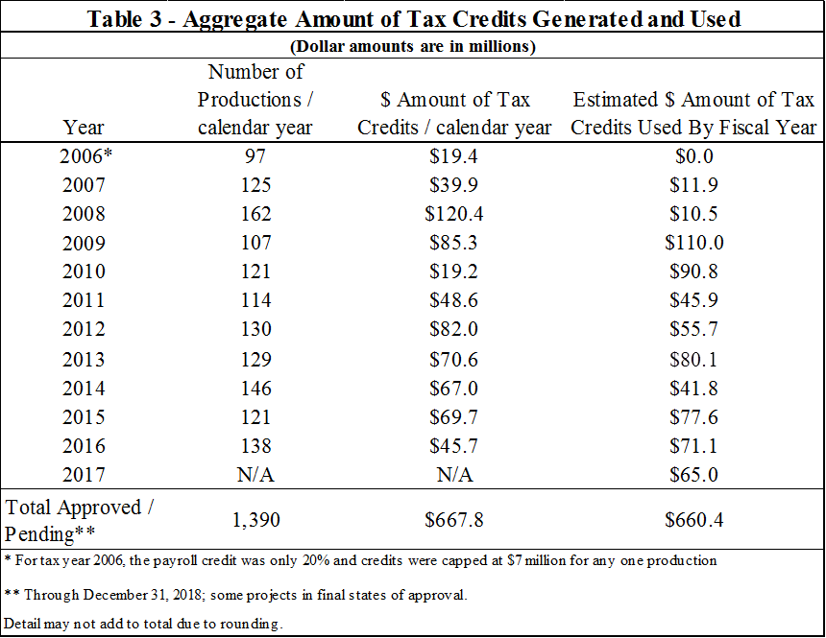

“Table 3” from the “Report on the Impact of Massachusetts Film Industry Tax Incentives through Calendar Year 2016”

The table shows the total credit liability of $667.8 million accumulated since the start of the credit. Note that there is typically a delay between when the filming activity occurs and when the credit is claimed (which is when the tax loss is realized by the state). The column on the right shows the total actual cost of $660.4 million to the state’s budget as filers claimed the credits. Filming may occur in one calendar year, but the associated credits might not be claimed, approved, and used until subsequent fiscal years.

Note that the revenue loss from film tax incentives is almost entirely attributable to the credit, while the sales tax exemption represents only $0.3 million. The FY22 Tax Expenditure Budget estimates the future cost of the film tax incentives as follows:

|  |  |  |  |  |  |  |
| --- | --- | --- | --- | --- | --- | --- |
|  | Tax type | FY 2018 | FY 2019 | FY 2020 | FY 2021 | FY 2022 |
| Film (or Motion Picture) Credit | Corporate and Income | $56.7 | $79.1 | $80.0 | $80.0 | $80.0 |
| Sales Tax Exemption | Sales | $0.3 | $0.3 | $0.3 | $0.3 | $0.3 |

**BENEFITS**

Film producers, whether in-state or out-of-state, derive an economic benefit from this tax expenditure directly. Individuals who are employed in the film industry and businesses selling inputs to the film industry will also derive an economic benefit from this tax expenditure.

After subtracting the film spending amount that goes to non-residents and non-Massachusetts businesses, as well as state spending reductions required to fund the tax credits in order to maintain a balanced budget, the film tax credit program resulted in $28.7 million in net new spending in the Massachusetts economy during the calendar year 2016. Over the period 2006 to 2016, the film incentive program resulted in $503.2 million in net new spending in the Massachusetts economy.

In addition to the net new direct spending, economic activity generated by film spending produces a positive multiplier impact. However, this is offset by the necessary cuts in state spending to pay for the film credits, a negative multiplier impact. After taking into account the full impacts, including the direct impact and the multiplier impact, the film incentive program in 2016 generated net new Massachusetts Gross State Product (GSP) of $60.7 million, and $27.8 million in personal income.

It is possible that Massachusetts could experience an increase in economic activity from greater exposure of the Commonwealth through films and other productions that are made in Massachusetts. Some studies have suggested that having high-profile movie and television actors in the Commonwealth for extended periods of time might be tantamount to advertising. However, those studies have generally been conducted or sponsored by interested parties, and there have been some reports indicating that the findings and methodologies of those studies that do exist are controversial or biased (see for example <http://www.cbpp.org/files/11-17-10sfp.pdf>). DOR is not aware of any published and peer-reviewed study measuring the direct and indirect impact of the film credit.

**EVALUATION: COMPARING COSTS AND BENEFITS**

The film tax incentives, principally the credit, have created jobs and increased state GSP, but it is hampered by the leakage out of state and the cost of the credits themselves. “Leakage” occurs when economic activity is generated by the tax incentive, but outside of Massachusetts; the benefits are not captured locally but instead leak into the broader national economy.

Since Massachusetts has a balanced budget requirement, every dollar spent on the film credit is one less dollar that can be spent in other ways. This offsets a portion of the benefits of the credit, which increases the cost per Massachusetts-resident job created.



Condensed from “Table 5” of the “Report on the Impact of Massachusetts Film Industry Tax Incentives through Calendar Year 2016”

The leakage also impacts the taxes generated by film activity. While film activity does generate new state tax collections (particularly income tax on wages), that revenue only equaled 14 cents for each dollar of tax incentives issued over the 2006 to 2016 period.

**SIMILAR TAX EXPENDITURES OFFERED BY OTHER STATES**

State film tax credits grew in popularity until 2009 when 44 states, Puerto Rico, and Washington D.C., offered some form of film and television production incentives. However, the number of states offering these programs has decreased in recent years. In 2018, only 31 states, Washington D.C., Puerto Rico and the U.S. Virgin Islands continue to maintain film incentive programs, and several of these states are tightening the requirements for qualifying expenses and establishing caps at both the project and annual-program levels.[1]

**IS THE INCENTIVE AS DESIGNED ACCOMPLISHING ITS PURPOSE?**

As noted, while the statute does not explicitly state a purpose, we infer that the credit is intended to:

1) promote filming in Massachusetts, and

2) create local jobs.

While these two goals are related, due to the structure of the credit they are not strictly linked, as is discussed below.

*Purpose: Promote film production in Massachusetts:*

The credit supports filming activity in Massachusetts. Although it has varied, the number of projects qualifying for the credit has generally increased since the recession in 2009, as this chart shows:

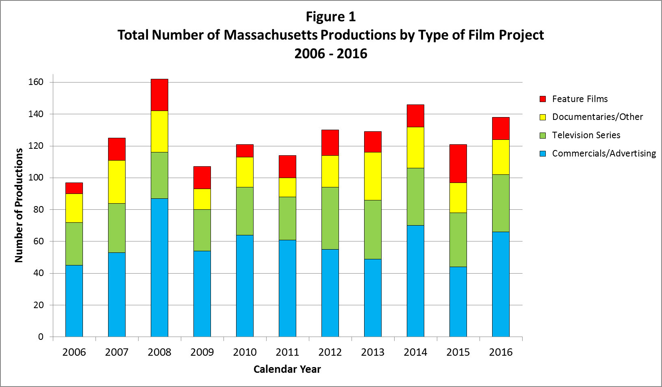

“Figure 1” of the “Report on the Impact of Massachusetts Film Industry Tax Incentives through Calendar Year 2016”

While few in number, feature films claim over 80% of the credits. In its current form, the film credit can be considered a feature film credit. This is significant because the spending patterns of a feature film differ from those for television programs or commercials.

**Total spending qualifying for the film credit, by type of production, 2006 to 2016**

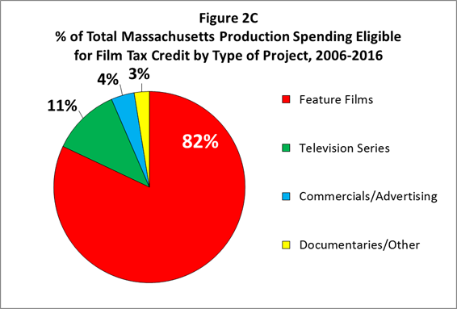

“Figure 2C” of the “Report on the Impact of Massachusetts Film Industry Tax Incentives through Calendar Year 2016”

A feature film will generally bring together talent and workers with special skills, some of which will be “imported” from outside the state. The film’s presence in the state will typically last only for several weeks, leaving little or no lasting presence in the local economy. By contrast, television productions usually establish a local presence and, if successful, remain for a number of years. The same is true for commercials: Although a single commercial will be completed in a short period of time, a successful production company will typically produce a steady stream of commercials each year, thus creating a local business.

Conclusion/Recommendations: [To be Entered by TERC]

*Purpose: Create local jobs:*

While the credit has led to increased film spending, this has not always translated into local jobs. This is because much of the production and wage spending that qualifies for the credit has gone to vendors and workers outside of the state. The Massachusetts film credit does not require production costs to be incurred with a Massachusetts-based business to qualify for a film tax credit. If a production otherwise qualifies, payments made to out-of-state vendors are eligible for the credit. This is significant as purchases generally stimulate economic activity only in the state or area where the purchase is made, and not elsewhere.

Although the payroll component of the credit is only available for wages paid for work in Massachusetts, a similar form of leakage occurs with wages paid to workers who reside outside the state. Again, this tends to affect feature films, where non-residents, in some cases highly paid, spend brief periods in Massachusetts before returning to their home states.[2]

The bottom half of the table below summarizes the percentage of qualified film credit spending that went to Massachusetts and non-Massachusetts residents and businesses (denoted as “MA Resident/Businesses” and “Non-MA Residents/Businesses” in the table).

**Film Spending by Category, with Massachusetts vs. Non-Massachusetts Amounts**

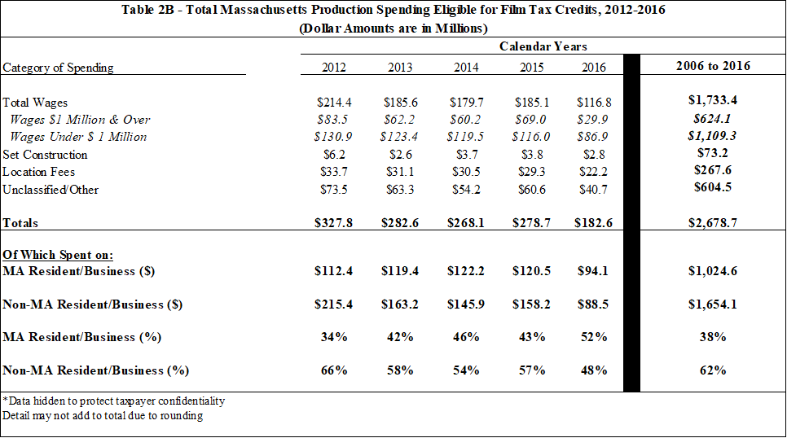

“Table 2B” from the “Report on the Impact of Massachusetts Film Industry Tax Incentives through Calendar Year 2016”

Note that generally more than half is spent outside of Massachusetts. While this does create jobs outside of Massachusetts, it dampens the local jobs-creation impact of the film credit.[3]

The table below provide further detail of the jobs created by the credit, broken out by “Resident” and “Non-Resident”.

**Full Time Equivalent Employment, Resident and Non-Resident**

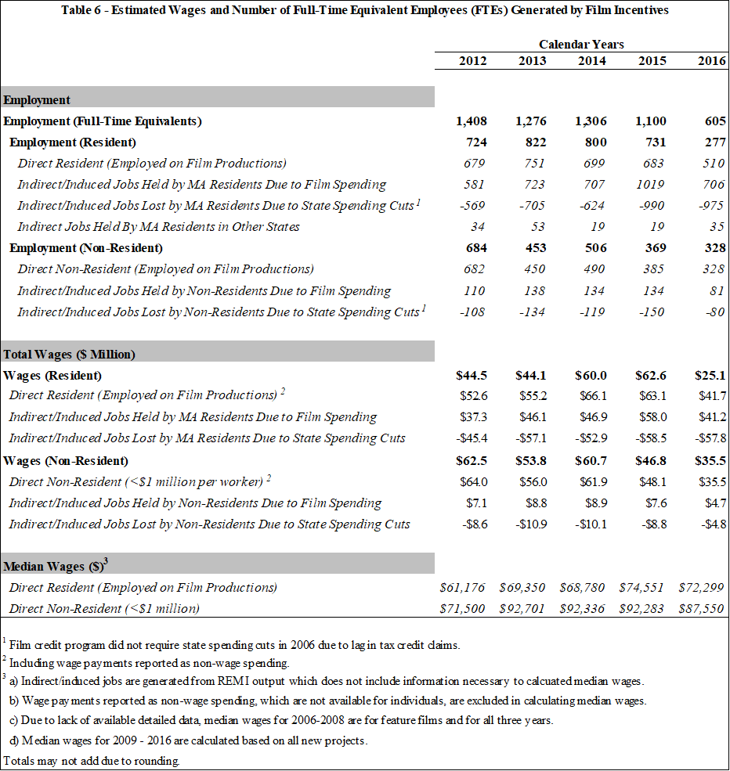

“Table 6” from the “Report on the Impact of Massachusetts Film Industry Tax Incentives through Calendar Year 2016”

To be completed further by TERC.

Conclusion/Recommendations: [To be Entered by TERC]

1. See National Conference of State Legislatures, <https://www.ncsl.org/research/fiscal-policy/state-film-production-incentives-and-programs.aspx>)
2. Between 2006 and 2016, $624.1 million in wages was paid to individuals earning over $1 million on a project; nearly all of them were Non-Massachusetts residents.
3. For more detail, see the full annual film reports at <https://www.mass.gov/lists/massachusetts-film-industry-tax-incentive-reports>