INDOOR AIR QUALITY ASSESSMENT

City of New Bedford
181 Hillman Street, Building #3
New Bedford, MA

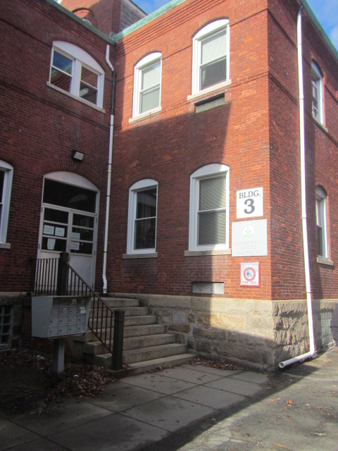

Prepared by:
Massachusetts Department of Public Health
Bureau of Climate and Environmental Health
Division of Environmental Health Regulations and Standards
January 2026

BACKGROUND
Building: | Building #3
Address: | 181 Hillman Street, New Bedford, MA
Assessment Coordinated Through: | Department of Labor Standards (DLS) and the City of New Bedford Facilities Department
Reason for Request: | DLS received a formal complaint of mold concerns
Date of Assessment: | January 8, 2026
Massachusetts Department of Public Health, Bureau of Climate and Environmental Health, Division of Environmental Health Regulations and Standards (MDPH/BCEH/EHRS) Staff Conducting Assessment: | Cory Holmes, Senior Advisor for Indoor Air Quality Inspections, Audits, Outreach, and Trainings
Building Description: | Building #3 is a two-story red brick and plaster building with basement that was originally constructed in the early 1930s as a vocational technical school. Building #3 is part of a multi-building complex of similar buildings at 181 Hillman Street. The building (and complex) is currently used by the city of New Bedford to house the Parks & Recreation Department as well as a number of educational programs.

METHODS
Please refer to the indoor air quality (IAQ) Manual for methods, sampling procedures, and interpretation of results (MDPH, 2015). The assessment focused on complaint areas on the first floor of the building. However, the recommendations listed should be considered Best Practices that should be implemented in other areas of the building if similar issues are present.

RESULTS AND DISCUSSION
Measurements for IAQ parameters are summarized below:
- Carbon dioxide measurements were below the MDPH guideline of 800 parts per million (ppm) indicating adequate air exchange in the space.
- Temperature was within the recommended range of 70°F to 78°F in areas tested.
- Relative humidity was below the recommended range of 40% to 60% in all areas tested, which is common during the heating season.
- Carbon monoxide levels were non-detectable (ND) in all areas tested.
- Fine particulate matter (PM2.5) concentrations were below the National Ambient Air Quality Standard (NAAQS) level of 35 μg/m³ in all areas tested and most were ND.

Ventilation
A heating, ventilating, and air conditioning (HVAC) system has several functions. First, it provides heating and, if equipped, cooling. Second, it is a source of fresh air. Finally, an HVAC system will dilute and remove normally occurring indoor environmental pollutants by not only introducing fresh air but also filtering the airstream and ejecting stale air to the outdoors via exhaust ventilation. Even if an HVAC system is operating as designed, point sources of respiratory irritation may exist and lead to symptoms in sensitive individuals.
The building reportedly has a ventilation system that is original to the building that provides heated air but not air conditioning. However, the office areas examined did not contain supply or exhaust vents and therefore depend on openable windows for fresh air and circulation.

Microbial/Moisture Concerns
The main reason for DPH visiting this facility was mold concerns regarding material described as white and powdery. This material is called efflorescence. Efflorescence results when rainwater penetrates into brick and mortar. A suspension of water and salts forms in the brick and mortar, which then travels to the wall surface. As the water evaporates, a white, powdery material is formed (efflorescence). While efflorescence is a sign of water exposure to brick, it is not mold growth.
The efflorescence was observed most prominently in the Parks & Recs area near the Out of School Time Coordinator’s office area where wooden paneling was opening, creating a seam for the efflorescence to migrate into occupied areas (Pictures 1 and 2). Similar conditions were also observed in room 105 (Picture 3). Although plaster and wooden paneling are not conducive to mold growth, carpeting in these areas can be. No musty odors were detected, and no visible mold was observed in these areas. In addition, moisture testing of carpeting indicated that all materials tested were found to have low (i.e., normal) moisture content at the time of the assessment.
For building materials to support mold growth, a source of moisture is necessary. Identification and elimination of the water moistening building materials is necessary to control mold growth. In this case the most obvious source of water infiltration is missing/damaged mortar around brickwork (Pictures 4 and 5), which indicate the building needs repointing.
Visible mold was noted however, in the break area. This area contained a refrigerator that had visible mold on the gaskets (Pictures 6 and 7) and a large formation of ice in the freezer (Picture 8). While this refrigerator is not covered by the food code, it is good practice to have a thermometer in each refrigerator that is visible to ensure refrigerated food temperatures are kept at 5ºC (41ºF) or less (US FDA, 2022). The refrigerator was at a proper temperature (38°F). Food preparation equipment should be kept clean and free from spills to prevent mold growth, pests, and odors. Food should also be stored in pest-proof containers that are closed every night.

Airborne Dust/Debris and Particulate Matter
Particulate matter is airborne solids that can be irritating to the eyes, nose and throat. The US EPA has established national ambient air quality standard (NAAQS) limits for exposure to particulate matter. The NAAQS originally established exposure limits to particulate matter with a diameter of 10 μm or less (PM10). According to the NAAQS, PM10 levels should not exceed 150 micrograms per cubic meter (μg/m³) in a 24-hour average (US EPA, 2025). These standards were adopted by both the American Society of Heating, Refrigeration and Air Conditioning Engineers (ASHRAE) and Building Officials and Code Administrators International (BOCA).
Since the issuance of the ASHRAE standard and BOCA Code, US EPA established a more protective standard for fine airborne particles. This more stringent PM2.5 standard requires outdoor air particle levels be maintained below 35 μg/m³ over a 24-hour average (US EPA, 2025). Although both the ASHRAE standard and BOCA Code adopted the PM10 standard for evaluating air quality, MDPH uses the more protective PM2.5 standard for evaluating airborne particulate matter concentrations in the indoor environment.
While some dust was observed on surfaces, levels of particulate matter in the 2.5 µm size range, which is the range most associated with health impacts, were very low or non-detectable (ND, Table 1). All measurements were lower than the EPA NAAQS level of 35 μg/m³, which is used to determine if outdoor air is in a healthy range. Outdoor levels were measured at 13 μg/m³. These measurements indicate that while dust/debris can be unsightly, it is not remaining suspended in the air where it can be inhaled.

Other IAQ Concerns
Some areas are covered with wall-to-wall carpet that is worn, soiled, and past its service life. Carpeting has a service life of approximately 10-11 years (IICRC, 2002). Carpeting that is beyond its service life becomes increasingly difficult to clean and may release fibers which can be irritating if airborne. Carpets should be vacuumed regularly with a high efficiency particulate arrestance (HEPA) filter equipped vacuum cleaner and cleaned annually (or semi-annually in soiled/high traffic areas) in accordance with Institute of Inspection, Cleaning and Restoration Certification (IICRC) recommendations (IICRC, 2012).
Due to the age of the building, it is important to determine if carpeting is adhered to asbestos-containing floor tile prior to any carpet removal. If asbestos present in flooring (floor tile or mastic), comply with all state and Federal asbestos handling and disposal laws and regulations.
Accumulated chalk dust was noted in one of the offices (Picture 9). Chalk dust can be easily aerosolized and serve as eye and respiratory irritant.
Finally, bird nesting materials were found in a vent along the exterior of the building (Picture 10). If this vent is active/open to the indoors, this material may introduce odors, mold, and other microbes into the indoor environment. The nest should be removed and the area cleaned/disinfected with a mild antimicrobial.

CONCLUSIONS/RECOMMENDATIONS

Water damage/mold recommendations
- Conduct a building envelope evaluation/repointing to eliminate leaks. Without repointing efforts, water penetration and efflorescence will continue to occur. Building occupants should ensure they report active leaks to building management for investigation and remediation.
- Until repointing can be done:
  - Remove paneling in problem areas and clean/scrape down areas of efflorescence.
  - To control for dusts, a high efficiency particulate arrestance (HEPA) filter equipped vacuum cleaner in conjunction with wet wiping of all surfaces is recommended.
  - Consider sealing with proper sealant material to reduce water penetration and efflorescence.
  - Reinstall paneling and ensure there are no gaps/open seams.
  - Remove carpeting in areas prone to moisture and install non-porous floor tiles. If removing and replacing the entire area is cost prohibitive, install a strip of tile along walls in leak prone areas that can be easily dried when wet.
- Porous stored items that have become water-damaged should be discarded unless they are valuable enough to require special cleaning.
- For more information on mold remediation, refer to the US EPA’s “Mold Remediation in Schools and Commercial Buildings,” available at: http://www.epa.gov/mold/mold-remediation-schools-and-commercial-buildings-guide.
- Clean mold from refrigerator and freezer gaskets. If they cannot be adequately cleaned, remove and replace.
- Defrost and clean freezer, monitor for further ice buildup.

Other recommendations
- Reduce clutter. Periodically remove unwanted items. Store remaining items neatly and off the floor. Where rooms have a history of moisture issues, consider storing items in waterproof totes.
- Replace worn, soiled, and damaged carpeting beyond its useful life (i.e., >11 years). Prior to carpet removal, determine if carpeting is adhered to asbestos-containing floor tile. If asbestos present in flooring, comply with all state and Federal asbestos handling and disposal laws and regulations.
- Until carpet can be replaced, clean in accordance with IICRC recommendations (IICRC, 2012); annually (or semi-annually in soiled/high traffic areas). Be sure to have any suspect floor tiles and mastic evaluated/remediated in accordance with state and federal regulations for asbestos-containing materials.
- For buildings in New England, periods of low relative humidity during the winter are often unavoidable. Therefore, scrupulous cleaning practices should be adopted to minimize common indoor air contaminants whose irritant effects can be enhanced when the relative humidity is low. To control dust, a high efficiency particulate arrestance (HEPA) filter equipped vacuum cleaner in conjunction with wet wiping of all surfaces is recommended. Avoid the use of feather dusters. Drinking water during the day can help ease some symptoms associated with a dry environment (throat and sinus irritations).
- Clean chalkboard trays regularly to avoid the build-up of dust. Avoid sweeping chalk dust into the air by wet wiping.
- Determine if the vent in Picture 10 is active/open to the indoors. If inactive consider removing and sealing any penetrations to prevent infiltration birds/pests, moisture and drafts. If active, the bird’s nest should be removed and the area cleaned/disinfected with an antimicrobial.
- Refer to resource manual and other related IAQ documents located on the MDPH’s website for further building-wide evaluations and advice on maintaining public buildings. These documents are available at: http://mass.gov/dph/iaq.

REFERENCES
IICRC. 2012. Institute of Inspection, Cleaning and Restoration Certification. Carpet Cleaning: FAQ.
MDPH. 2015. Massachusetts Department of Public Health. Indoor Air Quality Manual: Chapters I-III. Available at: https://www.mass.gov/lists/indoor-air-quality-manual-and-appendices.
US EPA. 2008. “Mold Remediation in Schools and Commercial Buildings”. Office of Air and Radiation, Indoor Environments Division, Washington, DC. EPA 402-K-01-001. September 2008. Available at: http://www.epa.gov/mold/mold-remediation-schools-and-commercial-buildings-guide.
US EPA. 2025. National Ambient Air Quality Standards (NAAQS). US Environmental Protection Agency, Office of Air Quality Planning and Standards, Washington, DC. Last updated on November 4, 2025
US FDA. 2022. 2022 Food Code. U.S. Department of Health and Human Services. U.S. Food and Drug Administration. College Park, MD January 18, 2023 Version. https://www.fda.gov/media/164194/download

Picture 1
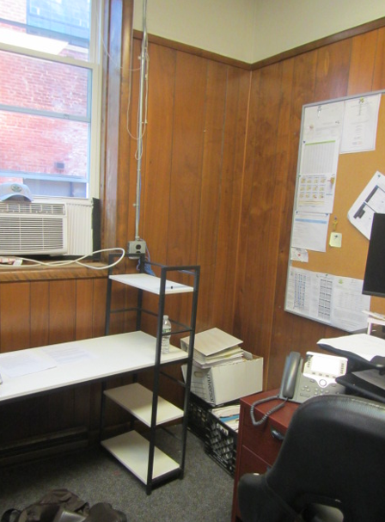
Corner of Parks & Recs/Out of School Time Coordinator’s office area with damaged paneling and efflorescence
Picture 2
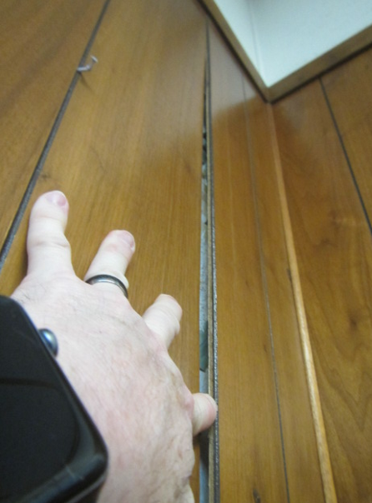
Close-up of Out of School Time Coordinator’s office area with damaged paneling and efflorescence
Picture 3
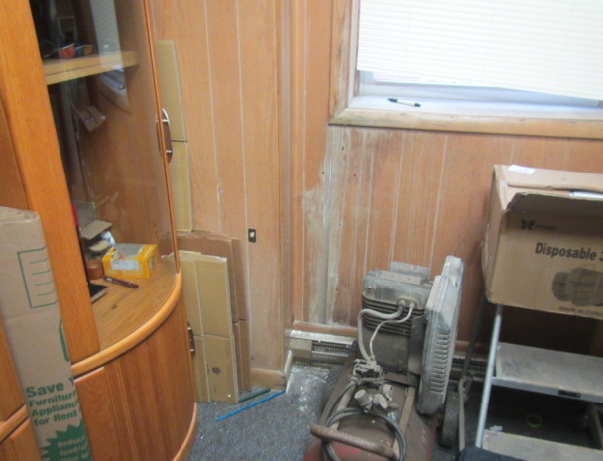
Water-damaged paneling and efflorescence in room 105
Picture 4
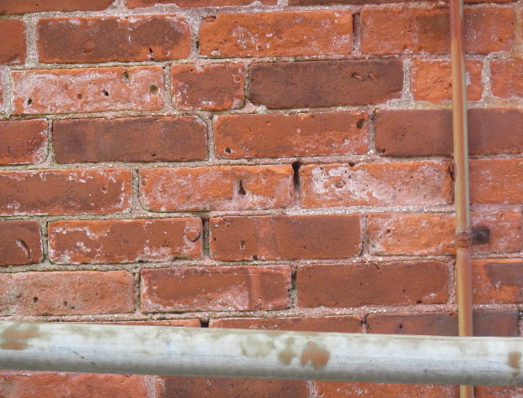
Efflorescence and missing/damaged mortar directly outside Parks & Recs area

Picture 5
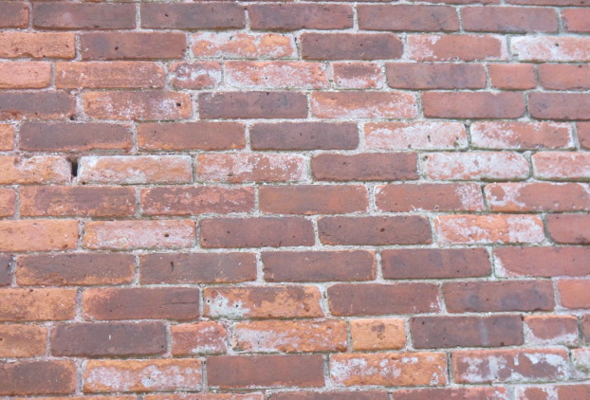
Efflorescence and missing/damaged mortar around exterior brickwork

Picture 6
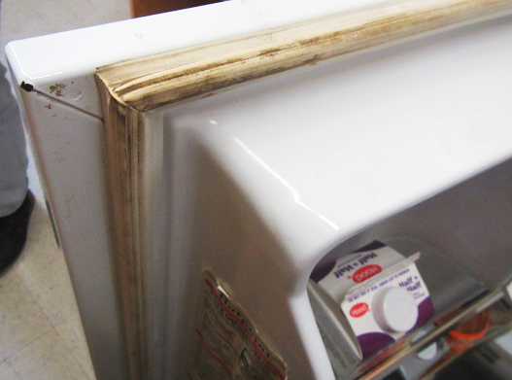
Visible mold growth on refrigerator gasket
Picture 7
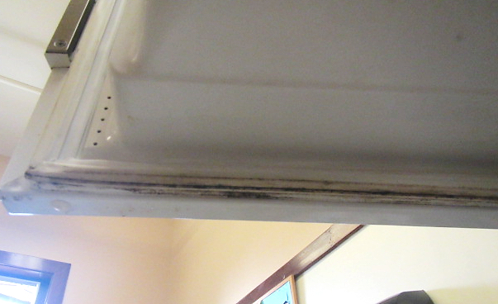
Visible mold growth on freezer gasket

Picture 8
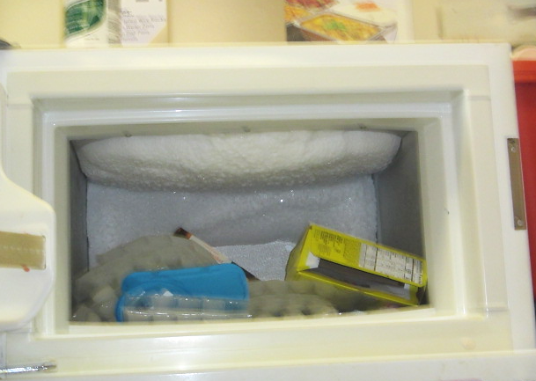
Ice formation in freezer
Picture 9
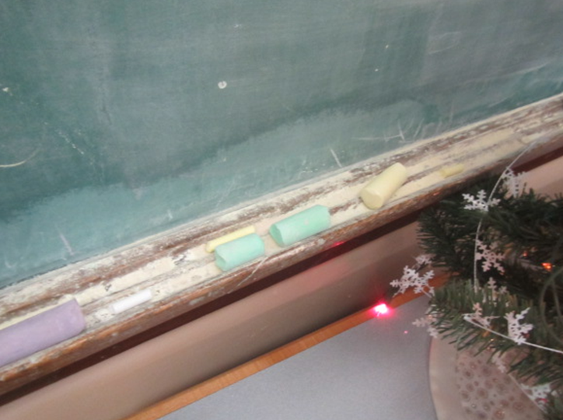
Accumulated chalk dust

Picture 10
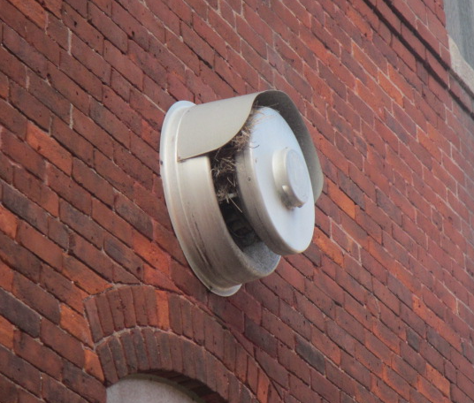
Bird’s nest in exterior vent

Location | Carbon  Dioxide  (ppm) | Carbon Monoxide  (ppm) | Temp  (°F) | Relative  Humidity  (%) | PM2.5  (µg/m³) | Occupants  in Room | Windows  Openable | Ventilation |  | Remarks
 |  |  |  |  |  |  |  | Supply | Exhaust | Remarks
Background | 409 | ND | 47 | 54 | 10 |  |  |  |  | Cold and clear
Parks and Recs Office/Out of School Time Coordinator | 723 | ND | 71 | 27 | ND | 0 | Y | N | N | No musty odors or visible mold observed, paneling over wall plaster separated with visible efflorescence (i.e., white powdery mineral deposits) behind paneling and on carpet), carpet squares
Conference Room | 779 | ND | 73 | 27 | ND | 3 | Y | N | N | Stained carpeting (under previous leak), moisture meter reading = dry
Staff Lounge | 727 | ND | 72 | 25 | ND | 0 | Y | N | N | Refrigerator temp 38°F, visible mold on gaskets, large ice structure on ceiling of freezer
Director’s Office | 770 | ND | 73 | 26 | ND | 1 | Y | N | N | Wall-to-wall carpeting
105 | 628 | ND | 72 | 26 | 1 | 0 | Y | N | N | Wall-to-wall carpeting, water-damaged wall panel, efflorescence

