Asian Births in Massachusetts
1996-1997

Jane Swift, Governor
William D. O’Leary, Secretary of Health and Human Services
Howard K. Koh, MD, MPH, Commissioner of Public Health
Daniel J. Friedman, Ph.D., Assistant Commissioner, Bureau of Health Statistics,
Research and Evaluation

The Commonwealth of Massachusetts Executive Office of Health and Human Services Department of Public Health Bureau of Health Statistics, Research and Evaluation 250 Washington Street Boston, MA 02108 617-624-5600

May, 2001

Acknowledgments

This report was prepared by: Abigail R. Averbach, M.S., Christine Judge, M.S., Malena Orejuela, M.P.H., Division of Research and Epidemiology, Bureau of Health Statistics, Research and Evaluation, Massachusetts Department of Public Health and Philip C. Nasca, Ph.D., Penelope Pekow, Ph.D., Lisa Chasan-Taber, Sc.D., Michael D. Schmidt, Layla Rouse, Juliet A. Allen and Angela K. Connor, University of Massachusetts Amherst, School of Public Health and Health Sciences, Department of Biostatistics and Epidemiology.

Special thanks go to: Daniel J. Friedman, Assistant Commissioner, Bureau of Health Statistics, Research and Evaluation; Bruce B. Cohen, Director, Division of Research and Epidemiology; Elaine B. Trudeau, Registrar, Registry of Vital Records and Statistics; Karin Barrett and Charlene J. Zion, Registry of Vital Records and Statistics; Zi Zhang and Jennifer Norton, Division of Research and Epidemiology. Thanks also go to Alfred DeMaria Jr., Saul Franklin and Mary Ostrem for reviewing the report; Dennis Sterzin and Susie Hart-Walker of Graphics for cover design and graphics support; An TonThat and Gregory Figaro for providing Asian language translation services; and David Thompson and Ken Lameires of the Copy Center for producing this report. Additional support was provided by Paulette DiMartino.

In addition, we extend our sincere gratitude to members of the Asian Births Report Task Force whose contributions of ideas and understanding of the various Asian communities were invaluable to the development and production of this report:

Tom Chung, Director of Research, Executive Office of Elder Affairs
Jennifer Cochran, Director, Refugee and Immigrant Health Program, MDPH
Bruce B. Cohen, Director, Division of Research and Epidemiology, MDPH
Alison Donta, Demographer, Division of Research and Epidemiology, MDPH (formerly)
SionKim Harris, Project Manager, Bureau of Family & Community Health, MDPH
Peggy Leong, Executive Director, South Cove Community Health Center
Wee Loc Ooi, Epidemiologist/Senior Research Scientist, Hebrew Rehabilitation Center
for the Aged, Research & Training Institute (formerly)
An TonThat, Director, Office of Refugee and Immigrant Health, MDPH
Hong Vuong, Research Analyst, Community Health Networks, MDPH (formerly)
Zi Zhang, Epidemiologist, Division of Research and Epidemiology, MDPH

Data in this report have been collected through the efforts of the Natality, Registration, and Statistical Units of the Registry of Vital Records and Statistics, whose staff include: Paul Budrow, Joan M. Burgess, Corinna Catucci, Yuen Fei Chan-Lee, Robert A. Coffin III, June Deloney, Alan Goldin, Annie Hobbs, Jane Kim, Judy Y. Lim, Maureen L. McKean, Robert McMahan, Pauline McNulty, Venita Morabito, Ann-Marie Neault, Waleska Ortiz, Jane Purtill, Mary Reddick-Pola, Mary Risser, Phyllis Rotman, Mary Lou Rossetti, Anne Rupp, Phyllis Zeuli, and Charlene Zion. Thanks also go to the members of the Division of Data Processing who helped prepare computer files.

To obtain additional copies of this report, contact the following office:

Massachusetts Department of Public Health
Bureau of Health Statistics, Research and Evaluation
250 Washington Street, Boston, MA 02108
(617) 624-5699

This and other Massachusetts Department of
Public Health publications and materials can be accessed
on the Internet: www.state.ma.us/dph/

Technical Foreword

Focus of this report

This is a report about Asian births in Massachusetts and includes all births in 1996 and 1997 to women residing in Massachusetts who identified their ancestry on the birth certificate as one of the groups with origins in the continent of Asia. These ancestry/ethnicity groups include: Asian Indian, Cambodian, Chinese, Filipino, Japanese, Korean, Laotian, Pakistani, Thai, and Vietnamese.¹ Data for these subgroups are presented for a variety of perinatal indicators statewide and for individual communities with high numbers of Asian births. For mothers of Chinese ethnicity (the largest group), data is further categorized and presented by the mother’s place of birth. The comparison group for these analyses is White non-Hispanic mothers who are not of Asian ancestry. Note that the ethnicity of an infant is based upon the self-reported ethnicity of the infant’s mother.

The purpose of this report is to provide data describing characteristics of births to Asian women in Massachusetts. It is not within the scope of this report to provide more complex analyses of birth outcomes among women of Asian ancestries. As such, this report does not provide measures of statistical significance. Rather, this report presents important baseline data on perinatal health outcomes of Asian women and infants in Massachusetts for 1996-1997.

The first edition of the report “Chinese and Southeast Asian Births,” published in 1993, covered four years of birth data from 1987 to 1990 and focused on births to mothers of Chinese, Vietnamese, Cambodian and Laotian ethnicities. Since the late 1980s, the number of annual births among all Asian ancestry groups has increased considerably in Massachusetts, from 2,498 in 1987 to 3,876 in 1997. The Asian Births Report Task Force, comprising representatives from the community of Asian health service providers and researchers, considered whether to replicate the earlier report by focusing on births to mothers only of Chinese and Southeast Asian ancestries or to expand the content of the report to include a broader focus. The Task Force recommended using the most inclusive list of subgroups, providing the maximum amount of information for program planners, community advocates and policy makers throughout the Commonwealth. We have used data for all subgroups where there was an adequate number of births to support analysis.

1998-1999 Supplement

Accompanying this report is a supplement that provides a summary of data on Asian Births in Massachusetts during 1998-1999, the most recent data available.

Changes in birth data

Asian Births in Massachusetts 1996-1997 presents, as closely as possible, natality data in a form that is consistent with data from 1995 and previous years. In 1996, Massachusetts implemented a major revision to the birth certificate form and installed a new Electronic Birth Certificate (EBC) system in Massachusetts maternity hospitals. As a result, beginning with 1996 birth data, there is new information that was previously not available (such as the mother’s language preference) as well as greater specificity in some of the data elements, which more correctly reflects the populations under study. However, the transition to the new format affected several data elements, and not all data elements presented in this report can be compared precisely with previously published data. Changes reflected in the calculation of the Kessner Adequacy of Prenatal Care Index make the comparison of data for prenatal care presented in this report with data prior to 1996 inappropriate. Other data items are comparable over time, but may be affected by minor changes in data collection, recording and coding.

Notes on Data Sources

All the information on Massachusetts births contained in this report is based upon data from the Massachusetts certificate of live birth. The terms used for Asian ethnic groups in this report are taken from the list of ancestries provided on the birth certificate. These terms are referred to as ethnicities, although they may also represent nationalities. Issues of nationality may influence women’s choices of ancestry on the birth certificate. For instance, if some Taiwanese or Tibetan women chose not to characterize their ancestry as Chinese, they would not be included under this ethnicity group.

In this publication, the term “Asian and Pacific Islander” refers to the 1990 U.S. Census race category. It is not used interchangeably with the term “Asian,” which does not include Pacific Islanders. Both terms appear throughout Chapter 1, but refer to two distinct classifications.

There are a few limitations to using 1990 census data. Although the 1990 census data is the most recent data currently available, it does not reflect changes in the population during the past 10 years. Second, there are known inaccuracies in census counts, particularly for Asian and Pacific Islanders. As measured by the net undercount, census-taking accuracy has shown an historic improvement from over 4 percent in 1950, to near 3 percent in 1960 and 1970 to a level of below 2 percent for the 1980 and 1990 censuses. The Census Bureau has historically used two approaches to measuring the undercount. One method uses birth and death records, immigration records and previous censuses to estimate the true population. This estimate is compared to the census count to measure the difference. The Census Bureau also conducts special surveys to measure the undercount. A scientific sample of census blocks are reinterviewed independently of the census enumeration. The results of these interviews are checked against the census records on an individual basis to see who was missed and who was counted in error. However, underlying the steady improvement in the national average undercount is a persistent differential undercount for Hispanic Americans, Native Americans, Blacks, and Asian and Pacific Islanders. These groups tend to be undercounted more than White non-Hispanics due to social and geographic factors.

Table of Contents

Technical Foreword | v
Executive Summary | 1
Chapter 1. Demographic Profile of Asians and Pacific Islanders in Massachusetts: 1980–1998 | 5

Figures:
- Distribution of Asian and Pacific Islander Population, Massachusetts: 1990 | 8
- Trends in the Chinese and Japanese Population, Massachusetts: 1890-1990 | 9
- Trends in Asian Populations, Massachusetts: 1980-1990 | 10
- Percentage Population Change by Race and Hispanic Ethnicity, Massachusetts: 1980-1990 and 1990-1998 | 11
- Educational Attainment of Asian and Pacific Islanders, Ages 25 Years and Above, Massachusetts: 1980 and 1990 | 13
1.6 Mean Household Income of Asians, Massachusetts: 1989 | 15
Chapter 2. Recent Trends in Asian Births in Massachusetts: 1996–1997 | 17

Figures:
2.1 Percentage of Asian Births by Ethnicity, Massachusetts: 1996-97 | 19
2.2 Number of Asian Births by Ethnicity and Mother’s Place of Birth, Massachusetts: 1996-97 | 21
- Number of Chinese, Southeast Asian and Other Asian Births  by Maternal Residence, in Selected Communities, Massachusetts: 1996-97 | 23
2.4 Number of Chinese, Southeast Asian and Other Asian Births at Selected Hospitals, Massachusetts 1996-97 | 25
Chapter 3. Demographic Characteristics of Asian Mothers: 1996–1997 | 27

Figures:
3.1 Age Distribution of Asian and White Non-Hispanic Mothers  by Ethnicity, Massachusetts: 1996–97 | 30
- Percent Distribution of Educational Level Completed Among  Asian and White Non-Hispanic Mothers by Ethnicity, Ages 20 Years and Above, Massachusetts: 1996-1997 | 32
3.3 Percentage Preferring a Language Other than English Among  Asian and White Non-Hispanic Mothers by Ethnicity,  Massachusetts: 1996-97 | 34
- Percentage of Non-U.S.-Born Asian and White Non-Hispanic Mothers by Ethnicity, Massachusetts: 1996-97 | 35

Chapter 4. Medical and Other Risk Characteristics of Asian Mothers: 1996–1997 |  | 37

Figures:
- Percent Distribution of Total Number of Live Births to Asian Mothers by Ethnicity and Place of Birth, Massachusetts: 1996-97 |  | 40
- Percentage of Asian and White Non-Hispanic Mothers who Smoked During Pregnancy, Massachusetts: 1996-97 |  | 41
- Percentage of Asian Mothers who were Hepatitis B Carriers by Ethnicity and Place of Birth, Massachusetts: 1996-97 |  | 43
- Percentage of Asian Mothers with Diabetes by Ethnicity and Place of Birth, Massachusetts: 1996-97 |  | 44
- Percentage of Asian Mothers with Infants Delivered by Cesarean Section by Ethnicity and Place of Birth, Massachusetts: 1996-97 |  | 46
Chapter 5. Prenatal Care among Asian Mothers: 1996–1997 |  | 47

Figures:
Percent Distribution of Adequate Prenatal Care Among Asian Mothers by Ethnicity and Place of Birth, Massachusetts: 1996-97 |  | 50
- Percent Distribution of Prenatal Care Payment Source Among Asian Mothers by Ethnicity and Place of Birth, Massachusetts: 1996-97 |  | 52
- Percent Distribution of Community Health Center as Site of Prenatal Care Among Asian Mothers by Ethnicity and Place of Birth, Massachusetts: 1996-97 |  | 54
- Percent Distribution of Hospital Clinic as Site of Prenatal Care Among Asian Mothers by Ethnicity and Place of Birth, Massachusetts: 1996-97 |  | 55
- Percent Distribution of Physician’s Office as Site of Prenatal Care Among Asian Mothers by Ethnicity and Place of Birth, Massachusetts: 1996-97 |  | 56
- Percent Distribution of HMO and Other Facilities as Site of Prenatal Care Among Asian Mothers by Ethnicity and Place of Birth, Massachusetts: 1996-97 |  | 57
- Percent Distribution of Asian Mothers Who Intended to Breastfeed by Ethnicity and Place of Birth, Massachusetts: 1996-97 |  | 59
Chapter 6. Preterm Births and Low Birthweight among Children Born to Asian Mothers in Massachusetts: 1996–1997 | 61

Figures:
Percent Distribution of Preterm Births Among Asian Mothers by Ethnicity and Place of Birth, Massachusetts: 1996-97 |  | 64
- Percent Distribution of Infant Birthweight Among Asian Mothers by Ethnicity and Place of Birth, Massachusetts: 1996-97 |  | 66
- Percent Distribution of Low Birthweight Infants to Asian Mothers by Ethnicity and Place of Birth, Massachusetts: 1996-97 |  | 67
- Percentage of Very Low Birthweight Infants Among All Low Birthweight Infants of Asian and White Non-Hispanic Mothers, Massachusetts: 1996-97 |  | 68
- Percentage of Infants with Gestational Age <37 Weeks Among All Low Birthweight Infants of Asian and White Non-Hispanic Mothers, Massachusetts: 1996-97 |  | 69
- Percent Plurality Distribution Among All Low Birthweight Infants of Asian and White Non-Hispanic Mothers, Massachusetts:  1996-97 |  | 70
APPENDIX I. Detailed Tables for Chapters 1-6 |  | 71
APPENDIX II. Community Tables |  | 107
APPENDIX III. Technical Notes |  | 153
Glossary |  | 157
Related Articles |  | 161
Asian Births In Massachusetts: 1996–1997 Evaluation Form |  | 163

EXECUTIVE SUMMARY

Overall Implications

In Massachusetts, the Asian and Pacific Islander population is large and heterogeneous. There is more variation within the different Asian groups than between the Asian population overall and other race categories such as White non-Hispanics. These differences within the Asian population have substantial implications for program development and health policy. Cambodian and Vietnamese mothers appear to be at a disadvantage when compared with other Asian groups; these mothers are more likely to be younger, less educated, and less likely to breastfeed than White non-Hispanic mothers and other Asian mothers. In addition, Vietnamese and Cambodian mothers had the lowest percentages of adequate prenatal care and the highest percentages of public funding for this care, compared with other Asian groups as well as White non-Hispanics. Both Vietnamese and Cambodian mothers prefer to converse in their native languages rather than in English.

Demographics

According to 1998 population estimates from the Massachusetts Institute for Social and Economic Research (MISER), there are 182,960 Asian and Pacific Islanders living in Massachusetts, constituting about 3% of the total population in the Commonwealth. According to 1990 Census data, the Chinese population comprises the largest group with approximately 37% of all Asian and Pacific Islanders in Massachusetts. The next three largest groups are Asian Indian (14%), Vietnamese (11%), and Cambodian (10%).

The Asian and Pacific Islander population is the fastest growing population group in Massachusetts. While the overall population growth in Massachusetts was only 5% between 1980 and 1990, the Asian and Pacific Islander population grew 171%, from 52,615 to 143,392. For the period between 1990 and 1998, the Asian and Pacific Islander population continues to be the fastest growing population (26%) in Massachusetts. This growth varied substantially by geographic location within Massachusetts.

According to 1990 Census data, the Asian and Pacific Islander population is mostly concentrated in Boston, followed by Lowell, Cambridge, Quincy and Worcester. Yet within these communities, the distribution of Asian and Pacific Islander ethnic groups varies enormously. For instance, in Quincy and Boston, the largest group is Chinese (75% and 55%, respectively), while in Lowell, 56% of the Asian and Pacific Islander population is Cambodian.

Educational attainment is skewed among Asian and Pacific Islanders. Based on 1990 Census data, they have a higher percentage of college graduates compared with the state overall but also a higher percentage of persons with less than a high school education. In addition, Asian and Pacific Islanders had a lower average household income in 1990 and a higher proportion below the poverty level than the statewide averages.

Births

During 1996 and 1997, there were 6,960 births among Massachusetts women of Asian ancestry, constituting 4.3% of all births in the state. The majority of these births occurred among women of Chinese ancestry (31%), followed by Vietnamese (18%), Cambodian (14%) and Asian Indian (14%).

The average annual number of births to Massachusetts women of Vietnamese and Chinese ancestries increased between the periods 1987-1990 and 1996-1997 by 39% and 21%, respectively. In contrast, average annual births to Cambodian and Laotian women declined by 22% and 20%, respectively, between these two time periods.

Almost half of all Asian births in Massachusetts were concentrated among residents of 7 cities: Boston (16%), Lowell (11%), Quincy (5%), Worcester (5%), Malden (4%), Lynn (3%) and Cambridge (3%). Over one-third of all Asian births in the state occurred at three hospitals: Beth Israel Deaconess Medical Center, Brigham and Women’s Hospital, and Lowell General Hospital (13%, 13%, and 10%, respectively).

Maternal Demographics
Massachusetts mothers of Chinese ancestry were more likely to be older and married than White non-Hispanic mothers. For instance, 5% of Chinese mothers were under the age of 25, compared with 17% of White non-Hispanic mothers. In contrast, Laotian (46%), Cambodian (43%), and Vietnamese (32%) mothers were more likely to be under 25 years old than White non-Hispanic mothers were. The majority of Asian mothers were born outside of the United States and indicated a preference for the English language rather than their native languages¹. Vietnamese and Cambodian mothers preferred their native languages to English.

Marked variation in maternal age, education and marital status exists among Chinese mothers according to place of birth. For instance, Chinese mothers born in the United States and Vietnam were more likely to be under 25 years old and unmarried than other Chinese mothers. Massachusetts mothers of Chinese ancestry born in Vietnam and the People’s Republic of China were more likely to have less than a high school education and less likely to prefer English than Chinese women born elsewhere.

Maternal Risk Factors
During 1996 and 1997, mothers of Asian ancestry were less likely to smoke prior to pregnancy than White non-Hispanic mothers (3% vs. 22%). Likewise, Asian mothers were less likely to smoke during pregnancy than White non-Hispanic mothers (2% vs. 14%).

Several maternal medical conditions were more frequently mentioned on birth certificates of infants born to Asian mothers compared with White non-Hispanic mothers in 1996 and 1997. These conditions were anemia, diabetes, and hepatitis B carrier. Delivery by Cesarean section was reported less frequently among Chinese mothers than among White non-Hispanics, with the exception of Hong Kong-born and Vietnamese- born Chinese mothers. Filipino and Thai mothers had higher percentages of delivery by Cesarean section than White non-Hispanic mothers did.

Prenatal Care
Adequacy of prenatal care varied between Asian ancestry groups. The percentage of Asian mothers receiving adequate prenatal care ranged from 45% to 79%. Southeast Asian women had considerably lower percentages of adequate prenatal care; Cambodian women had the lowest percentage (45.1%).

Source of payment for prenatal care varied substantially by mother’s ancestry. Forty-six percent of Vietnamese mothers and approximately half of Cambodian mothers had prenatal care paid with public funds, compared with only 7% of Japanese mothers and 23% of Chinese mothers.

Asian mothers were more likely to receive their prenatal care at physicians’ offices (range of 41% to 75%) than at hospital clinics or community health centers. The percentages of Asian mothers receiving prenatal care percentages at physicians’ offices were lower than for White non-Hispanic mothers (82%). Asian mothers used hospital clinics more often (range of 11% to 25%) than White non-Hispanic mothers did (7%).

Breastfeeding
Vietnamese, Laotian and Cambodian mothers reported the lowest percentages of breastfeeding or intent to breastfeed (41%, 40% and 35%, respectively). Asian Indian, Korean, Thai, Filipino, Japanese and Pakistani mothers had high percentages (all above 80%) of breastfeeding or intent to breastfeed compared with White non-Hispanic mothers (68%).

Low Birthweight
Infant birthweight varied not only across Asian ethnicities but within as well. While Chinese mothers overall had one of the lowest percentages of low birthweight infants (weighing less than 5.5 pounds) in Massachusetts (4.9%), Chinese women born in the U.S. had a higher percentage of low birthweight infants (8.4%). Low birthweight percentages were at least 8.5% for Pakistani, Laotian, Cambodian, Asian Indian and Thai mothers.

Preterm Births
The percentages of preterm births (births before 37 weeks of gestation) also varied by ethnic group. Overall, percentages were highest for Southeast Asian mothers, ranging from approximately 6-10%. Chinese mothers had a lower percentage of preterm births than White non-Hispanic mothers (4.9% and 6.6%, respectively), except for Chinese mothers born in the United States, who had a higher percentage (7.2%) than White non-Hispanic mothers.

__________________________________

1. Information on the mother’s language preference is collected from the mother at the time of birth, based on the birth certificate question, “In what language does the mother prefer to read or discuss health-related materials?”

Chapter 1

Demographic Profile of Asians and Pacific Islanders
in Massachusetts: 1980-1998

How many Asian and Pacific Islanders currently live in Massachusetts?

According to 1998 population estimates, there are 182,960 Asian and Pacific Islanders living in Massachusetts, representing approximately 3% of the total population in the Commonwealth. Based on 1990 Census data, the largest ethnic subgroup is the Chinese, comprising approximately 37% of all Asian and Pacific Islanders in Massachusetts. In addition, 14% of all Asian and Pacific Islanders are Asian Indian; 11% are Vietnamese; 10% are Cambodian; 8% are Korean; 6% are Japanese; 4% are Filipino; 3% are Laotian; and Thai, Pakistani and Pacific Islander each represent 1% (Figure 1.1).

Figure 1.1 Distribution of Asian and Pacific Islander Population

Massachusetts: 1990
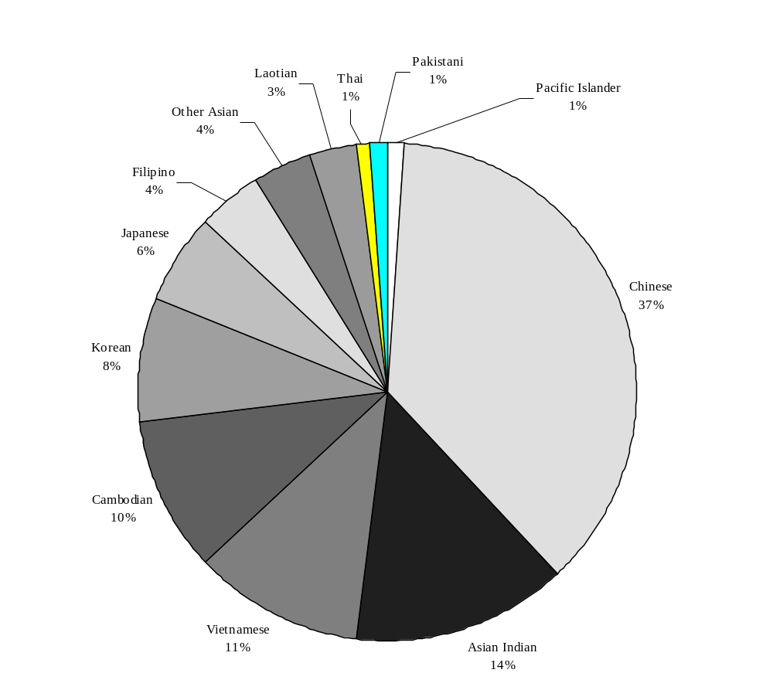

Source: U.S. Bureau of the Census (See Appendix Table A1.1 for additional data.)

How has the Asian and Pacific Islander population changed over the past century?

It is difficult to track long-term trends in the growth of the Asian and Pacific Islander population in Massachusetts because of limitations in the collection and reporting of race and ethnicity data in the U.S. Census. While many of the race and ethnicity categories changed from decade to decade, data for Chinese and Japanese were collected consistently throughout the last century, enabling examination of longer-term trends for these particular groups.

In 1890, there were 984 Chinese and 18 Japanese residing in the Commonwealth and by 1950, there were 3,627 Chinese and 384 Japanese. The second half of the twentieth century brought exponential growth in the Chinese population; by the 1990 U.S. Census, there were 53,792 Chinese living in Massachusetts. The Japanese population also experienced a large population increase during this time period; by 1990, there were 8,784 Japanese residents of Massachusetts (Figure 1.2). By comparison, the total Massachusetts population in 1890 was 2,238,943 and rose steadily to 4,690,514 in 1950 and to 6,016,425 in 1990.

Figure 1.2 Trends in the Chinese and Japanese Population

Massachusetts: 1890-1990
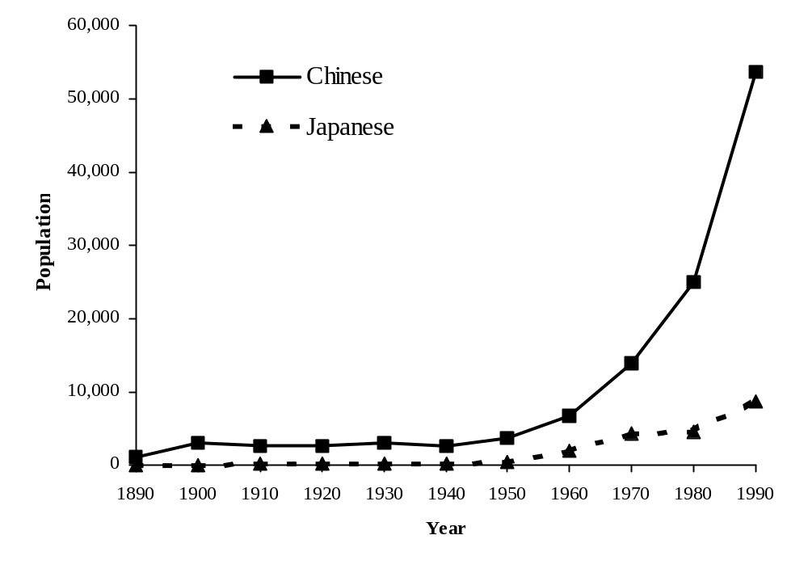

Source: U.S. Bureau of the Census

In addition to the increases in the Chinese and Japanese populations in Massachusetts over the last century, another indication of growth in the Asian and Pacific Islander population is the change in the number of ethnic categories that have appeared on the U.S. Census. In 1900, Chinese and Japanese were the only two Asian ethnic categories that were collected and reported in the U.S. Census. By the 1990 U.S. Census, there were 9 specified Asian and Pacific Islander ethnic groups as well as an open-ended option allowing for additional self-identification. Consequently, data were reported for 13 Asian and Pacific Islander ethnic groups in tabulations of the 1990 U.S. Census.

What was the level of growth in the Asian population between 1980 and 1990?

From 1980 to 1990, the total Asian population grew from approximately 52,615 to 143,392. The Chinese population more than doubled (from 25,015 in 1980 to 53,792 in 1990), and the Vietnamese population tripled (from 3,172 to 15,449) (Figure 1.3).
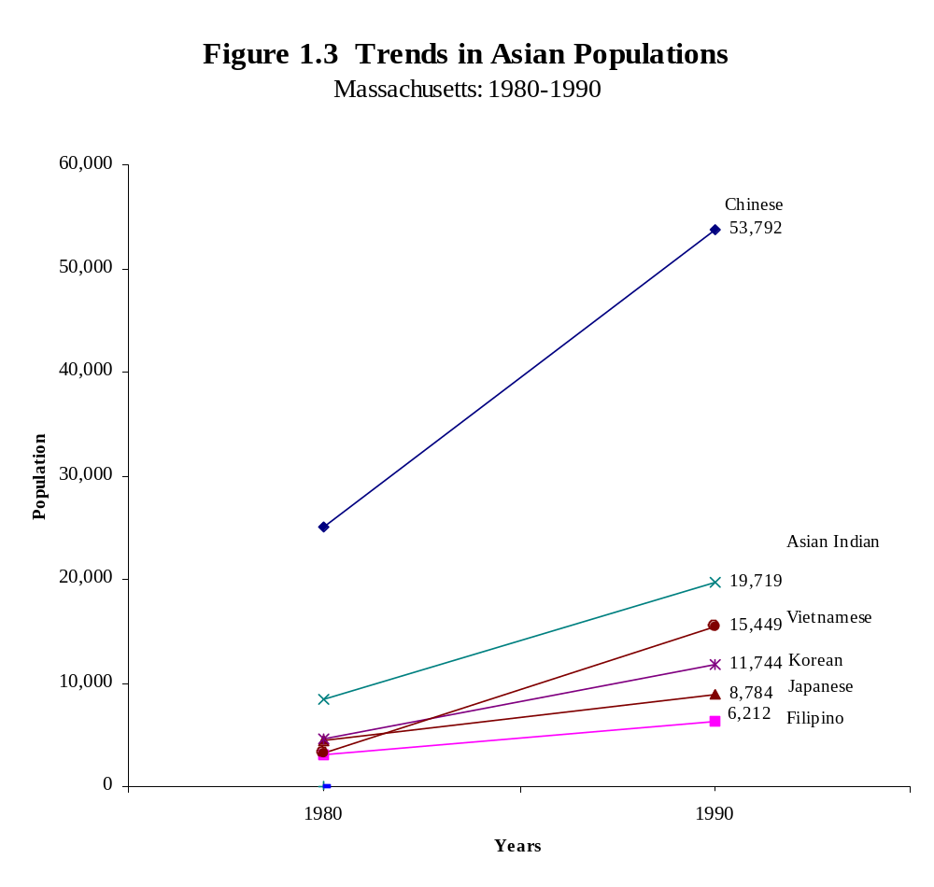

Source: U.S. Bureau of the Census (See Appendix Table A1.3 for additional data.)
How does the growth since 1980 in the Asian and Pacific Islander population compare with that of other population groups in Massachusetts?

The Asian and Pacific Islander population is the fastest growing population group in Massachusetts. From 1980 to 1990, overall population growth in Massachusetts was 5%, but the Asian and Pacific Islander community grew 171%. In comparison, the Hispanic population grew 104% during the 1980’s, and the Black non-Hispanic population grew 28%. The White non-Hispanic population held steady. Although population growth slowed for all racial groups from 1990-1998, the largest increases were still observed among Asian and Pacific Islanders with a 26% growth rate as compared to 23% among Hispanics, 4% among White non-Hispanics, 2% among Black non-Hispanics and 5% for the population as a whole (Figure 1.4).

Figure 1.4 Percentage Population Change by Race and

Hispanic Ethnicity

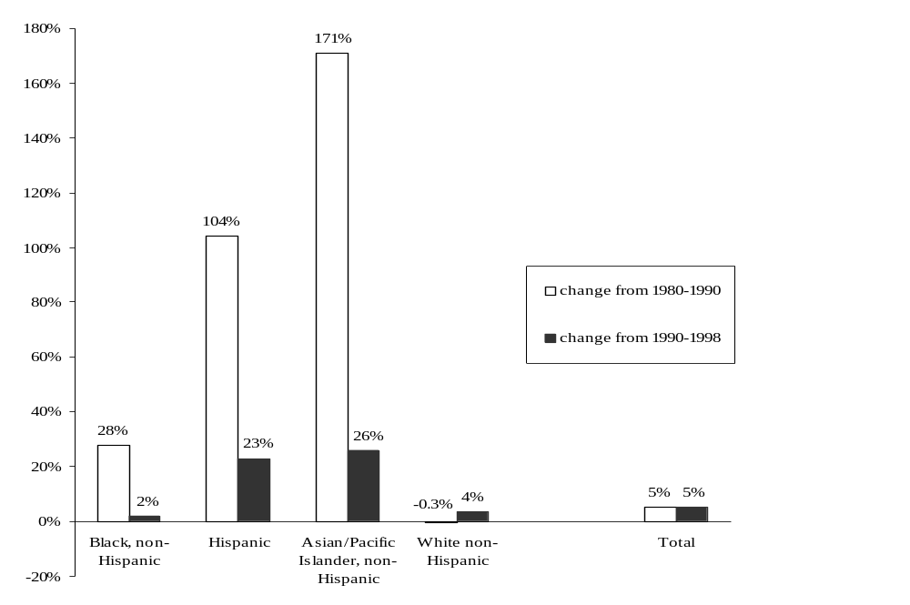Massachusetts 1980-1990 and 1990-1998

Source: U.S. Bureau of the Census for 1980 and 1990 data, and Massachusetts Institute for Social and Economic Research (MISER)/MDPH Bureau of Health Statistics Research & Evaluation for 1998 data (See Glossary in the Appendix for a description of MISER).

Where do Asian and Pacific Islanders primarily reside?

Boston had the largest Asian and Pacific Islander population in Massachusetts in 1990, followed by Lowell, Cambridge, Quincy, and Worcester. In 1990, there were twelve communities in Massachusetts with 2,000 or more Asian and Pacific Islander residents (Table A1.1). Among these communities, Lowell had the highest percentage of Asian and Pacific Islanders: one out of nine residents of Lowell was Asian and Pacific Islander. Six Massachusetts communities had Asian and Pacific Islander populations totaling 5% to 10% of their populations: Cambridge, 8.4%; Brookline, 8.4%; Amherst, 7.9%; Quincy, 6.6%; Boston, 5.3%; and Malden, 5.2%. Also, Revere, Chelsea and Fitchburg had rapidly growing Asian populations, as evidenced by the number of Asian births in these communities. (See Chapter 2 for more detail about births in those communities.)

As reported in Table A1.1, the distribution of Asian and Pacific Islander ethnic groups varied enormously from community to community in Massachusetts in 1990. In Quincy and Boston, a majority of the Asian and Pacific Islander population was Chinese (75% and 55 %, respectively). In Lowell, 56% of the Asian and Pacific Islander population was Cambodian, and 14% was Laotian. In Worcester, 50% of the Asian and Pacific Islander population was Vietnamese.

From 1990 to 1998 (the most current year population estimate), the growth of the Massachusetts Asian and Pacific Islander population varied substantially from community to community (Table A1.2). In some communities, the overall population growth was low or even declined during this time period (data not shown), while the Asian and Pacific Islander population experienced dramatic increases. For example, in Lynn, the overall population increased by only 3% while the total Asian and Pacific Islander population grew by 44%. Similarly, Amherst had an overall population increase of 16% between 1990 and 1998, whereas the total Asian and Pacific Islander population grew by 48%.

Table A1.3 presents data for the State and for communities that experienced large population increases for selected Asian ethnic groups between 1980 and 1990. Quincy and Malden showed the largest increases in the Chinese population, increasing by 1,257% and 1,167%, respectively. The largest increases in the Vietnamese population were in Lynn, Randolph, Malden, and Framingham.

What was the age distribution of the Asian and Pacific Islander population in Massachusetts in 1990?

In 1990, the Asian and Pacific Islander population in Massachusetts was slightly younger than the total state population. Sixty-eight percent of the Asian and Pacific Islander population was younger than age 35, compared with fifty-two percent of the state population as a whole (Table A1.4).

The youngest Asian ethnic group in 1990 was Cambodians, with 53% under age 20, followed by Laotians, with 47% under age 20. Slightly less than 27% of the Chinese population was less than 20 years old, which was similar to the statewide proportion of 26%.

How does the education level of the Asian and Pacific Islander population in Massachusetts in 1980 and 1990 compare with that of the state as a whole?

Patterns of educational attainment differ for Asian and Pacific Islanders compared with the Massachusetts population overall. In Massachusetts in 1980, the percentage of the Asian and Pacific Islander population 25 years and older that had not graduated from high school was similar to the statewide percentage; however, over 40% of all Asian and Pacific Islanders attended at least four years of college, compared with only 20% of the state population. By 1990, the percentage of Asian and Pacific Islanders who had not graduated high school decreased slightly, though less than for the state as a whole. At the same time, a higher percentage (45%) of Asian and Pacific Islanders in Massachusetts attended at least four years of college, compared with only 27% of the state population (Figure 1.5).

Figure 1.5 Educational Attainment of Asian and Pacific Islanders,

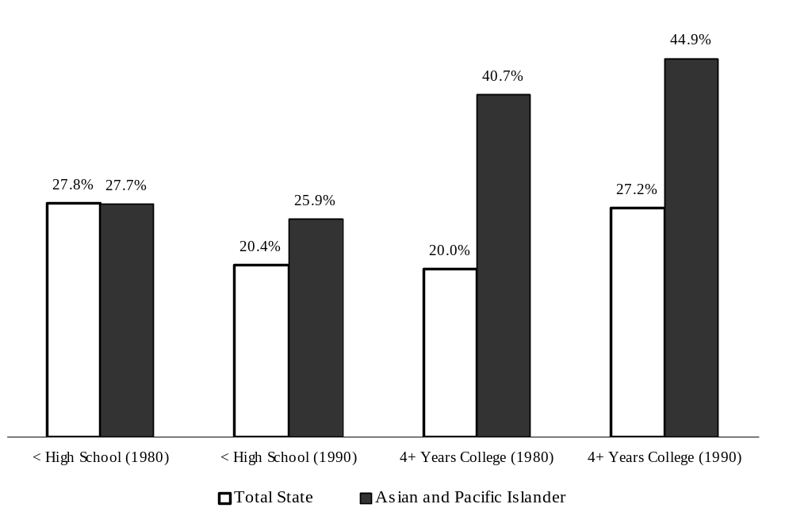Ages 25 Years and Above

Massachusetts: 1980 and 1990
Source: U.S. Bureau of the Census
How does the socioeconomic level of Asian and Pacific Islanders in Massachusetts compare with the statewide level?

Economic indicators comparing Asian and Pacific Islanders to the state as a whole for 1980 are mixed. On one hand, the average household income for Asian and Pacific Islanders was slightly higher than for Massachusetts residents overall. However, a much higher proportion of Asian and Pacific Islanders remained below the poverty level as compared with Massachusetts as a whole. This disparity increased from 1979 to 1989, with the percentage of persons living in poverty statewide decreasing by 7%, while the percentage of Asian and Pacific Islanders living in poverty increased by 21%. During the decade of the 1980s, the average annual household income for Asian and Pacific Islanders rose 111%, compared with an increase of 119% for the state as a whole. Due to this slightly lower growth rate for Asian and Pacific Islanders, by 1989, their average annual household income was slightly lower than for the state as a whole ($43,887 and $45,472, respectively) (Table A1.5).

Clearly, wide variation in economic status exists within the Asian population. According to the 1990 U.S. Census, the mean household income of the Asian population (not including Pacific Islanders) for the prior year (1989) was $43,950, while the same economic indicator for the state as a whole was slightly higher, at $45,472. The highest mean household income was observed among Asian Indians ($61,231), and the lowest was among Cambodians ($25,488) (Figure 1.6).

The Asian and Pacific Islander population continued in 1990 to have a higher percentage of persons with incomes below the poverty level (19.7%) when compared with the state overall (8.9%). Nearly half of the Cambodian population (46.4%) was living below the poverty level in 1989. However, a slightly lower percentage of Asian and Pacific Islanders were unemployed (6.4%) compared to the state population as a whole (6.7%) (Table A1.5).

Figure 1.6 Mean Household Income of Asians

Massachusetts: 1989

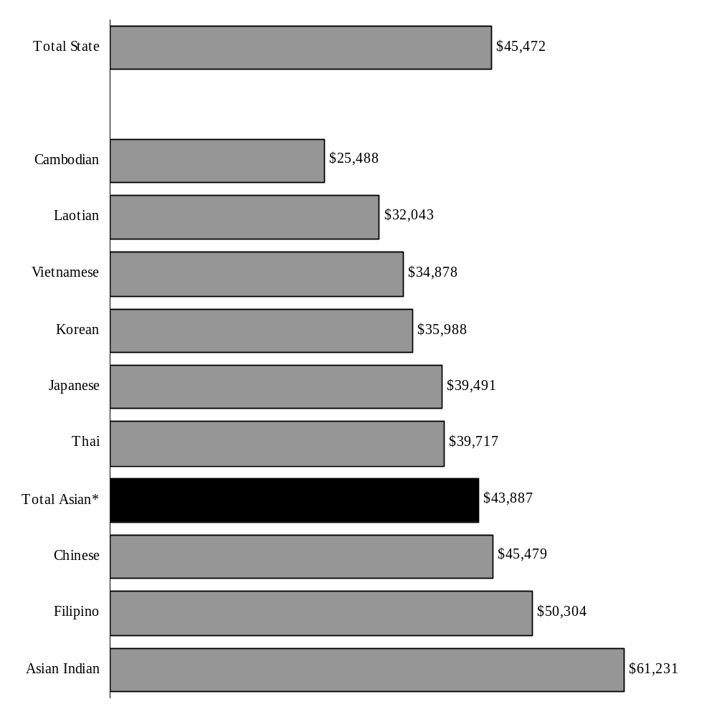

*This group does not include Pacific Islanders.

Source: U.S. Bureau of the Census (See Appendix Table A1.5 for additional data.)

Summary

In summary, the Asian and Pacific Islander population in Massachusetts has grown dramatically since 1950. In Massachusetts, there is a large and heterogeneous Asian and Pacific Islander population.

In 1990, 12 Massachusetts communities had an Asian and Pacific Islander population greater than 2,000 persons, accounting for almost 60% of all Asian and Pacific Islanders in the state. The Asian and Pacific Islander population was younger than the state as a whole. By 1998, 17 communities had Asian and Pacific Islander populations of at least 2,000.

The Asian and Pacific Islander population was also characterized by a dichotomous pattern in education and socioeconomic status. While the proportion of Asian and Pacific Islanders (ages 25 years and older) attending at least four years of college was much higher than the state as a whole, the proportion of Asian and Pacific Islanders with low educational attainment was above the state average as well.

Income and poverty data indicate enormous variation in the Asian community. Asian and Pacific Islanders in 1979 had a slightly higher average annual household income and a higher percentage of persons below the poverty level than were reported for the statewide population. By the time of the 1990 census, the average household income for Asian and Pacific Islanders had fallen slightly below the statewide level, and the proportion below poverty for Asian and Pacific Islanders had increased to more than twice the percentage for the state as a whole.

Chapter 2

Recent Trends in Asian Births
in Massachusetts: 1996-1997

What is the ethnic distribution of births among Asian women in Massachusetts?

In 1996 and 1997, the majority of Asian births occurred among women of Chinese, Vietnamese, Cambodian, and Asian Indian ancestry. The remaining Asian ethnic groups contributed from 1 to 6 percent of Asian births in Massachusetts during these two years.

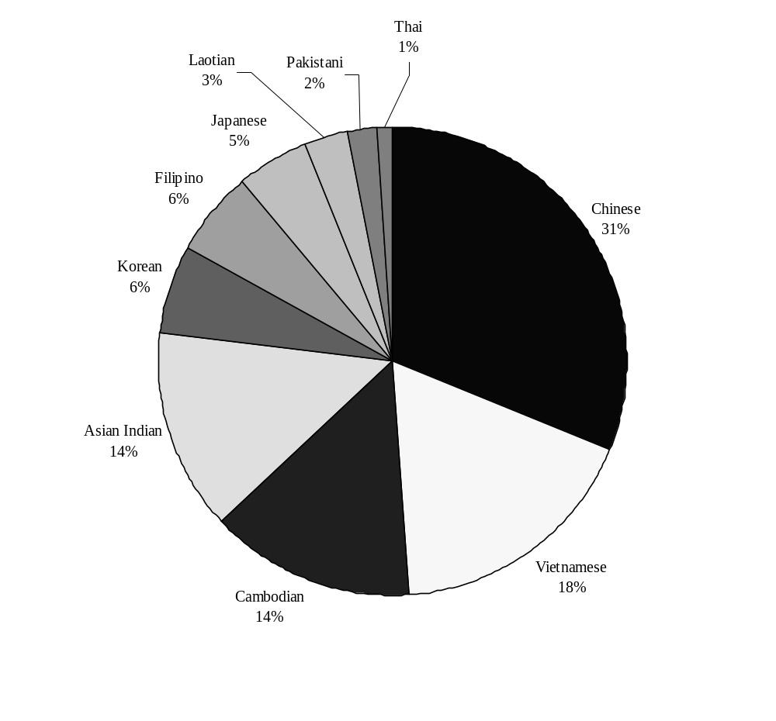

Figure 2.1 Percentage of Asian Births by Ethnicity

Massachusetts: 1996-1997

Source: Massachusetts Department of Public Health, Bureau of Health Statistics, Research and Evaluation (BHSR&E) (See Appendix Table A2.1.)

How many Asian births are there in Massachusetts?

From 1996 through 1997, there were 2,216 births among Massachusetts women of Chinese ancestry. These mothers were born in many different places: 1,156 in the People's Republic of China, 252 in Hong Kong, 250 in the U.S., 225 in Taiwan, 132 in Vietnam, and 119 in other places throughout the world.

Among Southeast Asians, there were 1,238 births to Vietnamese women, 970 births to Cambodian women, 219 to Laotian women and 82 to Thai women.

Among other Asian ethnic groups there were 954 births to Asian Indian women, 414 to Korean women, 402 to Filipino women, 314 to Japanese women, and 151 to Pakistani women (Figure 2.2).

Figure 2.2 Number of Asian Births by Ethnicity and

Mother's Place of Birth

Massachusetts: 1996-97

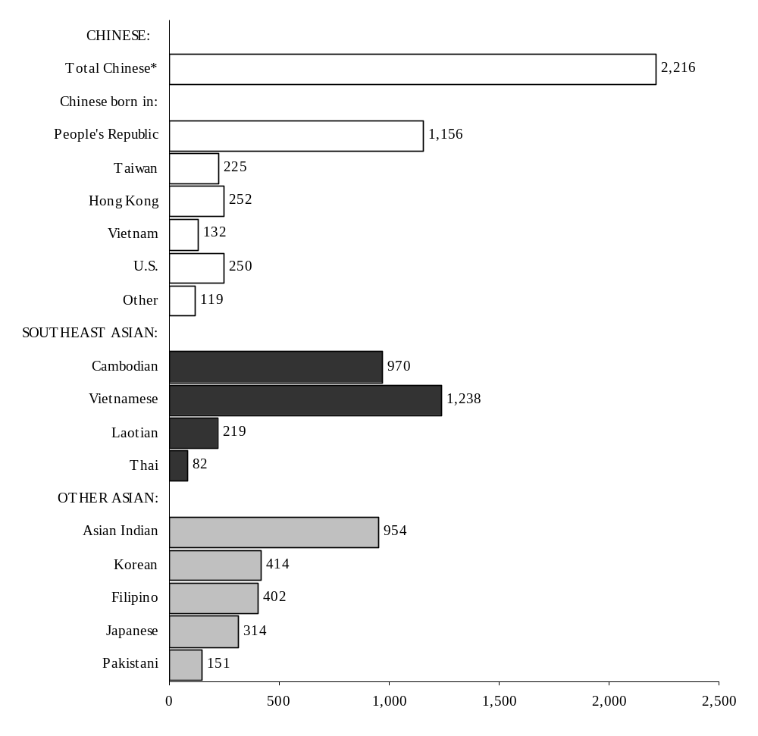

Source: Massachusetts Department of Public Health, BHSR&E (See Appendix Table A2.1.)

*Total includes 82 mothers of Chinese ancestry whose place of birth is unknown.

In Massachusetts, where do Asian mothers live?

Almost six out of every ten Asian births in Massachusetts during 1996 and 1997 were concentrated among residents of 13 cities and towns. Among Chinese residents of these 13 Massachusetts cities and towns, the majority of women who gave birth in 1996 and 1997 resided in Boston (455); this was followed by Quincy (221), Malden (143), Newton (97) and Cambridge (96). Cambodian mothers lived mainly in Lowell (483), Lynn (155), and Boston (24). Vietnamese mothers lived in Boston (393) and Worcester (198), with smaller populations in Springfield (68), Quincy (60), Malden (49), Lowell (47), and Lynn (37). Laotian mothers lived in Lowell (73), Lynn (16), and Springfield (16). Asian Indian mothers lived in Lowell (79), Boston (61), Waltham (51) and Framingham (47), with more than half of Asian Indian mothers (519) residing in other cities and towns in Massachusetts. The largest concentration of Japanese mothers was in Boston (61), and Brookline (38), while Korean mothers were most often residents of Boston (40) and Cambridge (46). Filipino mothers most often lived in Boston (40) and Quincy (23), while the largest concentration of Pakistani mothers lived in Boston (18). The distribution of Chinese, Southeast Asian, and other Asian births by mother’s place of residence is shown for selected communities in Figure 2.3.

Figure 2.3 Number of Chinese, Southeast Asian and
Other Asian Births by Maternal Residence, in Selected Communities*
Massachusetts: 1996-97

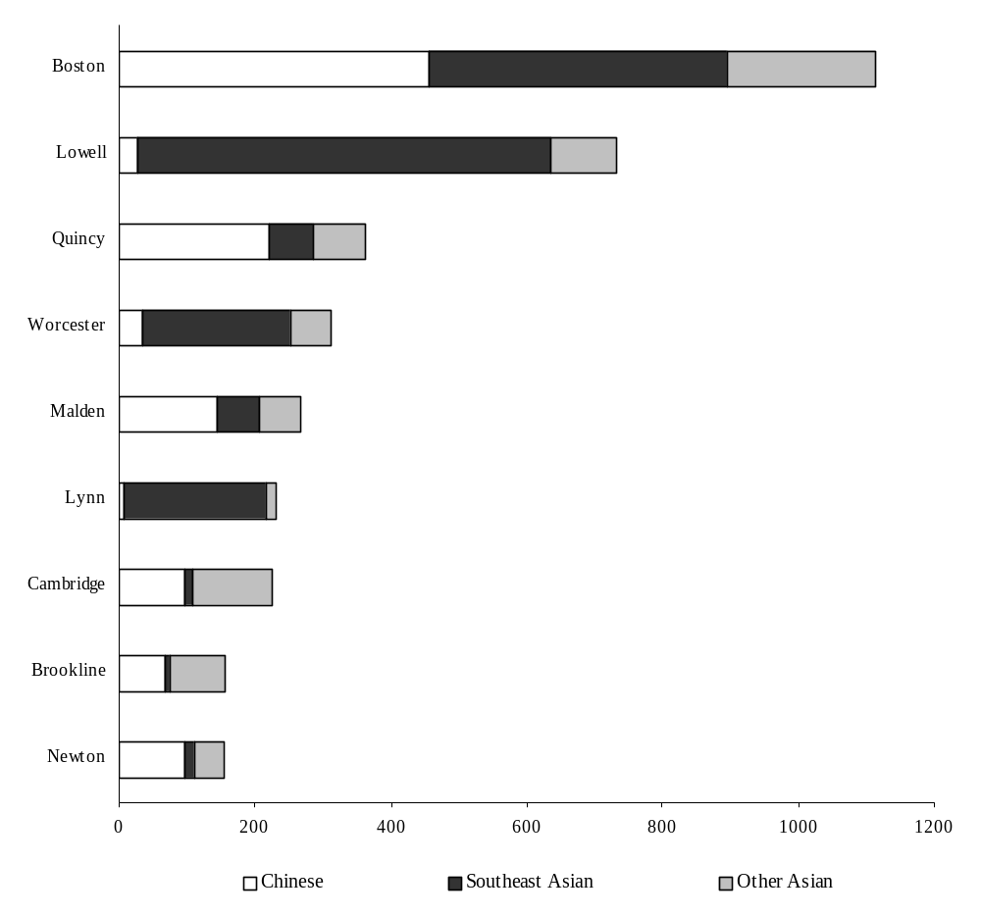

Source: Massachusetts Department of Public Health, BHSR&E (See Appendix Table A2.1.)

* Cities and towns with 150 or more Asian births from 1996-1997.

Note: Southeast Asian = Cambodian, Vietnamese, Laotian, Thai.
Other Asian = Asian Indian, Korean, Filipino, Japanese, Pakistani.

Comparing 1987-1990 with 1996-1997, what were the trends in the number of births among Asian women in Massachusetts?

Data are available to compare changes in the number of recorded births between two time periods (1987-1990 and 1996-1997) for the Chinese, Vietnamese, Cambodians and Laotians. From the earlier time period to the later time period, the average annual number of births among Chinese women increased 21%, from 914 to 1,108. The average annual number of births among Vietnamese women rose 39% between the two time periods, while births among Cambodian and Laotian women declined by 22% and 21%, respectively.

In which hospitals do Asian mothers deliver their infants?

From 1996 through 1997, Beth Israel Deaconess Medical Center had the highest number of births for Chinese women (628). Other hospitals with large numbers of Chinese births were Brigham and Women's Hospital (373), Newton-Wellesley Hospital (161), and New England Medical Center (104).

Among Southeast Asian women, the largest number of Cambodian women delivered their infants at Lowell General Hospital (427). Three hospitals recorded at least 90 deliveries by Vietnamese mothers: New England Medical Center (178), Saint Vincent Hospital (115), and Beth Israel Deaconess Hospital (94). The largest numbers of Laotian infants were delivered at Lowell General Hospital (57) and Leominster Hospital (48). Among other Asian ethnic groups, the largest numbers of Asian Indian births were recorded at Brigham and Women’s Hospital (112) and Lowell General Hospital (103). The largest numbers of Korean (100), Filipino (51), and Japanese (92) women also delivered at Brigham and Women’s Hospital from 1996-1997 (Figure 2.4).

Figure 2.4 Number of Chinese, Southeast Asian and

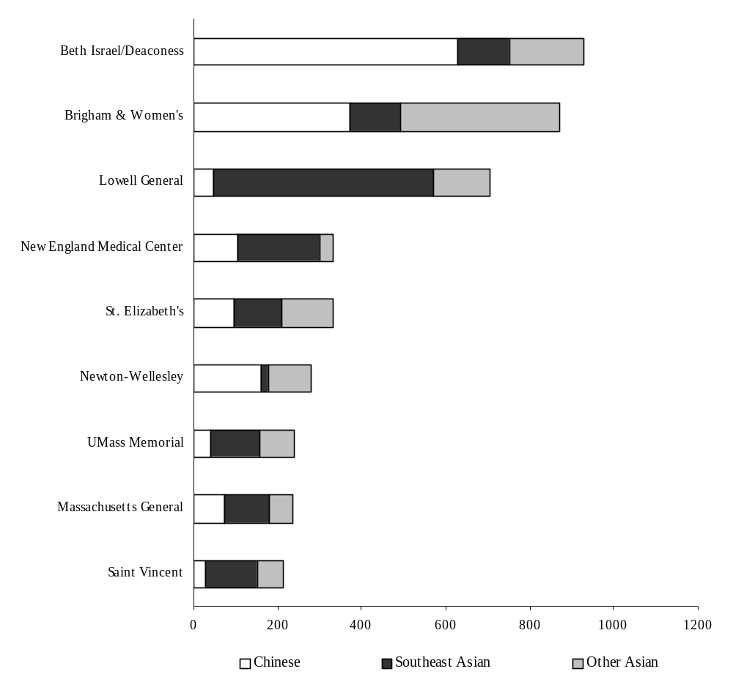Other Asian Births at Selected Hospitals*

Massachusetts: 1996-97

Source: Massachusetts Department of Public Health, BHSR&E (See Appendix Table A2.2.)

* Hospitals with 200 or more Asian births from 1996-1997.

Note: Southeast Asian = Cambodian, Vietnamese, Laotian, Thai.
Other Asian = Asian Indian, Korean, Filipino, Japanese, Pakistani.

Chapter 3

Demographic Characteristics of Asian Mothers:

1996-1997

How old are Asian mothers?

During 1996 and 1997, Chinese and Japanese mothers were more likely to give birth at age 35 years or older than either White non-Hispanic mothers or other Asian women. Over 25% of Chinese women and 27% of Japanese women who gave birth in Massachusetts in 1996-97 were age 35 years or older, compared to 21% of White non-Hispanic mothers. Among other Asian women the percent of births to women age 35 and older ranged from a low of 8% among Laotian women to a high of 24% among Filipino women.

Among Chinese mothers, the age distribution by country of mother's birth showed some variation. Chinese mothers born in Vietnam and in the People’s Republic tended to be younger than Chinese mothers born in Taiwan, Hong Kong, the United States, and other countries.

Southeast Asian mothers were younger than White non-Hispanic mothers and Chinese mothers, regardless of where the Chinese mothers were born. Over 16% of Cambodian mothers, 15% of Laotian mothers, and 7% of Vietnamese mothers were under 20 years of age, compared to 5% of White non-Hispanic mothers and 1 % of Chinese mothers. The percentage of mothers under age 20 among other Asian ancestry groups ranged from 1% for Asian Indians to approximately 5% among Filipinos (Figure 3.1).

Figure 3.1 Age Distribution of Asian and White
Non-Hispanic Mothers by Ethnicity
Massachusetts: 1996-97
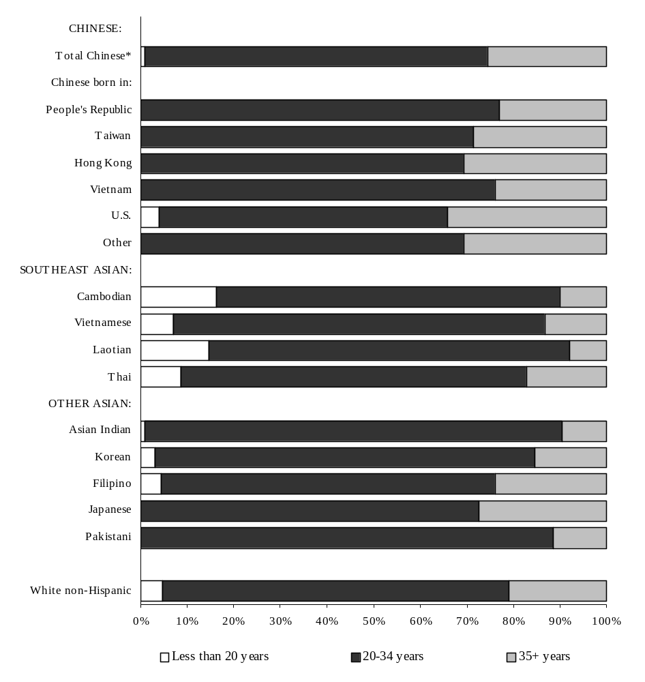

Source: Massachusetts Department of Public Health, BHSR&E (See Appendix Tables A3.1 & A3.3.)

*Total includes 82 mothers of Chinese ancestry whose place of birth is unknown.

Note: White Non-Hispanic group excludes women of Asian ancestry.

Are there differences in educational attainment among Asian mothers?

The large gap in educational attainment noted between Chinese mothers and Southeast Asian mothers in the 1987-1990 time period appears to have narrowed during the later time period. During the years 1996-1997, 86% of Chinese mothers had at least a high school education, compared to 62% for all Southeast Asian mothers combined (Cambodian, Vietnamese, Laotian, and Thai). These figures represent significant increases from 1987-1990, when the respective percentages were 69% for Chinese mothers and 19% for Southeast Asian mothers. Educational attainment was uniformly high among Asian Indians, Koreans, Filipinos, and Japanese, with 97% to 99% of these mothers reporting at least a high school education. Approximately 96% of White non-Hispanic mothers reported having at least a high school education (Figure 3.2).

A higher percentage of Southeast Asian mothers had less than a high school education (range: 11% to 39 %) compared with 14% of Chinese mothers and 4 % of White non-Hispanic mothers. Chinese mothers born in Taiwan and the U.S. had the lowest percentages of having less than a high school education (2% and 0%, respectively), while Chinese women born in the People’s Republic and Vietnam had the highest percentages (20% and 40%, respectively).

Attainment of higher education (at least a college degree) varied between groups. At least 60% of Asian Indian (72%), Korean (62%), and Japanese mothers (60%) had at least a college degree, compared to 53% of Chinese mothers and 41% of White non-Hispanic mothers. Southeast Asian mothers had the lowest percentages of attaining a college degree or higher (range: 4% to 11%), except for Thai mothers (43%). Chinese mothers born in Taiwan and the U.S. had the highest percentages of attaining at least a college degree (81% and 76%, respectively).

Figure 3.2 Percent Distribution of Educational Level Completed
Among Asian and White Non-Hispanic Mothers by
Ethnicity, Ages 20 Years and Above
Massachusetts: 1996-97

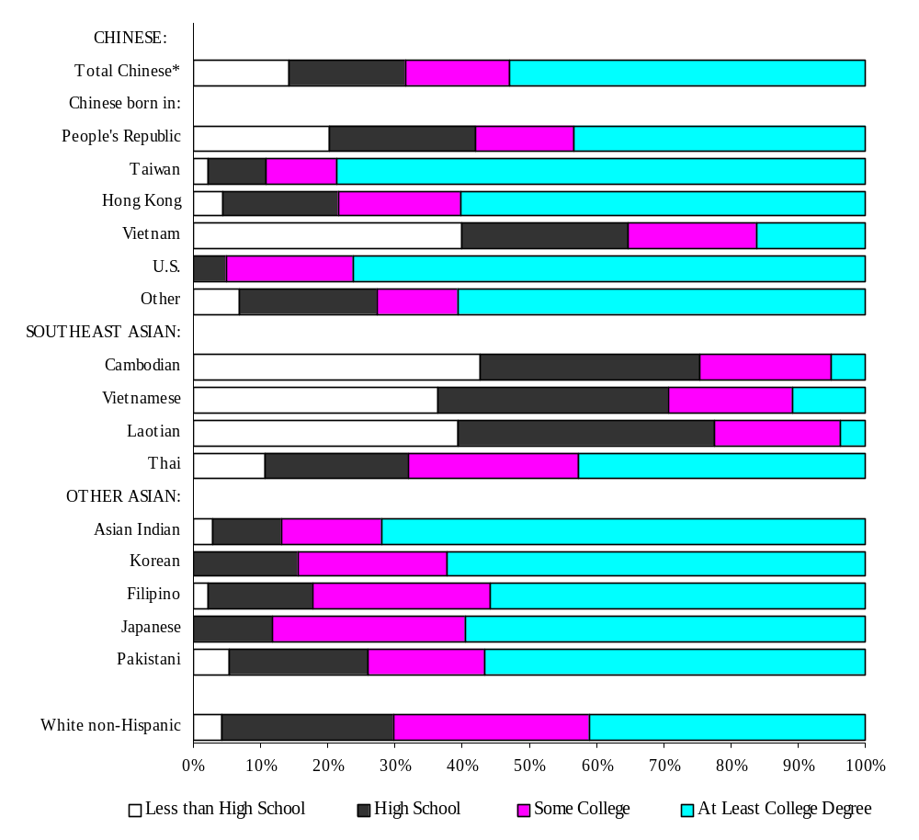

Source: Massachusetts Department of Public Health, BHSR&E (See Appendix Tables A3.1 & A3.3.)

*Total includes 82 mothers of Chinese ancestry whose place of birth is unknown.

Note: White Non-Hispanic group excludes women of Asian ancestry.
What proportion of Asian mothers are not married? How does the marital status distribution among Asian women compare with data for White non-Hispanic mothers?

A low proportion of Chinese (4%), Pakistani (4%), and Asian Indian (2%) mothers were unmarried in 1996 and 1997 when they delivered their infants, in contrast with 55% of Cambodian mothers, 36% of Vietnamese mothers, 35% of Laotian mothers, and 21% of Thai mothers during the same time period. The percentages of Filipino, Korean, and Japanese mothers who were unmarried were 12%, 10%, and 7%, respectively. About 18% of White non-Hispanic mothers were not married at the time of delivery. Some differences in reporting of marital status may be attributed to different cultural interpretations of the question.

What proportion of Asian mothers prefer to communicate in their native language instead of English1? How do data on Asian women compare with data for White non-Hispanic mothers?

Among Massachusetts residents of Chinese ancestry in 1996-97, more than 60% of those born in the People's Republic or in Vietnam preferred to converse in their native language rather than English. For Chinese women born in Taiwan or Hong Kong the percentage dropped to approximately 35%, while only 2% of U.S.-born Chinese women preferred Chinese. Among Southeast Asians the percentages preferring their native languages were 63% for Cambodian mothers, 58% for Vietnamese, and 56% for Laotians. Only 31% of Thai women preferred to communicate in their native language. For other Asian ancestry groups, the percentage of women preferring their native language ranged from a low of 7% among Filipino women to a high of 41% among Japanese women. The percentage of White non-Hispanic women who preferred to communicate in a language other than English was 2% (Figure 3.3).

What proportion of Asian mothers are non-U.S.-born? How do data on Asian women compare with data for White non-Hispanic mothers?

In 1996 and 1997, the vast majority of Chinese, Southeast Asians, and other Asian mothers were born outside of the United States. The percentage of non-U.S.-born women ranged from a low of 81% for Japanese women to a high of 99% for Vietnamese women. The percentage of White non-Hispanic women who were born outside the United States was 7% (Figure 3.4).

__________________________________________

1. Information on the mother’s language preference is collected from the mother at the time of birth, based on the birth certificate question, “In what language does the mother prefer to read or discuss health-related materials?”

Figure 3.3 Percentage Preferring a Language* Other than English

Among Asian and White Non-Hispanic

Mothers by Ethnicity

Massachusetts: 1996-97

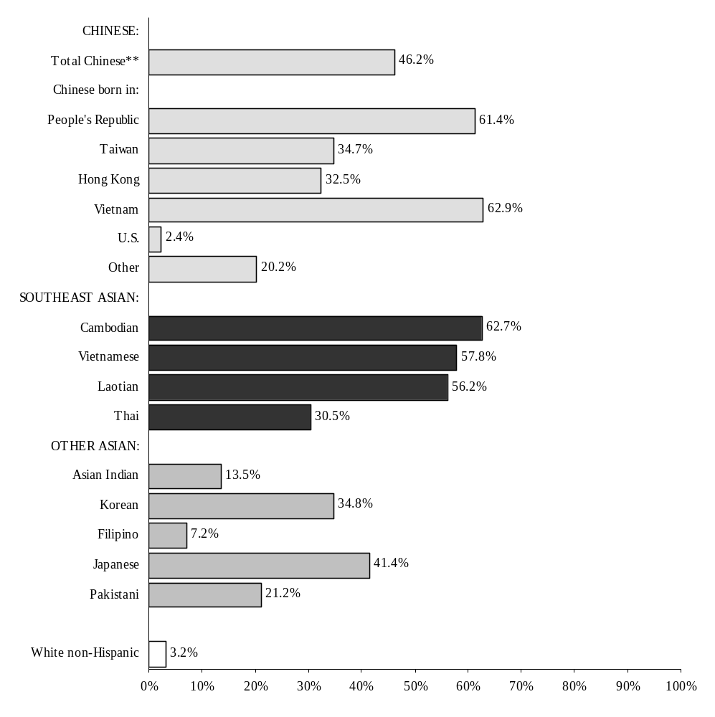

Source: Massachusetts Department of Public Health, BHSR&E (See Appendix Tables A3.1 & A3.3.)

* Information on the mother’s language preference is collected from the mother at the time of birth, based
on the birth certificate question, “In what language does the mother prefer to read or discuss
health-related materials?”
** Total includes 82 mothers of Chinese ancestry whose place of birth is unknown.

Note: White Non-Hispanic group excludes women of Asian ancestry.
Figure 3.4 Percentage of Non-U.S.-Born*
Asian and White Non-Hispanic Mothers
by Ethnicity
Massachusetts: 1996-97

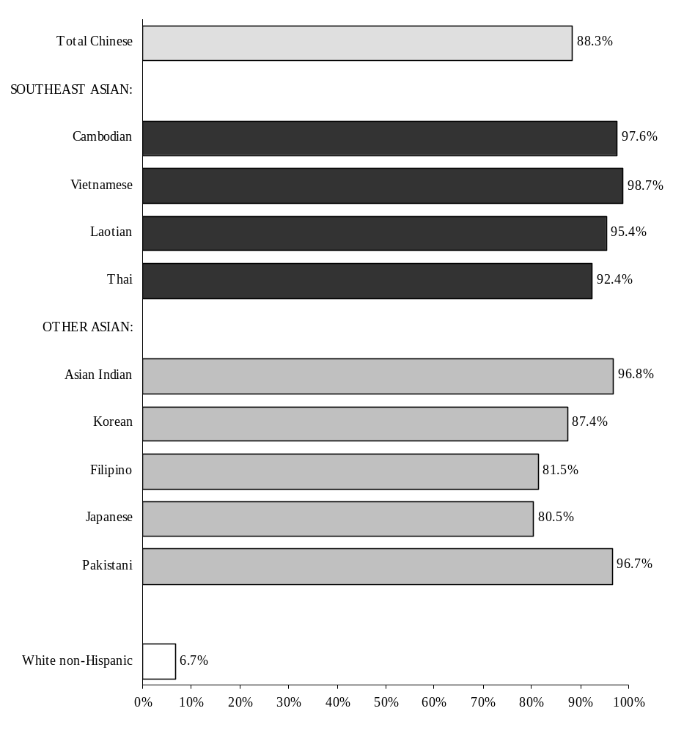

Source: Massachusetts Department of Public Health, BHSR&E (See Appendix Tables A3.1 & A3.3.)

* Not born in the United States, its possessions or protectorates. (See glossary for full definition.)

Note: White Non-Hispanic group excludes women of Asian ancestry.

Chapter 4

Medical and Other Risk Characteristics
of Asian Mothers: 1996-1997

Do Asian mothers differ in the total number of live births they have ever had?

During 1996 and 1997, Chinese women giving birth were generally older than other Asian women, and slightly more than half (52%) of these women were having their first child. This did not greatly vary by place of birth. The proportions of first live births among Southeast Asian women were lower, with the exception of Thai mothers, who had the highest percentage of first births (62%). For other Asian ancestry groups, percentages were variable. Asian Indian, Korean, and Japanese mothers had higher percentages (approximately 60%) while those for Filipino and Pakistani mothers were lower (49%, 41%). The percentage was also lower among White non-Hispanic mothers (45%).

From one-third to one-half of the mothers gave birth to their second child, with the highest percentages among Pakistani and White non-Hispanic mothers (52% and 49%, respectively). The proportion of women reporting four or more live births was more variable, with Cambodian and Laotian mothers having the highest percentages (20% and 19%, respectively). In contrast, these percentages ranged from 2-8% for all other Asian groups and White non-Hispanic mothers (Figure 4.1).

Figure 4.1 Percent Distribution of Total Number of Live Births

to Asian Mothers by Ethnicity and Place of Birth

Massachusetts: 1996-97

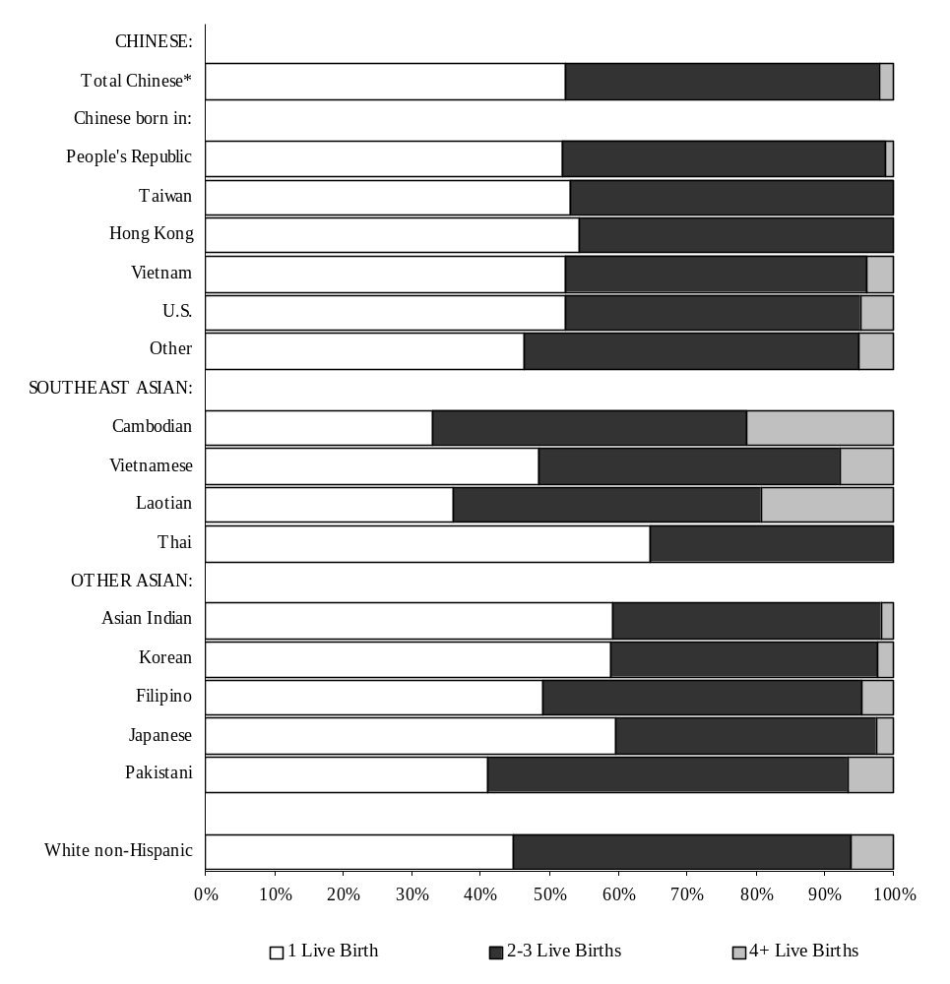

Source: Massachusetts Department of Public Health, BHSR&E (See Appendix Tables A4.1 & A4.3.)

* Total includes 82 mothers of Chinese ancestry whose place of birth is unknown.
What proportion of Asian mothers smoked cigarettes prior to and during pregnancy?

In 1996 and 1997, Asian mothers were far less likely to smoke both prior to and during pregnancy than White non-Hispanic mothers (Figure 4.2). Among Chinese mothers, only 2% reported smoking prior to pregnancy, dropping to 1% during pregnancy. Among other Asian mothers, percentages were highest among Korean, Filipino, and Japanese mothers (approximately 9% prior to pregnancy and dropping to 4% or less during pregnancy). A much higher percentage of White non-Hispanic mothers smoked: 22% prior to pregnancy, dropping to 14% during pregnancy. Among the Chinese mothers, the U.S.-born had the highest percentage of smokers.

Figure 4.2 Percentage of Asian and White Non-Hispanic Mothers Who Smoked During Pregnancy

Massachusetts: 1996-97

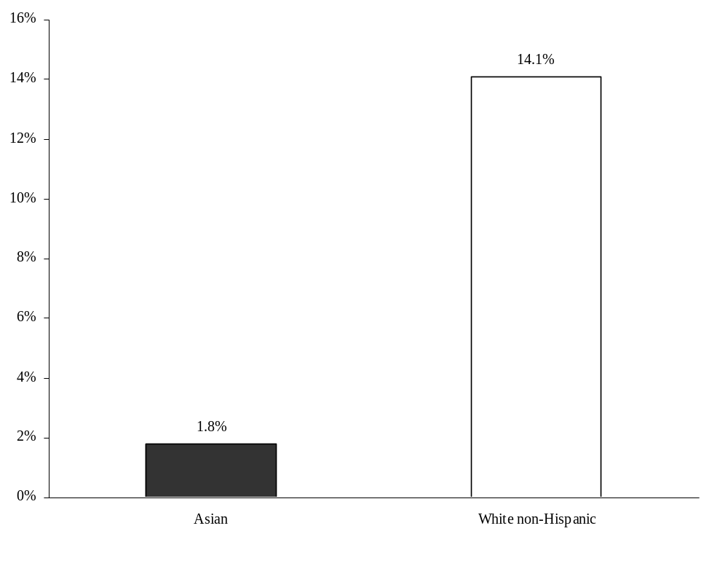
Source: Massachusetts Department of Public Health, BHSR&E (See Appendix Tables A4.1 & A4.3.)

Which medical conditions are most commonly reported for Asian mothers?

Overall, the prevalence of medical risk factors was similar between Asian and White non-Hispanic mothers in 1996 and 1997. However, anemia, diabetes, and hepatitis B carrier were mentioned more frequently on the birth certificates of infants born to Asian mothers than on the birth certificates of infants born to White non-Hispanic mothers.

Only 0.1% of White non-Hispanic mothers were hepatitis B carriers, compared to approximately 4% of Chinese mothers. Percentages among Southeast Asian mothers were comparable to those for Chinese mothers (except for Thai mothers, none of whom were hepatitis B carriers), ranging from 4% for Vietnamese mothers to 6% for Laotian mothers. The highest percentage of hepatitis B was among Chinese mothers born in the People's Republic of China (6%) (Figure 4.3).

Almost 6% of Chinese mothers, as compared to 3% of White non-Hispanic mothers, had diabetes reported (including both gestational and other diabetes). Among Chinese mothers, the proportion reported to have diabetes was particularly high among those born in Taiwan (10%) and Hong Kong (8%). Percentages among Southeast Asian mothers were lower, ranging from 0% (Thai) to 4% (Laotian). Among the other Asian ancestry groups, percentages were highest for Asian Indian and Pakistani mothers (approximately 8.5%) (Figure 4.4).

Figure 4.3 Percentage of Asian Mothers who were Hepatitis B Carriers by Ethnicity and Place of Birth Massachusetts: 1996-97

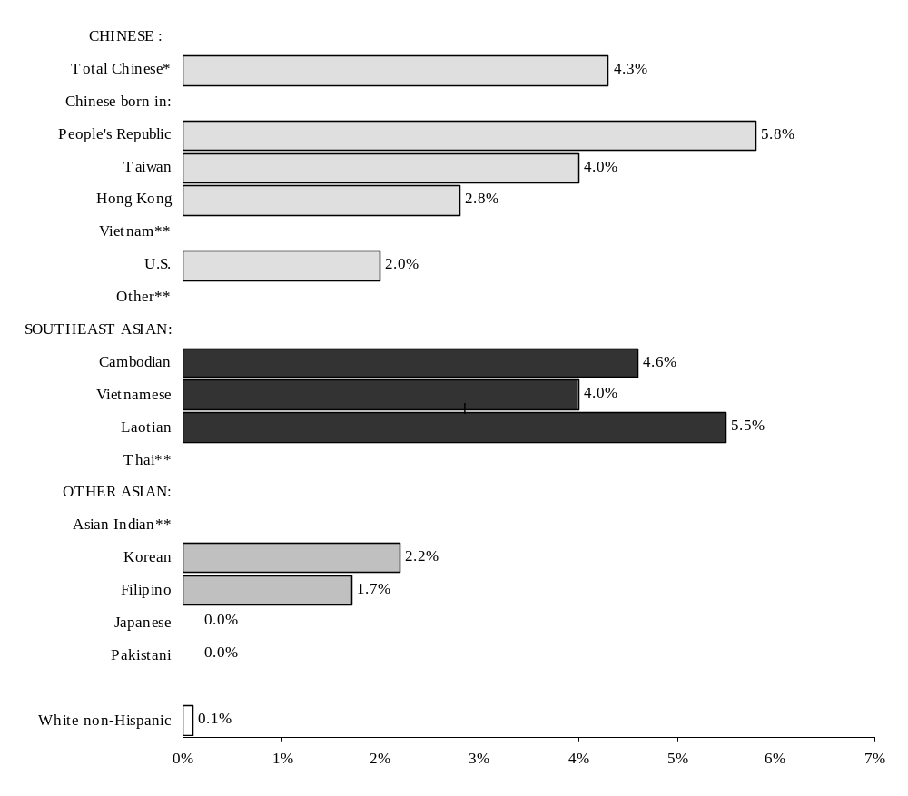

Source: Massachusetts Department of Public Health, BHSR&E (See Appendix Tables A4.1 & A4.3.)

*Total includes 82 mothers of Chinese ancestry whose place of birth is unknown.
** Percentages for Asian Indian, Thai, and Chinese mothers born in Vietnam and “Other” are based on fewer than five events and therefore excluded.

Figure 4.4 Percentage of Asian Mothers with Diabetes** by
Ethnicity and Place of Birth
Massachusetts: 1996-97

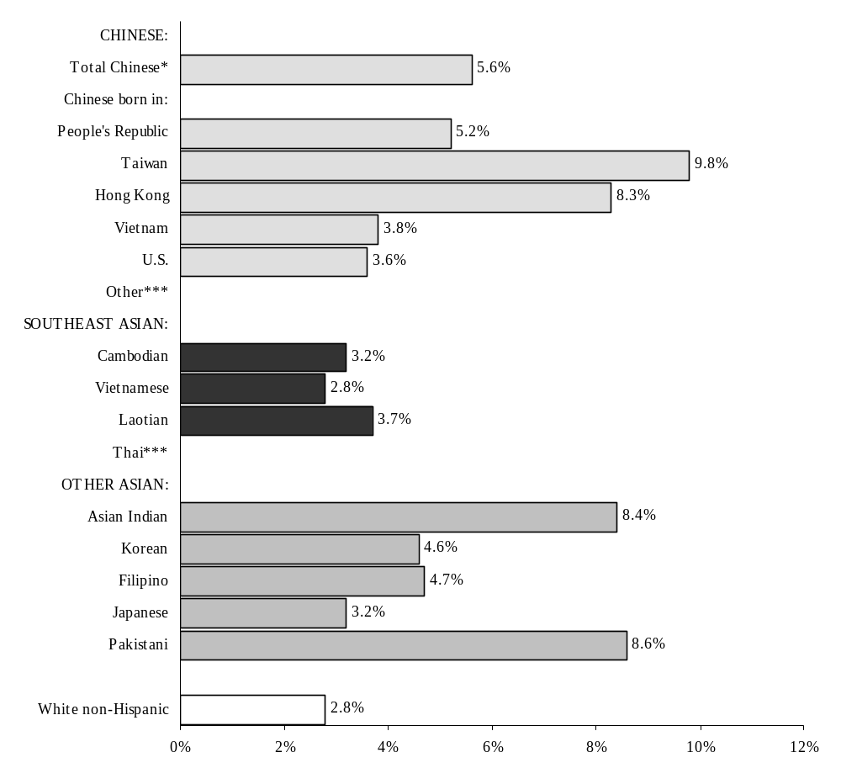Source: Massachusetts Department of Public Health, BHSR&E (See Appendix Tables A4.1 & A4.3.)

* Total includes 82 mothers of Chinese ancestry whose place of birth is unknown.
^{**Includes} both gestational and other diabetes.
*** Percentages for Thai and Chinese mothers born in “Other” are based on fewer than five events and therefore excluded.

What proportion of Asian mothers have Cesarean section deliveries? How does the proportion of Cesarean section deliveries vary among Asian women?

During 1996 and 1997, delivery by Cesarean section was reported less frequently among Chinese mothers (16%) than among White non-Hispanics (20%), with the exception of Hong Kong-born mothers (24%). Southeast Asian mothers typically had lower proportions of delivery by Cesarean section, with the lowest percentages among Cambodian and Laotian mothers (9% and 11%, respectively). However, there was a high percentage of delivery by Cesarean section among Thai women (21%). Among other Asian ancestry groups, the proportion of delivery by Cesarean section was comparable to that of White non-Hispanic mothers (20%) for Asian Indian mothers (21%) and Pakistani mothers (19%). Filipino mothers had a higher percentage of deliveries by Cesarean section (24%) than White non-Hispanic mothers, while Korean and Japanese mothers had lower percentages (17% and 13%, respectively).
Figure 4.5 Percentage of Asian Mothers with Infants Delivered by Cesarean Section** by Ethnicity and Place of Birth
Massachusetts: 1996-97

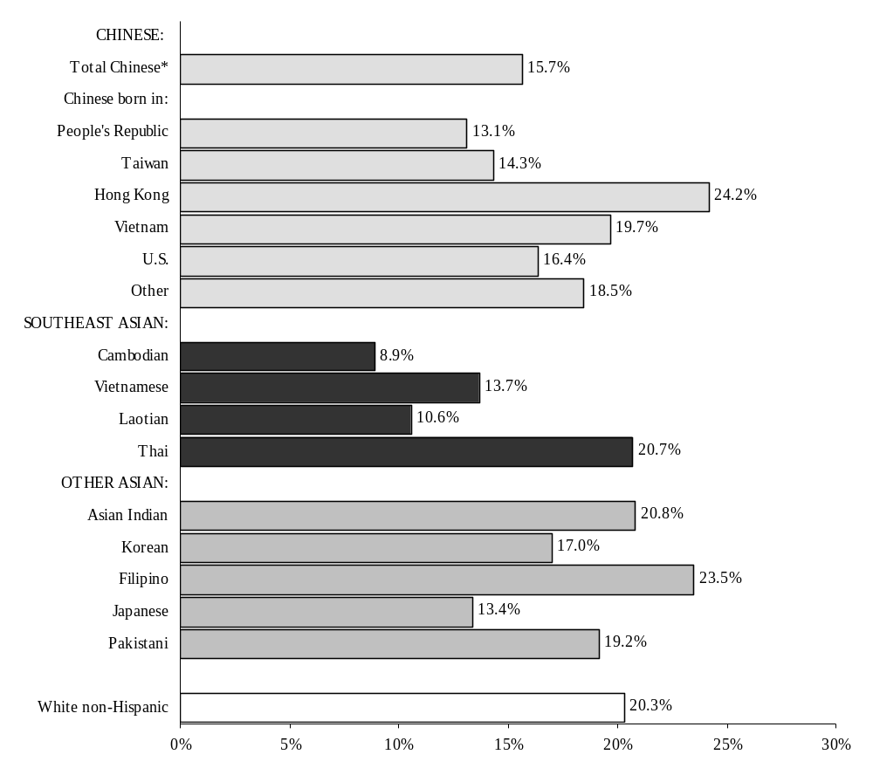

Source: Massachusetts Department of Public Health, BHSR&E (See Appendix Tables A4.1 & A4.3.)

* Total includes 82 mothers of Chinese ancestry whose place of birth is unknown.
** Includes both primary and repeat Cesarean sections. Excludes those with unknown mode of delivery.

Chapter 5

Prenatal Care Among Asian Mothers: 1996-1997

What proportion of Asian women receive adequate¹ prenatal care? How does the proportion of mothers receiving adequate prenatal care vary among Asian mothers?

During 1996 and 1997, similar proportions of Chinese women and White non-Hispanic women received adequate prenatal care: 79% and 83%, respectively. Among Chinese mothers, U.S.-born and Hong Kong-born women had the highest percentages of adequate prenatal care (86% and 83%, respectively), while the lowest percentage was among Chinese women born in Vietnam (72%).

Percentages were lower among Southeast Asian mothers (ranging from 45% to 67%). In this group, Vietnamese and Thai mothers had the highest percentages of adequate prenatal care (65% and 67%, respectively). Only 45% and 48% of Cambodian and Laotian mothers, respectively, received adequate prenatal care. Other Asian mothers received adequate prenatal care at comparable percentages to Chinese mothers, with the exception of Pakistani mothers who had a lower percentage (67%) (Figure 5.1).

¹Adequacy of prenatal care is a quantitative measure based on the timing and total number of prenatal visits; it is not a measure of the quality of care. Refer to the Glossary for a complete explanation.
Note: Changes reflected in the calculation of the Kessner Adequacy of Prenatal Care Index make the comparison of data for prenatal care presented in this report with data prior to 1996 inappropriate.

Figure 5.1 Percent Distribution of Adequate Prenatal Care**
Among Asian Mothers by Ethnicity and Place of Birth

Massachusetts: 1996-97

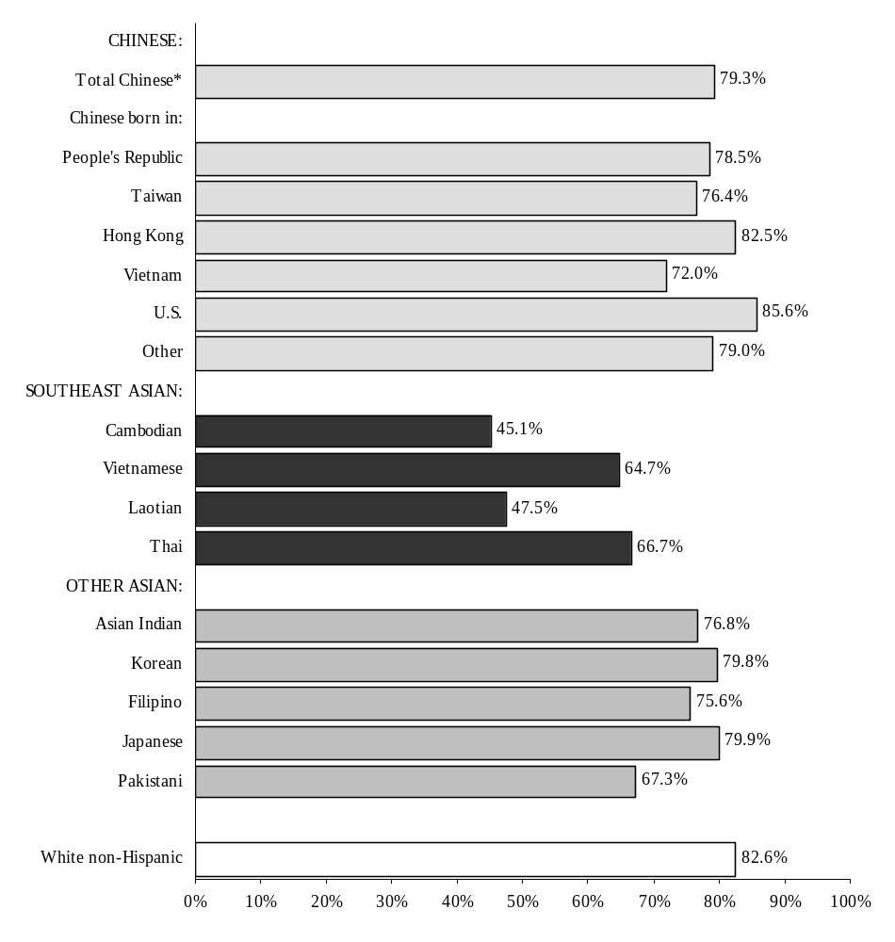

Source: Massachusetts Department of Public Health, BHSR&E (See Appendix Tables A5.1 & A5.3.)

* Total includes 82 mothers of Chinese ancestry whose place of birth is unknown.
** Excludes cases with unknown adequacy.

Note: Adequacy of prenatal care is a quantitative measure based on the timing and total number of prenatal
visits; it is not a measure of the quality of care. Refer to the Glossary for a complete explanation.

What kind of prenatal care health insurance do Asian mothers have?

Private insurance (Blue Cross/Blue Shield, commercial insurance, and HMOs) was the source of payment for prenatal care for 75% of Chinese mothers and 81% of White non-Hispanic mothers for 1996 and 1997. Use of public funds for prenatal care was highest among Vietnamese and Cambodian mothers (45.7% and 51.4%, respectively). About two percent of Chinese mothers and Japanese mothers and 5% of Korean mothers paid for prenatal care themselves, compared to under 1% of White non-Hispanic mothers
(Figure 5.2).

Figure 5.2 Percent Distribution of Prenatal Care Payment Source**
Among Asian Mothers by Ethnicity and Place of Birth

Massachusetts: 1996-97

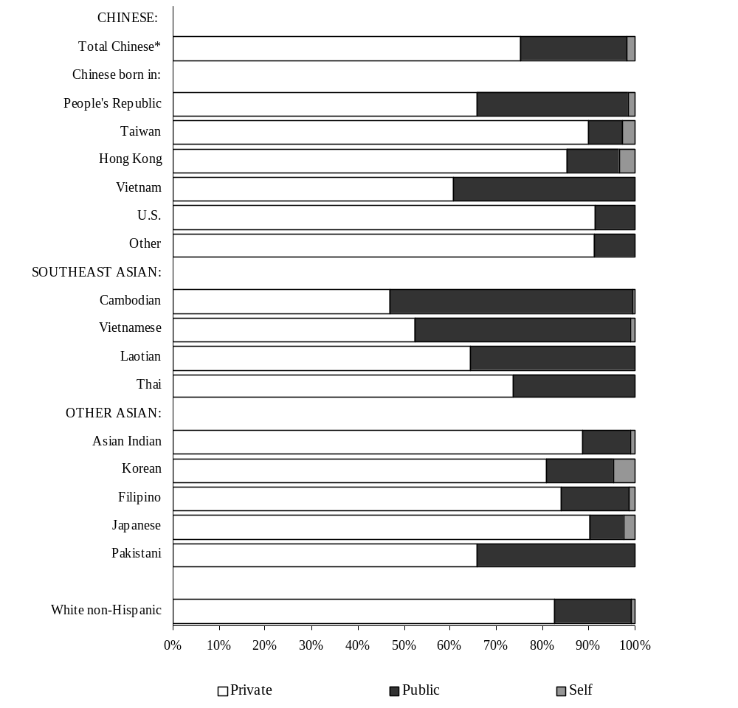

Source: Massachusetts Department of Public Health, BHSR&E (See Appendix Tables A5.1 & A5.3.)

* Total includes 82 mothers of Chinese ancestry whose place of birth is unknown.
** Payment Sources: Private = Blue Cross, commercial insurance, HMO; Public = Medicaid/MassHealth, Medicare, Healthy start, free care, or other government source; Self = self-paid

Where do Asian mothers receive prenatal care?

In 1996 and 1997, Asian women were most likely to receive their prenatal care at physicians' offices rather than hospital clinics, HMOs, or community health centers. Among Chinese women, prenatal care was most often obtained at a physician's office (55%), with community health centers (18%), HMO’s (14%) and hospital clinics (13%) used less frequently (Figures 5.3-5.6). In contrast, 82% of White non-Hispanic women received their prenatal care at physicians' offices. Among Chinese mothers, those born in Taiwan (78%) and the U.S. (71%) had the highest proportions receiving prenatal care at physicians’ offices, while the proportions were much lower among Chinese mothers born in the People’s Republic (43%) and Vietnam (42%). The majority of Asian Indian (75%), Filipino (71%), Japanese (68%), Korean (67%), and Pakistani (63%) mothers received prenatal care at physicians’ offices (Figure 5.5).

Among Southeast Asian women, the use of physicians' offices for prenatal care varied from 41% to 68%. Only 41% of Vietnamese mothers received their prenatal care in physicians' offices. Hospital clinic use for Southeast Asian mothers varied from 17% to 25%.

Use of hospital clinics and community health centers as the site of prenatal care varied widely by ethnicity and place of birth. Among Chinese women born in the People’s Republic and Vietnam, these sites accounted for almost half of all prenatal care, while the proportion was considerably smaller for those mothers born in Taiwan, Hong Kong or the U.S., at less than 20% for these groups. Higher proportions of Vietnamese (47%) and Cambodian (37%) mothers also received prenatal care at either a hospital clinic or community health center (Figures 5.3 – 5.4).

At least 80% of all mothers named a pediatric provider. Percentages were lowest among Chinese mothers (80%), compared to 97% among White non-Hispanic mothers.

Figure 5.3** Percent Distribution of Community Health Center as Site of Prenatal Care Among Asian Mothers

by Ethnicity and Place of Birth

Massachusetts: 1996-97
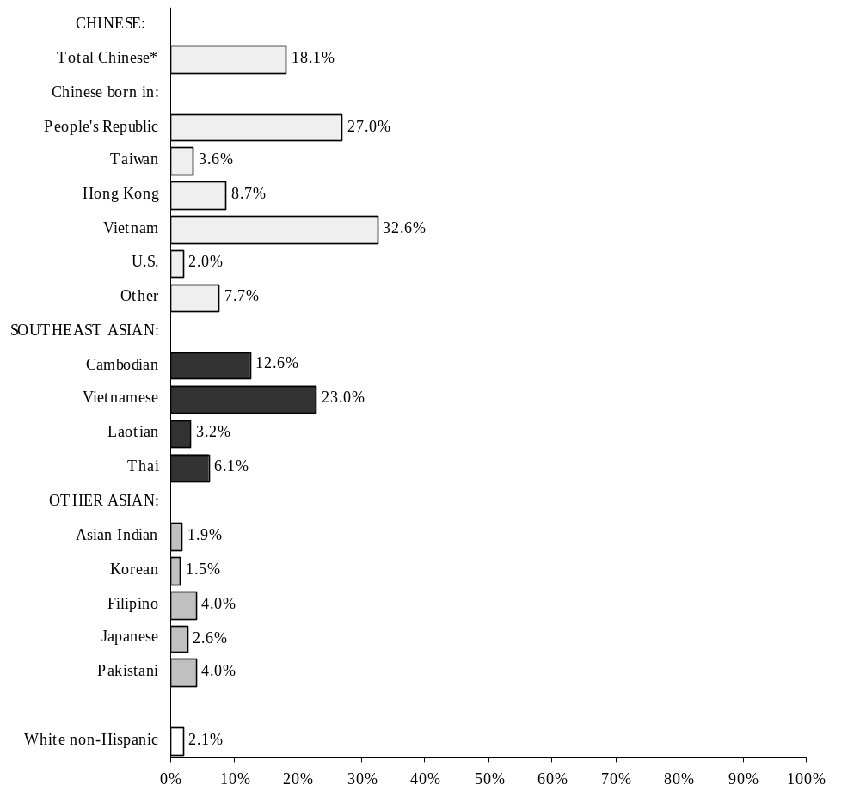

Source: Massachusetts Department of Public Health, BHSR&E (See Appendix Tables A5.1 & A5.3.)

*Total includes 82 mothers of Chinese ancestry whose place of birth is unknown.
**See Figures 5.4 – 5.6 for other prenatal care sites.

Figure 5.4** Percent Distribution of Hospital Clinic as Site of Prenatal Care Among Asian Mothers

by Ethnicity and Place of Birth

Massachusetts: 1996-97

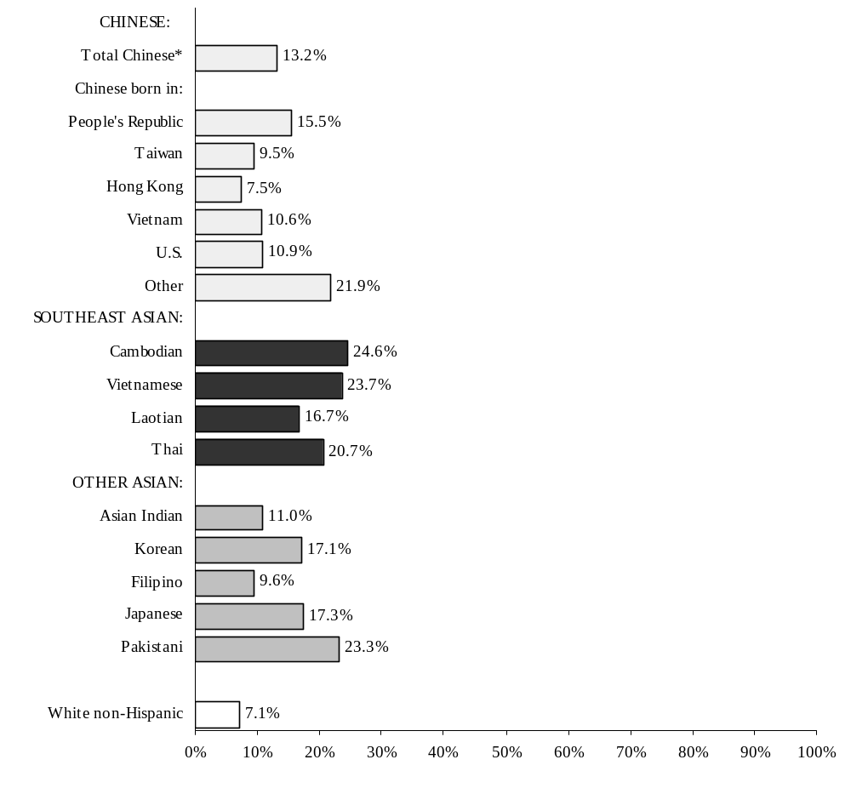

Source: Massachusetts Department of Public Health, BHSR&E (See Appendix Tables A5.1 & A5.3.)

* Total includes 82 mothers of Chinese ancestry whose place of birth is unknown.
**See Figures 5.3 and 5.5 – 5.6 for other prenatal care sites.

Figure 5.5** Percent Distribution of Physician’s Office as Site of Prenatal Care Among Asian Mothers

by Ethnicity and Place of Birth
Massachusetts: 1996-97

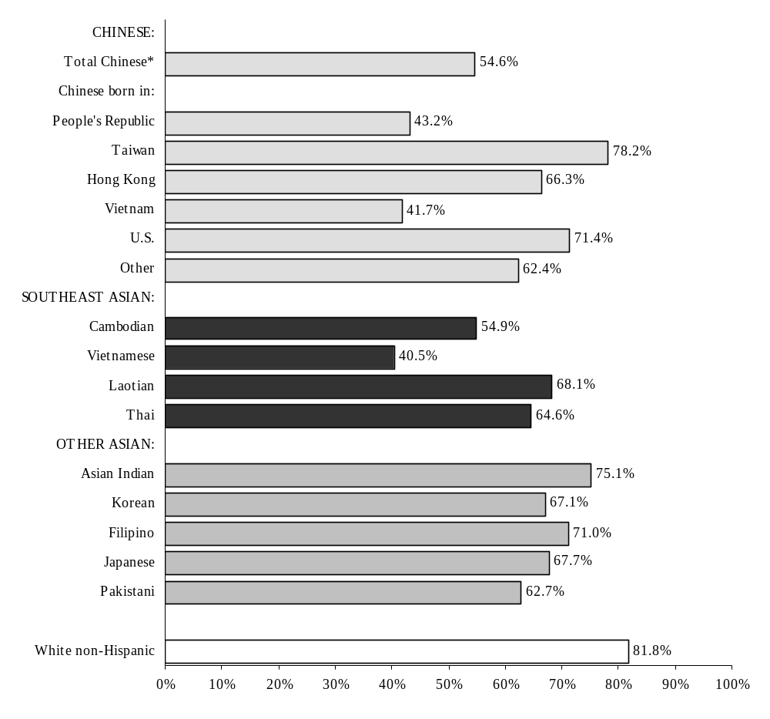

Source: Massachusetts Department of Public Health, BHSR&E (See Appendix Tables A5.1 & A5.3.)

* Total includes 82 mothers of Chinese ancestry whose place of birth is unknown.
**See Figures 5.3- 5.4 and 5.6 for other prenatal care sites.

Figure 5.6** Percent Distribution of HMO and Other

Facilities as Site of Prenatal Care Among Asian Mothers

by Ethnicity and Place of Birth

Massachusetts: 1996-97

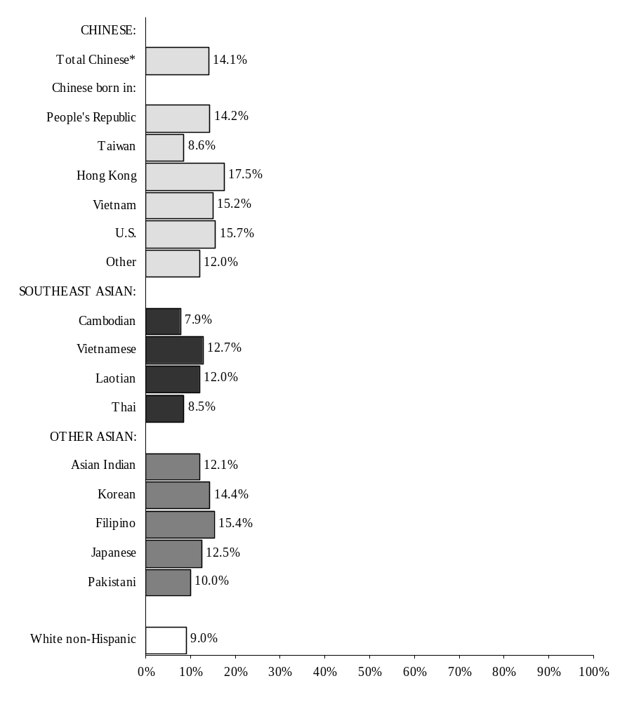

Source: Massachusetts Department of Public Health, BHSR&E (See Appendix Tables A5.1 & A5.3.)

* Total includes 82 mothers of Chinese ancestry whose place of birth is unknown.
**See Figures 5.3 – 5.5 for other prenatal care sites.
How does the prevalence of breastfeeding (or intention to breastfeed) vary among Asian mothers?

Breastfeeding or intention to breastfeed was similar among Chinese mothers and White non-Hispanic mothers (68%). Vietnamese, Laotian, and Cambodian mothers had the lowest percentages (41%, 40%, and 35%, respectively). Percentages were highest (over 90%) among Asian Indian, Japanese, and Pakistani mothers (Figure 5.7).

Figure 5.7 Percent Distribution of Asian Mothers Who
Intended to Breastfeed by Ethnicity and Place of Birth

Massachusetts: 1996-97

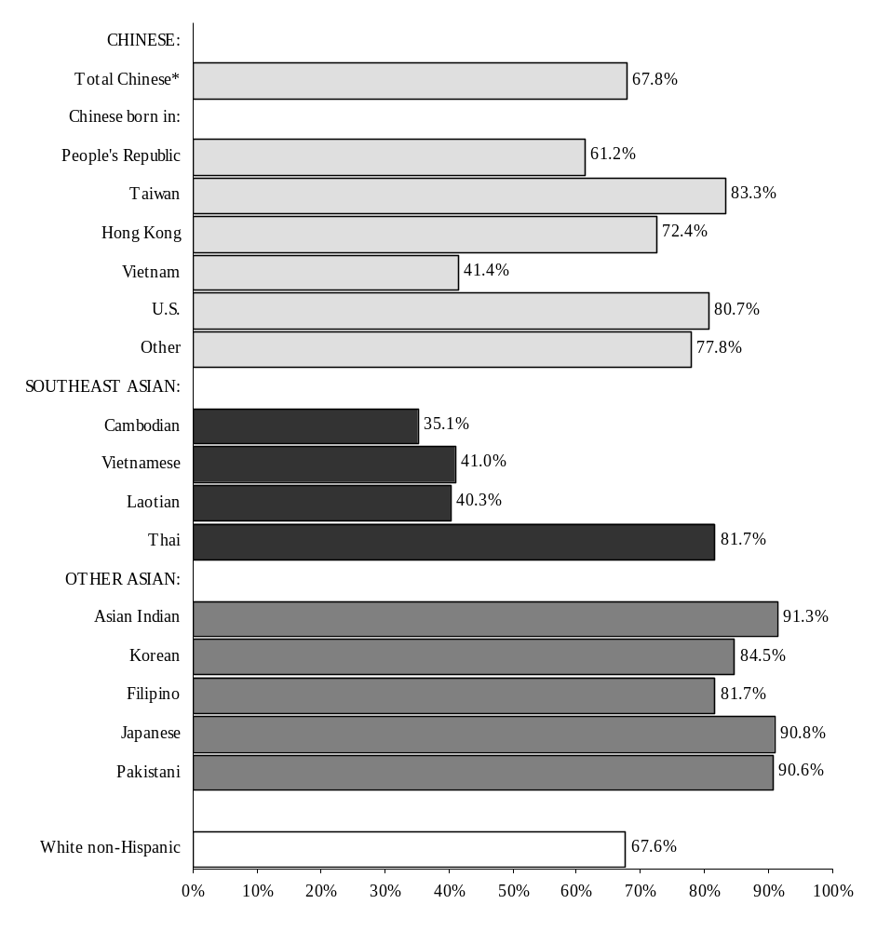

Source: Massachusetts Department of Public Health, BHSR&E (See Appendix Tables A5.1 & A5.3.)

* Total includes 82 mothers of Chinese ancestry whose place of birth is unknown

Chapter 6

Preterm Births and Low Birthweight among Children Born to Asian Mothers in Massachusetts:
1996-1997

What proportion of Chinese and Asian births occur before the completion of the 37th week of gestation (also known as early gestation or preterm births)?

Infants born before the completion of the 37th week of gestation are at greater risk of illness and death than are infants who are born at full term. Among Chinese mothers, 5% delivered preterm infants during 1996 and 1997. U.S.-born Chinese mothers had a greater proportion of preterm births (7%), than did Chinese women who were born in the People’s Republic, Vietnam, Hong Kong, or Taiwan (range: 3-5%). Overall, percentages of preterm births were higher for Southeast Asian mothers during this time period, ranging from 6% to 10%, and for other Asian ancestry groups, with the exception of Korean (4%) and Japanese (3%) mothers. Among White non-Hispanic mothers, 7% delivered their infants prematurely (Figure 6.1).

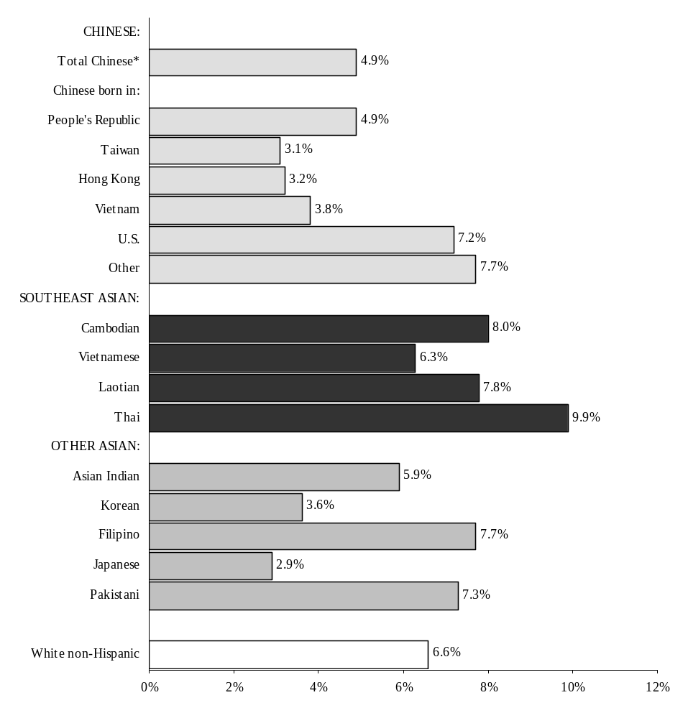Figure 6.1 Percent Distribution of Preterm** Births Among
Asian Mothers by Ethnicity and Place of Birth

Massachusetts: 1996-97

Source: Massachusetts Department of Public Health, BHSR&E (See Appendix Tables A6.1 & A6.3.)

* Total includes 82 mothers of Chinese ancestry whose place of birth is unknown.
** Preterm is defined as gestational age less than 37 weeks.

What proportion of Asian births are of low birthweight? Does the proportion of low birthweight vary among Asian groups?

Low birthweight infants weighing less than 2,500 grams (5.5 pounds) are at increased risk of illness and death. Chinese women overall had one of the lowest percentages of low birthweight infants in Massachusetts (4.9%) in 1996-1997, although Chinese women born in the U.S. had one of the highest percentages of low birthweight infants (8.4%). Percentages were comparably high among infants born to Pakistani (10.6%), Cambodian (8.9%), Asian Indian (8.8%), and Thai (8.5%) mothers. Among White non-Hispanics, 6% of infants were low birthweight. Korean mothers had the lowest percentage of low birthweight infants (2.7%) (Figures 6.2 and 6.3).

Figure 6.2 Percent Distribution of Infant Birthweight Among Asian
Mothers by Ethnicity and Place of Birth
Massachusetts: 1996-97

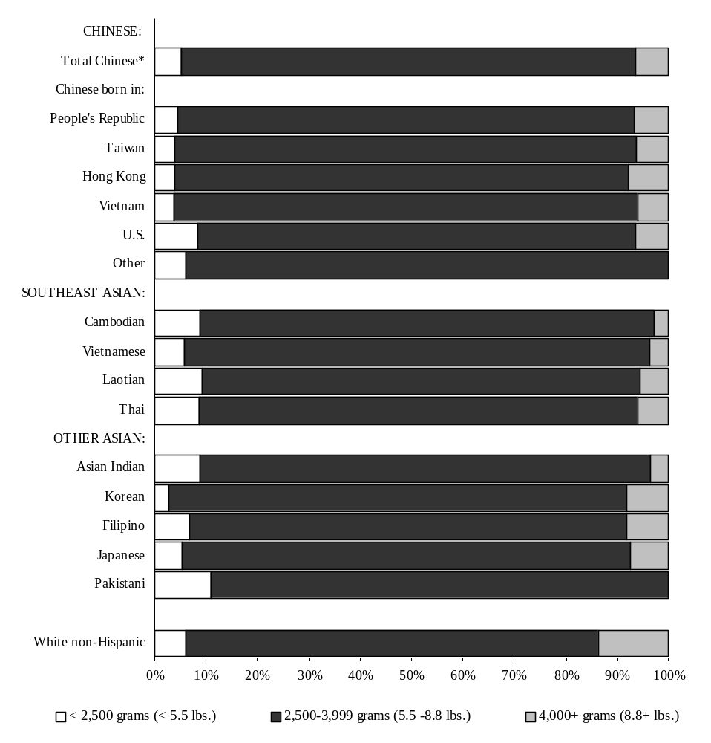

Source: Massachusetts Department of Public Health, BHSR&E (See Appendix Tables A6.1 & A6.3.)

* Total includes 82 mothers of Chinese ancestry whose place of birth is unknown.

Figure 6.3 Percent Distribution of Low Birthweight** Infants
to Asian Mothers by Ethnicity and Place of Birth
Massachusetts: 1996-97

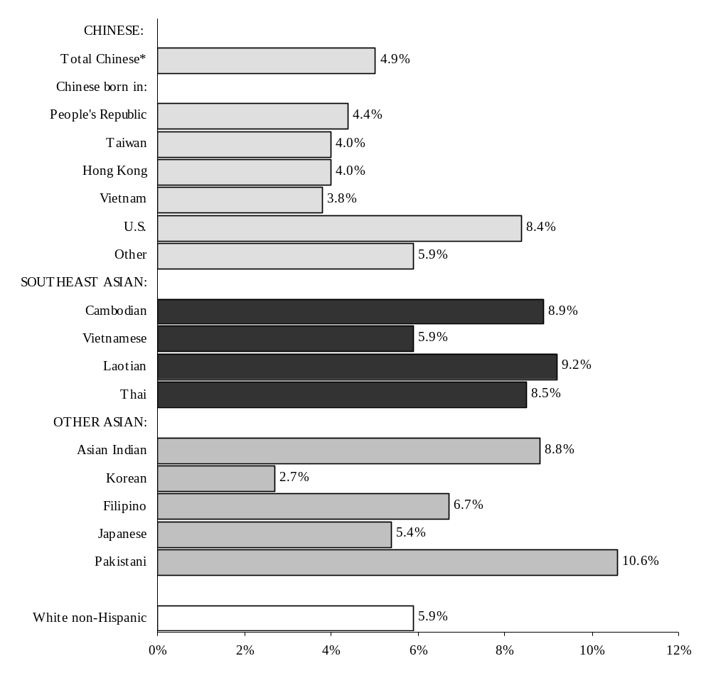

Source: Massachusetts Department of Public Health, BHSR&E (See Appendix Table A6.5.)

*Total includes 82 mothers of Chinese ancestry whose place of birth is unknown.
** Low birthweight is defined as less than 2,500 grams (5.5 lbs.).
Does the proportion of very low birthweight infants vary among Asian groups?

Very low birthweight infants weigh less than 1,500 grams (3.3 pounds), and are at even greater risk of illness and death than low birthweight infants. From 1996 to 1997, the percentage of very low birthweight infants born to Vietnamese and Cambodian mothers (0.9% and 1.5%, respectively), was comparable to the percentage for White non-Hispanic infants, 1.0% (Appendix Table A6.1). Less than one half of a percent of infants born to Chinese mothers were very low birthweight.

Among all low birthweight infants (less than 2,500 grams) during the years 1996 through 1997, 17% of infants born to White non-Hispanic mothers, 17% born to Cambodian mothers, and 15% of infants born to Vietnamese mothers were very low birthweight. The percentages of Asian Indian and Chinese infants that were very low birthweight were lower, at approximately 7% (Figure 6.4).

Note: The detailed low birthweight analysis that follows (beginning with Figure 6.4) includes only those ancestry groups with sufficient numbers of low birthweight infants for the two year period, 1996-1997, to support analysis. These groups include: Chinese, Vietnamese, Cambodian, Asian Indian and White non-Hispanic; and there is no further breakdown by birthplace for mothers of Chinese ancestry.

Figure 6.4 Percentage of Very Low Birthweight Infants*
Among All Low Birthweight Infants**
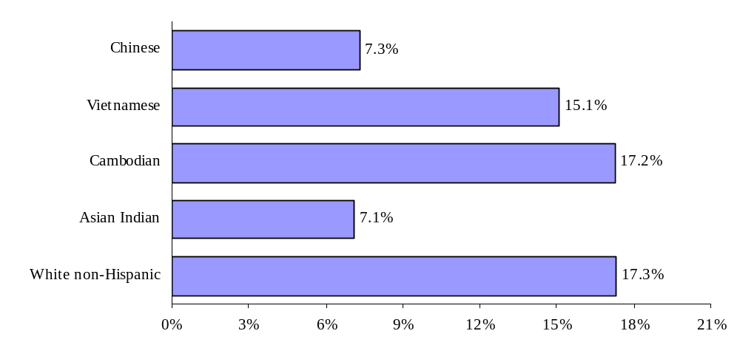of Asian and White Non-Hispanic Mothers
Massachusetts: 1996-97

Source: Massachusetts Department of Public Health, BHSR&E (See Appendix Table A6.12.)

* Infants with birthweight less than 1,500 grams (<3.3 lbs.)
**Infants with birthweight less than 2,500 grams (<5.5 lbs.)
What percentage of Asian women give birth to a low birthweight infant with a gestational period of less than 37 weeks?

There was a tendency for most low birthweight infants to be preterm, regardless of the mother’s ethnicity. During the years 1996-1997, low birthweight infants of Asian Indian women showed the lowest percent of early gestational age (47%), while the highest percent of early gestational age was observed among low birthweight infants of White non-Hispanic women (65%). Approximately 54% of Chinese low birthweight infants, 53% of Vietnamese low birthweight infants, and 55% of Cambodian low birthweight infants were preterm (Figure 6.5).

Figure 6.5 Percentage of Infants with
Gestational Age <37 weeks Among All Low
Birthweight Infants* of Asian and
White Non-Hispanic Mothers
Massachusetts: 1996-97

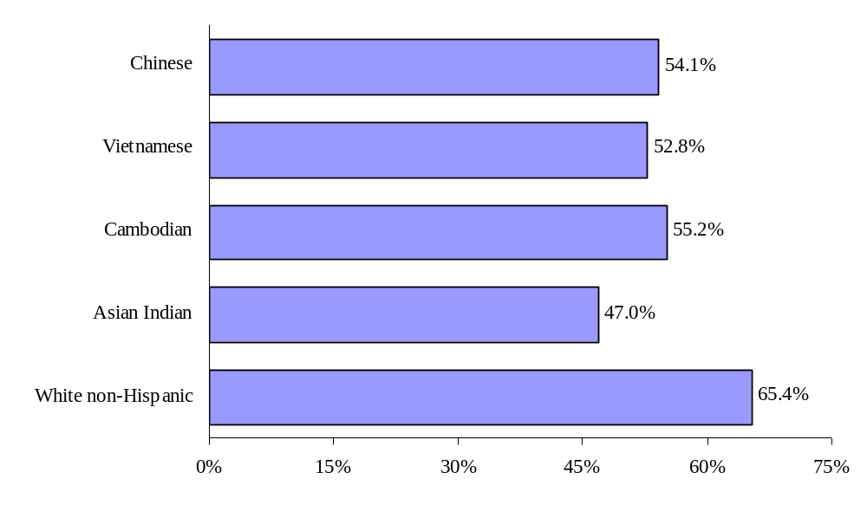

Source: Massachusetts Department of Public Health, BHSR&E (See Appendix Table A6.12.)

*Infants with birthweight less than 2,500 grams (<5.5 lbs.)
How is low birthweight related to plurality among Asian and White non-Hispanic women?

During the years 1996 and 1997, the strongest relationship between plurality (i.e. multiple births, such as twins and triplets) and low birthweight was observed among White non-Hispanic women. More than 30% of low birthweight infants delivered by White non-Hispanic women were multiple births. By comparison, the proportion of multiple births among low birthweight infants was much smaller for Chinese (21%), Asian Indian (14%), Cambodian (10%) and Vietnamese (8%) women (Figure 6.6).

Figure 6.6 Percent Plurality Distribution Among All
Low Birthweight Infants* of Asian and White
Non-Hispanic Mothers
Massachusetts: 1996-97

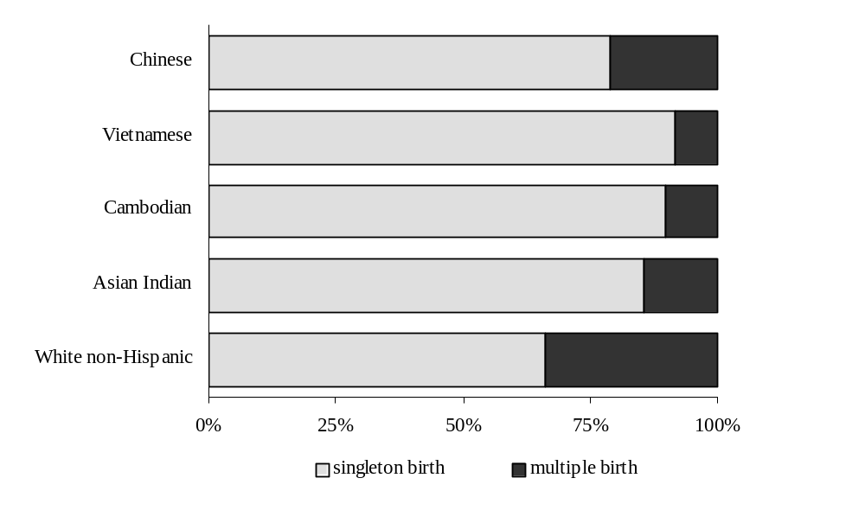

Source: Massachusetts Department of Public Health, BHSR&E (See Appendix Table A6.8.)

*Infants with birthweight less than 2,500 grams (<5.5 lbs.)

APPENDIX I

DETAILED TABLES

FOR CHAPTERS 1-6

APPENDIX II

COMMUNITY TABLES

Notes:
- Includes cities and towns with 100 or more Asian births from 1996-1997.
- Ancestries included for each community table are those with > 70 births, 1996 – 1997.
- “All Asians” category includes the following: Chinese, Vietnamese, Cambodian, Asian Indian, Korean, Filipino, Japanese, Laotian, Pakistani, and Thai.

APPENDIX III

TECHNICAL NOTES

Technical Notes

Limitations of Small Numbers
Cells in some tables in this publication, and particularly those tables specific to the individual cities and towns, contain small numbers and are suppressed in accordance with the guidelines set forth by the MDPH-BHSR&E for suppression of confidential data. Proportions based upon less than five observations are suppressed, and trends based upon small numbers should be interpreted cautiously.

Self-reported Data
Many items used in this publication, such as maternal smoking and type of health insurance coverage, are self-reported.

Assignment of an Infant's Race/Ethnicity

Prior to 1989, the race/ethnicity of an infant was assigned by combining information on the race/ethnicity of the mother and the race/ethnicity of the father. Since 1989, Massachusetts has followed the recommendation of the National Center for Health Statistics of classifying births according to the self-reported race/ethnicity of the mother. Therefore, beginning in 1989, the race/ethnicity of an infant is identical to the self-reported race/ethnicity of the infant's mother. Beginning in 1996, the list of ethnic categories on the birth certificate was modified. The categories used for analysis in this report are: Asian Indian, Cambodian, Chinese, Filipino, Japanese, Korean, Laotian, Pakistani, Thai, and Vietnamese.

This report utilizes the Ancestry/Ethnicity field from the birth certificate. The actual question on the birth certificate reads: “Please check one box which you feel best describes the mother’s ancestry.” A list of 42 ancestry groups is available from which to choose. Note that the ancestry question is separate from the question regarding the mother’s race. The race variable was not used to identify mothers for inclusion in this report; therefore, women of the 10 Asian ancestries included in this report could be of any race (White, Black, Asian, American Indian or Other).
Glossary

Anemia
Hemoglobin level of less than 13.0g/dL, or a hemocrit of less than 39%.

Adequacy of Prenatal Care
The Index of Adequacy of Prenatal Care (based on the Kessner Index) has five categories (adequate, intermediate, inadequate, no prenatal care, and unknown), based on the trimester in which prenatal care began and the number of prenatal visits. It is a quantitative measure and is not a measure of quality of care. The general classification scheme for full-term infants is as follows:

Category | Trimester Care Began | Number of Visits
Adequate | 1 | 9 or more
Intermediate | 1 | 5-8
 | 2 | 5 or more
Inadequate | 1 | 1-4
 | 2 | 1-4
 | 3 | 1 or more
No prenatal care | -- | 0
Unknown | Unknown | unknown

This classification is adjusted for gestational age to allow for proper classification of premature births.

Birthweight
The weight of an infant recorded at the time of delivery. It may be recorded in either pounds/ounces or grams. If recorded in pounds/ounces, it is converted to grams for use in this report.

1 pound = 453.6 grams
1,000 grams = 2 pounds and 3 ounces

Birthweight Categories
Low birthweight (LBW): An infant's weight of less than 2,500 grams (5.5 pounds) recorded at birth.
Very low birthweight (VLBW): An infant's weight of less than 1,500 grams (3.3 pounds) recorded at birth.

Breastfeeding
Mother was or was intending to breastfeed at the time the birth certificate was completed.

Cesarean Section or C-Section
Primary: A mother's first Cesarean section delivery.
Repeat: A Cesarean delivery that has been preceded by at least one Cesarean delivery.

Cesarean Section Rates

Total C-section rate = Number of C-section births X 100
Number of births

Diabetes
Metabolic disorder characterized by excessive discharge of urine and persistent thirst; includes juvenile onset, adult onset, and gestational diabetes during pregnancy.

Early Gestational Age or Preterm
Infants born before the mother completed the 37th week of pregnancy.

Eclampsia
A medical condition that affects women during or shortly after pregnancy. The condition may involve hypertension, edema, proteinuria, convulsions and coma.

Education
The level of education completed is provided on the birth certificate by the mother. The analysis of education presented in this report is limited to women 20 years of age and older.

Ethnicity
See the section in the Technical Notes titled: Assignment of an Infant's Race/Ethnicity

Gestational Age
Gestational age refers to the number of weeks the infant was in utero. Infants born before the mother completed the 37th week of pregnancy are considered early gestational age or preterm.

HMO
Health Maintenance Organization

Healthy Start
A Massachusetts-funded program providing services and financing for prenatal care to low-income pregnant women who lack health insurance but do not qualify for Medicaid.

Hepatitis B Carrier
An individual with ongoing evidence of infection with hepatitis B virus, as determined by the presence of hepatitis B surface antigen in the blood, likely to be more than six months after an acute episode of hepatitis B virus infection.

Hypertension
This includes both chronic and pregnancy-related hypertension (or high blood pressure).

Jaundice
A condition characterized by high levels of bilirubin (a bilirubin count greater than 10) and a yellowing of the patient’s skin.

Language Preference
Information on the mother’s language preference is collected from the mother at the time of birth, based on the birth certificate question, “In what language does the mother prefer to read or discuss health-related materials?”

Live Birth
A live birth is any infant who breathes or shows any other evidence of life (such as beating of the heart, pulsation of the umbilical cord, or definite movement of voluntary muscles) after separation from the mother's uterus, regardless of the duration of gestation.

Low Birthweight (LBW)
See Birthweight Categories.

MISER
MISER is the acronym for the Massachusetts Institute for Social and Economic Research. MISER, which is the official state data center designated by the U.S. Census Bureau, produces annual population estimates for intercensal years. MISER produces estimates of the combined
Asian/Pacific Islander/American Indian population. These estimates are then modified by the Bureau of Health Statistics, Research & Evaluation of the Massachusetts Department of Public Health to create separate estimates for the Asian and Pacific Islander population and the American Indian population.

NCHS
National Center for Health Statistics (U.S. Department of Health and Human Services, Centers for Disease Control and Prevention).

Non-U.S.-Born
Not born in the United States, its possessions or protectorates. (Those born in Puerto Rico, the U.S. Virgin Islands, and Guam are considered U.S.-born.)

Pediatric Provider
Information is collected on the birth certificate regarding whether or not the mother has already identified a pediatric provider for her newborn.

Private Insurance
Blue Cross/Blue Shield, commercial insurance, and health maintenance organizations (HMOs)

Public Insurance
Medicaid, Medicare, Healthy Start and other government programs.

Occurrence Birth
A birth occurring in the Commonwealth of Massachusetts, regardless of the residency of the mother. For individual cities/towns, an occurrence birth represents any birth occurring in that city/town, regardless of the residence of the mother. See Resident Birth.

Parity
The total number of live infants ever born to a woman, including the current birth.

Plurality
The number of births to a woman produced in the same gestational period. A singleton is the birth of one infant, twins represent the birth of two infants, etc.

Race
See the section in the Technical Notes titled: Assignment of an Infant's Race/Ethnicity.

Resident Birth
The birth of an infant whose mother reports that her usual place of residence is in Massachusetts. In Massachusetts, a resident is a person with a permanent address in one of the 351 cities or towns. Vital statistics data may be presented in terms either of residence or of occurrence. All data in this publication are resident data. Resident data include all events that occur to residents of the Commonwealth, wherever they occur. Occurrence data include all events that occur within the state, whether to residents or nonresidents. There is an exchange agreement among the 50 states, District of Columbia, Puerto Rico, Virgin Islands, Guam, and Canada that provides for exchange of copies of birth and death records. These records are used for statistical purposes, only, and allow each state or province to track the births and deaths of its residents.

Small for Gestational Age
The measurement of “small for gestational age” refers to the weight of the infant after taking into consideration the number of completed weeks of pregnancy.

Smoking
Information on smoking status, both before pregnancy and during pregnancy, is provided on the birth certificate by the mother.

U.S.-Born
Born in the United States, its possessions, or its protectorates. Those born in Puerto Rico, the US Virgin Islands, and Guam are considered U.S.-born.

Very Low Birthweight (VLBW)
See Birthweight Categories.

Related Articles

Arif MA, Qureshi AH, Jafarey SN, Alam SE, and Arif K. (1998) Maternal sociocultural status: A novel assessment of risk for the birth of small for gestational age, low birth weight infants.
J Obstetrics and Gynaecology Research. 24, 3: 215-22.

Baruffi G, Alexander G, and Novotny R. (1990) Causes of Infant Mortality in a Multiethnic Population. Asia-Pacific Journal of Public Health. 4, 2-3: 145-150.

Cohen, BB, Lederman RI, Friedman DJ. Do race and ancestry influence low birthweight?: Massachusetts Department of Public Health, Bureau of Health Statistics, Research and Evaluation. Presentation at American Public Health Association annual meeting, New York; October 1990.

Dietz PM, Adams MM, Kendrick JS, Mathis MP, and the PRAMS Working Group. (1998) Completeness of Ascertainment of Prenatal Smoking using Birth Certificates and Confidential Questionnaires: Variations by Maternal Attributes and Infant Birth Weight. Am J Epidemiology.
148: 11.

Doornbos JP, Nordbeck HJ, Ban Enk AE, Muller As, Treffers PE. (1991) Differential birthweights and the clinical relevance of birthweight standards in a multiethnic society. Int J Gynaecol Obstet. 34, 4:319-24.

Drew JH, Chan DP. (1989) Incidence of prematurity and low birth-weight in an immigrant Chinese population. Aust N Z J Obstet Gynaecol. 29, 3-2: 303-5.

Emery ES, Eaton A, Grether JK, and Nelson KB. (1997) Assessment of Gestational Age using Birth Certificate data compared with Medical Record Data. Paediatric and Perinatal Epidemiology. 11, 3:313-21.

Firdous R, Bhopal RS. (1989) Reproductive health of Asian women: a comparative study with hospital and community perspectives. Public Health. 103, 4:307-15.

Gann P. Nghiem L, Warner S. (1989) Pregnancy characteristics and outcomes of Cambodian refugees. Am J Public Health. 79, 9:1251-7.

Grether Jk, Schulman J, Cohen La. (1990) Sudden infant death syndrome among Asians in California. J Pediatr. 116, 4:525-8.

Helsel D, Petitti DB, Kunstadter P. (1992) Pregnancy outcomes among the Hmong; birthweight, age, and parity. Am J Public Health. 82, 10:1361-64.

Herrchen B, Gould JB, and Nesbitt TS. (1997) Vital statistics linked birth/infant death and hospital discharge linkage for epidemiological studies. Computers and Biomedical Research. 30, 4:290-305.

King Pa, Duthie Sj, Li DF, Ma HK. (1990) Obstetric outcome among Vietnamese refugees in Hong Kong: an age-matched case-controlled study. Int J Gynaecol Obstet. 33, 3:203-10.

Kleinman JC. (1990) Infant mortality among racial/ethnic minority groups, 1983-84. MMWR CDC Surveill Summ. 39, 3:31-9.

Li DK, Ni H, Schwarts SM, Dalling JR. (1990) Secular change in birthweight among Southeast Asian immigrants to the United States. Am J Public Health. 80, 6:685-688.

Phelan ST, Goldenberg R, Alexander G, and Cliver SP. (1998) Perinatal Mortality and its Relationship to the Reporting of Low-Birthweight Infants. Am J Public Health. 88, 8:1236-9.

Rumbaut RG, Weeks JR. (1989) “Infant health among Indochinese refugees; patterns of infant mortality, birthweight and prenatal care in comparative perspective”. Research in the Sociology of Health Care. JAI Press Inc.: 8:137-196; ISBN: 1-55938-043-8.

Schauberger Cw, Hammes B, Steingraeber PH. (1990) Obstetric care of a Southeast Asian refugee population in a midwestern community. J Perinatol. 10, 3:280-4.

Ventura SJ, Martin JA. Advance Report of Final Natality Statistics. Monthly Vital Statistics Report; USDHHS, PHS, CDC, NCHS; Feb 25, 1993; Vol. 41 (9), Supplement, p12, 42-43.

Viegas OA, Ratnam SS, Cole TJ. (1989) Ethnic and other factors affecting birthweight in Singapore. Int J Gynaecol Obstet. 29, 4:289-95.

Wang X, Strobino DM, Guyer B. (1992) Differences in cause-specific infant mortality among Chinese, Japanese, and White Americans. Am J Epidemiology. 135, 12:1382-93.

Weeks Jr, Rumbaut RG, Brindis C. Korenbrot CC, Minkler D. (1989) High fertility among Indochinese refugees. R01-HD15699, Public Health Rep. 104, 2:143-50.

Weeks Jr, Rumbaut RG. (1991) Infant mortality among ethnic immigrant groups. MCJ-060551. Soc Sci Med. 33, 3:327-34.

Yip R, Scanlon K, Trowbridge F. (1992) Improving growth status of Asian refugee children in the United States. JAMA. 267, 7:937-40.

Yip R, Li Z, Chong WH. (1991) Race and birth weight: the Chinese example. Pediatrics. 87, 5:688-93.

Yu E. (1982) The low mortality rates of Chinese infants: some plausible explanatory factors. Soc Sci Med. 16:253-265.

Asian Births in Massachusetts: 1996-1997 Evaluation Form

TO OUR READERS: In an attempt to better serve our users, we are enclosing this evaluation form. Please take the time to complete this questionnaire and return it to the address at the bottom of the page. Thank you.

What tables and charts do you find most useful?

What tables and charts do you find least useful?

Are there other tables and charts that you would like added to this publication? If yes, please describe them in detail.

Do you have other comments or suggestions?
Name (optional):
Address:

(For those who received the publication by mail) Is the mailing label address correct? If not, please correct the address. Thank you.

Please return your comments to:

Christine Judge
Division of Research and Epidemiology
Bureau of Health Statistics, Research and Evaluation
Massachusetts Department of Public Health
250 Washington Street
Boston, MA 02108

------------------------------------------------------------------------------------------------------------

Place
stamp
here

Christine Judge
Division of Research and Epidemiology
Bureau of Health Statistics, Research and Evaluation
Massachusetts Department of Public Health
250 Washington Street
Boston, MA 02108

------------------------------------------------------------------------------------------------------------

1. Births to women listing their ancestry as “Hawaiian” (21 births) or “Other Asian/Pacific Islander” (365 births) for the period 1996-1997 are not included in this report. 2. 1993 Research Conference on Undercounted Ethnic Populations. U.S. Bureau of the Census web page, http://www.census.gov/.
In 1990, the four race categories used by the federal government were: white, black, American Indian, and a combined category of Asian and Pacific Islander. Therefore, the population data based on the U.S. Census presented in Chapter 1 are for this combined race category whereas the birth data presented in Chapters 2-6 are only for Asian women. Both terms appear throughout this Chapter but they refer to two distinct classifications. (Please note that under revised federal government definitions beginning with the 2000 U.S. Census, there are five race categories: white, black, American Indian, Asian, and Native Hawaiian/Pacific Islander.)

