Asian Births in Massachusetts
1998-1999 Supplement

Argeo Paul Cellucci, Governor
Jane Swift, Lieutenant Governor
William D. O’Leary, Secretary of Health and Human Services
Howard K. Koh, MD, MPH, Commissioner of Public Health
Daniel J. Friedman, Ph.D., Assistant Commissioner, Bureau of Health Statistics, Research and Evaluation

The Commonwealth of Massachusetts

Executive Office of Health and Human Services

Department of Public Health

Bureau of Health Statistics, Research and Evaluation

250 Washington Street
Boston, MA 02108
617-624-5600

May, 2001

To obtain additional copies of this report, contact the following office:

Massachusetts Department of Public Health
Bureau of Health Statistics, Research and Evaluation
250 Washington Street, Boston, MA 02108
(617) 624-5699

This and other Massachusetts Department of
Public Health publications and materials can be accessed
on the Internet: www.state.ma.us/dph/
Technical Foreword

Purpose of this Supplement

This publication was prepared by staff of the Division of Research and Epidemiology, Bureau of Health Statistics, and was released concurrently with Asian Births in Massachusetts: 1996-1997 in May, 2001. It is intended as a supplement to that report. This supplement provides an overview of data on Asian births in Massachusetts for the years 1998-1999, which represent the most recent state birth data available. This supplement is intended for use in conjunction with Asian Births in Massachusetts: 1996-1997, although all necessary technical notes and definitions have been reproduced in this supplement. To obtain copies of the 1996-1997 report, please contact the Department as instructed on the preceding page.

Changes in birth data

Asian Births in Massachusetts: 1998-1999 Supplement presents, as closely as possible, natality data in a form that is consistent with data from 1995 and previous years. In 1996, Massachusetts implemented a major revision to the birth certificate form and installed a new Electronic Birth Certificate (EBC) system in Massachusetts maternity hospitals. As a result, beginning with 1996 birth data, there is new information that was previously not available (such as the mother’s language preference) as well as greater specificity in some of the data elements, which more correctly reflects the populations under study. However, the transition to the new format affected several data elements, and not all data elements presented in this report can be compared precisely with previously published data. Changes reflected in the calculation of the Kessner Adequacy of Prenatal Care Index make the comparison of data for prenatal care presented in this report with data prior to 1996 inappropriate. Other data items are comparable over time, but may be affected by minor changes in data collection, recording and coding.

Notes on Data Sources

All the information on Massachusetts births contained in this report is based upon data from the Massachusetts certificate of live birth. The terms used for Asian ethnic groups in this report are taken from the list of ancestries provided on the birth certificate. These terms are referred to as ethnicities, although they may also represent nationalities. Issues of nationality may influence women’s choices of ancestry on the birth certificate. For instance, if some Taiwanese or Tibetan women chose not to characterize their ancestry as Chinese, they would not be included under this ethnicity group.

Table of Contents

Technical Foreword | iii
Summary | 1
Figures | 3
Percentage of Asian Births by Ethnicity, Massachusetts: 1998-1999 | 5
Number of Chinese, Southeast Asian and Other Asian Births by  Maternal Residence, in Selected Communities, Massachusetts:  1998 -1999 | 6
Percentage Preferring a Language Other than English Among Asian  and White Non-Hispanic Mothers by Ethnicity, Massachusetts:  1998-1999 | 7
Percent Distribution of Adequate Prenatal Care Among Asian  Mothers by Ethnicity and Place of Birth, Massachusetts: 1998-1999 | 8
Percent Distribution of Low Birthweight Infants to Asian Mothers by  Ethnicity and Place of Birth, Massachusetts: 1998-1999 | 9
Tables | 11
1. Distribution of Asian Births by Community, Massachusetts: 1998-1999 | 13
2a. Percent Distribution of Mother’s Demographic Characteristics by Ethnicity, Massachusetts: 1998-1999 | 14
2b. Distribution of Mother’s Demographic Characteristics by Ethnicity, Massachusetts: 1998-1999 | 15
3a. Percent Distribution of Prenatal and Postnatal Care Characteristics of Mothers by Ethnicity, Massachusetts: 1998-1999 | 16
3b. Distribution of Prenatal and Postnatal Care Characteristics of Mothers by Ethnicity, Massachusetts: 1998-1999 | 17
4a. Percent Distribution of Infant Characteristics by Mother’s Ethnicity, Massachusetts: 1998-1999 | 18
4b. Distribution of Infant Characteristics by Mother’s Ethnicity, Massachusetts: 1998-1999 | 19
5. Selected Birth Characteristics by Ethnicity in Selected Communities, Massachusetts: 1998-1999 | 20
Technical Notes | 21
Glossary | 23

SUMMARY

Changes in Asian Births from 1996-1997 to 1998-1999
During 1998 and 1999, there were 7,616 births among Massachusetts women of Asian ancestry, representing almost a 10% increase in the number of births from 1996-1997. The majority of the increase (57%) was among Asian Indian mothers. These 7,616 Asian births constituted 4.7% of all Massachusetts births during this period, a slightly higher proportion of statewide births than in 1996-1997 (4.3%). The majority of these births occurred among women of Chinese ancestry (30%), followed by Asian Indian (18%), Vietnamese (17%), and Cambodian (14%) ancestries (Figure 1). Based on observations of these 4 largest groups, increases occurred between 1996-1997 and 1998-1999 in percentages of: mothers who prefer the English language; adequacy of prenatal care; breastfeeding; and infants with low birthweight. These changes were consistent across most of the other Asian ancestry groups as well, although some of the groups were too small to provide stable estimates of change.

Maternal Demographics
As in the period of 1996-1997, almost half of all Asian births in Massachusetts were concentrated among residents of 7 cities: Boston (14%), Lowell (11%), Quincy (5%), Worcester (5%), Malden (4%), Cambridge (3%), and Lynn (3%) (Figure 2). Although Boston had the highest number of Asian births (1,039), only 7% of all births to Boston residents were to Asian women. In comparison, in Lowell, 25% of all resident births were to Asian women (Table 1).

In 1998-1999, approximately 15% of Asian women who gave birth had completed less than a high school education; 21% had completed a high school diploma or GED; 15% had completed some college education; and 49% had completed at least a college degree. A higher percentage of Asian mothers (15%) than White non-Hispanic mothers (4%) had not completed high school. Over two-thirds of Cambodian, Vietnamese and Laotian mothers had not completed education beyond high school. In contrast, over 85% of Asian Indian, Japanese and Korean mothers had completed college degrees (Table 2a).

Massachusetts mothers of Chinese ancestry were more likely to be older and married than White non-Hispanic mothers. For instance, about 6% of Chinese mothers were under the age of 25, compared with 16% of White non-Hispanic mothers. In contrast, Laotian (47%), Cambodian (45%), and Vietnamese (26%) mothers were more likely to be under 25 years old than White non-Hispanic mothers (Table 2a). Over 25% of Chinese, Japanese and Filipino mothers were over age 35, compared to less than 11% for Laotian, Vietnamese, Cambodian and Pakistani mothers. The majority of Asian mothers were born outside of the United States and indicated a preference for the English language rather than their native languages. Over half of Vietnamese and Cambodian mothers preferred other languages to English (Table 2a). Chinese mothers born in the People’s Republic and Vietnam were also less likely to prefer English (Figure 3). (See Glossary for definition of language preference).

Prenatal Care
Adequacy of prenatal care varied between Asian ancestry groups. (Adequacy of prenatal care is a quantitative measure based on the timing and total number of prenatal visits; it is not a measure of the quality of care.) The percentage of Asian mothers receiving adequate prenatal care ranged from 46% to 87% (Figure 4). Chinese mothers born in Taiwan had the highest percentage of adequate prenatal care (87%), compared to White non-Hispanic mothers (83%). Southeast Asian women had considerably lower percentages of adequate prenatal care; Cambodian women had the lowest percentage, 46%. Asian women in some of the larger, urban communities such as Lowell (45%), Lynn (53%), Worcester (64%) and Springfield (67%) had lower percentages of adequate prenatal care than the statewide average for all Asian mothers (72%) (Table 5).

About seventy-three percent of Asian mothers had privately financed prenatal care, compared with 80% of White non-Hispanic mothers. In addition, 26% of Asian mothers had publicly financed prenatal care, compared with 15% of White non-Hispanic mothers. Source of payment for prenatal care also varied substantially among ancestry groups. Almost half of Cambodian mothers paid for prenatal care with public funds, compared with less than 7% of Japanese mothers (Table 3a).

Asian mothers were more likely to receive their prenatal care at physicians’ offices (range of 47% to 80%) than at hospital clinics or community health centers. Compared to White non-Hispanic mothers (84%), Asian mothers were less likely to receive prenatal care at physicians’ offices and more likely to receive care at hospital clinics (range of 9% to 26%) (Table 3a).

Breastfeeding
As in 1996-1997, Cambodian, Vietnamese and Laotian mothers continued to report the lowest percentages of breastfeeding (48%, 53% and 54% respectively). However, over 75% of all other Asian groups reported breastfeeding, in contrast with 71% of White non-Hispanic mothers (Table 3a).

Low Birthweight
The percentage of infants with low birthweight (under 5.5 pounds) varied among Asian ethnicity groups. Chinese mothers overall had one of the lowest percentages of low birthweight infants (5.8%). However, Chinese women born in Hong Kong had one of the highest percentages of low birthweight infants (9.2%) while those born in Taiwan had one of the lowest (4.2%). Low birthweight percentages were over 8% for Thai (11.1%), Asian Indian (9.7%), Cambodian (9.4%), Filipino (9.1%), Japanese (8.8%) and Laotian (8.0%) mothers (Figure 5). Asian mothers in Lowell (10.8%) and Lynn (9.5%) had higher percentages of low birthweight infants than the statewide average for Asian mothers (8%) (Table 5).

Preterm Births
The percentages of preterm births (births before 37 weeks of gestation) also varied by Asian ethnicity. Overall, percentages were highest for Southeast Asian mothers, ranging from 6 to 15%. Chinese mothers had a lower percentage of preterm births than White non-Hispanic mothers did (6% and 7%, respectively) (Table 4a).

FIGURES

Figure 1. Percentage of Asian Births by Ethnicity

Massachusetts: 1998-1999

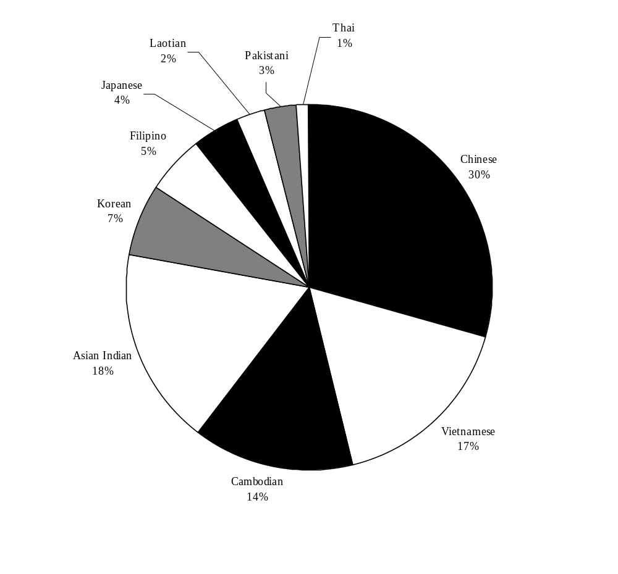

Source: Massachusetts Department of Public Health, Bureau of Health Statistics, Research and Evaluation (BHSR&E) (See Table 1.)

Figure 2. Number of Chinese, Southeast Asian and Other Asian Births by Maternal Residence, in Selected Communities* Massachusetts: 1998-99

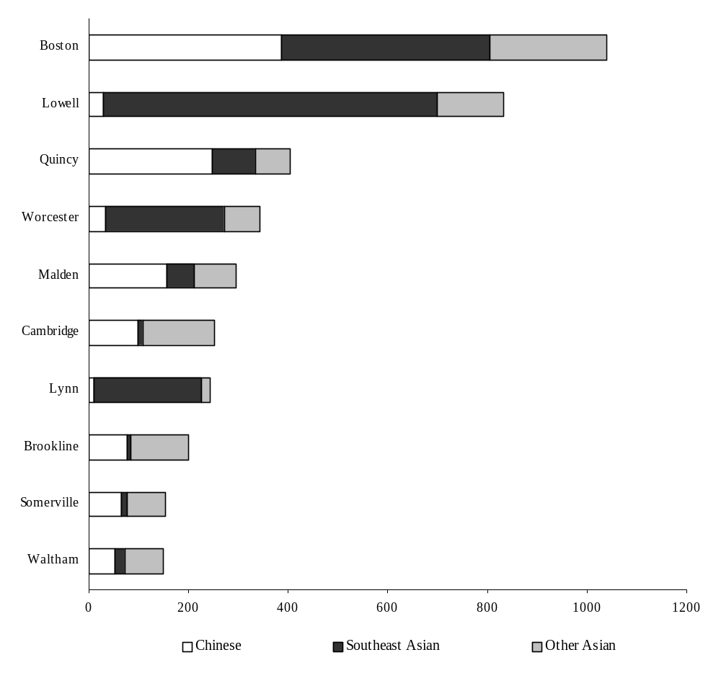

Source: Massachusetts Department of Public Health, BHSR&E (See Table 1)

* Cities and towns with 150 or more Asian births from 1998-1999.

Note: “ Southeast Asian” = Cambodian, Vietnamese, Laotian, Thai.
“Other Asian” = Asian Indian, Korean, Filipino, Japanese, Pakistani.

Figure 3. Percentage Preferring a Language* Other than English

Among Asian and White Non-Hispanic

Mothers by Ethnicity
Massachusetts: 1998-1999

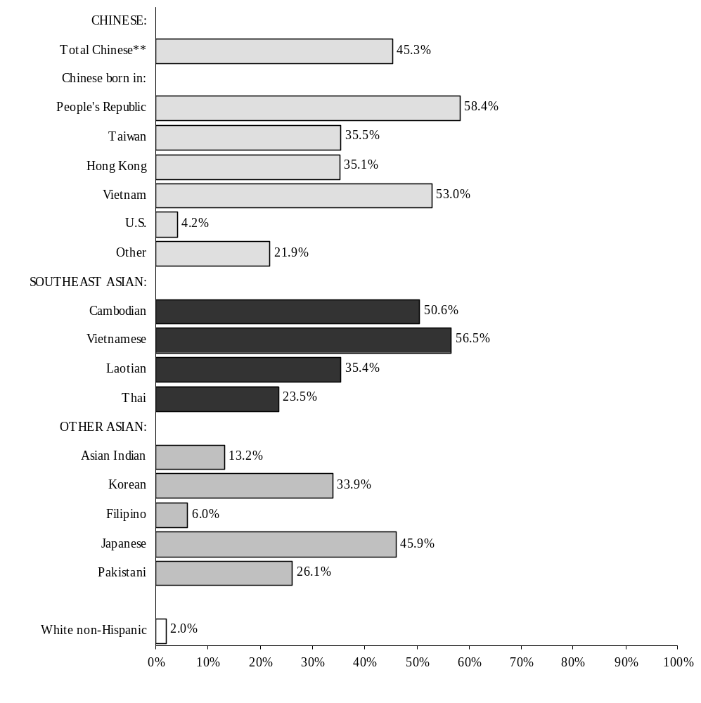
Source: Massachusetts Department of Public Health, BHSR&E (See Tables 2a and 2b.)

* Information on the mother’s language preference is collected from the mother at the time of birth, based on the birth certificate question, “In what language does the mother prefer to read or discuss health-related materials?”
** Total includes 16 mothers whose place of birth is unknown.

Note: White Non-Hispanic group excludes women of Asian ancestry.

Figure 4. Percent Distribution of Adequate Prenatal Care**
Among Asian Mothers by Ethnicity and Place of Birth

Massachusetts: 1998-99
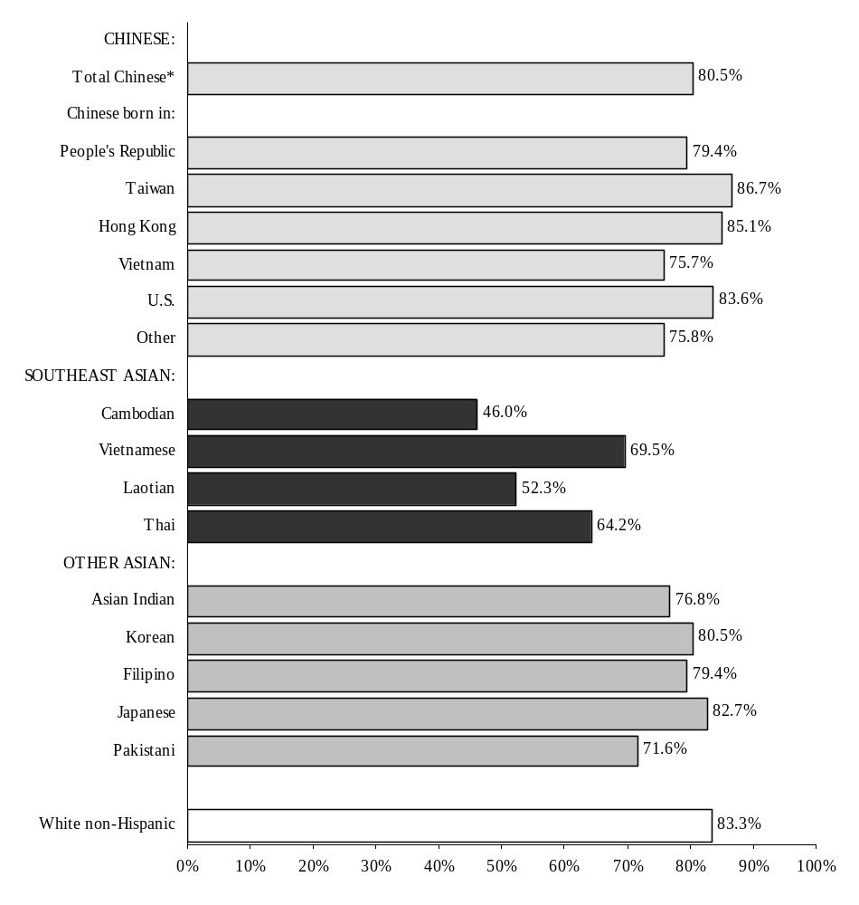

Source: Massachusetts Department of Public Health, BHSR&E (See Tables 3a and 3b.)

* Total includes 16 mothers whose place of birth is unknown.
** Excludes cases with unknown adequacy.

Note: Adequacy of prenatal care is a quantitative measure based on the timing and total number of prenatal visits; it is not a measure of the quality of care. Refer to the Glossary for a complete explanation.

Figure 5. Percent Distribution of Low Birthweight** Infants
to Asian Mothers by Ethnicity and Place of Birth
Massachusetts: 1998-99

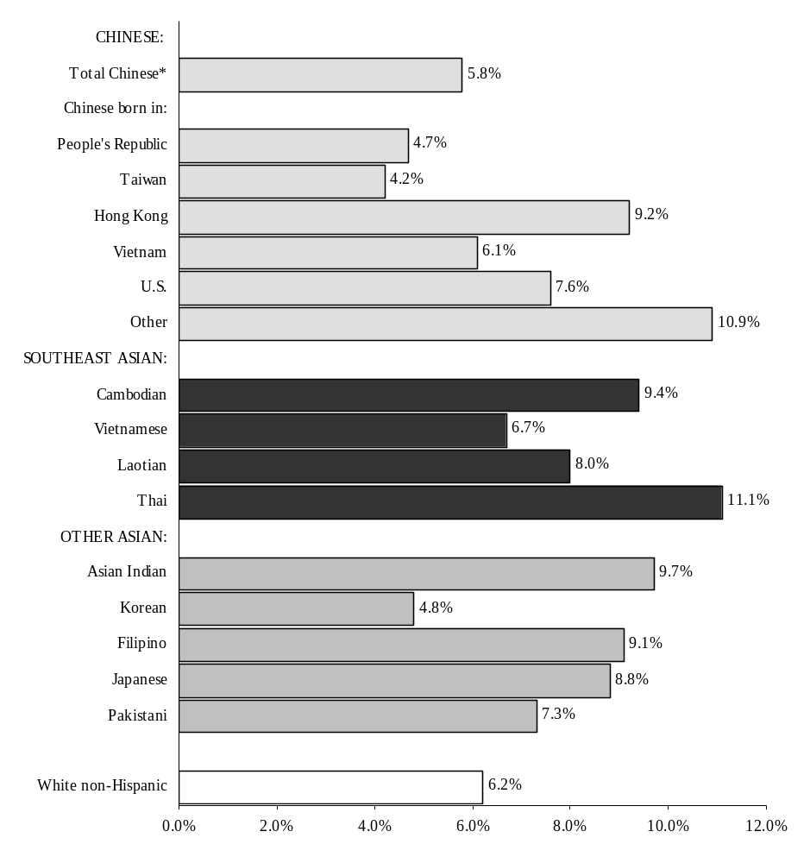
Source: Massachusetts Department of Public Health, BHSR&E (See Tables 4a and 4b.)

*Total includes 16 mothers of Chinese ancestry whose place of birth is unknown.
** Low birthweight is defined as less than 2,500 grams (5.5 lbs.).

DETAILED TABLES

Technical Notes

Limitations of Small Numbers
Cells in some tables in this publication, and particularly those tables specific to the individual cities and towns, contain small numbers and are suppressed in accordance with the guidelines set forth by the MDPH-BHSR&E for suppression of confidential data. Proportions based upon less than five observations are suppressed, and trends based upon small numbers should be interpreted cautiously.

Self-reported Data
Many items used in this publication, such as maternal smoking and type of health insurance coverage, are self-reported.

Assignment of an Infant's Race/Ethnicity
Prior to 1989, the race/ethnicity of an infant was assigned by combining information on the race/ethnicity of the mother and the race/ethnicity of the father. Since 1989, Massachusetts has followed the recommendation of the National Center for Health Statistics of classifying births according to the self-reported race/ethnicity of the mother. Therefore, beginning in 1989, the race/ethnicity of an infant is identical to the self-reported race/ethnicity of the infant's mother. Beginning in 1996, the list of ethnic categories on the birth certificate was modified. The categories used for analysis in this report are: Asian Indian, Cambodian, Chinese, Filipino, Japanese, Korean, Laotian, Pakistani, Thai, and Vietnamese.

This report utilizes the Ancestry/Ethnicity field from the birth certificate. The actual question on the birth certificate reads: “Please check one box which you feel best describes the mother’s ancestry.” A list of 42 ancestry groups is available from which to choose. Note that the ancestry question is separate from the question regarding the mother’s race. The race variable was not used to identify mothers for inclusion in this report; therefore, women of the 10 Asian ancestries included in this report could be of any race (White, Black, Asian, American Indian or Other).

Glossary

Anemia
Hemoglobin level of less than 13.0g/dL, or a hemocrit of less than 39%.

Adequacy of Prenatal Care
The Index of Adequacy of Prenatal Care (based on the Kessner Index) has five categories (adequate, intermediate, inadequate, no prenatal care, and unknown), based on the trimester in which prenatal care began and the number of prenatal visits. It is a quantitative measure and is not a measure of quality of care. The general classification scheme for full-term infants is as follows:

Category | Trimester Care Began | Number of Visits
Adequate | 1 | 9 or more
Intermediate | 1 | 5-8
 | 2 | 5 or more
Inadequate | 1 | 1-4
 | 2 | 1-4
 | 3 | 1 or more
No prenatal care | -- | 0
Unknown | Unknown | unknown

This classification is adjusted for gestational age to allow for proper classification of premature births.

Birthweight
The weight of an infant recorded at the time of delivery. It may be recorded in either pounds/ounces or grams. If recorded in pounds/ounces, it is converted to grams for use in this report.

1 pound = 453.6 grams
1,000 grams = 2 pounds and 3 ounces

Birthweight Categories
Low birthweight (LBW): An infant's weight of less than 2,500 grams (5.5 pounds) recorded at birth.
Very low birthweight (VLBW): An infant's weight of less than 1,500 grams (3.3 pounds) recorded at birth.

Breastfeeding
Mother was or was intending to breastfeed at the time the birth certificate was completed.
Cesarean Section or C-Section
Primary: A mother's first Cesarean section delivery.
Repeat: A Cesarean delivery that has been preceded by at least one Cesarean delivery.

Cesarean Section Rates

Total C-section rate = Number of C-section births X 100
Number of births

Diabetes
Metabolic disorder characterized by excessive discharge of urine and persistent thirst; includes juvenile onset, adult onset, and gestational diabetes during pregnancy.

Early Gestational Age or Preterm
Infants born before the mother completed the 37th week of pregnancy.

Eclampsia
A medical condition that affects women during or shortly after pregnancy. The condition may involve hypertension, edema, proteinuria, convulsions and coma.

Education
The level of education completed is provided on the birth certificate by the mother. The analysis of education presented in this report is limited to women 20 years of age and older.

Ethnicity
See the section in the Technical Notes titled: Assignment of an Infant's Race/Ethnicity

Gestational Age
Gestational age refers to the number of weeks the infant was in utero. Infants born before the mother completed the 37th week of pregnancy are considered early gestational age or preterm.

HMO
Health Maintenance Organization

Healthy Start
A Massachusetts-funded program providing services and financing for prenatal care to low-income pregnant women who lack health insurance but do not qualify for Medicaid.

Hepatitis B Carrier
An individual with ongoing evidence of infection with hepatitis B virus, as determined by the presence of hepatitis B surface antigen in the blood, likely to be more than six months after an acute episode of hepatitis B virus infection.

Hypertension
This includes both chronic and pregnancy-related hypertension (or high blood pressure).

Jaundice
A condition characterized by high levels of bilirubin (a bilirubin count greater than 10) and a yellowing of the patient’s skin.

Language Preference
Information on the mother’s language preference is collected from the mother at the time of birth, based on the birth certificate question, “In what language does the mother prefer to read or discuss health-related materials?”

Live Birth
A live birth is any infant who breathes or shows any other evidence of life (such as beating of the heart, pulsation of the umbilical cord, or definite movement of voluntary muscles) after separation from the mother's uterus, regardless of the duration of gestation.

Low Birthweight (LBW)
See Birthweight Categories.

MISER
MISER is the acronym for the Massachusetts Institute for Social and Economic Research. MISER, which is the official state data center designated by the U.S. Census Bureau, produces annual population estimates for intercensal years. MISER produces estimates of the combined
Asian/Pacific Islander/American Indian population. These estimates are then modified by the Bureau of Health Statistics, Research & Evaluation of the Massachusetts Department of Public Health to create separate estimates for the Asian and Pacific Islander population and the American Indian population.

NCHS
National Center for Health Statistics (U.S. Department of Health and Human Services, Centers for Disease Control and Prevention).

Non-U.S.-Born
Not born in the United States, its possessions or protectorates. (Those born in Puerto Rico, the U.S. Virgin Islands, and Guam are considered U.S.-born.)

Pediatric Provider
Information is collected on the birth certificate regarding whether or not the mother has already identified a pediatric provider for her newborn.

Private Insurance
Blue Cross/Blue Shield, commercial insurance, and health maintenance organizations (HMOs)

Public Insurance
Medicaid, Medicare, Healthy Start and other government programs.

Occurrence Birth
A birth occurring in the Commonwealth of Massachusetts, regardless of the residency of the mother. For individual cities/towns, an occurrence birth represents any birth occurring in that city/town, regardless of the residence of the mother. See Resident Birth.

Parity
The total number of live infants ever born to a woman, including the current birth.

Plurality
The number of births to a woman produced in the same gestational period. A singleton is the birth of one infant, twins represent the birth of two infants, etc.

Race
See the section in the Technical Notes titled: Assignment of an Infant's Race/Ethnicity.

Resident Birth
The birth of an infant whose mother reports that her usual place of residence is in Massachusetts. In Massachusetts, a resident is a person with a permanent address in one of the 351 cities or towns. Vital statistics data may be presented in terms either of residence or of occurrence. All data in this publication are resident data. Resident data include all events that occur to residents of the Commonwealth, wherever they occur. Occurrence data include all events that occur within the state, whether to residents or nonresidents. There is an exchange agreement among the 50 states, District of Columbia, Puerto Rico, Virgin Islands, Guam, and Canada that provides for exchange of copies of birth and death records. These records are used for statistical purposes, only, and allow each state or province to track the births and deaths of its residents.

Small for Gestational Age
The measurement of “small for gestational age” refers to the weight of the infant after taking into consideration the number of completed weeks of pregnancy.

Smoking
Information on smoking status, both before pregnancy and during pregnancy, is provided on the birth certificate by the mother.

U.S.-Born
Born in the United States, its possessions, or its protectorates. Those born in Puerto Rico, the US Virgin Islands, and Guam are considered U.S.-born.

Very Low Birthweight (VLBW)
See Birthweight Categories.

Asian Births in Massachusetts
1998-1999 Data Tables

Attached please find supplemental data tables for the report, Asian Births in Massachusetts: 1996-1997. These tables contain data for years 1998-1999 to update the appendix tables that appear in the report for 1996-1997. The 1998-1999 tables presented here retain the lettering/numbering scheme used in the report so that users can identify the corresponding tables between the two time periods for comparison purposes.

A subset of these tables appear in the report Asian Births in Massachusetts: 1998-1999 Supplement.

[Note: Tables that contain only 1990 Census or MISER population data are not reproduced here since these tables did not change between the two time periods.]

Contents:

- Statewide Data Tables
- Community Data Tables

