
BIRTH DEFECTS IN MASSACHUSETTS

Massachusetts Department of Public Health
Center for Birth Defects Research and Prevention

May 2009

INTRODUCTION

In the United States, one of every 33 infants is born with a birth defect. Although birth defects are rare when compared to other adverse birth outcomes, such as low birth weight or prematurity, they are the leading cause of death in the first year of life. Nationally, about 20% of all infant deaths are attributable to birth defects (abnormalities of structure, function or metabolism present before birth). Birth defects may also result in mental or physical disability. Some require costly medical care and cause great distress in families. The economic, emotional, and social impact on families is frequently catastrophic.

The causes of many birth defects are poorly understood. Certain genetic and environmental factors have been implicated in selected birth defects. These include prenatal environmental factors (such as infections), exposures to medications or other chemicals, drug or alcohol abuse, and nutritional deficiencies. Some birth defects can be caused by a single abnormal gene, while other birth defects arise due to a complex interplay between various genetic and environmental factors.

Studies have shown that the presence of adequate amounts of folic acid (vitamin B9) in the mother’s system before conception and during the first trimester may help prevent birth defects of the brain and spinal cord known as neural tube defects. Folate supplementation may also reduce risks of certain other birth defects.

For more than 70% of all birth defects, however, no known cause has been identified. Researchers are investigating a wide variety of environmental exposures (to the mother and fetus) and other risk factors as possible causes, with a focus on the month before and three months after conception.

BIRTH DEFECTS IN MASSACHUSETTS

In Massachusetts, birth defects are the leading cause of infant death and substantially contribute to prematurity. Among live births and stillbirths to Massachusetts residents in 2004-2005, 2,590 (2,536 live births and 54 stillbirths) had one or more structural birth defects for a prevalence rate of 166.8 per 10,000 live births.

Cardiovascular birth defects are the most commonly occurring birth defects in both Massachusetts and the
nation and contribute more to infant deaths than any

Most Common Types of Birth Defects,
Massachusetts: 2004-2005

other birth defect category. Of the ten most common birth defects in 2004-2005, three (atrial septal defects, ventricular septal defects, and valvular pulmonary stenosis) were cardiovascular in nature. Common non-cardiovascular defects included Down syndrome, polydactyly/syndactyly, hypospadias, clubfoot, orofacial clefts, and obstructive genitourinary defects.

Birth Defects & Selected Pregnancy Outcomes

Adverse pregnancy outcomes (C-sections, low birth weight, prematurity, multiple birth and infant death) are more frequent among infants born with birth defects than among infants born without birth defects. C-section deliveries were
38.5% higher for birth defect cases than births without birth

Pregnancy Outcomes,
Massachusetts: 2004-2005
defects. Birth defect cases were 2.8 times more likely to have low birth weight (less than 2,500 grams) and 2.4 times more likely to be born premature compared to births without birth defects. Infants with birth defects were 12.4 times more likely to die before their first birthday compared to infants without birth defects. While numbers of infants with birth defects are relatively small, it is important to recognize the long-term medical, economic and human impact of these outcomes when diagnosing and treating a baby with a birth defect.

Infant Sex

The Massachusetts’ birth defect prevalence rates for 2004-2005 were 135.0 among females and 197.6 among males per 10,000 live births. While the prevalences of most types of birth defects did not substantially differ by sex of the infant or fetus, male infants uniquely had hypospadias, but they were also more likely than female infants to have obstructive genitourinary defects, Hirschsprung disease, clubfoot, polydactyly/syndactyly, and cleft lip with or without cleft palate.
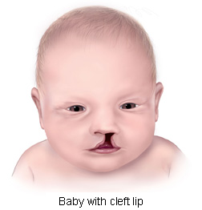

Baby with cleft lip
Courtesy of the Centers for Disease Control and Prevention.

Birth Defects in Massachusetts vs the US

Massachusetts has been one of 11 states with population-based monitoring programs to contribute birth defect data to the CDC’s published national prevalence estimates for 18 selected major birth defects. Massachusetts’ rates for 2004-2005 were significantly lower than US rates for about
half of the birth defects and were about the same as the national estimates for the other half. Differences in surveillance system methodology and regional variation may account for the lower rates for some defects.

Prevalence Rates for Massachusetts and the United States for Selected Birth Defects, 2004-2005 v,
Notably, in 2004-2005, birth defects were not reported in Massachusetts when they were prenatally diagnosed and the pregnancy was subsequently electively terminated. This selective ascertainment would tend to result in lower rates for Massachusetts for certain birth defects. Spontaneous deliveries of stillbirths greater than or equal to 20 weeks of gestation were reported by birthing hospitals. However, limited information about stillbirths is included in the maternal record. As a result, some birth defects in stillbirths are not well documented and are unable to be confirmed for inclusion in state as well as national surveillance.

Maternal Age & Birth Defects

The number of births to older mothers has been increasing over time in Massachusetts. There is a higher prevalence of birth defects and chromosomal defects in particular among mothers older than age 35.

Prevalence by Maternal Age¹,
Massachusetts: 2004-2005
Maternal  Age | # Cases | Rate² | 95% CI
<20 | 145 | 157.6 | (133.0-185.5)
20-24 | 379 | 161.5 | (145.7-178.4)
25-29 | 556 | 154.7 | (142.2-168.0)
30-34 | 791 | 158.4 | (147.6-169.7)
35+ | 665 | 181.1 | (167.7-195.3)

¹ Live births only.
² Rate per 10,000 live births. n = 2,536

Down syndrome and gastroschisis are two birth defects of interest in cases of relatively older or younger mothers, respectively.

Down Syndrome

As noted, there is a strong association established between the rate of Down Syndrome and advanced maternal age.

Rates of Down Syndrome among Maternal Age Groups, Massachusetts: 2004-2005
Although 45% of babies with Down syndrome were born to women under 35, the Down syndrome rate of 27.0 per 10,000 live births for women 35 years and older was about three times that of any other maternal age group.

Gastroschisis

On the other hand, gastroschisis is a defect that preferentially occurs among younger mothers, and is a condition of particular concern for that reason. In neonates with gastroschisis, the intestines—and sometimes other organs—protrude through a defect in the abdominal wall. During 2004-2005, younger mothers (age 19 and under) in Massachusetts had the highest rate (14.1 per 10,000 live births) of babies born with gastroschisis.

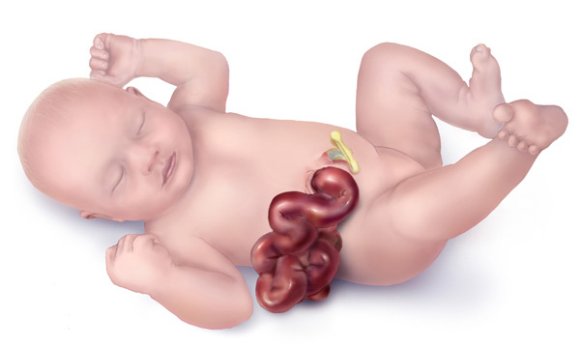

Baby with gastroschisis
Courtesy of the Centers for Disease Control and Prevention.

Rates of Gastroschisis among Maternal Age Groups, Massachusetts: 2004-2005

Assisted Reproductive Technology

The CDC reports that more than 1 percent of all infants today are conceived through assisted reproductive technology (ART). In 2005, Massachusetts was one of the five states with the highest frequencies of ART procedures performed, which may be due in part to more complete insurance coverage for ART in MA. Importantly, infants conceived by ART have been shown to be at two to four times greater risk for certain birth defects than infants conceived naturally.^{ix}

Multiple Births

Birth defects are more common among multiple births (more than one fetus) than in singleton births, and the number of multiple births has been increasing over time in Massachusetts. The birth defect prevalence rate was 164.3 for singletons and 216.4 for multiple births per 10,000 live births. Birth defects that commonly occurred in multiple births included atrial septal defects, hypospadias, clubfoot, Down syndrome, and tetralogy of Fallot.

Maternal Race / Hispanic Ethnicity

In Massachusetts and nationally, the prevalences of some birth defects are similar across all race groups, but other birth defects appear to vary by maternal race and Hispanic ethnicity. Possible explanations for the differences include genetic variation, diet and lifestyle, and varying access to prenatal screening and health care services.

Birth Defects by Maternal Race/Ethnicity¹,
Massachusetts: 2004-2005
Maternal  Race | #  Cases | Age-Adjusted  Rate² | 95% CI
White, Non-Hispanic | 1,761 | 161.8 | (154.3-169.4)
Black, Non-Hispanic | 219 | 187.5 | (162.6-212.3)
Hispanic | 331 | 183.4 | (163.6-203.1)
Asian, Non-Hispanic | 152 | 141.4 | (118.9-163.9)
Other | 72 | 195.5 | (150.4-240.7)
¹ Live births only.
² Rate per 10,000 live births. n = 2,535 (1 unknown race/ethnicity)

Birth Defects by Massachusetts Region

The Massachusetts Executive Office of Health and Human Services delineates regions for use by the Department of Public Health for statistical, care coordination, and administrative purposes. The birth defect prevalences in six Massachusetts regions were not statistically significantly different.
Birth Defects by Region¹,
Massachusetts: 2004-2005
¹ Live births only.
Region | #  Cases | Age-Adjusted  Rate² | 95% CI
Western | 270 | 148.7 | (131.0-166.5)
Central | 357 | 169.5 | (152.0-187.1)
Northeast | 503 | 156.8 | (143.1-170.5)
MetroWest | 580 | 162.8 | (149.8-176.3)
Southeast | 510 | 172.9 | (157.9-187.9)
Boston | 316 | 162.7 | (145.2-181.1)
² Rate per 10,000 live births. n = 2,536

The Financial Burden of Birth Defects

A recent estimate of hospital costs during the first two years of life for Massachusetts children born between 1998 and 2004 with orofacial clefts was $10 million.
The Massachusetts combined lifetime costs for babies born with 12 major structural birth defects were an estimated $125 million in 2005 dollars. Nationally, the lifetime costs of 18 common birth defects have been estimated to be $11 billion. These figures include direct costs of medical treatment, developmental services and special education, as well as indirect costs to society for lost wages due to early death or occupational limitations. Psychosocial costs are also of concern but are difficult to directly quantify.

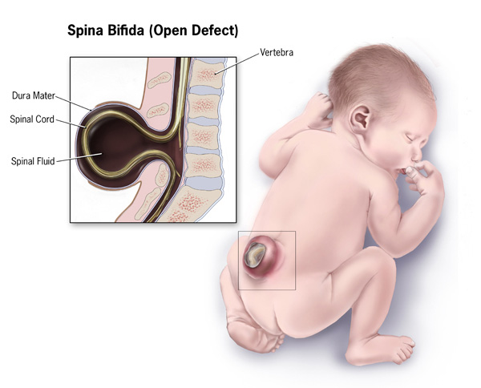

Baby with spina bifida
Courtesy of the Centers for Disease Control and Prevention.

THE MASSACHUSETTS CENTER FOR BIRTH DEFECTS RESEARCH AND PREVENTION

The Massachusetts Center for Birth Defects Research and Prevention is a key component of the Massachusetts public health system. It is made up of experienced staff from the Massachusetts Department of Public Health, Boston University’s Slone Epidemiology Center, and the Active Malformation Surveillance Program at Brigham and Women’s Hospital. The Center also draws on the expertise of the region’s clinicians and researchers and fosters communication among them.


Courtesy of the Centers for Disease Control and Prevention.

The Massachusetts Center performs the following activities: collects data on subjects with birth defects and identifies related trends; searches for causative factors linked with birth defects; addresses community concerns about birth defects; provides information and referral to families of children with birth defects; and measures the success of screening and prevention efforts.

FOR MORE INFORMATION
Marlene Anderka, ScD, MPH
Director | Center for Birth Defects Research & Prevention
Massachusetts Department of Public Health
Phone: 1-888-302-2101 (toll free)
marlene.anderka@state.ma.us

OUR WEBSITE
www.mass.gov/dph/birthdefects

RESOURCES ON THE WEB

Massachusetts Department of Public Health
www.mass.gov/DPH

March of Dimes
www.marchofdimes.com

Centers for Disease Control & Prevention
www.cdc.gov/ncbddd/bd

Photo of mother and baby on front page courtesy of the Centers for Disease Control and Prevention.

REFERENCES

Centers for Disease Control and Prevention (CDC). Basic Facts about Birth Defects. 2007. http://www.cdc.gov/ncbddd/bd/facts.htm Accessed February 11, 2009.
Centers for Disease Control and Prevention (CDC). National Center for Birth Defects and Developmental Disabilities. Birth Defects. ^{http://www.cdc.gov/ncbddd/bd/} Accessed February 11, 2009.
Wolff, T., C. T. Witkop, et al. (2009). "Folic Acid Supplementation for the Prevention of Neural Tube Defects: An Update of the Evidence for the U.S. Preventive Services Task Force." Ann Intern Med 150(9): 632-639.
Yoon PW, Rassmussen SA et al (2001). “The National Birth Defects Prevention Study.” Public Health Reports 116: 32-40.
CDC (2006). "Improved national prevalence estimates for 18 selected major birth defects--United States, 1999-2001." MMWR Morb Mortal Wkly Rep 54(51): 1301-5.
CDC (2004). "Spina bifida and anencephaly before and after folic acid mandate--United States, 1995-1996 and 1999-2000." MMWR Morb Mortal Wkly Rep 53(17): 362-5.
CDC (2009). "Assisted reproductive technology and trends in low birthweight— Massachusetts, 1997-2004." MMWR Morb Mortal Wkly Rep 58(3): 49-52.
Wright, V. C., J. Chang, et al. (2008). "Assisted reproductive technology surveillance—United States, 2005." MMWR Surveill Summ 57(5): 1-23.
Reefhuis, J., M. A. Honein, et al. (2009). "Assisted reproductive technology and major structural birth defects in the United States." Hum Reprod 24(2): 360-6.
Harris, JA. State-by-state cost of birth defects—1992. Teratology. Vol. 56, No.1/2, July/August 1997: 11-16. (Adjusted for inflation to 2005 dollars.)
Waitzman, NJ et al. Estimates of the economic costs of birth defects. Inquiry. 1994; 31(2): 188-205. (Adjusted for inflation to 2005 dollars.)

