
BIRTH DEFECTS IN MASSACHUSETTS 2008 - 2010
Massachusetts Department of Public Health
Center for Birth Defects Research and Prevention
December 2013

INTRODUCTION

One of every 33 infants is born with a birth defect in the United States., Birth defects are defined as the presence of abnormalities of structure, function or metabolism present before birth, and, although they are rare when compared to other adverse birth outcomes like low birth weight or prematurity, birth defects are the leading cause of death in the first year of life. Nationally, about 20% of all infant deaths are attributable to birth defects. Birth defects may also result in mental or physical disability, may require costly medical care, and can result in economic, emotional, and social distress for families.

The causes of many birth defects are poorly understood. Certain genetic and environmental factors have been implicated in selected birth defects. These include prenatal environmental factors (such as infections), exposures to medications or other chemicals, drug or alcohol abuse, and nutritional deficiencies. Some birth defects can be caused by a single abnormal gene, while others arise due to a complex interplay between various genetic and environmental factors.

Studies have shown that the presence of adequate amounts of folic acid (vitamin B9) in the mother’s system before conception and during the first trimester may help prevent birth defects of the brain and spinal cord known as neural tube defects. Folate supplementation may also reduce the risk of other birth defects.

However, for more than 70% of all birth defects, no known cause has been identified. Researchers are investigating a wide variety of environmental exposures and other risk factors as possible causes, with a focus on the month before and three months after conception.

BIRTH DEFECTS IN MASSACHUSETTS

In Massachusetts, birth defects are the leading cause of infant death and substantially contribute to prematurity. Among births to mothers residing in Massachusetts in 2008-2010, 4,012 (3,931 live
births and 81 stillbirths) had one or more structural birth defects with a prevalence rate of 178.5 per 10,000 live births.


Cardiovascular birth defects are the most commonly occurring birth defects in both Massachusetts and the nation and contribute more to infant deaths than any other type of birth defect. Of the ten most common birth defects occurring between 2008 and 2010, three (atrial septal defects, ventricular septal defects, and valvular pulmonary stenosis) were cardiovascular in nature. The most common non-cardiovascular defects among the most common defects were polydactyly/syndactyly, obstructive genitourinary defect, clubfoot, hypospadias, Trisomy 21 (Down syndrome), and orofacial clefts.

Most Common Types of Birth Defects by Body System,
Massachusetts: 2008-2010
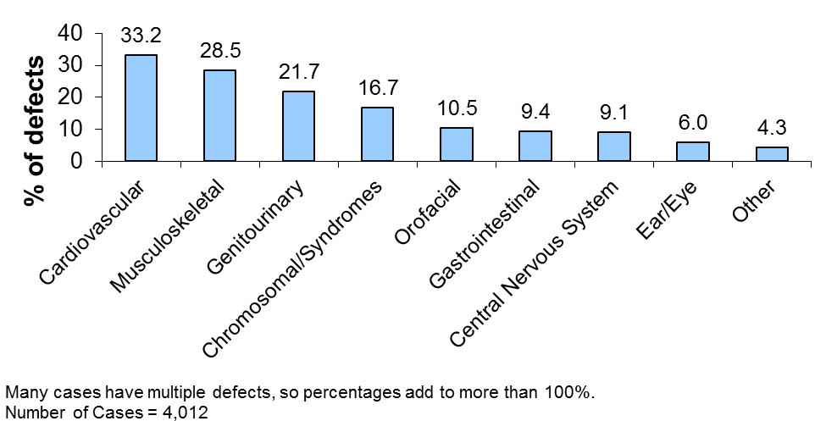

Birth Defects & Selected Pregnancy Outcomes

Adverse pregnancy outcomes (low birth weight, prematurity, multiple birth and infant death) and caesarian delivery (c-section) are more frequent among infants born with birth defects than among infants born without birth defects. The rate of C-section deliveries was 28.5% higher for infants with birth defects than unaffected infants.

Pregnancy Outcomes, Massachusetts: 2008-2010

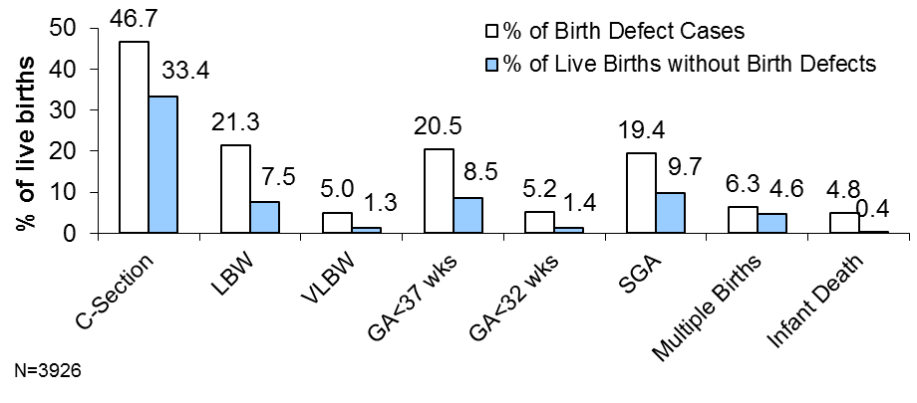

Infants with a birth defect were 2.8 times more likely to have low birth weight (LBW, less than 2,500 grams) and 2.4 times more likely to be born premature (gestational age < 37 weeks) compared to births without birth defects. Infants with birth defects were 12.0 times more likely to die in their first year compared to infants without birth defects. While the number of infants with birth defects is relatively small, it is important to recognize its long-term medical, economic, and emotional impact.

Infant Sex

The Massachusetts’ birth defect prevalence rates in 2008-2010 were 207.3 and 146.8 per 10,000 live births among males and females, respectively. While the prevalence of most types of birth defects did not substantially differ by sex of the infant or fetus, males infants were significantly more likely than female infants to have obstructive genitourinary defects, polydactyly/syndactyly, clubfoot, and cleft lip (with or without cleft palate) while female infants were more likely to have cleft palate without cleft lip. Male infants were uniquely susceptible to hypospadias.

Birth Defects in Massachusetts vs. the US

Massachusetts has been one of 11 states with population-based monitoring programs to contribute birth defect data to the CDC’s published national prevalence estimates for 18 selected major birth defects. Massachusetts’ rates for 2008-2010 were significantly lower than US rates for the anencephaly, spina bifida, cleft lip and gastroschisis. Massachusetts’ rates were lower (but not significantly) or about the same as the national estimates for the other selected defects. Differences in surveillance system methodology and regional variation may account for the lower rates for some defects.

Notably, by 2010, Massachusetts had not yet begun ascertaining prenatally diagnosed birth defects before a subsequent pregnancy loss (i.e. elective termination or miscarriage). This selective ascertainment would tend to result in lower detectable rates in Massachusetts for certain birth defects—particularly those incompatible with life.
Information on spontaneous deliveries of stillbirths greater than or equal to 20 weeks of gestation or birthweight over 350 grams was reported by birthing hospitals. However, only limited information about stillbirths is included in the maternal record. As a result, some birth defects among stillbirths are not well documented and are unable to be confirmed for inclusion in state and national surveillance estimates.

Prevalence Rates for Selected Birth Defects, Massachusetts and the United States: 2008-2010v

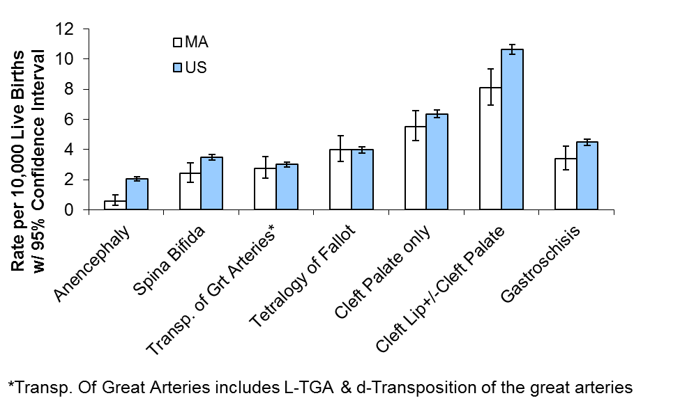

Maternal Age & Birth Defects

The number of births to older mothers has been increasing over time in Massachusetts^{x}. There is a higher prevalence of chromosomal defects in particular among mothers older than 35. This age group also appears to have the highest prevalence of birth defects overall.

Birth Defect Prevalence Rate by Maternal Age¹,
Massachusetts: 2008-2010
Maternal  Age | # Cases | Rate² | 95% CI
<20 | 234 | 178.7 | (156.5 – 203.1)
20-24 | 634 | 177.0 | (163.6 – 191.2)
25-29 | 928 | 167.1 | (156.6 – 178.1)
30-34 | 1095 | 157.7 | (148.5 – 167.2)
35+ | 1035 | 203.5 | (191.4 – 216.2)

¹ Live births
² Rate per 10,000 live births. n = 3,931 (5 unknown age)

Two birth defects of interest, because they occur most often in specific age groups, are Down syndrome and gastroschisis. Down syndrome occurs most often among mothers 35 years and older while gastroschisis occurs overwhelmingly in mothers less than 20 years of age.

Down Syndrome

As noted, there is a strong association established between the rate of Down syndrome and advanced maternal age. Although slightly more than half (54.2%) of live born babies with Down syndrome were born to women 35 years and older, the rate of Down syndrome in those mothers (29.5 per 10,000 live births) was more than four times that of mothers under 35 years (7.3 per 10,000 live births)

Prevalence Rates for Down Syndrome by Maternal Age Group for Live Births, Massachusetts: 2008-2010
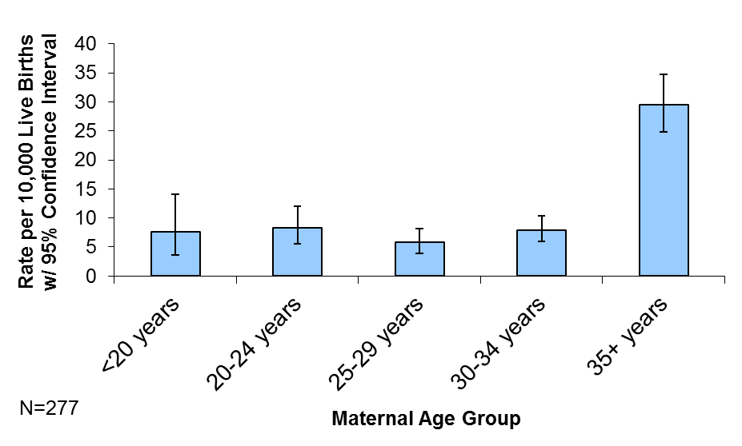

Gastroschisis

Gastroschisis, a condition where a child is born with the intestines—and sometimes other organs—protruding through a defect in the abdominal wall, occurs more often among younger mothers. Between 2008 and 2010, the youngest mothers (less than 20 years) in Massachusetts had the highest rate (16.8 per 10,000 live births) of babies born with gastroschisis.

Prevalence Rates for Gastroschisis by Maternal Age Group for Live Births, Massachusetts: 2008-2010
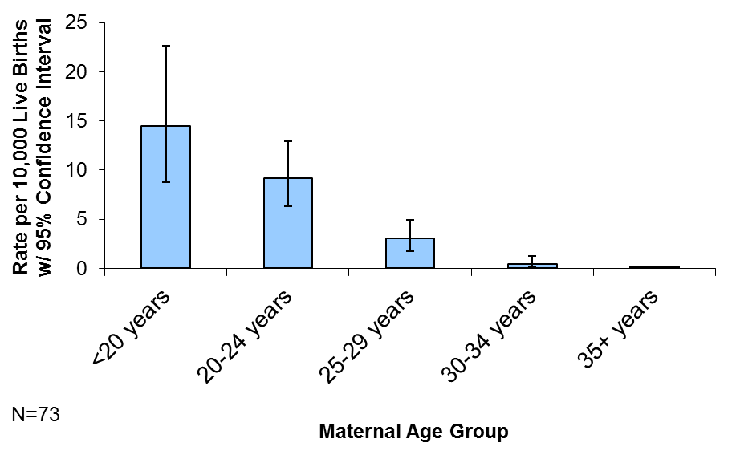

Assisted Reproductive Technology

The CDC reports that more than 1 percent of all infants today are conceived through the use of assisted reproductive technology (ART). In 2009, Massachusetts was the state with the fifth highest number of live-birth deliveries as a result of ART, which may be due in part to high rates of insurance coverage for ART in MA and a higher proportion of older women of reproductive age trying to conceive.. Infants conceived by have two to four times the risk for certain birth defects than infants conceived naturally.^{ix}

Multiple Births

Birth defects are more common among multiple births (more than one fetus) than in singleton births. The percent of births in Massachusetts that are multiples has fluctuated from a low of 4.2% to a high of 4.6% for the last 10 years.^{x} The birth defect prevalence rate in 2008-2010 was 173.8 and 275.0 per 10,000 live births for singletons and multiple births, respectively. Though many of the same defects—atrial septal defect, ventricular septal defect, hypospadias, clubfoot, obstructive genitourinary defect, polydactyly/syndactyly, Trisomy 21, cleft lip, and pulmonary stenosis—are among the most common in multiple and singleton births, all but polydactyly/syndactyly and obstructive genitourinary defects occur significantly more often among multiple births than in singleton births.

Maternal Race / Hispanic Ethnicity

In Massachusetts and nationally, the prevalences of some birth defects are similar across all race groups, but other birth defects appear to vary by maternal race and Hispanic ethnicity. Possible explanations for the differences include genetic variation, diet and lifestyle, and varying access to prenatal screening and health care services.

Birth Defect Prevalence Rate by Maternal Race/Ethnicity¹, Massachusetts: 2008-2010

Maternal  Race | #  Cases | Age-Adjusted  Rate² | 95% CI
White, Non-Hispanic | 2618 | 174.2 | (167.5 – 180.9)
Black, Non-Hispanic | 415 | 203.5 | (183.9 – 223.0)
Hispanic | 568 | 180.6 | (165.8 – 195.5)
Asian, Non-Hispanic | 243 | 143.4 | (125.3 – 161.4)
Other | 75 | 196.6 | (152.1 – 241.2)
¹ Live births only.
² Standardized to age-distribution of MA; rate per 10,000 live births. n = 3,919 (12 unknown race)

Birth Defects by Massachusetts Region

The Massachusetts Executive Office of Health and Human Services (EOHHS) delineates regions for use by the Department of Public Health for statistical, care coordination, and administrative purposes. The differences in birth defect prevalences among the six Massachusetts EOHHS regions were not statistically significant.

Birth Defect Prevalence Rate by Residence of Mother at Delivery¹, Massachusetts: 2008-2010

EOHHS  Region | #  Cases | Age-Adjusted  Rate² | 95% CI
Western | 461 | 180.4 | (163.9 - 196.9)
Central | 515 | 178.1 | (162.7 - 193.5)
Northeast | 836 | 178.3 | (166.2 - 190.4)
MetroWest | 840 | 165.5 | (154.3 - 176.7)
Southeast | 714 | 177.8 | (164.8 - 190.9)
Boston | 560 | 182.3 | (167.2 - 197.4)
¹ Live births only.
² Rate per 10,000 live births. n = 3,926 (5 unknown region)

The Financial Burden of Birth Defects

The Massachusetts combined lifetime cost for babies born with 12 major structural birth defects was estimated at $141.8 million in 2010 dollars.^{i} Nationally, the lifetime cost of 18 common birth defects has been estimated to be $12.5 billion.^{i} These figures include direct costs of medical treatment, developmental services and special education, as well as indirect costs to society for lost wages due to early death or occupational limitations. Psychosocial costs are also of concern but are difficult to directly quantify.

THE MASSACHUSETTS CENTER FOR BIRTH DEFECTS RESEARCH AND PREVENTION

The Massachusetts Center for Birth Defects Research and Prevention is a key component of the Massachusetts public health system. It is made up of experienced staff from the Massachusetts Department of Public Health, Boston University’s Slone Epidemiology Center, and the Active Malformations Surveillance Program at Brigham and Women’s Hospital (which ended operations in October, 2012). The Center also draws on the expertise of the region’s clinicians and researchers and fosters communication among them.

The Massachusetts Center performs the following activities: collects data on infants with birth defects and identifies related trends; searches for causative factors linked with birth defects; addresses community concerns about birth defects; provides information and referral to families of children with birth defects; and measures the success of screening and prevention efforts.

FOR MORE INFORMATION
Marlene Anderka, ScD, MPH
Director, Center for Birth Defects Research & Prevention
Massachusetts Department of Public Health
Phone: 1-888-302-2101 (toll free)
Email: marlene.anderka@state.ma.us

ON THE WEB
www.mass.gov/dph/birthdefects
www.cdc.gov/ncbddd/bd



REFERENCES

Centers for Disease Control and Prevention (CDC). National Center o^{n} Birth Defects and Developmental Disabilities. Birth Defects. ^{http://www.cdc.gov/ncbddd/bd/} Accessed February 11, 2009.
Centers for Disease Control and Prevention (CDC). Basic Facts about Birth Defects. 2007. http://www.cdc.gov/ncbddd/birthdefects/facts.html Accessed February 11, 2009.
Wolff, T., C. T. Witkop, et al. (2009). "Folic Acid Supplementation for the Prevention of Neural Tube Defects: An Update of the Evidence for the U.S. Preventive Services Task Force." Ann Intern Med 150(9): 632-639.
Yoon PW, Rassmussen SA et al (2001). “The National Birth Defects Prevention Study.” Public Health Reports 116: 32-40.
(CDC 2010). Parker SE, Mai CT, Canfield MA. Updated National Birth Defects Prevalence Estimates for Selected Birth Defects in the US, 2004-2006. Birth Defects Research (Part A) 2010; 88: 1008-1016.
CDC (2009). "Assisted reproductive technology and trends in low birthweight— Massachusetts, 1997-2004." MMWR Morb Mortal Wkly Rep 58(3): 49-52.
Sunderam S., Chang J. et al (2009). "Assisted reproductive technology surveillance—United States, 200⁹." MMWR Surveill Summ^{aries} ⁶¹(^{SS7}): 1-2³.
Reefhuis, J., M. A. Honein, et al. (2009). "Assisted reproductive technology and major structural birth defects in the United States." Hum Reprod 24(2): 360-6.
Massachusetts Births 2010. Boston, MA: Division of Research and Epidemiology, Bureau of Health Information, Statistics, Research, and Evaluation, Massachusetts Department of Public Health. March 2013 http://www.mass.gov/eohhs/gov/departments/dph/programs/health-stats/repi/birth-data.html ?^{i} Harris, JA. State-by-state cost of birth defects—1992. Teratology. Vol. 56, No.1/2, July/August 1997: 11-16. (Adjusted for inflation to 20¹⁰ dollars.);
^{i} Waitzman, NJ et al. Estimates of the economic costs of birth defects. Inquiry. 1994; 31(2): 188-205. (Adjusted for inflation to 20¹⁰ dollars.) ______________________________________________________________________________________________ All photos courtesy of the Centers for Disease Control and Prevention

