Massachusetts Birth Defects

Among Live and Stillbirths

2008-2010



Massachusetts Birth Defects Monitoring Program

Bureau of Family Health and Nutrition

Massachusetts Department of Public Health

December 2013

Massachusetts Birth Defects

Among Live and Stillbirths

2008-2010

Deval L. Patrick, Governor
John Polanowicz, Secretary, Executive Office of Health and Human Services
Cheryl Bartlett, Commissioner, Massachusetts Department of Public Health
Ron Benham, Director, Bureau of Family Health and Nutrition

Marlene Anderka, Director, Massachusetts Center for Birth Defects Research and

Prevention

Cathleen Higgins, Birth Defects Surveillance Coordinator

Christopher Borger, Birth Defects Epidemiologist

Massachusetts Department of Public Health
http://www.mass.gov/dph/birthdefects

November 2013

Acknowledgements

This report was prepared by the staff of the Massachusetts Center for Birth Defects Research and Prevention (MCBDRP) including: Christopher Borger, Marlene Anderka, Kelly Getz, Cathleen Higgins, Angela Lin, Rebecca Liberman, and Gerlinde Munshi.

Data in this report have been collected through the efforts of the medical abstractors of the MCBDRP including: Roberta Aucoin, Daniel Sexton, Lori Tetrault, Washa Liu, and Mitcheka Jalali.
We would like to acknowledge the following individuals for their time and commitment to supporting our efforts in improving the MCBDRP.

Lewis Holmes, MD, Mass General Hospital for Children
Carol Louik, ScD, Slone Epidemiology Center, Boston University
Allen Mitchell, MD, Slone Epidemiology Center, Boston University

Martha Werler, ScD, Slone Epidemiology Center, Boston University

Ed Doherty, March of Dimes Massachusetts Chapter

Registry of Vital Records and Statistics staff
Bureau of Health Information, Statistics, Research and Evaluation
Massachusetts Department of Public Health

Coleen Boyle, PhD, and staff

Division of Birth Defects and Developmental Disabilities
National Center on Birth Defects and Developmental Disabilities
Centers for Disease Control and Prevention

Funding for surveillance of 2008-2010 birth defects in Massachusetts was provided in part by the Centers for Disease Control and Prevention via the Centers for Birth Defects Research and Prevention Grant # U50-CCU113247.

For more information, contact:
Massachusetts Department of Public Health
Bureau of Family Health and Nutrition
Massachusetts Center for Birth Defects Research and Prevention
Massachusetts Birth Defects Monitoring Program
250 Washington Street
Boston, MA 02108
(617) 624-5510

This and other Department of Public Health publications and materials can be downloaded from the Internet at:
http://www.mass.gov/dph

Note to Readers: Changes in this year’s report

This report contains changes from previous reports. These are outlined by section.

Section Change or addition

Chapter 3 The figure for the overall trend in birth defect prevalence added in the last report was modified to represent a 2-year rolling.

A chart depicting a ten-year trend in the prevalence of hypospadias was added.

Chapter 5 The previous bar-chart comparing two-year, age-adjusted overall birth defect prevalence rates among race/ethnicities was replaced by a line-graph showing the 2-year rolling averages for the overall, age-adjusted birth defect prevalence rates. This does a better job showing trends over time.

TABLE OF CONTENTS

EXECUTIVE SUMMARY 11
Related Public Health Resources 16
Suggested Citation 16

Chapter 1: INTRODUCTION 18
Public Health Importance of Birth Defects 19
Birth Defects Surveillance in Massachusetts 21

Chapter 2: METHODS 24
Case Definition 25
Data Collection 25
Confidentiality 26

Data Analysis 26
Data Limitations 26

Chapter 3: PREVALENCE OF BIRTH DEFECTS 28

Table 1. Prevalence of Birth Defects 33
Figure 1. Overall Birth Defect Prevalence by Year 36
Table 2. Comparison of Selected Birth Defects to National Estimates 37
Table 3. Prevalence of Selected Birth Defects Adjusted for Cases
Not Currently Included in Massachusetts Surveillance (i.e.
Elective Termination) 38
Figure 2. Most Common Types of Birth Defects 39
Figure 3. Birth Defect Prevalence by Interpregnancy Interval 39

Table 4. Most Common Defects among Live Births and Stillbirths 40
Table 5. Counts of Birth Defects by Pattern among Live
Births and Stillbirths 41
Figure 4. Pregnancy Outcomes: Birth Defect Cases Compared to
Unaffected Live Births 44
Table 6. Prevalence of Birth Defects by Sex of Infant among Live
Births and Stillbirths 45
Table 7. Most Common Defects by Sex of Live Births and Stillbirths 52
Figure 5. Prevalence of Selected Birth Defects by Sex of Infant among
Live Births and Stillbirths 53
Figure 6a Age-adjusted Prevalence of Gastroschisis 53
Figure 6b Prevalence of Hypospadias 54

Chapter 4: PREVALENCE OF BIRTH DEFECTS BY PLURALITY
AND MATERNAL AGE 55
Table 8. Prevalence of Birth Defects by Plurality of Live Births and Stillbirths 58
Table 9. Most Common Defects by Plurality of Live Births and Stillbirths 65
Figure 7. Plurality of All Live Births and Birth Defect Cases 66
Figure 8. Prevalence of Selected Birth Defects by Plurality among Live Births
and Stillbirths 67
Table 10. Prevalence of Birth Defects by Maternal Age Group for Live Births 68
Figure 9. Rates of Down Syndrome by Maternal Age Group 82
Figure 10. Chromosomal and All Other Defects by Maternal Age Group 82
Figure 11. Rates of Gastroschisis among Maternal Age Group 83
Figure 12. Births by ART Use and Plurality 83
Table 11. Most Common Defects by Maternal Age among Live Births 84

Chapter 5: PREVALENCE OF BIRTH DEFECTS BY RACE / ETHNICITY

AND REGION 85
Table 12. Prevalence of Birth Defects by Maternal Race / Hispanic Ethnicity
for Live Births 89
Table 13. Most Common Defects by Maternal Race / Hispanic Ethnicity for
Live Births 101
Figure 13. Age-Adjusted Prevalence of Chromosomal and All Other Defects
by Maternal Race / Hispanic Ethnicity 102
Figure 14. Prevalence of Birth Defects by Maternal Race / Hispanic Ethnicity
and Birthplace 102
Figure 15. Age-Adjusted Prevalence of Birth Defects by Maternal Race /
Hispanic Ethnicity 103
Figure 16. Age-Adjusted Prevalence of Birth Defects by Region 103

Chapter 6: PREVALENCE OF BIRTH DEFECTS BY SEVERITY,

ETIOLOGY AND PATTERN 104

Table 14. Percentage of Birth Defect Cases by Severity Groups 108

Table 15. Pattern and Etiology of Birth Defect Cases 108

Figure 17. Birth Defect Cases with Known Etiology 109

Figure 18. Pattern of Birth Defect Cases with Unknown Etiology 109

APPENDICES 110
Technical Notes 111
Pattern Assignment Definitions 112
2008-2010 Populations Used in Calculating Rates 113
Birth Defect Codes and Exclusions by Defect Category 114
ICD9-CM/BPA Codes with Counts-Live Births and Stillbirths 119
Birth Defects by Severity 130
Glossary of Selected Birth Defect Terms 133
Map of Massachusetts EOHHS-Defined Regions and Overall, Age-Adjusted 137
Rate of Birth Defects
Frequency of Daily Multivitamin Use in the Month Prior to Pregnancy by
Socio-demographic Characteristics 138
Folic Acid Awareness and Behavior in Women Aged 18-44 139

References 140
Massachusetts Birth Defects 2008-2010 Evaluation Form 142

Executive Summary

Although birth defects are rare when compared to other adverse birth outcomes, such as low birthweight or prematurity, they are the second leading cause of death in the first year of life, the third largest cause of death between the ages of one and fourteen, and among the top ten causes of death among 15-24 year olds in Massachusetts. Nationally, about 20% of all infant deaths—defined as death within the first year of life—result from a birth defect. In Massachusetts, 15.0% of all infant deaths were attributable to birth defects (MADPH 2012).

The causes of birth defects are poorly understood. For 60-70% of major birth defects, no known cause has been identified. Researchers are looking at a wide variety of environmental exposures and risk factors as possible causes. Because most of the structural development of the fetus occurs during early pregnancy, studies usually focus on the “periconceptional” period, from the month before through the three months after conception. For the developing pregnancy, the environment includes any exposures to the fetus as well as any exposures to the mother.

Folic acid deficiency is related to certain birth defects. Although there is increased awareness of the importance of folic acid in preventing birth defects, almost half of Massachusetts mothers in Massachusetts with recent live births surveyed as part of the Centers for Disease Control and Prevention (CDC) Pregnancy Risk Assessment Monitoring System (PRAMS) did not take any multivitamins or prenatal vitamins during the month prior to pregnancy (Lu 2009).

The Massachusetts combined lifetime cost for babies born with any of the 12 major structural birth defects was estimated to be $141.8 million in 2010 dollars (see Technical Notes for inflation adjustment) (Harris and James 1997). These figures include direct costs of medical treatment, developmental services and special education, as well as indirect costs to society for lost wages and occupational limitations due to early death of or care for a child. The psychosocial costs cannot be calculated.

Over the past thirteen years, the Massachusetts Center for Birth Defects Research and Prevention (MCBDRP), aka “The Center” has developed and refined the surveillance performed through the Birth Defects Monitoring Program (BDMP). The first full year of population-based, active statewide surveillance data was 1999. The primary focus of the state surveillance system is the identification of major structural birth defects, with or without a chromosomal abnormality and non-chromosomal malformation syndromes. Inborn errors of metabolism such as phenylketonuria and congenital hypothyroidism are monitored separately by the state newborn screening program.

This report presents statewide data on the prevalence of birth defects among live births and stillbirths in Massachusetts during the years 2008, 2009, and 2010 and adds one year of new data to the previously published 2008-2009 report. Due to a change to the birth certificate in 2011 the BDMP decided to produce a report that includes three years of available data prior to this changeover. Our ability to find and identify infants born with birth defects to Massachusetts residents has improved over time and is reflected in increasing prevalence rates year-on-year (Figure 1). The 2008-2010 data are presented in combined form since the numbers are relatively small for individual defects. As in previous years, given the BDMP’s continued improvements in birth defects ascertainment, interpretations of these data with respect to previous reports must be made with caution.

The data allow for some preliminary trend analyses and evaluation of the efficacy of public health prevention efforts such as folic acid awareness and newborn screening. The BDMP continues to monitor and improve case ascertainment quality so that reliable and accurate data are available to inform policy planning of public health efforts. Preliminary trend analysis using data from this report and previous reports may be performed with the understanding that better ascertainment of cases and increased use of diagnostic technologies may be factors in any apparent increase in individual and overall birth defect rates. Trends in selected cardiovascular, orofacial and musculoskeletal birth defects for which we have large numbers of cases during each report interval allow for preliminary baseline prevalence rates to be estimated

Understanding frequencies and trends of various birth defects allows for better planning of services for families of affected infants and children who may have special health care needs. Coordination between the BDMP and Maternal & Child Health Programs such as Early Intervention helps to ensure services for these children and their families. Identifying trends in birth defects over time can also help to guide future program planning and prevention strategies.

Prevalence
Figure 1 shows the trend in birth defect prevalence over the ten-year period ending in 2010. The overall prevalence of birth defects among live births to Massachusetts residents in 2008-2010 was 178.5 per 10,000 live births. Among the 224,770 live births and 1,135 stillbirths to Massachusetts residents in 2008-2010, 3,931 (1.7%) live births and 81 (7.1 %) stillbirths had one or more birth defects. While Table 1 shows the prevalence of all defects tracked by the BDMP, table 4 shows those that are the most common between 2008 and 2010. The ten most common defects were unchanged from the previous two reports. Three of these ten defects were cardiovascular defects: atrial septal defects, ventricular septal defects, and pulmonary stenosis, valvular. Common non-cardiovascular defects included hypospadias (2nd or 3rd degree), clubfoot, polydactyly/syndactyly, Down syndrome, obstructive genitourinary defects, cleft lip with and without cleft palate and cleft palate without cleft lip.

The CDC publishes periodic national prevalence estimates for 21 selected defects. In the last review, Massachusetts was one of 11 states with population-based monitoring programs to contribute birth defect data. These average prevalence rates cover deliveries from 2004-2006 (CDC 2010). When compared to other states’ birth defects surveillance programs that utilize active case ascertainment, Massachusetts rates for 2008-2010 were significantly lower than national rates for approximately 45% of the defects and were about the same as the national estimates for the other 55%. The lower rates for certain defects may reflect differences in surveillance system methodology and regional variation. Also, Massachusetts does not report prenatally diagnosed birth defects if the pregnancy is electively terminated, and this would tend to result in lower rates for Massachusetts for certain defects. Based on previous studies of defects in association with prenatal screening and subsequent elective termination (Forrester, Merz et al. 1998; Cragan and Khoury 2000; Peller, Westgate et al. 2004), adjusted Massachusetts rate estimates that include such cases became similar to or slightly higher than the average U.S. rates. In addition, since information on stillbirths with a birth defect is sometimes limited, these cases cannot always be included in surveillance, leading to lower estimated prevalence rates.

Selected Pregnancy Outcomes
We compared selected pregnancy outcomes, including Cesarean-sections (C-sections), birth weight, gestational age, multiple birth and infant death among infants born with birth defects to those born without birth defects in 2008-2010. Of infants born with a birth defect, 46.7% were C-section deliveries, compared to 33.4% of unaffected births; 21.3% of birth defect cases were of low birth weight (<2500 grams; 5.5 lbs) as opposed to 7.5% of those without a birth defect; 20.5% of infants with defects were premature (gestational age < 37 weeks) compared with 8.5% of those without a birth defect; and 4.8% of infants with a birth defect died before their first birthday, compared to 0.4% of those without a birth defect. While the number of infants with birth defects is relatively small, it is important to recognize the impact of these adverse outcomes (Figure 4).

Sex
The birth defect case prevalence was 146.8 per 10,000 live births for females and 207.3 per 10,000 live births for males (Table 6). While the prevalence of most types of birth defects did not significantly differ by sex of the infant/fetus, some did. As seen in Table 7, the most common defects seen in males, in descending order of prevalence were hypospadias (2nd or 3rd degree), atrial septal defects, obstructive genitourinary defect, polydactyly/syndactyly, and clubfoot. The most common defects seen in females were atrial septal defects, ventricular septal defects, polydactyly/syndactyly, Down syndrome, and obstructive genitourinary defect.

Plurality
Examining birth defects by plurality is important since birth defects are more common among multiple births (twins, triplets, etc.), and since the number of multiple births has been increasing in Massachusetts since 1994. Plurality information obtained from reviewing the medical record differed slightly from the plurality recorded on the birth and fetal death records. Because medical record abstraction may reveal late losses not recorded at birth and is therefore thought to be more accurate, plurality from the BDMP’s medical record abstraction is used in this report. The birth defect case prevalence was 173.8 per 10,000 live births for singletons and 275.0 per 10,000 live births for multiple births, so the risk of a baby who was born as part of a set of twins, triplets, etc. is considerably higher than a baby born alone (Table 8).

The birth defects that occurred most often among multiple births (all of which occurred more often than in singleton births) were atrial septal defects, ventricular septal defects, hypospadias (2nd and 3rd degree), clubfoot, and obstructive genitourinary defect (Table 9).

Maternal Age
Monitoring birth defects by maternal age is important since the number of births to older mothers has been increasing over time in Massachusetts. The prevalence of birth defects varied by maternal age group; table 10 shows overall and defect-specific prevalence rates across age groups for the 2008-2010 period. For live births only, rates per 10,000 live births were 178.7 for mothers younger than 20 years, 177.0 for those 20-24 years, 167.1 for those 25-29 years, 157.7 for those 30-34 years and 203.5 for those 35 years and older. Mothers younger than the age of 20 had the highest rate (14.5 per 10,000) of gastroschisis among live births. This association has been shown in previous studies (Fillingham and Rankin 2008; Vu, Nobuhara et al. 2008). As expected, there was a strong association between Down syndrome and advanced maternal age. Although only about half of live born babies with Down syndrome were born to women 35 years or older, the Down syndrome rate of 29.5 per 10,000 live births for women 35 years and older was about four times that of mothers under the age of 35 years (7.3 per 10,000 live births). The pattern of higher Down syndrome rates among babies born to older women reflects the general pattern of greater frequency of chromosomal defects among the oldest maternal age group. One defect that appears to very age-specific is gastroschisis. This defect displayed an increase between 2000 and 2006 but appears to have remained stable since that point. This trend parallels the national trend and may reflect the aggressive strategies for and improvements in surveillance (Figure 10).

Maternal Race / Hispanic Ethnicity
The overall prevalence of birth defects varied by maternal race and Hispanic ethnicity. The age-adjusted birth defect prevalence per 10,000 live births was 174.2 for non-Hispanic whites, 203.5 for non-Hispanic blacks, 143.4 for non-Hispanic Asians/Pacific Islanders and 180.6 for Hispanics (Table 12). Due to small numbers, the rates for other races were not calculated individually. There were very few differences among the most commonly occurring defects according to race and ethnicity. All groups had atrial septal defects (secundum and NOS), polydactyly/syndactyly, and obstructive genitourinary defect amongst the most common defects. Down syndrome was among the most commonly occurring defects in all but non-Hispanic whites. Asians had lower age-adjusted rates of chromosomal defects and had significantly lower rates than any of the other racial/ethnic groups and, though the Hispanic rate was not significantly different from non-Hispanic-white or –black rates, the non-Hispanic black defect prevalence rate was significantly higher than that for the non-Hispanic whites. Figure 15 shows the trends in birth defect prevalence rates from 2000 to the most current data year. Asian women born in the U.S. had slightly higher, though not statistically significantly higher, a birth defect rate than those born outside the U.S (160.7 vs. 134.2 per 10,000 live births) Given that a much higher percentage of Asian women in Massachusetts (85.2%) were born outside the U.S. compared to other race/ethnicities, maternal birthplace may be a contributing factor in group differences—particular among Asian women. Conversely, though over 50% of non-Hispanic black women were born outside the U.S. the birth defect prevalence rates did not differ nearly as much as Asian women (205.3 vs. 203.2 per 10,000 live births respectively for those born inside and outside the U.S.)

Region
The birth defect rates among six Massachusetts regions in 2008-2010 were not statistically significantly different. The age-adjusted rates ranged from 165.53 per 10,000 live births in the Metro West region to 182.3 per 10,000 in the Boston region.

Assisted Reproductive Technology (ART)
In the last review of ART use in the U.S. in 2012, Massachusetts had the highest proportion of U.S. births conceived through assisted reproductive technology (ART) procedures among state residents (4.3% of MA births compared to 1.4% of births nationally). Massachusetts also had the fourth-highest number of total ART births in the U.S. with 9,845. This high frequency of ART procedures may be due in part to more complete insurance coverage in Massachusetts (Sunderam et al. 2012). In the U.S., ART has also been associated with some birth defects such as septal heart defects and cleft lip with and without cleft palate (Reefhuis, Honein et al. 2009).

Severity
A severity scale was developed by the Center in collaboration with our partners at Boston University and the Massachusetts General Hospital. This scale was based on the usual outcome for a specific birth defect including its typical compatibility with survival, the need for immediate treatment, the need for long-term care and the amenability of the defect to correction. We developed an automated algorithm to classify the majority of cases into the categories of “severe”, “serious”, “moderate”, and “mild” with a minority of cases requiring assignment by a clinician. Nearly 3% of cases with birth defects were classified as “severe” and most of these cases did not survive. This percentage was an underestimate of severe cases due to limited data and lack of prenatal diagnosis reporting. For example, researchers at CDC estimated that up to 80% of anencephaly cases and 50% of any neural tube defect may be electively terminated after prenatal diagnosis (Cragan and Khoury 2000). 18.4% of cases were affected with a “serious” birth defect. Many of these cases needed intensive medical care and planning for continuing care and long-term disability. “Moderate” birth defects comprised about 70% of the total cases. All of these needed medical follow up and many may have required a number of surgeries and extensive treatment. “Mild” birth defects comprised a little over 9% of the affected infants. These defects may or may not have required corrective treatment.

Etiology and Pattern
The surveillance system in Massachusetts allows for the collection of relevant etiology (cause) information. Cases with known etiology accounted for about 18.5% of the birth defects in Massachusetts in 2008-2010. Of the 743 cases with known cause, “single gene” etiology accounted for 21.5%, “chromosomal” etiology accounted for 72.8% and “maternal-fetal factors” accounted for 3.4% of cases. The vast majority of birth defects cases in Massachusetts in 2008-2010 (81.4% or 3,266 or 4,012 cases) had an unknown etiology.

Cases are also classified by the pattern of defects (i.e. whether one defect occurs with others). Of all 4,012 birth defect cases (3,931 live births and 81 stillbirths) 43.5% had a “solitary” (truly a single) defect pattern, 26.4% had “Major plus minors” (defined as having a major defect accompanied by one or more minor defects), 4.3% were a “sequence” (allowing for more than one major defect if the defects are related pathogenically), and 25.6% had “multiple major” defects. Cleft lip with and without cleft palate, hypospadias (2nd or 3rd degree), gastroschisis, and craniosynostosis appeared overwhelmingly as single defects rather than with other defects—all occurring more that 75% of the time as a “solitary” defect. Birth defects which appeared more often in conjunction with other defects included hydrocephaly, spina bifida, anotia/microtia, obstructive genitourinary defect, and all cardiovascular defects.

Related Public Health Resources
Two resources include: "Public Health Resources in Massachusetts" and a list of "Selected National Resources." Both may be found through the Massachusetts Department of Public Health website: www.mass.gov/dph/birthdefects.

Suggested Citation
Massachusetts Birth Defects 2008-2010. Boston, MA: Center for Birth Defects Research and Prevention, Bureau of Family Health & Nutrition, Massachusetts Department of Public Health. November 2013.

Chapter 1

Introduction

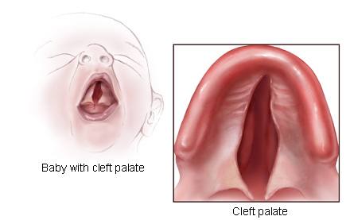
Courtesy of the Centers for Disease Control and Prevention
The Public Health Importance of Birth Defects
Each year in the United States, approximately 120,000 babies—1 in 33—are born with birth defects (MarchofDimes 2006). Birth defects, sometimes called congenital anomalies, are abnormalities of structure, function or metabolism present before birth. These abnormalities may be fatal or may result in physical or mental disability. Several thousand defects have been identified. Some are life threatening while others are less severe.

Birth defects can lead to lifelong disability, require costly medical care, and cause great distress in families. The economic, emotional and social impact on families can be catastrophic.

Although birth defects are rare when compared to other adverse birth outcomes, such as low birthweight or prematurity, they are the leading cause of death in the first year of life in the United States. Nationally, about 20% of all infant deaths result from a birth defect. In Massachusetts, 15% of all infant deaths were attributable to birth defects (MADPH 2012). The overall infant mortality rate for Massachusetts in 2009 was 4.9 per 1,000 births, and for the U.S. it was 6.3 per 1,000 births (Kochanek et al. (2011).

Causes of Birth Defects
The causes of most birth defects are poorly understood, but certain genetic and environmental factors have been associated with selected defects. These include prenatal environmental factors, such as infections (e.g., rubella), exposures to medications or other chemicals, drug or alcohol abuse, and nutritional deficiencies.

A single abnormal gene can cause certain birth defects. The gene may have an error in its code such as a missing piece or extra genetic material which can result in malformations. Other causes of birth defects may be multifactorial with genes and environmental factors both playing a role. For 70% of major birth defects, no known cause has been identified (CDC 2006). Chapter 6 presents data that most birth defect cases in Massachusetts have an unknown etiology. These cases were further classified by birth defect patterns.

Researchers are looking at a wide variety of environmental exposures and risk factors as causes of birth defects. Because most of the structural development of the fetus occurs during early pregnancy, studies usually focus on the “periconceptional” period, the month before and three months after conception. For the developing pregnancy, “the environment” includes any exposure to the fetus as well as the mother.

Birth Defects and Folic Acid Awareness and Behavior
Studies have shown that the presence of adequate amounts of folic acid (vitamin B9) in the mother’s system during the “periconceptional” period may help prevent defects of the brain and spinal cord known as neural tube defects. Mandatory fortification of cereal grains with folic acid has resulted in a 26% reduction in the number of babies born with these neural tube defects in the US (Mills and Signore, 2004). However, recent studies in certain populations have suggested that not all cases of neural tube defects are preventable by increasing folate intake (Heseker, Mason et al., 2008) and that periconceptional supplement use did not reduce the risk of neural tube defects possibly because folate fortification reduced the occurrence of only folic acid-sensitive neural tube defects (Mosley, Cleves et al., 2009).

The Behavioral Risk Factor Surveillance System (BRFSS), administered by the Massachusetts Department of Public Health, Bureau of Health Information Statistics, Research and Evaluation, included questions about folic acid awareness and behavior in its 2000 and 2004 surveys. In the 2004 survey, 63.8% of female respondents ages 18-49 reported that taking folic acid can prevent birth defects. Also, 51.6% of the participating women ages 18-49 reported that they take folic acid on a daily basis (see table in Appendix).

An additional and potentially more relevant indicator of folic acid intake can be multivitamin use among women who recently had a live birth. The Massachusetts Pregnancy Risk Assessment Monitoring System (PRAMS) survey of resident women who had a live birth includes questions about prenatal multivitamin use. Mothers of singletons, twins and triplets (higher order multiples were excluded) were asked about their weekly consumption of a multivitamin or prenatal vitamin the month prior to becoming pregnant. Among respondents, 37.6% reported that they took multivitamins daily in the month prior to pregnancy. (MA PRAMS Report 2010; these data—stratified by a number of demographic categories—are presented in the Appendix).

Healthy People 2020 Challenges
Healthy People 2020 has established the objectives of reducing the infant death related to any birth defect and specifically to congenital heart defects by 10%, spina bifida and anencephaly rates by 10%, and increase the 1-year survival rates of children born with Down syndrome by 10% (DHHS 2020). Birth defects surveillance is a critical component of the public health strategy to achieve these objectives. The active surveillance program in Massachusetts allows the Department of Public Health to monitor the extent and occurrence of birth defects within the Commonwealth. These data make it possible to identify:

- Changes in birth defect rates over time that may indicate a change in environmental conditions affecting the health of the population;
- Geographical areas with consistently high or unusual rates (clusters);
- Families of affected children who may benefit from services or who may be interested in participating in research studies; and
- Key data for preventive strategy planning by the Department of Public Health.

Economic Impact on Massachusetts
Estimating the economic impact of birth defects on the state of Massachusetts is challenging. The California Birth Defects Monitoring Program and the Metropolitan Atlanta Congenital Defects Program, using 1992 data, estimated the lifetime cost for families dealing with a baby with birth defects to be between $75,000 and $503,000 (CDC 1995). Their estimated lifetime cost for a baby born with spina bifida was $385,896 in 2007 ($439,059 in 2013 dollars).

Adjusting for inflation, the estimated combined lifetime cost in Massachusetts for babies born with 12 major structural birth defects was $151,322,760 in 2007 (see Technical Notes). These figures included direct costs of medical treatment, developmental services and special education, as well as indirect costs to society for lost wages due to early death or occupational limitations. There are also social and emotional impacts, which cannot be quantified.

Birth Defects Surveillance in Massachusetts
Over the past eleven years, the BDMP has developed and refined its surveillance program. The first full year of population-based, active surveillance statewide was 1999.

The primary focus of the state surveillance system is the identification of major structural birth defects with or without a chromosomal abnormality and non-chromosomal malformation syndromes. This includes ICD-9 CM codes ranging from 740.0 to 759.9 and a few selected codes outside this range for defects such as DiGeorge syndrome, Pierre Robin sequence and amniotic bands sequence.

The Center’s active surveillance system uses multiple sources of ascertainment. Birth, tertiary (Level III nurseries) and specialty care hospitals in Massachusetts routinely submit discharge lists and nursery data on infants born with birth defects. Since over 70% of out-of-state births to Massachusetts mothers occur in Rhode Island, two Rhode Island hospitals, the Women and Infants’ Hospital and the Rhode Island Hospital, were added in 2000. In 2001, the Massachusetts Eye and Ear Infirmary was included in order to increase ascertainment of eye and ear anomalies that come to their attention. Vital records also serve as an additional source. Fetal death reports and infant death certificates are reviewed. Birth certificates are checked for additional information such as residency of the mother.

Potential birth defect cases, reported from these varied sources, are assigned to medical record abstractors who make field visits to hospital medical records departments. Abstractors have specialized training and ongoing education to abstract medical records of potential cases. Abstraction is conducted on a regular basis using a Confidential Reporting and Abstraction Form (CRAF) to capture essential data for each birth defect case. The CRAFs are submitted to the Center for review of completeness and accuracy. Surveillance data are entered and maintained in a confidential electronic database.

Legislative Changes Regarding Birth Defects Surveillance
In March 2002, the Massachusetts Legislature amended the state birth defects monitoring statute (Chapter 111, section 67E) to allow expansion of the surveillance system to capture diagnoses through age three. It also extended the definition of mandated reporters to include attending physicians, primary care and specialist physicians who may diagnose birth defects. These physicians will now have a statutory duty to report within 30 days of making such a diagnosis. The amended statute also permits researchers to access state surveillance data after obtaining IRB approval and approval of the MDPH Commissioner pursuant to M.G.L.c.111s.24A/B/67E.

Update on the Implementation of the Regulations
In the winter of 2009, Massachusetts enacted regulations (105 CMR 302) related to the Massachusetts Birth Defects Monitoring Program. Among its provisions, the regulations expanded the reporting requirements for birth defects cases identified at or after birth extended reporting to cases identified prenatally, and established an Advisory Committee.

Since the enactment of these regulations, the MBDP has been working on their implementation. Hospitals across the state were notified of the new requirements, and the expanded post-natal reporting was implemented at these sites with the utilization of a revised Confidential Reporting and Abstracting Form (CRAF). An advisory group of obstetrical and radiological clinicians was convened to develop the specifications related to prenatal reporting, and the MBDP visited Massachusetts tertiary hospitals to determine where and how birth defects are diagnosed prenatally. The implementation of the prenatal specifications began in January 2011. As such, the addition of prenatal report is not reflected in the 2008-2009 report. However, the enhancements to case ascertainment of additional reporting sites (emergency rooms, day surgeries, and outpatient centers) and standardized electronic reports is likely reflected, at least in part, in the increase in overall birth defect prevalence compared to the previous report for 2006-2007.

An advisory committee, comprised of patients, families, health care providers, researchers, and other interested parties, was also established. Advisory committee meetings have been held twice per year for a total of six times as of December 2012.

The 2008-2010 Surveillance Report
This report presents statewide data on the prevalence of birth defects in live births and stillbirths in Massachusetts during the years 2008, 2009, and 2010. The data are presented in combined form since the numbers are relatively small for individual defects. The first annual report presented Massachusetts data for birth defects for the year 1999. Since that time we have produced reports every two years that reflect the nature of birth defects for a corresponding two-year period. Our ability to find and identify infants born with birth defects to Massachusetts residents has improved over time. The prevalence increases from the 2000-2001 report through this current version are at least partially attributable to continually improved case ascertainment. Because there were major changes to the Massachusetts birth certificate in 2011 that are delaying its release, the decision was made to produce this interim, 3-year report rather than wait to produce a two-year report as has been the practice. Once the new certificate has been released we will generate a regular two-year report for 2010-2011. As a result, the prevalence of all birth defects for this report (178.5 per 10,000 live births) is very similar to that the previous 2008-2009 report (175.3 per 10,000 live births). Interpretations of the report data must be made with caution as the continuing refinement and enhancement of our surveillance methods may have a continuing affect on the completeness of our case ascertainment and the subsequent estimation of defect prevalence.

Unless otherwise indicated this report uses the term “births” to mean live births plus stillbirths. A stillbirth was defined as the delivery of a fetus that was not alive and was greater than or equal to 20 weeks gestational age or weighed at least 350 grams (0.77 lbs).

Chapter 2

Methods

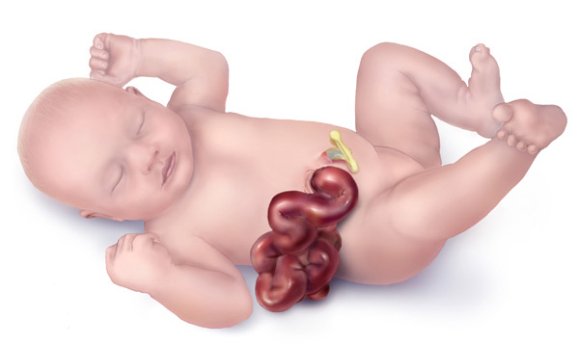
Baby with gastroschisis

Courtesy of the Centers for Disease Control and Prevention

Case Definition
This report summarizes data on selected birth defects present in births occurring during the calendar years 2008 through 2010 to Massachusetts residents. Cases met the following criteria:

- The infant was live born or the fetus was stillborn with a gestational age greater than or equal to 20 weeks or with a weight of at least 350 grams (0.77 lbs).

- The infant or fetus had a structural birth defect that met diagnostic criteria (see Birth Defects Codes and Exclusions by Defect Category in Appendices).

- The diagnosis was made before the infant reached one year of age.

Data Collection
The Massachusetts Birth Defects Monitoring Program (BDMP) used active population-based surveillance methods for statewide case ascertainment. Hospitals across the state submitted monthly discharge lists with birth defect diagnoses to the Center. Nursery and neonatal intensive care liaisons faxed or phoned in reports of birth defects. Abstractors reviewed medical charts for each potential case. Beginning with 2008 births, new regulations were implemented expanding the reporting sites to include outpatient centers, emergency rooms, day surgery, and hospital labs). Standardized electronic reporting from sites also began rolling out in 2008. Below is a list of selected enhancements made since the inception of the program:

2001 Massachusetts Eye & Ear Institute (specialty care) in Boston added
Women & Infants Hospital (maternity) and Hasbro Hospital (tertiary) in Rhode Island added to capture Southeastern Massachusetts out-of-state births and/or birth defect diagnosis

2002 Additional CNS diagnosis added

2005 Reviewed surveillance criteria that resulted in additions/clarifications resulting in increased ascertainment

2006 Additional GI diagnosis added

2007 Added DNA-based diagnosis and updated BPA/ICD-9 codes based on national surveillance guidelines

2009 New regulations promulgated affecting surveillance reporting: additional codes reported to capture existing reportable diagnoses, expanded site reporting (outpatient, ER, day surgery), and standardized electronic reporting from institutions.

If the infant or fetus had a birth defect that met the case definition criteria, detailed demographic and diagnostic information was recorded on a hospital reporting form. This information was entered into a confidential surveillance database for analysis.

Confidentiality
The Center has developed extensive procedures to guarantee the confidentiality of the data and protect the privacy of families. These procedures uphold the Center’s ethical and legal obligations to safeguard confidentiality and fully comply with the strict requirements of state and federal laws.

Data Analysis
A defect may have occurred as a single event or in combination with other defects. If the case had more than one defect within the same defect category, only one of these defects was counted in the category total. If the case had more than one defect in different defect categories, the case was listed in the total for each of these defect categories. Thus the counts in the defect categories presented in the prevalence tables represent the total number of defects and not the total number of cases with birth defects. Each case in the BDMP was linked to a Registry of Vital Records and Statistics record. In this report, maternal age race/ethnicity, and birth weight are drawn from the birth certificate. Because birth certificate data are more accurate for these fields than fetal death reports, analyses of maternal age and race/ethnicity are limited to live births.

The occurrence of birth defects is reported as prevalence. Prevalence is calculated as the number of birth defect cases born during the period 2008-2010 per 10,000 live births born during the same period. Prevalence tables include the number of cases found, the estimated prevalence rate per 10,000 live births and the 95% confidence interval for that rate. The incidence (new cases) of birth defects (based upon the number of embryos conceived within a year) is not fully measured because both the total number of conceptions that occur and the number of these conceptions resulting in a defect are not known (Sever 2004).

The confidence interval (CI) can be used to assess the magnitude and stability of a rate or ratio. The CI for rates in the tables is a range of possible values around the point estimate that has a 95% chance of including the actual underlying risk of an infant being born with a birth defect. Wide confidence intervals reflect the large variation due to small numbers (see Technical Notes).

Data Limitations
1. Birth defect counts for this report are only for calendar years 2008 through 2010. Due to the small numbers of birth defects relative to the number of births and the fact that the BDMP data ascertainment is constantly being refined, conclusions from these results—including inferences about multi-year trends—are not valid until a extensive multi-year estimates establish a stable, baseline rate.

2. Defects that are not diagnosed at birth and that do not need hospitalization may be underreported. Additionally, the diagnoses made after the first year of life and those made solely via prenatal testing could be missed.

3. Misclassification of birth defects may occur through coding errors or vague diagnoses. Quality control measures such as careful abstraction of the medical records minimize this error.

4. As medical diagnostic technology has improved, many prenatal and postnatal tests are now performed outside the traditional hospital setting. Prenatal diagnosis enables physicians to identify some birth defects well before the expected date of delivery and offers women alternatives in the management of their affected pregnancies. These decisions have significant implications for monitoring birth defects. For example, it is estimated that up to 50% of all pregnancies affected with a neural tube defect may be discontinued and would thus not be included in hospital records (Cragan and Khoury, 2000). In addition, postnatal tests such as echocardiograms and ultrasounds may identify internal organ defects not diagnosed in the birthing hospital.

5. Spontaneous abortions that are delivered prior to 20 weeks of gestation and at less than 350 grams are not included in the case definition. It has been estimated that about 29% of birth defects cases are missed by not monitoring early fetal losses (Forrester, Merz et al. 1998; Ethen and Canfield 2002).

6. Only diagnoses confirmed up to one year of age are currently included. The frequency of diagnosed malformations can be higher among older children due to ‘hidden’ abnormalities such as kidney malformations or certain heart defects which may be detected by accident when a child is symptomatic (Holmes 1994). Many defects are also detected when diagnostic tests are performed to confirm a more severe, accompanying defect. Finally, many defects that result in developmental delays (e.g. fetal alcohol syndrome) may not be detected until those delays become evident as a child is gets older.

7. In 2000, 1,318 births occurred to Massachusetts residents at out-of-state hospitals. Of these births, 68.9% occurred in Rhode Island (RI) hospitals. In order to capture data on infants with birth defects residing in the southeastern region of Massachusetts that were born or treated at RI hospitals, we received special permission and began receiving hospital discharge lists and abstracting medical records on infants with birth defects at two RI hospitals. Deliveries and diagnoses that occurred in other out-of-state facilities are not included at this time.

8. There are limitations when comparing the Massachusetts BDMP data to data from other states and national estimates. Factors such as differences in population demographics, living environment, and variances in surveillance/case ascertainment methods may contribute to differences in the prevalence of birth defects.

Glossary
A glossary of selected birth defect terms is included in the appendix of this report.

Chapter 3

Prevalence of Birth Defects

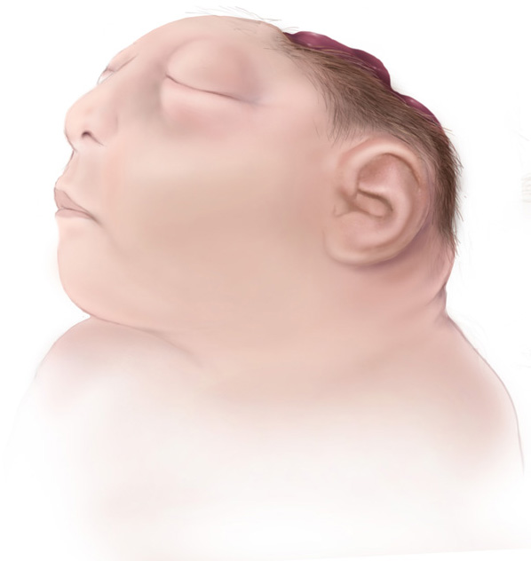

Baby with anencephaly

Courtesy of the Centers for Disease Control and Prevention

Overall Prevalence of Birth Defects
Table 1 shows the prevalence of defects for all births and for live births and stillbirths separately for the report period 2008-2010 while Figure 1 shows the overall trend in birth defects from 2000 to 2010. Among births to Massachusetts residents in 2008-2010, 4,012 had one or more structural birth defects that were ascertained by Massachusetts BDMP. Among these, 81 stillbirths were identified with a birth defect. Overall, 1.8% of births in the state (178.5 per 10,000 live births) were identified as having at least one birth defect. The majority of defects occurred in the cardiovascular (occurring in 33.2% of defect cases) and musculoskeletal (occurring in 28.5%) categories. Figure 2 shows the percentage of reported birth defects by defect category. Cases can be included in more than one defect category.

The CDC published improved national prevalence estimates for 18 selected major defects. Massachusetts was one of 11 states with population-based monitoring programs to contribute birth defect data. These average prevalence rates cover deliveries from 2004-2006 (CDC 2010). Massachusetts rates for 2008-2010 were significantly lower than the US rates for approximately 45% of the defects and were about the same as the national estimates for the other 55% (see Table 2). Differences in rates may reflect variations in defect criteria between surveillance systems as well as regions. Also, in Massachusetts, birth defects are not reported when they are prenatally diagnosed and the pregnancy is electively terminated, which would tend to result in lower rates for certain defects. Spontaneous deliveries of stillbirths equal to or greater than 20 weeks of gestation were reported by birthing hospitals but limited information about the stillbirth is included in the maternal record. Thus, some birth defects are not well documented and are unable to be confirmed for inclusion in state surveillance.

The CDC estimates that up to 50% of pregnancies with neural tube defects and up to 80% of pregnancies with anencephaly are electively terminated after prenatal diagnosis (Cragan and Khoury 2000). Substantial evidence from past studies has examined the effect of prenatal diagnoses and elective termination on the prevalence of various birth defects (Forrester, Merz et al. 1998). Researchers at Brigham and Women’s Hospital (BWH), where 11% of resident births occurred in 2004-2005, looked at past trends in elective termination in Massachusetts. For the two years 1994 and 1999, 40-80% of pregnancies prenatally diagnosed with either lethal or very severe defects were terminated (Peller, Westgate et al. 2004), suggesting that epidemiologic studies of major malformations must include elective terminations to be complete.

We can estimate cases not included in the surveillance if we compare our data to several studies such as the aforementioned BWH study (Table 3). These studies provide the number of cases captured by surveillance with and without the inclusion of electively terminated cases. We calculate the difference in number of cases between the two surveillance systems as a percentage of possible cases missed by a surveillance system such as ours which does not include electively terminated cases. We then adjust the Massachusetts rates for the selected birth defects to include all cases (non-terminated cases and estimated terminated cases), assuming that the cited studies examined populations similar to the residents of Massachusetts who had prenatal health access similar to that found in Massachusetts.

The unadjusted 2008-2010 Massachusetts rates for anencephaly, spina bifida, trisomy 13, and trisomy 18 were significantly lower than the national estimates. The rate for Down syndrome was similar to the national estimate (Table 2). Using 2008-2010 rates, an estimated 50-72% of anencephaly cases are missed through exclusion of terminated cases. Upon adjusting the Massachusetts rate of for these four defects and assessing overlapping confidence intervals (see Appendix for description of confidence intervals), Massachusetts rates of anencephaly appear significantly lower than the national estimate for all three estimates while Trisomy 21 appears significantly higher than the national estimate. Both spina bifida and Trisomy 18 rates, when adjusted, do not appear to be significantly dissimilar from the U.S. estimate. Table 3 lists the adjusted rates. The age-adjusted rate of Down syndrome in Massachusetts that is higher than the national estimate possibly reflects the higher birth rate for mothers over the age of 35 compared to the national average (CDC 2012). The lower anencephaly rate may the result of a very small number of actual cases having a disproportionate effect. Between 2008 and 2010 Massachusetts averaged just over 74,000 births and fewer than five cases per year.

Figure 3 provides the overall prevalence of birth defects by interpregnancy interval (IPI), defined as the time period in completed months between the date of conception of one pregnancy and the date of delivery of the preceding pregnancy, among women whose preceding pregnancy resulted in a live birth. There were no clear trends in the overall prevalence of birth defects by IPI. However, this does not preclude the existence of trends for individual birth defects that may be obscured when looking at defects overall.

Defect Pattern
Table 5 shows the distribution of birth defects by pattern (as does Table 15). Cases are classified by the pattern of defects (i.e. whether one defect occurs with others). Of all 4,012 birth defect cases (3,931 live births and 81 stillbirths), 43.6% had a “solitary” (truly a single) defect pattern, 26.5% had “Major plus minors” (defined as having a major defect accompanied by one or more minor defects), 4.3% were a “sequence” (allowing for more than one major defect if the defects are related pathogenically), and 25.6% had “multiple major” defects. Cleft lip with and without cleft palate, hypospadias (2nd or 3rd degree), gastroschisis, and craniosynostosis appeared more often as a single defect rather than with other defects—all occurring more than 75% of the time as a “solitary” defect. Birth defects which appeared more often in conjunction with other defects included hydrocephaly, spina bifida, anotia/microtia, obstructive genitourinary defect, and all cardiovascular defects.

Selected Pregnancy Outcomes
Figure 4 compares selected pregnancy outcome characteristics among infants born with birth defects to those born without birth defects in 2008-2010 by percentage. Of infants born with birth defects, 46.7% were delivered by Cesarean, compared to 33.4% of infants born with no birth defect births; 21.3% of infants with birth defects had low birthweight (<2,500 grams) as opposed to 7.5% of those without a birth defect; 20.5% of infants were premature (gestational age < 37 weeks), compared with 8.5% of those without a birth defect; 4.8% of infants with a birth defect died before their 1st birthday, compared to 0.4% of those without a birth defect. While numbers of infants with birth defects are relatively small, it is important to recognize the impact of these outcomes when diagnosing and treating a baby with a birth defect.

Prevalence of Birth Defects by Sex
Table 6 presents the prevalence of birth defects by sex of the infant/fetus. The overall prevalence was 146.8 for females and 207.3 for males per 10,000 live births. While the prevalence of most types of birth defects did not differ by sex of the infant/fetus, some conditions were significantly associated with sex (see Table 7). The most common defects seen in males, in order of prevalence beginning with the most prevalent defect, were hypospadias (2nd or 3rd degree), atrial septal defects (secundum and NOS), obstructive genitourinary defect, polydactyly/syndactyly, and clubfoot. The most common defects seen in females were atrial septal defects (secundum and NOS), ventricular septal defects (membranous and NOS), polydactyly/syndactyly, Down syndrome, and obstructive genitourinary defect. Selected birth defects by sex of infant are presented in Figure 4.

Trend Analyses of Selected Birth Defects
The statewide data on the prevalence of birth defects in live births and stillbirths during multiple years from this surveillance report as well as prior surveillance reports allow for some trend analysis. Data from the first few reports (1999-2004) must be interpreted with caution since surveillance techniques were being established and executed. Preliminary trend analysis with recent reports may be performed with the understanding that better ascertainment of cases and increased use of diagnostic technologies may have contributed to any apparent increase in birth defect rates. This is evidenced by a steady increase in the overall prevalence of birth defects as seen in Figure 1. A comparison of selected cardiovascular birth defects rates from 2008-2010 to rates in previous reports suggests that most rates have remained steady or slightly increased due to better case confirmation. Similar trends are found in selected orofacial and musculoskeletal birth defects as well.

Gastroschisis and hypospadias are some of the birth defects of interest due to increasing national prevalence trends. Surveillance in Massachusetts and elsewhere has suggested an increased risk of gastroschisis in pregnancies among very young women (under 20) up to 2006 with an apparent leveling of prevalence between 2006 and 2010, although the mechanisms for this are unknown. A recent study showed that although younger women had both a comparatively larger risk of gastroschisis and a greater prevalence of smoking, cigarette smoking had no effect on risk in women under 20, but smoking (possibly the duration of smoking) increased the risk in older women (Werler, Mitchell et al 2009). The rate of gastroschisis in Massachusetts increased 63.8% between 2000 and 2007 (Figure 5). This increasing trend paralleled increasing national rates of gastroschisis, although a factor in this increase may be better ascertainment of cases by the surveillance system in Massachusetts. This may have been due to aggressive strategies of case confirmation and improvements in surveillance, although over time, increases were observed in other locations around the U.S. and the world. As mentioned above, the rate of gastroschisis since 2007 seems to remain unchanged. Alternatively, the rate of hypospadias—the most common defect among male births and one that overwhelmingly appears as a solitary defect—appears to have seen an increase in the last few years. This increase may be a result of new reporting originating from outpatient facilities (see Chapter 2: Methods). Before this additional source for ascertaining defects was implemented, all hypospadias reports were the result of the identification of a surgical procedure only. Given that this increase in a relatively new finding, it will be important to focus on whether this is simply a result of better ascertainment or a genuine increase in the rates of this defect.

Defect¹ | Live birth  Count | Stillbirth  Count | Total  Count | Rate per  10,000  Births | 95%  Confidence  Interval
Total Cases | 3931 | 81 | 4012 | 178.49 | 173.06-184.05
Central Nervous System
Anencephaly | 9 | 4 | 13 | 0.58 | 0.31-0.99
Encephalocele | 5 | 0 | 5 | 0.22 | 0.07-0.52
Holoprosencephaly | 14 | 1 | 15 | 0.67 | 0.37-1.10
Hydrocephaly w/o Spina Bifida | 71 | 8 | 79 | 3.51 | 2.78-4.38
Microcephaly | 35 | 0 | 35 | 1.56 | 1.08-2.17
Spina Bifida w/ and w/o Hydrocephaly | 51 | 3 | 54 | 2.40 | 1.80-3.13
Spinal Cord | 87 | 0 | 87 | 3.87 | 3.10-4.77
Other CNS² | 165 | 3 | 168 | 7.47 | 6.39-8.69
Eye
Aniridia | 3 | 0 | 3 | 0.13 | 0.03-0.39
Anophthalmia/Microphthalmia | 32 | 2 | 34 | 1.51 | 1.05-2.11
Congenital Glaucoma, Congenital Cataract | 67 | 0 | 67 | 2.98 | 2.31-3.79
Other Eye² | 69 | 0 | 69 | 3.07 | 2.39-3.89
Ear
Anotia/Microtia | 39 | 0 | 39 | 1.74 | 1.23-2.37
Other Ear² | 73 | 1 | 74 | 3.29 | 2.59-4.13
Cardiovascular
Anomalous Pulmonary Venous Connection
Total/Partial Anomalous Pulm Venous Connection | 38 | 0 | 38 | 1.69 | 1.20-2.32
Atrioventricular Canal Defects
ASD Primum | 5 | 0 | 5 | 0.22 | 0.07-0.52
Common Atrium | 12 | 0 | 12 | 0.53 | 0.28-0.93
Complete Atrioventricular Canal Defect | 65 | 2 | 67 | 2.98 | 2.31-3.79
Endocardial Cushion (OS and NOS) | 35 | 0 | 35 | 1.56 | 1.08-2.17
VSD, Canal Type | 7 | 0 | 7 | 0.31 | 0.13-0.64
Conotruncal (Outlet) and Aortic Arch
Double Outlet Right Ventricle | 24 | 0 | 24 | 1.07 | 0.68-1.59
Interrupted Aortic Arch, Type B | 8 | 0 | 8 | 0.36 | 0.15-0.70
Tetralogy of Fallot w/ and w/o Pulmonary Atresia | 89 | 1 | 90 | 4.00 | 3.22-4.92
Truncus | 6 | 0 | 6 | 0.27 | 0.10-0.58
(cont’d)
d-Transposition of the Great Arteries | 54 | 1 | 55 | 2.45 | 1.84-3.19
Ebstein Anomaly
Ebstein Anomaly | 8 | 0 | 8 | 0.36 | 0.15-0.70
Heterotaxy (Laterality Defects)
Heterotaxy | 36 | 0 | 36 | 1.60 | 1.12-2.22
Left-Sided Obstruction
Aortic Valve Stenosis | 31 | 0 | 31 | 1.38 | 0.94-1.96
Coarctation of Aorta | 96 | 1 | 97 | 4.32 | 3.50-5.26
Hypoplastic Left Heart Syndrome | 29 | 2 | 31 | 1.38 | 0.94-1.96
Interrupted Aortic Arch (Type A and NOS) | 1 | 0 | 1 | 0.04 | 0.00-0.25
Patent Ductus Arteriosus
Patent Ductus Arteriosus | 307 | 0 | 307 | 13.66 | 12.17-15.27
Right-Sided Obstruction
Pulmonary Stenosis, Valvular | 156 | 0 | 156 | 6.94 | 5.89-8.12
Pulmonary Valve Atresia w/intact septum | 13 | 1 | 14 | 0.62 | 0.34-1.05
Pulmonary Valve Atresia with VSD | 6 | 0 | 6 | 0.27 | 0.10-0.58
Tricuspid Valve Atresia | 17 | 0 | 17 | 0.76 | 0.44-1.21
Septal Defects
ASD (Secundum and NOS) | 495 | 0 | 495 | 22.02 | 20.13-24.05
VSD (Membranous and NOS) | 263 | 11 | 274 | 12.19 | 10.79-13.72
VSD, Conoventricular/Malalignment | 38 | 2 | 40 | 1.78 | 1.27-2.42
Single Ventricle and L-TGA
L-TGA | 7 | 0 | 7 | 0.31 | 0.13-0.64
Single Ventricle | 9 | 0 | 9 | 0.40 | 0.18-0.76
Other Cardiovascular
Other Cardiovascular² | 473 | 11 | 484 | 21.53 | 19.66-23.54
Respiratory
Choanal Atresia | 16 | 0 | 16 | 0.71 | 0.41-1.16
Lung Anomalies | 43 | 0 | 43 | 1.91 | 1.38-2.58
Other Respiratory² | 26 | 3 | 29 | 1.29 | 0.86-1.85
Orofacial
Cleft Lip w/ and w/o Cleft Palate | 178 | 4 | 182 | 8.10 | 6.96-9.36
(cont’d)
Cleft Palate w/o Cleft Lip | 122 | 2 | 124 | 5.52 | 4.59-6.58
Pierre Robin Sequence | 43 | 0 | 43 | 1.91 | 1.38-2.58
Other Orofacial² | 115 | 2 | 117 | 5.21 | 4.30-6.24
Gastrointestinal
Biliary Atresia | 14 | 0 | 14 | 0.62 | 0.34-1.05
Esophageal Atresia/Tracheoesophageal Fistula | 51 | 0 | 51 | 2.27 | 1.69-2.98
Hirschsprung Disease | 52 | 0 | 52 | 2.31 | 1.73-3.03
Rectal and Large Intestinal Atresia/Stenosis | 68 | 1 | 69 | 3.07 | 2.39-3.89
Small Intestinal Atresia | 64 | 2 | 66 | 2.94 | 2.27-3.74
Other Gastrointestinal | 160 | 3 | 163 | 7.25 | 6.18-8.45
Genitourinary
Bladder Exstrophy | 4 | 0 | 4 | 0.18 | 0.05-0.46
Cloacal Exstrophy | 2 | 0 | 2 | 0.09 | 0.01-0.32
Hypospadias, 2nd or 3rd Degree³ | 309 | 0 | 309 | 13.75 | 12.26-15.37
Obstructive Genitourinary Defect | 344 | 4 | 348 | 15.48 | 13.90-17.20
Renal Agenesis/Hypoplasia | 8 | 3 | 11 | 0.49 | 0.24-0.88
Other Genitourinary² | 395 | 7 | 402 | 17.88 | 16.18-19.72
Musculoskeletal
Club Foot | 316 | 10 | 326 | 14.50 | 12.97-16.17
Craniosynostosis | 109 | 1 | 110 | 4.89 | 4.02-5.90
Diaphragmatic Hernia | 55 | 1 | 56 | 2.49 | 1.88-3.24
Gastroschisis | 73 | 3 | 76 | 3.38 | 2.66-4.23
Omphalocele | 24 | 2 | 26 | 1.16 | 0.76-1.69
Polydactyly/Syndactyly | 353 | 6 | 359 | 15.97 | 14.36-17.71
Reduction Deformity, Lower Limbs | 27 | 2 | 29 | 1.29 | 0.86-1.85
Reduction Deformity, Upper Limbs | 53 | 3 | 56 | 2.49 | 1.88-3.24
Skeletal Dysplasia | 29 | 1 | 30 | 1.33 | 0.90-1.91
Other Musculoskeletal² | 254 | 7 | 261 | 11.61 | 10.25-13.11
Chromosomal and other Syndromes
Klinefelter Syndrome | 8 | 0 | 8 | 0.36 | 0.15-0.70
Trisomy 13 | 6 | 4 | 10 | 0.44 | 0.21-0.82
Trisomy 18 | 27 | 11 | 38 | 1.69 | 1.20-2.32
(cont’d)
Trisomy 21 (Down Syndrome) | 277 | 12 | 289 | 12.86 | 11.42-14.43
Turner Syndrome | 15 | 7 | 22 | 0.98 | 0.61-1.48
Other Chromosomal Syndromes/Other Syndromes² | 306 | 4 | 310 | 13.79 | 12.30-15.41
Other
Amniotic Bands | 17 | 4 | 21 | 0.93 | 0.58-1.43
Skin Anomalies | 38 | 0 | 38 | 1.69 | 1.20-2.32
Other, Specified² | 29 | 0 | 29 | 1.29 | 0.86-1.85

^{1.} Cases can be included in the count for more than one defect. Cases are counted once in the total for a defect category.
² Rate may represent a heterogeneous group of defects.
³ Rate calculated using male live births.

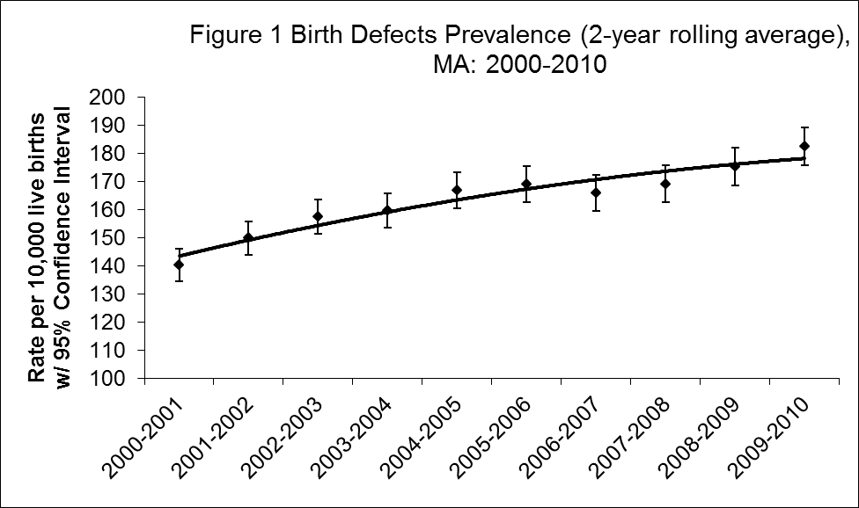

Defect | Count | Rate per 10,000 Births MA¹ | 95% Confidence Interval | Rate per 10,000 Births US² | 95% Confidence Interval
Anencephaly | 13 | 0.58 | 0.31-0.99 | 2.23 | 2.07 - 2.41
Spina bifida | 54 | 2.40 | 1.80-3.13 | 3.72 | 3.52 - 3.94
Anophthalmia/microphthalmia | 34 | 1.51 | 1.05-2.11 | 2.10 | 1.94 - 2.27
Truncus arteriosus (common truncus) | 6 | 0.27 | 0.10-0.58 | 0.74 | 0.65 - 0.84
Transposition of the great arteries³ | 62 | 2.76 | 2.11-3.54 | 3.04 | 2.85 - 3.24
Tetralogy of Fallot | 90 | 4.00 | 3.22-4.92 | 4.05 | 3.83 - 4.28
Atrioventricular canal defect ⁴ | 126 | 5.61 | 4.67-6.67 | 4.70 | 4.45 - 4.96
Hypoplastic left heart syndrome | 31 | 1.38 | 0.94-1.96 | 2.31 | 2.14 - 2.48
Cleft palate without cleft lip | 124 | 5.52 | 4.59-6.58 | 6.45 | 6.17 – 6.74
Cleft lip with and without cleft palate | 182 | 8.10 | 6.96-9.36 | 10.89 | 10.53 - 11.26
Esophageal atresia/tracheoesophageal fistula | 51 | 2.27 | 1.69-2.98 | 2.12 | 1.96 - 2.29
Rectal and large intestinal atresia/stenosis | 69 | 3.07 | 2.39-3.89 | 4.86 | 4.61 - 5.14
Reduction deformity, upper limbs | 56 | 2.49 | 1.88-3.24 | 3.64 | 3.43 - 3.86
Reduction deformity, lower limbs | 29 | 1.29 | 0.86-1.85 | 1.65 | 1.51 - 1.80
Gastroschisis | 76 | 3.38 | 2.66-4.23 | 4.72 | 4.49 - 4.97
Omphalocele | 26 | 1.16 | 0.76-1.69 | 1.92 | 1.77 - 2.08
Diaphragmatic hernia | 56 | 2.49 | 1.88-3.24 | 2.60 | 2.42 – 2.79
Trisomy 21 (Down syndrome) | 289 | 12.86 | 11.42-14.43 | 13.48 | 13.08 - 13.90
Trisomy 13 | 10 | 0.44 | 0.21-0.82 | 1.20 | 1.09 - 1.33
Trisomy 18 | 38 | 1.69 | 1.20-2.32 | 2.55 | 2.38 - 2.73

^{1.} MA rate is based on live births and stillbirths.
^{2.} Source: Updated National Birth Prevalence Estimates for Selected Birth Defects in the United States, 2004-2006. Birth Defects Research (Part A) 88(12): 1008-1016. Only ”active” surveillance system estimates are used and include systems that ascertain prenatally diagnosed and terminated pregnancies.
^{3.} Includes d–TGA and L–TGA.
^{4.} Includes ASD primum, common atrium, CAVC, endocardial cushion defect OS and NOS and VSD canal type.
Defect | MA rate | 95% Confidence Interval | Estimated  Missing %¹ | Estimate  Source² | Adjusted MA rate³ | 95% Confidence Interval | US rate⁴ | 95% Confidence Interval
Anencephaly | 0.58 | 0.31-0.99 | 66.7 | Peller, et al. | 0.98 | 0.61 - 1.48 | 2.23 | 2.07 – 2.41
Anencephaly | 0.58 | 0.31-0.99 | 50.0 | Cragan, et al. | 0.89 | 0.54 - 1.37 | 2.23 | 2.07 – 2.41
Anencephaly | 0.58 | 0.31-0.99 | 72.0 | Forrester, et al. | 0.98 | 0.61 - 1.48 | 2.23 | 2.07 – 2.41
Spina bifida | 2.40 | 1.80-3.13 | 45.5 | Peller, et al. | 4.00 | 3.22 - 4.92 | 3.72 | 3.52 – 3.94
Spina bifida | 2.40 | 1.80-3.13 | 29.0 | Cragan, et al. | 3.60 | 2.86 - 4.48 | 3.72 | 3.52 – 3.94
Spina bifida | 2.40 | 1.80-3.13 | 29.8 | Forrester, et al. | 4.14 | 3.34 - 5.07 | 3.72 | 3.52 – 3.94
Trisomy 21 (Down syndrome) | 12.86 | 11.42-14.43 | 35.2 | Peller, et al. | 21.44 | 19.57 - 23.44 | 13.48 | 13.08–13.90
Trisomy 21 (Down syndrome) | 12.86 | 11.42-14.43 | 37.3 | Forrester, et al. | 22.11 | 20.21 - 24.14 | 13.48 | 13.08–13.90
Trisomy 18 | 1.69 | 1.20-2.32 | 56.5 | Peller, et al. | 2.80 | 2.15 - 3.59 | 2.55 | 2.38 – 2.73
Trisomy 18 | 1.69 | 1.20-2.32 | 49.0 | Forrester, et al. | 2.89 | 2.23 - 3.69 | 2.55 | 2.38 – 2.73
- Missing were cases of all gestational ages for which the diagnosed defect was ascertained before or after an elective termination. Missing % is defined as the percentage of electively terminated cases divided by all cases liveborn, stillborn and electively terminated for each defect.
- Studies on the effect of prenatal diagnosis and elective terminations on birth defect surveillance. Peller, et al. provides data on liveborn, stillborn and elective terminations from a large urban tertiary center in Boston, MA, for the years 1974, 1979, 1984, 1989, 1994 and 1999 (Peller, Westgate et al. 2004). Cragan, et al. provides data on liveborn, stillborn and elective terminations from multiple states; the California Birth Defects Monitoring Program (1989 – 1991) was used here because it contributed the largest overall sample size to the study (Cragan and Khoury 2000). Forrester, et al. provides data on liveborn, stillborn and elective terminations from Hawaii’s population based, active surveillance system, 1987 – 1996 (Forrester, Merz et al. 1998).
- Adjusted rates included cases from elective terminations estimated according to the respective sources.
- Source: Updated National Birth Prevalence Estimates for Selected Birth Defects in the United States, 2004-2006. Birth Defects Research (Part A) 88(12): 1008-1016. Only “active” surveillance system estimates are used.

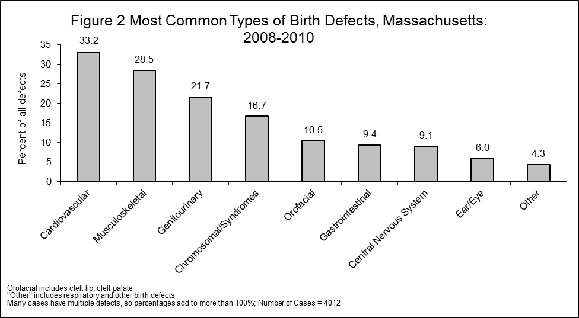

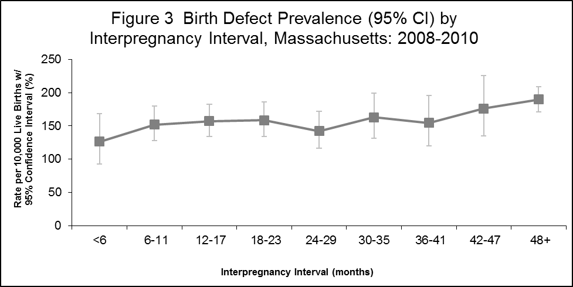

Interpregnancy Interval: the time period in completed months between the date of conception of one pregnancy and the date of delivery of the preceding pregnancy.
Note: Prevalence estimates are among singleton births to multigravid women whose preceding pregnancy resulted in a live birth.

Defect | Category | Count | Rate per  10,000  Births | 95%  Confidence  Interval
ASD (Secundum and NOS) | Cardiovascular | 495 | 22.02 | 20.13-24.05
Polydactyly/Syndactyly | Musculoskeletal | 359 | 15.97 | 14.36-17.71
Obstructive Genitourinary Defect | Genitourinary | 348 | 15.48 | 13.90-17.20
Club Foot | Musculoskeletal | 326 | 14.50 | 12.97-16.17
Hypospadias, 2nd or 3rd Degree | Genitourinary | 309 | 13.75 | 12.26-15.37
Trisomy 21 (Down Syndrome) | Chromosomal and other Syndromes | 289 | 12.86 | 11.42-14.43
VSD (Membranous and NOS) | Cardiovascular | 274 | 12.19 | 10.79-13.72
Cleft Lip w/ and w/o Cleft Palate | Orofacial | 182 | 8.10 | 6.96-9.36
Pulmonary Stenosis, Valvular | Cardiovascular | 156 | 6.94 | 5.89-8.12
Cleft Palate w/o Cleft Lip | Orofacial | 124 | 5.52 | 4.59-6.58

Hypospadias rate calculated using only male live births
Defect¹ | Isolated Defects |  |  | Multiple  Major Defects³ | Total  Cases
Defect¹ | Solitary | Major  +  Minor(s)² | Sequence | Multiple  Major Defects³ | Total  Cases
Total Cases | 1746 | 1061 | 174 | 1028 | 4009
Central Nervous System
Anencephaly | 10 | 2 | 0 | 1 | 13
Encephalocele | 1 | 2 | 0 | 2 | 5
Holoprosencephaly | 2 | 0 | 4 | 9 | 15
Hydrocephaly w/o Spina Bifida | 26 | 14 | 2 | 37 | 79
Microcephaly | 4 | 5 | 1 | 25 | 35
Spina Bifida w/ and w/o Hydrocephaly | 1 | 3 | 42 | 8 | 54
Spinal Cord | 10 | 15 | 29 | 33 | 87
Other CNS | 31 | 49 | 15 | 73 | 168
Eye
Aniridia | 0 | 0 | 0 | 3 | 3
Anophthalmia/Microphthalmia | 4 | 8 | 1 | 21 | 34
Congenital Glaucoma, Congenital Cataract | 39 | 9 | 1 | 18 | 67
Other Eye | 12 | 19 | 1 | 37 | 69
Ear
Anotia/Microtia | 7 | 12 | 2 | 18 | 39
Other Ear | 14 | 13 | 0 | 47 | 74
Cardiovascular
Anomalous Pulmonary Venous Connection
Total/Partial Anomalous Pulm Venous Conn | 4 | 19 | 9 | 6 | 38
Atrioventricular Canal Defects
ASD Primum | 0 | 2 | 1 | 2 | 5
Common Atrium | 0 | 0 | 10 | 2 | 12
Complete Atrioventricular Canal Defect | 1 | 6 | 9 | 51 | 67
Endocardial Cushion (OS and NOS) | 0 | 9 | 4 | 22 | 35
VSD, Canal Type | 1 | 2 | 0 | 4 | 7
Conotruncal (Outlet) and Aortic Arch
Double Outlet Right Ventricle | 0 | 11 | 5 | 8 | 24
Interrupted Aortic Arch, Type B | 1 | 2 | 0 | 5 | 8
Tetralogy of Fallot w/ and w/o Pulm Atresia | 17 | 34 | 2 | 37 | 90
(cont’d)
Truncus | 1 | 2 | 0 | 3 | 6
d-Transposition of the Great Arteries | 21 | 29 | 2 | 3 | 55
Ebstein Anomaly
Ebstein Anomaly | 3 | 4 | 0 | 1 | 8
Heterotaxy (Laterality Defects)
Heterotaxy | 1 | 0 | 31 | 4 | 36
Left-Sided Obstruction
Aortic Valve Stenosis | 4 | 19 | 2 | 6 | 31
Coarctation of Aorta | 10 | 57 | 2 | 28 | 97
Hypoplastic Left Heart Syndrome | 5 | 17 | 1 | 8 | 31
Interrupted Aortic Arch (Type A and NOS) | 0 | 1 | 0 | 0 | 1
Patent Ductus Arteriosus
Patent Ductus Arteriosus | 22 | 104 | 4 | 177 | 307
Right-Sided Obstruction
Pulmonary Stenosis, Valvular | 50 | 78 | 4 | 24 | 156
Pulmonary Valve Atresia w/intact septum | 4 | 7 | 1 | 2 | 14
Pulmonary Valve Atresia with VSD | 0 | 3 | 3 | 0 | 6
Tricuspid Valve Atresia | 1 | 12 | 1 | 3 | 17
Other Cardiovascular
Other Cardiovascular | 29 | 228 | 32 | 195 | 484
Septal Defects
ASD (Secundum and NOS) | 85 | 203 | 12 | 195 | 495
VSD (Membranous and NOS) | 37 | 134 | 2 | 101 | 274
VSD, Conoventricular/Malalignment | 6 | 19 | 1 | 14 | 40
Single Ventricle and L-TGA
L-TGA | 0 | 5 | 1 | 1 | 7
Single Ventricle | 1 | 5 | 3 | 0 | 9
Respiratory
Choanal Atresia | 6 | 2 | 0 | 8 | 16
Lung Anomalies | 32 | 4 | 1 | 6 | 43
Other Respiratory | 6 | 2 | 4 | 17 | 29
Orofacial
Cleft Lip w/ and w/o Cleft Palate | 130 | 13 | 4 | 35 | 182
Cleft Palate w/o Cleft Lip | 51 | 18 | 28 | 27 | 124
Pierre Robin Sequence | 4 | 3 | 29 | 7 | 43
Other Orofacial | 57 | 12 | 4 | 44 | 117
Gastrointestinal
Biliary Atresia | 8 | 1 | 2 | 3 | 14
Esophageal Atresia/Tracheoesophageal Fistula | 13 | 4 | 0 | 34 | 51
Hirschsprung Disease | 39 | 4 | 0 | 9 | 52
Rectal and Large Intestinal Atresia/Stenosis | 24 | 7 | 1 | 37 | 69
Small Intestinal Atresia | 22 | 19 | 1 | 24 | 66
Other Gastrointestinal | 60 | 45 | 17 | 41 | 163
Genitourinary
Bladder Exstrophy | 3 | 1 | 0 | 0 | 4
Cloacal Exstrophy | 0 | 0 | 1 | 1 | 2
Hypospadias, 2nd or 3rd Degree | 246 | 24 | 1 | 38 | 309
Obstructive Genitourinary Defect | 11 | 178 | 17 | 142 | 348
Renal Agenesis/Hypoplasia | 1 | 1 | 8 | 1 | 11
Other Genitourinary | 99 | 148 | 14 | 141 | 402
Musculoskeletal
Club Foot | 174 | 37 | 28 | 87 | 326
Craniosynostosis | 81 | 6 | 0 | 23 | 110
Diaphragmatic Hernia | 24 | 5 | 3 | 24 | 56
Gastroschisis | 60 | 9 | 1 | 6 | 76
Omphalocele | 8 | 4 | 0 | 14 | 26
Polydactyly/Syndactyly | 159 | 105 | 9 | 86 | 359
Reduction Deformity, Lower Limbs | 3 | 9 | 4 | 13 | 29
Reduction Deformity, Upper Limbs | 14 | 10 | 11 | 21 | 56
Skeletal Dysplasia | 0 | 0 | 0 | 30 | 30
Other Musculoskeletal | 22 | 29 | 41 | 169 | 261
Chromosomal and other Syndromes
Klinefelter Syndrome | 0 | 0 | 0 | 8 | 8
Trisomy 13 | 0 | 0 | 0 | 10 | 10
Trisomy 18 | 0 | 0 | 0 | 38 | 38
Trisomy 21 (Down Syndrome) | 0 | 0 | 0 | 289 | 289
Turner Syndrome | 0 | 0 | 0 | 22 | 22
Other Chrom Syndromes/Other Syndromes | 4 | 8 | 8 | 290 | 310
Other
Amniotic Bands | 0 | 1 | 17 | 3 | 21
Skin Anomalies | 6 | 1 | 1 | 30 | 38
Other, Specified | 2 | 6 | 14 | 7 | 29

^{1.} Cases can be included in more than one defect. Cases are counted once in the total for a defect category. (3 unk pattern)
^{2.} Major + Minor(s) includes Additive pattern.
^{3.} Multiple major includes all recognized syndromes.
^{4.} Counts may reflect a heterogeneous group of defects.

All pattern definitions can be found in the Appendix under Technical Notes

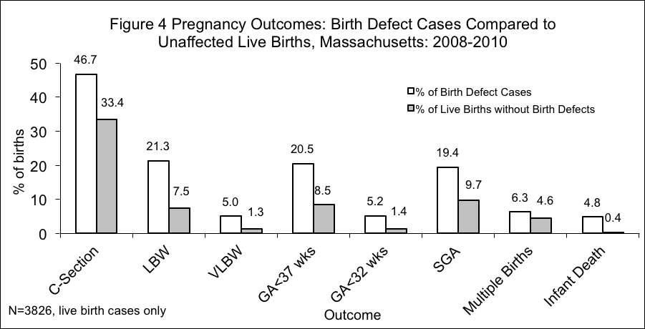
LBW: low birth weight (<2500gm); VLBW: very low birth weight (<1500gm); GA<37: gestational age less than 37 weeks; GA<32: gestational age less than 32 weeks; SGA: small-for-gestational age, defined as birth weight below the 10th percentile for gestational age on basis of a sex-specific US standard (Oken 2003)

Defect¹ | Sex | Count | Rate per  10,000  Births | 95%  Confidence  Interval
Total Cases | Male | 2690 | 207.3 | 199.2-215.7
Total Cases | Female | 1607 | 146.8 | 139.7-154.1
Central Nervous System
Anencephaly | Male | 10 | 0.87 | 0.42-1.60
Anencephaly | Female | 1 | 0.09 | 0.00-0.51
Encephalocele | Male | 0 | 0.00 | 0.00-0.32
Encephalocele | Female | 5 | 0.46 | 0.15-1.07
Holoprosencephaly | Male | 6 | 0.52 | 0.19-1.13
Holoprosencephaly | Female | 8 | 0.73 | 0.32-1.44
Hydrocephaly w/o Spina Bifida | Male | 40 | 3.47 | 2.48-4.73
Hydrocephaly w/o Spina Bifida | Female | 38 | 3.47 | 2.46-4.76
Microcephaly | Male | 17 | 1.47 | 0.86-2.36
Microcephaly | Female | 18 | 1.64 | 0.97-2.60
Spina Bifida w/ and w/o Hydrocephaly | Male | 28 | 2.43 | 1.61-3.51
Spina Bifida w/ and w/o Hydrocephaly | Female | 24 | 2.19 | 1.40-3.26
Spinal Cord | Male | 49 | 4.25 | 3.14-5.62
Spinal Cord | Female | 38 | 3.47 | 2.46-4.76
Other CNS² | Male | 81 | 7.03 | 5.58-8.73
Other CNS² | Female | 86 | 7.85 | 6.28-9.70
Eye
Aniridia | Male | 2 | 0.17 | 0.02-0.63
Aniridia | Female | 1 | 0.09 | 0.00-0.51
Anophthalmia/Microphthalmia | Male | 17 | 1.47 | 0.86-2.36
Anophthalmia/Microphthalmia | Female | 17 | 1.55 | 0.90-2.49
Congenital Glaucoma, Congenital Cataract | Male | 34 | 2.95 | 2.04-4.12
Congenital Glaucoma, Congenital Cataract | Female | 33 | 3.01 | 2.07-4.23
Other Eye² | Male | 34 | 2.95 | 2.04-4.12
Other Eye² | Female | 35 | 3.20 | 2.23-4.45
Ear
Anotia/Microtia | Male | 24 | 2.08 | 1.33-3.10
Anotia/Microtia | Female | 15 | 1.37 | 0.77-2.26
(cont’d)
Other Ear² | Male | 42 | 3.64 | 2.63-4.93
Other Ear² | Female | 32 | 2.92 | 2.00-4.13
Cardiovascular
Anomalous Pulmonary Venous Connection
Total/Partial Anomalous Pulmonary Venous Connection | Male | 23 | 2.00 | 1.26-2.99
Total/Partial Anomalous Pulmonary Venous Connection | Female | 15 | 1.37 | 0.77-2.26
Atrioventricular Canal Defects
ASD Primum | Male | 3 | 0.26 | 0.05-0.76
ASD Primum | Female | 2 | 0.18 | 0.02-0.66
Common Atrium | Male | 2 | 0.17 | 0.02-0.63
Common Atrium | Female | 10 | 0.91 | 0.44-1.68
Complete Atrioventricular Canal Defect | Male | 31 | 2.69 | 1.83-3.82
Complete Atrioventricular Canal Defect | Female | 35 | 3.20 | 2.23-4.45
Endocardial Cushion (OS and NOS) | Male | 13 | 1.13 | 0.60-1.93
Endocardial Cushion (OS and NOS) | Female | 22 | 2.01 | 1.26-3.04
VSD, Canal Type | Male | 5 | 0.43 | 0.14-1.01
VSD, Canal Type | Female | 2 | 0.18 | 0.02-0.66
Conotruncal (Outlet) and Aortic Arch
Double Outlet Right Ventricle | Male | 15 | 1.30 | 0.73-2.15
Double Outlet Right Ventricle | Female | 9 | 0.82 | 0.38-1.56
Interrupted Aortic Arch, Type B | Male | 2 | 0.17 | 0.02-0.63
Interrupted Aortic Arch, Type B | Female | 6 | 0.55 | 0.20-1.19
Tetralogy of Fallot w/ and w/o Pulmonary Atresia | Male | 56 | 4.86 | 3.67-6.31
Tetralogy of Fallot w/ and w/o Pulmonary Atresia | Female | 34 | 3.11 | 2.15-4.34
Truncus | Male | 2 | 0.17 | 0.02-0.63
Truncus | Female | 4 | 0.37 | 0.10-0.94
d-Transposition of the Great Arteries | Male | 37 | 3.21 | 2.26-4.42
d-Transposition of the Great Arteries | Female | 18 | 1.64 | 0.97-2.60
Ebstein Anomaly
Ebstein Anomaly | Male | 4 | 0.35 | 0.09-0.89
Ebstein Anomaly | Female | 4 | 0.37 | 0.10-0.94
Heterotaxy (Laterality Defects)
Heterotaxy | Male | 19 | 1.65 | 0.99-2.57
Heterotaxy | Female | 17 | 1.55 | 0.90-2.49
Left-Sided Obstruction
Aortic Valve Stenosis | Male | 18 | 1.56 | 0.93-2.47
Aortic Valve Stenosis | Female | 13 | 1.19 | 0.63-2.03
Coarctation of Aorta | Male | 51 | 4.42 | 3.29-5.82
Coarctation of Aorta | Female | 46 | 4.20 | 3.08-5.60
Hypoplastic Left Heart Syndrome | Male | 19 | 1.65 | 0.99-2.57
Hypoplastic Left Heart Syndrome | Female | 12 | 1.10 | 0.57-1.91
Interrupted Aortic Arch (Type A and NOS) | Male | 0 | 0.00 | 0.00-0.32
Interrupted Aortic Arch (Type A and NOS) | Female | 1 | 0.09 | 0.00-0.51
Patent Ductus Arteriosus
Patent Ductus Arteriosus | Male | 157 | 13.62 | 11.57-15.93
Patent Ductus Arteriosus | Female | 150 | 13.70 | 11.59-16.07
Right-Sided Obstruction
Pulmonary Stenosis, Valvular | Male | 70 | 6.07 | 4.73-7.67
Pulmonary Stenosis, Valvular | Female | 86 | 7.85 | 6.28-9.70
Pulmonary Valve Atresia w/intact septum | Male | 7 | 0.61 | 0.24-1.25
Pulmonary Valve Atresia w/intact septum | Female | 6 | 0.55 | 0.20-1.19
Pulmonary Valve Atresia with VSD | Male | 5 | 0.43 | 0.14-1.01
Pulmonary Valve Atresia with VSD | Female | 1 | 0.09 | 0.00-0.51
Tricuspid Valve Atresia | Male | 11 | 0.95 | 0.48-1.71
Tricuspid Valve Atresia | Female | 6 | 0.55 | 0.20-1.19
Septal Defects
ASD (Secundum and NOS) | Male | 231 | 20.04 | 17.54-22.80
ASD (Secundum and NOS) | Female | 264 | 24.11 | 21.29-27.20
VSD (Membranous and NOS) | Male | 132 | 11.45 | 9.58-13.58
VSD (Membranous and NOS) | Female | 142 | 12.97 | 10.92-15.29
VSD, Conoventricular/Malalignment | Male | 16 | 1.39 | 0.79-2.25
VSD, Conoventricular/Malalignment | Female | 22 | 2.01 | 1.26-3.04
Single Ventricle and L-TGA
L-TGA | Male | 5 | 0.43 | 0.14-1.01
L-TGA | Female | 2 | 0.18 | 0.02-0.66
Single Ventricle | Male | 7 | 0.61 | 0.24-1.25
Single Ventricle | Female | 2 | 0.18 | 0.02-0.66
Other Cardiovascular
Other Cardiovascular² | Male | 258 | 22.38 | 19.73-25.29
Other Cardiovascular² | Female | 222 | 20.27 | 17.69-23.12
Respiratory
Choanal Atresia | Male | 4 | 0.35 | 0.09-0.89
Choanal Atresia | Female | 12 | 1.10 | 0.57-1.91
Lung Anomalies | Male | 23 | 2.00 | 1.26-2.99
Lung Anomalies | Female | 20 | 1.83 | 1.12-2.82
Other Respiratory² | Male | 11 | 0.95 | 0.48-1.71
Other Respiratory² | Female | 17 | 1.55 | 0.90-2.49
Orofacial
Cleft Lip w/ and w/o Cleft Palate | Male | 120 | 10.41 | 8.63-12.45
Cleft Lip w/ and w/o Cleft Palate | Female | 61 | 5.57 | 4.26-7.16
Cleft Palate w/o Cleft Lip | Male | 41 | 3.56 | 2.55-4.83
Cleft Palate w/o Cleft Lip | Female | 82 | 7.49 | 5.96-9.30
Pierre Robin Sequence | Male | 17 | 1.47 | 0.86-2.36
Pierre Robin Sequence | Female | 26 | 2.37 | 1.55-3.48
Other Orofacial² | Male | 64 | 5.55 | 4.28-7.09
Other Orofacial² | Female | 53 | 4.84 | 3.63-6.33
Gastrointestinal
Biliary Atresia | Male | 6 | 0.52 | 0.19-1.13
Biliary Atresia | Female | 8 | 0.73 | 0.32-1.44
Esophageal Atresia/Tracheoesophageal Fistula | Male | 26 | 2.26 | 1.47-3.30
Esophageal Atresia/Tracheoesophageal Fistula | Female | 25 | 2.28 | 1.48-3.37
Hirschsprung Disease | Male | 39 | 3.38 | 2.41-4.63
Hirschsprung Disease | Female | 13 | 1.19 | 0.63-2.03
(cont’d)
Rectal and Large Intestinal Atresia/Stenosis | Male | 39 | 3.38 | 2.41-4.63
Rectal and Large Intestinal Atresia/Stenosis | Female | 30 | 2.74 | 1.85-3.91
Small Intestinal Atresia | Male | 36 | 3.12 | 2.19-4.32
Small Intestinal Atresia | Female | 28 | 2.56 | 1.70-3.70
Other Gastrointestinal² | Male | 94 | 8.15 | 6.59-9.98
Other Gastrointestinal² | Female | 69 | 6.30 | 4.90-7.97
Genitourinary
Bladder Exstrophy | Male | 3 | 0.26 | 0.05-0.76
Bladder Exstrophy | Female | 1 | 0.09 | 0.00-0.51
Cloacal Exstrophy | Male | 0 | 0.00 | 0.00-0.32
Cloacal Exstrophy | Female | 2 | 0.18 | 0.02-0.66
Hypospadias, 2nd or 3rd Degree | Male | 309 | 26.81 | 23.90-29.96
Hypospadias, 2nd or 3rd Degree | Female | 0 | 0.00 | 0.00-0.34
Obstructive Genitourinary Defect | Male | 230 | 19.95 | 17.46-22.71
Obstructive Genitourinary Defect | Female | 118 | 10.78 | 8.92-12.91
Renal Agenesis/Hypoplasia | Male | 7 | 0.61 | 0.24-1.25
Renal Agenesis/Hypoplasia | Female | 4 | 0.37 | 0.10-0.94
Other Genitourinary² | Male | 260 | 22.56 | 19.90-25.47
Other Genitourinary² | Female | 141 | 12.88 | 10.84-15.19
Musculoskeletal
Club Foot | Male | 213 | 18.48 | 16.08-21.13
Club Foot | Female | 110 | 10.05 | 8.26-12.11
Craniosynostosis | Male | 71 | 6.16 | 4.81-7.77
Craniosynostosis | Female | 39 | 3.56 | 2.53-4.87
Diaphragmatic Hernia | Male | 36 | 3.12 | 2.19-4.32
Diaphragmatic Hernia | Female | 18 | 1.64 | 0.97-2.60
Gastroschisis | Male | 33 | 2.86 | 1.97-4.02
Gastroschisis | Female | 43 | 3.93 | 2.84-5.29
Omphalocele | Male | 20 | 1.74 | 1.06-2.68
Omphalocele | Female | 6 | 0.55 | 0.20-1.19
(cont’d)
Polydactyly/Syndactyly | Male | 221 | 19.17 | 16.73-21.87
Polydactyly/Syndactyly | Female | 138 | 12.60 | 10.59-14.89
Reduction Deformity, Lower Limbs | Male | 17 | 1.47 | 0.86-2.36
Reduction Deformity, Lower Limbs | Female | 11 | 1.00 | 0.50-1.80
Reduction Deformity, Upper Limbs | Male | 28 | 2.43 | 1.61-3.51
Reduction Deformity, Upper Limbs | Female | 27 | 2.47 | 1.62-3.59
Skeletal Dysplasia | Male | 16 | 1.39 | 0.79-2.25
Skeletal Dysplasia | Female | 14 | 1.28 | 0.70-2.15
Other Musculoskeletal² | Male | 144 | 12.49 | 10.54-14.71
Other Musculoskeletal² | Female | 115 | 10.50 | 8.67-12.61
Chromosomal and other Syndromes
Klinefelter Syndrome | Male | 8 | 0.69 | 0.30-1.37
Klinefelter Syndrome | Female | 0 | 0.00 | 0.00-0.34
Trisomy 13 | Male | 3 | 0.26 | 0.05-0.76
Trisomy 13 | Female | 6 | 0.55 | 0.20-1.19
Trisomy 18 | Male | 17 | 1.47 | 0.86-2.36
Trisomy 18 | Female | 19 | 1.74 | 1.04-2.71
Trisomy 21 (Down Syndrome) | Male | 163 | 14.14 | 12.05-16.49
Trisomy 21 (Down Syndrome) | Female | 120 | 10.96 | 9.09-13.10
Turner Syndrome | Male | 0 | 0.00 | 0.00-0.32
Turner Syndrome | Female | 18 | 1.64 | 0.97-2.60
Other Chromosomal Syndromes/Other Syndromes² | Male | 153 | 13.27 | 11.25-15.55
Other Chromosomal Syndromes/Other Syndromes² | Female | 155 | 14.16 | 12.01-16.57
Other
Amniotic Bands | Male | 9 | 0.78 | 0.36-1.48
Amniotic Bands | Female | 10 | 0.91 | 0.44-1.68
Skin Anomalies | Male | 18 | 1.56 | 0.93-2.47
Skin Anomalies | Female | 20 | 1.83 | 1.12-2.82
Other, Specified² | Male | 15 | 1.30 | 0.73-2.15
Other, Specified² | Female | 14 | 1.28 | 0.70-2.15

^{1.} Cases can be included in more than one defect. Cases are counted once in the total for a defect category. Due to missing sex of infant counts may not match those in other tables.
² Rate may represent a heterogeneous group of defects.
³ Rate calculated using male live births.

Defect | Count | Rate per  10,000  Births | 95%  Confidence  Interval
FEMALE
ASD (Secundum and NOS) | 264 | 24.11 | 21.29-27.20
VSD (Membranous and NOS) | 142 | 12.97 | 10.92-15.29
Polydactyly/Syndactyly | 138 | 12.60 | 10.59-14.89
Trisomy 21 (Down Syndrome) | 120 | 10.96 | 9.09-13.10
Obstructive Genitourinary Defect | 118 | 10.78 | 8.92-12.91
Club Foot | 110 | 10.05 | 8.26-12.11
Pulmonary Stenosis, Valvular | 86 | 7.85 | 6.28-9.70
Cleft Palate w/o Cleft Lip | 82 | 7.49 | 5.96-9.30
Cleft Lip w/ and w/o Cleft Palate | 61 | 5.57 | 4.26-7.16
Coarctation of Aorta | 46 | 4.20 | 3.08-5.60
MALE
Hypospadias, 2nd or 3rd Degree | 309 | 26.81 | 23.90-29.96
ASD (Secundum and NOS) | 231 | 20.04 | 17.54-22.80
Obstructive Genitourinary Defect | 230 | 19.95 | 17.46-22.71
Polydactyly/Syndactyly | 221 | 19.17 | 16.73-21.87
Club Foot | 213 | 18.48 | 16.08-21.13
Trisomy 21 (Down Syndrome) | 163 | 14.14 | 12.05-16.49
VSD (Membranous and NOS) | 132 | 11.45 | 9.58-13.58
Cleft Lip w/ and w/o Cleft Palate | 120 | 10.41 | 8.63-12.45
Craniosynostosis | 71 | 6.16 | 4.81-7.77
Pulmonary Stenosis, Valvular | 70 | 6.07 | 4.73-7.67

Hypospadias rate calculated using male live births.

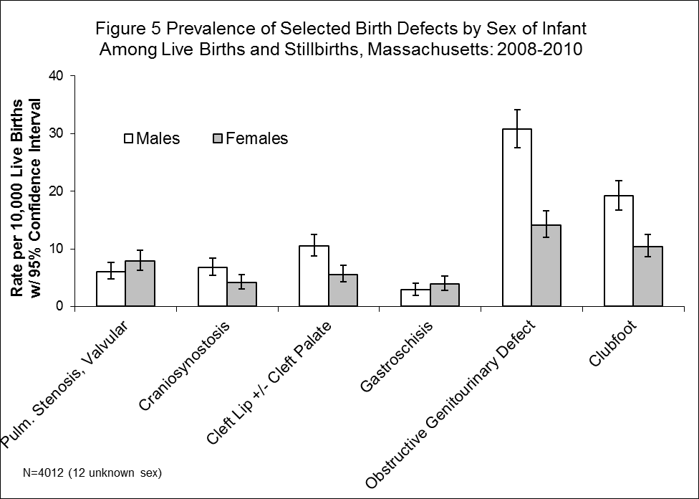

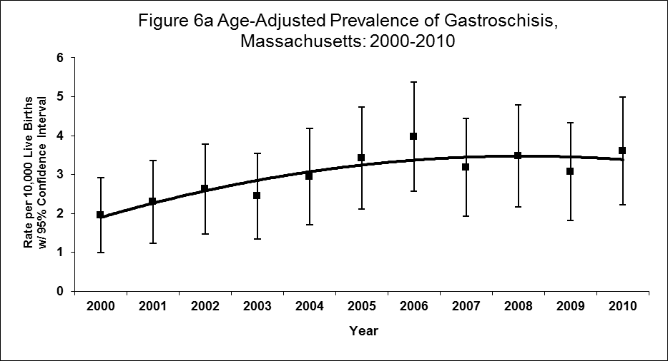

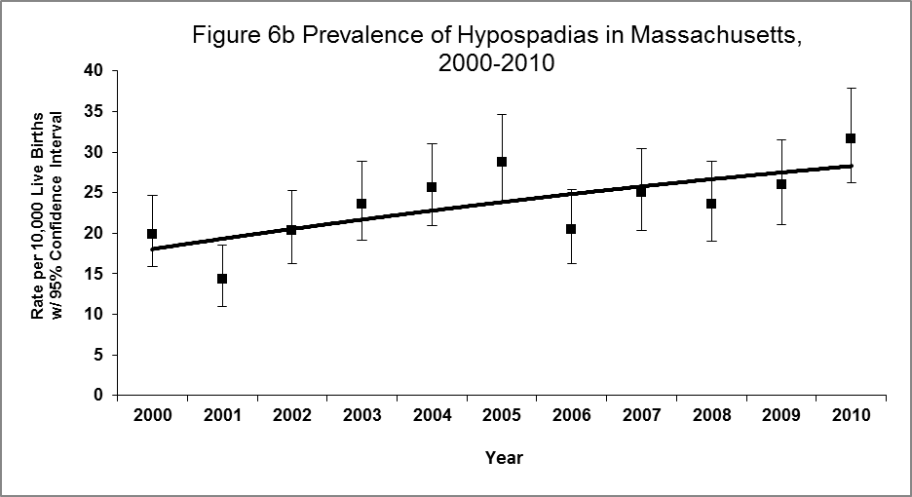

Chapter 4

Prevalence of Birth Defects by
Plurality and Maternal Age

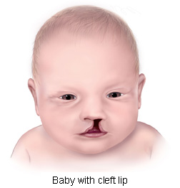

Courtesy of the Centers for Disease Control and Prevention

Plurality
Table 8 shows the distribution of birth defects by plurality. Plurality information obtained from reviewing the medical record differed slightly from the plurality recorded on the birth and fetal death records. Since medical record abstraction may reveal early losses not recorded at birth and is therefore more accurate, plurality from the medical record abstraction (rather than the birth certificate information) is used in this report. When using the medical record, the birth defect case prevalence was 173.83 for singletons and 275.00 for multiple births (more than one infant) per 10,000 live births. While multiple births comprised under 5% of all live births, they comprised over 7% of birth defects cases among live births (see Figures 7a and 7b). Birth defects that occurred most often among multiple births (all of which occurred more often than in singleton births) were atrial septal defects (secundum and NOS), ventricular septal defects (membranous and NOS), hypospadias (2nd and 3rd degree), clubfoot, and obstructive genitourinary defect. Figure 8 presents rates for selected birth defects for singletons and multiples. Table 9 lists the most common defects among singletons and multiples. Examining birth defects by plurality is important since the rate of multiple births has been increasing in Massachusetts since 1994.

Maternal Age
The prevalence of birth defects varied by maternal age. Defect rates among live born infants per 10,000 live births were 178.67 for mothers younger than 20 years, 177.00 for those 20-24 years, 167.11 for those 25-29 years, 157.66 for those 30-34 years and 203.52 for those 35 years and older.

As expected, there was a strong association between Down syndrome and advanced maternal age (see Figure 9). The Down syndrome rate of 31.1 per 10,000 live births for women 35 years and older was more than three times that of any other maternal age group. The pattern of higher Down syndrome rates among older women reflects the pattern of higher chromosomal defects in general among older women. Figure 9 shows the increase of Down syndrome rate as maternal age increases. Additionally, as seen in Figure 10, the proportion of all birth defects that are chromosomal in nature was higher in the 35+ age group than in other age groups and primarily accounts for most of the difference between that age group and the others.

Figure 11 shows that younger mothers (aged 19 and under) had the highest rate of gastroschisis cases at 14.5 per 10,000 live births. This association has been shown in previous studies (Forrester and Merz 1999). The youngest mothers had infants with higher rates of gastroschisis and reduction deformities of the upper limb than other age groups. Older mothers had higher rates for other defects including Down syndrome and ventricular septal defects (membranous and NOS). While results for other defects also differed by age group, the small numbers from three years of surveillance were not sufficient for interpretation.

Table 11 displays the most common birth defects for live births by maternal age groups. Obstructive genitourinary defect, polydactyly/syndactyly, and atrial septal defect (secundum or NOS) were three of the most frequently occurring defects common to all maternal age groups, clubfoot was among the most common birth defects in all but the oldest age group.

Monitoring birth defects by maternal age is important since the number of births to older mothers has been increasing over time in Massachusetts. The percentage of live births delivered to women ages 30+ has increased steadily since the 1980s to the point where the percent of total births delivered to women 30 years and older surpassed the percent of births to women below age 30 in 1996. More recent data suggest that the percent of births to women ages 30+ peaked around 2004 and has decreased only slightly since. There has been a marked change in the age distribution of Massachusetts women giving birth since 1980. Approximately 25% of women giving birth in 1980 were 30 years and older compared with 54% in 2010. Additionally, the proportion of multiple births in mothers over 35 years was twice that of mothers less than 35 years of age in 2010 (MADPH 2013).

A factor in both the increased percentage of women giving birth at an age of 35 or over and the disparity of multiple births among these older women giving birth may be the use of assisted reproductive technology (ART). Between 1997 and 2004, 2% of Massachusetts births resulted from ART (CDC 2009) though this may be an underestimate (Zhang Z, Macaluso M et al). According to the CDC, Massachusetts ranked fifth in the number of ART procedures performed in 2006 (8,305), after California, New York, Illinois and New Jersey. In 2006 Massachusetts had the highest ratio of the number of ART procedures among state residents at 1,291 per million residents. (Wright, Chang et al. 2008). Of the infants born in 2005 as a result of ART procedures, 43.5% were born in multiple birth deliveries (Wright, Chang et al. 2008). Figure 12 shows the disparity in percent of births that are single versus multiple from ART births and non-ART births in Massachusetts (CDC 2009). The vast majority of non-ART births are single deliveries, whereas almost half of ART births are multiple deliveries. ART poses many risks associated with multiple births that may lead to adverse maternal and infant outcomes such as low birthweight and preterm delivery. ART has also been associated with some birth defects such as septal heart defects and cleft lip with or without cleft palate (Reefhuis, Honein et al. 2009).

Defect² | Plurality | Count | Rate per  10,000  Births | 95%  Confidence  Interval
Total Cases | Singleton | 3727 | 173.8 | 168.3-179.5
Total Cases | Multiple | 285 | 275.0 | 244.0-308.8
Central Nervous System
Anencephaly | Singleton | 11 | 0.51 | 0.26-0.92
Anencephaly | Multiple | 2 | 1.93 | 0.23-6.97
Encephalocele | Singleton | 5 | 0.23 | 0.08-0.54
Encephalocele | Multiple | 0 | 0.00 | 0.00-3.56
Holoprosencephaly | Singleton | 14 | 0.65 | 0.36-1.10
Holoprosencephaly | Multiple | 1 | 0.96 | 0.02-5.38
Hydrocephaly w/o Spina Bifida | Singleton | 73 | 3.40 | 2.67-4.28
Hydrocephaly w/o Spina Bifida | Multiple | 6 | 5.79 | 2.12-12.60
Microcephaly | Singleton | 34 | 1.59 | 1.10-2.22
Microcephaly | Multiple | 1 | 0.96 | 0.02-5.38
Spina Bifida w/ and w/o Hydrocephaly | Singleton | 48 | 2.24 | 1.65-2.97
Spina Bifida w/ and w/o Hydrocephaly | Multiple | 6 | 5.79 | 2.12-12.60
Spinal Cord | Singleton | 85 | 3.96 | 3.17-4.90
Spinal Cord | Multiple | 2 | 1.93 | 0.23-6.97
Other CNS³ | Singleton | 158 | 7.37 | 6.26-8.61
Other CNS³ | Multiple | 10 | 9.65 | 4.63-17.74
Eye
Aniridia | Singleton | 3 | 0.14 | 0.03-0.41
Aniridia | Multiple | 0 | 0.00 | 0.00-3.56
Anophthalmia/Microphthalmia | Singleton | 33 | 1.54 | 1.06-2.16
Anophthalmia/Microphthalmia | Multiple | 1 | 0.96 | 0.02-5.38
Congenital Glaucoma, Congenital Cataract | Singleton | 65 | 3.03 | 2.34-3.86
Congenital Glaucoma, Congenital Cataract | Multiple | 2 | 1.93 | 0.23-6.97
Other Eye³ | Singleton | 67 | 3.12 | 2.42-3.97
Other Eye³ | Multiple | 2 | 1.93 | 0.23-6.97
Ear
Anotia/Microtia | Singleton | 38 | 1.77 | 1.25-2.43
Anotia/Microtia | Multiple | 1 | 0.96 | 0.02-5.38
(cont’d)
Other Ear³ | Singleton | 73 | 3.40 | 2.67-4.28
Other Ear³ | Multiple | 1 | 0.96 | 0.02-5.38
Cardiovascular
Anomalous Pulmonary Venous Connection
Total/Partial Anomalous Pulmonary Venous Connection | Singleton | 38 | 1.77 | 1.25-2.43
Total/Partial Anomalous Pulmonary Venous Connection | Multiple | 0 | 0.00 | 0.00-3.56
Atrioventricular Canal Defects
ASD Primum | Singleton | 5 | 0.23 | 0.08-0.54
ASD Primum | Multiple | 0 | 0.00 | 0.00-3.56
Common Atrium | Singleton | 10 | 0.47 | 0.22-0.86
Common Atrium | Multiple | 2 | 1.93 | 0.23-6.97
Complete Atrioventricular Canal Defect | Singleton | 66 | 3.08 | 2.38-3.92
Complete Atrioventricular Canal Defect | Multiple | 1 | 0.96 | 0.02-5.38
Endocardial Cushion (OS and NOS) | Singleton | 33 | 1.54 | 1.06-2.16
Endocardial Cushion (OS and NOS) | Multiple | 2 | 1.93 | 0.23-6.97
VSD, Canal Type | Singleton | 7 | 0.33 | 0.13-0.67
VSD, Canal Type | Multiple | 0 | 0.00 | 0.00-3.56
Conotruncal (Outlet) and Aortic Arch
Double Outlet Right Ventricle | Singleton | 23 | 1.07 | 0.68-1.61
Double Outlet Right Ventricle | Multiple | 1 | 0.96 | 0.02-5.38
Interrupted Aortic Arch, Type B | Singleton | 8 | 0.37 | 0.16-0.74
Interrupted Aortic Arch, Type B | Multiple | 0 | 0.00 | 0.00-3.56
Tetralogy of Fallot w/ and w/o Pulmonary Atresia | Singleton | 81 | 3.78 | 3.00-4.70
Tetralogy of Fallot w/ and w/o Pulmonary Atresia | Multiple | 9 | 8.68 | 3.97-16.48
Truncus | Singleton | 5 | 0.23 | 0.08-0.54
Truncus | Multiple | 1 | 0.96 | 0.02-5.38
d-Transposition of the Great Arteries | Singleton | 53 | 2.47 | 1.85-3.23
d-Transposition of the Great Arteries | Multiple | 2 | 1.93 | 0.23-6.97
Ebstein Anomaly
Ebstein Anomaly | Singleton | 8 | 0.37 | 0.16-0.74
Ebstein Anomaly | Multiple | 0 | 0.00 | 0.00-3.56
Heterotaxy (Laterality Defects)
Heterotaxy | Singleton | 33 | 1.54 | 1.06-2.16
Heterotaxy | Multiple | 3 | 2.89 | 0.60-8.46
Left-Sided Obstruction
Aortic Valve Stenosis | Singleton | 29 | 1.35 | 0.91-1.94
Aortic Valve Stenosis | Multiple | 2 | 1.93 | 0.23-6.97
Coarctation of Aorta | Singleton | 89 | 4.15 | 3.33-5.11
Coarctation of Aorta | Multiple | 8 | 7.72 | 3.33-15.21
Hypoplastic Left Heart Syndrome | Singleton | 28 | 1.31 | 0.87-1.89
Hypoplastic Left Heart Syndrome | Multiple | 3 | 2.89 | 0.60-8.46
Interrupted Aortic Arch (Type A and NOS) | Singleton | 1 | 0.05 | 0.00-0.26
Interrupted Aortic Arch (Type A and NOS) | Multiple | 0 | 0.00 | 0.00-3.56
Patent Ductus Arteriosus
Patent Ductus Arteriosus | Singleton | 296 | 13.81 | 12.28-15.47
Patent Ductus Arteriosus | Multiple | 11 | 10.61 | 5.30-18.99
Right-Sided Obstruction
Pulmonary Stenosis, Valvular | Singleton | 143 | 6.67 | 5.62-7.86
Pulmonary Stenosis, Valvular | Multiple | 13 | 12.54 | 6.68-21.45
Pulmonary Valve Atresia w/intact septum | Singleton | 14 | 0.65 | 0.36-1.10
Pulmonary Valve Atresia w/intact septum | Multiple | 0 | 0.00 | 0.00-3.56
Pulmonary Valve Atresia with VSD | Singleton | 6 | 0.28 | 0.10-0.61
Pulmonary Valve Atresia with VSD | Multiple | 0 | 0.00 | 0.00-3.56
Tricuspid Valve Atresia | Singleton | 17 | 0.79 | 0.46-1.27
Tricuspid Valve Atresia | Multiple | 0 | 0.00 | 0.00-3.56
Septal Defects
ASD (Secundum and NOS) | Singleton | 454 | 21.17 | 19.27-23.21
ASD (Secundum and NOS) | Multiple | 41 | 39.56 | 28.39-53.67
VSD (Membranous and NOS) | Singleton | 246 | 11.47 | 10.08-13.00
VSD (Membranous and NOS) | Multiple | 28 | 27.02 | 17.95-39.05
VSD, Conoventricular/Malalignment | Singleton | 34 | 1.59 | 1.10-2.22
VSD, Conoventricular/Malalignment | Multiple | 6 | 5.79 | 2.12-12.60
Single Ventricle and L-TGA
L-TGA | Singleton | 7 | 0.33 | 0.13-0.67
L-TGA | Multiple | 0 | 0.00 | 0.00-3.56
Single Ventricle | Singleton | 9 | 0.42 | 0.19-0.80
Single Ventricle | Multiple | 0 | 0.00 | 0.00-3.56
Other Cardiovascular
Other Cardiovascular³ | Singleton | 454 | 21.17 | 19.27-23.21
Other Cardiovascular³ | Multiple | 30 | 28.95 | 19.53-41.32
Respiratory
Choanal Atresia | Singleton | 13 | 0.61 | 0.32-1.04
Choanal Atresia | Multiple | 3 | 2.89 | 0.60-8.46
Lung Anomalies | Singleton | 40 | 1.87 | 1.33-2.54
Lung Anomalies | Multiple | 3 | 2.89 | 0.60-8.46
Other Respiratory³ | Singleton | 27 | 1.26 | 0.83-1.83
Other Respiratory³ | Multiple | 2 | 1.93 | 0.23-6.97
Orofacial
Cleft Lip w/ and w/o Cleft Palate | Singleton | 168 | 7.84 | 6.70-9.11
Cleft Lip w/ and w/o Cleft Palate | Multiple | 14 | 13.51 | 7.39-22.66
Cleft Palate w/o Cleft Lip | Singleton | 119 | 5.55 | 4.60-6.64
Cleft Palate w/o Cleft Lip | Multiple | 5 | 4.82 | 1.57-11.26
Pierre Robin Sequence | Singleton | 42 | 1.96 | 1.41-2.65
Pierre Robin Sequence | Multiple | 1 | 0.96 | 0.02-5.38
Other Orofacial³ | Singleton | 108 | 5.04 | 4.13-6.08
Other Orofacial³ | Multiple | 9 | 8.68 | 3.97-16.48
Gastrointestinal
Biliary Atresia | Singleton | 13 | 0.61 | 0.32-1.04
Biliary Atresia | Multiple | 1 | 0.96 | 0.02-5.38
Esophageal Atresia/Tracheoesophageal Fistula | Singleton | 47 | 2.19 | 1.61-2.92
Esophageal Atresia/Tracheoesophageal Fistula | Multiple | 4 | 3.86 | 1.05-9.88
Hirschsprung Disease | Singleton | 49 | 2.29 | 1.69-3.02
Hirschsprung Disease | Multiple | 3 | 2.89 | 0.60-8.46
(cont’d)
Rectal and Large Intestinal Atresia/Stenosis | Singleton | 67 | 3.12 | 2.42-3.97
Rectal and Large Intestinal Atresia/Stenosis | Multiple | 2 | 1.93 | 0.23-6.97
Small Intestinal Atresia | Singleton | 63 | 2.94 | 2.26-3.76
Small Intestinal Atresia | Multiple | 3 | 2.89 | 0.60-8.46
Other Gastrointestinal³ | Singleton | 151 | 7.04 | 5.96-8.26
Other Gastrointestinal³ | Multiple | 12 | 11.58 | 5.98-20.23
Genitourinary
Bladder Exstrophy | Singleton | 4 | 0.19 | 0.05-0.48
Bladder Exstrophy | Multiple | 0 | 0.00 | 0.00-3.56
Cloacal Exstrophy | Singleton | 2 | 0.09 | 0.01-0.34
Cloacal Exstrophy | Multiple | 0 | 0.00 | 0.00-3.56
Hypospadias, 2nd or 3rd Degree⁴ | Singleton | 282 | 25.73 | 11.66-14.78
Hypospadias, 2nd or 3rd Degree⁴ | Multiple | 27 | 51.31 | 17.17-37.90
Obstructive Genitourinary Defect | Singleton | 332 | 15.48 | 13.86-17.24
Obstructive Genitourinary Defect | Multiple | 16 | 15.44 | 8.82-25.07
Renal Agenesis/Hypoplasia | Singleton | 10 | 0.47 | 0.22-0.86
Renal Agenesis/Hypoplasia | Multiple | 1 | 0.96 | 0.02-5.38
Other Genitourinary³ | Singleton | 378 | 17.63 | 15.90-19.50
Other Genitourinary³ | Multiple | 24 | 23.16 | 14.84-34.46
Musculoskeletal
Club Foot | Singleton | 308 | 14.37 | 12.81-16.06
Club Foot | Multiple | 18 | 17.37 | 10.29-27.45
Craniosynostosis | Singleton | 104 | 4.85 | 3.96-5.88
Craniosynostosis | Multiple | 6 | 5.79 | 2.12-12.60
Diaphragmatic Hernia | Singleton | 48 | 2.24 | 1.65-2.97
Diaphragmatic Hernia | Multiple | 8 | 7.72 | 3.33-15.21
Gastroschisis | Singleton | 73 | 3.40 | 2.67-4.28
Gastroschisis | Multiple | 3 | 2.89 | 0.60-8.46
Omphalocele | Singleton | 22 | 1.03 | 0.64-1.55
Omphalocele | Multiple | 4 | 3.86 | 1.05-9.88
(cont’d)
Polydactyly/Syndactyly | Singleton | 343 | 16.00 | 14.35-17.78
Polydactyly/Syndactyly | Multiple | 16 | 15.44 | 8.82-25.07
Reduction Deformity, Lower Limbs | Singleton | 27 | 1.26 | 0.83-1.83
Reduction Deformity, Lower Limbs | Multiple | 2 | 1.93 | 0.23-6.97
Reduction Deformity, Upper Limbs | Singleton | 54 | 2.52 | 1.89-3.29
Reduction Deformity, Upper Limbs | Multiple | 2 | 1.93 | 0.23-6.97
Skeletal Dysplasia | Singleton | 28 | 1.31 | 0.87-1.89
Skeletal Dysplasia | Multiple | 2 | 1.93 | 0.23-6.97
Other Musculoskeletal³ | Singleton | 233 | 10.87 | 9.52-12.36
Other Musculoskeletal³ | Multiple | 28 | 27.02 | 17.95-39.05
Chromosomal and other Syndromes
Klinefelter Syndrome | Singleton | 7 | 0.33 | 0.13-0.67
Klinefelter Syndrome | Multiple | 1 | 0.96 | 0.02-5.38
Trisomy 13 | Singleton | 9 | 0.42 | 0.19-0.80
Trisomy 13 | Multiple | 1 | 0.96 | 0.02-5.38
Trisomy 18 | Singleton | 35 | 1.63 | 1.14-2.27
Trisomy 18 | Multiple | 3 | 2.89 | 0.60-8.46
Trisomy 21 (Down Syndrome) | Singleton | 273 | 12.73 | 11.27-14.34
Trisomy 21 (Down Syndrome) | Multiple | 16 | 15.44 | 8.82-25.07
Turner Syndrome | Singleton | 21 | 0.98 | 0.61-1.50
Turner Syndrome | Multiple | 1 | 0.96 | 0.02-5.38
Other Chromosomal Syndromes/Other Syndromes³ | Singleton | 288 | 13.43 | 11.93-15.08
Other Chromosomal Syndromes/Other Syndromes³ | Multiple | 22 | 21.23 | 13.30-32.14
Other
Amniotic Bands | Singleton | 16 | 0.75 | 0.43-1.21
Amniotic Bands | Multiple | 5 | 4.82 | 1.57-11.26
Skin Anomalies | Singleton | 34 | 1.59 | 1.10-2.22
Skin Anomalies | Multiple | 4 | 3.86 | 1.05-9.88
Other, Specified³ | Singleton | 27 | 1.26 | 0.83-1.83
Other, Specified³ | Multiple | 2 | 1.93 | 0.23-6.97

^{1.} Plurality is the number of births to a woman from the same pregnancy. A singleton is the birth of one infant; multiple represents more than one infant.
^{2.} Cases can be included in more than one defect. Due to missing plurality of infants, counts may not match those in other tables.
³ Rate may represent a heterogeneous group of defects.
⁴ Rate calculated using male live births.

Defect² | Count | Rate per  10,000  Births | 95%  Confidence  Interval
MULTIPLE
ASD (Secundum and NOS) | 41 | 39.56 | 28.39-53.67
VSD (Membranous and NOS) | 28 | 27.02 | 17.95-39.05
Hypospadias, 2nd or 3rd Degree³ | 27 | 26.05 | 17.17-37.90
Club Foot | 18 | 17.37 | 10.29-27.45
Obstructive Genitourinary Defect | 16 | 15.44 | 8.82-25.07
Polydactyly/Syndactyly | 16 | 15.44 | 8.82-25.07
Trisomy 21 (Down Syndrome) | 16 | 15.44 | 8.82-25.07
Cleft Lip w/ and w/o Cleft Palate | 14 | 13.51 | 7.39-22.66
Pulmonary Stenosis, Valvular | 13 | 12.54 | 6.68-21.45
Tetralogy of Fallot w/ and w/o Pulmonary Atresia | 9 | 8.68 | 3.97-16.48
SINGLETON
ASD (Secundum and NOS) | 454 | 21.17 | 19.27-23.21
Polydactyly/Syndactyly | 343 | 16.00 | 14.35-17.78
Obstructive Genitourinary Defect | 332 | 15.48 | 13.86-17.24
Club Foot | 308 | 14.37 | 12.81-16.06
Hypospadias, 2nd or 3rd Degree³ | 282 | 13.15 | 11.66-14.78
Trisomy 21 (Down Syndrome) | 273 | 12.73 | 11.27-14.34
VSD (Membranous and NOS) | 246 | 11.47 | 10.08-13.00
Cleft Lip w/ and w/o Cleft Palate | 168 | 7.84 | 6.70-9.11
Pulmonary Stenosis, Valvular | 143 | 6.67 | 5.62-7.86
Cleft Palate w/o Cleft Lip | 119 | 5.55 | 4.60-6.64

^{1.} Plurality is the number of births to a woman from the same pregnancy. A singleton is the birth of one infant; multiple represents more than one infant.
^{2.} Rate calculated using male live births.
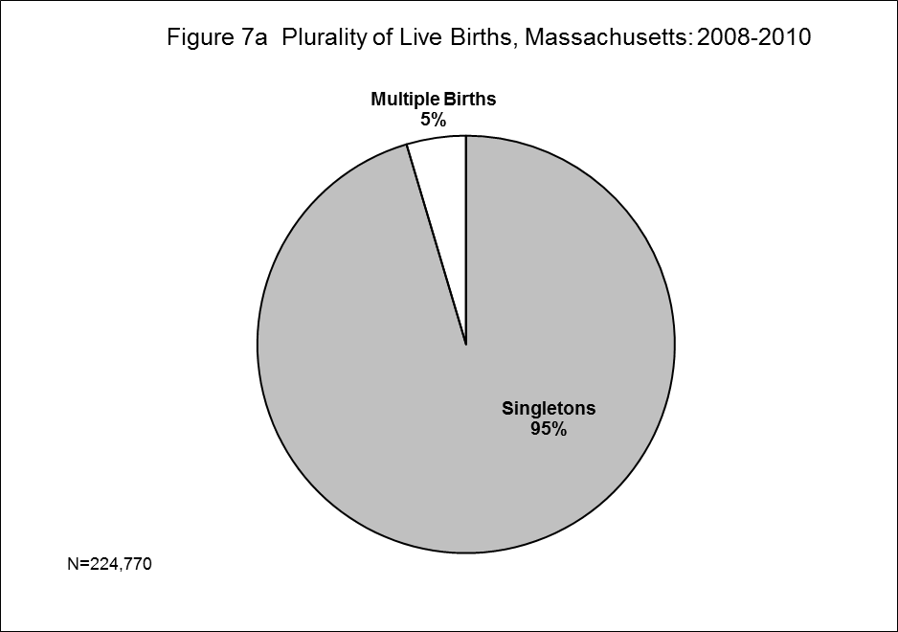

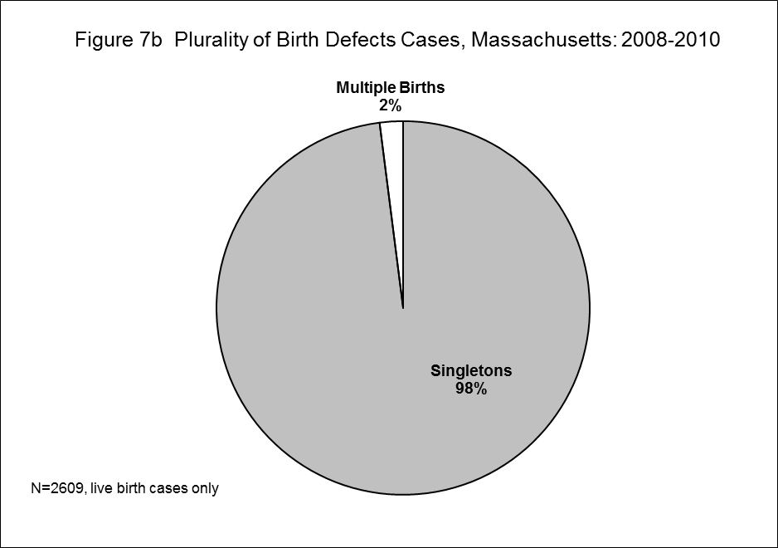

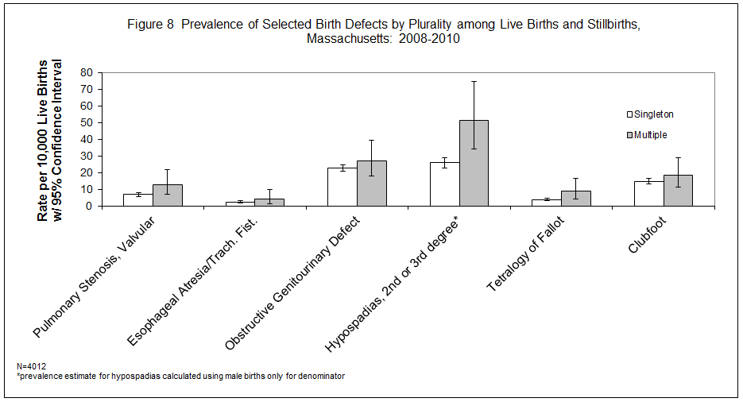

Defect¹ | Maternal  Age | Count | Rate per  10,000  Births | 95%  Confidence  Interval
Total Cases | <20 | 234 | 178.7 | 156.5-203.1
Total Cases | 20-24 | 634 | 177.0 | 163.6-191.2
Total Cases | 25-29 | 928 | 167.1 | 156.6-178.1
Total Cases | 30-34 | 1095 | 157.7 | 148.5-167.2
Total Cases | 35+ | 1035 | 203.5 | 191.4-216.2
Central Nervous System
Anencephaly | <20 | 1 | 0.76 | 0.02-4.25
Anencephaly | 20-24 | 4 | 1.12 | 0.30-2.86
Anencephaly | 25-29 | 3 | 0.54 | 0.11-1.58
Anencephaly | 30-34 | 1 | 0.14 | 0.00-0.80
Anencephaly | 35+ | 0 | 0.00 | 0.00-0.73
Encephalocele | <20 | 0 | 0.00 | 0.00-2.82
Encephalocele | 20-24 | 1 | 0.28 | 0.01-1.56
Encephalocele | 25-29 | 2 | 0.36 | 0.04-1.30
Encephalocele | 30-34 | 1 | 0.14 | 0.00-0.80
Encephalocele | 35+ | 1 | 0.20 | 0.00-1.10
Holoprosencephaly | <20 | 0 | 0.00 | 0.00-2.82
Holoprosencephaly | 20-24 | 5 | 1.40 | 0.45-3.26
Holoprosencephaly | 25-29 | 4 | 0.72 | 0.20-1.84
Holoprosencephaly | 30-34 | 3 | 0.43 | 0.09-1.26
Holoprosencephaly | 35+ | 2 | 0.39 | 0.05-1.42
Hydrocephaly w/o Spina Bifida | <20 | 10 | 7.64 | 3.66-14.04
Hydrocephaly w/o Spina Bifida | 20-24 | 18 | 5.02 | 2.98-7.94
Hydrocephaly w/o Spina Bifida | 25-29 | 13 | 2.34 | 1.25-4.00
Hydrocephaly w/o Spina Bifida | 30-34 | 15 | 2.16 | 1.21-3.56
Hydrocephaly w/o Spina Bifida | 35+ | 15 | 2.95 | 1.65-4.86
Microcephaly | <20 | 3 | 2.29 | 0.47-6.69
Microcephaly | 20-24 | 8 | 2.23 | 0.96-4.40
Microcephaly | 25-29 | 11 | 1.98 | 0.99-3.54
Microcephaly | 30-34 | 8 | 1.15 | 0.50-2.27
Microcephaly | 35+ | 5 | 0.98 | 0.32-2.29
(cont’d)
Spina Bifida w/ and w/o Hydrocephaly | <20 | 3 | 2.29 | 0.47-6.69
Spina Bifida w/ and w/o Hydrocephaly | 20-24 | 8 | 2.23 | 0.96-4.40
Spina Bifida w/ and w/o Hydrocephaly | 25-29 | 16 | 2.88 | 1.65-4.68
Spina Bifida w/ and w/o Hydrocephaly | 30-34 | 12 | 1.73 | 0.89-3.02
Spina Bifida w/ and w/o Hydrocephaly | 35+ | 11 | 2.16 | 1.08-3.87
Spinal Cord | <20 | 2 | 1.53 | 0.18-5.52
Spinal Cord | 20-24 | 10 | 2.79 | 1.34-5.13
Spinal Cord | 25-29 | 24 | 4.32 | 2.77-6.43
Spinal Cord | 30-34 | 30 | 4.32 | 2.91-6.17
Spinal Cord | 35+ | 21 | 4.13 | 2.56-6.31
Other CNS² | <20 | 21 | 16.03 | 9.93-24.51
Other CNS² | 20-24 | 34 | 9.49 | 6.57-13.26
Other CNS² | 25-29 | 37 | 6.66 | 4.69-9.18
Other CNS² | 30-34 | 36 | 5.18 | 3.63-7.18
Other CNS² | 35+ | 37 | 7.28 | 5.12-10.03
Eye
Aniridia | <20 | 0 | 0.00 | 0.00-2.82
Aniridia | 20-24 | 0 | 0.00 | 0.00-1.03
Aniridia | 25-29 | 2 | 0.36 | 0.04-1.30
Aniridia | 30-34 | 0 | 0.00 | 0.00-0.53
Aniridia | 35+ | 1 | 0.20 | 0.00-1.10
Anophthalmia/Microphthalmia | <20 | 1 | 0.76 | 0.02-4.25
Anophthalmia/Microphthalmia | 20-24 | 3 | 0.84 | 0.17-2.45
Anophthalmia/Microphthalmia | 25-29 | 11 | 1.98 | 0.99-3.54
Anophthalmia/Microphthalmia | 30-34 | 8 | 1.15 | 0.50-2.27
Anophthalmia/Microphthalmia | 35+ | 9 | 1.77 | 0.81-3.36
Congenital Glaucoma, Congenital Cataract | <20 | 7 | 5.34 | 2.15-11.01
Congenital Glaucoma, Congenital Cataract | 20-24 | 16 | 4.47 | 2.55-7.25
Congenital Glaucoma, Congenital Cataract | 25-29 | 14 | 2.52 | 1.38-4.23
Congenital Glaucoma, Congenital Cataract | 30-34 | 16 | 2.30 | 1.32-3.74
Congenital Glaucoma, Congenital Cataract | 35+ | 14 | 2.75 | 1.51-4.62
(cont’d)
Other Eye² | <20 | 9 | 6.87 | 3.14-13.04
Other Eye² | 20-24 | 16 | 4.47 | 2.55-7.25
Other Eye² | 25-29 | 21 | 3.78 | 2.34-5.78
Other Eye² | 30-34 | 12 | 1.73 | 0.89-3.02
Other Eye² | 35+ | 11 | 2.16 | 1.08-3.87
Ear
Anotia/Microtia | <20 | 2 | 1.53 | 0.18-5.52
Anotia/Microtia | 20-24 | 8 | 2.23 | 0.96-4.40
Anotia/Microtia | 25-29 | 13 | 2.34 | 1.25-4.00
Anotia/Microtia | 30-34 | 8 | 1.15 | 0.50-2.27
Anotia/Microtia | 35+ | 8 | 1.57 | 0.68-3.10
Other Ear² | <20 | 1 | 0.76 | 0.02-4.25
Other Ear² | 20-24 | 17 | 4.75 | 2.76-7.60
Other Ear² | 25-29 | 20 | 3.60 | 2.20-5.56
Other Ear² | 30-34 | 18 | 2.59 | 1.54-4.10
Other Ear² | 35+ | 17 | 3.34 | 1.95-5.35
Cardiovascular
Anomalous Pulmonary Venous Connection
Total/Partial Anomalous Pulmonary Venous Connection | <20 | 3 | 2.29 | 0.47-6.69
Total/Partial Anomalous Pulmonary Venous Connection | 20-24 | 3 | 0.84 | 0.17-2.45
Total/Partial Anomalous Pulmonary Venous Connection | 25-29 | 8 | 1.44 | 0.62-2.84
Total/Partial Anomalous Pulmonary Venous Connection | 30-34 | 13 | 1.87 | 1.00-3.20
Total/Partial Anomalous Pulmonary Venous Connection | 35+ | 11 | 2.16 | 1.08-3.87
Atrioventricular Canal Defects
ASD Primum | <20 | 0 | 0.00 | 0.00-2.82
ASD Primum | 20-24 | 0 | 0.00 | 0.00-1.03
ASD Primum | 25-29 | 2 | 0.36 | 0.04-1.30
ASD Primum | 30-34 | 1 | 0.14 | 0.00-0.80
ASD Primum | 35+ | 2 | 0.39 | 0.05-1.42
(cont’d)
Common Atrium | <20 | 0 | 0.00 | 0.00-2.82
Common Atrium | 20-24 | 1 | 0.28 | 0.01-1.56
Common Atrium | 25-29 | 5 | 0.90 | 0.29-2.10
Common Atrium | 30-34 | 4 | 0.58 | 0.16-1.47
Common Atrium | 35+ | 2 | 0.39 | 0.05-1.42
Complete Atrioventricular Canal Defect | <20 | 2 | 1.53 | 0.18-5.52
Complete Atrioventricular Canal Defect | 20-24 | 11 | 3.07 | 1.53-5.49
Complete Atrioventricular Canal Defect | 25-29 | 12 | 2.16 | 1.12-3.77
Complete Atrioventricular Canal Defect | 30-34 | 20 | 2.88 | 1.76-4.45
Complete Atrioventricular Canal Defect | 35+ | 20 | 3.93 | 2.40-6.07
Endocardial Cushion (OS and NOS) | <20 | 1 | 0.76 | 0.02-4.25
Endocardial Cushion (OS and NOS) | 20-24 | 7 | 1.95 | 0.79-4.03
Endocardial Cushion (OS and NOS) | 25-29 | 4 | 0.72 | 0.20-1.84
Endocardial Cushion (OS and NOS) | 30-34 | 7 | 1.01 | 0.41-2.08
Endocardial Cushion (OS and NOS) | 35+ | 16 | 3.15 | 1.80-5.11
VSD, Canal Type | <20 | 0 | 0.00 | 0.00-2.82
VSD, Canal Type | 20-24 | 1 | 0.28 | 0.01-1.56
VSD, Canal Type | 25-29 | 0 | 0.00 | 0.00-0.66
VSD, Canal Type | 30-34 | 2 | 0.29 | 0.03-1.04
VSD, Canal Type | 35+ | 4 | 0.79 | 0.21-2.01
Conotruncal (Outlet) and Aortic Arch
Double Outlet Right Ventricle | <20 | 0 | 0.00 | 0.00-2.82
Double Outlet Right Ventricle | 20-24 | 2 | 0.56 | 0.07-2.02
Double Outlet Right Ventricle | 25-29 | 7 | 1.26 | 0.51-2.60
Double Outlet Right Ventricle | 30-34 | 10 | 1.44 | 0.69-2.65
Double Outlet Right Ventricle | 35+ | 5 | 0.98 | 0.32-2.29
Interrupted Aortic Arch, Type B | <20 | 0 | 0.00 | 0.00-2.82
Interrupted Aortic Arch, Type B | 20-24 | 1 | 0.28 | 0.01-1.56
Interrupted Aortic Arch, Type B | 25-29 | 3 | 0.54 | 0.11-1.58
Interrupted Aortic Arch, Type B | 30-34 | 3 | 0.43 | 0.09-1.26
Interrupted Aortic Arch, Type B | 35+ | 1 | 0.20 | 0.00-1.10
(cont’d)
Tetralogy of Fallot w/ and w/o Pulmonary Atresia | <20 | 3 | 2.29 | 0.47-6.69
Tetralogy of Fallot w/ and w/o Pulmonary Atresia | 20-24 | 20 | 5.58 | 3.41-8.62
Tetralogy of Fallot w/ and w/o Pulmonary Atresia | 25-29 | 20 | 3.60 | 2.20-5.56
Tetralogy of Fallot w/ and w/o Pulmonary Atresia | 30-34 | 23 | 3.31 | 2.10-4.97
Tetralogy of Fallot w/ and w/o Pulmonary Atresia | 35+ | 23 | 4.52 | 2.87-6.79
Truncus | <20 | 0 | 0.00 | 0.00-2.82
Truncus | 20-24 | 1 | 0.28 | 0.01-1.56
Truncus | 25-29 | 2 | 0.36 | 0.04-1.30
Truncus | 30-34 | 1 | 0.14 | 0.00-0.80
Truncus | 35+ | 2 | 0.39 | 0.05-1.42
d-Transposition of the Great Arteries | <20 | 5 | 3.82 | 1.24-8.91
d-Transposition of the Great Arteries | 20-24 | 9 | 2.51 | 1.15-4.77
d-Transposition of the Great Arteries | 25-29 | 10 | 1.80 | 0.86-3.31
d-Transposition of the Great Arteries | 30-34 | 14 | 2.02 | 1.10-3.38
d-Transposition of the Great Arteries | 35+ | 16 | 3.15 | 1.80-5.11
Ebstein Anomaly
Ebstein Anomaly | <20 | 0 | 0.00 | 0.00-2.82
Ebstein Anomaly | 20-24 | 1 | 0.28 | 0.01-1.56
Ebstein Anomaly | 25-29 | 2 | 0.36 | 0.04-1.30
Ebstein Anomaly | 30-34 | 3 | 0.43 | 0.09-1.26
Ebstein Anomaly | 35+ | 2 | 0.39 | 0.05-1.42
Heterotaxy (Laterality Defects)
Heterotaxy | <20 | 3 | 2.29 | 0.47-6.69
Heterotaxy | 20-24 | 7 | 1.95 | 0.79-4.03
Heterotaxy | 25-29 | 9 | 1.62 | 0.74-3.08
Heterotaxy | 30-34 | 12 | 1.73 | 0.89-3.02
Heterotaxy | 35+ | 5 | 0.98 | 0.32-2.29
Left-Sided Obstruction
Aortic Valve Stenosis | <20 | 1 | 0.76 | 0.02-4.25
Aortic Valve Stenosis | 20-24 | 1 | 0.28 | 0.01-1.56
Aortic Valve Stenosis | 25-29 | 8 | 1.44 | 0.62-2.84
Aortic Valve Stenosis | 30-34 | 9 | 1.30 | 0.59-2.46
Aortic Valve Stenosis | 35+ | 12 | 2.36 | 1.22-4.12
Coarctation of Aorta | <20 | 6 | 4.58 | 1.68-9.97
Coarctation of Aorta | 20-24 | 13 | 3.63 | 1.93-6.21
Coarctation of Aorta | 25-29 | 24 | 4.32 | 2.77-6.43
Coarctation of Aorta | 30-34 | 28 | 4.03 | 2.68-5.83
Coarctation of Aorta | 35+ | 25 | 4.92 | 3.18-7.26
Hypoplastic Left Heart Syndrome | <20 | 4 | 3.05 | 0.83-7.82
Hypoplastic Left Heart Syndrome | 20-24 | 4 | 1.12 | 0.30-2.86
Hypoplastic Left Heart Syndrome | 25-29 | 6 | 1.08 | 0.40-2.35
Hypoplastic Left Heart Syndrome | 30-34 | 5 | 0.72 | 0.23-1.68
Hypoplastic Left Heart Syndrome | 35+ | 10 | 1.97 | 0.94-3.62
Interrupted Aortic Arch (Type A and NOS) | <20 | 0 | 0.00 | 0.00-2.82
Interrupted Aortic Arch (Type A and NOS) | 20-24 | 0 | 0.00 | 0.00-1.03
Interrupted Aortic Arch (Type A and NOS) | 25-29 | 1 | 0.18 | 0.00-1.00
Interrupted Aortic Arch (Type A and NOS) | 30-34 | 0 | 0.00 | 0.00-0.53
Interrupted Aortic Arch (Type A and NOS) | 35+ | 0 | 0.00 | 0.00-0.73
Patent Ductus Arteriosus
Patent Ductus Arteriosus | <20 | 11 | 8.40 | 4.19-15.03
Patent Ductus Arteriosus | 20-24 | 41 | 11.45 | 8.21-15.53
Patent Ductus Arteriosus | 25-29 | 69 | 12.43 | 9.67-15.73
Patent Ductus Arteriosus | 30-34 | 83 | 11.95 | 9.52-14.81
Patent Ductus Arteriosus | 35+ | 103 | 20.25 | 16.53-24.56
Right-Sided Obstruction
Pulmonary Stenosis, Valvular | <20 | 8 | 6.11 | 2.64-12.04
Pulmonary Stenosis, Valvular | 20-24 | 23 | 6.42 | 4.07-9.63
Pulmonary Stenosis, Valvular | 25-29 | 35 | 6.30 | 4.39-8.77
Pulmonary Stenosis, Valvular | 30-34 | 55 | 7.92 | 5.97-10.31
Pulmonary Stenosis, Valvular | 35+ | 35 | 6.88 | 4.79-9.57
(cont’d)
Pulmonary Valve Atresia w/intact septum | <20 | 2 | 1.53 | 0.18-5.52
Pulmonary Valve Atresia w/intact septum | 20-24 | 1 | 0.28 | 0.01-1.56
Pulmonary Valve Atresia w/intact septum | 25-29 | 2 | 0.36 | 0.04-1.30
Pulmonary Valve Atresia w/intact septum | 30-34 | 4 | 0.58 | 0.16-1.47
Pulmonary Valve Atresia w/intact septum | 35+ | 4 | 0.79 | 0.21-2.01
Pulmonary Valve Atresia with VSD | <20 | 1 | 0.76 | 0.02-4.25
Pulmonary Valve Atresia with VSD | 20-24 | 2 | 0.56 | 0.07-2.02
Pulmonary Valve Atresia with VSD | 25-29 | 0 | 0.00 | 0.00-0.66
Pulmonary Valve Atresia with VSD | 30-34 | 2 | 0.29 | 0.03-1.04
Pulmonary Valve Atresia with VSD | 35+ | 1 | 0.20 | 0.00-1.10
Tricuspid Valve Atresia | <20 | 1 | 0.76 | 0.02-4.25
Tricuspid Valve Atresia | 20-24 | 3 | 0.84 | 0.17-2.45
Tricuspid Valve Atresia | 25-29 | 2 | 0.36 | 0.04-1.30
Tricuspid Valve Atresia | 30-34 | 8 | 1.15 | 0.50-2.27
Tricuspid Valve Atresia | 35+ | 3 | 0.59 | 0.12-1.72
Septal Defects
ASD (Secundum and NOS) | <20 | 22 | 16.80 | 10.53-25.43
ASD (Secundum and NOS) | 20-24 | 69 | 19.26 | 14.99-24.38
ASD (Secundum and NOS) | 25-29 | 106 | 19.09 | 15.63-23.09
ASD (Secundum and NOS) | 30-34 | 144 | 20.73 | 17.49-24.41
ASD (Secundum and NOS) | 35+ | 154 | 30.28 | 25.69-35.46
VSD (Membranous and NOS) | <20 | 17 | 12.98 | 7.56-20.78
VSD (Membranous and NOS) | 20-24 | 40 | 11.17 | 7.98-15.21
VSD (Membranous and NOS) | 25-29 | 56 | 10.08 | 7.62-13.10
VSD (Membranous and NOS) | 30-34 | 71 | 10.22 | 7.98-12.89
VSD (Membranous and NOS) | 35+ | 79 | 15.53 | 12.30-19.36
VSD, Conoventricular/Malalignment | <20 | 3 | 2.29 | 0.47-6.69
VSD, Conoventricular/Malalignment | 20-24 | 4 | 1.12 | 0.30-2.86
VSD, Conoventricular/Malalignment | 25-29 | 9 | 1.62 | 0.74-3.08
VSD, Conoventricular/Malalignment | 30-34 | 9 | 1.30 | 0.59-2.46
VSD, Conoventricular/Malalignment | 35+ | 13 | 2.56 | 1.36-4.37
Single Ventricle and L-TGA
L-TGA | <20 | 0 | 0.00 | 0.00-2.82
L-TGA | 20-24 | 0 | 0.00 | 0.00-1.03
L-TGA | 25-29 | 4 | 0.72 | 0.20-1.84
L-TGA | 30-34 | 1 | 0.14 | 0.00-0.80
L-TGA | 35+ | 2 | 0.39 | 0.05-1.42
Single Ventricle | <20 | 1 | 0.76 | 0.02-4.25
Single Ventricle | 20-24 | 1 | 0.28 | 0.01-1.56
Single Ventricle | 25-29 | 2 | 0.36 | 0.04-1.30
Single Ventricle | 30-34 | 3 | 0.43 | 0.09-1.26
Single Ventricle | 35+ | 2 | 0.39 | 0.05-1.42
Other Cardiovascular
Other Cardiovascular² | <20 | 20 | 15.27 | 9.33-23.58
Other Cardiovascular² | 20-24 | 65 | 18.15 | 14.00-23.13
Other Cardiovascular² | 25-29 | 108 | 19.45 | 15.95-23.48
Other Cardiovascular² | 30-34 | 138 | 19.87 | 16.69-23.47
Other Cardiovascular² | 35+ | 142 | 27.92 | 23.52-32.91
Respiratory
Lung Anomalies | <20 | 1 | 0.76 | 0.02-4.25
Lung Anomalies | 20-24 | 3 | 0.84 | 0.17-2.45
Lung Anomalies | 25-29 | 14 | 2.52 | 1.38-4.23
Lung Anomalies | 30-34 | 15 | 2.16 | 1.21-3.56
Lung Anomalies | 35+ | 10 | 1.97 | 0.94-3.62
Other Respiratory² | <20 | 0 | 0.00 | 0.00-2.82
Other Respiratory² | 20-24 | 5 | 1.40 | 0.45-3.26
Other Respiratory² | 25-29 | 11 | 1.98 | 0.99-3.54
Other Respiratory² | 30-34 | 7 | 1.01 | 0.41-2.08
Other Respiratory² | 35+ | 3 | 0.59 | 0.12-1.72
Orofacial
Cleft Lip w/ and w/o Cleft Palate | <20 | 14 | 10.69 | 5.84-17.94
Cleft Lip w/ and w/o Cleft Palate | 20-24 | 29 | 8.10 | 5.42-11.63
Cleft Lip w/ and w/o Cleft Palate | 25-29 | 49 | 8.82 | 6.53-11.67
Cleft Lip w/ and w/o Cleft Palate | 30-34 | 49 | 7.06 | 5.22-9.33
Cleft Lip w/ and w/o Cleft Palate | 35+ | 37 | 7.28 | 5.12-10.03
Cleft Palate w/o Cleft Lip | <20 | 5 | 3.82 | 1.24-8.91
Cleft Palate w/o Cleft Lip | 20-24 | 22 | 6.14 | 3.85-9.30
Cleft Palate w/o Cleft Lip | 25-29 | 33 | 5.94 | 4.09-8.35
Cleft Palate w/o Cleft Lip | 30-34 | 36 | 5.18 | 3.63-7.18
Cleft Palate w/o Cleft Lip | 35+ | 26 | 5.11 | 3.34-7.49
Pierre Robin Sequence | <20 | 2 | 1.53 | 0.18-5.52
Pierre Robin Sequence | 20-24 | 8 | 2.23 | 0.96-4.40
Pierre Robin Sequence | 25-29 | 16 | 2.88 | 1.65-4.68
Pierre Robin Sequence | 30-34 | 11 | 1.58 | 0.79-2.83
Pierre Robin Sequence | 35+ | 6 | 1.18 | 0.43-2.57
Other Orofacial² | <20 | 3 | 2.29 | 0.47-6.69
Other Orofacial² | 20-24 | 21 | 5.86 | 3.63-8.96
Other Orofacial² | 25-29 | 28 | 5.04 | 3.35-7.29
Other Orofacial² | 30-34 | 33 | 4.75 | 3.27-6.67
Other Orofacial² | 35+ | 30 | 5.90 | 3.98-8.42
Gastrointestinal
Biliary Atresia | <20 | 3 | 2.29 | 0.47-6.69
Biliary Atresia | 20-24 | 1 | 0.28 | 0.01-1.56
Biliary Atresia | 25-29 | 3 | 0.54 | 0.11-1.58
Biliary Atresia | 30-34 | 5 | 0.72 | 0.23-1.68
Biliary Atresia | 35+ | 2 | 0.39 | 0.05-1.42
Esophageal Atresia/Tracheoesophageal Fistula | <20 | 1 | 0.76 | 0.02-4.25
Esophageal Atresia/Tracheoesophageal Fistula | 20-24 | 6 | 1.67 | 0.61-3.65
Esophageal Atresia/Tracheoesophageal Fistula | 25-29 | 17 | 3.06 | 1.78-4.90
Esophageal Atresia/Tracheoesophageal Fistula | 30-34 | 8 | 1.15 | 0.50-2.27
Esophageal Atresia/Tracheoesophageal Fistula | 35+ | 19 | 3.74 | 2.25-5.83
(cont’d)
Hirschsprung Disease | <20 | 2 | 1.53 | 0.18-5.52
Hirschsprung Disease | 20-24 | 10 | 2.79 | 1.34-5.13
Hirschsprung Disease | 25-29 | 17 | 3.06 | 1.78-4.90
Hirschsprung Disease | 30-34 | 18 | 2.59 | 1.54-4.10
Hirschsprung Disease | 35+ | 5 | 0.98 | 0.32-2.29
Rectal and Large Intestinal Atresia/Stenosis | <20 | 2 | 1.53 | 0.18-5.52
Rectal and Large Intestinal Atresia/Stenosis | 20-24 | 16 | 4.47 | 2.55-7.25
Rectal and Large Intestinal Atresia/Stenosis | 25-29 | 16 | 2.88 | 1.65-4.68
Rectal and Large Intestinal Atresia/Stenosis | 30-34 | 16 | 2.30 | 1.32-3.74
Rectal and Large Intestinal Atresia/Stenosis | 35+ | 18 | 3.54 | 2.10-5.59
Small Intestinal Atresia | <20 | 5 | 3.82 | 1.24-8.91
Small Intestinal Atresia | 20-24 | 8 | 2.23 | 0.96-4.40
Small Intestinal Atresia | 25-29 | 16 | 2.88 | 1.65-4.68
Small Intestinal Atresia | 30-34 | 16 | 2.30 | 1.32-3.74
Small Intestinal Atresia | 35+ | 19 | 3.74 | 2.25-5.83
Other Gastrointestinal² | <20 | 16 | 12.22 | 6.98-19.84
Other Gastrointestinal² | 20-24 | 25 | 6.98 | 4.52-10.30
Other Gastrointestinal² | 25-29 | 42 | 7.56 | 5.45-10.22
Other Gastrointestinal² | 30-34 | 36 | 5.18 | 3.63-7.18
Other Gastrointestinal² | 35+ | 41 | 8.06 | 5.79-10.94
Genitourinary
Bladder Exstrophy | <20 | 0 | 0.00 | 0.00-2.82
Bladder Exstrophy | 20-24 | 1 | 0.28 | 0.01-1.56
Bladder Exstrophy | 25-29 | 1 | 0.18 | 0.00-1.00
Bladder Exstrophy | 30-34 | 2 | 0.29 | 0.03-1.04
Bladder Exstrophy | 35+ | 0 | 0.00 | 0.00-0.73
Cloacal Exstrophy | <20 | 0 | 0.00 | 0.00-2.82
Cloacal Exstrophy | 20-24 | 0 | 0.00 | 0.00-1.03
Cloacal Exstrophy | 25-29 | 1 | 0.18 | 0.00-1.00
Cloacal Exstrophy | 30-34 | 1 | 0.14 | 0.00-0.80
Cloacal Exstrophy | 35+ | 0 | 0.00 | 0.00-0.73
(cont’d)
Hypospadias, 2nd or 3rd Degree³ | <20 | 10 | 7.64 | 3.66-14.04
Hypospadias, 2nd or 3rd Degree³ | 20-24 | 40 | 11.17 | 7.98-15.21
Hypospadias, 2nd or 3rd Degree³ | 25-29 | 73 | 13.15 | 10.30-16.53
Hypospadias, 2nd or 3rd Degree³ | 30-34 | 107 | 15.41 | 12.63-18.62
Hypospadias, 2nd or 3rd Degree³ | 35+ | 79 | 15.53 | 12.30-19.36
Obstructive Genitourinary Defect | <20 | 30 | 22.91 | 15.45-32.70
Obstructive Genitourinary Defect | 20-24 | 61 | 17.03 | 13.03-21.87
Obstructive Genitourinary Defect | 25-29 | 77 | 13.87 | 10.94-17.33
Obstructive Genitourinary Defect | 30-34 | 98 | 14.11 | 11.46-17.20
Obstructive Genitourinary Defect | 35+ | 78 | 15.34 | 12.12-19.14
Renal Agenesis/Hypoplasia | <20 | 0 | 0.00 | 0.00-2.82
Renal Agenesis/Hypoplasia | 20-24 | 2 | 0.56 | 0.07-2.02
Renal Agenesis/Hypoplasia | 25-29 | 1 | 0.18 | 0.00-1.00
Renal Agenesis/Hypoplasia | 30-34 | 4 | 0.58 | 0.16-1.47
Renal Agenesis/Hypoplasia | 35+ | 1 | 0.20 | 0.00-1.10
Other Genitourinary² | <20 | 16 | 12.22 | 6.98-19.84
Other Genitourinary² | 20-24 | 61 | 17.03 | 13.03-21.87
Other Genitourinary² | 25-29 | 94 | 16.93 | 13.68-20.71
Other Genitourinary² | 30-34 | 112 | 16.13 | 13.28-19.40
Other Genitourinary² | 35+ | 112 | 22.02 | 18.13-26.50
Musculoskeletal
Club Foot | <20 | 24 | 18.32 | 11.74-27.27
Club Foot | 20-24 | 68 | 18.98 | 14.74-24.07
Club Foot | 25-29 | 71 | 12.79 | 9.99-16.13
Club Foot | 30-34 | 92 | 13.25 | 10.68-16.25
Club Foot | 35+ | 61 | 11.99 | 9.17-15.41
Craniosynostosis | <20 | 2 | 1.53 | 0.18-5.52
Craniosynostosis | 20-24 | 6 | 1.67 | 0.61-3.65
Craniosynostosis | 25-29 | 26 | 4.68 | 3.06-6.86
Craniosynostosis | 30-34 | 43 | 6.19 | 4.48-8.34
Craniosynostosis | 35+ | 32 | 6.29 | 4.30-8.88
(cont’d)
Diaphragmatic Hernia | <20 | 5 | 3.82 | 1.24-8.91
Diaphragmatic Hernia | 20-24 | 9 | 2.51 | 1.15-4.77
Diaphragmatic Hernia | 25-29 | 10 | 1.80 | 0.86-3.31
Diaphragmatic Hernia | 30-34 | 15 | 2.16 | 1.21-3.56
Diaphragmatic Hernia | 35+ | 15 | 2.95 | 1.65-4.86
Gastroschisis | <20 | 19 | 14.51 | 8.73-22.65
Gastroschisis | 20-24 | 33 | 9.21 | 6.34-12.94
Gastroschisis | 25-29 | 17 | 3.06 | 1.78-4.90
Gastroschisis | 30-34 | 3 | 0.43 | 0.09-1.26
Gastroschisis | 35+ | 1 | 0.20 | 0.00-1.10
Omphalocele | <20 | 3 | 2.29 | 0.47-6.69
Omphalocele | 20-24 | 8 | 2.23 | 0.96-4.40
Omphalocele | 25-29 | 2 | 0.36 | 0.04-1.30
Omphalocele | 30-34 | 4 | 0.58 | 0.16-1.47
Omphalocele | 35+ | 7 | 1.38 | 0.55-2.84
Polydactyly/Syndactyly | <20 | 25 | 19.09 | 12.35-28.18
Polydactyly/Syndactyly | 20-24 | 61 | 17.03 | 13.03-21.87
Polydactyly/Syndactyly | 25-29 | 95 | 17.11 | 13.84-20.91
Polydactyly/Syndactyly | 30-34 | 101 | 14.54 | 11.84-17.67
Polydactyly/Syndactyly | 35+ | 71 | 13.96 | 10.90-17.61
Reduction Deformity, Lower Limbs | <20 | 2 | 1.53 | 0.18-5.52
Reduction Deformity, Lower Limbs | 20-24 | 7 | 1.95 | 0.79-4.03
Reduction Deformity, Lower Limbs | 25-29 | 4 | 0.72 | 0.20-1.84
Reduction Deformity, Lower Limbs | 30-34 | 9 | 1.30 | 0.59-2.46
Reduction Deformity, Lower Limbs | 35+ | 5 | 0.98 | 0.32-2.29
Reduction Deformity, Upper Limbs | <20 | 9 | 6.87 | 3.14-13.04
Reduction Deformity, Upper Limbs | 20-24 | 13 | 3.63 | 1.93-6.21
Reduction Deformity, Upper Limbs | 25-29 | 7 | 1.26 | 0.51-2.60
Reduction Deformity, Upper Limbs | 30-34 | 17 | 2.45 | 1.43-3.92
Reduction Deformity, Upper Limbs | 35+ | 7 | 1.38 | 0.55-2.84
(cont’d)
Skeletal Dysplasia | <20 | 0 | 0.00 | 0.00-2.82
Skeletal Dysplasia | 20-24 | 11 | 3.07 | 1.53-5.49
Skeletal Dysplasia | 25-29 | 7 | 1.26 | 0.51-2.60
Skeletal Dysplasia | 30-34 | 6 | 0.86 | 0.32-1.88
Skeletal Dysplasia | 35+ | 5 | 0.98 | 0.32-2.29
Other Musculoskeletal² | <20 | 21 | 16.03 | 9.93-24.51
Other Musculoskeletal² | 20-24 | 52 | 14.52 | 10.84-19.04
Other Musculoskeletal² | 25-29 | 57 | 10.26 | 7.77-13.30
Other Musculoskeletal² | 30-34 | 70 | 10.08 | 7.86-12.73
Other Musculoskeletal² | 35+ | 54 | 10.62 | 7.98-13.85
Chromosomal and other Syndromes
Klinefelter Syndrome | <20 | 0 | 0.00 | 0.00-2.82
Klinefelter Syndrome | 20-24 | 0 | 0.00 | 0.00-1.03
Klinefelter Syndrome | 25-29 | 1 | 0.18 | 0.00-1.00
Klinefelter Syndrome | 30-34 | 1 | 0.14 | 0.00-0.80
Klinefelter Syndrome | 35+ | 6 | 1.18 | 0.43-2.57
Trisomy 13 | <20 | 0 | 0.00 | 0.00-2.82
Trisomy 13 | 20-24 | 2 | 0.56 | 0.07-2.02
Trisomy 13 | 25-29 | 1 | 0.18 | 0.00-1.00
Trisomy 13 | 30-34 | 1 | 0.14 | 0.00-0.80
Trisomy 13 | 35+ | 2 | 0.39 | 0.05-1.42
Trisomy 18 | <20 | 2 | 1.53 | 0.18-5.52
Trisomy 18 | 20-24 | 3 | 0.84 | 0.17-2.45
Trisomy 18 | 25-29 | 3 | 0.54 | 0.11-1.58
Trisomy 18 | 30-34 | 5 | 0.72 | 0.23-1.68
Trisomy 18 | 35+ | 14 | 2.75 | 1.51-4.62
Trisomy 21 (Down Syndrome) | <20 | 10 | 7.64 | 3.66-14.04
Trisomy 21 (Down Syndrome) | 20-24 | 30 | 8.37 | 5.65-11.96
Trisomy 21 (Down Syndrome) | 25-29 | 32 | 5.76 | 3.94-8.14
Trisomy 21 (Down Syndrome) | 30-34 | 55 | 7.92 | 5.97-10.31
Trisomy 21 (Down Syndrome) | 35+ | 150 | 29.50 | 24.96-34.61
(cont’d)
Turner Syndrome | <20 | 3 | 2.29 | 0.47-6.69
Turner Syndrome | 20-24 | 4 | 1.12 | 0.30-2.86
Turner Syndrome | 25-29 | 4 | 0.72 | 0.20-1.84
Turner Syndrome | 30-34 | 0 | 0.00 | 0.00-0.53
Turner Syndrome | 35+ | 4 | 0.79 | 0.21-2.01
Other Chromosomal Syndromes/Other Syndromes² | <20 | 15 | 11.45 | 6.41-18.89
Other Chromosomal Syndromes/Other Syndromes² | 20-24 | 37 | 10.33 | 7.27-14.24
Other Chromosomal Syndromes/Other Syndromes² | 25-29 | 69 | 12.43 | 9.67-15.73
Other Chromosomal Syndromes/Other Syndromes² | 30-34 | 91 | 13.10 | 10.55-16.09
Other Chromosomal Syndromes/Other Syndromes² | 35+ | 94 | 18.48 | 14.94-22.62
Other
Amniotic Bands | <20 | 3 | 2.29 | 0.47-6.69
Amniotic Bands | 20-24 | 4 | 1.12 | 0.30-2.86
Amniotic Bands | 25-29 | 1 | 0.18 | 0.00-1.00
Amniotic Bands | 30-34 | 4 | 0.58 | 0.16-1.47
Amniotic Bands | 35+ | 5 | 0.98 | 0.32-2.29
Skin Anomalies | <20 | 2 | 1.53 | 0.18-5.52
Skin Anomalies | 20-24 | 8 | 2.23 | 0.96-4.40
Skin Anomalies | 25-29 | 6 | 1.08 | 0.40-2.35
Skin Anomalies | 30-34 | 13 | 1.87 | 1.00-3.20
Skin Anomalies | 35+ | 9 | 1.77 | 0.81-3.36
Other, Specified² | <20 | 2 | 1.53 | 0.18-5.52
Other, Specified² | 20-24 | 3 | 0.84 | 0.17-2.45
Other, Specified² | 25-29 | 8 | 1.44 | 0.62-2.84
Other, Specified² | 30-34 | 8 | 1.15 | 0.50-2.27
Other, Specified² | 35+ | 8 | 1.57 | 0.68-3.10

^{1.}Cases can be included in more than one defect. Cases are counted once in the total for a defect category. Because only live births are presented on this table, case totals are not listed. Due to missing age of mother counts may not match those in other tables.
^{2.}Rate may represent a heterogeneous group of defects.
³ Rate calculated using male live births.
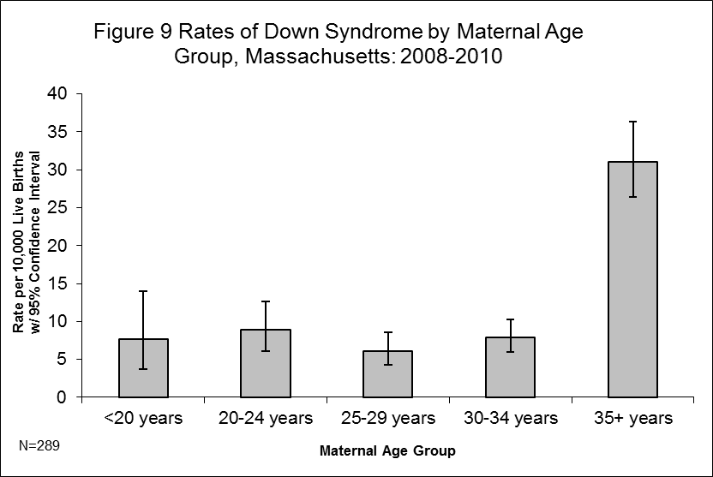

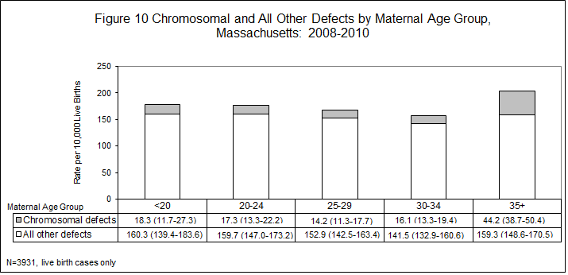

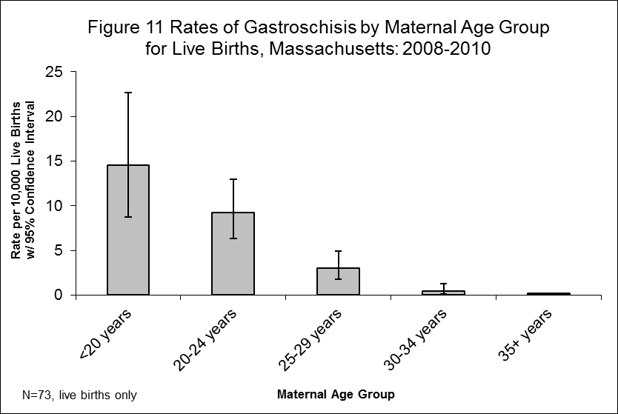

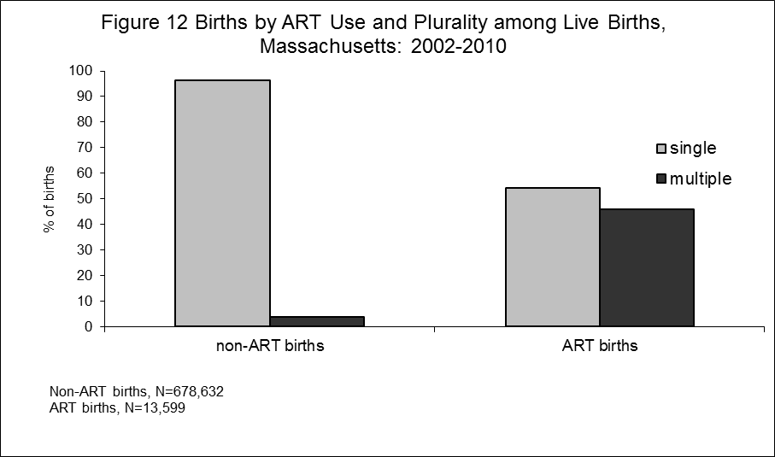

Maternal Age | Defect | Count | Rate per  10,000  Births | 95%  Confidence  Interval
<20 | Obstructive Genitourinary Defect | 30 | 22.91 | 15.45-32.70
<20 | Polydactyly/Syndactyly | 25 | 19.09 | 12.35-28.18
<20 | Club Foot | 24 | 18.32 | 11.74-27.27
<20 | ASD (Secundum and NOS) | 22 | 16.80 | 10.53-25.43
<20 | Gastroschisis | 19 | 14.51 | 8.73-22.65
20-24 | ASD (Secundum and NOS) | 69 | 19.26 | 14.99-24.38
20-24 | Club Foot | 68 | 18.98 | 14.74-24.07
20-24 | Obstructive Genitourinary Defect | 61 | 17.03 | 13.03-21.87
20-24 | Polydactyly/Syndactyly | 61 | 17.03 | 13.03-21.87
20-24 | VSD (Membranous and NOS) | 40 | 11.17 | 7.98-15.21
25-29 | ASD (Secundum and NOS) | 106 | 19.09 | 15.63-23.09
25-29 | Polydactyly/Syndactyly | 95 | 17.11 | 13.84-20.91
25-29 | Obstructive Genitourinary Defect | 77 | 13.87 | 10.94-17.33
25-29 | Hypospadias, 2nd or 3rd Degree¹ | 73 | 13.15 | 10.30-16.53
25-29 | Club Foot | 71 | 12.79 | 9.99-16.13
30-34 | ASD (Secundum and NOS) | 144 | 20.73 | 17.49-24.41
30-34 | Hypospadias, 2nd or 3rd Degree¹ | 107 | 15.41 | 12.63-18.62
30-34 | Polydactyly/Syndactyly | 101 | 14.54 | 11.84-17.67
30-34 | Obstructive Genitourinary Defect | 98 | 14.11 | 11.46-17.20
30-34 | Club Foot | 92 | 13.25 | 10.68-16.25
35+ | ASD (Secundum and NOS) | 154 | 30.28 | 25.69-35.46
35+ | Trisomy 21 (Down Syndrome) | 150 | 29.50 | 24.96-34.61
35+ | VSD (Membranous and NOS) | 79 | 15.53 | 12.30-19.36
35+ | Hypospadias, 2nd or 3rd Degree¹ | 79 | 15.53 | 12.30-19.36
35+ | Obstructive Genitourinary Defect | 78 | 15.34 | 12.12-19.14

¹Hypospadias rate calculated using male live births.

Chapter 5

Prevalence of Birth Defects by

Race / Ethnicity and Region

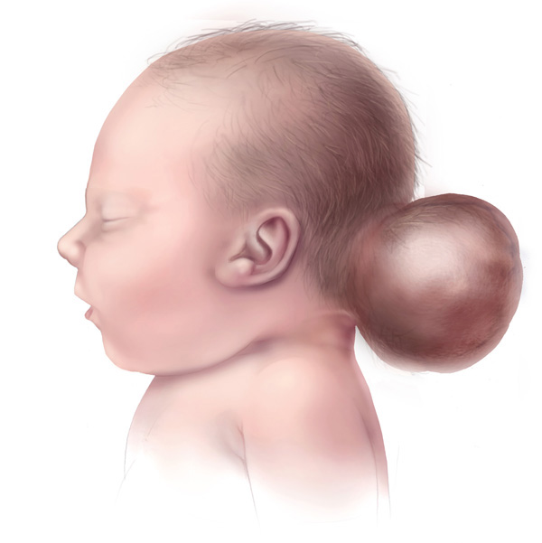

Baby with encephalocele

Courtesy of the Centers for Disease Control and Prevention
Maternal Race / Hispanic Ethnicity
Table 12 shows the variation in prevalence of birth defects by maternal race and Hispanic ethnicity. The age-adjusted rate per 10,000 live births was 174.2 for non-Hispanic whites, 203.5 for non-Hispanic blacks, 143.4 for non-Hispanic Asians/Pacific Islanders and 180.6 for Hispanics. In some analyses, the rates for other races were not calculated due to small numbers or the rates for other races were combined as one “other” category.

Table 13 shows the most common defects by maternal race and Hispanic ethnicity. There were very few differences among the most commonly occurring defects in the different race/ethnicities. All groups had atrial septal defects (secundum and NOS), polydactyly/syndactyly, and obstructive genitourinary defect amongst the most common defects. Down syndrome among the most common in all groups except white, non-Hispanic while hypospadias (2nd and 3rd degree) was among the common only in white, non-Hispanic and black, non-Hispanic. Non-Hispanic Asians had a significantly lower age-adjusted rate of chromosomal defects that was significantly lower than the non-Hispanic white rate. The non-Hispanic black and Hispanic rates were significantly different from one another, but both were significantly greater than the non-Hispanic white rate for chromosomal defects. This finding is similar to the 2008-2009 report but different from the 2006-2007 report, where the non-Hispanic black and Hispanic rates of chromosomal defects were not significantly different from non-Hispanic white rate. Maternal birthplace (U.S. versus non-U.S.) may be a contributing factor in racial/ethnic differences as women born in the U.S. had slightly—though not statistically significantly—higher rates than those born outside the U.S for most groups especially among non-Hispanic Asians more than 85% of whom were born outside the U.S. The non-Hispanic black rate of birth defects for non-U.S. residents was the only one of the four major racial/ethnic group that had the same as the birth rate for U.S. residents and non-residents. The prevalence of birth defects in children of Hispanic women born in the U.S. Territories (including Puerto Rico, U.S. Virgin Islands and Guam) was about the same as the rates of women born in the U.S (182.9.1 and 188.7 per 10,000 live births, respectively).

To better understand birth defect patterns in maternal race and ethnicity, we explored differences among the groups for certain categories of birth defects. Figure 13 shows the rate of chromosomal defects and all other defects according to maternal race and ethnicity. These rates were age-adjusted because chromosomal defects as well as other defects may be related to maternal age and differences may exist between racial and ethnic groups.

Multiple factors likely contribute to differences in prevalence by racial and ethnic groups including genetic variation, diet and lifestyle, differential access or use of health care services including prenatal screening and diagnosis, or socioeconomic differences.

Figure 15 shows the rolling 2-year, age-adjusted birth defect prevalence rates between 2000 and 2010. The non-Hispanic black group, which saw a drop in prevalence rates starting in 2004-2005, has seen the greatest increase in prevalence rate since 2006-2007 while Hispanic rates, which had been increasing, saw rates dropping from 2007-2008 to the current two-year average. The other groups, non-Hispanic Asian and non-Hispanic white, saw only modest increases in prevalence rates since 2006-2007.

Birth Defects by Massachusetts Region
The Massachusetts Commonwealth’s Executive Office of Health and Human Services delineates regions for use by the Department of Public Health for statistical, care coordination and administrative purposes. The six regions are based on geographical groupings of cities and towns: Western, Central, Northeast, Metro West, Boston and Southeast. A map of these regions is provided in the Appendix section of this report.

The age-adjusted birth defect rates by the six regions in 2008-2010 are shown in Figure 16. Although the regional differences in birth defect prevalence rate among the regions are not statistically significant from one another, the rates range from 165.5 per 10,000 live births in the Metro West region to 182.3 per 10,000 in the Boston region.

Defect | Maternal  Race¹ | Count² | Rate per  10,000  Births³ | 95%  Confidence  Interval
Total Cases | White, Non-Hispanic | 2618 | 174.22 | 167.5-180.9
Total Cases | Black, Non-Hispanic | 415 | 203.47 | 183.9-223.0
Total Cases | Asian, Non-Hispanic | 243 | 143.37 | 125.3-161.4
Total Cases | Hispanic | 568 | 180.64 | 165.8-195.5
Central Nervous System
Anencephaly | White, Non-Hispanic | 4 | 0.27 | 0.07-0.68
Anencephaly | Black, Non-Hispanic | 1 | 0.49 | 0.01-2.73
Anencephaly | Asian, Non-Hispanic | 1 | 0.56 | 0.01-3.15
Anencephaly | Hispanic | 2 | 0.62 | 0.07-2.23
Encephalocele | White, Non-Hispanic | 3 | 0.20 | 0.04-0.58
Encephalocele | Black, Non-Hispanic | 0 | 0.00 | 0.00-1.81
Encephalocele | Asian, Non-Hispanic | 0 | 0.00 | 0.00-2.08
Encephalocele | Hispanic | 2 | 0.62 | 0.07-2.23
Holoprosencephaly | White, Non-Hispanic | 7 | 0.47 | 0.19-0.96
Holoprosencephaly | Black, Non-Hispanic | 1 | 0.49 | 0.01-2.73
Holoprosencephaly | Asian, Non-Hispanic | 1 | 0.56 | 0.01-3.15
Holoprosencephaly | Hispanic | 4 | 1.23 | 0.34-3.15
Hydrocephaly w/o Spina Bifida | White, Non-Hispanic | 38 | 2.53 | 1.79-3.48
Hydrocephaly w/o Spina Bifida | Black, Non-Hispanic | 13 | 6.38 | 3.39-10.90
Hydrocephaly w/o Spina Bifida | Asian, Non-Hispanic | 1 | 0.56 | 0.01-3.15
Hydrocephaly w/o Spina Bifida | Hispanic | 16 | 4.93 | 2.82-8.00
Microcephaly | White, Non-Hispanic | 24 | 1.60 | 1.03-2.38
Microcephaly | Black, Non-Hispanic | 4 | 1.96 | 0.53-5.02
Microcephaly | Asian, Non-Hispanic | 1 | 0.56 | 0.01-3.15
Microcephaly | Hispanic | 5 | 1.54 | 0.50-3.59
Spina Bifida w/ and w/o Hydrocephaly | White, Non-Hispanic | 32 | 2.13 | 1.46-3.01
Spina Bifida w/ and w/o Hydrocephaly | Black, Non-Hispanic | 5 | 2.45 | 0.80-5.72
Spina Bifida w/ and w/o Hydrocephaly | Asian, Non-Hispanic | 3 | 1.69 | 0.35-4.95
Spina Bifida w/ and w/o Hydrocephaly | Hispanic | 8 | 2.46 | 1.06-4.85
Spinal Cord | White, Non-Hispanic | 59 | 3.93 | 2.99-5.07
Spinal Cord | Black, Non-Hispanic | 8 | 3.92 | 1.69-7.73
Spinal Cord | Asian, Non-Hispanic | 6 | 3.39 | 1.24-7.37
Spinal Cord | Hispanic | 12 | 3.70 | 1.91-6.46
(cont’d)
Other CNS⁵ | White, Non-Hispanic | 97 | 6.47 | 5.24-7.89
Other CNS⁵ | Black, Non-Hispanic | 28 | 13.73 | 9.12-19.85
Other CNS⁵ | Asian, Non-Hispanic | 8 | 4.52 | 1.95-8.90
Other CNS⁵ | Hispanic | 29 | 8.93 | 5.98-12.83
Eye
Aniridia | White, Non-Hispanic | 2 | 0.13 | 0.02-0.48
Aniridia | Black, Non-Hispanic | 0 | 0.00 | 0.00-1.81
Aniridia | Asian, Non-Hispanic | 1 | 0.56 | 0.01-3.15
Aniridia | Hispanic | 0 | 0.00 | 0.00-1.14
Anophthalmia/Microphthalmia | White, Non-Hispanic | 20 | 1.33 | 0.81-2.06
Anophthalmia/Microphthalmia | Black, Non-Hispanic | 3 | 1.47 | 0.30-4.30
Anophthalmia/Microphthalmia | Asian, Non-Hispanic | 2 | 1.13 | 0.14-4.08
Anophthalmia/Microphthalmia | Hispanic | 7 | 2.16 | 0.87-4.44
Congenital Glaucoma, Congenital Cataract | White, Non-Hispanic | 35 | 2.33 | 1.63-3.25
Congenital Glaucoma, Congenital Cataract | Black, Non-Hispanic | 11 | 5.39 | 2.69-9.65
Congenital Glaucoma, Congenital Cataract | Asian, Non-Hispanic | 3 | 1.69 | 0.35-4.95
Congenital Glaucoma, Congenital Cataract | Hispanic | 16 | 4.93 | 2.82-8.00
Other Eye⁵ | White, Non-Hispanic | 45 | 3.00 | 2.19-4.01
Other Eye⁵ | Black, Non-Hispanic | 5 | 2.45 | 0.80-5.72
Other Eye⁵ | Asian, Non-Hispanic | 5 | 2.82 | 0.92-6.59
Other Eye⁵ | Hispanic | 14 | 4.31 | 2.36-7.23
Ear
Anotia/Microtia | White, Non-Hispanic | 20 | 1.33 | 0.81-2.06
Anotia/Microtia | Black, Non-Hispanic | 2 | 0.98 | 0.12-3.54
Anotia/Microtia | Asian, Non-Hispanic | 7 | 3.95 | 1.59-8.14
Anotia/Microtia | Hispanic | 9 | 2.77 | 1.27-5.26
Other Ear⁵ | White, Non-Hispanic | 50 | 3.33 | 2.47-4.40
Other Ear⁵ | Black, Non-Hispanic | 3 | 1.47 | 0.30-4.30
Other Ear⁵ | Asian, Non-Hispanic | 9 | 5.08 | 2.32-9.64
Other Ear⁵ | Hispanic | 9 | 2.77 | 1.27-5.26
Cardiovascular
Anomalous Pulmonary Venous Connection
Total/Partial Anomalous Pulmonary Venous Connection | White, Non-Hispanic | 23 | 1.53 | 0.97-2.30
Total/Partial Anomalous Pulmonary Venous Connection | Black, Non-Hispanic | 2 | 0.98 | 0.12-3.54
Total/Partial Anomalous Pulmonary Venous Connection | Asian, Non-Hispanic | 6 | 3.39 | 1.24-7.37
Total/Partial Anomalous Pulmonary Venous Connection | Hispanic | 6 | 1.85 | 0.68-4.02
Atrioventricular Canal Defects
ASD Primum | White, Non-Hispanic | 4 | 0.27 | 0.07-0.68
ASD Primum | Black, Non-Hispanic | 0 | 0.00 | 0.00-1.81
ASD Primum | Asian, Non-Hispanic | 1 | 0.56 | 0.01-3.15
ASD Primum | Hispanic | 0 | 0.00 | 0.00-1.14
Common Atrium | White, Non-Hispanic | 6 | 0.40 | 0.15-0.87
Common Atrium | Black, Non-Hispanic | 2 | 0.98 | 0.12-3.54
Common Atrium | Asian, Non-Hispanic | 1 | 0.56 | 0.01-3.15
Common Atrium | Hispanic | 0 | 0.00 | 0.00-1.14
Complete Atrioventricular Canal Defect | White, Non-Hispanic | 42 | 2.80 | 2.02-3.79
Complete Atrioventricular Canal Defect | Black, Non-Hispanic | 10 | 4.90 | 2.35-9.02
Complete Atrioventricular Canal Defect | Asian, Non-Hispanic | 4 | 2.26 | 0.62-5.78
Complete Atrioventricular Canal Defect | Hispanic | 7 | 2.16 | 0.87-4.44
Endocardial Cushion (OS and NOS) | White, Non-Hispanic | 27 | 1.80 | 1.19-2.62
Endocardial Cushion (OS and NOS) | Black, Non-Hispanic | 3 | 1.47 | 0.30-4.30
Endocardial Cushion (OS and NOS) | Asian, Non-Hispanic | 1 | 0.56 | 0.01-3.15
Endocardial Cushion (OS and NOS) | Hispanic | 3 | 0.92 | 0.19-2.70
VSD, Canal Type | White, Non-Hispanic | 4 | 0.27 | 0.07-0.68
VSD, Canal Type | Black, Non-Hispanic | 2 | 0.98 | 0.12-3.54
VSD, Canal Type | Asian, Non-Hispanic | 0 | 0.00 | 0.00-2.08
VSD, Canal Type | Hispanic | 1 | 0.31 | 0.01-1.72
Conotruncal (Outlet) and Aortic Arch
Double Outlet Right Ventricle | White, Non-Hispanic | 19 | 1.27 | 0.76-1.98
Double Outlet Right Ventricle | Black, Non-Hispanic | 1 | 0.49 | 0.01-2.73
Double Outlet Right Ventricle | Asian, Non-Hispanic | 1 | 0.56 | 0.01-3.15
Double Outlet Right Ventricle | Hispanic | 2 | 0.62 | 0.07-2.23
(cont’d)
Interrupted Aortic Arch, Type B | White, Non-Hispanic | 5 | 0.33 | 0.11-0.78
Interrupted Aortic Arch, Type B | Black, Non-Hispanic | 2 | 0.98 | 0.12-3.54
Interrupted Aortic Arch, Type B | Asian, Non-Hispanic | 0 | 0.00 | 0.00-2.08
Interrupted Aortic Arch, Type B | Hispanic | 1 | 0.31 | 0.01-1.72
Tetralogy of Fallot w/ and w/o Pulmonary Atresia | White, Non-Hispanic | 48 | 3.20 | 2.36-4.24
Tetralogy of Fallot w/ and w/o Pulmonary Atresia | Black, Non-Hispanic | 11 | 5.39 | 2.69-9.65
Tetralogy of Fallot w/ and w/o Pulmonary Atresia | Asian, Non-Hispanic | 7 | 3.95 | 1.59-8.14
Tetralogy of Fallot w/ and w/o Pulmonary Atresia | Hispanic | 19 | 5.85 | 3.52-9.14
Truncus | White, Non-Hispanic | 5 | 0.33 | 0.11-0.78
Truncus | Black, Non-Hispanic | 0 | 0.00 | 0.00-1.81
Truncus | Asian, Non-Hispanic | 0 | 0.00 | 0.00-2.08
Truncus | Hispanic | 0 | 0.00 | 0.00-1.14
d-Transposition of the Great Arteries | White, Non-Hispanic | 42 | 2.80 | 2.02-3.79
d-Transposition of the Great Arteries | Black, Non-Hispanic | 4 | 1.96 | 0.53-5.02
d-Transposition of the Great Arteries | Asian, Non-Hispanic | 3 | 1.69 | 0.35-4.95
d-Transposition of the Great Arteries | Hispanic | 5 | 1.54 | 0.50-3.59
Ebstein Anomaly
Ebstein Anomaly | White, Non-Hispanic | 5 | 0.33 | 0.11-0.78
Ebstein Anomaly | Black, Non-Hispanic | 1 | 0.49 | 0.01-2.73
Ebstein Anomaly | Asian, Non-Hispanic | 0 | 0.00 | 0.00-2.08
Ebstein Anomaly | Hispanic | 2 | 0.62 | 0.07-2.23
Heterotaxy (Laterality Defects)
Heterotaxy | White, Non-Hispanic | 22 | 1.47 | 0.92-2.22
Heterotaxy | Black, Non-Hispanic | 4 | 1.96 | 0.53-5.02
Heterotaxy | Asian, Non-Hispanic | 3 | 1.69 | 0.35-4.95
Heterotaxy | Hispanic | 4 | 1.23 | 0.34-3.15
Left-Sided Obstruction
Aortic Valve Stenosis | White, Non-Hispanic | 25 | 1.67 | 1.08-2.46
Aortic Valve Stenosis | Black, Non-Hispanic | 4 | 1.96 | 0.53-5.02
Aortic Valve Stenosis | Asian, Non-Hispanic | 0 | 0.00 | 0.00-2.08
Aortic Valve Stenosis | Hispanic | 2 | 0.62 | 0.07-2.23
(cont’d)
Coarctation of Aorta | White, Non-Hispanic | 69 | 4.60 | 3.58-5.82
Coarctation of Aorta | Black, Non-Hispanic | 8 | 3.92 | 1.69-7.73
Coarctation of Aorta | Asian, Non-Hispanic | 2 | 1.13 | 0.14-4.08
Coarctation of Aorta | Hispanic | 16 | 4.93 | 2.82-8.00
Hypoplastic Left Heart Syndrome | White, Non-Hispanic | 20 | 1.33 | 0.81-2.06
Hypoplastic Left Heart Syndrome | Black, Non-Hispanic | 5 | 2.45 | 0.80-5.72
Hypoplastic Left Heart Syndrome | Asian, Non-Hispanic | 0 | 0.00 | 0.00-2.08
Hypoplastic Left Heart Syndrome | Hispanic | 4 | 1.23 | 0.34-3.15
Interrupted Aortic Arch (Type A and NOS) | White, Non-Hispanic | 0 | 0.00 | 0.00-0.25
Interrupted Aortic Arch (Type A and NOS) | Black, Non-Hispanic | 0 | 0.00 | 0.00-1.81
Interrupted Aortic Arch (Type A and NOS) | Asian, Non-Hispanic | 0 | 0.00 | 0.00-2.08
Interrupted Aortic Arch (Type A and NOS) | Hispanic | 1 | 0.31 | 0.01-1.72
Patent Ductus Arteriosus
Patent Ductus Arteriosus | White, Non-Hispanic | 197 | 13.13 | 11.36-15.10
Patent Ductus Arteriosus | Black, Non-Hispanic | 34 | 16.67 | 11.55-23.30
Patent Ductus Arteriosus | Asian, Non-Hispanic | 22 | 12.42 | 7.78-18.80
Patent Ductus Arteriosus | Hispanic | 48 | 14.78 | 10.90-19.60
Right-Sided Obstruction
Pulmonary Stenosis, Valvular | White, Non-Hispanic | 95 | 6.33 | 5.12-7.74
Pulmonary Stenosis, Valvular | Black, Non-Hispanic | 28 | 13.73 | 9.12-19.85
Pulmonary Stenosis, Valvular | Asian, Non-Hispanic | 8 | 4.52 | 1.95-8.90
Pulmonary Stenosis, Valvular | Hispanic | 23 | 7.08 | 4.49-10.63
Pulmonary Valve Atresia w/intact septum | White, Non-Hispanic | 8 | 0.53 | 0.23-1.05
Pulmonary Valve Atresia w/intact septum | Black, Non-Hispanic | 2 | 0.98 | 0.12-3.54
Pulmonary Valve Atresia w/intact septum | Asian, Non-Hispanic | 0 | 0.00 | 0.00-2.08
Pulmonary Valve Atresia w/intact septum | Hispanic | 2 | 0.62 | 0.07-2.23
Pulmonary Valve Atresia with VSD | White, Non-Hispanic | 2 | 0.13 | 0.02-0.48
Pulmonary Valve Atresia with VSD | Black, Non-Hispanic | 2 | 0.98 | 0.12-3.54
Pulmonary Valve Atresia with VSD | Asian, Non-Hispanic | 1 | 0.56 | 0.01-3.15
Pulmonary Valve Atresia with VSD | Hispanic | 1 | 0.31 | 0.01-1.72
(cont’d)
Tricuspid Valve Atresia | White, Non-Hispanic | 11 | 0.73 | 0.37-1.31
Tricuspid Valve Atresia | Black, Non-Hispanic | 2 | 0.98 | 0.12-3.54
Tricuspid Valve Atresia | Asian, Non-Hispanic | 1 | 0.56 | 0.01-3.15
Tricuspid Valve Atresia | Hispanic | 2 | 0.62 | 0.07-2.23
Septal Defects
ASD (Secundum and NOS) | White, Non-Hispanic | 316 | 21.07 | 18.81-23.52
ASD (Secundum and NOS) | Black, Non-Hispanic | 65 | 31.88 | 24.60-40.63
ASD (Secundum and NOS) | Asian, Non-Hispanic | 34 | 19.19 | 13.29-26.82
ASD (Secundum and NOS) | Hispanic | 72 | 22.17 | 17.35-27.93
VSD (Membranous and NOS) | White, Non-Hispanic | 164 | 10.93 | 9.32-12.74
VSD (Membranous and NOS) | Black, Non-Hispanic | 26 | 12.75 | 8.33-18.68
VSD (Membranous and NOS) | Asian, Non-Hispanic | 25 | 14.11 | 9.13-20.83
VSD (Membranous and NOS) | Hispanic | 42 | 12.94 | 9.32-17.48
VSD, Conoventricular/Malalignment | White, Non-Hispanic | 29 | 1.93 | 1.29-2.78
VSD, Conoventricular/Malalignment | Black, Non-Hispanic | 4 | 1.96 | 0.53-5.02
VSD, Conoventricular/Malalignment | Asian, Non-Hispanic | 0 | 0.00 | 0.00-2.08
VSD, Conoventricular/Malalignment | Hispanic | 5 | 1.54 | 0.50-3.59
Single Ventricle and L-TGA
L-TGA | White, Non-Hispanic | 6 | 0.40 | 0.15-0.87
L-TGA | Black, Non-Hispanic | 1 | 0.49 | 0.01-2.73
L-TGA | Asian, Non-Hispanic | 0 | 0.00 | 0.00-2.08
L-TGA | Hispanic | 0 | 0.00 | 0.00-1.14
Single Ventricle | White, Non-Hispanic | 6 | 0.40 | 0.15-0.87
Single Ventricle | Black, Non-Hispanic | 1 | 0.49 | 0.01-2.73
Single Ventricle | Asian, Non-Hispanic | 2 | 1.13 | 0.14-4.08
Single Ventricle | Hispanic | 0 | 0.00 | 0.00-1.14
Other Cardiovascular
Other Cardiovascular⁵ | White, Non-Hispanic | 305 | 20.34 | 18.12-22.75
Other Cardiovascular⁵ | Black, Non-Hispanic | 59 | 28.93 | 22.03-37.32
Other Cardiovascular⁵ | Asian, Non-Hispanic | 27 | 15.24 | 10.04-22.18
Other Cardiovascular⁵ | Hispanic | 69 | 21.25 | 16.53-26.89
Respiratory
Lung Anomalies | White, Non-Hispanic | 22 | 1.47 | 0.92-2.22
Lung Anomalies | Black, Non-Hispanic | 4 | 1.96 | 0.53-5.02
Lung Anomalies | Asian, Non-Hispanic | 1 | 0.56 | 0.01-3.15
Lung Anomalies | Hispanic | 15 | 4.62 | 2.59-7.62
Other Respiratory⁵ | White, Non-Hispanic | 22 | 1.47 | 0.92-2.22
Other Respiratory⁵ | Black, Non-Hispanic | 0 | 0.00 | 0.00-1.81
Other Respiratory⁵ | Asian, Non-Hispanic | 1 | 0.56 | 0.01-3.15
Other Respiratory⁵ | Hispanic | 3 | 0.92 | 0.19-2.70
Orofacial
Cleft Lip w/ and w/o Cleft Palate | White, Non-Hispanic | 128 | 8.53 | 7.12-10.15
Cleft Lip w/ and w/o Cleft Palate | Black, Non-Hispanic | 11 | 5.39 | 2.69-9.65
Cleft Lip w/ and w/o Cleft Palate | Asian, Non-Hispanic | 12 | 6.77 | 3.50-11.83
Cleft Lip w/ and w/o Cleft Palate | Hispanic | 25 | 7.70 | 4.98-11.37
Cleft Palate w/o Cleft Lip | White, Non-Hispanic | 94 | 6.27 | 5.06-7.67
Cleft Palate w/o Cleft Lip | Black, Non-Hispanic | 4 | 1.96 | 0.53-5.02
Cleft Palate w/o Cleft Lip | Asian, Non-Hispanic | 5 | 2.82 | 0.92-6.59
Cleft Palate w/o Cleft Lip | Hispanic | 16 | 4.93 | 2.82-8.00
Pierre Robin Sequence | White, Non-Hispanic | 33 | 2.20 | 1.51-3.09
Pierre Robin Sequence | Black, Non-Hispanic | 1 | 0.49 | 0.01-2.73
Pierre Robin Sequence | Asian, Non-Hispanic | 1 | 0.56 | 0.01-3.15
Pierre Robin Sequence | Hispanic | 6 | 1.85 | 0.68-4.02
Other Orofacial⁵ | White, Non-Hispanic | 80 | 5.33 | 4.23-6.64
Other Orofacial⁵ | Black, Non-Hispanic | 14 | 6.87 | 3.75-11.52
Other Orofacial⁵ | Asian, Non-Hispanic | 7 | 3.95 | 1.59-8.14
Other Orofacial⁵ | Hispanic | 13 | 4.00 | 2.13-6.85
Gastrointestinal
Biliary Atresia | White, Non-Hispanic | 6 | 0.40 | 0.15-0.87
Biliary Atresia | Black, Non-Hispanic | 1 | 0.49 | 0.01-2.73
Biliary Atresia | Asian, Non-Hispanic | 4 | 2.26 | 0.62-5.78
Biliary Atresia | Hispanic | 3 | 0.92 | 0.19-2.70
(cont’d)
Esophageal Atresia/Tracheoesophageal Fistula | White, Non-Hispanic | 42 | 2.80 | 2.02-3.79
Esophageal Atresia/Tracheoesophageal Fistula | Black, Non-Hispanic | 3 | 1.47 | 0.30-4.30
Esophageal Atresia/Tracheoesophageal Fistula | Asian, Non-Hispanic | 1 | 0.56 | 0.01-3.15
Esophageal Atresia/Tracheoesophageal Fistula | Hispanic | 5 | 1.54 | 0.50-3.59
Hirschsprung Disease | White, Non-Hispanic | 32 | 2.13 | 1.46-3.01
Hirschsprung Disease | Black, Non-Hispanic | 2 | 0.98 | 0.12-3.54
Hirschsprung Disease | Asian, Non-Hispanic | 7 | 3.95 | 1.59-8.14
Hirschsprung Disease | Hispanic | 11 | 3.39 | 1.69-6.06
Rectal and Large Intestinal Atresia/Stenosis | White, Non-Hispanic | 46 | 3.07 | 2.25-4.09
Rectal and Large Intestinal Atresia/Stenosis | Black, Non-Hispanic | 8 | 3.92 | 1.69-7.73
Rectal and Large Intestinal Atresia/Stenosis | Asian, Non-Hispanic | 5 | 2.82 | 0.92-6.59
Rectal and Large Intestinal Atresia/Stenosis | Hispanic | 8 | 2.46 | 1.06-4.85
Small Intestinal Atresia | White, Non-Hispanic | 40 | 2.67 | 1.91-3.63
Small Intestinal Atresia | Black, Non-Hispanic | 3 | 1.47 | 0.30-4.30
Small Intestinal Atresia | Asian, Non-Hispanic | 9 | 5.08 | 2.32-9.64
Small Intestinal Atresia | Hispanic | 11 | 3.39 | 1.69-6.06
Other Gastrointestinal⁵ | White, Non-Hispanic | 99 | 6.60 | 5.36-8.04
Other Gastrointestinal⁵ | Black, Non-Hispanic | 21 | 10.30 | 6.38-15.74
Other Gastrointestinal⁵ | Asian, Non-Hispanic | 13 | 7.34 | 3.91-12.55
Other Gastrointestinal⁵ | Hispanic | 24 | 7.39 | 4.74-11.00
Genitourinary
Bladder Exstrophy | White, Non-Hispanic | 3 | 0.20 | 0.04-0.58
Bladder Exstrophy | Black, Non-Hispanic | 0 | 0.00 | 0.00-1.81
Bladder Exstrophy | Asian, Non-Hispanic | 0 | 0.00 | 0.00-2.08
Bladder Exstrophy | Hispanic | 1 | 0.31 | 0.01-1.72
Cloacal Exstrophy | White, Non-Hispanic | 1 | 0.07 | 0.00-0.37
Cloacal Exstrophy | Black, Non-Hispanic | 1 | 0.49 | 0.01-2.73
Cloacal Exstrophy | Asian, Non-Hispanic | 0 | 0.00 | 0.00-2.08
Cloacal Exstrophy | Hispanic | 0 | 0.00 | 0.00-1.14
(cont’d)
Hypospadias, 2nd or 3rd Degree | White, Non-Hispanic | 228 | 15.20 | 13.29-17.31
Hypospadias, 2nd or 3rd Degree | Black, Non-Hispanic | 36 | 17.65 | 12.37-24.44
Hypospadias, 2nd or 3rd Degree | Asian, Non-Hispanic | 15 | 8.47 | 4.74-13.97
Hypospadias, 2nd or 3rd Degree | Hispanic | 26 | 8.01 | 5.23-11.73
Obstructive Genitourinary Defect | White, Non-Hispanic | 223 | 14.87 | 12.98-16.95
Obstructive Genitourinary Defect | Black, Non-Hispanic | 31 | 15.20 | 10.33-21.58
Obstructive Genitourinary Defect | Asian, Non-Hispanic | 25 | 14.11 | 9.13-20.83
Obstructive Genitourinary Defect | Hispanic | 61 | 18.79 | 14.37-24.13
Renal Agenesis/Hypoplasia | White, Non-Hispanic | 3 | 0.20 | 0.04-0.58
Renal Agenesis/Hypoplasia | Black, Non-Hispanic | 3 | 1.47 | 0.30-4.30
Renal Agenesis/Hypoplasia | Asian, Non-Hispanic | 0 | 0.00 | 0.00-2.08
Renal Agenesis/Hypoplasia | Hispanic | 1 | 0.31 | 0.01-1.72
Other Genitourinary⁵ | White, Non-Hispanic | 272 | 18.14 | 16.04-20.42
Other Genitourinary⁵ | Black, Non-Hispanic | 34 | 16.67 | 11.55-23.30
Other Genitourinary⁵ | Asian, Non-Hispanic | 29 | 16.37 | 10.96-23.51
Other Genitourinary⁵ | Hispanic | 53 | 16.32 | 12.23-21.35
Musculoskeletal
Club Foot | White, Non-Hispanic | 224 | 14.93 | 13.04-17.02
Club Foot | Black, Non-Hispanic | 30 | 14.71 | 9.93-21.00
Club Foot | Asian, Non-Hispanic | 13 | 7.34 | 3.91-12.55
Club Foot | Hispanic | 41 | 12.63 | 9.06-17.13
Craniosynostosis | White, Non-Hispanic | 91 | 6.07 | 4.88-7.45
Craniosynostosis | Black, Non-Hispanic | 4 | 1.96 | 0.53-5.02
Craniosynostosis | Asian, Non-Hispanic | 3 | 1.69 | 0.35-4.95
Craniosynostosis | Hispanic | 9 | 2.77 | 1.27-5.26
Diaphragmatic Hernia | White, Non-Hispanic | 34 | 2.27 | 1.57-3.17
Diaphragmatic Hernia | Black, Non-Hispanic | 5 | 2.45 | 0.80-5.72
Diaphragmatic Hernia | Asian, Non-Hispanic | 3 | 1.69 | 0.35-4.95
Diaphragmatic Hernia | Hispanic | 8 | 2.46 | 1.06-4.85
(cont’d)
Gastroschisis | White, Non-Hispanic | 39 | 2.60 | 1.85-3.55
Gastroschisis | Black, Non-Hispanic | 12 | 5.88 | 3.04-10.28
Gastroschisis | Asian, Non-Hispanic | 2 | 1.13 | 0.14-4.08
Gastroschisis | Hispanic | 17 | 5.24 | 3.05-8.38
Omphalocele | White, Non-Hispanic | 14 | 0.93 | 0.51-1.57
Omphalocele | Black, Non-Hispanic | 6 | 2.94 | 1.08-6.40
Omphalocele | Asian, Non-Hispanic | 0 | 0.00 | 0.00-2.08
Omphalocele | Hispanic | 4 | 1.23 | 0.34-3.15
Polydactyly/Syndactyly | White, Non-Hispanic | 217 | 14.47 | 12.61-16.53
Polydactyly/Syndactyly | Black, Non-Hispanic | 48 | 23.54 | 17.36-31.21
Polydactyly/Syndactyly | Asian, Non-Hispanic | 28 | 15.81 | 10.50-22.85
Polydactyly/Syndactyly | Hispanic | 52 | 16.02 | 11.96-21.00
Reduction Deformity, Lower Limbs | White, Non-Hispanic | 16 | 1.07 | 0.61-1.73
Reduction Deformity, Lower Limbs | Black, Non-Hispanic | 2 | 0.98 | 0.12-3.54
Reduction Deformity, Lower Limbs | Asian, Non-Hispanic | 1 | 0.56 | 0.01-3.15
Reduction Deformity, Lower Limbs | Hispanic | 8 | 2.46 | 1.06-4.85
Reduction Deformity, Upper Limbs | White, Non-Hispanic | 37 | 2.47 | 1.74-3.40
Reduction Deformity, Upper Limbs | Black, Non-Hispanic | 3 | 1.47 | 0.30-4.30
Reduction Deformity, Upper Limbs | Asian, Non-Hispanic | 3 | 1.69 | 0.35-4.95
Reduction Deformity, Upper Limbs | Hispanic | 10 | 3.08 | 1.48-5.66
Skeletal Dysplasia | White, Non-Hispanic | 17 | 1.13 | 0.66-1.81
Skeletal Dysplasia | Black, Non-Hispanic | 5 | 2.45 | 0.80-5.72
Skeletal Dysplasia | Asian, Non-Hispanic | 1 | 0.56 | 0.01-3.15
Skeletal Dysplasia | Hispanic | 5 | 1.54 | 0.50-3.59
Other Musculoskeletal⁵ | White, Non-Hispanic | 160 | 10.67 | 9.08-12.45
Other Musculoskeletal⁵ | Black, Non-Hispanic | 33 | 16.18 | 11.14-22.73
Other Musculoskeletal⁵ | Asian, Non-Hispanic | 14 | 7.90 | 4.32-13.26
Other Musculoskeletal⁵ | Hispanic | 41 | 12.63 | 9.06-17.13
Chromosomal and other Syndromes
Klinefelter Syndrome | White, Non-Hispanic | 7 | 0.47 | 0.19-0.96
Klinefelter Syndrome | Black, Non-Hispanic | 0 | 0.00 | 0.00-1.81
Klinefelter Syndrome | Asian, Non-Hispanic | 0 | 0.00 | 0.00-2.08
Klinefelter Syndrome | Hispanic | 1 | 0.31 | 0.01-1.72
Trisomy 13 | White, Non-Hispanic | 5 | 0.33 | 0.11-0.78
Trisomy 13 | Black, Non-Hispanic | 1 | 0.49 | 0.01-2.73
Trisomy 13 | Asian, Non-Hispanic | 0 | 0.00 | 0.00-2.08
Trisomy 13 | Hispanic | 0 | 0.00 | 0.00-1.14
Trisomy 18 | White, Non-Hispanic | 13 | 0.87 | 0.46-1.48
Trisomy 18 | Black, Non-Hispanic | 4 | 1.96 | 0.53-5.02
Trisomy 18 | Asian, Non-Hispanic | 1 | 0.56 | 0.01-3.15
Trisomy 18 | Hispanic | 7 | 2.16 | 0.87-4.44
Trisomy 21 (Down Syndrome) | White, Non-Hispanic | 172 | 11.47 | 9.82-13.32
Trisomy 21 (Down Syndrome) | Black, Non-Hispanic | 34 | 16.67 | 11.55-23.30
Trisomy 21 (Down Syndrome) | Asian, Non-Hispanic | 18 | 10.16 | 6.02-16.06
Trisomy 21 (Down Syndrome) | Hispanic | 49 | 15.09 | 11.16-19.95
Turner Syndrome | White, Non-Hispanic | 9 | 0.60 | 0.27-1.14
Turner Syndrome | Black, Non-Hispanic | 1 | 0.49 | 0.01-2.73
Turner Syndrome | Asian, Non-Hispanic | 0 | 0.00 | 0.00-2.08
Turner Syndrome | Hispanic | 3 | 0.92 | 0.19-2.70
Other Chromosomal Syndromes/Other Syndromes⁵ | White, Non-Hispanic | 218 | 14.53 | 12.67-16.60
Other Chromosomal Syndromes/Other Syndromes⁵ | Black, Non-Hispanic | 27 | 13.24 | 8.73-19.27
Other Chromosomal Syndromes/Other Syndromes⁵ | Asian, Non-Hispanic | 15 | 8.47 | 4.74-13.97
Other Chromosomal Syndromes/Other Syndromes⁵ | Hispanic | 44 | 13.55 | 9.85-18.19
Other
Amniotic Bands | White, Non-Hispanic | 11 | 0.73 | 0.37-1.31
Amniotic Bands | Black, Non-Hispanic | 4 | 1.96 | 0.53-5.02
Amniotic Bands | Asian, Non-Hispanic | 0 | 0.00 | 0.00-2.08
Amniotic Bands | Hispanic | 2 | 0.62 | 0.07-2.23
(cont’d)
Skin Anomalies | White, Non-Hispanic | 20 | 1.33 | 0.81-2.06
Skin Anomalies | Black, Non-Hispanic | 8 | 3.92 | 1.69-7.73
Skin Anomalies | Asian, Non-Hispanic | 3 | 1.69 | 0.35-4.95
Skin Anomalies | Hispanic | 6 | 1.85 | 0.68-4.02
Other, Specified⁵ | White, Non-Hispanic | 19 | 1.27 | 0.76-1.98
Other, Specified⁵ | Black, Non-Hispanic | 4 | 1.96 | 0.53-5.02
Other, Specified⁵ | Asian, Non-Hispanic | 2 | 1.13 | 0.14-4.08
Other, Specified⁵ | Hispanic | 2 | 0.62 | 0.07-2.23

^{1.} Due to small numbers, races classified as “other” are not included.
^{2.} Cases can be included in more than one defect. Cases are counted once in the total for a defect category. Because only live births are presented on this table, case totals are not listed. Due to missing race of mother counts may not match those in other tables.
³ Overall rates are standardized to the age distribution of Massachusetts
⁴ Rate calculated using male live births.
⁵ Rate may represent a heterogeneous group of defects.

Maternal Race¹ | Defect | Count | Rate per  10,000  Births | 95%  Confidence  Interval
White,  Non-Hispanic | ASD (Secundum and NOS) | 316 | 21.07 | 18.81-23.52
White,  Non-Hispanic | Hypospadias, 2nd or 3rd Degree² | 228 | 15.20 | 13.29-17.31
White,  Non-Hispanic | Club Foot | 224 | 14.93 | 13.04-17.02
White,  Non-Hispanic | Obstructive Genitourinary Defect | 223 | 14.87 | 12.98-16.95
White,  Non-Hispanic | Polydactyly/Syndactyly | 217 | 14.47 | 12.61-16.53
Black,  Non-Hispanic | ASD (Secundum and NOS) | 65 | 31.88 | 24.60-40.63
Black,  Non-Hispanic | Polydactyly/Syndactyly | 48 | 23.54 | 17.36-31.21
Black,  Non-Hispanic | Hypospadias, 2nd or 3rd Degree² | 36 | 17.65 | 12.37-24.44
Black,  Non-Hispanic | Trisomy 21 (Down Syndrome) | 34 | 16.67 | 11.55-23.30
Black,  Non-Hispanic | Obstructive Genitourinary Defect | 31 | 15.20 | 10.33-21.58
Asian,  Non-Hispanic | ASD (Secundum and NOS) | 34 | 19.19 | 13.29-26.82
Asian,  Non-Hispanic | Polydactyly/Syndactyly | 28 | 15.81 | 10.50-22.85
Asian,  Non-Hispanic | VSD (Membranous and NOS) | 25 | 14.11 | 9.13-20.83
Asian,  Non-Hispanic | Obstructive Genitourinary Defect | 25 | 14.11 | 9.13-20.83
Asian,  Non-Hispanic | Trisomy 21 (Down Syndrome) | 18 | 10.16 | 6.02-16.06
Hispanic | ASD (Secundum and NOS) | 72 | 22.17 | 17.35-27.93
Hispanic | Obstructive Genitourinary Defect | 61 | 18.79 | 14.37-24.13
Hispanic | Polydactyly/Syndactyly | 52 | 16.02 | 11.96-21.00
Hispanic | Trisomy 21 (Down Syndrome) | 49 | 15.09 | 11.16-19.95
Hispanic | VSD (Membranous and NOS) | 42 | 12.94 | 9.32-17.48

^{1.} Due to small numbers, races classified as “other” are not included.
^{2.} Rate calculated using male live births.
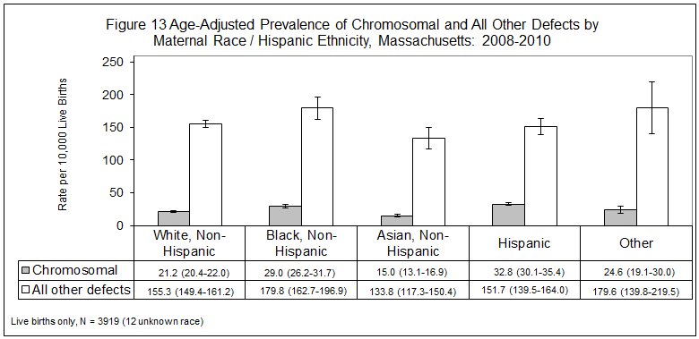

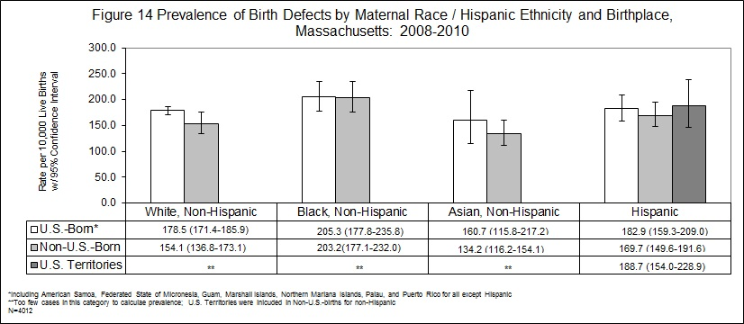
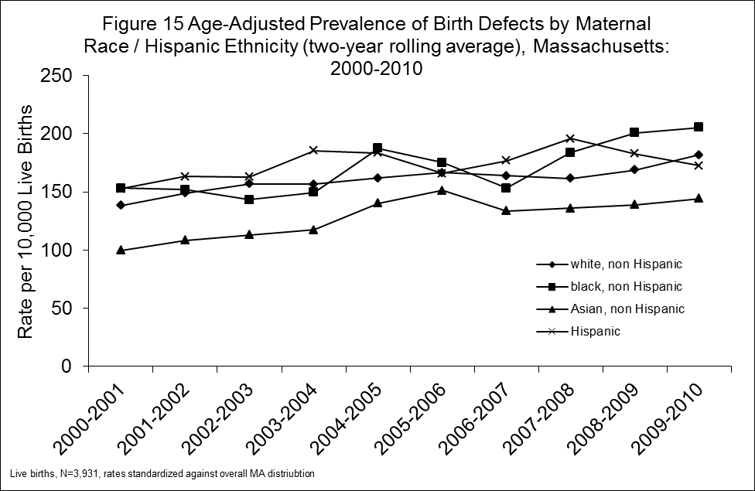

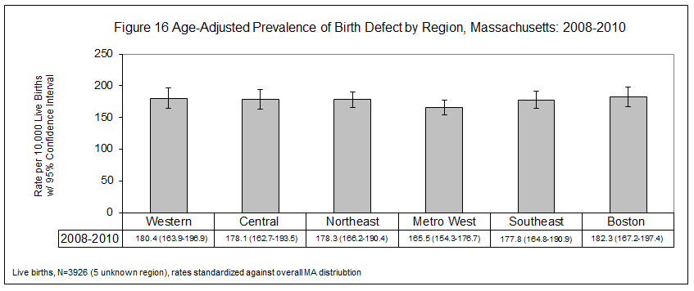

Chapter 6

Prevalence of Birth Defects by Severity, Etiology and Pattern

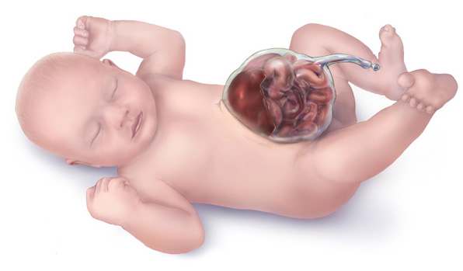

Baby with omphalocele

Courtesy of the Centers for Disease Control and Prevention

Prevalence of Birth Defects by Severity

Birth defects cases were categorized by their level of severity. A severity scale was developed by the Center in collaboration with our partners at Boston University and the Massachusetts General Hospital. This scale was based on the usual outcome for a specific birth defect including its typical compatibility with survival, the need for immediate treatment, the need for long-term care and the amenability of the defect to correction.

We developed an automated algorithm to classify the majority of cases into the categories of “severe”, “serious”, “moderate”, and “mild” with a minority of cases requiring assignment by a clinician. “Severe” was defined as requiring supportive measures, usually incompatible with life; “serious” was defined as correctable, most having long-term needs; “moderate” was defined as mostly amenable to correction, many having long-term needs; and “mild” was defined as amenable to correction, with minimal long-term needs. The rules for designing the new automated algorithm are in the Technical Notes, and a list of selected defects within each severity category is in the Appendix.

Nearly 3% of cases with birth defects were classified as “severe” and most of these cases did not survive. This percentage was an underestimate of severe cases due to limited data and lack of prenatal diagnosis reporting. For example, researchers at CDC estimated that up to 80% of anencephaly cases and 50% of any neural tube defect may be electively terminated after prenatal diagnosis (Cragan and Khoury 2000).

18.4% of cases were affected with a “serious” birth defect. Many of these cases needed intensive medical care and planning for continuing care and long-term disability.

“Moderate” birth defects comprised about 70% of the total cases. All of these needed medical follow up and many may have required a number of surgeries and extensive treatment.

“Mild” birth defects comprised a little over 9% of the affected infants. These defects may or may not have required corrective treatment. Within the classification of “mild severity,” there was variability. For example, children with microphthalmia (small eyes) could have mild reduction in the size of the globe or a more severe reduction resulting in visual loss or the need for intrusive ophthalmologic medical care. In contrast, infants with isolated dextrocardia (heart in the right side of the chest instead of the left) with no other heart defect have no clinical consequence.

Prevalence of Birth Defects by Etiology and Pattern
To enhance the existing active birth defects surveillance program, a method was developed to classify cases by etiology and pattern. The surveillance system in Massachusetts allowed for the collection of relevant etiology information.
Categories with sufficient detail were created, allowing similar cases to be grouped using knowledge of pathogenesis and embryologic mechanisms. The case classification defined a case as a biologic entity rather than a collection of individual defects. The schema was based upon general principles outlined in the literature (Rasmussen, Olney et al. 2003; Cary, Feldkamp et al. 2005).

CDC estimates that about 30% of birth defectsnationwide have a known cause (or etiology). In Massachusetts, cases with known etiology accounted for only 18.5% of the birth defects in 2008-2010. Of the cases with known cause, “single gene” etiology accounted for 21.6%, “chromosomal” etiology accounted for 72.8% and “maternal-fetal factors” accounted for 3.4% of cases. The vast majority of birth defects cases in Massachusetts in 2008-2010 (81.4%, or 3,266 of 4,012 total cases had an unknown cause.

As Figure 17 shows, single gene etiology accounted for 21.5% of the known etiology cases. Single gene defects include achondroplasia, Marfan syndrome (deletion 15q21.1), Smith-Lemli-Opitz syndrome and other examples of defects categorized as Mendelian syndrome. Chromosomal etiology accounted for almost 73% of the cases with known etiology. Cases with chromosomal etiology include trisomy 13, 18 and 21, Turner syndrome and other chromosomal duplications and deletions. Maternal-fetal and other factors accounted for 3.4% of all cases with known etiology. Maternal-fetal factors include teratogens such as maternal diabetes and uterine factors such as deformation or didelphy uterus. The “other factor” known etiology cases which contribute less that 1% of cases and are not shown in Figure 17 include conjoined twins. Cases with known etiology may also be classified by pattern, with the categories and definitions listed in Table 15. The majority of cases with known etiology fall within the “multiple majors” pattern including combinations of two or more major defects.

Cases are also classified by the pattern of defects i.e. whether one defect occurs with others. Of all 4,012 birth defect cases (3,931 live births and 81 stillbirths) 43.5% had a “solitary” (truly a single) defect pattern, 26.4% had “Major plus minors” (defined as having a major defect accompanied by one or more minor defects), 4.3% were a “sequence” (allowing for more than one major defect if the defects are related pathogenically), and 25.6% had “multiple major” defects. As shown in Table 15, among only those 743 cases that had a known cause, the vast majority (93%, or 695 of 743 cases) were defined as having multiple major defects. This finding is in line with the majority of defects with a known etiology being chromosomal in natural and having diagnostic testing to determine a specific cause. Cleft lip with and without cleft palate, hypospadias (2nd or 3rd degree), gastroschisis, and craniosynostosis appeared more often as a single defect rather than with other defects—all occurring more than 75% of the time as a “solitary” defect. Birth defects which appeared more often in conjunction with other defects included anopthalmia/micropthalmia, complete atrioventricular canal defect (CAVC), esophageal atresia, obstructive genitourinary defect, and all cardiovascular defects.

See Figure 18 for the distribution of cases with unknown etiology among these patterns.

Table 14 Percentage of Birth Defect Cases by Severity Groups, Massachusetts: 2008-2010

Severity Categories | Percentage of Birth Defects Cases
Severe, supportive measures, usually incompatible with life | 2.8%
Serious, may be correctable, most have long-term needs | 18.4%
Moderate, most correctable, many have long-term needs | 69.5%
Mild, may be correctable, minimal long-term needs | 9.2%

Table 15 Pattern and Etiology of Birth Defect Cases,
Massachusetts: 2008-2010

Pattern | Description | Cases
Pattern | Description | Known Etiology | Unknown Etiology
Isolated | Solitary defect | 8 | 1,738
Isolated | Major and minors (different organ/body parts) or 2 or more defects (same organ/body part) | 16 | 1,045
Isolated | Sequence: Common primary defect with consistent, related anomalies | 24 | 150
Multiple Majors | 2 or more major defects in different organs/body parts | 695 | 333
Total |  | 743 (18.5%) | 3,266 (81.4%)

2 cases had an unknown pattern

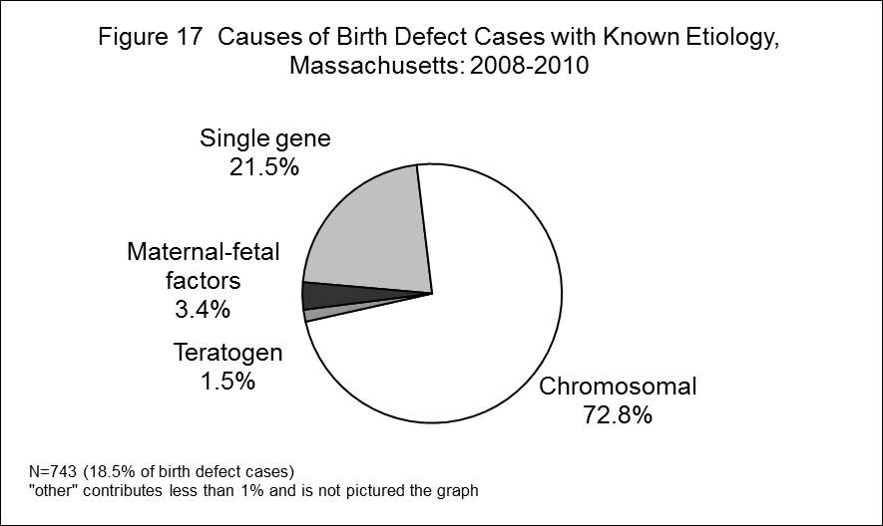

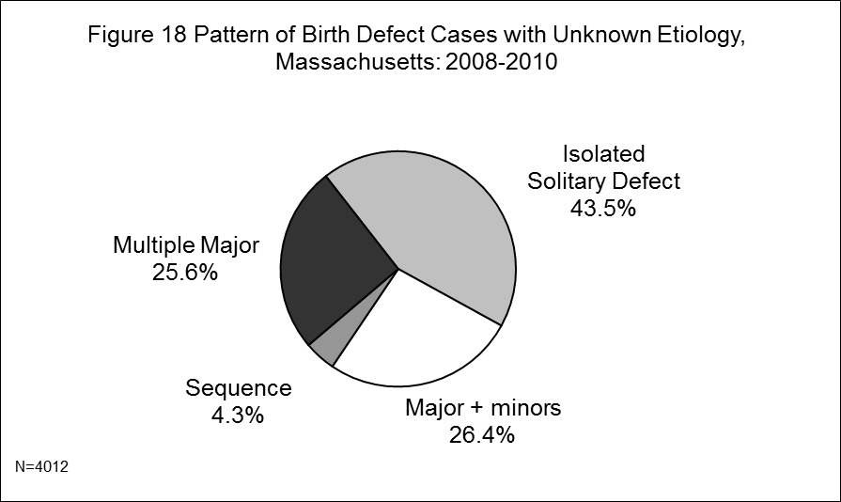

Appendices

Technical Notes

Definitions

2008-2010 Denominators Used in Calculating Rates

Birth Defects Codes and Exclusions by Defect Category

All ICD9/BPA Codes with Counts – Live Births and Stillbirths

Birth Defects by Severity

Glossary of Selected Birth Defect Terms

Map of Massachusetts EOHHS-Defined Regions and Age-Adjusted Overall Birth Defects Prevalence, 2008-2010

Folic Acid Use/Awareness Tables

References

Technical Notes

Data Sources
Surveillance records were matched to records from the Registry of Vital Records and Statistics to gain supplemental information or to verify information on the cases. All records were matched. Birth certificate data were used as the source of information for mother’s date of birth and race/ethnicity. Surveillance records provided all diagnostic and the remaining demographic information.

Prevalence, Rates and Confidence Intervals
Prevalence is defined as the number of individuals with a disease or condition over a specified period of time divided by the number of individuals at risk during the same period. The numerator is the number of cases of birth defects. Since the preferred denominator is all pregnancies and since the number of pregnancies cannot be determined, the number of total births is used as an approximation.

The rates provided in the tables are estimations of the proportion of infants born with birth defects. This rate is expressed as birth defect births per 10,000 births and is calculated by the formula:

Cases/total number live births x 10,000

Fetal deaths are included in the numerator but not in the denominator, so the result is technically a ratio and not a rate. This method of calculating rates is consistent with the national “Guidelines for Conducting Birth Defects Surveillance.” (National Birth Defects Prevention Network, June 2004) Because the number of fetal deaths is so small, the inclusion of fetal deaths in the denominator would not substantially change the ratio.

The confidence interval (CI) is a method of assessing the magnitude and stability of a rate or ratio. The CI represents a range of values that has a 95% probability of including the true rate or ratio. Observed rates are subject to statistical variation. Thus, even if the underlying risk of an infant being born with a birth defect is identical in two subpopulations, the observed rates for the subpopulations may differ because of random variation. The confidence interval describes the precision of the observed rate as an estimate of the underlying risk of being born with a birth defect, with a wider interval indicating less certainty about this estimate. The width of the interval reflects the size of the subpopulation and the number of cases of birth defects. Smaller subpopulations with fewer defects lead to wider confidence intervals. The 95% confidence intervals used in the report are based on the Poisson distribution.

Assignment of Race/Ethnicity
The Center follows the recommendation of the National Center for Health Statistics of classifying births according to the self-reported race/ethnicity of the mother. The Massachusetts birth certificate records mother’s race and ethnicity, including Hispanic ethnicity and was used to more accurately calculate Hispanic-specific rates of birth defect prevalence. Race/ethnicity is a self-reported item and is subject to the usual limitations of this type of information.

Calculation of 2010 Dollars
2010 dollars were calculated from the Bureau of Labor Statistics’ CPI Inflation Calculator. The CPI inflation calculator uses the average Consumer Price Index for a given calendar year. This data represents changes in prices of all goods and services purchased for consumption by urban households. This index value has been calculated every year since 1913. For the current year, the latest monthly index value is used. http://www.bls.gov/data/inflation_calculator.htm

Assignment of Severity

Cases with birth defects were categorized by their level of severity. The severity scale was developed by the Center in collaboration with our partners at Boston University and the Massachusetts General Hospital. This scale was based on the usual outcome for a specific birth defect including its typical compatibility with survival, the need for immediate treatment, the need for long-term care and the amenability of the defect to correction.

An automated algorithm was created for the 2004-2005 report based on modified rules that had been developed to determine severity of defects described in previous birth defects surveillance reports, and the program was validated using the data described in the reports. As codes have been added to the BDMP’s surveillance system, those codes have been added to the severity assignment algorithm. The automated process for 2008-2010 data was able to assign severity levels to the majority of the cases, with the remaining assigned manually by the Center’s Clinical Geneticist. The process that included the automated categorization system produced percentages of birth defects within each of the four severity categories in 2008-2010 that were similar to those attained in each of the categories in previous reports.

Some of the rules for assigning severity level are briefly described here. First, each defect labeled by an ICD9/BPA code was assigned a severity score or range of severity scores based on the defining characteristics of the defect. Each infant/fetus case was usually assigned a severity score based on the most severe defect it displayed. An exception was when the infant/fetus had 3 or more mild defects and was categorized as a moderate case. Cases with infant death when a lethal anomaly was not present were reviewed by the Center Clinical Geneticist and manually assigned a severity level. Cases with one or more defects that ranged in a single severity category may have required further review and manual assignment of severity level. Cases with a syndrome plus defect(s) were listed by the severity of the syndrome only. Syndromes were defined as a group of malformations that occurred together frequently enough to be recognized collectively as a distinct abnormal condition. The remainder of complex cases such as multiple major cases and syndromes required manual review by the Clinical Geneticist.

Pattern assignment definitions
Solitary defect: Truly solitary defect

Major and Minor defects: More than one defect of the same organ or body part; Major plus minor defects in different organs or body parts

Sequence: Several defects in different organs/body parts that are related pathogenically

Multiple major defects: Multiple major defects in different organs and/or body parts including all defects that arise from a recognized syndrome.

2008, 2009, and 2010 Populations Used in Calculating Rates

Numbers of Live Births to MA Residents*
 |  | 2008 | 2009 | 2010 | Total
 |  | N=76,969 | N=74,966 | N=72,835 | N=224,770
By Maternal Age | <20 | 4,623 | 4,528 | 3,946 | 13,097
By Maternal Age | 20-24 | 12,475 | 12,048 | 11,298 | 35,821
By Maternal Age | 25-29 | 19,019 | 18,469 | 18,043 | 55,531
By Maternal Age | 30-34 | 23,152 | 23,143 | 23,158 | 69,453
By Maternal Age | 35+ | 17,679 | 16,774 | 16,385 | 50,838
By Maternal Age | Unknown** | 3 | 4 | 5 | 12
By Infant’s Sex | Male | 39,447 | 38,534 | 37,287 | 115,268
By Infant’s Sex | Female | 37,521 | 36,431 | 35,546 | 109,498
By Infant’s Sex | Unknown** | 1 | 1 | 2 | 4
By Plurality | Singleton | 73,475 | 71,423 | 69,508 | 214,406
By Plurality | Multiple Birth | 3,494 | 3,543 | 3,327 | 10,364
By Maternal Race/Ethnicity | White | 51,760 | 49,759 | 48,466 | 149,985
By Maternal Race/Ethnicity | Black | 6,652 | 6,945 | 6,794 | 20,391
By Maternal Race/Ethnicity | Hispanic | 10,895 | 10,986 | 10,588 | 32,469
By Maternal Race/Ethnicity | Asian/PI | 5,958 | 5,939 | 5,817 | 17,714
By Maternal Race/Ethnicity | American Indian** | 145 | 122 | 105 | 372
By Maternal Race/Ethnicity | Other, non-Hisp** | 1,417 | 1,036 | 978 | 3,431
By Maternal Race/Ethnicity | Unknown** | 142 | 179 | 87 | 408
By EOHHS Region | Western | 8,952 | 8,655 | 8,485 | 26,092
By EOHHS Region | Central | 10,091 | 9,828 | 9,347 | 29,266
By EOHHS Region | Northeast | 15,969 | 15,808 | 15,252 | 47,029
By EOHHS Region | Metro West | 17,572 | 16,986 | 16,669 | 51,227
By EOHHS Region | Southeast | 14,023 | 13,458 | 12,995 | 40,476
By EOHHS Region | Boston | 10,362 | 10,231 | 10,087 | 30,680

* data runs for total year and two-year total in each demographic strata (i.e. age, sex, plurality, race/eth) are mutually exclusive.
** some variables not included (or categories are collapsed) for risk factor analysis due to low cell counts

Source: MassCHIP v3.0r327

Birth Defect Codes and Exclusions¹ by Defect Category
Defect | ICD-9 / BPA² | NOTES
Central Nervous System
Anencephaly | 740.020-740.100
Encephalocele | 742.000-742.090
Holoprosencephaly | 742.260-742.267
Hydrocephaly | 742.300, 742.310, 742.380, 742.390 | Postnatal diagnosis required. Exclude mild or transient hydrocephaly due to intraventricular hemorrhage; ventriculomegaly. Include if associated with prenatal infection.
Microcephaly | 742.100 | Include if 2 SD below the mean, adjusted for gestational age and length.
Spina bifida | 741.001-741.999 | Include cases with and without associated hydrocephaly.
Spinal cord | 742.580
Other CNS | 742.200-742.250, 742.270-742.290, 742.320, 742.400-742.480, 742.900 | Postnatal diagnosis required. Exclude cysts due to IVH, anoxia, postnatal infection.
Eye
Aniridia | 743.420-743.424
Anophthalmia/microphthalmia | 743.000-743.104 | Include all truly small eyes/globes, more than short palpebal fissures.
Congenital glaucoma, congenital cataract | 743.200-743.204, 743.320-743.326, 743.350-743.364 | Exclude minor lens opacities.
Other eye³ | 743.300-743.314, 743.340-743.344, 743.410, 743.430-743.636 | Exclude blue sclera corneal opacity. Exclude long eyelashes, small palpebal fissures, tear duct cysts, blocked tear ducts; eyelid, lacrimal system and orbit anomalies.
Ear
Anotia/microtia | 744.010-744.214 | Exclude microtia type I mild.
Other ear³ | 744.000, 744.240, 744.250 | Exclude low-set/rotated, absent ear lobes, minor anomalies.

Birth Defect Codes and Exclusions¹ by Defect Category (cont’d)
Defect | ICD-9 / BPA² | NOTES
Cardiovascular
Anomalous Pulmonary Venous Connection
Total/partial anomalous pulmonary venous connection | 747.420, 747.430
Atrioventricular Canal Defects
ASD primum | 745.600
Common atrium | 745.610
Complete atrioventricular canal defect | 745.620, 745.630
Endocardial cushion defect (OS and NOS) | 745.680, 745.690
VSD, canal type | 745.685
Conotruncal (Outlet) and Aortic Arch
Double outlet right ventricle | 745.185-745.189
d-Transposition of the great arteries | 745.100, 745.110
Interrupted aortic arch, type B | 747.217
Tetralogy of Fallot w/ and w/o pulmonary atresia | 745.200, 747.310
Truncus | 745.000
Ebstein Anomaly
Ebstein anomaly | 746.200
Laterality Defects
Heterotaxy, situs inversus | 759.300-759.395
Left-Sided Obstruction
Aortic valve stenosis | 746.300
Coarctation of aorta | 747.100-747.190
Hypoplastic left heart syndrome | 746.700, 747.200
Interrupted aortic arch (type A and NOS) | 747.215, 747.216

Birth Defect Codes and Exclusions¹ by Defect Category (cont’d)
Defect | ICD-9 / BPA² | NOTES
Patent Ductus Arteriosus
Patent ductus arteriosus | 747.000 | Exclude if on prostaglandin or gestational age <37 weeks. Include if >=37 weeks and >=6 wks when last noted or <6 wks if treated with indocin or surgery or associated with other codable defect.
Right-Sided Obstruction
Pulmonary stenosis, valvular | 746.010
Pulmonary valve atresia w/ intact septum | 746.000
Pulmonary valve atresia with VSD | 746.030
Tricuspid valve atresia | 746.100
Septal Defects
ASD (secundum, OS and NOS) | 745.510, 745.580, 745.599
VSD (membranous and NOS) | 745.485, 745.490
VSD, conoventricular/malalignment | 745.487
Single Ventricle and L-TGA
L-TGA | 745.120
Single ventricle | 745.300-745.380
Other Cardiovascular
Other cardiovascular³ | 745.010, 746.080, 746.090, 746.400-746.600, 746.800-746.995, 747.210, 747.220-747.300, 747.320-747.410, 747.480-747.810, 747.880 | Exclude pulmonary/tricuspid/aortic valve insufficiency/regurgitation, mitral valve congenital insufficiency. Exclude peripheral pulmonary artery stenosis with physiologic PPS (i.e. <36 wks).

Birth Defect Codes and Exclusions¹ by Defect Category (cont’d)
Defect | ICD-9 / BPA² | NOTES
Respiratory
Choanal atresia | 748.010-748.014
Lung anomalies³ | 748.400-748.580, 748.880 | Exclude hypoplasia of lung if GA<36 weeks, or associated with space occupying lesion, diaphragmatic hernia, skeletal dysplasia, bilateral renal agenesis/oligohydramnios.
Other respiratory³ | 748.000, 748.205, 748.310-748.385, 748.690 | Exclude laryngo-tracheomalacia.
Orofacial
Cleft lip w/ and w/o cleft palate | 749.101-749.290 | Exclude isolated alveolar ridge, cleft gum.
Cleft palate w/o cleft lip | 749.001-749.090 | Exclude isolated submucous cleft, bifid uvula.
Pierre Robin sequence | 524.080
Other orofacial³ | 744.400, 744.480, 748.120, 748.180, 750.120, 750.130
Gastrointestinal
Biliary atresia | 751.650
Esophageal atresia/tracheoesophageal fistula | 750.300-750.330
Hirschsprung disease | 751.300-751.340
Rectal and large intestinal atresia/stenosis | 751.200-751.240
Small intestinal atresia | 751.100-751.195
Other gastrointestinal³ | 750.600-751.010, 751.400-751.540, 751.560, 751.580, 751.660-751.800 | Exclude isolated anal fistula, pyloric stenosis, unspecified anomalies of upper alimentary tract, superficial rectal fissure, tongue tie, protruding tongue.
Genitourinary
Bladder exstrophy | 753.500
Cloacal exstrophy | 751.550
Hypospadias, 2nd or 3rd degree | 752.606-752.627 | Exclude 1st degree hypospadias and epispadias.
Obstructive genitourinary defect³ | 753.200-753.290, 753.600-753.690 | Include primary diagnosis with surgical intervention and secondary diagnosis with postnatal confirmation.
Renal agenesis/hypoplasia | 753.000-753.008 | Exclude isolated renal agenesis/hypoplasia.
Other genitourinary³ | 752.000-752.480, 752.700-752.880, 753.110, 753.120, 753.160, 753.180, 753.310-753.480, 753.485, 753.700-753.880 | Exclude isolated undescended testicle(s), unspecified genitourinary anomalies.

Birth Defect Codes and Exclusions¹ by Defect Category (cont’d)
Defect | ICD-9 / BPA² | NOTES
Musculoskeletal
Clubfoot | 754.500, 754.520-754.735 | Exclude positional, flexible, untreated (casting, surgery).
Craniosynostosis | 756.000-756.024, 756.050, 756.056, 756.410 | Exclude deformational plagiocephaly and other abnormal head shape w/o craniosynostosis.
Diaphragmatic hernia | 756.600-756.619
Gastroschisis | 756.710
Omphalocele | 756.700
Polydactyly/syndactyly | 755.005-755.199 | Exclude postaxial polydactyly: Type B. Exclude extra digit, NOS. Exclude accessory digits, NOS: hand/foot not specified, hand/hoot pre/postaxial not specified. Exclude isolated 2-3 toe syndactyly.
Reduction deformity, lower limbs | 755.300-755.390
Reduction deformity, upper limbs | 755.200-755.290
Skeletal dysplasia | 755.555, 756.430-756.590
Other musculoskeletal³ | 754.200-754.410, 754.510, 754.880, 755.440-755.800, 756.080-756.340,756.620, 756.680, 756.720-756.880 | Exclude if flexible, untreated, positional. Exclude congenital dislocation hip. Exclude supernumerary rib in cervical region, deviated septum.
Chromosomal and Other Syndromes
Klinefelter syndrome | 758.700-758.790
Trisomy 13 | 758.100-758.190
Trisomy 18 | 758.200-758.290
Trisomy 21 (Down syndrome) | 758.000-758.090
Turner syndrome | 758.600-758.690
Other chromosomal syndromes/other syndromes | 279.110, 756.045, 756.046, 756.055, 756.057-756.065, 756.525, 756.830, 756.850, 758.300-758.590, 758.800-758.990, 759.500, 759.610, 759.800-759.890 | Exclude balanced autosomal translocation.
Other
Amniotic bands | 658.800
Skin anomalies³ | 757.110-757.800 | Exclude other specified, unspecified congenital anomalies of the integument. Exclude skin tags, urticaria pigmentosa, nevus not elsewhere classified (port wine, nevus flammeus, stork bite), specified anomalies of hair or nails, hypoplastic breast/nipple, absent nipple, small nipple.
Other, Specified | 759.000-759.240, 759.680, 759.700 | Exclude ectopic, lobulation, hyperplasia, splenomegaly, hypoplasia, misshapen and other specified or unspecified anomalies of spleen. Exclude hypoplasia and other specified or unspecified anomalies of the adrenal gland.
¹ Other ICD 9 codes and diagnoses outside of the 740.0 - 759.9 range which are also excluded are: Syringomyelia, isolated; inguinal hernia, umbilical hernia, testicular torsion, sacral/pilonidal dimple, tibial torsion, hydroceles, webbing of neck and associated abnormalities, heart murmurs without confirmation of a structural defect.
² Coding scheme derives from International Classification of Diseases (ICD) 9th Revision/British Pediatric Association (BPA), 1979.
³ Some defect(s) in this category are included only with surgical intervention or other treatment, if isolated; otherwise they require a codable defect.

Central Nervous System
 | Anencephaly | 740020 | 13
 | Meningomyelocele/myelomeningocele, Highest level, thoracic, Arnold Chiari malformation ± hydrocephalus, open lesion | 741002 | 1
 | Meningomyelocele/myelomeningocele, Highest level, lumbar, Arnold Chiari malformation ± hydrocephalus, open lesion | 741003 | 15
 | Meningomyelocele/myelomeningocele, Highest level, sacral, Arnold Chiari malformation ± hydrocephalus, open lesion | 741004 | 1
 | Meningomyelocele/myelomeningocele, Highest level unspecified, Arnold Chiari malformation ± hydrocephalus, open lesion | 741009 | 1
 | Meningomyelocele/myelomeningocele, Highest level, lumbar, Arnold Chiari malformation ± hydrocephalus, closed lesion | 741103 | 5
 | Meningocele, Highest level, lumbar, Arnold Chiari malformation ± hydrocephalus, closed lesion | 741113 | 1
 | Lipomeningomyelocele, Highest level, sacral, Arnold Chiari malformation ± hydrocephalus, closed lesion | 741144 | 2
 | Meningomyelocele/myelomeningocele, Highest level, lumbar, Arnold Chiari malformation ± hydrocephalus, unspec. open/closed lesion | 741203 | 1
 | Meningomyelocele/myelomeningocele, Highest level, sacral, Arnold Chiari malformation ± hydrocephalus, unspec. open/closed lesion | 741204 | 1
 | Meningomyelocele/myelomeningocele, Highest level, thoracic, Hydrocephalus, other (aqueduct of Sylvius) or NOS, open lesion | 741302 | 1
 | Meningomyelocele/myelomeningocele, Highest level, lumbar, Hydrocephalus, other (aqueduct of Sylvius) or NOS, open lesion | 741303 | 2
 | Meningomyelocele/myelomeningocele, Highest level, sacral, Hydrocephalus, other (aqueduct of Sylvius) or NOS, closed lesion | 741404 | 1
 | Lipomeningomyelocele, Highest level, lumbar, Hydrocephalus, other (aqueduct of Sylvius) or NOS, closed lesion | 741443 | 1
 | Meningomyelocele/myelomeningocele, Highest level, thoracic, No mentioned hydrocephalus, open lesion | 741702 | 1
 | Meningomyelocele/myelomeningocele, Highest level, lumbar, No mentioned hydrocephalus, open lesion | 741703 | 1
 | Meningomyelocele/myelomeningocele, Highest level, sacral, No mentioned hydrocephalus, open lesion | 741704 | 1
 | Meningomyelocele/myelomeningocele, Highest level unspecified, No mentioned hydrocephalus, open lesion | 741709 | 1
 | Unspecified spina bifida, Highest level, sacral, No mentioned hydrocephalus, open lesion | 741794 | 1
 | Meningocele, Highest level, lumbar, No mentioned hydrocephalus, closed lesion | 741813 | 1
 | Meningocele, Highest level, sacral, No mentioned hydrocephalus, closed lesion | 741814 | 1
 | Lipomeningomyelocele, Highest level, lumbar, No mentioned hydrocephalus, closed lesion | 741843 | 5
 | Lipomeningocele, Highest level, lumbar, No mentioned hydrocephalus, closed lesion | 741853 | 2
 | Lipomeningocele, Highest level, sacral, No mentioned hydrocephalus, closed lesion | 741854 | 2
 | Meningomyelocele/myelomeningocele, Highest level, lumbar, No mentioned hydrocephalus, unspecified open/closed lesion | 741903 | 1
 | Meningomyelocele/myelomeningocele, Highest level, sacral, No mentioned hydrocephalus, unspecified open/closed lesion | 741904 | 1
 | Meningocele, Highest level, sacral, No mentioned hydrocephalus, unspecified open/closed lesion | 741914 | 1
 | Unspecified spina bifida, Highest level, lumbar, No mentioned hydrocephalus, unspecified open/closed lesion | 741993 | 1
 | Unspecified spina bifida, Highest level unspecified, No mentioned hydrocephalus, unspecified open/closed lesion | 741999 | 1
 | Encephalocele, Occipital | 742000 | 2
 | Encephalocele, Other Specified (including midline) | 742080 | 1
 | Encephalocele, Frontal (including proencephalon) | 742085 | 1
 | Encephalocele, Parietal | 742086 | 2
 | Encephalocele, NOS | 742090 | 1
 | Microcephalus | 742100 | 35
 | S Cerebrum anomalies | 742200 | 3
 | Corpus callosum anomalies (don't code colpocephaly with ACC) | 742210 | 101
 | Cerebellum anomalies | 742230 | 11
 | Cerebellar Hypoplasia | 742235 | 7
 | Agyria and lissencephaly | 742240 | 5
 | Microgyria / polymicrogyria | 742250 | 23
 | Holoprosencephaly, NOS | 742260 | 5
 | Holoprosencephaly, Alobar | 742265 | 2
 | Holoprosencephaly, Semilobar | 742266 | 3
 | Holoprosencephaly, Lobar | 742267 | 5
 | S Brain, reduction defect OS (8/02 Includes colpocephaly, pachygyria, schizencephaly) & absent septum pellucidum | 742280 | 49
 | Hydrocephaly, Anomalies of Aqueduct of Sylvius | 742300 | 15
 | Dandy-Walker Malformation | 742310 | 20
 | Hydranencephaly | 742320 | 8
 | Hydrocephaly, Other Specified | 742380 | 16
 | Hydrocephaly, NOS | 742390 | 23
 | Enlarged brain and head / enlarged head / enlarged brain / megalencephaly / macrocephaly | 742400 | 22
 | Brain cysts: Porencephaly / porencephalic | 742410 | 2
 | S Brain cysts: Cerebral / subependymal / periventricular | 742420 | 5
 | Brain: Other specified anomalies / cortical atrophy / cranial nerve defects | 742480 | 7
 | Spinal cord: Diastematomyelia | 742520 | 1
 | Spinal cord: Hydromyelia / hydrorachis | 742540 | 2
 | Spinal cord: Other specified anomalies (Includes tethered cord) (and arachnoid cyst) | 742580 | 85
Eye
 | Anophthalmos, Right | 743002 | 1
 | Microphthalmos, Laterality Unk | 743100 | 1
 | Microphthalmos, Left | 743101 | 15
 | Microphthalmos, Right | 743102 | 5
 | Microphthalmos, Unilateral, Side Unk | 743103 | 1
 | Microphthalmos, Bilateral | 743104 | 12
 | Buphthalmos/Congenital Glaucoma, Laterality Unk | 743200 | 1
 | Buphthalmos/Congenital Glaucoma, Left | 743201 | 2
 | Buphthalmos/Congenital Glaucoma, Right | 743202 | 1
 | Buphthalmos/Congenital Glaucoma, Bilateral | 743204 | 9
 | Absence of lens/Congenital Aphakia, Laterality Unk | 743300 | 1
 | Absence of lens/Congenital Aphakia, Right | 743302 | 1
 | Cataract, NOS, Left | 743321 | 12
 | Cataract, NOS, Right | 743322 | 17
 | Cataract, NOS, Bilateral | 743324 | 16
 | Coloboma of lens, Laterality Unk | 743340 | 1
 | Cataract, anterior polar, Left | 743351 | 3
 | Cataract, anterior polar, Right | 743352 | 2
 | Cataract, other specified, Left | 743361 | 2
 | Cataract, other specified, Right | 743362 | 1
 | Cataract, other specified, Bilateral | 743364 | 3
 | S Cornea, other anomalies. Excludes: megalocornea (use 743.220) | 743410 | 9
 | Absence of iris/Aniridia, Laterality Unk | 743420 | 1
 | Absence of iris/Aniridia, Bilateral | 743424 | 2
 | S Iris: Coloboma | 743430 | 11
 | S Iris,other anomalies: polycoria/ectopic pupil (For Peter's SYNDROME, use 759800. For Peter's ANOMALY,use 743460-469).Excludes:Brushfield spots | 743440 | 1
 | Peters Anomaly, Left | 743461 | 1
 | S Anterior segment: OS colobomas and anomalies (Use for Rieger SYNDROME, use 759800. For Reiger ANOMALY, use 743470-474) | 743480 | 3
 | S Anterior segment: Unspecified colobomas and anomalies | 743490 | 3
 | S Vitreous humor: Specified anomalies (includes PHPV) | 743500 | 4
 | S Retina: Specified anomalies / congenital retinal aneurysm. Excludes:Stickler syndrome(use_759.860) | 743510 | 6
 | S Optic disc: Specified anomalies / hypoplastic optic nerve / coloboma of the optic disc | 743520 | 34
 | S Choroid: Coloboma | 743535 | 6
 | S Eyelids: Coloboma | 743636 | 1
 | S Tear ducts: # STENOSIS, stricture, or obstruction of lacrimal duct | 743650 | 3
 | S Absence or stricture of auditory canal | 744000 | 13
 | S Anomaly of middle ear / fusion of ossicles | 744020 | 13
 | S Anomaly of inner ear / congenital anomaly of membranous labyrinth or organ of Corti | 744030 | 16
 | S Ear: Unspecified anomalies with hearing impairment / congenital deafness, NOS | 744090 | 6
 | S # Ear : ACCESSORY auricle / polyotia | 744100 | 10
 | Microtia, Laterality Unk | 744210 | 1
 | Microtia, Left | 744211 | 14
 | Microtia, Right | 744212 | 17
 | Microtia, Bilateral | 744214 | 7
 | S Ear: Other misshapen ear / cleft / malformed /#POINTED / # ELFIN,pixie-like / # LOP / # CAULIFLOWER / # ABSENT or decreased cartilage -- a conditional exclusion if <36wks | 744230 | 17
 | S Ear: Other specified anomalies (see also 744.230) / #DARWIN tubercle | 744280 | 10
Cardiovascular
 | Anomalous Pulmonary Venous Connection
 | Total anomalous pulmonary venous return/connection/drainage | 747420 | 20
 | Partial anomalous pulmonary venous return/connection/drainage | 747430 | 18
 | Atrioventricular Canal Defects
 | Atrial septal defect, primum type (ASD1) | 745600 | 5
 | Common Atrium | 745610 | 12
 | Complete atrioventricular canal (CAVC) | 745630 | 67
 | Endocardial cushion defect, Other specified | 745680 | 30
 | Ventricular septal defect, inflow type (subtricuspid, canal-type) (VSDavc) | 745685 | 7
 | Endocardial cushion defect, NOS | 745690 | 5
 | Conotruncal (Outlet) and Aortic Arch
 | Truncus Arteriosus | 745000 | 6
 | Dextro-transposition of great arteries (dTGA, dTGV) w/ intact ventricular septum | 745100 | 29
 | Dextro-transposition of great arteries (dTGA, dTGV) w/ ventricular septal defect | 745110 | 26
 | Double-outlet right ventricle (DORV) with normally related great arteries | 745185 | 9
 | Double-outlet right ventricle (DORV) with transposed great arteries | 745186 | 8
 | Double-outlet right ventricle (DORV), Other Specified | 745188 | 4
 | Double-outlet right ventricle (DORV), NOS | 745189 | 3
 | Tetralogy of Fallot | 745200 | 65
 | Interrupted aortic arch, type B | 747217 | 8
 | Pulmonary atresia with VSD (tetralogy of Fallot with pulmonary atresia) | 747310 | 25
 | Ebstein Anomaly
 | Ebstein Malformation or Anomaly | 746200 | 8
 | Heterotaxy (Laterality Defects)
 | Complete situs inversus w/ dextrocardia | 759300 | 10
 | Situs inversus w/ levocardia | 759310 | 1
 | Situs inversus abdominis | 759330 | 1
 | Situs ambiguus, right; right isomerism | 759350 | 3
 | Situs ambiguus, left; left isomerism | 759360 | 3
 | Situs ambiguus, sidedness NOS | 759380 | 18
 | Heterotaxy, NOS | 759395 | 1
 | Left-Sided Obstruction
 | Aortic stenosis, valvar | 746300 | 31
 | Hypoplastic left heart syndrome | 746700 | 30
 | Coarctation of the aorta (COA), preductal (proximal) | 747100 | 1
 | Coarctation of the aorta (COA), postductal (distal) | 747110 | 1
 | Coarctation of the aorta, juxtaductal | 747120 | 12
 | Coarctation of the aorta, NOS | 747190 | 83
 | Aorta: Atresia / absence | 747200 | 1
 | Interrupted aortic arch, type A | 747216 | 1
 | Other Cardiovascular
 | Aortic septal defect / aortopulmonary window. Excludes: atrial septal defect(use 745.590) | 745010 | 3
 | Pulmonary valve: Other specified anomalies. Excludes: infundibular PS (746.830) | 746080 | 31
 | Tricuspid stenosis or hypoplasia *added 10/12* | 746106 | 3
 | Aortic valve: bicuspid BAV / insufficiency or regurgitation / # MILD',MINIMAL', 'TRIVIAL',or 'PHYSIOLOGIC' ~ | 746400 | 1
 | Bicuspid Aortic Valve (BAV); new code for cases starting DOB 1/1/07 | 746470 | 97
 | Aortic valve: Other specified anomalies / aortic valve atresia. Excludes: supravalvular aortic stenosis(747.220) | 746480 | 29
 | Aortic valve: Unspecified anomalies | 746490 | 1
 | Mitral valve: Congenital mitral stenosis | 746500 | 15
 | Mitral valve: Absence, atresia, or hypoplasia | 746505 | 12
 | Mitral valve: insufficiency or regurgitation, congenital/# MILD', MINIMAL','TRIVIAL', or 'PHYSIOLOGIC' ~ | 746600 | 3
 | Situs: Dextrocardia without situs inversus / dextrocardia with situs solitus. Excludes: dextrocardia with situs inversus (use_759.300) | 746800 | 7
 | Cor triatriatum | 746820 | 3
 | Pulmonary infundibular (subvalvular) stenosis | 746830 | 21
 | Heart: Other specified anomalies / ectopia cordis / mesocardia / conduction defects, NOS | 746880 | 126
 | Hypoplastic left ventricle. Excludes: hypoplastic left heart syndrome (746.700) | 746881 | 7
 | Hypoplastic right heart or right ventricle / Uhl's disease (parchment RV) | 746882 | 8
 | Anomalies of coronary artery or sinus | 746885 | 27
 | Valves: Unspecified anomalies | 746900 | 1
 | "Pulmonic" or pulmonary atresia, stenosis, or hypoplasia, NOS w/ no mention of whether valve or artery | 746995 | 2
 | Aorta: Hypoplasia | 747210 | 33
 | Supra-aortic stenosis / supravalvular aortic stenosis. Excludes: aortic stenosis, congenital(see 746.300) | 747220 | 5
 | Aorta: Persistent right aortic arch | 747230 | 54
 | Aorta: Vascular ring / double aortic arch / vascular ring compression of trachea | 747250 | 12
 | Aorta: Congenital aneurysm / dilatation | 747270 | 7
 | Aorta: Other specified anomalies | 747280 | 1
 | S Pulmonary artery: stenosis. Use 746.995 if artery or valve is not specified | 747320 | 19
 | S Pulmonary artery: other specified / pulmonary artery hypoplasia | 747380 | 12
 | Persistent left superior vena cava | 747410 | 62
 | Great veins: Other specified anomalies (includes IVC interruption, bilateral SVC) | 747480 | 43
 | S Peripheral arteries: Other anomalies / aberrant subclavian artery | 747640 | 44
 | S Peripheral vascular system:Other anomalies / primary pulmonary artery hypertension | 747680 | 1
 | Arteriovenous malformation or aneurysm of brain | 747800 | 1
 | Cerebral vessels: Other anomalies / vein of Galen | 747810 | 2
 | S Circulatory system: Other specified anomalies. Excludes cong aneurysms: coronary ~ (746.880),peripheral ~ (747.640), pulmonary~ (747.330), retinal ~(743.510), ruptured cerebral arterioven | 747880 | 12
 | Patent Ductus Arteriosus
 | # PATENT ductus arteriosus (PDA). Always code if >=36 wks. and >=6 weeks of age. Always code if >=36 wks with a medical / surgical intervention such as indomethacinor surgical ligation. Otherwise, a | 747000 | 307
 | Right-Sided Obstruction
 | Pulmonary valve atresia/intact ventricular septum | 746000 | 14
 | Pulmonic stenosis, valvar | 746010 | 156
 | Pulmonary valve atresia with VSD (not TOF variant 747.310) | 746030 | 6
 | Tricuspid atresia | 746100 | 17
 | Septal Defects
 | Ventricular septal defect, Perimembranous (type II, membranous) (VSDmem) | 745485 | 257
 | Ventricular septal defect, Malalignment-type (type I, subarterial) (VSDmal) | 745487 | 40
 | Ventricular septal defect, NOS | 745490 | 17
 | Atrial septal defect, Secundum type (ASD2) | 745510 | 422
 | Atrial septal defect, OS | 745580 | 3
 | Atrial septal defect, NOS | 745599 | 70
 | Single Ventricle and L-TGA
 | L-TGA /Corrected transposition of great vessels / ventricular inversion. Excludes: dextrocardia (use 746800) | 745120 | 7
 | Single ventricle, NOS | 745300 | 4
 | Single ventricle, Double Inlet Left Ventricle | 745310 | 3
 | Single ventricle, Double Inlet Right Ventricle | 745320 | 2
Respiratory
 | S Choanal stenosis (For NBDPS: choanal atresia = 748.010 etc) | 748000 | 2
 | Choanal atresia, Left | 748011 | 2
 | Choanal atresia, Right | 748012 | 6
 | Choanal atresia, Bilateral | 748014 | 8
 | Nose: Agenesis or underdevelopment | 748100 | 6
 | Nose: Tubular / single nostril / proboscis (most cases with proboscis have holoprosencephaly) | 748185 | 1
 | Larynx: Web, glottic | 748205 | 1
 | Larynx: Web, NOS | 748209 | 2
 | Congenital subglottic stenosis. Excludes: stenosis that the chart states was acquired or secondary to endotracheal (ET)intubation or ventilation. | 748310 | 1
 | Other anomalies of trachea. Excludes: vascular ring compression of the trachea (use 747.250) | 748330 | 5
 | S Stenosis of bronchus | 748340 | 1
 | S Other anomalies of bronchus | 748350 | 1
 | Larynx: Cleft / laryngotracheoesophageal cleft / 1/04: use for laryngeal atresia/stenosis | 748385 | 12
 | S Lung cysts: Single | 748400 | 1
 | S Lung cysts: CCAM (cong cystic adenomatoid malf), Other specified | 748480 | 24
 | S Lung agenesis or aplasia | 748500 | 1
 | S # HYPOPLASIA of lung or pulmonary hypoplasia -- a conditional exclusion only in infants <36wks. | 748510 | 3
 | S Lung: sequestration | 748520 | 13
 | Lung: Bilobed right / right lung with left lung bronchial pattern | 748625 | 3
 | S Lung: Other and unspecified anomalies | 748690 | 4
 | S Respiratory system: Other specified anomalies / congenital lobar emphysema / lymphangiectasia of lung | 748880 | 4
Orofacial
 | Pierre Robin sequence (not a true "syndrome") | 524080 | 43
 | S Branchial cleft, sinus, fistula, cyst, or pit | 744400 | 47
 | S Other branchial cleft anomalies / dermal sinus of head | 744480 | 21
 | S Face or neck: Other specified anomalies (6/03 eg. facial cleft) | 744880 | 8
 | Nose: Fissured, notched, or cleft | 748120 | 1
 | Nose: OS anomalies (For NBDPS:nasal pyriform aperture stenosis is here, not Cho Sten)/ small nose and nostril / absent nasal septum / # FLAT or WIDE nasal bridge/ #BEAKED nose | 748180 | 34
 | Cleft hard palate, Bilateral | 749010 | 8
 | Cleft hard palate, Central | 749020 | 5
 | Cleft hard palate, NOS | 749030 | 23
 | Cleft soft palate, Bilateral | 749050 | 2
 | Cleft soft palate, Central | 749060 | 4
 | Cleft soft palate, NOS | 749070 | 64
 | Cleft palate, NOS | 749090 | 18
 | Cleft lip, Unilateral, Left | 749101 | 29
 | Cleft lip, Unilateral, Right | 749102 | 19
 | Cleft lip, Bilateral | 749110 | 4
 | Cleft lip, Central | 749120 | 1
 | S Cleft: Incomplete CL/ microform /pseudo / fused lip /healed lip | 749190 | 7
 | Cleft lip, NOS | 749195 | 4
 | Cleft lip and palate, Unilateral cleft lip, Left | 749201 | 37
 | Cleft lip and palate, Unilateral cleft lip, Right | 749202 | 30
 | Cleft lip and palate, Bilateral cleft lip | 749210 | 41
 | Cleft lip and palate, Central cleft lip | 749220 | 2
 | Cleft lip and palate, NOS | 749290 | 8
 | Tongue: large / macroglossia | 750120 | 7
Orofacial
 | Pierre Robin sequence (not a true "syndrome") | 524080 | 43
 | S Branchial cleft, sinus, fistula, cyst, or pit | 744400 | 47
 | S Other branchial cleft anomalies / dermal sinus of head | 744480 | 21
 | S Face or neck: Other specified anomalies (6/03 eg. facial cleft) | 744880 | 8
 | Nose: Fissured, notched, or cleft | 748120 | 1
 | Nose: OS anomalies (For NBDPS:nasal pyriform aperture stenosis is here, not Cho Sten)/ small nose and nostril / absent nasal septum / # FLAT or WIDE nasal bridge/ #BEAKED nose | 748180 | 34
 | Cleft hard palate, Bilateral | 749010 | 8
 | Cleft hard palate, Central | 749020 | 5
 | Cleft hard palate, NOS | 749030 | 23
 | Cleft soft palate, Bilateral | 749050 | 2
 | Cleft soft palate, Central | 749060 | 4
 | Cleft soft palate, NOS | 749070 | 64
 | Cleft palate, NOS | 749090 | 18
 | Cleft lip, Unilateral, Left | 749101 | 29
 | Cleft lip, Unilateral, Right | 749102 | 19
 | Cleft lip, Bilateral | 749110 | 4
 | Cleft lip, Central | 749120 | 1
 | S Cleft: Incomplete CL/ microform /pseudo / fused lip /healed lip | 749190 | 7
 | Cleft lip, NOS | 749195 | 4
 | Cleft lip and palate, Unilateral cleft lip, Left | 749201 | 37
 | Cleft lip and palate, Unilateral cleft lip, Right | 749202 | 30
 | Cleft lip and palate, Bilateral cleft lip | 749210 | 41
 | Cleft lip and palate, Central cleft lip | 749220 | 2
 | Cleft lip and palate, NOS | 749290 | 8
 | Tongue: large / macroglossia | 750120 | 7
Gastrointestial
 | Esophageal atresia without TE fistula | 750300 | 6
 | Esophageal atresia with TE fistula | 750310 | 39
 | Tracheoesophageal fistula without mention of esophageal atresia | 750320 | 2
 | Tracheoesophageal fistula, "H" type | 750325 | 4
 | Microgastria | 750700 | 1
 | Persistent omphalomesenteric duct / persistent vitelline duct | 751000 | 3
 | # MECKEL'S diverticulum | 751010 | 19
 | Intestinal atresia/stenosis, Duodenum | 751100 | 38
 | Intestinal atresia/stenosis, Jejunum | 751110 | 20
 | Intestinal atresia/stenosis, Ileum | 751120 | 12
 | Intestinal atresia/stenosis, Large Intestine, NOS | 751200 | 2
 | Rectal atresia/stenosis without mention of fistula | 751220 | 5
 | Anal atresia with fistula | 751230 | 38
 | Anal atresia without mention of fistula | 751240 | 24
 | Hirschsprung disease: Long-segment (aganglionosis beyond rectum) | 751310 | 29
 | Hirschsprung disease: Short-segment(aganglionosis involving no more than the anal sphincter and the rectum) | 751320 | 9
 | Hirschsprung disease, NOS | 751330 | 14
 | Malrotation: cecum and/or colon | 751400 | 1
 | Anomalies of mesentery | 751410 | 1
 | Congenital adhesions or bands of omentum and peritoneum / Ladd's bands | 751420 | 2
 | Malrotation: Other specified and unspecified | 751490 | 79
 | Malrotation: small intestine alone | 751495 | 2
 | Duplication of anus, appendix, cecum, or intestine / enterogenous cyst | 751500 | 12
 | Microcolon | 751520 | 12
 | Ectopic (displaced, anteriorly placed) anus | 751530 | 14
 | Congenital anal fistula | 751540 | 2
 | Duodenal web | 751560 | 1
 | Intestine: Other specified anomalies / # RECTAL fissures | 751580 | 6
 | Cystic or fibrocystic disease of liver | 751610 | 3
 | Other anomalies of liver / # HEPATOMEGALY / # HEPATOSPLENOMEGALY (also use code 759.020). Excludes: Budd-Chiari syndrome (453.000) | 751620 | 9
 | Agenesis or hypoplasia of gallbladder | 751630 | 1
 | Other anomalies of gallbladder / duplication of gall bladder | 751640 | 1
 | Biliary atresia, extrahepatic or NOS (use 751.670 for intrahepatic) | 751650 | 14
 | Choledochal cysts | 751660 | 3
 | Other anomalies of hepatic or bile ducts | 751670 | 3
 | Pancreas: Annular | 751720 | 8
 | Pancreatic cyst. Excludes: fibrocystic disease of pancreas (277.000) | 751740 | 1
Genitourinary
 | Cloacal exstrophy | 751550 | 2
 | Gyne: S Ovaries absence or agenesis | 752000 | 3
 | Gyne: S Ovaries, Other specified anomalies | 752080 | 4
 | Gyne: S Ovaries, Multiple cysts | 752085 | 7
 | Gyne: S Fallopian tube or broad ligament, absent | 752100 | 1
 | Gyne: Uterus, other anomalies / bicornuate/ unicornis | 752380 | 2
 | Gyne: Vagina, absence or atresia complete or partial | 752410 | 1
 | Gyne: Hymen # IMPERFORATE | 752430 | 1
 | Gyne: Vulva Absence or anomaly / # FUSION / # HYPOPLASTIC labia majora -- conditional exclusion if <36 wks. | 752440 | 1
 | Gyne: OS anomalies of cervix, vagina, or external female genitalia /# VAGINAL tags / # HYMENAL tags | 752480 | 7
 | Hypospadias, Second Degree | 752606 | 111
 | Hypospadias, Third Degree | 752607 | 15
 | Hypospadias, Second Degree with Chordee | 752626 | 125
 | Hypospadias, Third Degree with Chordee | 752627 | 59
 | Indeterminate sex, NOS / ambiguous genitalia | 752790 | 20
 | Testis and scrotum: Other anomalies / polyorchidism / bifid scrotum. Excludes: torsion of the testes or spermatic cord(608.200) | 752820 | 25
 | Penis: Other anomalies / concealed penis / absent or hooded foreskin / #REDUNDANT foreskin (Redundant foreskin is never coded.) | 752860 | 82
 | Penis: Small / hypoplastic / micropenis | 752865 | 15
 | Genital organs: Other specified anomalies / microgenitalia / macrogenitalia | 752880 | 2
 | Renal agenesis, bilateral | 753000 | 9
 | Renal hypoplasia, bilateral | 753005 | 2
 | S Kidney/renal: absence, agenesis, dysplasia, or hypoplasia, NOS | 753009 | 11
 | S Kidney/renal: cyst, single | 753100 | 12
 | Kidneys: Polycystic, infantile type (IPKD) | 753110 | 11
 | Kidneys: Polycystic, adult type (APKD) | 753120 | 1
 | S Kidneys: Multicystic renal dysplasia / multicystic kidney | 753160 | 55
 | Kidney: Other specified disease / cystic NOS | 753180 | 2
 | S Congenital hydronephrosis / pyelocaliectasis | 753200 | 327
 | S Atresia, stricture, or stenosis of ureter / ureteropelvic junction obstruction or stenosis /ureterovesical junction obstruction or stenosis / hypoplastic ureter | 753210 | 80
 | S Megaloureter, NOS / hydroureter | 753220 | 58
 | S Other and unspecified obstructive defects of renal pelvis and ureter | 753290 | 1
 | S Kidney: Double or triple, pelvis / pyelon duplex or triplex | 753310 | 19
 | S Kidney: Lobulated, fused, or horseshoe / crossed fused ectopia | 753320 | 9
 | S Kidney: Ectopic / pelvic | 753330 | 10
 | S Kidney: Enlarged, hyperplastic, or giant | 753340 | 1
 | S Kidney: Other specified anomalies | 753380 | 3
 | S Ureter: Accessory / double ureter / duplex collecting system | 753410 | 50
 | S Ureter: Ectopic | 753420 | 13
 | S Ureter: Other specified anomalies / ureterocele | 753480 | 35
 | S Ureter: Variations of vesicoureteral reflux | 753485 | 119
 | Bladder exstrophy | 753500 | 4
 | Urethra: Congenital posterior urethral valves or posterior urethral obstruction | 753600 | 33
 | Other atresia, or stenosis of bladder neck | 753610 | 2
 | Obstruction, atresia or stenosis of urinary meatus / meatal stenosis | 753630 | 2
 | Other and unspecified atresia and stenosis of urethra and bladder neck | 753690 | 6
 | # Urachus: PATENT | 753700 | 5
 | Urachus: Cyst | 753710 | 14
 | Urachus: Other and unspecified anomaly | 753790 | 1
 | Absence of bladder or urethra | 753800 | 5
 | Ectopic bladder | 753810 | 1
 | Congenital diverticulum or hernia of bladder | 753820 | 2
 | Double urethra or urinary meatus | 753840 | 3
 | Other specified anomalies of bladder and urethra | 753880 | 5
Musculoskeletal
 | Certain cong musculoskeletal anomalies face, face, jaw: Use for asymmetry of face | 754000 | 7
 | Congenital postural scoliosis | 754200 | 21
 | S Bowing, femur | 754400 | 2
 | S Bowing, tibia and/or fibula | 754410 | 4
 | S Genu recurvatum | 754430 | 1
 | S Dislocation of knee, congenital | 754440 | 4
 | S Clubfoot: Talipes equinovarus | 754500 | 138
 | S Clubfoot: Talipes calcaneovarus | 754510 | 3
 | S Clubfoot: # METATARSUS varus or adductus | 754520 | 27
 | S Clubfoot: Complex varus deformities | 754530 | 4
 | S Unspecified varus deformities of feet | 754590 | 2
 | S Talipes calcaneovalgus | 754600 | 14
 | S Other specified valgus deformities of foot | 754680 | 1
 | S Unspecified valgus deformities of foot | 754690 | 1
 | S Clubfoot, NOS / talipes, NOS | 754730 | 145
 | S Other specified deformities of ankle and / or toes / dorsiflexion of foot. Excludes: widely spaced first and second toes (use_755.600) | 754780 | 5
 | S Other specified deformity of hands (see 755.500 for specified anomalies of fingers) | 754880 | 1
 | S Polydactyly fingers / postaxial polydactyly, Type A | 755005 | 88
 | S Polydactyly: Accessory thumbs (preaxial polydactyly) | 755010 | 81
 | S Polydactyly: Accessory toes (postaxial) | 755020 | 78
 | S Polydactyly: Accessory big toe (preaxial) | 755030 | 16
 | S Polydactyly: Accessory digits hand, NOS (preaxial, postaxial not specified) | 755095 | 7
 | S Polydactyly: Accessory digits foot, NOS (preaxial, postaxial not specified) | 755096 | 17
 | S Syndactyly: Fused fingers | 755100 | 37
 | S Syndactyly: Webbed fingers | 755110 | 22
 | S Syndactyly: Fused toes | 755120 | 36
 | S Syndactyly: Webbed toes / # WEBBING between the second and third toes. | 755130 | 68
 | S Syndactyly: Unspecified (webbed vs. fused) thumb and / or fingers, NOS | 755193 | 13
 | S Syndactyly: Unspecified toes | 755194 | 7
 | S Syndactyly: Unspecified (webbed vs. fused) Toes | 755199 | 9
 | Transverse deficiency or amputation of the arm, NOS, Bilateral | 755204 | 1
 | Absence of the forearm and hand, Left | 755241 | 3
 | Absence of the forearm and hand, Right | 755242 | 2
 | Absence of hand or fingers, Laterality Unk | 755245 | 1
 | Absence of hand or fingers, Left | 755246 | 11
 | Absence of hand or fingers, Right | 755247 | 9
 | Absence of hand or fingers, Bilateral | 755249 | 5
 | Longitudinal deficiency of arm, NOS, Bilateral | 755254 | 1
 | Split-Hand, Left | 755256 | 3
 | Split-Hand, Right | 755257 | 3
 | Split-Hand, Bilateral | 755259 | 3
 | Thumb only missing or hypoplastic, Left | 755261 | 3
 | Thumb only missing or hypoplastic, Right | 755262 | 5
 | Thumb only missing or hypoplastic, Bilateral | 755264 | 2
 | Radial aplasia/hypoplasia, Left | 755266 | 2
 | Radial aplasia/hypoplasia, Right | 755267 | 5
 | Radial aplasia/hypoplasia, Bilateral | 755269 | 1
 | Ulnar aplasia/hypoplasia, Right | 755272 | 1
 | Ulnar aplasia/hypoplasia, Bilateral | 755274 | 1
 | Transverse deficiency or amputation of the leg, NOS, Bilateral | 755304 | 1
 | Absence of thigh only (lower leg and foot present), Left | 755331 | 1
 | Absence of the lower leg and foot, Left | 755341 | 1
 | Absence of foot or toes, Left | 755346 | 3
 | Absence of foot or toes, Right | 755347 | 7
 | Absence of foot or toes, Bilateral | 755349 | 6
 | Split-Foot, Left | 755356 | 1
 | Split-Foot, Right | 755357 | 2
 | Split-Foot, Bilateral | 755359 | 4
 | Tibial aplasia/hypoplasia, Right | 755367 | 2
 | Tibial aplasia/hypoplasia, Bilateral | 755369 | 2
 | Fibular aplasia/hypoplasia, Left | 755371 | 1
 | Fibular aplasia/hypoplasia, Right | 755372 | 2
 | S Anomalies of fingers /camptodactyly/macro- /brachy-/clino-, triphalangeal thumb. Excludes:acrocephalosyndactyly(see756.050) /Apert synd(see756.055) | 755500 | 50
 | S Radioulnar synostosis | 755536 | 3
 | S Anomalies of elbow and upper arm | 755540 | 4
 | S Upper limb: Other specified anomalies / hyperextensibility of upper limb / shortening of upper limb | 755580 | 2
 | S Upper limb: Hypoplasia / Fingers, hands, or arms: hypoplasia. Excludes: aplasia or absent upper limb (see 755.2) | 755585 | 25
 | S Knee: anomalies / hyperextended knee | 755640 | 1
 | S Upper leg: anomalies / anteversion of femur | 755650 | 1
 | S Lower limb: other specified anomalies / hyperextended legs / shortening of legs | 755680 | 4
 | S Lower limb: hypoplasia / Toes, feet, legs: hypoplasia. Excludes: aplasia of or absent lower limb (see 755.3) | 755685 | 14
 | = Arthrogryposis multiplex congenita / distal arthrogryposis syndrome. Temporarily includes: one or more flexion contractures of individual joints | 755800 | 21
 | Craniosynostosis, Sagittal | 756005 | 70
 | Craniosynostosis, Metopic | 756006 | 18
 | Craniosynostosis, Coronal, Left | 756011 | 4
 | Craniosynostosis, Coronal, Right | 756012 | 13
 | Craniosynostosis, Coronal, Bilateral | 756014 | 8
 | Craniosynostosis, Lambdoidal, Left | 756021 | 3
 | Craniosynostosis, Lambdoidal, Right | 756022 | 4
 | Craniosynostosis, Lambdoidal, Bilateral | 756024 | 3
 | Skull and face bone: Other specified anomalies / localized skull defects / mid-facial hypoplasia / prominent maxilla/hypotelorism / # FLATocciput / # PROMINENT occiput. | 756080 | 9
 | Klippel-Feil syndrome / Wildervanck syndrome | 756110 | 1
 | Spine: Kyphosis / kyphoscoliosis | 756120 | 16
 | Vertebrae, cervical: anomalies | 756140 | 8
 | Vertebrae, cervical: hemivertebrae | 756145 | 5
 | Vertebrae, thoracic: anomalies | 756150 | 20
 | Vertebrae, thoracic: hemivertebrae | 756155 | 21
 | Vertebrae, lumbar: anomalies | 756160 | 10
 | Vertebrae, lumbar: hemivertebrae | 756165 | 9
 | Vertebrae, sacrococcygeal: anomalies / agenesis of sacrum. Excludes: pilonidal sinus (see 685.100) | 756170 | 27
 | Sacral agenesis | 756175 | 3
 | Vertebrae: Other specified anomalies | 756180 | 4
 | Vertebrae: Hemivertebrae, NOS | 756185 | 2
 | Unspecified anomalies of spine | 756190 | 1
 | S Ribs: Absence | 756300 | 24
 | S Ribs: Fused | 756320 | 14
 | S Ribs: Extra | 756330 | 15
 | S Ribs: Other anomalies | 756340 | 17
 | Sternum: Other anomalies / double ossification center in manubrium / bifid/ short | 756380 | 3
 | = Achondroplasia | 756430 | 9
 | = Thanatophoric dwarfism | 756447 | 4
 | = Other specified chondrodystrophy. Excludes: Conradi's (use 756.575) | 756480 | 5
 | = Osteogenesis imperfecta | 756500 | 4
 | = Infantile cortical hyperostosis / Caffey syndrome | 756530 | 2
 | = Conradi syndrome / chondrodysplasia punctata. Excludes: warfarin embryopathy | 756575 | 2
 | = Other specified osteodystrophies | 756580 | 2
 | = Unspecified osteodystrophies | 756590 | 2
 | Diaphragmatic hernia, NOS (inc. absent/hemidiaphragm), Laterality Unk | 756600 | 5
 | Diaphragmatic hernia, NOS (inc. absent/hemidiaphragm), Left | 756601 | 29
 | Diaphragmatic hernia, NOS (inc. absent/hemidiaphragm), Right | 756602 | 4
 | Diaphragmatic hernia, Bochdalek, Left | 756611 | 13
 | Diaphragmatic hernia, Morgagni, Right | 756617 | 3
 | Diaphragmatic hernia, Morgagni, Unilat, Side Unk | 756618 | 1
 | Diaghragmatic hernia, Morgagni, Bilateral | 756619 | 1
 | S Diaphragm: Eventration | 756620 | 10
 | Omphalocele | 756700 | 26
 | Gastroschisis | 756710 | 76
 | Prune belly syndrome | 756720 | 2
 | Poland syndrome or anomaly | 756800 | 7
 | S Other absent or hypoplastic muscle / absent pectoralis major. Excludes: prune belly syndrome (use 756720) | 756810 | 1
 | = Amyotrophia congenita (= one specific type of arthrogryposis) | 756840 | 1
 | Muscle, tendon, fascia and connective tissue: Other specified anomalies / myopathy, congenital NOS | 756880 | 1
Chromosomal
 | Moebius syndrome (multiple cranial nerve palsies, esp. CN 7, limb, tongue abns) | 352600 | 1
 | = Treacher-Collins syndrome / Mandibulofacial dysostosis | 756045 | 2
 | = Other craniofacial syndromes / Hallermann-Streiff syndrome | 756046 | 4
 | = Apert syndrome / Acrocephalosyndactyly types I or II | 756055 | 1
 | = Goldenhar syndrome / oculoauriculovertebral dysplasia | 756060 | 1
 | = Hemifacial microsomia | 756065 | 7
 | = Ellis-van Creveld syndrome | 756525 | 1
 | = Nail-patella syndrome | 756830 | 1
 | = Specified syndromes, not elsewhere classified, involving skin anomalies | 757300 | 1
 | = Down syndrome: trisomy 21 | 758000 | 277
 | = Down syndrome: translocation 21, duplication 21q, Robertsonian translocation, isochrome 21q | 758020 | 6
 | = Down syndrome: mosaic | 758040 | 5
 | = Down syndrome: diagnosed clinically, but no karyotype report in medical record | 758090 | 1
 | = Trisomy 13 (archaic Patau syndrome): cytogenetics result in record | 758100 | 9
 | = Trisomy 13: no cytogenetics in record | 758190 | 1
 | = Trisomy 18 (archaic Edwards syndrome): cytogenetics result in record | 758200 | 37
 | = Trisomy 18: translocation trisomy with duplication 18q | 758220 | 1
 | = Deletion 21q, monosomy 21, or a G-group NOS (archaic) | 758300 | 3
 | = Deletion 5p / Cri du chat syndrome | 758310 | 5
 | = Deletion 13q / deletion of long arm of 13 | 758330 | 2
 | = Deletion 17p or 18p / deletion of short arm chromosome 17 or 18 | 758350 | 3
 | = 22q11 deletion (Added 7/04: apply to 1/01. Also code phenotype if stated, eg. DGS 279.110) | 758370 | 23
 | = Deletion: Autosome (not X or Y)(ie. #1-16, 4q,5q,19,20) / (From 8/02, used for 22q11, prior to the specific 22q code added 7/04) | 758380 | 40
 | = Deletion: unspecified autosome | 758390 | 1
 | = Trisomy 8 | 758500 | 3
 | = Trisomy: 6, 7, 9, 10, 11, 12 / Other trisomy C (archaic) | 758510 | 5
 | = Trisomy, partial / 8/02 "partial trisomy" = "duplication". But, for "dup NOS" use 758930 | 758530 | 33
 | = 1/06 Clarified: "Other Trans" Incl Unbal AND Other Bal Translocations, OS. Excludes bal trans in normal (758.400) | 758540 | 21
 | = Autosome OS: Other spec anomalies / marker / 8/02: Ring, derivative, mosaic, isochrome, "additional" material / 3/03 inversions. 2/08 Never code "pericentric inv 9" | 758580 | 25
 | = Triploidy | 758586 | 1
 | = Turner phenotype: karyotype 45,X [XO] Note: The 7586xx code series that follows excludes pure gonadal dysgenesis(752.720) | 758600 | 17
 | = Turner phenotype: variant karyotypes, eg. isochromosome, mosaic (eg X, XX,XY), partial X deletion, ring X chromosome. Excludes: Turner phenotype with normal karyotype | 758610 | 5
 | = Klinefelter syndrome: 47, XXY | 758700 | 6
 | = Klinefelter phenotype: other karyotype with additnl X chrome, e.g., XXXY, XXYY, XXXXY | 758710 | 2
 | = Mosaic XO/XY, 45X/46XY. Excludes: with Turner phenotype(758.610) | 758800 | 1
 | = Mosaic including XXXXY, 49XXXXY. Excludes: with Klinefelter phenotype (use 758.710) | 758830 | 1
 | = XYY, male / 47,XYY / mosaic XYY male | 758840 | 4
 | = XXX female / 47XXX / Triple X syndrome | 758850 | 14
 | = Additional sex chromosomes, NOS | 758860 | 1
 | = Sex chromosome: Other specified anomaly / fragile X | 758880 | 6
 | = Unspecified chromosome: Deletion of chromosome(s), NOS | 758920 | 1
 | Other specified DNA based diagnosis | 758999 | 4
 | = Tuberous sclerosis / Bourneville's disease | 759500 | 7
 | = Sturge-Weber syndrome/ Encephalocutaneous angiomatosis/ | 759610 | 3
 | = Malf. Syndromes/face: Aarskog /BOF /BOR /Fraser /FreemanSheldon / Kabuki / Miller-Dieker/ Noonan /Opitz G / oral-facial-digita/ Oto-palato-digital / Septo-optic dysplasia / Waardenburg / Williams | 759800 | 28
 | = Malf. Syndromes/short stature: Smith-Lemli-Optiz /de Lange / Cockayne / Laurence-Moon-Biedl / Russell-Silver / Seckel | 759820 | 6
 | = Malf. Syndromes/limbs: Baller-Gerold/ Carpenter / caudal regression /Fryns/ Holt-Oram / Klippel-Trenaunay-Webe/ LimbBodyWall /Roberts/ Rubinstein-Taybi / sirenomelia / thrombocytopenia-absent radius | 759840 | 4
 | = Malf. Syndromes/other skeletal: Marfan / Stickler/ Beemer Langer | 759860 | 8
 | = Malf. Syndromes/metabolic: Alagille /Alport / Beckwith-Wiedemann / Johansen-Blizzard/ leprechaunism / Lowe/ Menkes(kinky hair) /Prader-Willi/ Zellweger | 759870 | 29
 | = Malf OS: VATER/VACTERL/Acardia/ Angelman/Bloom/CHARGE/hemihyper/Meckel-Gruber/Neu-Laxova/PentalogyCantrell/ Sotos/ TownesBrock/ WalkerWarburg/ Weaver / 10/02 VCFS,Shprintzen: code also chrome/FISH | 759890 | 45
 | DiGeorge S (10/02: Use for specific phenotype with chrome/FISH 22q, if available 758.370) | 279110 | 5
Other
 | Amniotic band sequence | 658800 | 21
 | = Collodion baby | 757110 | 5
 | = Other and unspecified ichthyosis | 757190 | 7
 | = X-linked ichthyosis | 757196 | 5
 | Ichthyosiform erythroderma | 757197 | 5
 | = Epidermolysis bullosa | 757330 | 3
 | = Ectodermal dysplasia. Excludes: Ellis-van Creveld syndrome (756.525) | 757340 | 3
 | = X-linked type ectodermal dysplasia (especially, HED Hypohidrotic Ectodermal Dysplasia) | 757345 | 1
 | = Incontinentia pigmenti | 757350 | 1
 | = Xeroderma pigmentosum | 757360 | 1
 | Hair: Other specified anomalies | 757480 | 4
 | Skin: Other specified anomalies / scalp defects. For specified anomalies of skin see 757.390. For specified anomalies of hair, see_757480. For specified anomalies of nails_757.580 | 757800 | 9
 | Spleen: Absence / asplenia | 759000 | 6
 | Spleen: Accessory / 8/02 Use for polysplenia, though not exactly the same | 759040 | 11
 | Spleen: Other specified anomalies | 759080 | 3
 | Thyroglossal duct anomalies / thyroglossal cyst | 759220 | 1
 | Anomalies of thymus / absent thymus / # THYMICHYPERTROPHY | 759240 | 7
 | Multiple congenital anomalies (In MA, ="MCA NOS", not "MCA no specific dx") / anomaly, multiple, NOS / deformity, multiple, NOS | 759700 | 1

Severe, supportive measures, usually incompatible with life
Anencephaly
Bilateral renal agenesis
Trisomy 13
Trisomy 18
Severe identifiable syndrome or condition, not elsewhere classified
Severe isolated defects, not elsewhere classified
Multiple severe defects, (Severe MCA,NEC)
Serious, may be correctable, most have long – term needs
Achondroplasia
Aniridia
Anophthalmia
Arthrogryposis
Biliary atresia
Bladder exstrophy
Cloacal exstrophy
CHD, multiple mod – severe, not elsewhere classified
Double outlet right ventricle
Encephalocele
Heterotaxy with CHD
Holoprosencephaly
Hypoplastic left heart syndrome
Limb reductions, mod – severe
Osteogenesis imperfecta
Sacral agenesis, caudal regression, sirenomelia
Single ventricle
Spina bifida
Amniotic band complex
Down syndrome
Mod serious syndrome/condition, not elsewhere classified
Mod serious defect, not elsewhere classified
Mod – severe multiple defects, (Mod – severe MCA,NEC)
Moderate, most correctable, many have long – term needs
Aortic valve stenosis
Atrial septal defect
Atrioventricular canal AVC / AVSD / ECD
Choanal atresia
Cleft lip/ palate
Coarctation
Cataract, glaucoma
Clubfoot
Coloboma
CHD, Mult mild – mod not, listed elsewhere
Moderate, most correctable, many have long – term needs (cont’d)
Craniosynostosis
Dandy – Walker malformation
Diaphragmatic hernia
Esophageal atresia/ TEF
Ebstein anomaly
Gastroschisis
Genitourinary, obstructive
Hirschsprung disease
Penis, buried, hidden
Hydrocephalus
Hypospadias, 2nd or 3rd degree
Intestinal atresia: duod, jejunal, ileal
Imperforate anus/rectal atresia and stenosis
Interrupted aortic arch
Klinefelter syndrome
Limb reductions, mild – mod
Malrotation
Microcephaly
Microtia
Omphalocele
Pulm sequestration/ CCAM
Pulmonary atresia/stenosis
Tethered cord
Tetralogy of Fallot
Total /partial anom. pulm venous return
Transposition great arteries
Tricuspid atresia/stenosis
Turner syndrome
Ventricular septal defect
Moderate syndrome/condition, not elsewhere classified
Moderate defect, not elsewhere classified
Moderate multiple severe defects, (Moderate MCA,NEC)
DiGeorge/ VCF/ 22q11 del spectrum
Goldenhar/FAVS/ OAVD
Mild, may be correctable, minimal long – term needs
Bicuspid aortic valve
Meckel’s diverticulum
Microphthalmia
CHD, OS, asymptomatic
Patent ductus arteriosus
Polydactyly, accessory thumbs, syndactyly
Heterotaxy without CHD, Situs inversus totalis without CHD, Situs inversus abdominis, isolated dextrocardia
Mild defect, not listed above

Glossary

These definitions are derived from the Massachusetts Department of Public Health report titled Massachusetts Births, 2007 except where noted.

Birthweight
The weight of an infant recorded at the time of delivery. It may be recorded in either pounds/ounces or grams.

1 pound = 453.6 grams
1,000 grams = 2 pounds and 3 ounces

EOHHS
Executive Office of Health and Human Services for the Massachusetts Department of Public Health

Infant
A child whose age is less than one year (365 days).

Infant Death
Death of a child whose age is less than one year.

Interpregnancy Interval (IPI): The time period in completed months between the date of conception of one pregnancy and the date of delivery of the preceding pregnancy.

Live Birth
Any infant who breathes or shows any other evidence of life (such as beating of the heart, pulsation of the umbilical cord, or definite movement of voluntary muscles) after separation from the mother’s uterus, regardless of the duration of gestation.

Neonatal
Infant under 28 days of age.

Neonatal Death
Death of a child whose age is less than 28 days.

Plurality
The number of births to a woman produced in the same gestational period. A singleton is the birth of one infant; twins represent the births of two infants, etc.

Resident Birth
The birth of an infant whose mother reports that her usual place of residence is in Massachusetts. In Massachusetts, a resident is a person with a permanent address in one of the 351 cities or towns.

Small for gestational age: Term used to describe an infant whose birth weight is below the 10th percentile (i.e. below 90% of infants) for gestational age on basis of a sex-specific US standard (Oken 2003).

Stillbirth
The birth of a dead fetus at greater than or equal to 20 weeks gestation, or with a weight of at least 350 grams.
Glossary of Selected Birth Defect Terms¹

Achondroplasia: A genetic dysplasia of cartilage and long bones caused by mutations in the gene FGFR3. It results in disproportionate short stature with short limbs and relatively more normal trunk size. Persons affected with achondroplasia can have abnormalities of the foramen magnum potentially causing damage to the upper spinal cord. Spinal canal stenosis is a problem starting in late adolescence. There may also be lumbar lordosis, limited elbow extension and early arthritis. People with achondroplasia typically have normal intelligence.

Agenesis, aplasia: Congenital absence of a body part or organ, implying that the structure never formed. Result of an error in development, as opposed to an external process.

Agenesis corpus callosum: Congenital absence of the part of the brain which connects the two cerebral hemispheres.

Amniotic band sequence: Highly variable group of defects (or single defect) due to

encirclement (strangulation) of a body part by strands of a fragmented amniotic sac.

Includes terminal transverse limb defects, clefts and body wall defects.

Anencephaly: Congenital absence of the skull and brain.

Aniridia: Congenital complete absence of the iris of the eye.

Anophthalmia: Congenital complete (or essentially complete) absence of the eye globe.

Anotia: Congenital absence of the ear.

Aortic valve stenosis: Congenital heart defect characterized by aortic valve narrowing reducing the flow of blood.

Arthrogryposis: Multiple congenital contractures of various joints.

Atresia / Imperforation: Congenital absence or closure of a normal opening (valve or lumen).

Atresia or stenosis of large intestine, rectum and anus: Congenital absence, closure or constriction of the large intestine, rectum or anus (commonly known as imperforate anus).

Atresia or stenosis of small intestine: Congenital absence, closure or constriction of the small intestine (duodenal, jejunal, ileal atresia/stenosis).

Atrial Septal Defect (ASD): Congenital heart defect characterized by one or more openings in the atrial septum (wall between the right and left atria). Most common type is called ASD, secundum.

Biliary atresia: Congenital absence of the ducts in the biliary tract.

Birth defect: Congenital abnormalities of structure, function or metabolism present before birth.

Birth Prevalence: (# of cases with birth defect A in an area and time period/ # of live births in that area and time period) x 10,000. For more information see Technical Notes section.

Bladder exstrophy: Congenital exposure of the bladder mucosa caused by incomplete closure of the anterior bladder wall and the abdominal cavity.

Branchial cleft, fistula, tag, cyst: Congenital abnormality of the neck or area just below the collarbone (clavicle). Includes skin pits (cleft), tissue tags, or cysts.

Cataract: Congenital opacity (clouding) of the lens of the eye.

Choanal atresia, choanal stenosis: Congenital absence (or narrowing) of the passageway between the nose and pharynx due to a thick bone or thin “membranous” bone.

Cleft lip: Congenital defect of the upper lip in which there is incomplete closure.

Cleft palate: Congenital defect in the closure of the palate; the structure which separates the nasal cavities and the back of the mouth. May involve the soft palate, hard palate or alveolus (gum).

Clubfoot: See Talipes Equinovarus.

Cluster: An apparently unusual concentration of a health condition in a particular area and time period.

Coarctation of the aorta: Congenital heart defect characterized by narrowing of the descending aorta. Usually occurs as an indentation at a specific location, less commonly diffuse narrowing.

Confidence Interval (95%): The interval that contains the true prevalence (which we can only estimate) 95% of the time. For more information see Technical Notes section.

Congenital: Abnormality or problem present at birth. Includes defects detected prenatally and those not recognized until after the newborn period.

Congenital heart defect (CHD), cardiovascular malformation (CVM): Abnormal heart structure present at birth. Includes defects detected prenatally, and those recognized after the newborn period.

Craniosynostosis: Congenital abnormality of skull shape due to premature fusion of the sutures between the skull bones. Head may be elongated, foreshortened, tower – like or asymmetrically flattened.

Dandy – Walker malformation: Congenital defect of the cerebellum involving a small cerebellar vermis and cystic dilation of the fourth ventricle.

Diaphragmatic hernia: Congenital defect of the muscular diaphragm resulting in herniation of the abdominal contents into the chest. Incomplete, asymptomatic variation is called eventration.

Down syndrome (trisomy 21): Distinctive and common chromosome abnormality syndrome caused by an extra copy of chromosome 21. Can be complete (trisomy 21), attached to another chromosome (translocation), or mixed with cells containing normal chromosomes (mosaic).

Dysplasia: Abnormal cell organization of an organ. Usually congenital, may be acquired.

Ebstein anomaly: Congenital heart defect characterized by downward displacement of the tricuspid valve into the right ventricle, associated with tricuspid valve regurgitation.

Encephalocele: Congenital defect of the skull resulting in herniation (protrusion) of the brain.

Endocardial cushion defect (ECD), atrioventricular canal (AVC) defect, atrioventricular septal defect (AVSD): Congenital heart defect characterized by a combined atrial and ventricular septal defects, and common atrioventricular valve (instead of distinct tricuspid and mitral valves). In contrast to complete AVC, the partial AVC includes an atrial septal defect, primum type, plus a cleft mitral valve.

Esophageal atresia: Congenital discontinuity of the lumen of the esophagus. Usually associated with a tracheoesophageal fistula (TEF) which is an abnormal connection between the esophagus and trachea.

Folate: B vitamin necessary for red blood cell production; folate deficiency can lead to anemia and, during embryogenesis, can affect the normal development of the fetus' neural tube; found in liver, green leafy vegetables, beans, beets, broccoli, cauliflower, citrus fruits, and sweet potatoes. See folic acid.

Folic Acid: One of the B vitamins especially important for a woman to take before conception to help prevent neural tube defects in a fetus; essential for DNA synthesis and therefore the growth and division of cells; obtained from fortified foods or from a multivitamin containing at least 4mg; also found in natural sources including liver, beans, and leafy green vegetables. While folate and folic acid are both forms of water-soluble B vitamins, folic acid refers to the synthetic vitamin used in supplements, whereas folate is the form found in foods.

Fistula: Abnormal connection between an internal organ and the body surface, or between two internal organs or structures. Can be congenital or acquired.

Gastroschisis: Congenital opening of the abdominal wall with protrusion of the abdominal contents. Can be distinguished from omphalocele by location usually to the right of the umbilicus.

Heterotaxy (situs anomalies): Congenital malposition of the abdominal organs often associated with a congenital heart defect.

Hirschsprung disease: Congenital aganglionic megacolon (enlarged colon) due to absent nerves in the wall of the colon.

Holoprosencephaly: Spectrum of congenital defects of the forebrain due to failure of the brain to develop into two equal halves. Includes alobar (single ventricle), semilobar and lobar types.

Hydrocephalus: Accumulation of fluid within the spaces of the brain. Can be congenital or acquired.

Hydronephrosis: Enlargement of the urine – filled chambers (pelves, calyces) of the kidney

Hyperplasia: Overgrowth due to an increase in the number of cells of tissue.

Hypertrophy: Overgrowth due to enlargement of existing cells.

Hypoplasia: Small size of organ or part due to arrested development.

Hypoplastic left heart syndrome (HLHS): Congenital heart defect characterized by extreme smallness of left – sided structures. Classically, aortic valve/mitral valve atresia or marked hypoplasia, ascending aorta and left ventricle hypoplasia.

Hypospadias: Congenital defect of the penis in which the urethral meatus (urinary outlet) is not on the glans (tip). Severity based on location from shaft to scrotum and perineum.

Limb deficiency, upper (arms) / lower (legs): Congenital absence of a portion or entire limb. Types include transverse (resembling an amputation), longitudinal (missing ray) and intercalary (missing proximal or middle segment(s) of a limb).

Macrocephaly: Large head due to extra fluid or extra volume.

Meninges: Membranes that cover the brain and spinal cord.

Microcephaly: Small head, with corresponding smallness of the brain.

Microphthalmia: Congenital smallness of the eye globe.

Microtia: Congenital smallness or maldevelopment of the external ear, with or without absence or narrowing of the external auditory canal.

Mosaic: In genetics, two or more different chromosome types in cell lines. Proportion of normal to abnormal cells usually correlated to severity.

Neural tube defect (NTD): Congenital opening from head to the base of the spine resulting from failure of the neural tube to close in the first month of pregnancy. Includes anencephaly, spina bifida and encephalocele.

NOS: Not Otherwise Specified

Obstructive genitourinary defect: Congenital narrowing or absence of the urinary tract structure at any level. Severity often depends upon the level of the obstruction. Often accompanied by hydronephrosis.

Omphalocele: Congenital opening of the abdominal wall with protrusion of the abdominal contents. Can be distinguished from gastroschisis by location within umbilical ring.

Patent ductus arteriosus (PDA): Congenital heart defect characterized by persistence of the fetal blood vessel connecting the pulmonary artery and the aorta. This is normal in fetal life, but can cause problems after birth, particularly in premature infants. This condition causes abnormal cardiac circulation and pressure in the heart during contractions. The vast majority close spontaneously and cause no problems. Medical or surgical correction may be done. This is only an abnormality if it causes significant medical problems.

Polydactyly: Extra fingers or toes which may be medial (pre – axial) or lateral (postaxial).

Pulmonary atresia: Congenital heart defect characterized by absence of the pulmonary valve or pulmonary artery itself. May occur with an intact ventricular septum (PA/IVS) or with a ventricular septal defect, in which it is more properly called Tetralogy of Fallot with pulmonary atresia (TOF/PA).

Pulmonary stenosis (PS): Congenital heart defect characterized by narrowing of the pulmonary valve.

Renal agenesis: Congenital absence of the kidney.

Spina bifida: Neural tube defect with protrusion of the spinal cord and/or meninges. Includes myelomeningocele (involving both spinal cord and meninges) and meningocele (involving just the meninges).

Stenosis: Narrowing or constriction of the diameter of a bodily passage or orifice.

Talipes equinovarus (Clubfoot): A development disorder of the foot and ankle that affects one (unilateral) or both (bilateral) feet. The foot is in an incorrect anatomical position, and is inclined inward, axially rotated outward, and points downward. Clubfoot is a complex disorder that is caused by genetic and environmental influences.

Tetralogy of Fallot (TOF): Congenital heart defect composed of ventricular septal defects, pulmonary stenosis or atresia, displacement of the aorta to the right and hypertrophy of right ventricle.

Tracheoesophageal fistula (TEF): See esophageal atresia.

Translocation: Chromosome rearrangement in which a piece of genetic material is transferred from one segment to another. May be balanced (no chromosome material gained or lost), or unbalanced (material has been gained or lost).

Transposition of the great vessels (arteries) (dTGA): Congenital heart defect in which the aorta arises from the right ventricle, and the pulmonary artery arises from the left ventricle (opposite of normal).

Tricuspid atresia: Congenital heart defect characterized by the absence of the tricuspid valve.

Trisomy: Chromosome abnormality characterized by a third copy of a chromosome. Includes complete and partial formation of an extra chromosome.

Trisomy 13: Chromosome abnormality caused by an extra chromosome 13.

Trisomy 18: Chromosomal abnormality caused by an extra chromosome 18.

Trisomy 21: See Down syndrome.

Truncus arteriosus: Congenital heart defect characterized by a single great arterial trunk, instead of a separate aorta and pulmonary artery.

Ventricular Septal Defect (VSD): Congenital heart defect characterized by one or several openings in the ventricular septum. Includes subtypes based on location of the “hole” in the septum, ie. membranous, muscular, conoventricular, subtricuspid/canal.

¹ Adapted from Texas Birth Defects Epidemiology & Surveillance, Texas Department of State Health Services, http://www.dshs.state.tx.us/birthdefects/glossary.shtm. Modified 5/2/13, Accessed 3/14/13

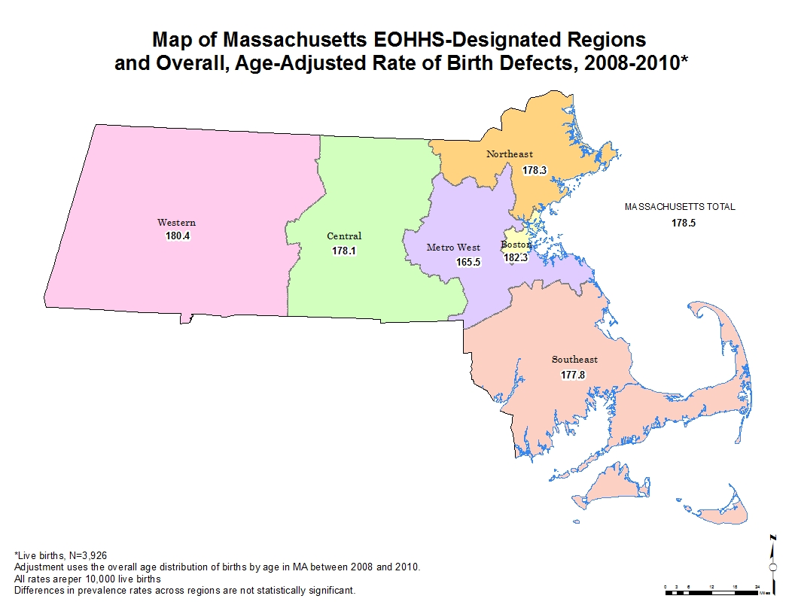

Frequency of Daily Multivitamin Use in the Month Prior to Pregnancy by Socio-demographic Characteristics, Massachusetts, 2009¹

Characteristic | Weighted n | Weighted % |  | 95% CL
Total | 26921 | 37.6 |  | 34.3 | - | 41.1
Maternal race/ethnicity
White, non-Hispanic | 19958 | 41.7 |  | 36.8 | - | 46.6
Black, non-Hispanic | 1830 | 28.2 |  | 23.4 | - | 33.6
Hispanic | 2399 | 22.5 |  | 18.6 | - | 27.0
Asian, non-Hispanic | 2397 | 42.1 |  | 36.4 | - | 48.0
Other, non-Hispanic | 337 | 43.2 |  | 27.0 | - | 61.0
Maternal age (years)
<20 | 630 | 15.8 |  | 10.0 | - | 24.1
20-29 | 8816 | 26.9 |  | 22.5 | - | 31.9
30-39 | 16342 | 50.5 |  | 45.3 | - | 55.7
40+ | 1133 | 46.3 |  | 28.7 | - | 64.8
Maternal education
<High school | 1523 | 24.1 |  | 17.0 | - | 32.9
High school diploma | 4305 | 20.8 |  | 15.8 | - | 27.0
Some college | 4746 | 34.1 |  | 27.3 | - | 41.7
College graduate | 16347 | 53.4 |  | 48.0 | - | 58.7
Household poverty level
≤100% FPL | 3083 | 19.9 |  | 15.1 | - | 25.7
>100% FPL | 23837 | 42.6 |  | 38.6 | - | 46.6
Maternal nativity
Non-US-born | 6038 | 31.7 |  | 27.5 | - | 36.1
US-born | 20882 | 39.8 |  | 35.6 | - | 44.3

^{1.} Data obtained from resident women who had given live birth in Massachusetts in 2009. The survey was conducted by Massachusetts as part of the CDC Pregnancy Risk Assessment Monitoring System (PRAMS).

Folic Acid Awareness and Behavior in Women Ages 18-44,
Massachusetts 2000 and 2004¹

Survey Year, Age Group | Recognized that taking folic acid can prevent birth defects (%) | Take folic acid daily (%)
2000
18 – 24 | 35.8 | 35.0
25 – 29 | 57.6 | 40.7
30 – 34 | 64.9 | 46.9
35 – 39 | 61.6 | 45.3
40 – 44 | 60.3 | 45.7
2004
18 – 24 | NA² | NA²
25 – 29 | NA² | 53.8
30 – 34 | 75.3 | 57.1
35 – 39 | 78.6 | 53.6
40 – 44 | 63.6 | 55.1

^{1.} Data obtained from women surveyed by the Behavioral Risk Factor Surveillance System (BRFSS), maintained by the Massachusetts Department of Public Health, Bureau of Health Statistics, Research and Evaluation. The difference in the data may be associated with demographical factors such as age, gender and race/ethnicity of the respondent groups. 2004 is the final year this question was included on the survey.
^{2.} Underlying sample size is less than 50 respondents (insufficient data).

References

Cary, J., M. Feldkamp, et al. (2005). "An etiologic classification of congenital malformations, including orofacial clefts, in Utah." Proceedings of the Greenwood Genetic Center 24: 69.
CDC (1995). "Economic costs of birth defects and cerebral palsy--United States, 1992." MMWR Morb Mortal Wkly Rep 44(37): 694-9.
CDC (2004). "Spina bifida and anencephaly before and after folic acid mandate--United States, 1995-1996 and 1999-2000." MMWR Morb Mortal Wkly Rep 53(17): 362-5.
CDC (2006). "Improved national prevalence estimates for 18 selected major birth defects--United States, 1999-2001." MMWR Morb Mortal Wkly Rep 54(51): 1301-5.
CDC (2009). "Assisted reproductive technology and trends in low birthweight--Massachusetts, 1997-2004." MMWR Morb Mortal Wkly Rep 58(3): 49-52.
CDC (2010). Updated National Birth Prevalence Estimates for Selected Birth Defects in teh United States, 2004-2006. Birth Defects Research (Part A) 88(12): 1008-1016.
CDC (2012). Martin JA, Hamilton BE, Ventura SJ, et al. Births: Final Data for 2010. National Vital Statistics Reports. 61(1): 1-71.
Cragan, J. D. and M. J. Khoury (2000). "Effect of prenatal diagnosis on epidemiologic studies of birth defects." Epidemiology 11(6): 695-9.
DHHS (2020). U.S. Department of Health and Human Services. Office of Disease Prevention and Health Promotion. Healthy People 2020. Washington, DC. Available at healthypeople.gov. Accessed 18Oct2013.
Ethen, M. K. and M. A. Canfield (2002). "Impact of including elective pregnancy terminations before 20 weeks gestation on birth defect rates." Teratology 66 Suppl 1: S32-5.
Fillingham, A. and J. Rankin (2008). "Prevalence, prenatal diagnosis and survival of gastroschisis." Prenatal Diagnosis 28(13): 1232-1237.
Forrester, M. B. and R. D. Merz (1999). "Epidemiology of abdominal wall defects, Hawaii, 1986-1997." Teratology 60(3): 117-23.
Forrester, M. B., R. D. Merz, et al. (1998). "Impact of prenatal diagnosis and elective termination on the prevalence of selected birth defects in Hawaii." Am J Epidemiol 148(12): 1206-11.
Harris, J. A. and L. James (1997). "State-by-state cost of birth defects--1992." Teratology 56(1-2): 11-6.
Heseker, H. B., J. B. Mason, et al. (2008). "Not all cases of neural-tube defect can be prevented by increasing the intake of folic acid." Br J Nutr: 1-8.
Holmes, L. (1994). Congenital Malformations. Principles and Practices of Pediatrics. Philadelphia, J.B. Lippincott Co.: 277-279.
Kochanek, K et al. ”Deaths: Final Data for 2009.” National Viatl Statistics Reports 60(3)
Lu, E. (2009). Bureau of Family Health and Nutrition, Massachusetts Department of Public Health: personal communication.
MADPH (2007). Massachusetts Births 2005. Boston, Division of Research and Epidemiology, Center for Health Information, Statistics, Research, and Evaluation, Massachusetts Department of Public Health.
MADPH (2008). Massachusetts Births 2006. Boston, Division of Research and Epidemiology, Bureau of Health Information, Statistics, Research, and Evaluation, Massachusetts Department of Public Health.
MADPH (2009). Massachusetts Births 2007. Boston, Division of Research and Epidemiology, Bureau of Health Information, Statistics, Research, and Evaluation, Massachusetts Department of Public Health.
MADPH (2013). Massachusetts Births 2010. Boston, MA: Division of Research and Epidemiology, Bureau of Health Information, Statistics, Research, and Evaluation, Massachusetts Department of Public Health.
MA PRAMS Report (2012) Massachusetts Department of Public Health. Massachusetts Pregnancy Risk Assessment Monitoring System (PRAMS) 2009 Surveillance Report. Boston, MA; February 2012.
MarchofDimes (2006). Birth Defects. March of Dimes Birth Defects Foundation.
Mills, J. L. and C. Signore (2004). "Neural tube defect rates before and after food fortification with folic acid." Birth Defects Res A Clin Mol Teratol 70(11): 844-5.
Mosley, B. S., M. A. Cleves, et al. (2009). "Neural tube defects and maternal folate intake among pregnancies conceived after folic acid fortification in the United States." Am J Epidemiol 169(1): 9-17.
Peller, A. J., M. N. Westgate, et al. (2004). "Trends in congenital malformations, 1974-1999: effect of prenatal diagnosis and elective termination." Obstet Gynecol 104(5 Pt 1): 957-64.
Rasmussen, S. A., R. S. Olney, et al. (2003). "Guidelines for case classification for the National Birth Defects Prevention Study." Birth Defects Res A Clin Mol Teratol 67(3): 193-201.
Reefhuis, J., M. A. Honein, et al. (2009). "Assisted reproductive technology and major structural birth defects in the United States." Hum Reprod 24(2): 360-6.
Sever, L., Ed. (2004). Guidelines for Conducting Birth Defects Surveillance. Atlanta, National Birth Defects Prevention Network, Inc.
Sunderam, S et al (2012). "Assisted reproductive technology surveillance--United States, 2009." MMWR Surveill Summ 61(SS7): 1-23.
Vu, L. T., K. K. Nobuhara, et al. (2008). "Increasing Prevalence of Gastroschisis: Population-based Study in California." The Journal of Pediatrics 152(6): 807-811.
Werler, M., A. Mitchel, et al (2009). ”Is there epidemiological evidence to support vascular disruption as a pathogenesis of gastroschisis?” Am J Med Gen Part A. 149A:1399-1406.

All previous birth defects reports can be found at:
http://www.mass.gov/eohhs/gov/departments/dph/programs/family-health/birth-defect/monitoring/surveillance-reports.html

Massachusetts Birth Defects 2008-2010 Evaluation Form

TO OUR READERS:
To better serve our users, we are enclosing this evaluation form. Please complete this questionnaire and return it to the address at the bottom of the page.

What tables and figures do you find most useful?

What tables and figures do you find least useful?

Are there other tables and figures that you would like added to this publication? If yes, please describe them in detail.

Do you have other comments or suggestions?

Thank you.

Please return your comments to:

Cathleen A. Higgins, Surveillance Coordinator

Center for Birth Defects Research and Prevention
Bureau of Family Health & Nutrition
Massachusetts Department of Public Health
250 Washington Street, 5th floor, Boston, MA 02108

