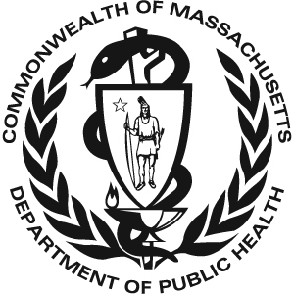 Massachusetts Universal Newborn Hearing 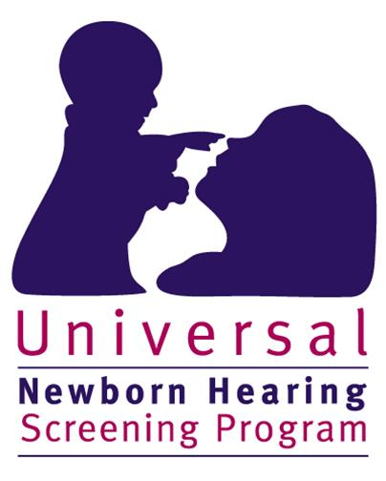
Screening Program
2012 Data

There were 72,976 total births in Massachusetts in 2012. 72,343 (99.4%*) of these infants received a hearing screen. 634 infants were not screened. Of the 634 infants that did not receive a screen:
- 257 died before a screen was performed or their parents/guardians did not provide consent to perform the screen
- 377 (0.4%*) had unknown screening status or did not receive a screen for unknown reasons (lost to screening follow-up)

Of the 72,343 infants that were screened:
- 71,189 (98.4%) passed the screen
- 1,153 (1.6%) failed the screen

Of the 1,153 infants that failed the hearing screen:
- 790 (68.4%) were diagnosed with normal hearing
- 200 (17.3%) were diagnosed with hearing loss
- 163 (14.1%) did not have a final confirmatory diagnosis when this data was reported. Of these infants without a final confirmatory diagnosis:
  - 51 were deceased or their parents/guardians declined follow-up diagnostic services
  - 14 moved out of state
  - 69 received diagnostic testing but were pending a final diagnosis
  - 29 (2.5% of the 1,153 infants that failed the screen) were lost to diagnostic follow-up

Of the 200 infants with hearing loss:
- 143 (71.5%) were enrolled in Early Intervention (EI)
- 19 (9.5%) received ‘other’ services such as monitoring services or non-Part C EI
- The remaining 38 infants (19.0%) were not documented to be receiving EI services for the following reasons:
  - 10 were deceased or declined EI services
  - 10 moved out of state
  - 18 were not receiving EI services for other or unknown reasons (9.0% lost to EI follow-up)

* % screened does not include deceased children without a screen

