The 2012 Barbara Wilensky Gopen Memorial Fellowship

Sponsored by the Massachusetts Developmental Disabilities Network Programs:
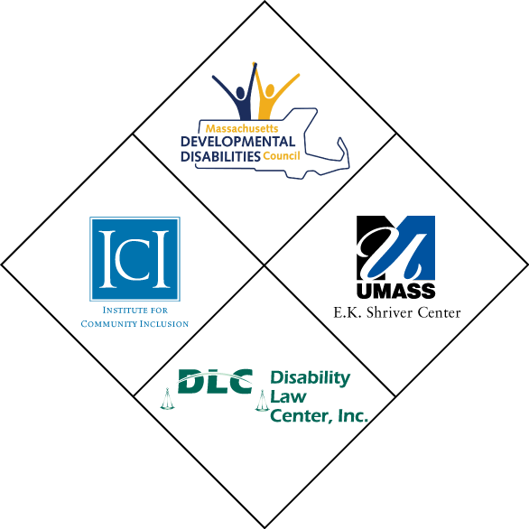
- Massachusetts Developmental Disabilities Council (MDDC)
- Institute for Community Inclusion, UMass Boston, University Center for Excellence in Developmental Disabilities (ICI)
- Eunice Kennedy Shriver Center, University Center for Excellence in Developmental Disabilities
- Disability Law Center (DLC)

Overview of the Gopen Fellowship
The Barbara Wilensky Gopen Fellowship offers a unique opportunity for a person with a developmental disability or a family member to gain valuable knowledge and experience by working with members of the Massachusetts Developmental Disabilities Network Programs.
The overall goal of the Gopen Fellowship is to foster the leadership capability of individuals by supporting their development of an original project. The Fellowship provides a general understanding of how the system of disability services works both in the Commonwealth and on the federal level. It also builds the capacity of the Fellow's personal advocacy and leadership skills.
The selected fellow will design and implement a project of their choice to gain expertise in their field of concentration. Activities are based on the Fellow’s interest and may include but are not limited to grassroots advocacy, public policy analysis, research and leadership development.
Concurrent with their project work, Gopen Fellows learn about public policy and disabilities, the legislative process and the role of disability agencies in Massachusetts. Fellows attend local and national public policy forums to broaden their knowledge on current disability topics.
The Fellowship offers an educational and supportive environment designed for an individual who has personal advocacy experience to start working in the professional disability field. As fellows choose their project design, develop their work plan, conduct research and create their final product, they are guided by Institute for Community Inclusion (ICI) and Massachusetts Developmental Disabilities Council (MDDC) staff to develop the skills they need, understand how the system works, and learn how they can create change.
The Gopen Fellow works 20 hours per week. The one-year award includes a stipend of $20,000 plus fringe benefits.
The deadline to submit applications for the 2012 Fellowship is 5:00pm on Friday, October 14th, 2011.
Background
The Fellowship was established in 2001 to honor lifelong disability advocate Barbara Wilensky Gopen. Barbara was a person with a disability who made a lifetime commitment to improving the lives of people with developmental disabilities. She was a longtime member of the Massachusetts Developmental Disabilities Council, where she served as a leader for many years.

Eligibility
The Barbara Wilensky Gopen Memorial Fellowship is open to individuals with developmental disabilities and family members living in Massachusetts. The Fellowship is designed for individuals who seek to increase their knowledge and skills in developmental disabilities. Eligible applicants do not have extensive professional work experience in the disability field, nor do they have advanced degrees or professional training in related fields. Gopen Fellowship applicants may have personal or volunteer disability or advocacy experience.
Individuals with developmental disabilities are strongly encouraged to apply.

Gopen Fellows and Their Accomplishments
Over the past decade Gopen Fellows have designed unique projects in their areas of interest, including youth recreation, legislative advocacy, self-advocate leadership development, positive behavioral supports, accessible community technology, sibling support, multicultural outreach, transportation, disability awareness, cultural accessibility and reasonable accommodations for autism spectrum disorders.
Former Gopen Fellows continue to use the expertise gained from their Fellowship to help people with disabilities. They have attended graduate school, pursued other Fellowships, obtained employment in their area of interest and continued their disability advocacy by serving on boards and commissions.
Basic Requirements for the Gopen Fellowship
Gopen Fellows are motivated learners and enthusiastic about gaining expertise in their selected topic area. They possess good communication skills and take the initiative to maximize their Fellowship experience. They are able to work well independently and collaboratively with individuals and in groups.
2012 Gopen Fellowship requirements:
- Work 20 hours per week for a period of 12 months (January – December).
- Design and implement a unique project conceived by the selected Fellow.
- Initiate contacts and meet with professionals in the chosen topic area.
- Develop and distribute a final product.
- Create a project work plan and write quarterly status reports.
- Spend at least two days per week working at ICI’s Park Plaza office in Boston and one day per month at the MDDC’s office in Quincy.
- Attend MDDC quarterly Council meetings and Public Policy Team meetings.
- Attend Friday morning LEND Fellowship classes in Boston (no summer session).
- Participate in training and other leadership activities at ICI.
- Attend conferences, trainings and other events on disability advocacy and public policy.
- Present the accomplishments of the Fellowship at the MDDC’s December quarterly meeting and an ICI staff meeting.
- If applicable, give a presentation at a regional or national meeting in conjunction with other individuals or colleagues (paper, poster, or oral presentation).
Timeline
- August 24, 2011: Application period begins
- Friday, October 14th at 5pm: Deadline to submit applications
- Thursday, November 10th: Applicants notified of finalist status
- Week of November 21st: Finalist interviews
- Wednesday, November 30th: Finalists notified of committee’s decision
- January 1, 2012: Fellowship begins

Applying for the Fellowship
The application will consist of a brief written proposal, a resume and three letters of reference. Refer to the attached “Application Instructions” for details on completing and submitting the application.
Applicants will be judged on their project’s originality and methodology, their ability to implement the proposed project, the expected impact of the project after it is completed and their potential to benefit from the Fellowship experience.
The review committee will interview all finalists the week of November 21th. Staff is available to answer questions about preparing the application materials.
For more information please contact David Helm at ICI by email (David.helm@childrens.harvard.edu) or phone at 857.218.4327 (voice).
************************************************************************This information is posted on the ICI and MDDC websites:
- www.communityinclusion.org
- www.mass.gov/mddc
Application Instructions

The 2012 Barbara Wilensky Gopen Memorial Fellowship

- Submit a 3-5 page proposal:

1. Write a detailed narrative:

a) Describe your background, including your personal disability experience.

b) Why do you want to be the Gopen Fellow? What do you expect to achieve?

c) If you are selected, what do you see yourself doing after the Fellowship ends?

2. Provide information about your proposed project:
- Why did you choose this particular project?

- What makes your project unique?

- What is the goal of the project?
- The project goal is a concise statement of the project’s purpose and the specific result expected from it.

d) Specify the major objectives:
- Objectives are outcomes or results to be achieved within the project period which directly contribute to achievement of the project goal.
e) What steps will you take to implement your project?
f) Describe the final product. How will you publicize its availability and distribute it?

g) How will the project benefit people with developmental disabilities and/or their family members?
- Attach your resume.

- Submit 3 Letters of Reference with your application. For letters being sent separately by email, include “Gopen LOR – (applicant’s name)” on the subject line.

Send your application by mail or email to:
David T. Helm, Ph.D.
Institute for Community Inclusion
University of Massachusetts Boston
100 Morrissey Blvd.
Boston, MA 02125

David.helm@childrens.harvard.edu

David.helm@childrens.harvard.edu

The deadline to submit applications and letters of reference for the 2012 Gopen Fellowship is 5:00pm on Friday, October 14th, 2011.

