STD, HIV/AIDS and Viral Hepatitis Surveillance Report 2012

Massachusetts Department of Public Health

Bureau of Infectious Disease

Division of STD Prevention and HIV/AIDS Surveillance
Division of Epidemiology and Immunization

December 2013

TABLE OF CONTENTS

1. Executive Summary

2. Chlamydia..........................................................................................................3

3. Gonorrhea..........................................................................................................6

4. Syphilis..............................................................................................................8

5. HIV/AIDS........................................................................................................10

6. Viral Hepatitis………………………………………………………………..12

7. STDs and HIV/AIDS in Adolescents and Young Adults……………………16

8. STDs and HIV/AIDS in Women………………………………………….…18

9. Racial/Ethnic Health Disparities in STDs and HIV/AIDS………………..…20

10. STDs and HIV/AIDS in Men Who Have Sex with Men……………….…....22

11. Strengths and Limitations of Data…………………….……………………..24

12. Interpreting STD and HIV/AIDS Data………………………………………25

13. STD, HIV/AIDS and Viral Hepatitis Contact Information………………….26

14. STD, HIV/AIDS and Viral Hepatitis Resources…………………………….27

Executive Summary 2012

The annual publication of the Massachusetts STD, HIV/AIDS, and Viral Hepatitis Surveillance Report provides an occasion to reflect upon trends in these diseases within the Commonwealth of Massachusetts.

In 2012, the following trends in the three most commonly reported bacterial STIs in Massachusetts were observed:
- Infectious syphilis (primary, secondary, and early latent syphilis) incidence rates continued to increase yearly – a trend which began in the last quarter of 2007. Although infectious syphilis remains relatively rare overall, the disease remained at epidemic levels among men who have sex with men.
- The number of gonorrhea cases increased in 2012 by 10%. Gonorrhea primarily remains concentrated within non-white populations living in major urban centers.
- Chlamydia cases have, for the first time, leveled off. Case reporting is reflective of access to screening with more sensitive laboratory testing and/or increased electronic laboratory reporting. Moreover, recent research has revealed gaps in our understanding of what proportion of chlamydia cases will progress to complications, such as epididymitis, pelvic inflammatory disease, ectopic pregnancy, infertility, or chronic pelvic pain.

Regarding HIV/AIDS, notable trends in 2011 included the following:
- Newly diagnosed infections and deaths continued to decline, but the actual number of persons known to be living with HIV/AIDS in Massachusetts increased to over 18,000 in 2011 because survival continued to improve.
- Similar to other sexually transmitted infections, black and Hispanic/Latino residents have higher rates of HIV infection compared to white residents.
- Male-to-male sex remains the single largest identified exposure mode among newly diagnosed HIV infection cases.

With regard to viral hepatitis, we observed the following trends in 2012:
- Confirmed cases of chronic hepatitis B continued to decline, a trend due in large part to increasing levels of immunity against hepatitis B in adults at risk of infection and near universal immunization of children against hepatitis B.
- There has been an overall decline in the number of newly diagnosed hepatitis C cases reported in Massachusetts since 2004. However, at approximately 72 cases per 100,000 population in 2012, hepatitis C remains one of the highest volume reportable infections. There continues to be a high number of hepatitis C cases reported among adolescents and young adults, reflecting ongoing transmission among young people injecting drugs in the state.

Highlighted on pages 16-23 are trends within special populations disproportionally affected by STIs, HIV/AIDS, and/or viral hepatitis. Massachusetts data are reflective of a number of national trends among women, minorities (both sexual and racial/ethnic minorities), and youth. Where we differ is in some increasing gaps among certain racial/ethnic and sexual minorities in reported STIs. It remains to be determined whether this reflects improved access to care leading to more screening and identification of infection, true increases in infection within certain minority populations, or true decreases in infection within non-minority populations. Improvements in reporting systems, which provide more complete information on other possible risk and protective associations, are critical for improving our understanding of disparities in reportable diseases.

The focus of this annual surveillance report is necessarily on diseases reportable to the state and cannot address all determinants of health. However, it should be recognized that sexually transmitted infections, including HIV/AIDS and viral hepatitis, occur at the nexus of individual human behavior, community risk, clinical diagnosis and treatment, and public health prevention and control. The intended audience for this annual surveillance report includes the clinicians and the laboratory professionals who report these cases, as well as the community organizations, local public health departments, policymakers, and researchers who are interested in the sexual health and well-being of residents of the Commonwealth of Massachusetts. We welcome feedback, and invite you, the reader, to begin by thinking in terms of disease statistics, but end by acting in terms of health promotion.

Brenda Cole, MEd, Director, Division of STD Prevention
Daniel Church, MPH, Coordinator, Adult Viral Hepatitis Prevention
Dawn Fukuda, MPH, Director, Office of HIV/AIDS
Katherine Hsu, MD, MPH, Medical Director, Division of STD Prevention and HIV/AIDS Surveillance
Alfred DeMaria, Jr., MD, Medical Director and State Epidemiologist, Bureau of Infectious Disease
Kevin Cranston, MDiv, Director, Bureau of Infectious Disease

CHLAMYDIA
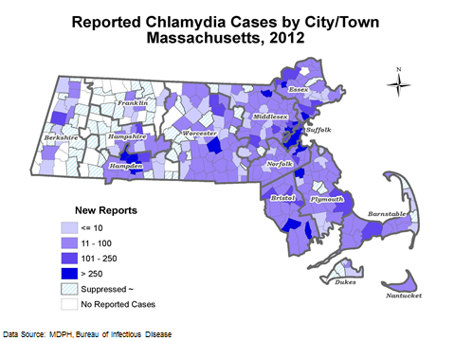
In 2012, there were 23,129 reported chlamydia cases in Massachusetts, making chlamydia the most reported infection in the Commonwealth. Chlamydia infection is widely distributed in Massachusetts. There were no major shifts in the geographic distribution of cases within the state in the past year.
Additional information about chlamydia infection and other STIs is available online at www.mass.gov/dph/cdc/std.
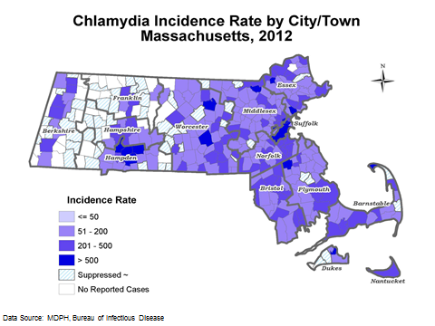
The overall Massachusetts chlamydia incidence rate of 348 per 100,000 is lower than the national rate of 458 per 100,000. Massachusetts ranked 11th lowest in chlamydia incidence rate among the 50 states. The highest chlamydia incidence rates are in large urban areas around Boston and Springfield.
Throughout the state, the majority of cities and towns fall into the 50 to 200 cases per 100,000 population range.
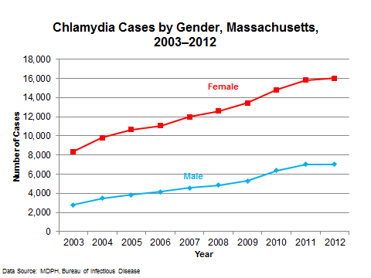
The total number of reported chlamydia cases in Massachusetts has more than doubled in the past ten years, from 11,208 in 2002 to 23,129 in 2012.
There was a 1% increase in the number of cases reported in 2012 compared to 2011.
Of the total reported cases in 2012, 7,050 (31%) were in men, 16,041 (69%) were in women and 38 (<1%) had no gender reported. The greater number of chlamydia cases among women is a combined effect of increased incidence and a higher level of screening as compared to men.
CHLAMYDIA
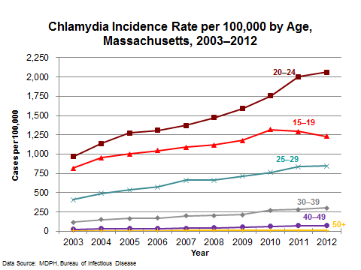
Across age groups, chlamydia incidence rate has remained highest among adolescents and young adults from 2003 to 2012. In 2012, the chlamydia incidence rate in Massachusetts among adolescents (ages 15-19) was 1,232 per 100,000 compared to 2,083 nationally. The rate among young adults (ages 20-24) in Massachusetts was 2,064 cases per 100,000 compared to 2,515 nationally.

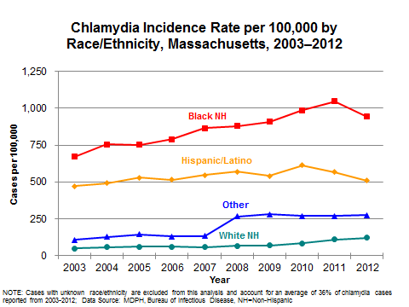
Historically, members of communities of color have been disproportionately affected by STIs. In 2012, compared to the white population, the incidence rate of reported chlamydia infection in Massachusetts was eight times higher in the black and four times higher in the Hispanic/Latino population. Disparities in the chlamydia incidence rate in Massachusetts have decreased in recent years. Since 2008, changes in electronic reporting of laboratory results indicating STI cases to MDPH resulted in an increased proportion of STI cases being categorized as “other” race. Thus, as of 2008, increases in the rate of STIs in the “other” category may be related to electronic reporting rather than increase in incidence in these populations. Please note that cases with unknown race/ethnicity are no longer included in this analysis.
INFERTILITY PREVENTION PROJECT
Since 1997, the Division of STD Prevention has participated in the Infertility Prevention Project (IPP), funded by the Centers for Disease Control and Prevention (CDC). The goal of this project is to reduce infertility and other health consequences of chlamydia infection through screening and treatment of women who are at higher risk for infection.
In 2012, 17,261 IPP specimens were tested for chlamydia infection. Seven percent were positive. 13,103 of these specimens were also tested for gonorrhea, of which 0.8% were positive. Test results from participating sites have yielded the following:

Infertility Prevention Project, Percent Positive for Chlamydia Infection Among Females, Massachusetts, 2012
Site Type | Number tested | Percent Positive
School-Based Health Centers | (N = 940) | 7%
Correctional Facilities | (N = 454) | 4%
Family Planning Clinics | (N = 13,353) | 6%
Expanded STD Screening Sites* | (N = 2,514) | 9%
Data Source: MDPH Bureau of Infectious Disease
*Includes females under age 26 years, tested at Prevention, Integrated Counseling, Screening, and Referral sites under IPP.

EXPEDITED PARTNER THERAPY

The MDPH promulgated regulations in August 2011 to permit clinicians to prescribe or dispense antibiotic treatment for the partners of persons with chlamydia infection without having to examine the partner, known as Expedited Partner Therapy (EPT). In January 2012, the chlamydia case report form was modified to capture information regarding partner notification and treatment including EPT. EPT is underutilized and underreported in Massachusetts for chlamydia infection. An analysis of 2012 laboratory-confirmed chlamydia cases revealed that only 29% of cases had complete EPT information. Of those, 88% of providers reported partner notification, mainly via patient notification of partners. Providers offered EPT in 18% of cases; of those, 51% used patient-delivered prescriptions only; 43% used patient-delivered medications; and 6% reported using a combination of methods. Community health centers, hospital-based clinics, and STD/family planning clinics reported using EPT in a larger proportion of patients compared to other clinical settings.

GONORRHEA
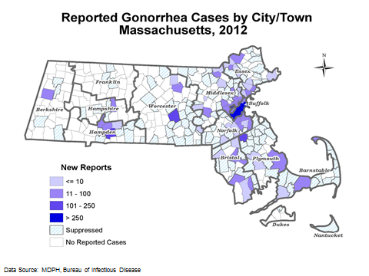
The number of gonorrhea cases in Massachusetts in 2012 was 2,591, a 10% increase from the previous year. Cases are more common in urban locations.
Additional information about gonorrhea and other STIs is available online at www.mass.gov/dph/cdc/std.

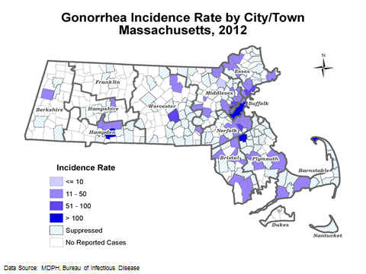

The Massachusetts gonorrhea incidence rate of 39 per 100,000 is less than half the national rate of 104 per 100,000. Massachusetts ranked ninth lowest in gonorrhea incidence rate among the 50 states. Across the Commonwealth, the highest concentration of cases is in the eastern part of the state, with the highest incidence rates in Provincetown, Brockton, Boston and Springfield.

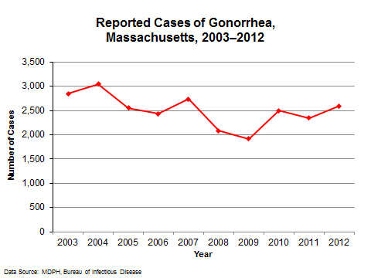

From 2003 to 2012, the number of gonorrhea cases fluctuated with increases and decreases both year to year and over the ten-year period. Overall, there are fewer gonorrhea cases reported in recent years; the number of cases decreased by 9% from 2003 (N=2,842) to 2012 (N=2,591).

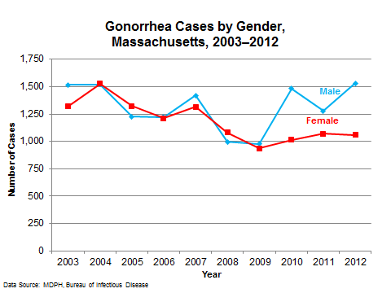
GONORRHEA

From 2003 to 2009, the number of gonorrhea cases reported among males was about the same as the number reported among females. However, in the past three years from 2010 to 2012, more cases were reported among males than females (males accounted for an average of 58% of cases and females 42%).

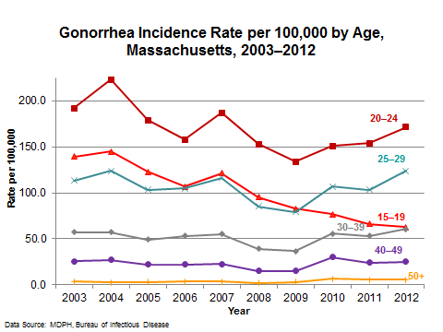

From 2003 to 2012, the gonorrhea incidence rate per 100,000 was highest among young adults ages 20 to 24 years (171 per 100,000). In 2012, the gonorrhea incidence rate among young adults (ages 20 to 24 years old) was four times the state-wide incidence rate; among 25 to 29 year olds (124 per 100,000) it was three times the state-wide incidence rate (39 per 100,000).

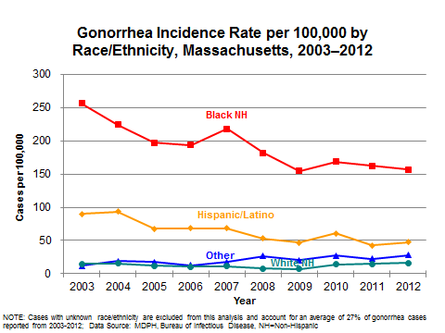
In 2012, in Massachusetts, the reported gonorrhea incidence rate was 10 times higher in the black population (157 cases per 100,000) and three times higher in the Hispanic/Latino population (48 cases per 100,000) compared to the white population (16 cases per 100,000). In 2008, changes in electronic reporting of laboratory results indicating STI cases to MDPH resulted in an increased proportion of STI cases being categorized as “other” race. Thus, as of 2008, increases in the rate of STIs in the “other” category may be related to electronic reporting. Please note that cases with unknown race/ethnicity are no longer included in this analysis.
SYPHILIS
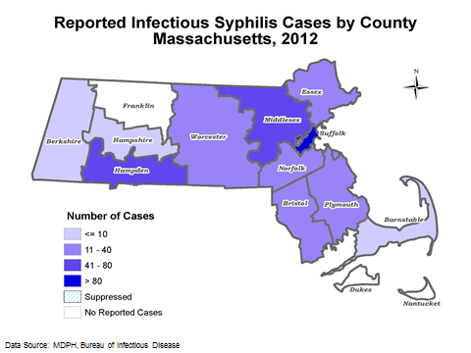
In 2012, there were 512 infectious syphilis cases (primary, secondary, and early latent) reported in Massachusetts. Although infectious syphilis cases have been reported in almost all counties, 34% of the cases were reported in Suffolk County and 19% were reported in Hampden County
Additional information about infectious syphilis is available online at www.mass.gov/dph/cdc/std.

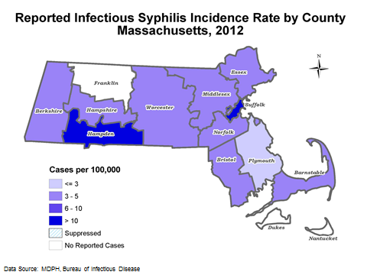
In 2012, the infectious syphilis incidence rate for Massachusetts was 8 per 100,000. This represents the highest infectious syphilis rate in the past ten years. By county, the highest infectious syphilis rates were in Suffolk (26 per 100,000 and Hampden (22 per 100,000); followed by Barnstable (7 per 100,000), Middlesex (6 per 100,000), and Worcester and Essex (both 5 per 100,000). Berkshire, Bristol, Hampshire, Norfolk and Plymouth Counties had syphilis rates less than five per 100,000 and Dukes, Franklin and Nantucket Counties had rates of zero.
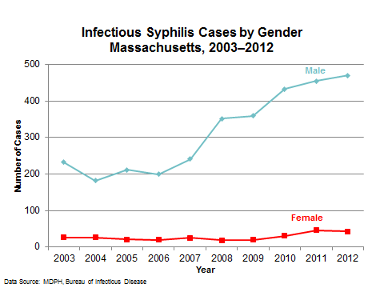
In Massachusetts, the male-to-female ratio of infectious syphilis cases increased from 9:1 in 2003, to 20:1 in 2008, then decreased to 11:1 in 2012. The elevated male-to-female ratio reflects an increase in the number of infectious syphilis cases diagnosed in men who have sex with men. Although the number of female cases is much smaller than male, it has more than doubled in the past five years from 2008 (N=18) to 2012 (N=42).

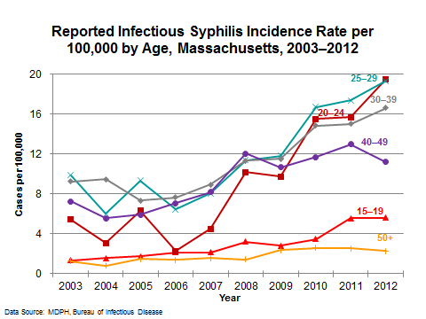
SYPHILIS
In contrast to chlamydia and gonorrhea cases, which tend to occur more frequently among adolescents and young adults, the majority of infectious syphilis cases are reported in individuals age 30 years and above (58% of cases in 2012). However, in recent years, the proportion of cases among people in their twenties has increased (from 25% of cases in 2003 to 36% of cases in 2012) and the infectious syphilis rate per 100,000 was highest among 20-24 and 25-29 year olds from 2010 to 2012.
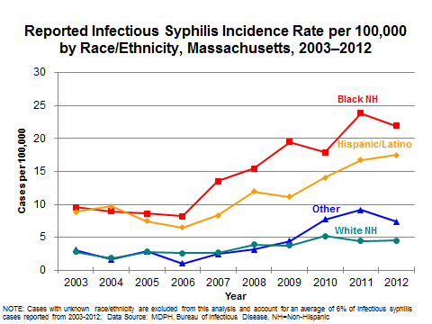

In 2012, the infectious syphilis incidence rate was four times higher in the black population (22 cases per 100,000) and three times higher in the Hispanic/Latino population (18 cases per 100,000) compared to the white population (5 cases per 100,000). Please note that cases with unknown race/ethnicity are no longer included in this analysis.

SYPHILIS IN MEN WHO HAVE SEX WITH MEN (MSM)
In Massachusetts, MSM represent a higher-risk group for infectious syphilis. Of the 512 infectious syphilis cases in 2012, 384 (75%) were reported in MSM. Forty-one percent (N=157) of the MSM with infectious syphilis disclosed that they were co-infected with HIV. Thirty-seven percent of the infectious syphilis cases in MSM were reported in Suffolk County and 15% were reported in Hampden County.

Transmission of syphilis can occur between men through unprotected oral and anal sex. Additional information and resources regarding MSM and STIs is available online at http://www.mass.gov/eohhs/gov/departments/dph/prog-a-j/bcdc/factsheets.html

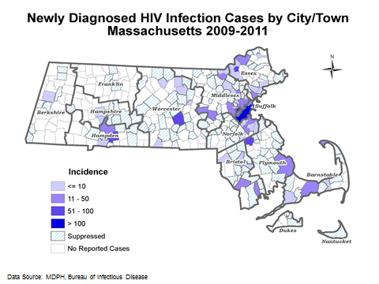
HIV/AIDS
Of the 351 cities and towns in Massachusetts, 193 (55%) had at least one HIV infection diagnosis from 2009 to 2011. The majority of HIV infection diagnoses were reported in large urban areas.
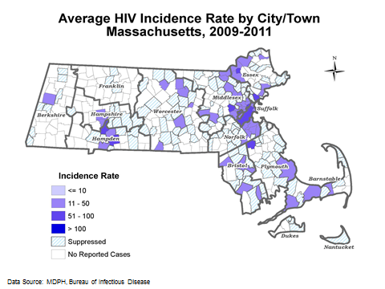
HIV infection case and incidence data by city and town are available online at www.mass.gov/dph/cdc/aids . Additional information is available through the MDPH HIV/AIDS Epidemiologic Profile at the same weblink.
Of those cities and towns where HIV infections were diagnosed within the three-year period 2009 to 2011, the majority (75%) had rates under 10 per 100,000 population.

Provincetown had the highest rate of HIV infection diagnosis at 404 per 100,000 population.
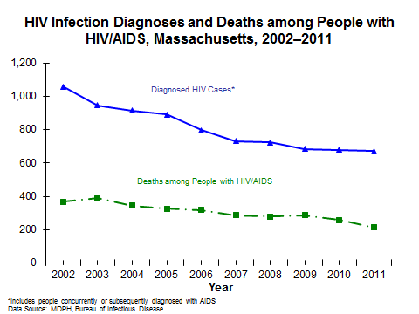

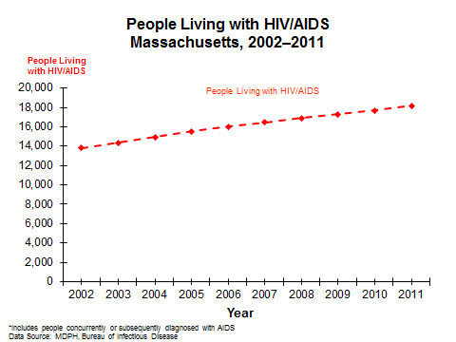
In 2011, there were 673 HIV infection diagnoses and 212 deaths among people reported with HIV/AIDS in Massachusetts. HIV infection diagnoses and deaths among people with HIV/AIDS continue to decline each year, but because infection diagnoses continue to exceed the number of deaths annually, the number of people known to be living with HIV/AIDS in Massachusetts has increased by 24% from 13,812 on December 31, 2002 to 18,166 on December 31, 2011.

HIV/AIDS
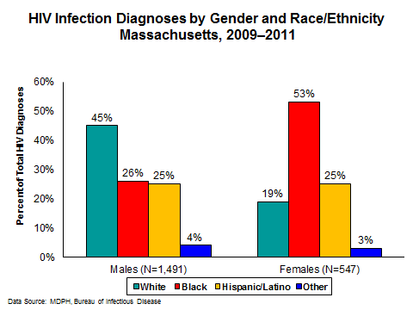

From 2009 to 2011, of the 2,038 HIV infection diagnoses in Massachusetts, 1,491 (73%) were in men and 547 (27%) were in women. Most of the newly diagnosed HIV infections in men were in white men, whereas the majority of newly diagnosed HIV infections in women were in black women.

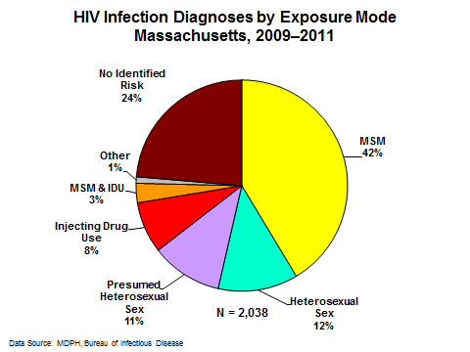

From 2009 to 2011, the primary exposure mode reported among HIV infection diagnoses in Massachusetts was male-to-male sex at 42%, followed by heterosexual sex (12%), presumed heterosexual sex (11%), and injection drug use (8%). Twenty-four percent of diagnoses were reported without adequate risk information.

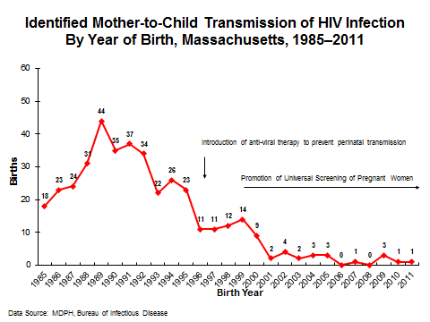
Since the mid-1990’s, Massachusetts has experienced a dramatic reduction in mother-to-child transmission of HIV infection. From 2002 to 2011, the number of HIV-infected newborns identified ranged from zero (in 2006 and 2008) to four (in 2002). The decline is attributed to improvements in HIV screening during pregnancy and the treatment of HIV-infected women with anti-retroviral therapy. However, every case of mother-to-child transmission remains a sentinel event mandating investigation to identify if new systems can be put in place to assure maximum efforts to prevent vertical transmission.

VIRAL HEPATITIS
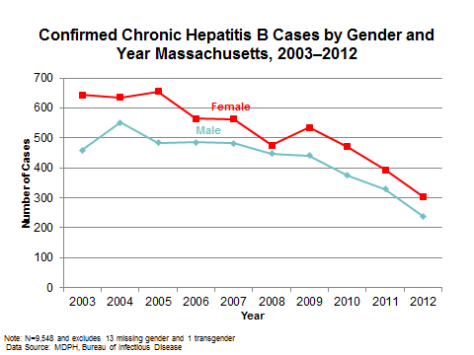
The number of confirmed cases of chronic hepatitis B reported in Massachusetts has been declining since 2005. In 2012, 543 confirmed chronic cases were reported. This number is likely to increase due to continued processing of case reports and case confirmation. Even so, there is an overall downward trend in both confirmed and probable cases of hepatitis B infection (data not shown), due in large part to increasing levels of immunity against hepatitis B in adults at risk of infection and almost universal immunization of children against hepatitis B.

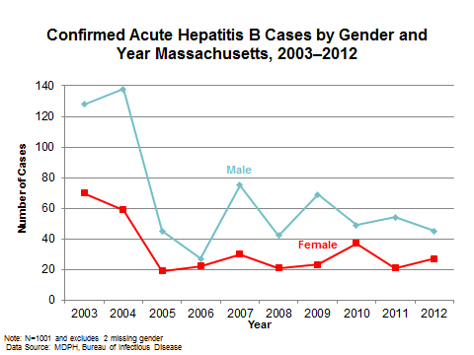
Seventy-two confirmed cases of acute hepatitis B were identified in 2012. Confirmation of acute infection requires additional information, including specific laboratory test results and symptom information, which are not always reported to MDPH. Furthermore, acute HBV infection is often asymptomatic and those individuals are consequently unlikely to seek care. Thus, the number of confirmed acute cases of hepatitis B virus infection is likely an underestimate of the true number of acute cases in the state.

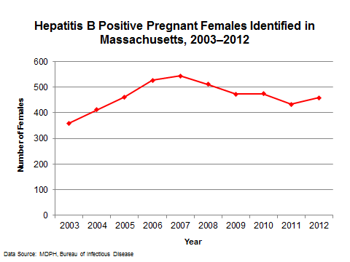
It is recommended that pregnant women be screened for hepatitis B during pregnancy to allow case management to begin early and prevent transmission of the virus to infants. Since 2007, the Perinatal Hepatitis B Program has partnered with local public health programs to increase identification of household and sexual contacts of hepatitis B surface antibody (HBsAg)-positive pregnant women in an effort to reduce the risk of maternal-child transmission of hepatitis B.

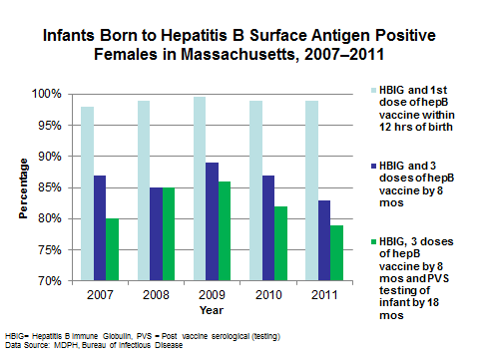
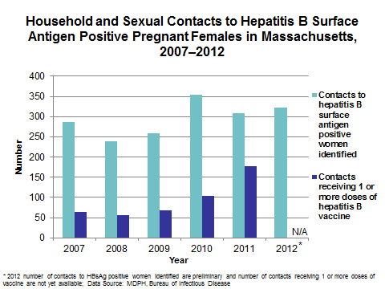
VIRAL HEPATITIS
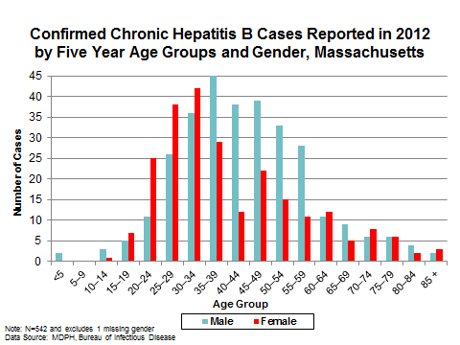

Due to enhanced surveillance focused on identifying pregnant women who are hepatitis B positive, a large number of the hepatitis B cases identified and reported in 2012 were in women between the ages of 20 and 39 years. While efforts are made to identify infection among the household and sexual contacts of these women, there are many barriers to getting those partners tested.

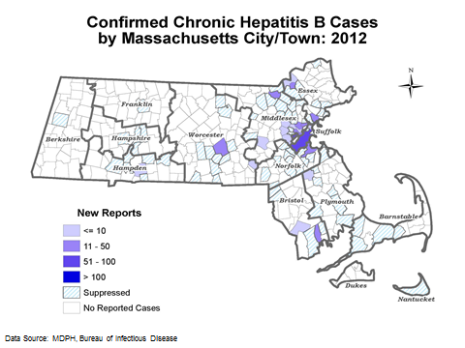

Most newly diagnosed cases of chronic hepatitis B are in people living in urban areas such as Boston, Worcester, Lowell, and Springfield.

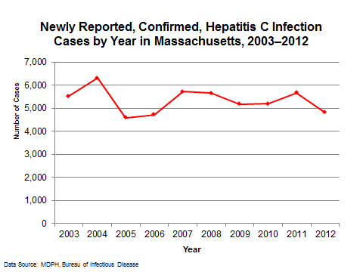
VIRAL HEPATITIS

There has been a decline in the number of newly diagnosed confirmed hepatitis C infection cases reported in Massachusetts since 2004. However, the overall number of cases reported remains very high with 7,000 to 10,000 newly diagnosed confirmed and probable cases reported to MDPH annually since 2003. There are hepatitis C cases reported to MDPH for 2012 that have yet to be fully investigated, so the number is likely to increase. Hepatitis C remains one of the highest volume infectious diseases reported in Massachusetts.

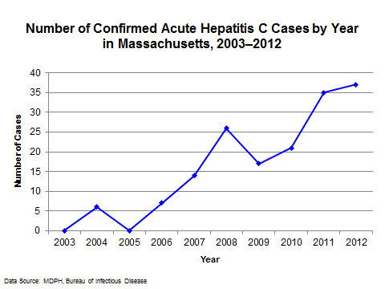
Improvements in surveillance have allowed for better identification of acute cases of hepatitis C. Thirty-seven acute cases were confirmed in 2012. Classification of acute cases requires information on hepatitis A and B test results, serum liver enzyme tests and symptoms. One-hundred eighty-one reported cases of hepatitis C were clinically consistent with acute infection, but hepatitis A or B laboratory results were not available to rule out these other causes of viral hepatitis. Cases of acute hepatitis C are reported in CDC’s annual summary of notifiable diseases, while chronic hepatitis C is not.

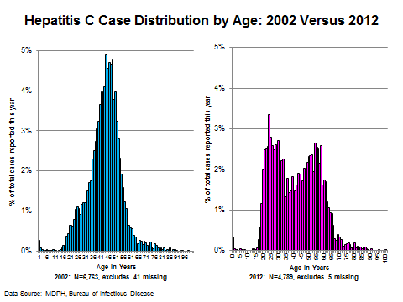

The age distribution of hepatitis C cases reported in Massachusetts has changed between 2002 and 2012. In 2002 the reported cases were distributed in a uni-modal curve with one age peak between the ages of 44 and 50 years. In 2012, the reported cases were distributed in a bi-modal curve with one peak at 24 years of age and a second at 54 years.

VIRAL HEPATITIS

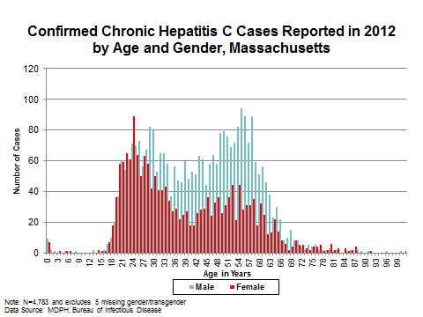

More hepatitis C cases reported in 2012 are identified in males than in females in almost all age groups, except the 15 to 24 year age group, where the number of females is slightly higher than males.

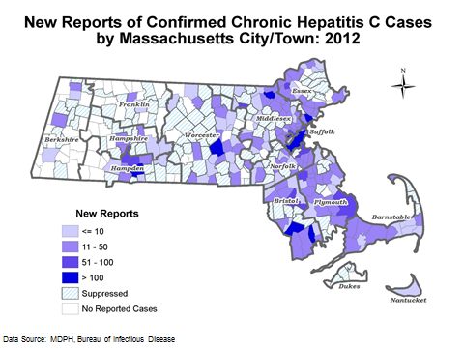

Cases of hepatitis C are reported in communities across Massachusetts, with more cases being identified in people living the urban areas of Boston, Worcester, and Springfield.

STDs AND HIV/AIDS IN ADOLESCENTS & YOUNG ADULTS

Compared to older adults, sexually active adolescents and young adults are at higher risk for acquiring STIs because of a combination of behavioral, biological and cultural factors. The higher prevalence of STIs among adolescents may also reflect multiple barriers to accessing quality STD prevention services, including lack of insurance or unwillingness to use parents’ insurance due to confidentiality concerns, lack of other ability to pay for services in the absence of insurance, lack of transportation, discomfort with facilities and services designed for adults, and concerns about confidentiality. (Source: CDC. Sexually Transmitted Disease Surveillance, 2011. Atlanta: U.S. Department of Health and Human Services; 2012.)
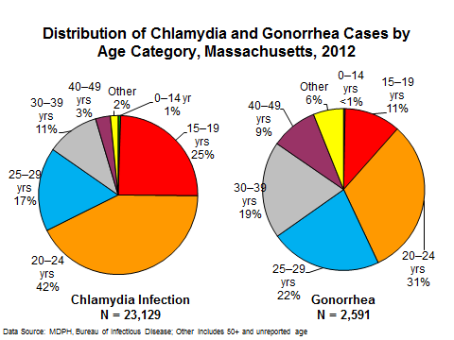

In 2012, 67% of chlamydia cases and 42% of gonorrhea cases were reported in adolescents and young adults (ages 15-24).

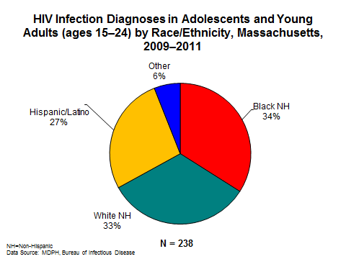

From 2009 to 2011, HIV infection diagnoses among adolescents and young adults in Massachusetts had the following racial/ethnic distribution: black (non-Hispanic) (34%), white (non-Hispanic) (33%), Hispanic/Latino (27%), and other (6%).

STDs AND HIV/AIDS IN ADOLESCENTS & YOUNG ADULTS
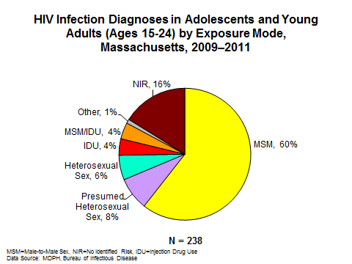

From 2009 to 2011, the primary mode of exposure for HIV infection diagnoses in adolescents and young adults was male-to-male sex (60%), followed by presumed heterosexual sex (8%), heterosexual sex (6%), and injecting drug use and MSM/IDU (both 4%). Sixteen percent of adolescents and young adults were reported with no risk information.

The Youth Risk Behavior Survey (YRBS) is performed biennially among a sample of 9th to 12th grade students. A review of data provided from the Massachusetts YRBS over the past two decades indicates that three markers of risky youth sexual behavior (ever having had sex, first sex before age 13 years, and four or more lifetime sexual partners) reached all-time lows in 2003 (respectively 41%, 5%, and 10%), and after slight increases of potential concern in 2009, returned to similar lows in 2011 (to 42%, 4%, and 11% in 2011). In contrast, two correlates of protective sexual behaviors, use of condoms at last sex and being taught about HIV/AIDS in school, have shown declines from previous gains (respectively 58% in 2011 down from 65% in 2005, and 84% in 2011 down from 93% in 2005).

Sexual Behaviors Among Massachusetts High School Students, 2003–2011
 | Affirmative Responses (Percent)
 | 2003 | 2005 | 2007 | 2009 | 2011
Lifetime sexual intercourse | 41 | 45 | 44 | 46 | 42
Sexual intercourse before age 13 | 5 | 5 | 6 | 5 | 4
Four or more lifetime sexual partners | 10 | 13 | 12 | 13 | 11
Condom use at last sexual intercourse | 57 | 65 | 61 | 58 | 58
Taught in school about AIDS or HIV | 92 | 93 | 89 | 87 | 84
Data Source: Massachusetts Department of Elementary and Secondary Education, Massachusetts Youth Risk Behavior Survey

STDs AND HIV/AIDS IN WOMEN

In women untreated STIs can lead to serious health consequences, including pelvic inflammatory disease, infertility, ectopic pregnancy and cervical cancer. Women are disproportionately impacted by STI complications because STIs are more likely to remain undetected, delaying treatment. While women are highly susceptible to infection anatomically, they are less likely to have symptoms and if they do exhibit symptoms, more likely to attribute them to something else. (Source: CDC. CDC Fact Sheet, 10 Ways STDs Impact Women Differently from Men. April 2011. Available at: http://www.cdc.gov/nchhstp/newsroom/docs/STDs-Women-042011.pdf)
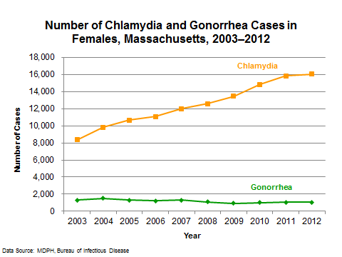

Unlike gonorrhea, chlamydia infection in Massachusetts is more commonly reported in women. From 2003 to 2012, the number of chlamydia cases in women increased by 91%, in part due to increased adoption of routine screening by Massachusetts healthcare providers, as recommended by the Centers for Disease Control and Prevention.

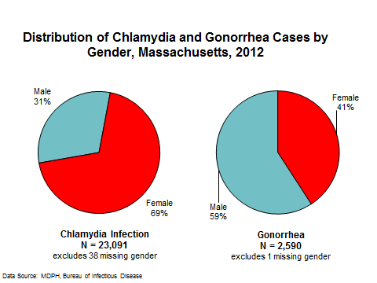

While the male-to-female ratio of gonorrhea cases is 1.4 to 1, women are over-represented among chlamydia cases by a ratio of 2.3 to 1.
The greater number of chlamydia cases in women is attributable in part to increased screening in women as compared to men.

STDs AND HIV/AIDS IN WOMEN
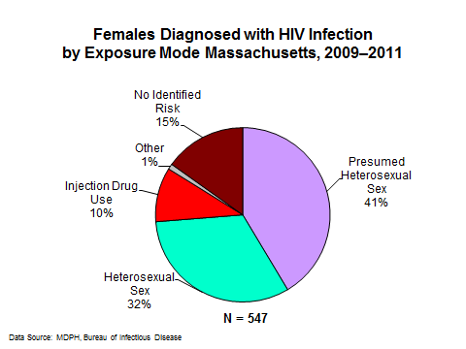

From 2009 to 2011, the exposure modes for the 547 HIV infection diagnoses reported in women in Massachusetts were attributed to presumed heterosexual sex (41%), heterosexual sex (32%), injection drug use (10%), and other exposure modes (1%). Fifteen percent of women were reported with no identified risk for HIV exposure.

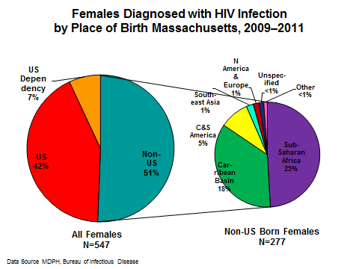

From 2009 to 2011, 51% of women diagnosed with HIV infection were born outside of the U.S. For men diagnosed from 2009 to 2011, only 25% were born outside of the U.S.

Eighty-four percent of women diagnosed with HIV infection who were born outside of the U.S. were born in regions of the world where heterosexual sex is the predominant mode of transmission of HIV infection.

RACIAL/ETHNIC DISPARITIES IN STDs AND HIV/AIDS

As stated in the 2011 Sexually Transmitted Disease Surveillance Report from the Centers for Disease Control and Prevention (CDC), national surveillance data show higher rates of reported STIs among some racial or ethnic minority groups when compared with rates among white residents. Race and ethnicity in the United States are risk markers that correlate with other more fundamental determinants of health status such as poverty, unemployment, low educational attainment, access to quality health care, and living in communities with high prevalence of STDs. “Acknowledging the inequity in STD rates by race or ethnicity is one of the first steps in empowering affected communities to organize and focus on this problem.” (Source: CDC. Sexually Transmitted Disease Surveillance, 2011. Atlanta: U.S. Department of Health and Human Services; 2012. )
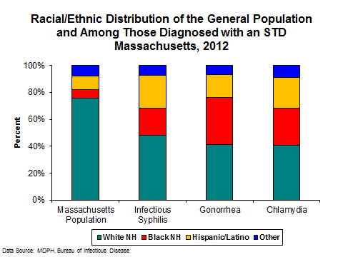

Although communities of color represent only 24% of the total Massachusetts population, these communities bear a disproportionate burden of STIs. In 2012, 52% of infectious syphilis cases, 59% of gonorrhea cases, and 59% of chlamydia cases occurred in individuals from communities of color.

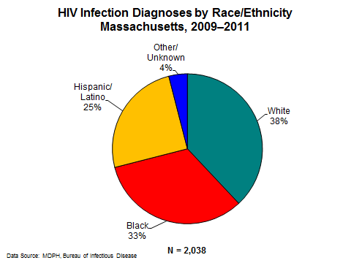

From 2009 to 2011, the racial/ethnic distribution of HIV infection diagnoses in Massachusetts was: white (non-Hispanic) (38%), black (non-Hispanic) (33%), Hispanic/Latino (25%), and other/unknown (4%).

RACIAL/ETHNIC DISPARITIES IN STDs AND HIV/AIDS
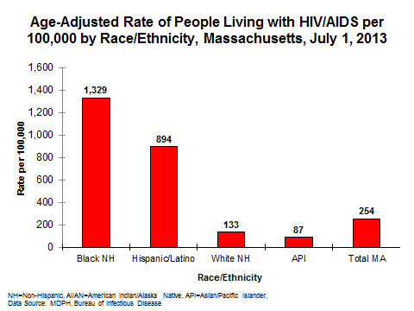

In Massachusetts, in 2013, the prevalence rate of people living with HIV/AIDS was highest among the black (non-Hispanic) and Hispanic/Latino populations. As compared to the white (non-Hispanic) population, the rate of people living with HIV/AIDS was ten times higher among the black (non-Hispanic) population and seven times higher among the Hispanic/Latino population.

STDs AND HIV/AIDS IN MEN WHO HAVE SEX WITH MEN

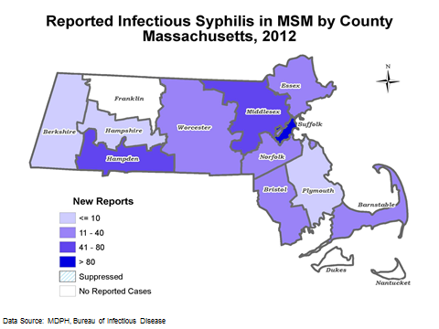
Notifiable disease surveillance data on syphilis and data from the National Gonococcal Isolate Surveillance Project suggest that some STDs are increasing in MSM, including men who have sex with both men and women. Because STIs and the behaviors associated with acquiring them increase the likelihood of acquiring and transmitting HIV infection, the rise in STIs among MSM may be associated with the increase in HIV diagnosis among MSM. (Source: CDC. Sexually Transmitted Disease Surveillance, 2011. Atlanta: U.S. Department of Health and Human Services; 2012.)

In 2012, 384 infectious syphilis cases were reported in MSM in Massachusetts, of which 37% (N=141) were in Suffolk County.

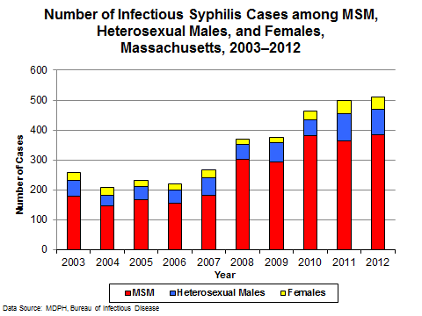
From 2003 to 2012, MSM have accounted for the majority of infectious syphilis cases in Massachusetts, ranging from 69% to 82%. During this time period the number of reported cases among MSM more than doubled, from 179 to 384.
In 2012, 52% of reported infectious syphilis cases in MSM were reported among white individuals, 16% among black, 20% among Hispanic/Latino, 6% among individuals of other race/ethnicity, and 7% among individuals with unknown race/ethnicity. The median age of the cases was 34 years, a slight drop from 36 years in 2011.

STDs AND HIV/AIDS IN MEN WHO HAVE SEX WITH MEN
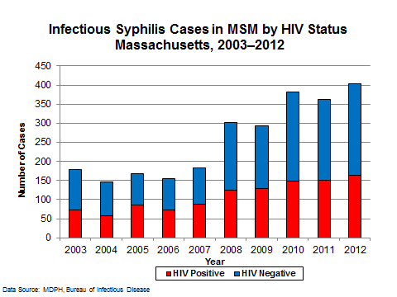

In 2012, 41% of the reported infectious syphilis cases in MSM occurred in individuals who reported that they were HIV-positive.

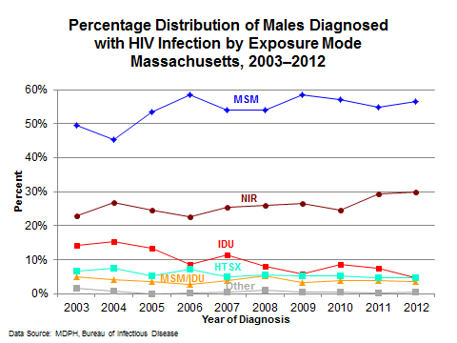

Among males, the proportion of reported HIV infection cases with male-to-male sex as the reported mode of exposure increased from 50% in 2003 to 56% in 2012.

Strengths and Limitations of Data

 | HIV/AIDS Case Data | STD Case Data | Viral Hepatitis Case Data
Description | - Collected by MDPH Bureau of Infectious Disease, HIV/AIDS Surveillance Program.  - Reportable statewide.  - All licensed healthcare providers are required by law to report.  - HIV infection and AIDS cases are reported by name.  - Individuals diagnosed out of state have been excluded in analysis. | - Collected by MDPH Bureau of Infectious Disease, Division of STD Prevention.  - Reportable statewide.  - All laboratories and healthcare providers are required by law to report STIs (including syphilis, gonorrhea, chlamydia infection, lymphoma granuloma venereum, chancroid, granuloma inguinale, neonatal herpes infection) | - Collected by MDPH Bureau of Infectious Disease, Office of Integrated Surveillance and Informatics Services.  - Reportable statewide.  - All laboratories and healthcare providers are required to report cases, or laboratory indicators, of hepatitis B and C infection.
Strengths | - Statewide reporting, population-based.  - Risk information is available.  - Completeness of reporting is high.  - Comparable with other states. | - Statewide reporting, population-based.  - Comparable with other states.  - Enhanced reporting of positive laboratory results. | - Statewide reporting, population-based.  - Enhanced reporting of acute cases, hepatitis B cases in child-bearing aged women and children and hepatitis C infection among cases ages 15-25 years.
Limitations | - Under-reporting (10%-15%) hampers interpretation of HIV/AIDS case data.  - Not all HIV/AIDS cases are reported at time of diagnosis (reporting lag).  - HIV/AIDS data may be incomplete because some HIV-infected people may not have been tested or have entered care. | - Under-reporting of up to 10% of STD cases.  - Race/ethnicity is missing in 36% of chlamydia, 27% of gonorrhea and 6% of infectious syphilis cases.  - Bias is introduced for some STDs, such as chlamydia infection, where screening of asymptomatic persons occurs more frequently in women than in men. | - Race data are missing in 30% of confirmed chronic hepatitis B and 40% of confirmed hepatitis C cases in 2012; ethnicity data are missing in 51% of confirmed chronic hepatitis B and 62% of confirmed hepatitis C cases in 2012.  - Risk history data are missing in a majority of reported hepatitis B and C cases.

Interpreting STD and HIV/AIDS Data
All viral hepatitis data reported are current as of July 1, 2013, all HIV/AIDS data are as of July 1, 2013, and all STD data are as of September 1, 2013.
I. HIV/AIDS Exposure Mode Definitions
The HIV/AIDS exposure mode indicates the most probable risk behavior associated with HIV infection. Assignment of exposure mode is done in accordance with Centers for Disease Control and Prevention guidelines when multiple exposure modes are reported. Following is a description of the exposure mode categories:
- MSM (Male to Male Sex): Includes men who report sexual contact with other men, and men who report sexual contact with both men and women. Please note the acronym MSM is also used to refer to “men who have sex with men”.
- IDU (Injection Drug Use): Cases in persons who report injection drug use.
- MSM/IDU: Cases in men who report both injection drug use and sexual contact with other men.
- Heterosexual Sex: Cases in persons who report specific heterosexual sex with a person with, or at increased risk for, HIV infection (e.g. an injection drug user). The sub-categories for this mode of transmission are listed below.
  - Heterosexual Sex w/ an Injection Drug User
  - Heterosexual Sex w/ a person w/ HIV infection or AIDS
  - Heterosexual Sex w/ Bisexual male
  - Other Heterosexual Sex: Includes all other sub-categories of risk, such as heterosexual contact with a person infected through a blood transfusion.
- Presumed Heterosexual: Cases among females who report heterosexual sex but do not report any other personal risk or any knowledge of specific risk in their male sex partners. As of January 1, 2011, males that were previously grouped in this category are categorized as No Identified Risk. Presumed Heterosexual is an exposure mode category used by the Massachusetts HIV/AIDS Surveillance Program. The Centers for Disease Control and Prevention (CDC) categorizes these cases as No Identified Risk.
- Pediatric: Infection before the age of 13 years, including mother to child transmission through pregnancy, childbirth or breastfeeding and blood transfusions to children.
- NIR (No Identified Risk): Cases in persons with no reported history of exposure to HIV through any of the listed exposure categories. Follow-up is conducted to determine risk for those cases that are initially reported without a risk identified. Includes cases among men who were previously categorized as Presumed Heterosexual.
II. References to Newly Diagnosed HIV Infections
Due to reporting delays related to site-specific reporting issues, all HIV/AIDS data reflect HIV diagnosed through 2011. Newly diagnosed HIV infections/cases include all persons diagnosed with HIV in 2011, including those who were concurrently or subsequently diagnosed with AIDS.
III. Race/Ethnicity of STD and HIV/AIDS Cases
Race/ethnicity references to white residents and black residents represent persons who are white non-Hispanic and black non-Hispanic, respectively. All references to Hispanic/Latino for race/ethnicity represent persons of Hispanic/Latino heritage regardless of race.
IV. STD Case Reports and Analyses
All information on STD cases reflect year of report and all incidence calculations represent crude rates. The source of denominators for calculating rates was the US Census Bureau, Population Division, Table 2 (Annual Estimates of the Resident Population by Sex and Age for Massachusetts) and Table 3 (Annual Estimates of the Resident Population by Sex, Race, and Hispanic Origin for Massachusetts). The distribution of STD cases with unknown race/ethnicity has changed from previous issues of this report: cases with unknown race/ethnicity are now removed from the analyses instead of redistributed. Due to this change, STD incidence rates by race/ethnicity are lower for all years than previously reported.
V. Cell suppression methodology of STD and HIV/AIDS data:
Values less than five are suppressed for populations less than 50,000 or for unknown values. Additional values may be suppressed to prevent back calculation.

STD, HIV/AIDS and Viral Hepatitis Contact Information
Topic | Contact | E-Mail | Phone
Division of STD Prevention & HIV/AIDS Surveillance, and
Ratelle STD/HIV Prevention Training Center
Policy Development and Administration | Brenda Cole (STD Division Director) | BrendaCole@state.ma.us | 617-983-6941
Sylvie Ratelle STD/HIV Prevention Training Center | Katherine Hsu (Medical Director)  Janine Dyer (Deputy Director) | Katherine.Hsu@state.ma.us  Janine.Dyer@state.ma.us | 617-983-6948  617-983-6964
STD/HIV/AIDS Surveillance and Epidemiology | Betsey John (Director, HIV/AIDS and STD Surveillance)  Yuren Tang (STD Epidemiologist) | Betsey.John@state.ma.us  Yuren.Tang@state.ma.us | 617-983-6570  617-983-6554
STD Clinical Services | Katherine Hsu (Medical Director)  Barbara Coughlin (Public Health Nurse) | Katherine.Hsu@state.ma.us  Barbara.Coughlin@state.ma.us | 617-983-6948  413-586-7525
STD Disease Intervention Field Services and  STD Partner Notification | David Goudreau  (Field Operations Manager) | David.Goudreau@state.ma.us | 617-983-6835
STD Health Education, Training, and Prevention | Brenda Hernandez  (Special Projects Coordinator)  Laura Smock (IPP Coordinator) | Brenda.Hernandez@state.ma.us  Laura.Smock@state.ma.us | 617-983-6943  617-983-6961
Office of HIV/AIDS
Policy, Planning, Resource Allocation, Data Management, Capacity Building, Research and Evaluation | Dawn Fukuda (Director, Office of HIV/AIDS)  Maura Driscoll Miminos  (Director for HIV Program Monitoring and Evaluation)  Tammy Goodhue (Director of Capacity Building and Health Communications) | Dawn.Fukuda@state.ma.us  Maura.Miminos@state.ma.us  Tammy.Goodhue@state.ma.us | 617-624-5303  617-624-5324  617-624-5338
Administration and Finance, Personnel, Contracts and Procurement, Budget | Bob Carr (Deputy Bureau Director)  Ceci Dunn (Director of Disease Response Systems)  Cheryl Bernard (Director of Administration and Finance) | Bob.Carr@state.ma.us  Ceci.Dunn@state.ma.us  Cheryl.Bernard@state.ma.us | 617-624-5317  617-624-5370  617-624-5355
Consumer Office | Paul Goulet  (Director of Consumer Office) | Paul.b.Goulet@state.ma.us | 617-624-5389
Prevention and Screening | Barry Callis  (Director of Prevention and Screening Unit) | Barry.Callis@state.ma.us | 617-624-5316
Medical Case Management and Health Related Support Services | Linda Goldman  (Director of Client Health Services) | Linda.Goldman@state.ma.us | 617-624-5347
Viral Hepatitis Program
Viral Hepatitis Programs | Daniel Church (Viral Hepatitis Prevention Coordinator, Division of Epidemiology and Immunization | Daniel.Church@state.ma.us | 617-983-6830
Viral Hepatitis Surveillance and Epidemiology | Kerri Barton (Epidemiologist)  Shauna Onofrey (Viral Hepatitis Surveillance Coordinator) | Kerri.Barton@state.ma.us  Shauna.Onofrey@state.ma.us | 617-983-6876  617-983-6776

STD, HIV/AIDS and Viral Hepatitis Resources

Training
Professional training to community based organizations, local public health departments, and medical providers can be requested and is free of charge.
Type of Training | Contact Information and Website
STD Education, STD Partner Notification, and  STD Reporting | 617-983-6940  www.mass.gov/dph/cdc/std
HIV/AIDS Reporting and Surveillance Projects | 617-983-6560  www.mass.gov/dph/cdc/aids
HIV/AIDS Provider Trainings | 617-624-5338  www.mass.gov/dph/aids
Viral Hepatitis Education | 617-983-6830  http://www.mass.gov/eohhs/consumer/wellness/disease-prevention/communicable-diseases/hepatitis/hepatitis-c/viral-hepatitis-educational-materials.html
STD/HIV Diagnosis, Treatment, and Management | 617-983-6945  www.RatellePTC.org

Material and Clinical Toolkits
Health education materials and clinical toolkits can be requested free of charge.
Type of Material | Contact Information and Website
STD, HIV, Viral Hepatitis Fact Sheets | 617-983-6940  http://www.mass.gov/eohhs/gov/departments/dph/prog-a-j/bcdc/factsheets.html
HIV/AIDS Reporting for Health Care Providers Brochure | 617-983-6560  www.mass.gov/eohhs/provider/reporting-to-state/diseases-and-conditions/hiv-aids/hiv-reporting-in-mass-for-health-care-providers.html
Viral Hepatitis Posters and Brochures | 617-983-6800  http://www.maclearinghouse.com/category/HEP.html
STD/HIV Diagnosis, Treatment, and  Management Toolkits | 617-983-9645  www.RatellePTC.org

MDPH and MDPH Funded Websites
Division of STD Prevention www.mass.gov/dph/cdc/std
Office of HIV/AIDS www.mass.gov/dph/aids
HIV/AIDS Surveillance Program www.mass.gov/dph/cdc/aids
Viral Hepatitis Program www.mass.gov/hepc
Sylvie Ratelle STD/HIV Prevention Training Center www.RatellePTC.org

National Websites
Center for Disease Control and Prevention www.cdc.gov
Division of STD Prevention www.cdc.gov/std
Division of HIV/AIDS Prevention www.cdc.gov/hiv
Division of Viral Hepatitis www.cdc.gov/ncidod/diseases/hepatitis
National Network of STD/HIV Prevention
Training Centers www.nnptc.org
CDC funded viral hepatitis online training http://depts.washington.edu/hepstudy/

Gottlieb SL. Summary: the natural history and immunobiology of Chlamydia trachomatis genital infection and implications for chlamydia control. Journal of Infectious Diseases 201:S190-204, 2010.
Due to reporting delays related to site-specific reporting issues, all HIV/AIDS data reflect HIV diagnosed through 2011.
Please note all national STD rates cited are from 2011; Centers for Disease Control and Prevention. Sexually Transmitted Disease Surveillance 2011.Atlanta: U.S. Department of Health and Human Services; 2012
Please note all national STD rates cited are from 2011; Centers for Disease Control and Prevention. Sexually Transmitted Disease Surveillance 2011.Atlanta: U.S. Department of Health and Human Services; 2012.

