Massachusetts Birth Defects

2013-2014

Massachusetts Birth Defects Monitoring Program

Massachusetts Center for Birth Defects Research and Prevention

Bureau of Family Health and Nutrition

Massachusetts Department of Public Health

September 2019

Charles D. Baker, Governor

Karyn E. Polito, Lieutenant Governor

Marylou Sudders, Secretary, Executive Office of Health and Human Services

Monica Bharel, MD, MPH, Commissioner, Massachusetts Department of Public Health

Craig Andrade, Director, Bureau of Family Health and Nutrition

Mahsa Yazdy, Director, Massachusetts Center for Birth Defects Research and Prevention
Acknowledgements

This report was prepared by Rebecca Liberman and Cathleen Higgins, Massachusetts Center for Birth Defects Research and Prevention.

We would like to thank the Massachusetts Center for Birth Defects Research and Prevention staff who contributed to this report, including: Xiaoli Chen, Dominique Heinke, Angela Lin, Gerlinde Munshi, Eirini Nestoridi and Mahsa Yazdy

Data in this report have been collected through the efforts of Center field staff, including: Roberta Aucoin, Mitcheka Jalali, Washa Liu, Daniel Sexton, Lori Tetrault and Ashley Tracey.

We would like to acknowledge the following individuals and organizations for their time and commitment in supporting the Center:

Lewis Holmes, MD, MassGeneral Hospital for Children

Allen Mitchell, MD, Slone Epidemiology Center, Boston University

Martha Werler, DSc, Department of Epidemiology, Boston University School of Public Health

Ed Doherty, March of Dimes Massachusetts Chapter

Massachusetts Registry of Vital Records and Statistics

Office of Data Management and Outcomes Assessment, Massachusetts Department of
Public Health

Division of Birth Defects and Developmental Disabilities, NCBDDD, Centers for Disease Control and Prevention

For more information, contact:
Massachusetts Department of Public Health
Center for Birth Defects Research and Prevention
250 Washington Street, 5th floor
Boston, MA 02108
(617) 624-5510 or 1-888-302-2101 (toll free)

This report can be found on our website: www.mass.gov/dph/birthdefects

Table of Contents
EXECUTIVE SUMMARY 5
CHAPTER 1: INTRODUCTION 9
CHAPTER 2: METHODS 12
Table 2.1. Major Changes to Birth Defects Surveillance, Massachusetts 2000-2014 13
CHAPTER 3: PREVALENCE OF BIRTH DEFECTS 16
Figure 3.1. Birth Defects by Body System, with and without Other Pregnancy Losses 16
Figure 3.2a. Prevalence of Selected Birth Defects, Massachusetts vs. United States 17
Figure 3.2b. Age-Adjusted Prevalence of Selected Birth Defects, Massachusetts vs. United States 18
Figure 3.3. Pregnancy Outcomes among Live Births with and without Birth Defects 19
CHAPTER 4: PREVALENCE OF BIRTH DEFECTS BY SEX AND PLURALITY 20
Figure 4. Prevalence of Birth Defects in Singleton and Multiple Births 20
CHAPTER 5: PREVALENCE OF BIRTH DEFECTS BY MATERNAL AGE 21
Table 5.1. Overall Prevalence of Birth Defects by Maternal Age, 21
Figure 5.1. Prevalence of Down Syndrome by Maternal Age 22
Figure 5.2. Prevalence of Gastroschisis by Maternal Age 23
CHAPTER 6: PREVALENCE OF BIRTH DEFECTS BY MATERNAL RACE/ETHNICITY AND REGION 24
Table 6.1. Age-Adjusted Prevalence of Birth Defects by Maternal Race/Ethnicity 24
Table 6.2. Age-Adjusted Prevalence of Birth Defects by Maternal Residence Region 25
CHAPTER 7: BIRTH DEFECTS BY PATTERN AND ETIOLOGY 26
Figure 7.1. Birth Defects by Pattern 26
Figure 7.2. Birth Defects by Etiology 27
CHAPTER 8: TREND ANALYSIS 28
Figure 8.1a. Overall Prevalence of Birth Defects in Massachusetts, 2-year Rolling Average 28
Live Births and Stillbirths, 2000-2014 28
Figure 8.1b. Overall Prevalence of Birth Defects in Massachusetts, 2-year Rolling Average 29
Live Births, Stillbirths, and Other Pregnancy Losses, 2000-2014 29
Figure 8.2. Prevalence of Gastroschisis by Year and Maternal Age 30
Figure 8.3. Prevalence of Birth Defects by Maternal Race/Ethnicity 31
Figure 8.4. Prevalence of Birth Defects by Maternal Residence Region 32
RESOURCES, SUGGESTED CITATION, CONTACT INFORMATION 33
TABLES 34
Table T.1. Prevalence of Birth Defects 34
Table T.2. Prevalence of Selected Birth Defects, Massachusetts vs. United States 38
Table T.3. Prevalence of Birth Defects by Infant Sex, Live Births, Stillbirths and Other Pregnancy Losses 39
Table T.4. Prevalence of Birth Defects by Plurality, Live Births, Stillbirths 46
Table T.5. Prevalence of Birth Defects by Maternal Age, Live Births, Stillbirths, and Other Pregnancy Losses 52
Table T.6. Prevalence of Birth Defects by Maternal Race, Live Births, Stillbirths, and Other Pregnancy Losses 67
REFERENCES 79
APPENDICES 80
Appendix 1: Technical Notes 80
Appendix 2: Glossary of Terms Used in this Report 82
Appendix 3: Massachusetts 2013-2014 Live Birth Populations Used in Calculating Rates 87
Appendix 4: ICD-9-CM/BPA Birth Defect Codes Used in this Report and Inclusions/Exclusions 88
Appendix 5: Pre-Pregnancy Multivitamin Use, Massachusetts: 2011 94
Appendix 6: Map of Massachusetts Regions 95
EVALUATION FORM 96

EXECUTIVE SUMMARY

One in 33 infants in the United States is born with a birth defect. Birth defects are defined as conditions that develop before birth affecting the structure of one or more parts of the body (1,2). Although birth defects are rare when compared to other adverse pregnancy outcomes like low birth weight or prematurity, birth defects are the leading cause of death in the first year of life. Nationally, about 20% of all infant deaths are attributable to birth defects. Birth defects may also result in mental and/or physical disability, may require costly medical care, and may cause economic, emotional, and social distress for families.

The causes of many birth defects are poorly understood. Certain genetic and environmental factors have been implicated in selected birth defects. These include prenatal environmental factors, such as infections, exposures to medications or other chemicals, drug or alcohol abuse, and nutritional deficiencies. Some birth defects can be caused by a single abnormal gene, while others arise due to a complex interplay between various genetic and environmental factors.

Studies have shown that the presence of adequate amounts of folic acid (vitamin B9) in the mother’s system before conception and during the first trimester may help prevent birth defects of the brain and spinal cord known as neural tube defects (3). However, for more than 70% of all birth defects, no known cause has been identified (4). Researchers continue to investigate a wide variety of risk factors as possible causes.

The combined lifetime cost for infants born with 12 major structural birth defects in Massachusetts has been estimated at over 200 million dollars (5). Nationally, the lifetime cost of 17 common birth defects has been estimated to be over 9 billion in 2012 dollars (6).

This report presents data on the prevalence of birth defects in Massachusetts during the years 2013 and 2014. Two years of data are combined in this report, since the numbers of cases are often small for individual defects within a single year.

The Massachusetts Birth Defects Monitoring Program (BDMP) has data going back to 2000, allowing for some analysis of trends. Increasing rates over time reflect improved case ascertainment, the addition of new defects collected, and the collection of data on other pregnancy losses, which include terminations and early miscarriages. The program is constantly working to improve case-finding, in order to provide the most complete data possible to inform public health policy, planning and prevention efforts.

Prevalence of Birth Defects in Massachusetts

Among 143,662 Massachusetts residents who delivered in 2013 or 2014, there are 3,894 cases (3,015 live births, 68 stillbirths, and 811 other pregnancy losses) with one or more structural birth defects. This results in an overall prevalence rate of 271 per 10,000 live births.

Among live births and stillbirths, cardiovascular defects are the most commonly occurring birth defects in Massachusetts, followed by musculoskeletal, genitourinary and chromosomal defects. When other pregnancy losses are included, then chromosomal birth defects become the most common. Specifically, trisomy 21 (Down syndrome) is the most common birth defect when all birth outcomes are included, followed by atrial septal defect (a cardiovascular defect).

Birth Defects in Massachusetts vs. the United States

Massachusetts is one of 11 states with an active case ascertainment program and contributes data to published national prevalence estimates for selected birth defects. For most defects, Massachusetts rates in 2013-2014 are similar to the most recent published national rates from 2004-2006 (7). Massachusetts rates are significantly higher for trisomy 21, trisomy 13 and trisomy 18, even after age-adjustment, likely because of the inclusion of early miscarriages in Massachusetts. Massachusetts rates of omphalocele are also higher than national rates. Differences in surveillance system methodology, types of pregnancy outcomes included, and demographic variation may also contribute to the differences in rates for certain birth defects.

Until 2011, Massachusetts only collected information on live birth and stillbirth cases. Limiting the data to live births and stillbirths can result in undercounting of certain birth defects—especially those not compatible with life. Beginning in early 2011, Massachusetts began ascertaining prenatally-diagnosed birth defects in pregnancies that ended in other types of pregnancy losses. When Massachusetts data was limited to live births and stillbirths, rates of spina bifida and anencephaly were lower than national estimates, but in the current report, which includes these other pregnancy losses, the rates are similar.

Adverse Pregnancy Outcomes

Live born infants with birth defects are more likely to have adverse outcomes such as low birth weight, prematurity, and small for gestational age (SGA) than those without birth defects. Infants with a birth defect are more than twice as likely to have low birth weight (less than 2500 grams) and to be born premature (before 37 weeks) compared to those without birth defects. Cesarean (C-section) deliveries are also more common among live born infants with birth defects than among unaffected infants.

Maternal Age

The prevalence of birth defects varies by maternal age. The number of births to older mothers has been increasing over time in Massachusetts (8). Older mothers have a higher prevalence of birth defects compared to younger mothers. Overall birth defect rates were highest for mothers ages 35 years and older (350.7 per 10,000 live births).

There is a strong association between the rate of Down syndrome (trisomy 21) and advanced maternal age. In Massachusetts, the rate of Down syndrome in mothers ages 35 and older is 68 per 10,000 live births, over 5 times greater than the rate in mothers younger than 35.

Gastroschisis, a condition in which a child is born with the intestines protruding through a hole in the abdominal wall, occurs more often among younger mothers. In 2013-2014, mothers 20-24 years old had the highest rate of gastroschisis (14.3 per 10,000 live births), while the rate among mothers ages 35 and older was 0.6 per 10,000.
Assisted Reproductive Technology

It is estimated that 1.5 percent of United States infants are conceived through the use of assisted reproductive technology (ART) (9). In 2013, Massachusetts had one of the highest rates of ART use in the nation. This may be partly due to high rates of insurance coverage for ART in Massachusetts and a higher proportion of older women of reproductive age trying to conceive. Infants conceived by ART have been shown to have an increased risk for certain birth defects compared to those conceived spontaneously (10).

Multiple Births

Birth defects are significantly more common among multiple births (e.g., twins and triplets) than in singleton births. Approximately 4.3% of Massachusetts live births are multiple births (8). The birth defect prevalence rate in 2013-2014 is 265.6 per 10,000 live births for singletons and 385.2 per 10,000 live births for multiples.

Maternal Race/Ethnicity

Birth defect rates may vary by maternal race and ethnicity. In 2013-2014 in Massachusetts, the overall age-adjusted prevalence rate of birth defects does not significantly differ by race/ethnicity, although as in previous years, Asians tend to have lower rates of birth defects.

Region

The Massachusetts Executive Office of Health and Human Services divides the state into six regions, which are used for statistical, care coordination, and administrative purposes. In 2013-2014, the overall age-adjusted birth defect prevalence rate did not substantially differ by region, although the Metro West and Southeastern regions had the lowest rates. The end of medical record abstraction at Rhode Island hospitals may impact the Southeastern region rates.

Etiology and Pattern

The surveillance system in Massachusetts collects information on etiology (cause), whenever available. The majority of birth defect cases in 2013-2014 had an unknown cause, which is consistent with the published research.

Pattern refers to whether a birth defect occurs with other defects. Approximately 34% of birth defects occurred with defects in other organs or as part of syndromes, while 66% occurred as isolated defects or were confined to the same organ, occurred with minor defects, or were part of a sequence of developmental events.

Analysis of Trends

The overall prevalence of birth defects among live births and stillbirths in Massachusetts increased from 187.5 to 214.6 per 10,000 live births between 2011-2012 and 2013-2014. This increase is partly related to collecting more types of birth defects starting in 2014. Adding additional birth outcomes (other types of pregnancy losses) beginning in 2012 also contributed to an increase in birth defect prevalence rates.

This report includes selected trend analyses using current and previous years’ data, with the understanding that there have been modifications to the surveillance system that may contribute to increases in birth defect rates, including expanded and improved case ascertainment, the addition of other pregnancy losses, and improved prenatal diagnosis.

CHAPTER 1: INTRODUCTION

The Public Health Importance of Birth Defects

Each year in the United States, approximately 120,000 babies—1 in 33—are born with birth defects (1). Birth defects, or congenital anomalies, are serious abnormalities of body structure present before birth.

Although birth defects are rare when compared to other adverse pregnancy outcomes, they are the leading cause of infant death in the United States. Nationally, about 20% of all infant deaths result from birth defects (11), which is consistent with the number of infant deaths among cases found in the Massachusetts Birth Defects Monitoring Program surveillance system and with a recent report using Massachusetts death data from vital records (12).

Birth defects may cause significant physical or mental disability. There can be substantial costs to those affected and to their families, including direct costs of medical treatment, developmental services and special education, as well as indirect costs related to loss of work and productivity.

Causes of Birth Defects

The causes of most birth defects are poorly understood, but certain genetic and environmental factors have been reported to be associated with selected defects. These include prenatal environmental factors, such as infections (e.g., rubella), exposures to medications or other chemicals, drug or alcohol abuse, and nutritional deficiencies.

A single abnormal gene can cause certain birth defects. The gene may have an error in its code such as a missing piece or extra genetic material which can result in malformations. Other causes of birth defects may be multifactorial with genes and environmental factors both playing a role. For 70% of birth defects, no known cause has been identified (4). Researchers are looking at a wide variety of environmental exposures and other possible risk factors as potential causes of birth defects.

Birth Defects and Folic Acid

Studies have shown that the presence of adequate amounts of folic acid (vitamin B9) in the mother’s system during the “periconceptional” period (one month before through three months after conception) may help prevent defects of the brain and spinal cord known as neural tube defects. Fortification of cereal grains with folic acid has resulted in a 26% reduction in the number of babies born with these neural tube defects in the United States (13). However, some studies in certain populations suggest that not all cases of neural tube defects are preventable by increasing folic acid intake (14).

Healthy People 2020 Challenges

The Healthy People 2020 objectives (15) include reducing rates of fetal and infant death, lowering the occurrence of neural tube defects, and reducing developmental disability. Birth defects surveillance is a critical component of the public health strategy to achieve these objectives. The birth defects surveillance program in Massachusetts allows the Department of Public Health to monitor the occurrence of birth defects in the state. This data makes it possible to identify changes in birth defect rates over time, to identify geographical areas with unusually high or low rates, and to allow for development of strategies for prevention and for providing services to affected families.

Birth Defects Surveillance in Massachusetts

Since 1999, the Massachusetts Birth Defects Monitoring Program (BDMP) located within the Massachusetts Center for Birth Defects Research and Prevention has conducted statewide, population-based active surveillance of birth defects among Massachusetts residents. The Center collects data on birth defects and identifies related trends, searches for potential causative factors associated with birth defects, addresses community concerns about birth defects, provides information to families of children with birth defects, and collects information on related screening and prevention efforts.

The BDMP identifies cases with structural birth defects diagnosed through 1 year of age. The primary focus of the state surveillance system is the identification of major structural birth defects that occur with or without a chromosomal abnormality or other non-chromosomal malformation syndrome.

The program’s active surveillance system uses multiple sources of ascertainment, including prenatal reports, delivery and specialty care hospitals and birthing centers. Vital records serve as an additional source of information, providing demographic and clinical information on cases and acting as an additional source of case-finding.

Potential birth defect cases, identified through these varied sources, are assigned to medical record abstractors who review maternal and infant medical records. All cases are coded according to the International Classification of Diseases, Ninth Revision, Clinical Modification, modified British Pediatric Association (ICD-9-CM/BPA) system. Complex cases and cases in which the infant died are reviewed by a clinical geneticist.

The birth defects included in Massachusetts surveillance are ICD-9-CM/BPA codes ranging from 740.0 to 759.9 and several other selected codes outside this range for defects such as DiGeorge syndrome, Pierre Robin sequence and amniotic bands. A list of the ICD-9-CM/BPA codes for defects presented in this report is provided in Appendix 4.

Economic Impact on Massachusetts

The estimated lifetime cost in Massachusetts for babies born with one of 12 major structural birth defects is 200 million in 2012 dollars (5). This includes direct costs of medical treatment, developmental services and special education, as well as indirect costs to society for lost wages due to early death or occupational limitations. There can also be social and emotional impacts, which are difficult to quantify.

Birth Defects Surveillance Regulations

In 2009, Massachusetts promulgated regulations (105 CMR 302) related to the Massachusetts Birth Defects Monitoring Program, which expanded reporting requirements for birth defects cases identified at or after birth and extended reporting to cases identified prenatally.

The 2013-2014 Surveillance Report

This report presents statewide data on the prevalence of birth defects in live births, stillbirths, and other pregnancy losses in Massachusetts during the years 2013-2014. Most of the data is presented with the years 2013 and 2014 combined, since the numbers are relatively small for individual defects in a single year.

In early 2011, Massachusetts began ascertaining prenatally-diagnosed birth defects in pregnancies that ended in pregnancy losses other than a live birth or stillbirth, with the first full year of data available in 2012. Unless otherwise noted, data presented includes all pregnancy outcomes.

In 2014, we expanded the defect codes collected in Surveillance to be consistent with national reporting guidelines. We discuss the impact of this expanded reporting in Chapter 8: Trend Analysis.

CHAPTER 2: METHODS

Case Definition

This report presents data on selected birth defects among deliveries to Massachusetts residents occurring during the calendar years 2013 and 2014. Cases were included if they met the following criteria:

Live birth, or stillbirth (fetal death) with a gestational age of at least 20 weeks or with a weight of at least 350 grams, or other pregnancy loss (includes early fetal deaths<20 weeks and <350 grams, elective terminations).

The infant or fetus had a structural birth defect that met diagnostic criteria listed in Appendix 4.

For live births, the diagnosis must have been confirmed during the first year of life.

Data Collection

Hospitals across the state submit monthly reports with birth defect diagnoses to the BDMP. Abstractors review maternal and infant medical records to collect information for each potential case. Beginning with 2008 births, reporting sites were expanded to include outpatient centers, emergency rooms, day surgery clinics, and laboratories.

Each live born case in the BDMP is linked to a Registry of Vital Records and Statistics record of live birth. Each reportable fetal death case is linked to a fetal death certificate, when available. Demographic and clinical variables, including maternal age, race/ethnicity, gestational age, birth weight, method of delivery, plurality, and region of residence are obtained from the live birth or fetal death certificate. Infant sex is ascertained from birth defects surveillance data because it is usually considered to be more accurate. For stillbirths without a fetal death certificate and for other pregnancy losses, demographic and clinical information comes from surveillance data.

Changes in Massachusetts Birth Defects Surveillance Over time

A number of changes have taken place in our surveillance program over the years, which impact trends over time in prevalence of birth defects. Recent surveillance changes include the use of an electronic case report form for abstraction and the discontinuation of abstraction at two Rhode Island hospitals in 2011, the collection of cases diagnosed prenatally that did not result in a live birth or stillbirth (other pregnancy losses) in 2012, and the addition of a number of several new diagnostic codes in 2014, consistent with national reporting guidelines.

The surveillance program changes are summarized in Table 2.1 below.

Table 2.1. Major Changes to Birth Defects Surveillance, Massachusetts 2000-2014
2001:
-Added 2 tertiary Rhode Island hospitals near the Massachusetts border
-Added a tertiary specialty referral hospital (Massachusetts Eye and Ear
Infirmary)
2002:
-Expanded list of central nervous system defect codes collected
-Expanded reporting sources to include physicians, outpatient clinics and genetic services
2005:
-Added birth defect diagnoses
-Clarified rules around which diagnoses must be reported
2006:
-Expanded the list of gastrointestinal defect codes
2007:
-Added code for genetic diagnosis and modified coding to be consistent with
other programs
2009:
-Standardized electronic case reporting
-New Birth Defect Monitoring Program regulations promulgated:
-Included additional birth defect codes
-Expanded reporting sites to include outpatient visits, emergency department, and day surgery
-Allowed collection of additional birth outcomes and prenatal diagnostic
reporting
2011:
-Developed electronic case report form for abstraction
-Discontinued abstraction at Rhode Island hospitals
-State implementation of new birth certificate format, with additional categories
for race and other changes
-Began collecting information on other pregnancy losses, including early
miscarriages and elective terminations—2012 is first full year
2012:
-First full year of including other pregnancy losses

2014:
-New birth defects diagnosis codes added, including hypospadias Grade 1 and muscular ventricular septal defects, to comply with national standards

The discontinuation of data collection at Rhode Island hospitals, where some cases born to Massachusetts residents in the southeastern part of the state are delivered or receive treatment, is expected to reduce our case numbers, but the program will continue to ascertain cases with known birth outcomes that receive diagnosis or treatment in Massachusetts. Based on 2008-2009 data, we estimate that fewer than 20 live birth cases per year would be affected by this change, and for many of these we would still be able to obtain the information through referral hospital or prenatal diagnostic information. The impact is expected to be greater for cases with other pregnancy losses.

The addition of other pregnancy losses to our surveillance adds a significant number of cases to our Surveillance program and brings our rates closer to national rates. The addition of additional diagnostic codes to our reporting adds a substantial number of cases. For example, the prevalence of overall birth defects in 2012 increased from approximately 195 per 10,000 for live births and stillbirths only, to 243 per 10,000 with other losses included (https://www.mass.gov/lists/massachusetts-birth-defects-surveillance-reports#2011-2012-). The addition of more defects in 2014 also added a substantial number of cases.

Quality Control

To ensure data quality, the BDMP performs regular data quality checks. Key demographic and clinical information on live births and fetal deaths is checked against vital records data. The BDMP system includes many built-in logic and range checks, as well as checks for missing information. In addition, each case receives clinical review, which provides an additional layer of checking, as well as ensuring that diagnostic information is as accurate as possible. Regular data reports are run to identify missing or unusual data values, and periodic re-abstraction and data entry checks are also performed.

Confidentiality

The program has developed extensive procedures to safeguard the confidentiality of the data and to protect the privacy of families. These procedures uphold ethical and legal obligations to protect confidentiality and comply with the requirements of state and federal laws.

Data Analysis

A birth defect may occur as a single event or in combination with other defects. If a case had more than one defect within the same defect category, only one of these defects was counted in the category total. If a case had more than one defect in different defect categories, the case was listed in the total for each of these defect categories. Thus the counts in the defect categories presented in the prevalence tables represent the total number of defects and not the total number of cases with birth defects. For live births and stillbirths in this report, maternal age, race/ethnicity, plurality and infant birth weight are drawn from Vital Records. In cases where a stillbirth lacks a fetal death certificate and for other pregnancy losses, demographic and clinical information comes from surveillance data. For all outcomes, infant sex is drawn from surveillance data because it is generally considered to be more accurate.

The occurrence of birth defects is reported as a prevalence rate. Prevalence rate is calculated as the number of birth defect cases per 10,000 live births delivered during the same time period. Prevalence tables include the number of cases, the estimated prevalence rate per 10,000 live births and the 95% confidence interval (CI) for each rate. Prevalence rather than incidence rates are used because incidence (new cases) of birth defects would need to be based on the number of embryos conceived within a year. This cannot be fully measured because the total number of conceptions and the number of these conceptions resulting in a delivery with a birth defect are not known (16).

Information on counts used for denominators in rates can be found in Appendix 3. The CI can be used to assess the magnitude and stability of a rate or ratio. The CI for rates presented in this report consists of a range of possible values around the point estimate that has a 95% chance of including the actual underlying rate of a birth defect. Wide CI reflects the large variation due to small numbers (see Appendix 1: Technical Notes).

Limitations

- Defects that are not diagnosed at birth and that do not require hospitalization may be underreported.

- Misclassification of birth defects may occur as a result of surveillance system coding errors or incomplete diagnostic information.

- Only diagnoses confirmed through 1 year of age are currently included in BDMP surveillance. This may lead to undercounting of defects that are difficult to detect by this time.

- The discontinuation of case abstraction in Rhode Island in 2011 may lead to undercounting of cases that receive no care in Massachusetts, especially cases born to residents of the southeastern part of the state after 2010.

- Patent ductus arteriosus (PDA) is not included in this report, because this defect is often minor and is normal for infants born prematurely.

- Comparisons between Massachusetts data and national estimates should be interpreted with caution, as there are differences in surveillance system methodologies, types of pregnancy outcomes included, and demographic variations.

- Trends over time should be interpreted carefully, with consideration of the changes that have taken place over time, such as the addition of new codes and additional pregnancy outcomes.

Additional report notes can be found in Appendix 1: Technical Notes.

Glossary

A glossary of selected terms used in this report is included in Appendix 2.

CHAPTER 3: PREVALENCE OF BIRTH DEFECTS

Overall Prevalence of Birth Defects

There were 143,662 live births to Massachusetts residents in 2013-2014, and our surveillance identified 3894 deliveries with at least one structural birth defect. This represents an overall Massachusetts birth defect rate of 271.0 (95% CI: 262.7-279.6) per 10,000 live births. Counts and rates for specific birth defects are shown in Table T.1.

Figure 3.1. shows the percentage of reported birth defects by body system category with and without including other pregnancy losses. Among live birth and stillbirth cases, cardiovascular defects are the most common, followed by musculoskeletal, genitourinary and chromosomal defects. When we add the other pregnancy loss cases, then chromosomal defects become the most common. Because cases can have multiple defects, the same case may be included in more than one body system category.

Figure 3.1. Birth Defects by Body System, with and without Other Pregnancy Losses, Massachusetts, 2013-2014

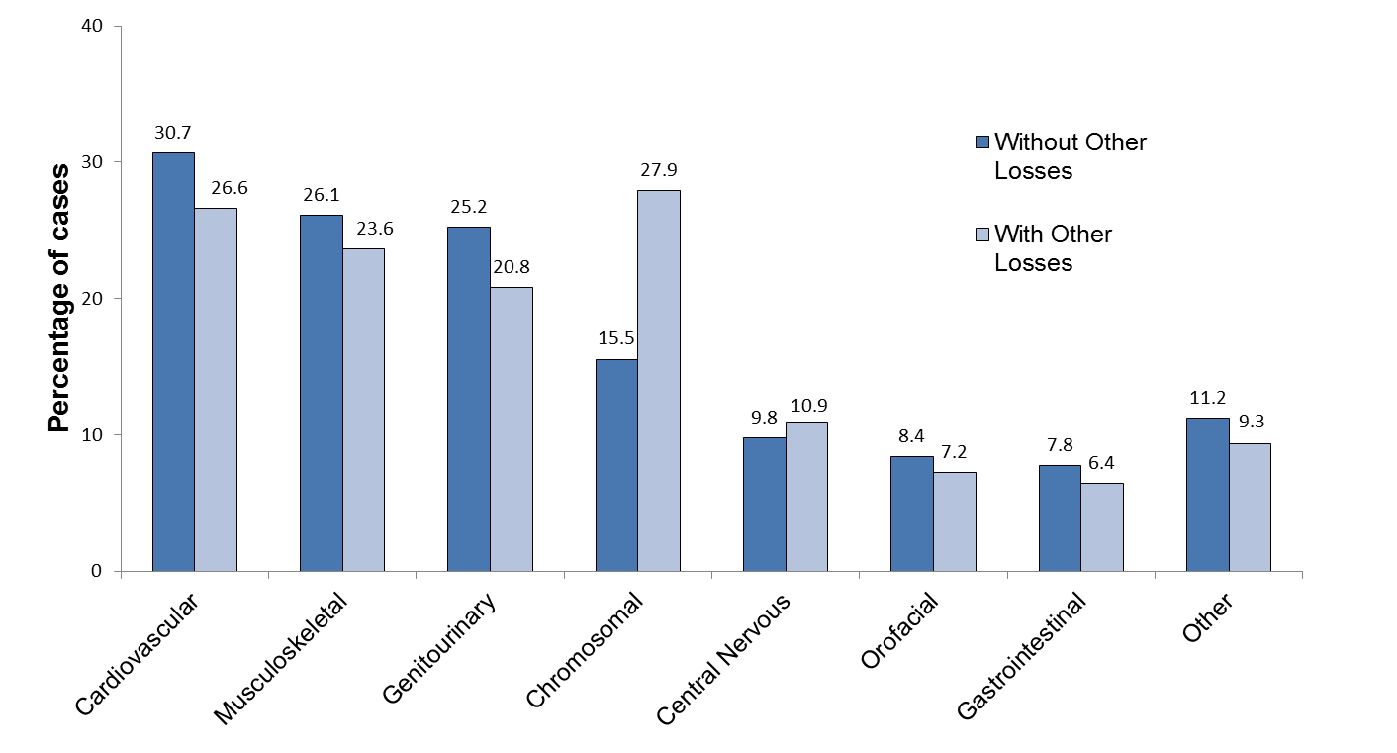

Because cases can have defects in more than one body system, percentages sum to more than 100.
Birth Defects in Massachusetts vs. United States

Massachusetts is one of 11 states that has an active case ascertainment program and contributes birth defects data to published national prevalence estimates for selected birth defects. For many defects, Massachusetts rates are similar to national rates. However, Massachusetts rates for 2013-2014 are significantly higher for omphalocele, atrioventricular septal defects, and for trisomy 21 (Down syndrome), trisomy 13, and trisomy 18, even after age-adjustment (Figure 3.2a, Figure 3.2b, Table T.2). Differences in surveillance system methodology, types of pregnancy outcomes included, and demographic variation may account for the differences in rates for certain defects. Massachusetts rates in 2013-2014 included other pregnancy losses, including early fetal deaths<20 weeks, which are not included in national estimates.

Figure 3.2a. Prevalence of Selected Birth Defects, Massachusetts vs. United States
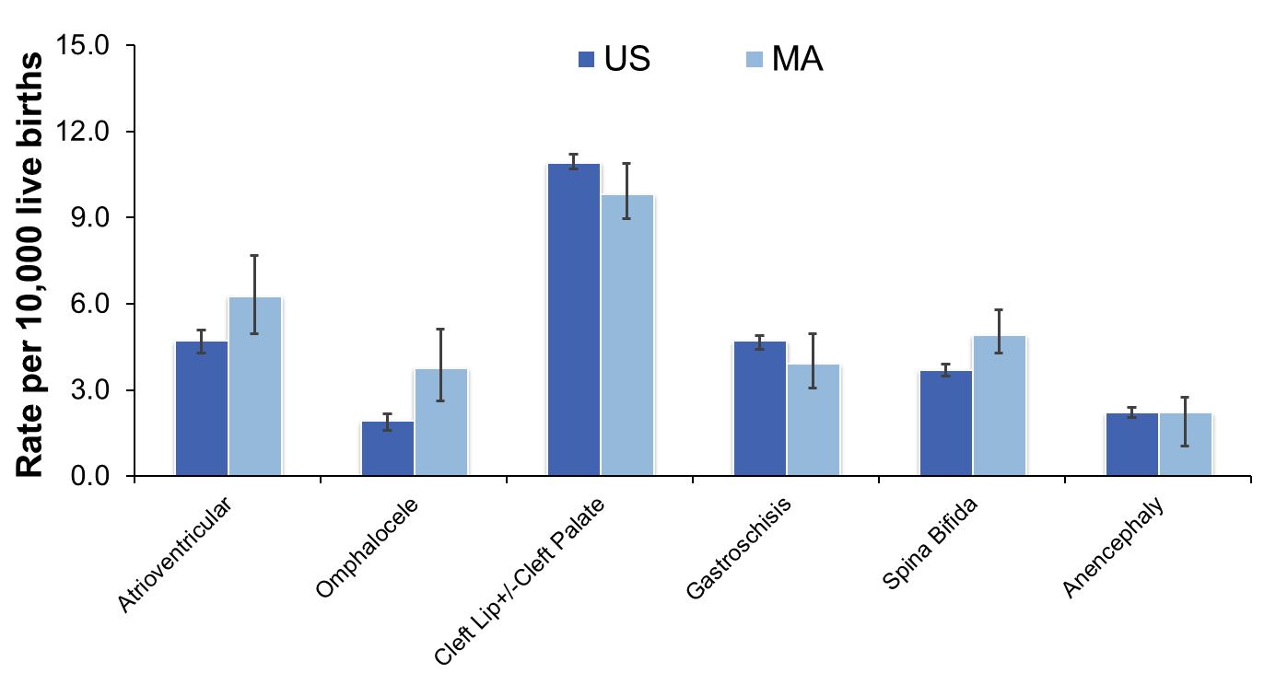

MA rates based on live births, stillbirths, and other pregnancy losses, N=3894.
US rates based on crude, pooled prevalence data from 11 active case-ascertainment programs, including Massachusetts (7). Nine of the 11 states contributing to the pooled estimates include elective terminations but not fetal deaths less than 20 weeks or less than 350 grams.
Error bars represent 95% confidence interval.

Figure 3.2b. Age-Adjusted Prevalence of Selected Birth Defects, Massachusetts vs. United States
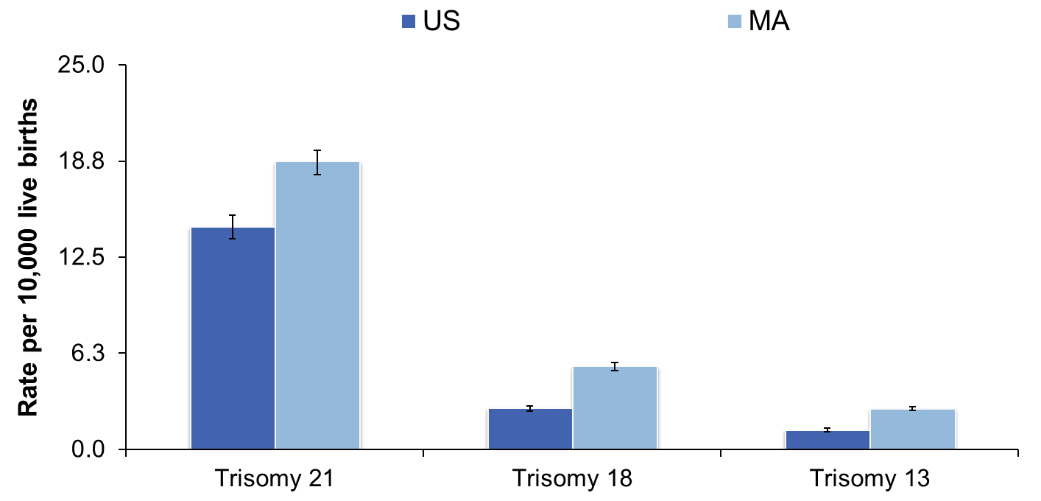

MA rates based on live births, stillbirths, and other pregnancy losses, N=3894 and adjusted to maternal age distribution of US population 2006. National Vital Statistics Reports 2009 Volume 57, Number 7.

US rates based on crude, pooled prevalence data from 11 active case-ascertainment programs, including Massachusetts (7). Nine of the 11 states contributing to the pooled estimates include elective terminations but not fetal deaths less than 20 weeks or less than 350 grams.
Error bars represent 95% confidence interval.

Selected Pregnancy Outcomes

Adverse pregnancy outcomes such as Cesarean section (C-section), low birth weight, prematurity, and small for gestational age (SGA) are more frequent among live born infants with birth defects than among unaffected infants. Infants with a birth defect are 2.7 times more likely to have low birth weight (less than 2500 grams) or very low birth weight (less than 1500 grams) and 2.4 times more likely to be born premature (before 37 weeks) compared to those without birth defects (Figure 3.3). Cesarean (C-section) deliveries are more common among live born infants with birth defects (43%) compared to unaffected infants (31%). In addition, infants with birth defects are more likely to die in their first year of life.

Figure 3.3. Pregnancy Outcomes among Live Births with and without Birth Defects, Massachusetts: 2013-2014

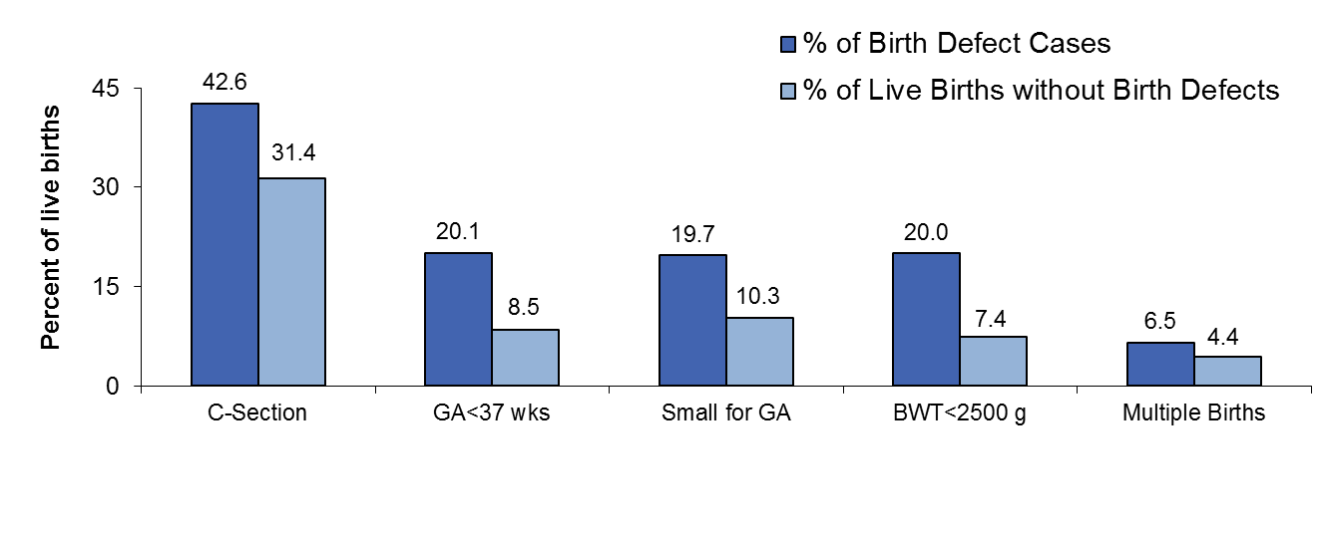

N=3015 live births with birth defects; N=140,647 live births without birth defects.
C-section: Cesarean section; GA: gestational age; BWT: birth weight
Small for GA calculation based on method described by Oken et al. in 2003, defined as birth weight below the 10th percentile for gestational age based on a sex-specific US standard (17).

CHAPTER 4: PREVALENCE OF BIRTH DEFECTS BY SEX AND PLURALITY

Several birth defects are more common in males than in females, including club foot (Table T.3). Also, several obstructive genitourinary defects occur exclusively in males, leading to higher rates of these defects as well.

The overall birth defect rate in singletons is 265.6 (95% CI: 257.1-274.2) per 10,000 live births, while the rate in multiples is 385.2 (95% CI: 338.4-436.6) per 10,000 live births. While many individual defects do not differ significantly by plurality (Figure 4), the rates of septal defects and atrial and ventricular septal defects are significantly higher in multiples than in singletons (Table T.4).

Figure 4. Prevalence of Birth Defects in Singleton and Multiple Births, Massachusetts: 2013-2014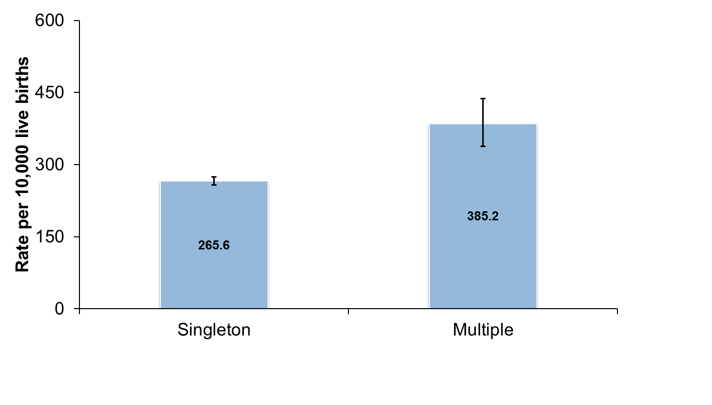

Live births, stillbirths and other pregnancy losses, N=3894.
Error bars represent 95% confidence interval.

CHAPTER 5: PREVALENCE OF BIRTH DEFECTS BY MATERNAL AGE

Maternal Age

The prevalence of birth defects varies by maternal age (Table 5.1), with rates highest for mothers ages 35 years and older (350.7 per 10,000 live births) and second highest for mothers younger than 20 years of age (275.7 per 10,000 live births).

Table 5.1. Overall Prevalence of Birth Defects by Maternal Age,
Massachusetts: 2013-2014
Maternal Age (years) | Cases | Rate | 95% Confidence Interval
<20 | 143 | 275.7 | 232.4-324.8
20-24 | 455 | 232.6 | 212.0-254.8
25-29 | 832 | 234.7 | 219.2-251.0
30-34 | 1294 | 258.3 | 244.6-272.5
35+ | 1170 | 350.7 | 331.2-371.0

Live births, stillbirths, and other pregnancy losses. N=3894.
Rate per 10,000 live births.

Monitoring birth defects by maternal age is important in part because the percentage of women giving birth in the state who are age 35 or older doubled from 11.4% in 1989 to 22.2% in 2011 (8), with more multiple births among mothers over age 35 than among younger mothers.

The use of assisted reproductive technology (ART) is a factor in the increased percentage of women ages 35 and older giving birth and the increased frequency of multiple births among Massachusetts mothers. Massachusetts has the highest ART rate in the nation, with 4.5% of live births conceived with ART (9).

The prevalence rates of specific birth defects by age group are shown in Table T.5. Gastroschisis rates are highest in women under 25 years of age, while trisomy 21 (Down syndrome) rates are highest in women ages 35 and older.

Down Syndrome

There is a strong association between Down syndrome and advanced maternal age (Figure 5.1). In Massachusetts, the rate of Down syndrome in mothers 35 and older is 68 per 10,000 live births, which is more than 5 times greater than the rate in mothers younger than 35. This reflects the general pattern of higher chromosomal defect rates among older women.

Figure 5.1. Prevalence of Down Syndrome by Maternal Age,
Massachusetts: 2013-2014

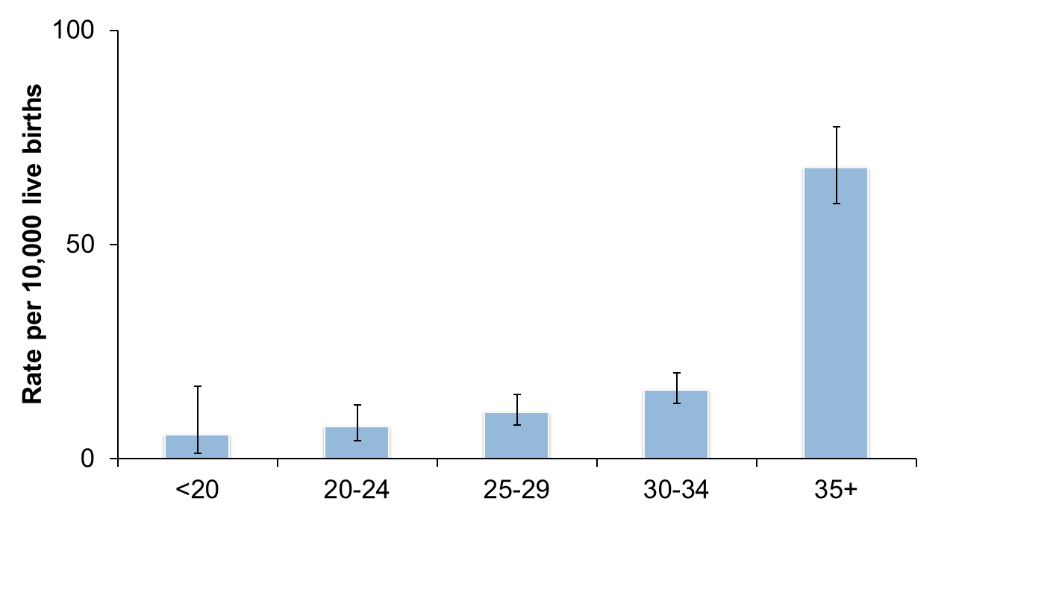

Live births, stillbirths, and other losses, N=365.
Error bars represent 95% confidence interval.
Gastroschisis

Mothers ages 20-24 had the highest rate of gastroschisis cases at 14.3 per 10,000 live births (Figure 5.2). The association between gastroschisis and younger maternal age has been shown in previous studies (18).

Figure 5.2. Prevalence of Gastroschisis by Maternal Age,
Massachusetts: 2013-2014

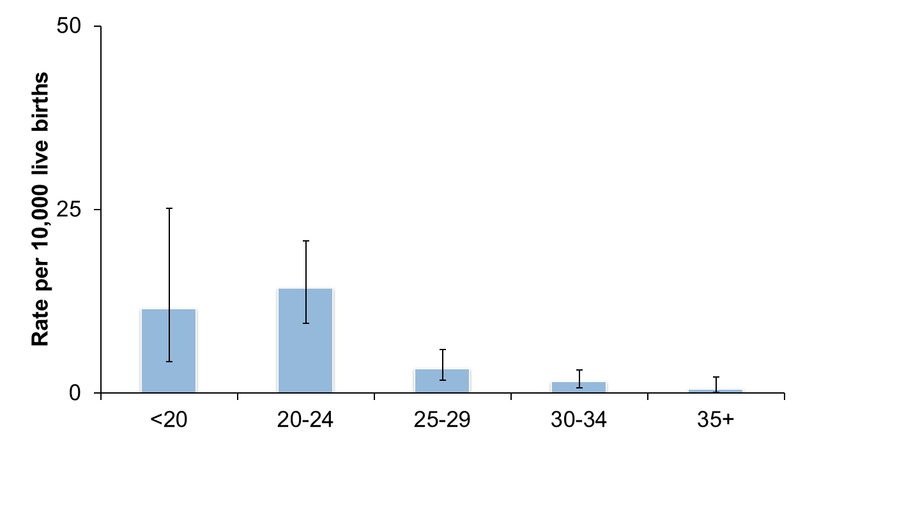

Live birth, stillbirths, and other losses, N=56.
Error bars represent 95% confidence interval.

CHAPTER 6: PREVALENCE OF BIRTH DEFECTS BY MATERNAL RACE/ETHNICITY AND REGION

Maternal Race/Ethnicity

In Massachusetts and nationally, birth defect rates vary by maternal race/ethnicity. Table 6.1 shows the variation in age-adjusted birth defect rates by racial/ethnic group in Massachusetts during the current reporting period.

Table 6.1. Age-Adjusted Prevalence of Birth Defects by Maternal Race/Ethnicity,
Massachusetts: 2013-2014

Maternal  Race | Cases | Age-Adjusted  Rate¹ | 95% Confidence Interval
White, Non-Hispanic | 2,452 | 274.3 | 258.8-289.9
Black, Non-Hispanic | 387 | 280.9 | 251.7-310.1
Asian, Non-Hispanic | 277 | 220.0 | 146.1-293.9
Hispanic | 121 | 248.4 | 231.1-265.7
Other, Non-Hispanic² | 30 | 221.1 | 135.9-306.2

Live births, stillbirths, and other pregnancy losses. N=3847. Excludes 47 cases missing race information.

¹ Rate per 10,000 live births, adjusted to statewide maternal age distribution of the birthing
population.
² Includes American Indian.

The age-adjusted overall birth defect rates did not differ significantly by race, although the rate in Asian mothers was slightly lower than the rate among other racial groups. Possible explanations for racial differences include genetic variation, diet differences, and varying access to prenatal screening and health care services. For example, data from the 2011 Massachusetts Pregnancy Risk Assessment Monitoring System shows racial/ethnic differences in the use of a multivitamin in the month prior to pregnancy (19). These results are shown in Appendix 5. Table T.6. shows the prevalence rates of the individual birth defects by maternal race/ethnicity. Trends over time in maternal race/ethnicity can be found in Chapter 8.

Maternal Region of Residence

The Massachusetts Executive Office of Health and Human Services divides the state into six regions for statistical, care coordination and administrative purposes. The six regions are based on geographical groupings of cities and towns: Western, Central, Northeast, Metro West, Southeast, and Boston. A map of these regions is provided in Appendix 6. The age-adjusted birth defect rates by the six regions in 2013-2014 are shown in Table 6.2. There were no significant differences in rates by region. We also observed no evidence of trends over time (Figure 6.2).

Table 6.2. Age-Adjusted Prevalence of Birth Defects by Maternal Residence Region, Massachusetts: 2013-2014

Region | Cases | Age-Adjusted  Rate¹ | 95% Confidence Interval
Western | 419 | 265.4 | 240.6-290.1
Central | 518 | 292.4 | 258.1-326.8
Northeast | 864 | 284.7 | 264.9-304.4
Metro West | 898 | 251.9 | 236.0-267.8
Southeast | 620 | 252.4 | 233.8-271.2
Boston | 575 | 283.3 | 253.9-312.7

Live births, stillbirths, and other pregnancy losses, N=3894.
¹ Rate per 10,000 live births, adjusted to statewide maternal age distribution of the birthing population.

CHAPTER 7: BIRTH DEFECTS BY PATTERN AND ETIOLOGY

Pattern

Cases are classified based on their pattern (i.e., whether a defect occurs with others). Of the 3894 birth defect cases in 2013-2014, 34% had multiple major defects or syndromes, and 66% were isolated (Figure 7.1). Approximately 59% of the isolated cases had single defects, and nearly 34% had multiple defects within the same organ or a single major defect with one or more minor defects; the remaining 7% are part of a sequence of developmental events. Birth defects that tend to occur as solitary defects include hypospadias, gastroschisis, and craniosynostosis.

Figure 7.1. Birth Defects by Pattern, Massachusetts: 2013-2014

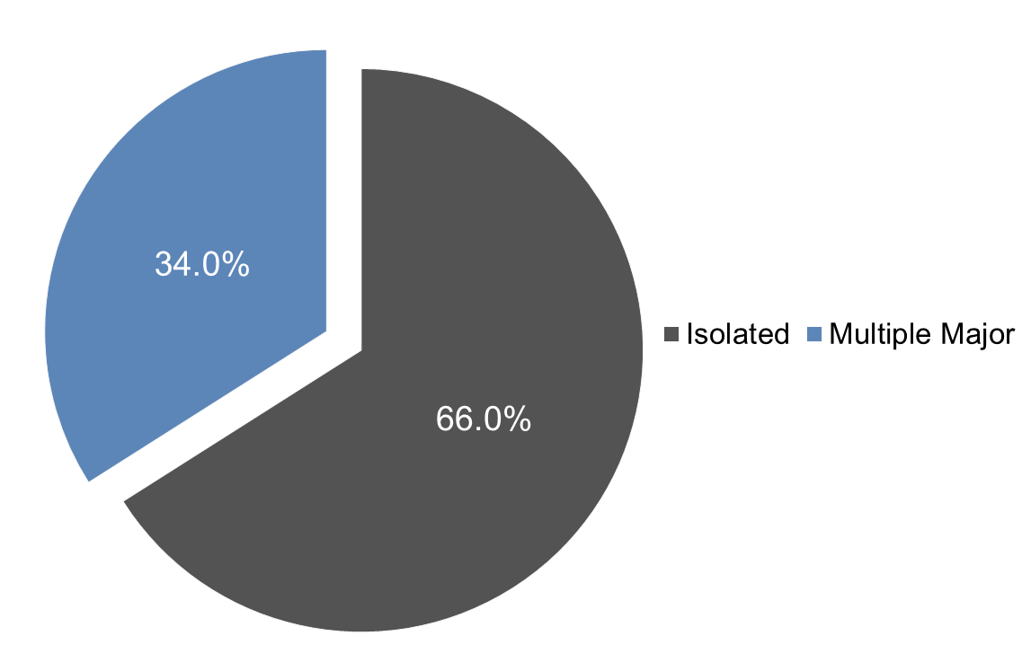

Live births, stillbirths and other pregnancy losses, N=3894.
Isolated defects include cases with a single defect, those with multiple defects in the same organ, those with a single major defect and one or more minor defects, and those with defects that occur as part of a sequence of events.

Etiology

The surveillance system in Massachusetts collects etiology or causal information for birth defects, when available. Cases are classified into etiology categories, with similar cases grouped using knowledge of pathogenesis and embryologic mechanisms. Etiology classification considers each case as a biologic entity rather than a collection of individual defects. The schema was developed based on general principles outlined in the literature (20,21,22).

The majority of birth defects cases in Massachusetts in 2013-2014 (70.5%) had an unknown cause (Figure 7.2). Most of the cases with known etiology were whole chromosome abnormalities (extra copy or missing copy of a chromosome), such as trisomy 13 and Turner syndrome. Other examples of defects with known etiologies include single gene defects, such as achondroplasia, Smith-Lemli-Opitz syndrome and other defects considered to be a Mendelian syndrome. Examples of known etiologies include teratogens (e.g., thalidomide), maternal conditions (e.g., diabetes), and conditions of the uterine environment (e.g., didelphys uterus).

Figure 7.2. Birth Defects by Etiology, Massachusetts: 2013-2014

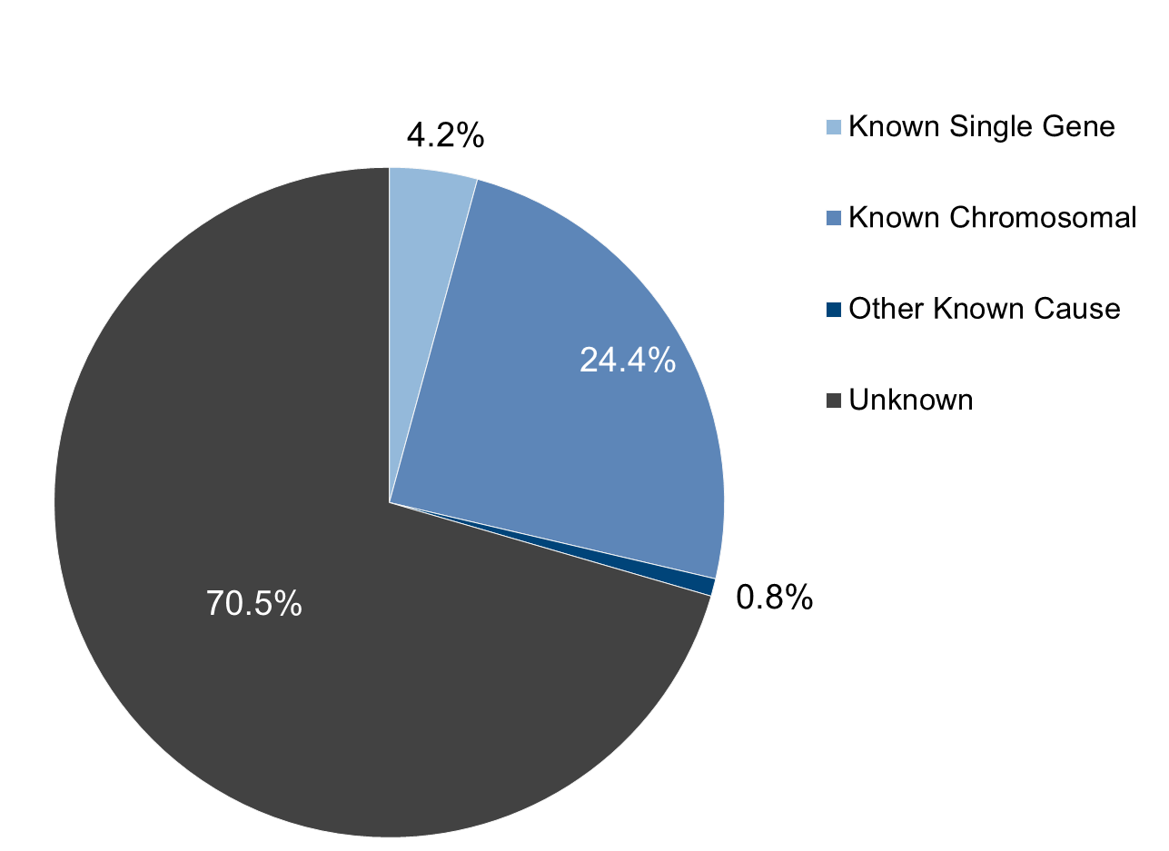
Live births, stillbirths, and other pregnancy losses, N=3894. Percentages may not add to 100% due to rounding.

CHAPTER 8: TREND ANALYSIS

The rate of birth defects in Massachusetts has increased steadily over time (Figure 8.1a). This likely reflects improvements in case ascertainment or confirmation as described above, changes in the distribution of demographic variables over time (e.g., more births to older mothers), changes in survival to diagnosis, and random variation, more than true increases in the overall rate of birth defects. The addition of new reporting sources and codes would also have impacted these trends.

The addition of other pregnancy losses in 2012 resulted in a large increase in birth defect prevalence rates (Figure 8.1b). The collection of additional defects beginning in 2014, including grade 1 hypospadias, resulted in further increases in prevalence rates.

Figure 8.1a. Overall Prevalence of Birth Defects in Massachusetts, 2-year Rolling Average

Live Births and Stillbirths, 2000-2014

Excludes new defects added in 2014

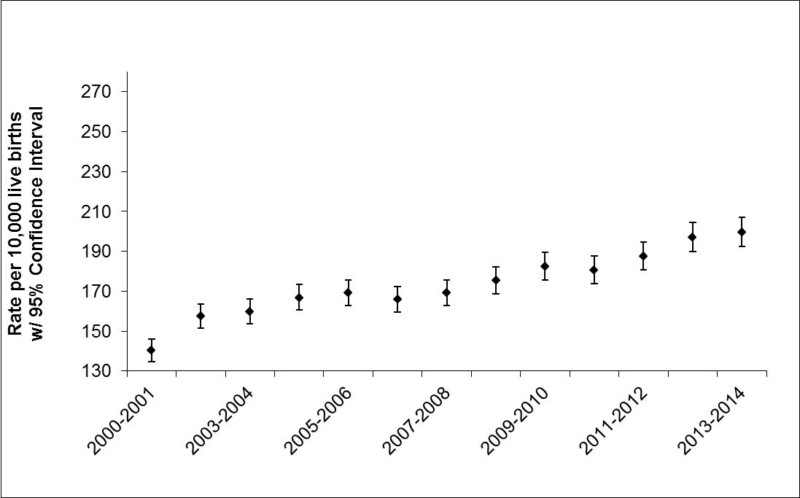

Note: Y axis begins at 130.
Error bars represent 95% confidence interval.

Figure 8.1b. Overall Prevalence of Birth Defects in Massachusetts, 2-year Rolling Average

Live Births, Stillbirths, and Other Pregnancy Losses, 2000-2014

Includes new defects added in 2014

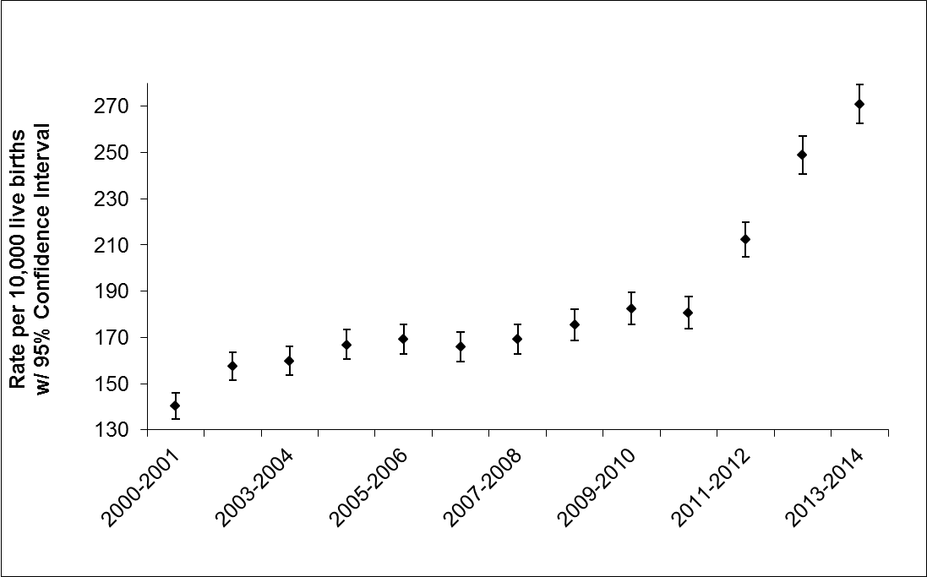

Other losses added 2012
New defects added 2014
Note: Y axis begins at 130.
Error bars represent 95% confidence interval.

Trends in Gastroschisis

Figure 8.2. presents gastroschisis rates by maternal age in Massachusetts over a 12-year time span. Rates of gastroschisis have been increasing over time among 20-24 year old mothers in Massachusetts. This is similar to trends seen nationally (23).

Figure 8.2. Prevalence of Gastroschisis by Year and Maternal Age,
Massachusetts: 2000-2014

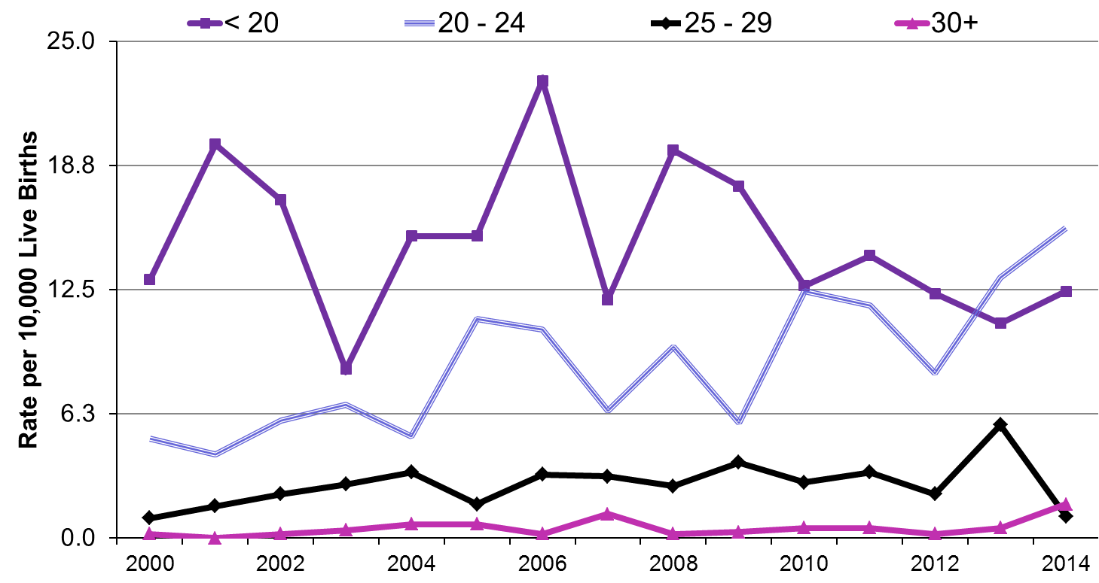

Includes live births and stillbirths.

Trends in Maternal Race/Ethnicity

Figure 8.3. shows the age-adjusted birth defect rates by race/ethnicity between 2009 and 2014 in two-year intervals. Rates in 2013-2014 did not differ significantly by race/ethnicity. In 2009-2010 and 2011-2012, Asians had significantly lower rates of birth defects, but with the addition of other pregnancy losses in 2013-2014, this difference is no longer significant.

Figure 8.3. Prevalence of Birth Defects by Maternal Race/Ethnicity,
Massachusetts: 2009-2014

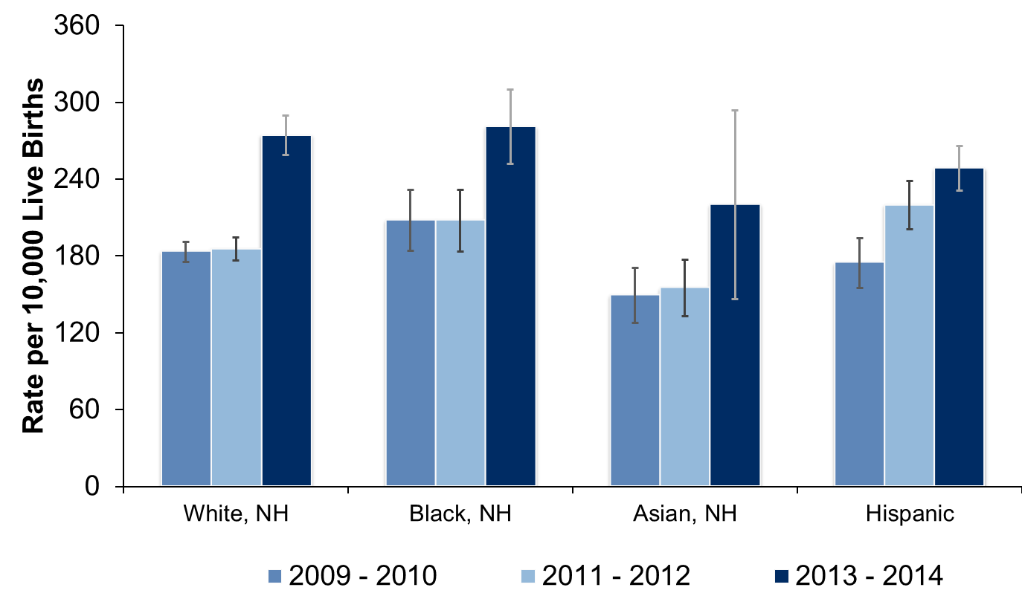

Includes live births, stillbirths, and other pregnancy losses (2013 on). NH=Non-Hispanic.
Adjusted to statewide maternal age distribution of the Massachusetts birth population in each 2-year period.
Error bars represent 95% confidence interval.

Trends in Maternal Region of Residence

Figure 8.4 shows prevalence of birth defects by region of maternal residence over time. In 2013-2014 the overall age-adjusted birth defect prevalence was lowest in the Metro West and Southeastern regions and highest for the Central and Northeast regions. The end of abstraction of Rhode Island hospitals likely impacted the Southeastern region rates.

Figure 8.4. Prevalence of Birth Defects by Maternal Residence Region,
Massachusetts: 2009-2014

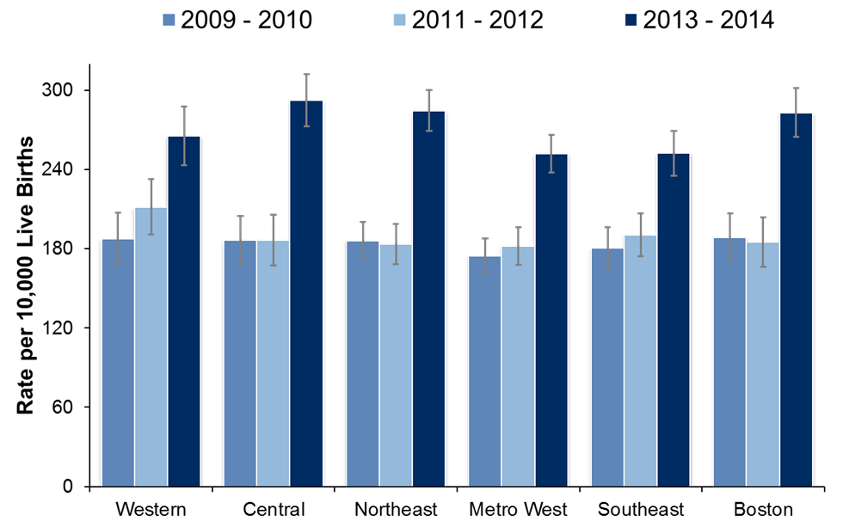

Includes live births, stillbirths, and other pregnancy losses (2013 on). NH=Non-Hispanic.
Adjusted to statewide maternal age distribution of the Massachusetts birth population in each 2-year period.
Error bars represent 95% confidence interval.

RESOURCES, SUGGESTED CITATION, CONTACT INFORMATION

Resources

For additional information on birth defects:

www.mass.gov/dph/birthdefects

Suggested Citation

Massachusetts Birth Defects 2013-2014. Boston, MA: Center for Birth Defects Research and Prevention, Bureau of Family Health and Nutrition, Massachusetts Department of Public Health. September 2019.

http://www.mass.gov/eohhs/gov/departments/dph/programs/family-health/birth-defect/monitoring/surveillance-reports.html

Friendly URL: www.mass.gov/dph/birthdefects

Contact Information

For more information contact:

Cathleen A. Higgins, Surveillance Coordinator
Massachusetts Department of Public Health
Center for Birth Defects Research and Prevention
250 Washington Street, 5th Floor
Boston, MA 02108
Phone: 617-624-5510
cathleen.higgins@state.ma.us

TABLES

Table T.1. Prevalence of Birth Defects, Massachusetts: 2013-2014

Defect¹ | Live Birth  Count | Stillbirth Count | Other Pregnancy Loss Count | Total  Count | Rate per  10,000Live  Births | 95%  Confidence  Interval
Total Cases with a Reportable Birth Defect | 3015 | 68 | 811 | 3894 | 271.0 | 262.7-279.6
Central Nervous System
Anencephaly | 1 | 1 | 29 | 31 | 2.16 | 1.47-3.06
Encephalocele | 10 | 1 | 12 | 23 | 1.60 | 1.01-2.40
Holoprosencephaly | 8 | 3 | 12 | 23 | 1.60 | 1.01-2.40
Hydrocephaly without Spina Bifida | 59 | 4 | 16 | 79 | 5.50 | 4.35-6.85
Microcephaly | 52 | 2 | 2 | 56 | 3.90 | 2.94-5.06
Spina Bifida with/without Hydrocephaly | 32 | 4 | 34 | 70 | 4.87 | 3.80-6.16
Spinal Cord² | 59 | 1 | 1 | 61 | 4.25 | 3.25-5.45
Other Central Nervous System² | 146 | 4 | 35 | 185 | 12.88 | 11.09-14.87
Eye
Aniridia | 6 |  | 0 | 6 | 0.42 | 0.15-0.91
Anophthalmia/Microphthalmia | 17 |  | 2 | 19 | 1.32 | 0.80-2.07
Congenital Glaucoma, Congenital Cataract | 57 |  | 0 | 57 | 3.97 | 3.01-5.14
Other Eye² | 67 |  | 0 | 67 | 4.66 | 3.61-5.92
Ear
Anotia/Microtia | 34 | 3 | 1 | 38 | 2.65 | 1.87-3.63
Other Ear² | 83 | 1 | 1 | 85 | 5.92 | 4.73-7.32
Cardiovascular
Anomalous Pulmonary Venous Connection
Anomalous Pulmonary Venous Connection | 27 |  | 1 | 28 | 1.95 | 1.30-2.82
Atrioventricular Canal Defects
Atrial Septal Defect (ASD) Primum | 1 | 1 | 1 | 3 | 0.21 | 0.04-0.61
Common Atrium | 1 |  | 0 | 1 | 0.07 | 0.00-0.39
Complete Atrioventricular Canal Defect | 43 | 7 | 14 | 64 | 4.45 | 3.43-5.69
Endocardial Cushion Defect | 11 | 1 | 4 | 16 | 1.11 | 0.64-1.81
Ventricular Septal Defect (VSD), Canal Type | 4 | 1 | 1 | 6 | 0.42 | 0.15-0.91
Conotruncal (Outlet) and Aortic Arch
Double Outlet Right Ventricle | 23 | 3 | 7 | 33 | 2.30 | 1.58-3.23
Interrupted Aortic Arch, Type B | 3 |  | 0 | 3 | 0.21 | 0.04-0.61
Tetralogy of Fallot | 65 | 2 | 10 | 77 | 5.36 | 4.23-6.70
Truncus Arteriosus (Common Truncus) | 7 | 1 | 1 | 9 | 0.63 | 0.29-1.19
Dextro-Transposition of the Great Arteries | 37 | 1 | 3 | 41 | 2.85 | 2.05-3.87
Ebstein Anomaly
Ebstein Anomaly | 7 | 0 | 0 | 7 | 0.49 | 0.20-1.00
Heterotaxy (Laterality Defects)
Heterotaxy | 18 | 2 | 4 | 24 | 1.67 | 1.07-2.49
Left-Sided Obstruction
Aortic Arch Atresia without Hypoplastic Left Heart Syndrome | 0 | 1 | 0 | 1 | 0.07 | 0.00-0.39
Aortic Valve Stenosis | 16 | 0 | 2 | 18 | 1.25 | 0.74-1.98
Coarctation of Aorta | 68 | 1 | 0 | 69 | 4.80 | 3.74-6.08
Hypoplastic Left Heart Syndrome | 21 | 3 | 15 | 39 | 2.71 | 1.93-3.71
Interrupted Aortic Arch, Type A or Not otherwise specified (NOS) | 1 | 0 | 1 | 2 | 0.14 | 0.02-0.50
Right-Sided Obstruction
Pulmonary Stenosis, Valvar | 106 | 1 | 4 | 111 | 7.73 | 6.36-9.30
Pulmonary Valve Atresia with Intact Septum | 7 | 1 | 1 | 9 | 0.63 | 0.29-1.19
Pulmonary Valve Atresia with VSD | 7 | 0 | 3 | 10 | 0.70 | 0.33-1.28
Tricuspid Valve Atresia | 10 | 0 | 1 | 11 | 0.77 | 0.38-1.37
Septal Defects
ASD (Secundum and NOS) | 327 | 1 | 6 | 334 | 23.25 | 20.82-25.88
VSD (Membranous and NOS) | 189 | 6 | 16 | 211 | 14.69 | 12.77-16.81
VSD (Muscular) | 160 | 1 | 1 | 162 | 11.28 | 9.61-13.15
VSD, Conoventricular/Malalignment | 23 | 1 | 2 | 26 | 1.81 | 1.18-2.65
Single Ventricle and Levo-Transposition
Levo-Transposition of the Great Arteries | 7 | 0 | 0 | 7 | 0.49 | 0.20-1.00
Single Ventricle | 4 | 0 | 2 | 6 | 0.42 | 0.15-0.91
Other Cardiovascular
Other Cardiovascular^{2,3} | 318 | 7 | 31 | 356 | 24.78 | 22.28-27.49
Respiratory
Choanal Atresia | 11 | 0 | 0 | 11 | 0.77 | 0.38-1.37
Lung Anomalies | 34 | 1 | 1 | 36 | 2.51 | 1.76-3.47
Other Respiratory² | 16 | 3 | 3 | 22 | 1.53 | 0.96-2.32
Orofacial
Cleft Lip with/without Cleft Palate | 124 | 1 | 15 | 140 | 9.75 | 8.20-11.50
Cleft Palate without Cleft Lip | 85 | 2 | 4 | 91 | 6.33 | 5.10-7.78
Pierre Robin Sequence | 25 | 0 | 0 | 25 | 1.74 | 1.13-2.57
Other Orofacial² | 48 | 0 | 3 | 51 | 3.55 | 2.64-4.67
Gastrointestinal
Biliary Atresia | 4 | 0 | 0 | 4 | 0.28 | 0.08-0.71
Esophageal Atresia/Tracheoesophageal Fistula | 40 | 0 | 1 | 41 | 2.85 | 2.05-3.87
Hirschsprung Disease | 25 | 0 | 0 | 25 | 1.74 | 1.13-2.57
Rectal and Large Intestinal Atresia/Stenosis | 53 | 0 | 5 | 58 | 4.04 | 3.07-5.22
Small Intestinal Atresia | 42 | 0 | 1 | 43 | 2.99 | 2.17-4.03
Other Gastrointestinal² | 102 | 4 | 5 | 111 | 7.73 | 6.36-9.30
Genitourinary
Bladder Exstrophy | 5 | 0 | 0 | 5 | 0.35 | 0.11-0.81
Cloacal Exstrophy | 2 | 0 | 0 | 2 | 0.14 | 0.02-0.50
Hypospadias⁴, 1st Degree or NOS | 228 | 0 | 1 | 229 | 31.16 | 27.26-35.47
Hypospadias⁴, 2nd or 3rd Degree | 176 | 1 | 0 | 177 | 24.08 | 20.67-27.91
Obstructive Genitourinary Defect | 201 | 2 | 12 | 215 | 14.97 | 13.03-17.11
Renal Agenesis/Hypoplasia | 36 | 2 | 10 | 48 | 3.34 | 2.46-4.43
Other Genitourinary² | 296 | 6 | 13 | 315 | 21.93 | 19.57-24.48
Musculoskeletal
Club Foot | 202 | 5 | 28 | 235 | 16.36 | 14.33-18.59
Craniosynostosis | 88 | 0 | 1 | 89 | 6.20 | 4.98-7.62
Diaphragmatic Hernia | 38 | 4 | 9 | 51 | 3.55 | 2.64-4.67
Gastroschisis | 52 | 2 | 2 | 56 | 3.90 | 2.94-5.06
Omphalocele | 18 | 8 | 28 | 54 | 3.76 | 2.82-4.90
Polydactyly/Syndactyly | 221 | 1 | 12 | 234 | 16.29 | 14.27-18.51
Reduction Deformity, Lower Limbs | 19 | 1 | 8 | 28 | 1.95 | 1.30-2.82
Reduction Deformity, Upper Limbs | 48 | 0 | 11 | 59 | 4.11 | 3.13-5.30
Skeletal Dysplasia | 31 | 1 | 8 | 40 | 2.78 | 1.99-3.79
Other Musculoskeletal² | 159 | 6 | 37 | 202 | 14.06 | 12.19-16.14
Chromosomal and other Syndromes
Klinefelter Syndrome | 9 | 1 | 3 | 13 | 0.90 | 0.48-1.55
Trisomy 13 | 4 | 1 | 45 | 50 | 3.48 | 2.58-4.59
Trisomy 18 | 15 | 13 | 82 | 110 | 7.66 | 6.29-9.23
Trisomy 21 (Down Syndrome) | 165 | 15 | 185 | 365 | 25.41 | 22.87-28.15
Turner Syndrome⁵ | 7 | 3 | 68 | 78 | 10.83 | 8.53-13.56
Other Chromosomal Syndromes/Other Syndromes² | 239 | 10 | 231 | 480 | 33.41 | 30.49-36.53
Other
Amniotic Bands | 8 | 0 | 4 | 12 | 0.84 | 0.43-1.46
Skin Anomalies² | 21 | 0 | 1 | 22 | 1.53 | 0.96-2.32
Other, Specified² | 20 | 1 | 3 | 24 | 1.67 | 1.07-2.49

NOS: Not Otherwise Specified; ASD: Atrial Septal Defect; VSD: Ventricular Septal Defect.
¹ Cases can be included in the count for more than one defect. Cases are counted once in the total for a defect category.
² Rate represents a heterogeneous group of defects.
³ Excludes Patent Ductus Arteriosus.
⁴ Rate calculated using male live births.
⁵ Rate calculated using female live births.

Table T.2. Prevalence of Selected Birth Defects, Massachusetts vs. United States
Defect | Count  MA | Rate MA¹ | 95% CI | Rate US² | 95%  Confidence  Interval
Anencephaly | 31 | 2.16 | 1.47-3.06 | 2.23 | 2.07-2.41
Spina Bifida without Anencephaly | 70 | 4.87 | 3.80-6.16 | 3.72 | 3.52-3.94
Anophthalmia/Microphthalmia | 19 | 1.32 | 0.80-2.07 | 2.10 | 1.94-2.27
Truncus Arteriosus (Common Truncus) | 9 | 0.63 | 0.29-1.19 | 0.74 | 0.65-0.84
Transposition of the Great Arteries | 48 | 3.34 | 2.46-4.43 | 3.04 | 2.85-3.24
Tetralogy of Fallot | 77 | 5.36 | 4.23-6.70 | 4.05 | 3.83-4.28
Atrioventricular Septal Defect³ | 90 | 6.26 | 5.04-7.70 | 4.70 | 4.45-4.96
Hypoplastic Left Heart Syndrome | 39 | 2.71 | 1.93-3.71 | 2.31 | 2.14-2.48
Cleft Palate without Cleft Lip | 91 | 6.33 | 5.10-7.78 | 6.45 | 6.17-6.74
Cleft Lip with/without Cleft Palate | 140 | 9.75 | 8.20-11.50 | 10.89 | 10.53-11.26
Esophageal Atresia/Tracheoesophageal Fistula | 41 | 2.85 | 2.05-3.87 | 2.12 | 1.96-2.29
Rectal and Large Intestinal Atresia/Stenosis | 58 | 4.04 | 3.07-5.22 | 4.86 | 4.61-5.14
Reduction Deformity, Lower Limbs | 28 | 1.95 | 1.30-2.82 | 1.65 | 1.51-1.80
Reduction Deformity, Upper Limbs | 59 | 4.11 | 3.13-5.30 | 3.64 | 3.43-3.86
Gastroschisis | 56 | 3.90 | 2.94-5.06 | 4.72 | 4.49-4.97
Omphalocele | 54 | 3.76 | 2.82-4.90 | 1.92 | 1.77-2.08
Diaphragmatic Hernia | 51 | 3.55 | 2.64-4.67 | 2.60 | 2.42-2.79
Trisomy 21 (Down Syndrome) ⁴ | 365 | 18.70 | 17.88-19.44 | 14.47 | 14.11-14.83
Trisomy 13⁴ | 50 | 2.64 | 2.53-2.75 | 1.26 | 1.16-1.37
Trisomy 18⁴ | 110 | 5.39 | 5.14-5.63 | 2.66 | 2.50-2.81

¹ Rate per 10,000 live births. Includes live births, stillbirths, and other pregnancy losses, 2013 and 2014.
² Rate per 10,000 live births. US rates based on crude, pooled prevalence data from 11 active case-ascertainment programs, including Massachusetts, from 2004-2006 (7). Nine of the other states contributing to the pooled estimates include elective terminations in addition to live births and stillbirths.
³ Includes endocardial cushion defect, complete atrioventricular canal defect, atrial septal defect (ASD) primum, common atrium, and canal type ventricular septal defect (VSD).
⁴ Adjusted for maternal age distribution of US population 2006.

Table T.3. Prevalence of Birth Defects by Infant Sex, Live Births, Stillbirths and Other Pregnancy Losses, Massachusetts: 2013-2014
Defect¹ | Sex | Count | Rate per  10,000  Live  Births | 95%  Confidence  Interval
Central Nervous System
Anencephaly | Male | 17 | 2.31 | 1.35-3.70
 | Female | 6 | 0.86 | 0.31-1.86
Encephalocele | Male | 10 | 1.36 | 0.65-2.50
 | Female | 10 | 1.43 | 0.68-2.62
Holoprosencephaly | Male | 10 | 1.36 | 0.65-2.50
 | Female | 13 | 1.85 | 0.99-3.17
Hydrocephaly | Male | 43 | 5.85 | 4.23-7.88
 | Female | 34 | 4.85 | 3.36-6.77
Microcephaly | Male | 25 | 3.40 | 2.20-5.02
 | Female | 30 | 4.28 | 2.88-6.10
Spina Bifida with/without Hydrocephaly | Male | 32 | 4.35 | 2.98-6.15
 | Female | 33 | 4.70 | 3.24-6.60
Spinal Cord² | Male | 31 | 4.22 | 2.87-5.99
 | Female | 30 | 4.28 | 2.88-6.10
Other Central Nervous System² | Male | 103 | 14.02 | 11.44-17.00
 | Female | 75 | 10.69 | 8.41-13.40
Eye
Aniridia | Male | 4 | 0.54 | 0.15-1.39
 | Female | 2 | 0.29 | 0.03-1.03
Anophthalmia/Microphthalmia | Male | 8 | 1.09 | 0.47-2.14
 | Female | 11 | 1.57 | 0.78-2.80
Congenital Glaucoma, Congenital Cataract | Male | 36 | 4.90 | 3.43-6.78
 | Female | 21 | 2.99 | 1.85-4.57
Other Eye² | Male | 24 | 3.27 | 2.09-4.86
 | Female | 43 | 6.13 | 4.43-8.25
Ear
Anotia/Microtia | Male | 19 | 2.59 | 1.56-4.04
 | Female | 18 | 2.57 | 1.52-4.05
Other Ear² | Male | 39 | 5.31 | 3.77-7.25
 | Female | 46 | 6.56 | 4.80-8.74
Cardiovascular
Anomalous Pulmonary Venous Connection
Anomalous Pulmonary Venous Connection | Male | 14 | 1.91 | 1.04-3.20
 | Female | 14 | 2.00 | 1.09-3.35
Atrioventricular Canal Defects
Atrial Septal Defect (ASD) Primum | Male | 2 | 0.27 | 0.03-0.98
 | Female | 1 | 0.14 | 0.00-0.79
Common Atrium | Male | 1 | 0.14 | 0.00-0.76
 | Female | 0 | 0 | -
Complete Atrioventricular Canal Defect | Male | 33 | 4.49 | 3.09-6.31
 | Female | 30 | 4.28 | 2.88-6.10
Endocardial Cushion Defect | Male | 5 | 0.68 | 0.22-1.59
 | Female | 10 | 1.43 | 0.68-2.62
Ventricular Septal Defect (VSD), Canal Type | Male | 4 | 0.54 | 0.15-1.39
 | Female | 2 | 0.29 | 0.03-1.03
Conotruncal (Outlet) and Aortic Arch
Double Outlet Right Ventricle | Male | 22 | 2.99 | 1.88-4.53
 | Female | 10 | 1.43 | 0.68-2.62
Interrupted Aortic Arch, Type B | Male | 1 | 0.14 | 0.00-0.76
 | Female | 2 | 0.29 | 0.03-1.03
Tetralogy of Fallot | Male | 35 | 4.76 | 3.32-6.62
 | Female | 41 | 5.84 | 4.19-7.93
Truncus Arteriosus (Common Truncus) | Male | 3 | 0.41 | 0.08-1.19
 | Female | 6 | 0.86 | 0.31-1.86
Dextro-Transposition of the Great Arteries | Male | 28 | 3.81 | 2.53-5.51
 | Female | 13 | 1.85 | 0.99-3.17
Ebstein Anomaly
Ebstein Anomaly | Male | 2 | 0.27 | 0.03-0.98
 | Female | 5 | 0.71 | 0.23-1.66
Heterotaxy (Laterality Defects)
Heterotaxy | Male | 13 | 1.77 | 0.94-3.02
 | Female | 10 | 1.43 | 0.68-2.62
Left-Sided Obstruction
Aortic Arch Atresia without Hypoplastic Left Heart Syndrome | Male | 1 | 0.14 | 0.00-0.76
 | Female | 0 | - | -
Aortic Valve Stenosis | Male | 15 | 2.04 | 1.14-3.37
 | Female | 3 | 0.43 | 0.09-1.25
Coarctation of Aorta | Male | 37 | 5.03 | 3.54-6.94
 | Female | 32 | 4.56 | 3.12-6.44
Hypoplastic Left Heart Syndrome | Male | 22 | 2.99 | 1.88-4.53
 | Female | 11 | 1.57 | 0.78-2.80
Interrupted Aortic Arch (Type A and NOS) | Male | 1 | 0.14 | 0.00-0.76
 | Female | 1 | 0.14 | 0.00-0.79
Right-Sided Obstruction
Pulmonary Stenosis, Valvular | Male | 52 | 7.08 | 5.28-9.28
 | Female | 58 | 8.27 | 6.28-10.68
Pulmonary Valve Atresia with intact septum | Male | 4 | 0.54 | 0.15-1.39
 | Female | 5 | 0.71 | 0.23-1.66
Pulmonary Valve Atresia with VSD | Male | 6 | 0.82 | 0.30-1.78
 | Female | 3 | 0.43 | 0.09-1.25
Tricuspid Valve Atresia | Male | 5 | 0.68 | 0.22-1.59
 | Female | 6 | 0.86 | 0.31-1.86
Septal Defects
ASD (Secundum and NOS) | Male | 168 | 22.86 | 19.53-26.59
 | Female | 165 | 23.51 | 20.06-27.39
VSD (Membranous and NOS) | Male | 101 | 13.74 | 11.19-16.70
 | Female | 107 | 15.25 | 12.50-18.43
VSD (Muscular) | Male | 70 | 9.53 | 7.43-12.03
 | Female | 91 | 12.97 | 10.44-15.92
VSD, Conoventricular/Malalignment | Male | 15 | 2.04 | 1.14-3.37
 | Female | 11 | 1.57 | 0.78-2.80
Single Ventricle and Levo-Transposition
Levo-Transposition of the Great Arteries | Male | 5 | 0.68 | 0.22-1.59
 | Female | 2 | 0.29 | 0.03-1.03
Single Ventricle | Male | 4 | 0.54 | 0.15-1.39
 | Female | 1 | 0.14 | 0.00-0.79
Other Cardiovascular
Other Cardiovascular^{2,3} | Male | 195 | 26.53 | 22.94-30.53
 | Female | 155 | 22.09 | 18.75-25.85
Respiratory
Choanal Atresia | Male | 4 | 0.54 | 0.15-1.39
 | Female | 7 | 1.00 | 0.40-2.06
Lung Anomalies | Male | 19 | 2.59 | 1.56-4.04
 | Female | 17 | 2.42 | 1.41-3.88
Other Respiratory² | Male | 17 | 2.31 | 1.35-3.70
 | Female | 4 | 0.57 | 0.16-1.46
Orofacial
Cleft Lip with/without Cleft Palate | Male | 84 | 11.43 | 9.12-14.15
 | Female | 53 | 7.55 | 5.66-9.88
Cleft Palate without Cleft Lip | Male | 38 | 5.17 | 3.66-7.10
 | Female | 53 | 7.55 | 5.66-9.88
Pierre Robin Sequence | Male | 14 | 1.91 | 1.04-3.20
 | Female | 11 | 1.57 | 0.78-2.80
Other Orofacial² | Male | 23 | 3.13 | 1.98-4.70
 | Female | 27 | 3.85 | 2.54-5.60
Gastrointestinal
Biliary Atresia | Male | 1 | 0.14 | 0.00-0.76
 | Female | 3 | 0.43 | 0.09-1.25
Esophageal Atresia/Tracheoesophageal Fistula | Male | 25 | 3.40 | 2.20-5.02
 | Female | 16 | 2.28 | 1.30-3.70
Hirschsprung Disease | Male | 17 | 2.31 | 1.35-3.70
 | Female | 8 | 1.14 | 0.49-2.25
Rectal and Large Intestinal Atresia/Stenosis | Male | 27 | 3.67 | 2.42-5.35
 | Female | 31 | 4.42 | 3.00-6.27
Small Intestinal Atresia | Male | 26 | 3.54 | 2.31-5.18
 | Female | 17 | 2.42 | 1.41-3.88
Other Gastrointestinal² | Male | 58 | 7.89 | 5.99-10.20
 | Female | 53 | 7.55 | 5.66-9.88
Genitourinary
Bladder Exstrophy | Male | 2 | 0.27 | 0.03-0.98
 | Female | 3 | 0.43 | 0.09-1.25
Cloacal Exstrophy | Male | 0 | 0 | -
 | Female | 2 | 0.29 | 0.03-1.03
Hypospadias⁴, 1st Degree or NOS | Male | 229 | 31.16 | 27.26-35.47
 | Female | 0 | - | -
Hypospadias⁴, 2nd or 3rd Degree | Male | 177 | 24.08 | 20.67-27.91
 | Female | 0 | 0 | -
Obstructive Genitourinary Defect | Male | 143 | 19.46 | 16.40-22.92
 | Female | 72 | 10.26 | 8.03-12.92
Renal Agenesis/Hypoplasia | Male | 30 | 4.08 | 2.75-5.83
 | Female | 17 | 2.42 | 1.41-3.88
Other Genitourinary² | Male | 197 | 26.81 | 23.19-30.82
 | Female | 113 | 16.10 | 13.27-19.36
Musculoskeletal
Club Foot | Male | 146 | 19.87 | 16.77-23.36
 | Female | 83 | 11.83 | 9.42-14.66
Craniosynostosis | Male | 57 | 7.76 | 5.87-10.05
 | Female | 32 | 4.56 | 3.12-6.44
Diaphragmatic Hernia | Male | 18 | 2.45 | 1.45-3.87
 | Female | 32 | 4.56 | 3.12-6.44
Gastroschisis | Male | 32 | 4.35 | 2.98-6.15
 | Female | 24 | 3.42 | 2.19-5.09
Omphalocele | Male | 25 | 3.40 | 2.20-5.02
 | Female | 23 | 3.28 | 2.08-4.92
Polydactyly/Syndactyly | Male | 137 | 18.64 | 15.65-22.04
 | Female | 96 | 13.68 | 11.08-16.71
Reduction Deformity, Lower Limbs | Male | 20 | 2.72 | 1.66-4.20
 | Female | 6 | 0.86 | 0.31-1.86
Reduction Deformity, Upper Limbs | Male | 30 | 4.08 | 2.75-5.83
 | Female | 28 | 3.99 | 2.65-5.77
Skeletal Dysplasia | Male | 21 | 2.86 | 1.77-4.37
 | Female | 18 | 2.57 | 1.52-4.05
Other Musculoskeletal² | Male | 101 | 13.74 | 11.19-16.70
 | Female | 93 | 13.25 | 10.70-16.24
Chromosomal and other Syndromes
Klinefelter Syndrome | Male | 13 | 1.77 | 0.94-3.02
 | Female | 0 | - | -
Trisomy 13 | Male | 24 | 3.27 | 2.09-4.86
 | Female | 23 | 3.28 | 2.08-4.92
Trisomy 18 | Male | 55 | 7.48 | 5.64-9.74
 | Female | 46 | 6.56 | 4.80-8.74
Trisomy 21 (Down Syndrome) | Male | 175 | 23.81 | 20.42-27.61
 | Female | 174 | 24.80 | 21.25-28.77
Turner Syndrome⁵ | Male | 1 | 0.14 | 0.00-0.76
 | Female | 76 | 10.83 | 8.53-13.56
Other Chromosomal Syndromes/Other Syndromes² | Male | 235 | 31.98 | 28.02-36.34
 | Female | 238 | 33.92 | 29.74-38.51
Other
Amniotic Bands | Male | 3 | 0.41 | 0.08-1.19
 | Female | 7 | 1.00 | 0.40-2.06
Skin Anomalies | Male | 14 | 1.91 | 1.04-3.20
 | Female | 8 | 1.14 | 0.49-2.25
Other, Specified² | Male | 16 | 2.18 | 1.24-3.54
 | Female | 8 | 1.14 | 0.49-2.25

NOS: Not Otherwise Specified. ASD: Atrial Septal Defect; VSD: Ventricular Septal Defect.
¹ Cases can be included in the count for more than one defect. Cases are counted once in the total for a defect category.
² Rate represents a heterogeneous group of defects.
³ Excludes Patent Ductus Arteriosus.
⁴ Rate calculated using male live births.
⁵ Rate calculated using female live births.

Table T.4. Prevalence of Birth Defects by Plurality, Live Births, Stillbirths, and Other Pregnancy Losses, Massachusetts: 2013-2014
Defect¹ | Plurality | Count | Rate per 10,000  Live Births | 95% Confidence Interval
Central Nervous System
Anencephaly | Singleton | 31 | 2.26 | 1.53-3.20
 | Multiple | 0 | 0 | -
Encephalocele | Singleton | 23 | 1.67 | 1.06-2.51
 | Multiple | 0 | 0 | -
Holoprosencephaly | Singleton | 23 | 1.67 | 1.06-2.51
 | Multiple | 0 | 0 | -
Hydrocephaly without Spina Bifida | Singleton | 77 | 5.61 | 4.43-7.01
 | Multiple | 2 | 3.16 | 0.38-11.40
Microcephaly | Singleton | 55 | 4.01 | 3.02-5.21
 | Multiple | 1 | 1.58 | 0.04-8.79
Spina Bifida with/without Hydrocephaly | Singleton | 69 | 5.02 | 3.91-6.36
 | Multiple | 1 | 1.58 | 0.04-8.79
Spinal Cord² | Singleton | 57 | 4.15 | 3.14-5.38
 | Multiple | 4 | 6.31 | 1.72-16.17
Other Central Nervous System² | Singleton | 179 | 13.03 | 11.19-15.09
 | Multiple | 6 | 9.47 | 3.48-20.61
Eye
Aniridia | Singleton | 6 | 0.44 | 0.16-0.95
 | Multiple | 0 | 0 | -
Anophthalmia/Microphthalmia | Singleton | 19 | 1.38 | 0.83-2.16
 | Multiple | 0 | 0 | -
Congenital Glaucoma, Congenital Cataract | Singleton | 57 | 4.15 | 3.14-5.38
 | Multiple | 0 | 0 | -
Other Eye² | Singleton | 66 | 4.81 | 3.72-6.11
 | Multiple | 1 | 1.58 | 0.04-8.79
Ear
Anotia/Microtia | Singleton | 37 | 2.69 | 1.90-3.71
 | Multiple | 1 | 1.58 | 0.04-8.79
Other Ear² | Singleton | 82 | 5.97 | 4.75-7.41
 | Multiple | 3 | 4.74 | 0.98-13.84
Cardiovascular
Anomalous Pulmonary Venous Connection
Anomalous Pulmonary Venous Connection | Singleton | 27 | 1.97 | 1.30-2.86
 | Multiple | 1 | 1.58 | 0.04-8.79
Atrioventricular Canal Defects
Atrial Septal Defect (ASD) primum | Singleton | 3 | 0.22 | 0.05-0.64
 | Multiple | 0 | 0 | -
Common Atrium | Singleton | 1 | 0.07 | 0.00-0.41
 | Multiple | 0 | 0 | -
Complete Atrioventricular Canal Defect | Singleton | 62 | 4.51 | 3.46-5.79
 | Multiple | 2 | 3.16 | 0.38-11.40
Endocardial Cushion Defect | Singleton | 14 | 1.02 | 0.56-1.71
 | Multiple | 2 | 3.16 | 0.38-11.40
Ventricular Septal Defect (VSD), Canal Type | Singleton | 6 | 0.44 | 0.16-0.95
 | Multiple | 0 | 0 | -
Conotruncal (Outlet) and Aortic Arch
Double Outlet Right Ventricle | Singleton | 33 | 2.40 | 1.65-3.37
 | Multiple | 0 | 0 | -
Interrupted Aortic Arch, Type B | Singleton | 3 | 0.22 | 0.05-0.64
 | Multiple | 0 | 0 | -
Tetralogy of Fallot | Singleton | 73 | 5.32 | 4.17-6.68
 | Multiple | 4 | 6.31 | 1.72-16.17
Truncus Arteriosus (Common Truncus) | Singleton | 7 | 0.51 | 0.20-1.05
 | Multiple | 2 | 3.16 | 0.38-11.40
Dextro-Transposition of the Great Arteries | Singleton | 39 | 2.84 | 2.02-3.88
 | Multiple | 2 | 3.16 | 0.38-11.40
Ebstein Anomaly
Ebstein Anomaly | Singleton | 7 | 0.51 | 0.20-1.05
 | Multiple | 0 | 0 | -
Heterotaxy (Laterality Defects)
Heterotaxy | Singleton | 23 | 1.67 | 1.06-2.51
 | Multiple | 1 | 1.58 | 0.04-8.79
Left-Sided Obstruction
Aortic Valve Atresia | Singleton | 1 | 0.07 | 0.00-0.41
 | Multiple | 0 | 0 | -
Aortic Valve Stenosis | Singleton | 17 | 1.24 | 0.72-1.98
 | Multiple | 1 | 1.58 | 0.04-8.79
Coarctation of Aorta | Singleton | 61 | 4.44 | 3.40-5.71
 | Multiple | 8 | 12.63 | 5.45-24.88
Hypoplastic Left Heart Syndrome | Singleton | 38 | 2.77 | 1.96-3.80
 | Multiple | 1 | 1.58 | 0.04-8.79
Interrupted Aortic Arch (Type A and NOS) | Singleton | 2 | 0.15 | 0.02-0.53
 | Multiple | 0 | 0 | -
Right-Sided Obstruction
Pulmonary Stenosis, Valvar | Singleton | 97 | 7.06 | 5.73-8.62
 | Multiple | 14 | 22.10 | 12.08-37.08
Pulmonary Valve Atresia with intact septum | Singleton | 8 | 0.58 | 0.25-1.15
 | Multiple | 1 | 1.58 | 0.04-8.79
Pulmonary Valve Atresia with Ventricular Septal Defect | Singleton | 9 | 0.66 | 0.30-1.24
 | Multiple | 1 | 1.58 | 0.04-8.79
Tricuspid Valve Atresia | Singleton | 10 | 0.73 | 0.35-1.34
 | Multiple | 1 | 1.58 | 0.04-8.79
Septal Defects
ASD (Secundum and NOS) | Singleton | 307 | 22.36 | 19.93-25.00
 | Multiple | 27 | 42.62 | 28.09-62.01
VSD (Membranous and NOS) | Singleton | 193 | 14.05 | 12.14-16.18
 | Multiple | 18 | 28.41 | 16.84-44.91
VSD, Muscular | Singleton | 145 | 10.56 | 8.91-12.42
 | Multiple | 17 | 26.84 | 15.63-42.97
VSD, Conoventricular/Malalignment | Singleton | 25 | 1.82 | 1.18-2.69
 | Multiple | 1 | 1.58 | 0.04-8.79
Single Ventricle and L-TGA
Levo-Transposition of the Great Arteries | Singleton | 6 | 0.44 | 0.16-0.95
 | Multiple | 1 | 1.58 | 0.04-8.79
Single Ventricle | Singleton | 6 | 0.44 | 0.16-0.95
 | Multiple | 0 | 0 | -
Other Cardiovascular^{2,3} | Singleton | 340 | 24.76 | 22.20-27.53
 | Multiple | 16 | 25.26 | 14.44-41.01
Respiratory
Choanal Atresia | Singleton | 11 | 0.80 | 0.40-1.43
 | Multiple | 0 | 0 | -
Lung Anomalies | Singleton | 35 | 2.55 | 1.78-3.54
 | Multiple | 1 | 1.58 | 0.04-8.79
Other Respiratory² | Singleton | 21 | 1.53 | 0.95-2.34
 | Multiple | 1 | 1.58 | 0.04-8.79
Orofacial
Cleft Lip with and without Cleft Palate | Singleton | 133 | 9.68 | 8.11-11.48
 | Multiple | 7 | 11.05 | 4.44-22.77
Cleft Palate without Cleft Lip | Singleton | 87 | 6.34 | 5.07-7.81
 | Multiple | 4 | 6.31 | 1.72-16.17
Pierre Robin Sequence | Singleton | 23 | 1.67 | 1.06-2.51
 | Multiple | 2 | 3.16 | 0.38-11.40
Other Orofacial² | Singleton | 46 | 3.35 | 2.45-4.47
 | Multiple | 5 | 7.89 | 2.56-18.42
Gastrointestinal
Biliary Atresia | Singleton | 4 | 0.29 | 0.08-0.75
 | Multiple | 0 | 0 | -
Esophageal Atresia/Tracheoesophageal Fistula | Singleton | 38 | 2.77 | 1.96-3.80
 | Multiple | 3 | 4.74 | 0.98-13.84
Hirschsprung Disease | Singleton | 24 | 1.75 | 1.12-2.60
 | Multiple | 1 | 1.58 | 0.04-8.79
Rectal and Large Intestinal Atresia/Stenosis | Singleton | 57 | 4.15 | 3.14-5.38
 | Multiple | 1 | 1.58 | 0.04-8.79
Small Intestinal Atresia | Singleton | 39 | 2.84 | 2.02-3.88
 | Multiple | 4 | 6.31 | 1.72-16.17
Other Gastrointestinal² | Singleton | 107 | 7.79 | 6.39-9.42
 | Multiple | 4 | 6.31 | 1.72-16.17
Genitourinary
Bladder Exstrophy | Singleton | 5 | 0.36 | 0.12-0.85
 | Multiple | 0 | 0 | -
Cloacal Exstrophy | Singleton | 2 | 0.15 | 0.02-0.53
 | Multiple | 0 | 0 | -
Hypospadias⁴, 1st Degree or NOS | Singleton | 206 | 29.30 | 25.43-33.58
 | Multiple | 23 | 72.42 | 45.91-108.66
Hypospadias⁴, 2nd or 3rd Degree | Singleton | 167 | 23.75 | 20.28-27.64
 | Multiple | 10 | 31.49 | 15.1-57.9
Obstructive Genitourinary Defect | Singleton | 201 | 14.64 | 12.68-16.81
 | Multiple | 14 | 22.10 | 12.08-37.08
Renal Agenesis/Hypoplasia | Singleton | 46 | 3.35 | 2.45-4.47
 | Multiple | 2 | 3.16 | 0.38-11.40
Other Genitourinary² | Singleton | 300 | 21.85 | 19.44-24.46
 | Multiple | 15 | 23.68 | 13.25-39.05
Musculoskeletal
Club Foot | Singleton | 222 | 16.17 | 14.11-18.44
 | Multiple | 13 | 20.52 | 10.93-35.09
Craniosynostosis | Singleton | 84 | 6.12 | 4.88-7.57
 | Multiple | 5 | 7.89 | 2.56-18.42
Diaphragmatic Hernia | Singleton | 47 | 3.42 | 2.51-4.55
 | Multiple | 4 | 6.31 | 1.72-16.17
Gastroschisis | Singleton | 54 | 3.93 | 2.95-5.13
 | Multiple | 2 | 3.16 | 0.38-11.40
Omphalocele | Singleton | 50 | 3.64 | 2.70-4.80
 | Multiple | 4 | 6.31 | 1.72-16.17
Polydactyly/Syndactyly | Singleton | 223 | 16.24 | 14.18-18.52
 | Multiple | 11 | 17.36 | 8.67-31.07
Reduction Deformity, Lower Limbs | Singleton | 25 | 1.82 | 1.18-2.69
 | Multiple | 3 | 4.74 | 0.98-13.84
Reduction Deformity, Upper Limbs | Singleton | 55 | 4.01 | 3.02-5.21
 | Multiple | 4 | 6.31 | 1.72-16.17
Skeletal Dysplasia | Singleton | 39 | 2.84 | 2.02-3.88
 | Multiple | 1 | 1.58 | 0.04-8.79
Other Musculoskeletal² | Singleton | 189 | 13.76 | 11.87-15.87
 | Multiple | 13 | 20.52 | 10.93-35.09
Chromosomal/other Syndromes
Klinefelter Syndrome | Singleton | 13 | 0.95 | 0.50-1.62
 | Multiple | 0 | 0 | -
Trisomy 13 | Singleton | 50 | 3.64 | 2.70-4.80
 | Multiple | 0 | 0 | -
Trisomy 18 | Singleton | 107 | 7.79 | 6.39-9.42
 | Multiple | 3 | 4.74 | 0.98-13.84
Trisomy 21 (Down Syndrome) | Singleton | 357 | 26.00 | 23.37-28.83
 | Multiple | 8 | 12.63 | 5.45-24.88
Turner Syndrome⁵ | Singleton | 78 | 10.83 | 8.53-13.56
 | Multiple | 0 | 0 | -
Other Chromosomal² | Singleton | 468 | 34.08 | 31.07-37.31
 | Multiple | 12 | 18.94 | 9.79-33.09
Other
Amniotic Bands | Singleton | 11 | 0.80 | 0.40-1.43
 | Multiple | 1 | 1.58 | 0.04-8.79
Skin Anomalies | Singleton | 22 | 1.60 | 1.00-2.43
 | Multiple | 0 | 0 | -
Other, Specified² | Singleton | 23 | 1.67 | 1.06-2.51
 | Multiple | 1 | 1.58 | 0.04-8.79

NOS: Not Otherwise Specified. ASD: Atrial Septal Defect; VSD: Ventricular Septal Defect.
¹ Cases can be included in the count for more than one defect. Cases are counted once in the total for a defect category.
² Rate represents a heterogeneous group of defects.
³ Excludes Patent Ductus Arteriosus.
⁴ Rate calculated using male live births.
⁵ Rate calculated using female live births.

Table T.5. Prevalence of Birth Defects by Maternal Age, Live Births, Stillbirths, and Other Pregnancy Losses, Massachusetts: 2013-2014
Defect¹ | Maternal  Age | Count | Rate per  10,000  Live  Births | 95%  Confidence  Interval
Central Nervous System
Anencephaly | <20 | 2 | 3.86 | 0.47-13.93
 | 20-24 | 4 | 2.05 | 0.56-5.24
 | 25-29 | 12 | 3.38 | 1.75-5.91
 | 30-34 | 8 | 1.60 | 0.69-3.15
 | 35+ | 5 | 1.50 | 0.49-3.50
Encephalocele | <20 | 0 | 0 | -
 | 20-24 | 6 | 3.07 | 1.13-6.68
 | 25-29 | 5 | 1.41 | 0.46-3.29
 | 30-34 | 6 | 1.20 | 0.44-2.61
 | 35+ | 6 | 1.80 | 0.66-3.91
Holoprosencephaly | <20 | 2 | 3.86 | 0.47-13.93
 | 20-24 | 4 | 2.05 | 0.56-5.24
 | 25-29 | 6 | 1.69 | 0.62-3.68
 | 30-34 | 6 | 1.20 | 0.44-2.61
 | 35+ | 5 | 1.50 | 0.49-3.50
Hydrocephaly without Spina Bifida | <20 | 5 | 9.64 | 3.13-22.50
 | 20-24 | 20 | 10.23 | 6.25-15.79
 | 25-29 | 15 | 4.23 | 2.37-6.98
 | 30-34 | 18 | 3.59 | 2.13-5.68
 | 35+ | 21 | 6.30 | 3.90-9.62
Microcephaly | <20 | 5 | 9.64 | 3.13-22.50
 | 20-24 | 10 | 5.11 | 2.45-9.40
 | 25-29 | 19 | 5.36 | 3.23-8.37
 | 30-34 | 12 | 2.39 | 1.24-4.18
 | 35+ | 10 | 3.00 | 1.44-5.51
Spina Bifida with/without Hydrocephaly | <20 | 3 | 5.78 | 1.19-16.90
 | 20-24 | 7 | 3.58 | 1.44-7.37
 | 25-29 | 12 | 3.38 | 1.75-5.91
 | 30-34 | 28 | 5.59 | 3.71-8.08
 | 35+ | 20 | 6.00 | 3.66-9.26
Spinal Cord² | <20 | 4 | 7.71 | 2.10-19.74
 | 20-24 | 8 | 4.09 | 1.77-8.06
 | 25-29 | 10 | 2.82 | 1.35-5.19
 | 30-34 | 28 | 5.59 | 3.71-8.08
 | 35+ | 11 | 3.30 | 1.65-5.90
Other Central Nervous System² | <20 | 11 | 21.21 | 10.59-37.94
 | 20-24 | 36 | 18.41 | 12.89-25.48
 | 25-29 | 43 | 12.13 | 8.78-16.34
 | 30-34 | 53 | 10.58 | 7.92-13.84
 | 35+ | 42 | 12.59 | 9.07-17.02
Eye
Aniridia | <20 | 0 | 0 | -
 | 20-24 | 0 | 0 | -
 | 25-29 | 2 | 0.56 | 0.07-2.04
 | 30-34 | 4 | 0.80 | 0.22-2.04
 | 35+ | 0 | 0 | -
Anophthalmia/Microphthalmia | <20 | 1 | 1.93 | 0.05-10.74
 | 20-24 | 5 | 2.56 | 0.83-5.97
 | 25-29 | 1 | 0.28 | 0.01-1.57
 | 30-34 | 4 | 0.80 | 0.22-2.04
 | 35+ | 8 | 2.40 | 1.04-4.73
Congenital Glaucoma, Congenital Cataract | <20 | 1 | 1.93 | 0.05-10.74
 | 20-24 | 12 | 6.14 | 3.17-10.72
 | 25-29 | 12 | 3.38 | 1.75-5.91
 | 30-34 | 21 | 4.19 | 2.59-6.41
 | 35+ | 11 | 3.30 | 1.65-5.90
Other Eye² | <20 | 2 | 3.86 | 0.47-13.93
 | 20-24 | 16 | 8.18 | 4.68-13.29
 | 25-29 | 10 | 2.82 | 1.35-5.19
 | 30-34 | 25 | 4.99 | 3.23-7.37
 | 35+ | 14 | 4.20 | 2.29-7.04
Ear
Anotia/Microtia | <20 | 1 | 1.93 | 0.05-10.74
 | 20-24 | 7 | 3.58 | 1.44-7.37
 | 25-29 | 13 | 3.67 | 1.95-6.27
 | 30-34 | 12 | 2.39 | 1.24-4.18
 | 35+ | 5 | 1.50 | 0.49-3.50
Other Ear² | <20 | 0 | 0 | -
 | 20-24 | 7 | 3.58 | 1.44-7.37
 | 25-29 | 22 | 6.21 | 3.89-9.40
 | 30-34 | 31 | 6.19 | 4.20-8.78
 | 35+ | 25 | 7.49 | 4.85-11.06
Cardiovascular
Anomalous Pulmonary Venous Connection
Anomalous Pulmonary Venous Connection | <20 | 0 | 0 | -
 | 20-24 | 4 | 2.05 | 0.56-5.24
 | 25-29 | 5 | 1.41 | 0.46-3.29
 | 30-34 | 10 | 2.00 | 0.96-3.67
 | 35+ | 9 | 2.70 | 1.23-5.12
Atrioventricular Canal Defects
Atrial Septal Defect (ASD) Primum | <20 | 0 | 0 | -
 | 20-24 | 0 | 0 | -
 | 25-29 | 1 | 0.28 | 0.01-1.57
 | 30-34 | 1 | 0.20 | 0.01-1.11
 | 35+ | 1 | 0.30 | 0.01-1.67
Common Atrium | <20 | 0 | 0 | -
 | 20-24 | 0 | 0 | -
 | 25-29 | 1 | 0.28 | 0.01-1.57
 | 30-34 | 0 | 0 | -
 | 35+ | 0 | 0 | -
Complete Atrioventricular Canal Defect | <20 | 1 | 1.93 | 0.05-10.74
 | 20-24 | 9 | 4.60 | 2.10-8.74
 | 25-29 | 13 | 3.67 | 1.95-6.27
 | 30-34 | 16 | 3.19 | 1.83-5.19
 | 35+ | 25 | 7.49 | 4.85-11.06
Endocardial Cushion Defect | <20 | 1 | 1.93 | 0.05-10.74
 | 20-24 | 0 | 0 | -
 | 25-29 | 0 | 0 | -
 | 30-34 | 8 | 1.60 | 0.69-3.15
 | 35+ | 7 | 2.10 | 0.84-4.32
Ventricular Septal Defect (VSD), Canal Type | <20 | 0 | 0 | -
 | 20-24 | 0 | 0 | -
 | 25-29 | 1 | 0.28 | 0.01-1.57
 | 30-34 | 2 | 0.40 | 0.05-1.44
 | 35+ | 3 | 0.90 | 0.19-2.63
Conotruncal (Outlet) and Aortic Arch
Double Outlet Right Ventricle | <20 | 1 | 1.93 | 0.05-10.74
 | 20-24 | 7 | 3.58 | 1.44-7.37
 | 25-29 | 7 | 1.97 | 0.79-4.07
 | 30-34 | 11 | 2.20 | 1.10-3.93
 | 35+ | 7 | 2.10 | 0.84-4.32
Interrupted Aortic Arch, Type B | <20 | 1 | 1.93 | 0.05-10.74
 | 20-24 | 1 | 0.51 | 0.01-2.85
 | 25-29 | 0 | 0 | -
 | 30-34 | 1 | 0.20 | 0.01-1.11
 | 35+ | 0 | 0 | -
Tetralogy of Fallot | <20 | 2 | 3.86 | 0.47-13.93
 | 20-24 | 7 | 3.58 | 1.44-7.37
 | 25-29 | 17 | 4.80 | 2.79-7.68
 | 30-34 | 30 | 5.99 | 4.04-8.55
 | 35+ | 21 | 6.30 | 3.90-9.62
Truncus Arteriosus (Common Truncus) | <20 | 1 | 1.93 | 0.05-10.74
 | 20-24 | 2 | 1.02 | 0.12-3.69
 | 25-29 | 0 | 0 | -
 | 30-34 | 4 | 0.80 | 0.22-2.04
 | 35+ | 2 | 0.60 | 0.07-2.17
Dextro-Transposition of the Great Arteries | <20 | 1 | 1.93 | 0.05-10.74
 | 20-24 | 6 | 3.07 | 1.13-6.68
 | 25-29 | 8 | 2.26 | 0.97-4.45
 | 30-34 | 16 | 3.19 | 1.83-5.19
 | 35+ | 10 | 3.00 | 1.44-5.51
Ebstein Anomaly
Ebstein Anomaly | <20 | 0 | 0 | -
 | 20-24 | 0 | 0 | -
 | 25-29 | 2 | 0.56 | 0.07-2.04
 | 30-34 | 2 | 0.40 | 0.05-1.44
 | 35+ | 3 | 0.90 | 0.19-2.63
Heterotaxy (Laterality Defects)
Heterotaxy | <20 | 1 | 1.93 | 0.05-10.74
 | 20-24 | 5 | 2.56 | 0.83-5.97
 | 25-29 | 5 | 1.41 | 0.46-3.29
 | 30-34 | 9 | 1.80 | 0.82-3.41
 | 35+ | 4 | 1.20 | 0.33-3.07
Left-Sided Obstruction
Aortic Arch Atresia without Hypoplastic Left Heart | <20 | 0 | 0 | -
 | 20-24 | 1 | 0.51 | 0.01-2.85
 | 25-29 | 0 | 0 | -
 | 30-34 | 0 | 0 | -
 | 35+ | 0 | 0 | -
Aortic Valve Stenosis | <20 | 0 | 0 | -
 | 20-24 | 2 | 1.02 | 0.12-3.69
 | 25-29 | 6 | 1.69 | 0.62-3.68
 | 30-34 | 6 | 1.20 | 0.44-2.61
 | 35+ | 4 | 1.20 | 0.33-3.07
Coarctation of Aorta | <20 | 3 | 5.78 | 1.19-16.90
 | 20-24 | 6 | 3.07 | 1.13-6.68
 | 25-29 | 13 | 3.67 | 1.95-6.27
 | 30-34 | 36 | 7.18 | 5.03-9.95
 | 35+ | 11 | 3.30 | 1.65-5.90
Hypoplastic Left Heart Syndrome | <20 | 0 | 0 | -
 | 20-24 | 5 | 2.56 | 0.83-5.97
 | 25-29 | 8 | 2.26 | 0.97-4.45
 | 30-34 | 18 | 3.59 | 2.13-5.68
 | 35+ | 8 | 2.40 | 1.04-4.73
Interrupted Aortic Arch (Type A and NOS) | <20 | 0 | 0 | -
 | 20-24 | 1 | 0.51 | 0.01-2.85
 | 25-29 | 0 | 0 | -
 | 30-34 | 1 | 0.20 | 0.01-1.11
 | 35+ | 0 | 0 | -
Right-Sided Obstruction
Pulmonary Stenosis, Valvular | <20 | 5 | 9.64 | 3.13-22.50
 | 20-24 | 11 | 5.62 | 2.81-10.06
 | 25-29 | 26 | 7.33 | 4.79-10.75
 | 30-34 | 34 | 6.79 | 4.70-9.48
 | 35+ | 35 | 10.49 | 7.31-14.59
Pulmonary Valve Atresia with Intact septum | <20 | 1 | 1.93 | 0.05-10.74
 | 20-24 | 1 | 0.51 | 0.01-2.85
 | 25-29 | 2 | 0.56 | 0.07-2.04
 | 30-34 | 2 | 0.40 | 0.05-1.44
 | 35+ | 3 | 0.90 | 0.19-2.63
Pulmonary Valve Atresia with VSD | <20 | 1 | 1.93 | 0.05-10.74
 | 20-24 | 1 | 0.51 | 0.01-2.85
 | 25-29 | 2 | 0.56 | 0.07-2.04
 | 30-34 | 3 | 0.60 | 0.12-1.75
 | 35+ | 3 | 0.90 | 0.19-2.63
Tricuspid Valve Atresia | <20 | 0 | 0 | -
 | 20-24 | 2 | 1.02 | 0.12-3.69
 | 25-29 | 1 | 0.28 | 0.01-1.57
 | 30-34 | 5 | 1.00 | 0.32-2.33
 | 35+ | 3 | 0.90 | 0.19-2.63
Septal Defects
ASD (Secundum and NOS) | <20 | 14 | 26.99 | 14.76-45.29
 | 20-24 | 36 | 18.41 | 12.89-25.48
 | 25-29 | 63 | 17.77 | 13.66-22.74
 | 30-34 | 114 | 22.75 | 18.77-27.33
 | 35+ | 107 | 32.08 | 26.29-38.76
VSD (Membranous and NOS) | <20 | 14 | 26.99 | 14.76-45.29
 | 20-24 | 19 | 9.71 | 5.85-15.17
 | 25-29 | 51 | 14.39 | 10.71-18.92
 | 30-34 | 62 | 12.37 | 9.49-15.86
 | 35+ | 65 | 19.48 | 15.04-24.84
VSD (Muscular) | <20 | 4 | 7.71 | 2.10-19.74
 | 20-24 | 19 | 9.71 | 5.85-15.17
 | 25-29 | 31 | 8.74 | 5.94-12.41
 | 30-34 | 67 | 13.37 | 10.36-16.98
 | 35+ | 41 | 12.29 | 8.82-16.67
VSD, Conoventricular/Malalignment | <20 | 2 | 3.86 | 0.47-13.93
 | 20-24 | 3 | 1.53 | 0.32-4.48
 | 25-29 | 5 | 1.41 | 0.46-3.29
 | 30-34 | 7 | 1.40 | 0.56-2.88
 | 35+ | 9 | 2.70 | 1.23-5.12
Single Ventricle and Levo-Transposition
Levo-Transposition of the Great Arteries | <20 | 0 | 0 | -
 | 20-24 | 2 | 1.02 | 0.12-3.69
 | 25-29 | 0 | 0 | -
 | 30-34 | 2 | 0.40 | 0.05-1.44
 | 35+ | 3 | 0.90 | 0.19-2.63
Single Ventricle | <20 | 0 | 0 | -
 | 20-24 | 1 | 0.51 | 0.01-2.85
 | 25-29 | 3 | 0.85 | 0.17-2.47
 | 30-34 | 1 | 0.20 | 0.01-1.11
 | 35+ | 1 | 0.30 | 0.01-1.67
Other Cardiovascular
Other Cardiovascular^{2,3} | <20 | 16 | 30.85 | 17.63-50.09
 | 20-24 | 41 | 20.96 | 15.04-28.44
 | 25-29 | 77 | 21.72 | 17.14-27.15
 | 30-34 | 132 | 26.34 | 22.04-31.24
 | 35+ | 90 | 26.98 | 21.69-33.16
Respiratory
Choanal Atresia | <20 | 0 | 0 | -
 | 20-24 | 2 | 1.02 | 0.12-3.69
 | 25-29 | 2 | 0.56 | 0.07-2.04
 | 30-34 | 5 | 1.00 | 0.32-2.33
 | 35+ | 2 | 0.60 | 0.07-2.17
Lung Anomalies² | <20 | 1 | 1.93 | 0.05-10.74
 | 20-24 | 1 | 0.51 | 0.01-2.85
 | 25-29 | 10 | 2.82 | 1.35-5.19
 | 30-34 | 13 | 2.59 | 1.38-4.44
 | 35+ | 11 | 3.30 | 1.65-5.90
Other Respiratory | <20 | 1 | 1.93 | 0.05-10.74
 | 20-24 | 4 | 2.05 | 0.56-5.24
 | 25-29 | 3 | 0.85 | 0.17-2.47
 | 30-34 | 8 | 1.60 | 0.69-3.15
 | 35+ | 6 | 1.80 | 0.66-3.91
Orofacial
Cleft Lip with/without Cleft Palate | <20 | 2 | 3.86 | 0.47-13.93
 | 20-24 | 14 | 7.16 | 3.91-12.01
 | 25-29 | 37 | 10.44 | 7.35-14.39
 | 30-34 | 47 | 9.38 | 6.89-12.47
 | 35+ | 40 | 11.99 | 8.57-16.33
Cleft Palate without Cleft Lip | <20 | 4 | 7.71 | 2.10-19.74
 | 20-24 | 9 | 4.60 | 2.10-8.74
 | 25-29 | 24 | 6.77 | 4.34-10.07
 | 30-34 | 29 | 5.79 | 3.88-8.31
 | 35+ | 25 | 7.49 | 4.85-11.06
Pierre Robin Sequence | <20 | 1 | 1.93 | 0.05-10.74
 | 20-24 | 4 | 2.05 | 0.56-5.24
 | 25-29 | 6 | 1.69 | 0.62-3.68
 | 30-34 | 10 | 2.00 | 0.96-3.67
 | 35+ | 4 | 1.20 | 0.33-3.07
Other Orofacial² | <20 | 0 | 0 | -
 | 20-24 | 11 | 5.62 | 2.81-10.06
 | 25-29 | 7 | 1.97 | 0.79-4.07
 | 30-34 | 21 | 4.19 | 2.59-6.41
 | 35+ | 12 | 3.60 | 1.86-6.28
Gastrointestinal
Biliary Atresia | <20 | 0 | 0 | -
 | 20-24 | 0 | 0 | -
 | 25-29 | 1 | 0.28 | 0.01-1.57
 | 30-34 | 3 | 0.60 | 0.12-1.75
 | 35+ | 0 | 0 | -
Esophageal Atresia/Tracheoesophageal Fistula | <20 | 2 | 3.86 | 0.47-13.93
 | 20-24 | 5 | 2.56 | 0.83-5.97
 | 25-29 | 7 | 1.97 | 0.79-4.07
 | 30-34 | 17 | 3.39 | 1.98-5.43
 | 35+ | 10 | 3.00 | 1.44-5.51
Hirschsprung Disease | <20 | 0 | 0 | -
 | 20-24 | 4 | 2.05 | 0.56-5.24
 | 25-29 | 5 | 1.41 | 0.46-3.29
 | 30-34 | 12 | 2.39 | 1.24-4.18
 | 35+ | 4 | 1.20 | 0.33-3.07
Rectal and Large Intestinal Atresia/Stenosis | <20 | 4 | 7.71 | 2.10-19.74
 | 20-24 | 13 | 6.65 | 3.54-11.37
 | 25-29 | 10 | 2.82 | 1.35-5.19
 | 30-34 | 20 | 3.99 | 2.44-6.16
 | 35+ | 11 | 3.30 | 1.65-5.90
Small Intestinal Atresia | <20 | 3 | 5.78 | 1.19-16.90
 | 20-24 | 3 | 1.53 | 0.32-4.48
 | 25-29 | 10 | 2.82 | 1.35-5.19
 | 30-34 | 15 | 2.99 | 1.68-4.94
 | 35+ | 12 | 3.60 | 1.86-6.28
Other Gastrointestinal² | <20 | 6 | 11.57 | 4.25-25.18
 | 20-24 | 15 | 7.67 | 4.29-12.65
 | 25-29 | 32 | 9.03 | 6.17-12.74
 | 30-34 | 31 | 6.19 | 4.20-8.78
 | 35+ | 27 | 8.09 | 5.33-11.78
Genitourinary
Bladder Exstrophy | <20 | 0 | 0 | -
 | 20-24 | 1 | 0.51 | 0.01-2.85
 | 25-29 | 2 | 0.56 | 0.07-2.04
 | 30-34 | 2 | 0.40 | 0.05-1.44
 | 35+ | 0 | 0 | -
Cloacal Exstrophy | <20 | 0 | 0 | -
 | 20-24 | 1 | 0.51 | 0.01-2.85
 | 25-29 | 0 | 0 | -
 | 30-34 | 1 | 0.20 | 0.01-1.11
 | 35+ | 0 | 0 | -
Hypospadias⁴, 1st Degree or NOS | <20 | 13 | 48.93 | 26.05-83.67
 | 20-24 | 27 | 26.85 | 17.7-39.07
 | 25-29 | 62 | 34.37 | 26.35-44.06
 | 30-34 | 81 | 31.78 | 25.24-39.51
 | 35+ | 46 | 26.66 | 19.52-35.56
Hypospadias⁴, 2nd or 3rd Degree | <20 | 5 | 18.82 | 6.11-43.92
 | 20-24 | 24 | 23.87 | 15.29-35.51
 | 25-29 | 40 | 22.17 | 15.84-30.19
 | 30-34 | 68 | 26.68 | 20.72-33.83
 | 35+ | 40 | 23.18 | 16.56-31.57
Obstructive Genitourinary Defect | <20 | 14 | 26.99 | 14.76-45.29
 | 20-24 | 26 | 13.29 | 8.68-19.48
 | 25-29 | 47 | 13.26 | 9.74-17.63
 | 30-34 | 81 | 16.17 | 12.84-20.09
 | 35+ | 47 | 14.09 | 10.35-18.74
Renal Agenesis/Hypoplasia | <20 | 2 | 3.86 | 0.47-13.93
 | 20-24 | 6 | 3.07 | 1.13-6.68
 | 25-29 | 17 | 4.80 | 2.79-7.68
 | 30-34 | 15 | 2.99 | 1.68-4.94
 | 35+ | 8 | 2.40 | 1.04-4.73
Other Genitourinary² | <20 | 16 | 30.85 | 17.63-50.09
 | 20-24 | 34 | 17.38 | 12.04-24.29
 | 25-29 | 62 | 17.49 | 13.41-22.42
 | 30-34 | 122 | 24.35 | 20.22-29.07
 | 35+ | 81 | 24.28 | 19.28-30.18
Musculoskeletal
Club Foot | <20 | 7 | 13.50 | 5.43-27.81
 | 20-24 | 33 | 16.87 | 11.61-23.70
 | 25-29 | 56 | 15.80 | 11.93-20.51
 | 30-34 | 73 | 14.57 | 11.42-18.32
 | 35+ | 66 | 19.78 | 15.30-25.17
Craniosynostosis | <20 | 0 | 0 | -
 | 20-24 | 7 | 3.58 | 1.44-7.37
 | 25-29 | 21 | 5.92 | 3.67-9.05
 | 30-34 | 35 | 6.99 | 4.87-9.71
 | 35+ | 26 | 7.79 | 5.09-11.42
Diaphragmatic Hernia | <20 | 1 | 1.93 | 0.05-10.74
 | 20-24 | 6 | 3.07 | 1.13-6.68
 | 25-29 | 20 | 5.64 | 3.45-8.71
 | 30-34 | 14 | 2.79 | 1.53-4.69
 | 35+ | 10 | 3.00 | 1.44-5.51
Gastroschisis | <20 | 6 | 11.57 | 4.25-25.18
 | 20-24 | 28 | 14.32 | 9.51-20.69
 | 25-29 | 12 | 3.38 | 1.75-5.91
 | 30-34 | 8 | 1.60 | 0.69-3.15
 | 35+ | 2 | 0.60 | 0.07-2.17
Omphalocele | <20 | 2 | 3.86 | 0.47-13.93
 | 20-24 | 5 | 2.56 | 0.83-5.97
 | 25-29 | 8 | 2.26 | 0.97-4.45
 | 30-34 | 20 | 3.99 | 2.44-6.16
 | 35+ | 19 | 5.70 | 3.43-8.89
Polydactyly/Syndactyly | <20 | 10 | 19.28 | 9.25-35.45
 | 20-24 | 41 | 20.96 | 15.04-28.44
 | 25-29 | 57 | 16.08 | 12.18-20.83
 | 30-34 | 74 | 14.77 | 11.60-18.54
 | 35+ | 52 | 15.59 | 11.64-20.44
Reduction Deformity, Lower Limbs | <20 | 1 | 1.93 | 0.05-10.74
 | 20-24 | 6 | 3.07 | 1.13-6.68
 | 25-29 | 9 | 2.54 | 1.16-4.82
 | 30-34 | 9 | 1.80 | 0.82-3.41
 | 35+ | 3 | 0.90 | 0.19-2.63
Reduction Deformity, Upper Limbs | <20 | 2 | 3.86 | 0.47-13.93
 | 20-24 | 15 | 7.67 | 4.29-12.65
 | 25-29 | 11 | 3.10 | 1.55-5.55
 | 30-34 | 17 | 3.39 | 1.98-5.43
 | 35+ | 14 | 4.20 | 2.29-7.04
Skeletal Dysplasia | <20 | 2 | 3.86 | 0.47-13.93
 | 20-24 | 3 | 1.53 | 0.32-4.48
 | 25-29 | 10 | 2.82 | 1.35-5.19
 | 30-34 | 13 | 2.59 | 1.38-4.44
 | 35+ | 12 | 3.60 | 1.86-6.28
Other Musculoskeletal² | <20 | 10 | 19.28 | 9.25-35.45
 | 20-24 | 26 | 13.29 | 8.68-19.48
 | 25-29 | 42 | 11.85 | 8.54-16.01
 | 30-34 | 76 | 15.17 | 11.95-18.99
 | 35+ | 48 | 14.39 | 10.61-19.08
Chromosomal and other Syndromes
Klinefelter Syndrome | <20 | 0 | 0 | -
 | 20-24 | 1 | 0.51 | 0.01-2.85
 | 25-29 | 2 | 0.56 | 0.07-2.04
 | 30-34 | 5 | 1.00 | 0.32-2.33
 | 35+ | 5 | 1.50 | 0.49-3.50
Trisomy 13 | <20 | 1 | 1.93 | 0.05-10.74
 | 20-24 | 0 | 0 | -
 | 25-29 | 10 | 2.82 | 1.35-5.19
 | 30-34 | 10 | 2.00 | 0.96-3.67
 | 35+ | 29 | 8.69 | 5.82-12.49
Trisomy 18 | <20 | 1 | 1.93 | 0.05-10.74
 | 20-24 | 2 | 1.02 | 0.12-3.69
 | 25-29 | 11 | 3.10 | 1.55-5.55
 | 30-34 | 24 | 4.79 | 3.07-7.13
 | 35+ | 72 | 21.58 | 16.89-27.18
Trisomy 21 (Down Syndrome) | <20 | 3 | 5.78 | 1.19-16.90
 | 20-24 | 15 | 7.67 | 4.29-12.65
 | 25-29 | 39 | 11.00 | 7.82-15.04
 | 30-34 | 81 | 16.17 | 12.84-20.09
 | 35+ | 227 | 68.05 | 59.48-77.50
Turner Syndrome⁵ | <20 | 3 | 11.86 | 2.45-34.65
 | 20-24 | 9 | 9.47 | 4.33-17.98
 | 25-29 | 18 | 10.34 | 6.13-16.34
 | 30-34 | 28 | 11.37 | 7.56-16.44
 | 35+ | 20 | 12.42 | 7.59-19.18
Other Chromosomal Syndromes/Other Syndromes² | <20 | 17 | 32.77 | 19.09-52.47
 | 20-24 | 43 | 21.99 | 15.91-29.61
 | 25-29 | 90 | 25.39 | 20.41-31.21
 | 30-34 | 159 | 31.73 | 26.99-37.07
 | 35+ | 171 | 51.26 | 43.87-59.55
Other
Amniotic Bands | <20 | 1 | 1.93 | 0.05-10.74
 | 20-24 | 1 | 0.51 | 0.01-2.85
 | 25-29 | 4 | 1.13 | 0.31-2.89
 | 30-34 | 3 | 0.60 | 0.12-1.75
 | 35+ | 3 | 0.90 | 0.19-2.63
Skin Anomalies | <20 | 0 | 0 | -
 | 20-24 | 2 | 1.02 | 0.12-3.69
 | 25-29 | 9 | 2.54 | 1.16-4.82
 | 30-34 | 7 | 1.40 | 0.56-2.88
 | 35+ | 4 | 1.20 | 0.33-3.07
Other, Specified² | <20 | 0 | 0 | -
 | 20-24 | 5 | 2.56 | 0.83-5.97
 | 25-29 | 7 | 1.97 | 0.79-4.07
 | 30-34 | 9 | 1.80 | 0.82-3.41
 | 35+ | 3 | 0.90 | 0.19-2.63

NOS: Not Otherwise Specified. ASD: Atrial Septal Defect; VSD: Ventricular Septal Defect.
¹ Cases can be included in the count for more than one defect. Cases are counted once in the total for a defect category.
² Rate represents a heterogeneous group of defects.
³ Excludes Patent Ductus Arteriosus.
⁴ Rate calculated using male live births.
⁵ Rate calculated using female live births.

Table T.6. Prevalence of Birth Defects by Maternal Race, Live Births, Stillbirths, and Other Pregnancy Losses, Massachusetts: 2013-2014
Defect¹ | Maternal  Race | Count | Rate per  10,000  Live  Births | 95%  Confidence  Interval
Central Nervous System
Anencephaly | White | 20 | 2.25 | 1.38-3.48
 | Black | 2 | 1.42 | 0.17-5.13
 | Asian | 1 | 0.79 | 0.02-4.40
 | Hispanic | 4 | 1.60 | 0.44-4.10
Encephalocele | White | 8 | 0.90 | 0.39-1.78
 | Black | 5 | 3.55 | 1.15-8.28
 | Asian | 5 | 3.95 | 1.28-9.22
 | Hispanic | 4 | 1.60 | 0.44-4.10
Holoprosencephaly | White | 16 | 1.80 | 1.03-2.93
 | Black | 1 | 0.71 | 0.02-3.95
 | Asian | 2 | 1.58 | 0.19-5.71
 | Hispanic | 3 | 1.20 | 0.25-3.51
Hydrocephaly without Spina Bifida | White | 38 | 4.28 | 3.03-5.88
 | Black | 12 | 8.51 | 4.40-14.87
 | Asian | 8 | 6.32 | 2.73-12.45
 | Hispanic | 18 | 7.20 | 4.27-11.38
Microcephaly | White | 27 | 3.04 | 2.01-4.43
 | Black | 8 | 5.68 | 2.45-11.19
 | Asian | 4 | 3.16 | 0.86-8.09
 | Hispanic | 17 | 6.80 | 3.96-10.89
Spina Bifida with/without Hydrocephaly | White | 48 | 5.41 | 3.99-7.17
 | Black | 3 | 2.13 | 0.44-6.22
 | Asian | 3 | 2.37 | 0.49-6.93
 | Hispanic | 12 | 4.80 | 2.48-8.39
Spinal Cord² | White | 41 | 4.62 | 3.32-6.27
 | Black | 5 | 3.55 | 1.15-8.28
 | Asian | 5 | 3.95 | 1.28-9.22
 | Hispanic | 9 | 3.60 | 1.65-6.84
Other Central Nervous System² | White | 109 | 12.29 | 10.09-14.82
 | Black | 24 | 17.03 | 10.91-25.34
 | Asian | 16 | 12.64 | 7.23-20.53
 | Hispanic | 33 | 13.21 | 9.09-18.55
Eye
Aniridia | White | 6 | 0.68 | 0.25-1.47
 | Black | 0 | 0 | -
 | Asian | 0 | 0 | -
 | Hispanic | 0 | 0 | -
Anophthalmia/Microphthalmia | White | 12 | 1.35 | 0.70-2.36
 | Black | 2 | 1.42 | 0.17-5.13
 | Asian | 2 | 1.58 | 0.19-5.71
 | Hispanic | 2 | 0.80 | 0.10-2.89
Congenital Glaucoma, Congenital Cataract | White | 33 | 3.72 | 2.56-5.22
 | Black | 8 | 5.68 | 2.45-11.19
 | Asian | 3 | 2.37 | 0.49-6.93
 | Hispanic | 13 | 5.20 | 2.77-8.90
Other Eye² | White | 46 | 5.19 | 3.80-6.92
 | Black | 4 | 2.84 | 0.77-7.27
 | Asian | 8 | 6.32 | 2.73-12.45
 | Hispanic | 8 | 3.20 | 1.38-6.31
Ear
Anotia/Microtia | White | 19 | 2.14 | 1.29-3.34
 | Black | 4 | 2.84 | 0.77-7.27
 | Asian | 3 | 2.37 | 0.49-6.93
 | Hispanic | 11 | 4.40 | 2.20-7.88
Other Ear² | White | 55 | 6.20 | 4.67-8.07
 | Black | 6 | 4.26 | 1.56-9.27
 | Asian | 9 | 7.11 | 3.25-13.50
 | Hispanic | 13 | 5.20 | 2.77-8.90
Cardiovascular
Anomalous Pulmonary Venous Connection
Anomalous Pulmonary Venous Connection | White | 16 | 1.80 | 1.03-2.93
 | Black | 4 | 2.84 | 0.77-7.27
 | Asian | 4 | 3.16 | 0.86-8.09
 | Hispanic | 3 | 1.20 | 0.25-3.51
Atrioventricular Canal Defects
Atrial Septal Defect (ASD) Primum | White | 2 | 0.23 | 0.03-0.81
 | Black | 0 | 0 | -
 | Asian | 0 | 0 | -
 | Hispanic | 1 | 0.40 | 0.01-2.23
Common Atrium | White | 0 | 0 | -
 | Black | 1 | 0.71 | 0.02-3.95
 | Asian | 0 | 0 | -
 | Hispanic | 0 | 0 | -
Complete Atrioventricular Canal Defect | White | 34 | 3.83 | 2.65-5.36
 | Black | 9 | 6.39 | 2.92-12.12
 | Asian | 4 | 3.16 | 0.86-8.09
 | Hispanic | 15 | 6.00 | 3.36-9.90
Endocardial Cushion Defect | White | 5 | 0.56 | 0.18-1.32
 | Black | 8 | 5.68 | 2.45-11.19
 | Asian | 1 | 0.79 | 0.02-4.40
 | Hispanic | 2 | 0.80 | 0.10-2.89
Ventricular Septal Defect (VSD), Canal Type | White | 3 | 0.34 | 0.07-0.99
 | Black | 1 | 0.71 | 0.02-3.95
 | Asian | 0 | 0 | -
 | Hispanic | 2 | 0.80 | 0.10-2.89
Conotruncal (Outlet) and Aortic Arch
Double Outlet Right Ventricle | White | 19 | 2.14 | 1.29-3.34
 | Black | 4 | 2.84 | 0.77-7.27
 | Asian | 2 | 1.58 | 0.19-5.71
 | Hispanic | 7 | 2.80 | 1.13-5.77
Interrupted Aortic Arch, Type B | White | 1 | 0.11 | 0.00-0.63
 | Black | 1 | 0.71 | 0.02-3.95
 | Asian | 0 | 0 | -
 | Hispanic | 1 | 0.40 | 0.01-2.23
Tetralogy of Fallot | White | 48 | 5.41 | 3.99-7.17
 | Black | 5 | 3.55 | 1.15-8.28
 | Asian | 8 | 6.32 | 2.73-12.45
 | Hispanic | 14 | 5.60 | 3.06-9.40
Truncus Arteriosus (Common Truncus) | White | 6 | 0.68 | 0.25-1.47
 | Black | 2 | 1.42 | 0.17-5.13
 | Asian | 0 | 0 | -
 | Hispanic | 1 | 0.40 | 0.01-2.23
Dextro-Transposition of the Great Arteries | White | 33 | 3.72 | 2.56-5.22
 | Black | 4 | 2.84 | 0.77-7.27
 | Asian | 1 | 0.79 | 0.02-4.40
 | Hispanic | 3 | 1.20 | 0.25-3.51
Ebstein Anomaly
Ebstein Anomaly | White | 6 | 0.68 | 0.25-1.47
 | Black | 0 | 0 | -
 | Asian | 0 | 0 | -
 | Hispanic | 0 | 0 | -
Heterotaxy (Laterality Defects)
Heterotaxy | White | 12 | 1.35 | 0.70-2.36
 | Black | 4 | 2.84 | 0.77-7.27
 | Asian | 3 | 2.37 | 0.49-6.93
 | Hispanic | 5 | 2.00 | 0.65-4.67
Left-Sided Obstruction
Aortic Arch Atresia without Hypoplastic Left Heart | White | 0 | 0 | -
 | Black | 0 | 0 | -
 | Asian | 0 | 0 | -
 | Hispanic | 1 | 0.40 | 0.01-2.23
Aortic Valve Stenosis | White | 17 | 1.92 | 1.12-3.07
 | Black | 1 | 0.71 | 0.02-3.95
 | Asian | 0 | 0 | -
 | Hispanic | 0 | 0 | -
Coarctation of Aorta | White | 48 | 5.41 | 3.99-7.17
 | Black | 8 | 5.68 | 2.45-11.19
 | Asian | 5 | 3.95 | 1.28-9.22
 | Hispanic | 8 | 3.20 | 1.38-6.31
Hypoplastic Left Heart Syndrome | White | 21 | 2.37 | 1.47-3.62
 | Black | 5 | 3.55 | 1.15-8.28
 | Asian | 4 | 3.16 | 0.86-8.09
 | Hispanic | 6 | 2.40 | 0.88-5.23
Interrupted Aortic Arch (Type A and NOS) | White | 1 | 0.11 | 0.00-0.63
 | Black | 1 | 0.71 | 0.02-3.95
 | Asian | 0 | 0 | -
 | Hispanic | 0 | 0 | -
Right-Sided Obstruction
Pulmonary Stenosis, Valvar | White | 66 | 7.44 | 5.75-9.47
 | Black | 16 | 11.35 | 6.49-18.44
 | Asian | 8 | 6.32 | 2.73-12.45
 | Hispanic | 21 | 8.40 | 5.20-12.85
Pulmonary Valve Atresia with intact septum | White | 4 | 0.45 | 0.12-1.15
 | Black | 2 | 1.42 | 0.17-5.13
 | Asian | 2 | 1.58 | 0.19-5.71
 | Hispanic | 1 | 0.40 | 0.01-2.23
Pulmonary Valve Atresia with VSD | White | 8 | 0.90 | 0.39-1.78
 | Black | 2 | 1.42 | 0.17-5.13
 | Asian | 0 | 0 | -
 | Hispanic | 0 | 0 | -
Tricuspid Valve Atresia | White | 8 | 0.90 | 0.39-1.78
 | Black | 1 | 0.71 | 0.02-3.95
 | Asian | 0 | 0 | -
 | Hispanic | 2 | 0.80 | 0.10-2.89
Septal Defects
ASD (Secundum and NOS) | White | 216 | 24.35 | 21.21-27.82
 | Black | 38 | 26.96 | 19.08-37.01
 | Asian | 22 | 17.38 | 10.89-26.32
 | Hispanic | 51 | 20.41 | 15.20-26.83
VSD (Membranous and NOS) | White | 125 | 14.09 | 11.73-16.79
 | Black | 25 | 17.74 | 11.48-26.19
 | Asian | 16 | 12.64 | 7.23-20.53
 | Hispanic | 42 | 16.81 | 12.11-22.72
VSD (Muscular) | White | 111 | 12.51 | 10.29-15.07
 | Black | 10 | 7.10 | 3.40-13.05
 | Asian | 10 | 7.90 | 3.79-14.53
 | Hispanic | 29 | 11.60 | 7.77-16.67
VSD, Conoventricular/Malalignment | White | 10 | 1.13 | 0.54-2.07
 | Black | 7 | 4.97 | 2.00-10.23
 | Asian | 3 | 2.37 | 0.49-6.93
 | Hispanic | 5 | 2.00 | 0.65-4.67
Single Ventricle and Levo-Transposition
Levo-Transposition of the Great Arteries | White | 4 | 0.45 | 0.12-1.15
 | Black | 0 | 0 | -
 | Asian | 0 | 0 | -
 | Hispanic | 3 | 1.20 | 0.25-3.51
Single Ventricle | White | 4 | 0.45 | 0.12-1.15
 | Black | 0 | 0 | -
 | Asian | 1 | 0.79 | 0.02-4.40
 | Hispanic | 1 | 0.40 | 0.01-2.23
Other Cardiovascular
Other Cardiovascular^{2,3} | White | 229 | 25.81 | 22.58-29.38
 | Black | 39 | 27.67 | 19.68-37.83
 | Asian | 24 | 18.96 | 12.15-28.21
 | Hispanic | 59 | 23.61 | 17.97-30.45
Respiratory
Choanal Atresia | White | 8 | 0.90 | 0.39-1.78
 | Black | 1 | 0.71 | 0.02-3.95
 | Asian | 1 | 0.79 | 0.02-4.40
 | Hispanic | 1 | 0.40 | 0.01-2.23
Lung Anomalies | White | 18 | 2.03 | 1.20-3.21
 | Black | 5 | 3.55 | 1.15-8.28
 | Asian | 5 | 3.95 | 1.28-9.22
 | Hispanic | 8 | 3.20 | 1.38-6.31
Other Respiratory² | White | 10 | 1.13 | 0.54-2.07
 | Black | 0 | 0 | -
 | Asian | 2 | 1.58 | 0.19-5.71
 | Hispanic | 9 | 3.60 | 1.65-6.84
Orofacial
Cleft Lip with/without Cleft Palate | White | 99 | 11.16 | 9.07-13.59
 | Black | 8 | 5.68 | 2.45-11.19
 | Asian | 15 | 11.85 | 6.63-19.55
 | Hispanic | 18 | 7.20 | 4.27-11.38
Cleft Palate without Cleft Lip | White | 59 | 6.65 | 5.06-8.58
 | Black | 5 | 3.55 | 1.15-8.28
 | Asian | 9 | 7.11 | 3.25-13.50
 | Hispanic | 16 | 6.40 | 3.66-10.40
Pierre Robin Sequence | White | 17 | 1.92 | 1.12-3.07
 | Black | 2 | 1.42 | 0.17-5.13
 | Asian | 1 | 0.79 | 0.02-4.40
 | Hispanic | 4 | 1.60 | 0.44-4.10
Other Orofacial² | White | 33 | 3.72 | 2.56-5.22
 | Black | 5 | 3.55 | 1.15-8.28
 | Asian | 5 | 3.95 | 1.28-9.22
 | Hispanic | 6 | 2.40 | 0.88-5.23
Gastrointestinal
Biliary Atresia | White | 1 | 0.11 | 0.00-0.63
 | Black | 0 | 0 | -
 | Asian | 1 | 0.79 | 0.02-4.40
 | Hispanic | 2 | 0.80 | 0.10-2.89
Esophageal Atresia/Tracheoesophageal Fistula | White | 34 | 3.83 | 2.65-5.36
 | Black | 3 | 2.13 | 0.44-6.22
 | Asian | 1 | 0.79 | 0.02-4.40
 | Hispanic | 3 | 1.20 | 0.25-3.51
Hirschsprung Disease | White | 13 | 1.47 | 0.78-2.51
 | Black | 5 | 3.55 | 1.15-8.28
 | Asian | 2 | 1.58 | 0.19-5.71
 | Hispanic | 5 | 2.00 | 0.65-4.67
Rectal and Large Intestinal Atresia/Stenosis | White | 33 | 3.72 | 2.56-5.22
 | Black | 7 | 4.97 | 2.00-10.23
 | Asian | 3 | 2.37 | 0.49-6.93
 | Hispanic | 14 | 5.60 | 3.06-9.40
Small Intestinal Atresia | White | 26 | 2.93 | 1.91-4.29
 | Black | 4 | 2.84 | 0.77-7.27
 | Asian | 3 | 2.37 | 0.49-6.93
 | Hispanic | 9 | 3.60 | 1.65-6.84
Other Gastrointestinal² | White | 68 | 7.67 | 5.95-9.72
 | Black | 14 | 9.93 | 5.43-16.67
 | Asian | 7 | 5.53 | 2.22-11.40
 | Hispanic | 19 | 7.60 | 4.58-11.87
Genitourinary
Bladder Exstrophy | White | 3 | 0.34 | 0.07-0.99
 | Black | 1 | 0.71 | 0.02-3.95
 | Asian | 0 | 0 | -
 | Hispanic | 1 | 0.40 | 0.01-2.23
Cloacal Exstrophy | White | 1 | 0.11 | 0.00-0.63
 | Black | 0 | 0 | -
 | Asian | 0 | 0 | -
 | Hispanic | 1 | 0.40 | 0.01-2.23
Hypospadias⁴, 1st Degree or NOS | White | 170 | 37.44 | 32.02-43.51
 | Black | 10 | 13.86 | 6.65-25.49
 | Asian | 9 | 13.92 | 6.36-26.42
 | Hispanic | 38 | 29.75 | 21.05-40.84
Hypospadias⁴, 2nd or 3rd Degree | White | 122 | 26.87 | 22.31-32.08
 | Black | 21 | 29.11 | 18.02-44.50
 | Asian | 7 | 10.83 | 4.35-22.31
 | Hispanic | 25 | 19.57 | 12.67-28.90
Obstructive Genitourinary Defect | White | 133 | 14.99 | 12.55-17.77
 | Black | 20 | 14.19 | 8.67-21.92
 | Asian | 15 | 11.85 | 6.63-19.55
 | Hispanic | 42 | 16.81 | 12.11-22.72
Renal Agenesis/Hypoplasia | White | 36 | 4.06 | 2.84-5.62
 | Black | 5 | 3.55 | 1.15-8.28
 | Asian | 1 | 0.79 | 0.02-4.40
 | Hispanic | 5 | 2.00 | 0.65-4.67
Other Genitourinary² | White | 201 | 22.66 | 19.63-26.02
 | Black | 35 | 24.84 | 17.30-34.54
 | Asian | 28 | 22.12 | 14.70-31.97
 | Hispanic | 45 | 18.01 | 13.13-24.10
Musculoskeletal
Club Foot | White | 164 | 18.49 | 15.77-21.54
 | Black | 17 | 12.06 | 7.03-19.31
 | Asian | 11 | 8.69 | 4.34-15.55
 | Hispanic | 35 | 14.01 | 9.76-19.48
Craniosynostosis | White | 72 | 8.12 | 6.35-10.22
 | Black | 3 | 2.13 | 0.44-6.22
 | Asian | 2 | 1.58 | 0.19-5.71
 | Hispanic | 11 | 4.40 | 2.20-7.88
Diaphragmatic Hernia | White | 33 | 3.72 | 2.56-5.22
 | Black | 3 | 2.13 | 0.44-6.22
 | Asian | 6 | 4.74 | 1.74-10.32
 | Hispanic | 9 | 3.60 | 1.65-6.84
Gastroschisis | White | 34 | 3.83 | 2.65-5.36
 | Black | 5 | 3.55 | 1.15-8.28
 | Asian | 2 | 1.58 | 0.19-5.71
 | Hispanic | 11 | 4.40 | 2.20-7.88
Omphalocele | White | 33 | 3.72 | 2.56-5.22
 | Black | 2 | 1.42 | 0.17-5.13
 | Asian | 4 | 3.16 | 0.86-8.09
 | Hispanic | 11 | 4.40 | 2.20-7.88
Polydactyly/Syndactyly | White | 116 | 13.08 | 10.81-15.68
 | Black | 46 | 32.64 | 23.90-43.54
 | Asian | 21 | 16.59 | 10.27-25.36
 | Hispanic | 49 | 19.61 | 14.51-25.92
Reduction Deformity, Lower Limbs | White | 23 | 2.59 | 1.64-3.89
 | Black | 3 | 2.13 | 0.44-6.22
 | Asian | 2 | 1.58 | 0.19-5.71
 | Hispanic | 0 | 0 | -
Reduction Deformity, Upper Limbs | White | 35 | 3.95 | 2.75-5.49
 | Black | 8 | 5.68 | 2.45-11.19
 | Asian | 2 | 1.58 | 0.19-5.71
 | Hispanic | 13 | 5.20 | 2.77-8.90
Skeletal Dysplasia | White | 28 | 3.16 | 2.10-4.56
 | Black | 5 | 3.55 | 1.15-8.28
 | Asian | 2 | 1.58 | 0.19-5.71
 | Hispanic | 3 | 1.20 | 0.25-3.51
Other Musculoskeletal² | White | 118 | 13.30 | 11.01-15.93
 | Black | 30 | 21.29 | 14.36-30.39
 | Asian | 14 | 11.06 | 6.05-18.56
 | Hispanic | 35 | 14.01 | 9.76-19.48
Chromosomal and other Syndromes
Klinefelter Syndrome | White | 11 | 1.24 | 0.62-2.22
 | Black | 0 | 0 | -
 | Asian | 0 | 0 | -
 | Hispanic | 1 | 0.40 | 0.01-2.23
Trisomy 13 | White | 36 | 4.06 | 2.84-5.62
 | Black | 1 | 0.71 | 0.02-3.95
 | Asian | 3 | 2.37 | 0.49-6.93
 | Hispanic | 3 | 1.20 | 0.25-3.51
Trisomy 18 | White | 54 | 6.09 | 4.57-7.94
 | Black | 14 | 9.93 | 5.43-16.67
 | Asian | 14 | 11.06 | 6.05-18.56
 | Hispanic | 18 | 7.20 | 4.27-11.38
Trisomy 21 (Down Syndrome) | White | 229 | 25.81 | 22.58-29.38
 | Black | 34 | 24.13 | 16.71-33.71
 | Asian | 22 | 17.38 | 10.89-26.32
 | Hispanic | 57 | 22.81 | 17.28-29.55
Turner Syndrome⁵ | White | 48 | 11.08 | 8.17-14.70
 | Black | 6 | 8.72 | 3.20-18.98
 | Asian | 5 | 8.08 | 2.62-18.85
 | Hispanic | 5 | 4.09 | 1.33-9.55
Other Chromosomal Syndromes/Other Syndromes² | White | 303 | 34.16 | 30.42-38.22
 | Black | 35 | 24.84 | 17.30-34.54
 | Asian | 33 | 26.07 | 17.95-36.62
 | Hispanic | 65 | 26.01 | 20.07-33.15
Other
Amniotic Bands | White | 8 | 0.90 | 0.39-1.78
 | Black | 2 | 1.42 | 0.17-5.13
 | Asian | 0 | 0 | -
 | Hispanic | 2 | 0.80 | 0.10-2.89
Skin Anomalies | White | 15 | 1.69 | 0.95-2.79
 | Black | 4 | 2.84 | 0.77-7.27
 | Asian | 1 | 0.79 | 0.02-4.40
 | Hispanic | 2 | 0.80 | 0.10-2.89
Other, Specified² | White | 13 | 1.47 | 0.78-2.51
 | Black | 4 | 2.84 | 0.77-7.27
 | Asian | 4 | 3.16 | 0.86-8.09
 | Hispanic | 3 | 1.20 | 0.25-3.51

Race/ethnic groups used: White, Non-Hispanic; Black, Non-Hispanic; Asian, Non-Hispanic; Hispanic.
Other, Non-Hispanic not presented due to small numbers.

NOS: Not Otherwise Specified. ASD: Atrial Septal Defect; VSD: Ventricular Septal Defect.
¹ Cases can be included in the count for more than one defect. Cases are counted once in the total for a defect category.
² Rate represents a heterogeneous group of defects.
³ Excludes Patent Ductus Arteriosus.
⁴ Rate calculated using male live births.
⁵ Rate calculated using female live births.

REFERENCES

- Centers for Disease Control and Prevention (CDC). Birth Defects. https://www.cdc.gov/ncbddd/birthdefects/index.html Accessed January 22, 2019.
- Centers for Disease Control and Prevention (CDC). Facts about Birth Defects. https://www.cdc.gov/ncbddd/birthdefects/facts.html Accessed January 22, 2019.
- Wolff T, Witkop CT, et al. (2009). “Folic Acid Supplementation for the Prevention of Neural Tube Defects: An Update of the Evidence for the U.S. Preventive Services Task Force.” Ann Intern Med 150(9): 632-639.
- Yoon PW, Rassmussen SA, et al. (2001). “The National Birth Defects Prevention Study.” Public Health Reports 116: 32-40.
- Harris JA and James L (1997) “State-by-state cost of birth defects—1992.” Teratology 56(1-2): 11-16. Adjusted for inflation to 2012 dollars using US Bureau of Labor Statistics Inflation calculator.
- Waitzman NJ, et al. (1995) “Economic costs of birth defects and cerebral palsy—United States 1992.” MMWR 44(37):694-9. Adjusted for inflation to 2012 dollars using US Bureau of Labor Statistics Inflation calculator.
- Parker SE, Mai CT, Canfield MA (2010). “Updated National Birth Defects Prevalence Estimates for Selected Birth Defects in the US, 2004-2006.” Birth Defects Research (Part A) 88: 1008-1016.
- Division of Research and Epidemiology, Bureau of Health Information, Statistics, Research, and Evaluation, Massachusetts Department of Public Health (2015) “Massachusetts Births 2014”.
- Sunderam S, Kissen DM, et al. (2015). “Assisted reproductive technology surveillance—United States, 2013.” MMWR Surveillance Summaries Dec 4;64(11):1-25. doi: 10.15585/mmwr.ss6411a1.
- Reefhuis J, Honein MA, et al. (2009). “Assisted reproductive technology and major structural birth defects in the United States.” Hum Reprod 24(2): 360-10.
- Mathews TJ, MacDorman MF (2013) Infant mortality statistics from the 2010 period linked birth/infant death data set. National Center for Health Statistics: National Vital Statistics Reports. Volume 62, No. 8.
- Division of Research and Epidemiology, Bureau of Health Information, Statistics, Research, and Evaluation, Massachusetts Department of Public Health (2015) “Massachusetts Deaths 2012: Data Brief”.
- Mills JL and Signore C (2004). “Neural tube defect rates before and after food fortification with folic acid.” Birth Defects Res A Clin Mol Teratol 70(11): 844-5.
- Heseker HB, Mason JB, et al. (2008). “Not all cases of neural-tube defect can be prevented by increasing the intake of folic acid.” Br J Nutr: 1-8.
- U.S. Department of Health and Human Services, HealthyPeople.gov: http://www.healthypeople.gov/2020/topics-objectives/topic/maternal-infant-and-child-health/objectives_Accessed Jan 22, 2019.
- Sever L, Ed. (2004). Guidelines for Conducting Birth Defects Surveillance. Atlanta, National Birth Defects Prevention Network, Inc.
- Oken E, Kleinman KP, Rich-Edwards J, Gilman MW (2003). “A nearly continuous measure of birth weight for gestational age using a United States national reference.” BMC Pediatr. 3:6. Epub 2003 Jul 8.
- Kirby RS, Marshall J, Tanner JP, et al. (2013) “Prevalence and correlates of gastroschisis in 15 states, 1995-2005”. Obstet Gyn Aug;122(2 Pt 1): 275-281.
- Office of Data Translation, Bureau of Family Health and Nutrition, Massachusetts Department of Public Health (2015) Massachusetts Pregnancy Risk Assessment Monitoring System (PRAMS) 2011 Surveillance Report.
- Cary J, Feldkamp M, et al. (2005). “An etiologic classification of congenital malformations, including orofacial clefts, in Utah.” Proceedings of the Greenwood Genetic Center 24: 69.
- Rasmussen SA, Olney RS, et al. (2003). “Guidelines for case classification for the National Birth Defects Prevention Study.” Birth Defects Res A Clin Mol Teratol 67(3): 193-201.
- Holmes L (1994) Congenital Malformations in Principles and Practices of Pediatrics. 2nd edition, Lippincott Williams and Wilkins: 277-279.
- St. Louis AM, Kim K, Brown ML, et al. (2017) Prevalence trends of selected major birth defects: A multi-state population-based retrospective study, United States, 1999 to 2007.

APPENDICES

Appendix 1: Technical Notes

Data Sources

Surveillance records were matched to records from the Registry of Vital Records and Statistics to obtain demographic and clinical information. For live births, birth certificate data were used as the source of information for maternal age, region of maternal residence (based on city), race/ethnicity, birth weight, plurality and gestational age (clinical estimate). All diagnostic information and infant sex were obtained from surveillance data. All live births were matched to a birth certificate. For fetal deaths that did not match to a fetal death certificate, surveillance data was used to obtain diagnostic and clinical information. Information on other pregnancy losses was obtained from surveillance.

Prevalence, Rates and Confidence Interval

Prevalence is defined as the number of individuals with a disease or condition over a specified period of time divided by the number of individuals at risk during the same period. The numerator is the number of cases of birth defects. Since the preferred denominator is all pregnancies and since the number of pregnancies cannot be determined, the number of total live births is used as an approximation.

The rates provided in the tables and figures are estimations of the proportion of deliveries with birth defects overall and within subgroups. This rate is expressed as birth defect births per 10,000 live births and is calculated by the formula:

Number of Cases / total number live births x 10,000

Fetal deaths and other pregnancy losses are included in the numerator but not in the denominator, so the result is technically a ratio and not a rate. This method of calculating rates is consistent with methods outlined in Sever, 2004 and the National Birth Defects Prevention Network “Guidelines for Conducting Birth Defects Surveillance”: https://www.nbdpn.org/docs/Ch_8_Statistics6-04_2016DEC14.pdf.

The confidence interval (CI) is a method of assessing the magnitude and stability of a rate or ratio. The CI represents a range of values that has a 95% probability of including the true rate or ratio. Observed rates are subject to statistical variation. Thus, even if the underlying risk of a birth defect is identical in two subpopulations, the observed rates for the subpopulations may differ because of random variation. The width of the CI indicates the precision of the observed rate as an estimate of the underlying risk of having a birth defect, with a wider interval indicating less certainty about this estimate. The width of the CI reflects the size of the subpopulation and the number of cases of birth defects. Smaller subpopulations with fewer defects lead to wider CI. The 95% CI used in the report is calculated using the Poisson method, except for the CI for the age-adjusted rates, which are calculated using the standard method. If CI for two rates overlaps, this means that we cannot rule out random variation to explain any differences in the rates.

Assignment of Race/Ethnicity

The Massachusetts Center for Birth Defects Research and Prevention follows the recommendation of the National Center for Health Statistics of classifying births according to the self-reported race/ethnicity of the mother. The 2003 version of the Certificate of Live Birth was implemented in Massachusetts in early 2011, and this new certificate allows for reporting of more than one racial and ethnic category. Race/ethnicity is a self-reported item and is subject to the usual limitations of this type of information.

Calculation of 2012 Dollars

Calculation of cost of birth defects in 2012 dollars was made using the Bureau of Labor Statistics consumer price index (CPI) Inflation Calculator. The CPI inflation calculator uses the average Consumer Price Index for a given calendar year.

Pattern assignment definitions

Solitary defect: Truly solitary defect.

Major and Minor defects: More than one defect of the same organ or body part; Major plus minor defects in different organs or body parts.

Sequence: Several defects in different organs/body parts that are related pathogenically.

Multiple major defects: Multiple major defects in different organs and/or body parts including all defects that arise from a recognized syndrome.

Isolated vs. Multiple Major designation

Isolated cases: cases that have only a single defect, those with multiple defects within the same organ, those with a single major defect with one or more minor defects, and those with defects that are part of a sequence of developmental events.

Multiple major cases: cases that have multiple major defects in different organs with or without being part of a recognized syndrome.

Appendix 2: Glossary of Terms Used in this Report

Agenesis, aplasia, or hypoplasia The absence or incomplete development of an organ or body part.

Anencephaly Congenital absence of the skull, with cerebral hemispheres completely missing or reduced to small masses attached to the base of the skull. Anencephaly is not compatible with life.

Anophthalmia A developmental defect characterized by complete absence of the eyes, or by the presence of vestigial eyes.

Anotia A congenital absence of one or both ears.

Aortic valve stenosis A cardiac anomaly characterized by a narrowing or stricture of the aortic valve. This condition causes abnormal cardiac circulation and pressure in the heart during contractions. This condition can be repaired surgically in some cases.

Atresia Absence or closure of a normal opening.

Atrial septal defect (ASD) A congenital cardiac malformation in which there are one or more openings in the atrial septum (muscular and fibrous wall between the right and left atria) allowing a mixing of oxygenated and unoxygenated blood. The openings vary in size and may resolve without treatment or may require surgical treatment.

Biliary atresia A congenital absence or underdevelopment of one or more of the ducts in the biliary tract. Correctable surgically.

Birthweight The weight of an infant recorded at the time of delivery. It may be recorded in either pounds/ounces or grams.

Birth prevalence the number of birth defect cases at a given time, calculated as follows:

The number of cases with birth defect A in an area and time period
_______________________________________________________ x 10,000

The number of live births in that area and time period

Bladder exstrophy Incomplete closure of the anterior wall of the bladder and the abdominal cavity. The abdominal wall and underlying organs do not fuse properly so that the bladder is exposed on the outside of the body.

Cataract An opacity (clouding) of the lens of the eye.

Choanal atresia or stenosis A congenital anomaly in which a bony or membranous formation blocks the passageway between the nose and the pharynx. This defect is usually repaired surgically after birth.

Cleft lip The congenital failure of the fetal components of the lip to fuse or join, forming a groove or fissure in the lip.

Cleft palate The congenital failure of the palate to fuse properly, forming a grooved depression or fissure in the roof of the mouth. This defect varies in degree of severity. The fissure can extend into the hard and soft palate and into the nasal cavities.

Cluster An apparently unusual concentration of a health condition in a particular area and time period.

Coarctation of the aorta Localized narrowing of the aorta. This condition causes abnormal cardiac circulation and pressure in the heart during contractions. This condition can vary from mild to severe.

Confidence interval (CI) (95%) The interval that contains the true prevalence (which we can only estimate) 95% of the time.

Congenital Existing at or dating from birth.

Craniosynostosis A premature closing of the cranial sutures before or soon after birth. This condition is occasionally associated with other skeletal defects. If no surgical correction is made, the growth of the skull is inhibited, and the head is deformed.

Diaphragmatic hernia A failure of the diaphragm to form completely, leaving a hole. Abdominal organs may protrude through the hole into the chest cavity and interfere with development of the heart and lungs.

Down syndrome (Trisomy 21) The chromosomal abnormality characterized by an extra copy of chromosome 21. In rare cases this syndrome is caused by translocation. Down syndrome can occur in mosaic (i.e., there is a population of normal cells and a population of trisomy 21 cells). Many infants have congenital heart disease.

Ebstein anomaly A congenital heart defect in which the tricuspid valve is displaced downward into the right ventricle causing abnormal patterns of cardiac circulation.

Embryogenesis The development and growth of an embryo, especially the period from the second through the eighth week after conception.

Encephalocele The protrusion of the brain substance through a defect in the skull.

Endocardial cushion defect A variety of septal defects (malformations of the walls separating the two atria and two ventricles of the heart) resulting from imperfect fusion of the endocardial cushions in the embryonic heart.

Esophageal stenosis or atresia A narrowing or incomplete formation of the esophagus. Usually a surgical emergency. Frequently associated with a tracheoesophageal fistula.

Fetal death See stillbirth.

Fistula An abnormal passage from an internal organ to the body surface or between two internal organs or structures.

Folate A B vitamin necessary for red blood cell production. Folate deficiency can lead to anemia and, during embryogenesis, can affect the normal development of the fetus’ neural tube.

Folic acid One of the B vitamins especially important for a woman to take before conception to help prevent neural tube defect. Folic acid refers to the synthetic vitamin used in supplements, whereas folate is the form found in foods.

Gastroschisis A congenital opening of the abdominal wall with protrusion of the intestines. This condition is surgically treated.

Hernia A protrusion of an organ or part through connective tissue or through a wall of the cavity in which it is normally enclosed.

Hirschsprung disease The congenital absence of autonomic ganglia (nerves controlling involuntary and reflexive movement) in the muscles of the colon. This results in immobility of the intestines and may cause obstruction or stretching of the intestines. This condition is repaired surgically in early childhood by the removal of the affected portion of the intestine.

Holoprosencephaly Failure of the brain to develop into two equal halves, so there is structural abnormality of the brain. There may be associated midline facial defects including cyclopia (fusion of the eye orbits into a single cavity containing one eye) in severe cases. About half the cases are probably due to a single gene defect (the HPE gene). Frequently occurs with Trisomy 13.

Hydrocephalus The abnormal accumulation of fluid within the spaces of the brain.

Hypoplasia A condition of arrested development in which an organ or body part remains below the normal size or in an immature state.

Hypoplastic left heart syndrome Atresia, or marked hypoplasia, of the aortic opening or valve, with hypoplasia of the ascending aorta and defective development of the left ventricle (with mitral valve atresia). This condition is usually fatal if not treated.

Hypospadias A congenital defect in males in which the urinary meatus (urinary outlet) is on the underside of the penis or on the perineum (area between the genitals and the anus). The condition may be surgically corrected if needed for cosmetic, urologic, or reproductive reasons.

Infant A child whose age is less than one year (365 days).

Infant Death Death of a child whose age is less than one year.

Limb defects See Reduction deformities.

Live Birth Any infant who breathes or shows any other evidence of life at birth.

Microcephaly Congenital small size of the head relative to the height, with corresponding small brain size.

Microphthalmia The congenital abnormal smallness of one or both eyes. Can occur in the presence of other ocular defects.

Microtia A small or maldeveloped external ear and atretic or stenotic external auditory canal.

Mosaic In genetics, this refers to an individual organism that has two or more kinds of genetically different cell types. The degree of abnormality depends on the type of tissue containing affected cells. Individuals may vary from near normal to full manifestation of the genetic syndrome. Can occur in any chromosome abnormality syndrome.

Neural tube defect A defect resulting from failure of the neural tube to close in the first month of pregnancy. The major conditions include anencephaly, spina bifida, and encephalocele.

Obstructive genitourinary defect Stenosis or atresia of the urinary tract at any level. Severity of the defect depends largely upon the level of the obstruction. Urine accumulates behind the obstruction and damages the organs.

Omphalocele The protrusion of an organ into the umbilicus. The defect is usually closed surgically soon after birth. Contrast with Gastroschisis.

Other Pregnancy Loss/Other Loss Spontaneous pregnancy loss at less than 20 weeks gestation and weighing less than 350 grams OR elective termination.

Patent ductus arteriosus (PDA) A hole between the pulmonary artery and the aorta. This is normal in fetal life, but can cause problems after birth. The vast majority close spontaneously and cause no problems. Medical or surgical correction may be done. PDA in a premature infant is not considered a birth defect.

Plurality The number of births to a woman produced in the same gestational period. A singleton is the birth of one infant; twins represent the births of two infants, etc.

Poisson regression A type of statistical analysis based on the Poisson distribution used to compare rates of rare occurrences such as birth defects between different population groups, different areas, or different times.

Prevalence With respect to the prevalence of birth defects, see “Birth prevalence”.

Pulmonary valve atresia or stenosis A congenital heart condition characterized by absence or constriction of the pulmonary valve. This condition causes abnormal cardiac circulation and pressure in the heart during contractions. This condition can vary from mild to severe. Mild forms are relatively well tolerated and require no intervention. More severe forms are surgically corrected.

Reduction defects of the lower limbs The congenital absence of a portion of the lower limb.

Reduction defects of the upper limbs The congenital absence of a portion of the upper limb.

Renal agenesis The failure of embryonic development of the kidney.

Small for gestational age (SGA) Term used to describe an infant whose birth weight is below the 10th percentile (i.e., below 90% of infants) for gestational age on basis of a sex-specific US standard (Oken, 2003).

Spina bifida A neural tube defect resulting from failure of the spinal neural tube to close. The spinal cord and/or meninges may or may not protrude. This usually results in damage to the spinal cord with paralysis of the involved limbs. Includes myelomeningocele (involving both spinal cord and meninges) and meningocele (involving just the meninges).

Stenosis A narrowing or constriction of the diameter of a bodily passage or orifice.

Stenosis or atresia of large intestine, rectum and anus The absence, closure or constriction of the large intestine, rectum or anus. Can be surgically corrected or bypassed.

Stenosis or atresia of the small intestine A narrowing or incomplete formation of the small intestine obstructing movement of food through the digestive tract.

Stillbirth (Fetal Death) Death of a fetus delivered of at least 20 weeks gestation, or with a weight of at least 350 grams.

Tetralogy of Fallot A congenital cardiac anomaly consisting of four defects: ventricular septal defect, pulmonary valve stenosis or atresia, displacement of the aorta to the right, and hypertrophy of right ventricle. The condition is corrected surgically.

Tracheoesophageal fistula An abnormal passage between the esophagus and trachea.
Corrected surgically. It is frequently associated with esophageal atresia.

Translocation The rearrangement of genetic material within the same chromosome or the transfer of a segment of one chromosome to another one. People with balanced translocations do not always manifest genetic syndromes, but may be carriers of genetic syndromes and can have children with unbalanced translocations. Can occur with any chromosomal anomaly syndrome.

Transposition of the great vessels (Transposition of the great arteries/TGA) A congenital malformation in which the aorta arises from the right ventricle and the pulmonary artery from the left ventricle (opposite of normal), so that the venous return from the peripheral circulation is recirculated without being oxygenated in the lungs. Can occur in Levo (L-) or Dextro (d-) form. Dextro usually requires immediate surgical correction.

Tricuspid valve atresia or stenosis A congenital cardiac condition characterized by the absence or constriction of the tricuspid valve. The opening between the right atrium and right ventricle is absent or restricted, and normal circulation is not possible. This condition is often associated with other cardiac defects. This condition is surgically corrected depending on the severity.

Trisomy A chromosomal abnormality characterized by one more than the normal number of chromosomes. Normally, cells contain two of each chromosome. In trisomy, cells contain three copies of a specific chromosome.

Trisomy 13 The chromosomal abnormality caused by an extra chromosome 13. The syndrome can occur in mosaic so that there is a population of normal cells and a population of trisomy 13 cells. The syndrome is characterized by impaired midline facial development, cleft lip and palate, polydactyly and mental retardation. Most infants do not survive beyond 6 months of life.

Trisomy 18 The chromosomal abnormality characterized by an extra copy of chromosome 18. Trisomy 18 can occur in mosaic. The syndrome is characterized by mental retardation, neonatal hepatitis, low-set ears, skull malformation and short digits. Cardiac and renal anomalies are also common. Survival for more than a few months is rare.

Trisomy 21 See Down syndrome.

Truncus arteriosus (Common truncus) A congenital heart defect in which the common arterial trunk fails to divide into pulmonary artery and aorta. This is corrected surgically.

Ventricle One of the two lower chambers of the heart (plural ventricles). The right ventricle sends blood to the lungs, and the left ventricle passes oxygen-rich blood to the rest of the body.

Ventricular septal defect (VSD) A congenital cardiac malformation in which there are one or more openings in the ventricular septum (muscular and fibrous wall between the right and left ventricle or right and left lower chambers of the heart) allowing a mixing of oxygenated and deoxygenated blood. The openings vary in size and may resolve without treatment or require surgical treatment.

Definitions adapted from: Texas Department of State Health Services Glossary of Birth Defects Terms, April 2010.

Appendix 3: Massachusetts 2013-2014 Live Birth Populations Used in Calculating Rates

Numbers of Live Births to Massachusetts Residents
 |  | 2013  N=71,794 | 2014  N=71,868 | Total  N=143,662
By Maternal Age | <20 | 2768 | 2419 | 5187
 | 20-24 | 9947 | 9611 | 19,558
 | 25-29 | 17,622 | 17,829 | 35,451
 | 30-34 | 24,857 | 25,248 | 50,105
 | 35+ | 16,598 | 16,761 | 33,359
 | Unknown | 2 | 0 | 2
By Infant Sex | Male | 36,600 | 36,890 | 73,490
 | Female | 35,194 | 34,978 | 70,172
 | Unknown/Ambiguous | 0 | 0 | 0
By Plurality | Singleton | 68,526 | 68,801 | 137,327
 | Multiple Birth | 3268 | 3067 | 6335
By Maternal Race/Ethnicity | White | 44,581 | 44,129 | 88,710
 | Black | 7022 | 7071 | 14,093
 | Hispanic | 12,320 | 12,670 | 24,990
 | Asian/Pacific Islander | 6231 | 6426 | 12,657
 | American Indian/Other | 760 | 624 | 1384
 | Unknown | 880 | 948 | 1828
By Region | Western | 8119 | 8059 | 16,178
 | Central | 9032 | 9130 | 18,162
 | Northeast | 15,207 | 15,217 | 30,424
 | Metro West | 16,804 | 16,914 | 33,718
 | Southeast | 12,476 | 12,514 | 24,990
 | Boston | 10,156 | 10,034 | 143,662

Based on data from the Massachusetts Registry of Vital Records and Statistics. Division of Research and Epidemiology, Bureau of Health Information, Statistics, Research, and Evaluation, Massachusetts Department of Public Health “Massachusetts Births 2013” and “Massachusetts Births 2014” with the addition of updated vital records information (e.g. from late-filed birth certificates).

Appendix 4: ICD-9-CM/BPA Birth Defect Codes Used in this Report
and Inclusions/Exclusions

Birth Defect | ICD-9-CM Codes¹ | Modified ICD-9-CM/BPA Codes² | Comments
Central Nervous System
Anencephaly | 740.0 –740.1 | 740.00 – 740.10, 740.20, 740.21, 740.29
Encephalocele | 742.0 | 742.00 – 742.09
Holoprosencephaly | 742.2 | 742.26
Hydrocephaly without Spina Bifida | 742.3 | 742.30-742.32, 742.38-742.39
Microcephaly | 742.1 | 742.10, 742.286
Spina bifida with and without Hydrocephaly | 741.0, 741.9 | 741.00 – 741.99
Spinal Cord anomalies | 348.0, 745.51, 742.53, 742.59 | 742.50, 742.51,742.52,742.53,742.54,742.58
Other Central Nervous System | 742.2, 742.4,742.8,  742.9 | 742.20, 742.21,  742.23-742.25,  742.27-742.29,  742.40-742.42, 742.480,742.485,742.88, 742.90
Eye
Aniridia | 743.45 | 743.420-743.424
Anophthalmia/Microphthalmia | 743.0, 743.1 | 743.00 – 743.10
Congenital Glaucoma/Congenital Cataract | 743.30 – 743.34 | 743.20, 743.32, 743.35, 743.36
Other Eye | 743.35, 743.41-44, 743.46-743.49, 743.51-743.59, 743.66 | 743.300-743.314,  743.340-743.344,  743.410, 743.430, 743.440,  743.460-743.474, 743.480-743.530, 743.535, 743.580, 743.590,743.610, 743.620, 743.636,743.650,743.800
Ear
Anotia/Microtia | 744.01, 744.23 | 744.01, 744.21
Other Ear | 744.02-744.09, 744.24,744.3 | 744.00,744.02-744.10,  744.23-744.25, 744.280,744.300

Birth Defect | ICD-9-CM Codes¹ | Modified ICD-9-CM/BPA Codes² | Comments
Cardiovascular
Aortic Arch Atresia | 747.22 | 747.200 | Without Hypoplastic Left Heart Syndrome
Aortic Valve Stenosis | 746.3 | 746.30
Atrial Septal Defect (ASD), Primum | 745.61 | 745.60
ASD, Secundum, and Not otherwise specified (NOS) | 745.5 | 745.51, 745.58,745.59
Coarctation of Aorta | 747.10 | 747.10 – 747.19
Common Atrium | 745.69 | 745.61
Complete Atrioventricular Canal Defect | 745.69 | 745.62, 745.63
Dextro-Transposition of the Great Arteries | 745.10 | 745.10, 745.11 | Excludes 745.19 (NOS)
Double Outlet Right Ventricle | 745.11 | 745.185, 745.186, 745.188, 745.189
Ebstein Anomaly | 746.2 | 746.20
Endocardial cushion defect | 745.60, 745.69 | 745.68, 745.69 | Includes other specified (OS) and NOS
Hypoplastic Left Heart Syndrome | 746.7 | 746.70
Interrupted Aortic Arch | 747.11 | 747.215 – 747.217 | Includes Type A, Type B and NOS
Levo-Transposition of the Great Arteries | 745.10, 745.12 | 745.12
Partial anomalous pulmonary venous connection | 747.42 | 747.43
Pulmonary Valve Atresia | 746.01 | 746.00, 746.03 | With intact ventricular septum (746.000), with VSD (746.030)
Pulmonary Stenosis, Valvular | 746.02 | 746.01
Single Ventricle | 745.3 | 745.30-745.33,745.38
Tetralogy of Fallot | 745.2 | 745.20, 747.31
Total and partial anomalous pulmonary venous connection | 747.41 | 747.42,747.43
Tricuspid Valve Atresia | 746.1 | 746.10 | Excludes tricuspid valve stenosis (746.106)
Truncus Arteriosus (Common Truncus) | 745.0 | 745.00  (excluding 745.01)
Ventricular Septal Defect (VSD), Canal Type | 745.69 | 745.685

Birth Defect | ICD-9-CM Codes¹ | Modified ICD-9-CM/BPA Codes² | Comments
VSD, Conoventricular/Malalignment | 745.4 | 745.487 | Excludes canal type and muscular (745.486).
VSD, Membranous or NOS | 745.4 | 745.485, 745.49 | Excludes canal type and muscular (745.486).
VSD, Muscular | 745.4 | 745.486
Other Cardiovascular | 746.4, 746.8, 746.9,747.2, 747.40, 747.49, 747.6,  747.8 | 745.010, 746.080, 746.090, 746.106,  746.400-746.505, 746.600,746.800,746.820, 746.830, 746.850,  746.880-746.882, 746.885,746.900,746.995, 747.210,747.220,747.230,  747.250,747.270,747.280,  747.300,747.320,747.380, 747.410,747.480,747.490,  747.620,747.640,747.650, 747.680,747.800,747.810,  747.880
Respiratory
Choanal Atresia | 748.0 | 748.00,748.01
Lung Anomalies | 748.4, 748.5 | 748.40, 748.41, 748.48, 748.50, 748.51, 748.52, 748.58, 748.88
Other Respiratory | 748.3,748.6, 748.8 | 748.000, 748.100,  748.185, 748.205, 748.209,748.310, 748.330- 748.350,748.380,748.385, 748.390,748.625,748.690 | Excludes laryngo-tracheomalacia
Orofacial
Cleft Palate without Cleft Lip | 749.0 | 749.00 – 749.09 | Prior to 2014, excludes isolated submucous cleft palate
Cleft lip with/without Cleft Palate | 749.1, 749.2 | 749.10 – 749.19, 749.20-749.29
Pierre Robin Sequence | 756.0 | 524.080
Other Orofacial | 744.8 | 744.400,744.480,744.880,  748.120, 748.180, 750.120,750.130
Gastrointestinal
Biliary Atresia | 751.61 | 751.65
Esophageal Atresia/  Tracheoesophageal Fistula | 750.3 | 750.30 – 750.35
Hirschsprung Disease | 751.3 | 751.30-751.34
Rectal and Large Intestinal Atresia/Stenosis | 751.2 | 751.20 – 751.24
Birth Defect | ICD-9-CM Codes¹ | Modified ICD-9-CM/BPA Codes² | Comments
Small Intestinal Atresia | 751.1 | 751.10 – 751.19
Other Gastrointestinal | 750.4,750.6,  750.7,750.8,  751.5, 751.7 | 750.380, 750.430, 750.480, 750.60,750.70, 750.80, 751.00,  751.010, 751.400-751.420, 751.490, 751.495, 751.50,751.52,  751.53, 751.54, 751.56, 751.58, 751.61-751.64, 751.66, 751.67, 751.70, 751.72, 751.74, 751.80
Genitourinary
Bladder Exstrophy | 753.5 | 753.50
Cloacal Exstrophy | 751.5 | 751.555
Hypospadias | 752.61 | 752.60-752.62 | In males only. Excludes 752.61 and 752.621 Prior to 2014, excludes 752.600, 752.605, 752.620,752.625
Obstructive Genitourinary Defect | 753.2, 753.6 | 753.20 - 753.22,753.29,  753.60-753.69 | Includes posterior urethral valve  requires surgery or other defect
Renal Agenesis/Hypoplasia | 753.0 | 753.00- 753.01 | Prior to 2014 excludes unilateral renal agenesis
Other Genitourinary | 752.0, 752.1, 752.3, 752.4, 752.8, 753.0-753.8 | 752.00, 752.08, 752.085, 752.10,752.20,  752.30,752.32,  752.38, 752.40-752.44, 752.48, 752.70,  752.79-752.82, 752.85,  752.860, 752.865,  752.880, 752.901,  753.10-753.12, 753.13 753.16, 753.18,  753.31-753.34,753.38,753.40,  753.410, 753.420,753.480,753.485, 753.70, 753.710, 753.790-753.820, 753.84, 753.88
Musculoskeletal
Club Foot | 754.51, 754.70 | 754.50, 754.51, 754.52, 754.53, 754.59, 754.60, 754.68, 754.69, 754.73 (excluding 754.735) | Requires casting or surgery for live births
Craniosynostosis | No specific code | 756.00 – 756.03
Diaphragmatic Hernia | 756.6 | 756.600 - 756.605,  756.610 – 756.617,  756.618-756.619
Gastroschisis | 756.73 | 756.71

Birth Defect | ICD-9-CM Codes¹ | Modified ICD-9-CM/BPA Codes² | Comments
Omphalocele | 756.72 | 756.70
Polydactyly/syndactyly | 755.0, 755.1 | 755.005, 755.01-755.03, 755.095-755.096, 755.10-755.13, 755.19-755.199 | Hands require bone or cartilage involvement. Excludes webbing of toes 2-3
Reduction Deformity, Lower limbs | 755.3 | 755.30-755.39
Reduction Deformity, Upper limbs | 755.2 | 755.20-755.29
Skeletal Dysplasia | 755.55, 756.4, 756.5 | 755.555, 756.400,  756.41, 756.43, 756.447, 756.46, 756.480, 756.49, 756.50, 756.53, 756.54, 756.575, 756.58, 756.59
Other Musculoskeletal | 756.19,756.3,756.8 | 754.00,754.20, 754.21, 754.22,  754.400, 754.410, 754.430, 754.440, 754.780, 754.820, 754.840, 754.880,  755.44-755.50, 755.530, 755.536,  755.54, 755.58, 755.585, 755.640, 755.650, 755.680, 755.685, 755.800,756.080, 756.110, 756.120, 756.140, 756.145, 756.146, 756.150, 756.155, 756.156, 756.160, 756.165, 756.166, 756.170, 756.175, 756.180, 756.185, 756.190, 756.300, 756.310-756.350, 756.380, 756.620, 756.680, 756.690, 756.720, 756.790, 756.795, 756.80, 756.81, 756.84, 756.88
Chromosomal
Klinefelter Syndrome | 758.7 | 758.70-758.71, 758.79
Trisomy 13 | 758.1 | 758.10 – 758.19
Trisomy 18 | 758.2 | 758.20 – 758.29
Trisomy 21 (Down syndrome) | 758.0 | 758.00 – 758.09
Turner Syndrome | 758.6 | 758.60 – 758.69 | In females only

Birth Defect | ICD-9-CM Codes¹ | Modified ICD-9-CM/BPA Codes² | Comments
Other Chromosomal | various | 279.110, 352.600, 756.040, 756.045  756.046, 756.050,  756.055-756.057, 756.060, 756.065, 756.525  756.550 - 756.570,  756.830, 756.850, 757.300  758.300 - 758.400,  758.50-758.54,  758.580, 758.585,  758.586, 758.590,  758.80 - 758.86,  758.88, 758.89,  758.90 - 759.93  758.990, 758.999,  759.340, 759.400-759.480, 759.500, 759.610, 759.620, 759.800, 759.820, 759.840, 759.860, 759.870,759.890
Other
Amniotic Bands | No specific code | 658.80
Heterotaxy/Situs Inversus | 759.3 | 759.30-759.33, 759.35-759.395 | Displayed as part of the group of cardiovascular defects in tables
Skin Anomalies | 757.1, 757.31, 757.39, 757.4, 757.8 | 757.34, 757.36, 757.48, 757.80, 757.35, 757.33, 757.11, 757.19, 757.195-757.197
Other | various | 255.20, 658.80, 759.00, 759.01, 759.04,  759.08, 759.21, 759.22, 759.24, 759.68, 759.70, 759.90

NOS: Not Otherwise Specified; VSD: Ventricular Septal Defect; ASD: Atrial Septal Defect.

¹ International Classification of Diseases, 9th Revision.
² Centers for Disease Control/Clinical Modification, British Pediatric Association.

Note on codes: Some codes in the table above use shorthand with only 2 digits after the decimal point. If not specified, the third digit is implied and can be anything from 0-9.

Appendix 5: Pre-Pregnancy Multivitamin Use, Massachusetts: 2011

Prevalence of Multivitamin Use in the Month Prior to Pregnancy,
Massachusetts: 2011

Frequency | %
Did not take a multivitamin at all | 46.9
1-3 times per week | 6.1
4-6 times per week | 7.7
Daily | 39.4

Daily Multivitamin Use in the Month Prior to Pregnancy
by Socio-demographic Characteristics, Massachusetts: 2011

Characteristic | Weighted n | Weighted % |  | 95% Confidence Interval
Total | 27520 | 39.4 |  | 36.2 | - | 42.7
Maternal race/ethnicity
White, non-Hispanic | 18917 | 43.9 |  | 39.2 | - | 48.7
Black, non-Hispanic | 2019 | 31.4 |  | 24.7 | - | 39.0
Hispanic | 3190 | 25.7 |  | 21.0 | - | 31.0
Asian, non-Hispanic | 2202 | 44.6 |  | 35.1 | - | 54.5
Other, non-Hispanic | 890 | 33.6 |  | 20.5 | - | 49.9
Maternal age (years)
<20 | 530 | 14.7 |  | 6.7 | - | 29.2
20-29 | 7524 | 27.1 |  | 22.6 | - | 32.0
30-39 | 17910 | 50.2 |  | 45.5 | - | 54.9
40+ | 1557 | 55.4 |  | 39.9 | - | 70.0
Maternal education
<High school | 1432 | 19.9 |  | 13.7 | - | 28.1
High school diploma | 4055 | 24.2 |  | 18.6 | - | 30.8
Some college | 4692 | 30.6 |  | 24.5 | - | 37.4
College graduate | 16759 | 56.6 |  | 51.4 | - | 61.6
Household poverty level
≤100% FPL¹ | 3892 | 22.2 |  | 17.5 | - | 27.7
>100% FPL | 21909 | 47.5 |  | 43.3 | - | 51.8
Maternal nativity
Non-US-born | 7548 | 35.3 |  | 30.7 | - | 40.2
US-born | 19840 | 41.0 |  | 36.8 | - | 45.3

¹Federal Poverty Line

Source: Office of Data Translation, Bureau of Family Health and Nutrition, Massachusetts Department of Public Health (2015) Massachusetts Pregnancy Risk Assessment Monitoring System (PRAMS) 2011 Surveillance Report.

Appendix 6: Map of Massachusetts Regions

190.8
182.2
186.6
211.6
183.7

EVALUATION FORM
Massachusetts Birth Defects 2013-2014

TO OUR READERS:
To better serve our users, we are enclosing this evaluation form. Please complete this questionnaire and Fax, email or mail using the contact information at the bottom of this page.

What tables and figures do you find MOST useful?

What tables and figures do you find LEAST useful?

Are there other tables and figures that you would like added to this publication? If yes, please describe.

Do you have other comments or suggestions?

Thank you.

Please return your comments to:
Surveillance Coordinator
Center for Birth Defects Research and Prevention
Bureau of Family Health & Nutrition
Massachusetts Department of Public Health
250 Washington Street, 5th floor, Boston, MA 02108
Phone: 617-624-5510
Fax: 617-624-5574
cathleen.higgins@state.ma.us

