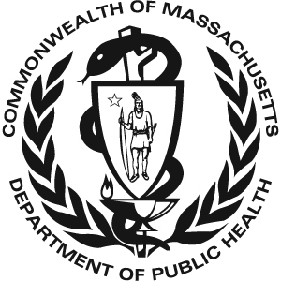 Massachusetts Universal Newborn Hearing 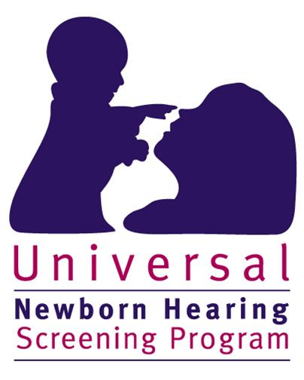
Screening Program
2013 Data

There were 72,201 total births in Massachusetts in 2013. 71,573 (99.5%*) of these infants received a hearing screen. 628 infants were not screened. Of the 628 infants that did not receive a screen:
- 273 died before a screen was performed or their parents/guardians did not provide consent to perform the screen
- 355 (0.5%*) had unknown screening status or did not receive a screen for unknown reasons (lost to screening follow-up)

Of the 71,573 infants that were screened:
- 70,338 (98.3%) passed the screen
- 1,235 (1.7%) failed the screen

Of the 1,235 infants that failed the hearing screen:
- 898 (72.7%) were diagnosed with normal hearing
- 157 (12.7%) were diagnosed with hearing loss
- 180 (14.6%) did not have a final confirmatory diagnosis when this data was reported. Of these infants without a final confirmatory diagnosis:
  - 34 were deceased or their parents/guardians declined follow-up diagnostic services
  - 36 moved out of state or did not reside in Massachusetts
  - 55 received diagnostic testing but were pending a final diagnosis
  - 55 (4.4% of the 1,235 infants that failed the screen) were lost to diagnostic follow-up

Of the 157 infants with hearing loss:
- 120 (76.4%) were enrolled in Early Intervention (EI)
- 3 (1.9%) received ‘other’ services such as monitoring services or non-Part C EI
- The remaining 34 infants (21.6%) were not documented to be receiving EI services for the following reasons:
  - 10 were deceased or declined EI services
  - 6 moved out of state or did not reside in Massachusetts
  - 18 were not receiving EI services for other or unknown reasons (11.5% lost to EI follow-up)

* % screened does not include deceased children without a screen

