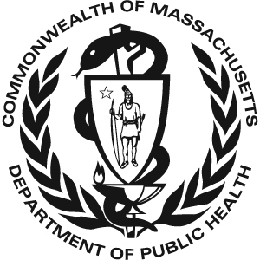 Massachusetts Universal Newborn Hearing 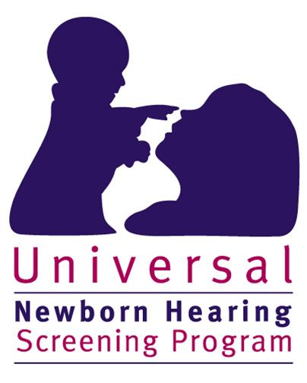
Screening Program
2014 Data

There were 72,479 total births in Massachusetts in 2014. 71,872 (99.5%*) of these infants received a hearing screen. 606 infants were not screened. Of the 606 infants that did not receive a screen:
- 306 died before a screen was performed or their parents/guardians did not provide consent to perform the screen
- 300 (0.5%*) had unknown screening status or did not receive a screen for unknown reasons (lost to screening follow-up)

Of the 71,872 infants that were screened:
- 70,560 (98.2%) passed the screen
- 1,313 (1.8%) failed the screen

Of the 1,313 infants that failed the hearing screen:
- 955 (72.7%) were diagnosed with normal hearing
- 177 (13.5%) were diagnosed with hearing loss
- 181 (13.8%) did not have a final confirmatory diagnosis when this data was reported. Of these infants without a final confirmatory diagnosis:
  - 32 were deceased or their parents/guardians declined follow-up diagnostic services
  - 40 moved out of state or did not reside in Massachusetts
  - 48 received diagnostic testing but were pending a final diagnosis
  - 61 (4.6% of the 1,313 infants that failed the screen) were lost to diagnostic follow-up

Of the 177 infants with hearing loss:
- 149 (84.2%) were enrolled in Early Intervention (EI)
- 4 (2.2%) received ‘other’ services such as monitoring services or non-Part C EI
- The remaining 24 infants (13.6%) were not documented to be receiving EI services for the following reasons:
  - 3 were deceased or declined EI services
  - 7 moved out of state or did not reside in Massachusetts
  - 14 were not receiving EI services for other or unknown reasons (7.9% lost to EI follow-up)

* % screened is calculated when deceased children without a screen are not included in the denominator

