
The Commonwealth of Massachusetts
Executive Office of Health and Human Services
Department of Public Health
250 Washington Street, Boston, MA 02108-4619

CHARLES D. BAKER
Governor
KARYN E. POLITO
Lieutenant Governor

MARYLOU SUDDERS
Secretary
MONICA BHAREL, MD, MPH Commissioner

Tel: 617-624-6000
www.mass.gov/dph

July 29, 2015

Steven T. James
House Clerk
State House Room 145
Boston, MA 02133

William F. Welch
Senate Clerk
State House Room 335
Boston, MA 02133

Dear Mr. Clerk,

Pursuant to Section 25A of Chapter 112 of the Massachusetts General Laws, the attached report details the investigatory and disciplinary actions conducted by the Massachusetts Board of Registration in Pharmacy during the period of December 1, 2013 to December 1, 2014. Specifically, the enclosed report details all formal Complaints and Staff Assignments/Investigations that were pending, received, initiated, or opened by the Board during this time period.

Sincerely,

Monica Bharel, MD, MPH
Commissioner
Department of Public Health
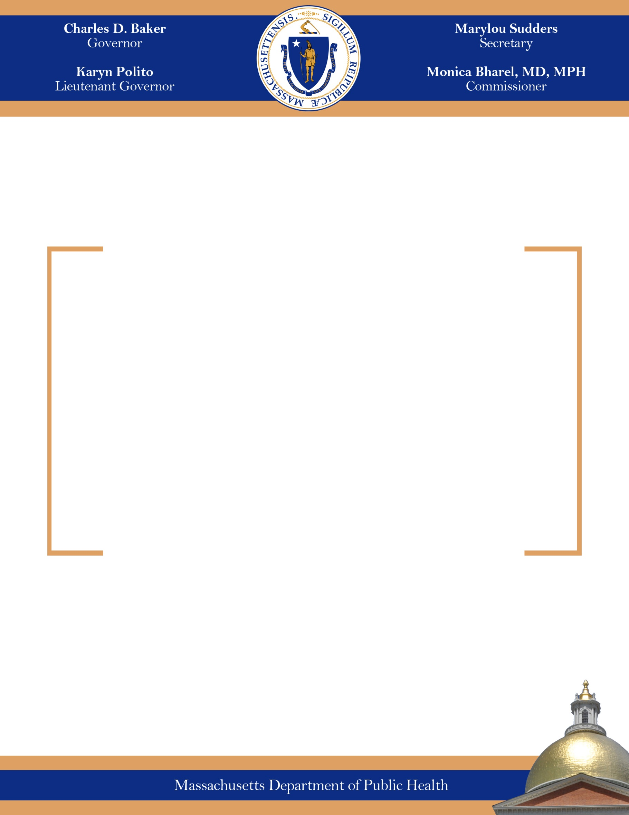
Board of Registration in Pharmacy

Annual Report on Investigations and Disciplinary Actions

July 2015

Legislative Mandate

The attached report details the investigatory and disciplinary actions conducted by the Massachusetts Board of Registration in Pharmacy (the Board), as required by Section 25A of Chapter 112 of the Massachusetts General Laws:

Section 25A. The board shall submit an annual report to the department of public health, the joint committee on public health and the joint committee on health care financing on or before December 31. The report shall detail the investigatory and disciplinary actions conducted by the board and shall detail: (1) each complaint received by the board or initiated by the board; (2) the date of the complaint; (3) the violation alleged; (4) the name of any state or federal agency that collaborated with the investigation; (5) the summary of the final decision of the board to: (i) dismiss the complaint, (ii) impose an informal sanction or penalty, (iii) impose a formal sanction or penalty or (iv) amend a previously issued sanction or penalty; and (6) whether the board reported the result of its investigation to another state board, federal agency or external entity.

All relevant data collected and analyzed under subsections (b) to (e), inclusive, of section 39D shall be summarized and included in the report. The report shall be made available, including by electronic means, to the public and all hospitals, pharmacies and health care providers doing business in the commonwealth. Said report shall be posted on the department of public health’s website.
Summary
The enactment of Chapter 159 of the Acts of 2014 brought with it many new requirements and opportunities for the Board. The Board staff is deeply involved in writing new regulations that will greatly enhance industry practice and pharmacy oversight across the Commonwealth.

Achievements throughout 2014 include:
- The Board achieved a noticeable field presence due to an increase in investigative staff, in addition to a heightened oversight of sterile compounding pharmacies
- Since February 2014, the Board staff has conducted over 900 pharmacy inspections
- A large portion of these inspections were retail compliance inspections at chain and independent community pharmacies
- Each inspection included a review of the pharmacy's Continuous Quality Improvement Program (CQI Program)
- The CQI Program, required by regulation, is a system of standards and procedures to identify and evaluate quality-related events and improve patient care.
- The ability of Board staff to almost double the number of retail inspections in 2014 reinforces the importance of maintaining quality assurance systems and reducing overall pharmacy medication errors

Changes at the Board arose in the wake of the fungal meningitis outbreak in fall 2012, when the Board implemented regulatory and administrative reforms to improve oversight of the compounding pharmacy industry. Specifically:

- Board staff instituted new or updated existing administrative procedures, including:
  - priorities for complaint investigations
  - timelines and guidelines for standard investigation activities
  - guidelines for handling evidence and chain of custody logs
  - processes for complaint intake and triage
- The Board established a sterile compounding pharmacy inspection log to supplement and enhance reporting capabilities of the Board
- The Board instituted a weekly critical incident report
- Board staff developed new policies and procedures, including:
  - managing communication about abnormal test results
  - managing above action limit environmental monitoring results
  - pharmacy retail drug store closures
  - handling incoming reports of theft or loss of controlled substances

Pharmacy Board staff made the restructuring and reorganization of the Pharmacy Board’s website a priority over the past year with the aim to better service the needs of the pharmacy community. The website contains updated forms for mandatory reporting and a template of the Pharmacy Board’s new retail compliance inspection for pharmacies to conduct self-inspections, as well as important news, updates, and alerts to the pharmacy community and consumers. The website revamp will continue in FY15 as the Pharmacy Board implements new licensing categories and promulgates its new regulations.

These efforts helped the Board achieve its goal of enhanced oversight of the compounding pharmacy industry, as well as traditional retail pharmacies. The Board submits the enclosed report detailing all formal Complaints and Staff Assignments/Investigations that were pending, received, initiated, or opened by the Board during the period of December 1, 2013 to December 1, 2014.
Case Flow Overview

To provide context to the enclosed report, we are providing you with an overview of the Board’s case flow. The Board receives informal complaints alleging regulatory violations or other misconduct against a licensee. At a weekly pharmacy triage meeting, Board Staff determine whether the allegations, if true, assert a violation of laws or regulations governing the practice of pharmacy by the particular licensee, and take one of three actions.

If they determine that the facts alleged, if true, would not constitute a violation, Board staff will close the matter. If they determine that the facts alleged do constitute a violation and that there is clear evidence supporting the allegations, Board staff open a formal Disciplinary Complaint (Complaint). If further information is needed to make the determination, Board staff open a Staff Assignment.

In the case of both Complaints and Staff Assignments, Board staff conducts further investigation as necessary. If the evidence gathered in a Staff Assignment clearly supports a violation, the Staff Assignment may be immediately converted into a Complaint. If the Staff Assignment does not yield clear evidence supporting a violation against a particular licensee, Board staff will close the Staff Assignment.

As part of the investigation, the investigator contacts the licensee for a response to the allegations. The investigators also obtain evidence, as available, from complainants and other witnesses. When the investigation is complete, the investigator writes a report. The report is then reviewed by the Director of Compliance to ensure accuracy and completeness.

Next, the Director of Compliance determines whether the Complaint will be presented to the Board or go to the Board Delegated Complaint Review (BDCR) committee. The BDCR has authority to dispose of Staff Assignments or Complaints that fall under set criteria.

The Complaint would then be slotted for review on a Board meeting agenda and subsequently presented to the Board. Following the Board meeting review, the Board members may take the following actions: (1) dismiss the matter; (2) request further investigation; (3) authorize commencement of disciplinary proceedings; and/or (4) authorize terms for resolution of the Complaint by consent agreement.

In reviewing the enclosed report, you are likely to notice that investigation and resolution of these cases may vary considerably. Various factors may contribute to the length of a case staying open including, complexity, availability of obtaining evidence or witnesses, concurrent criminal matters where board cases may be delayed or placed on hold, lengthy administrative hearings, appeal of final decisions, etc. The below charts summarize relevant information captured in the overall data.
Formal Complaint Status Totals:

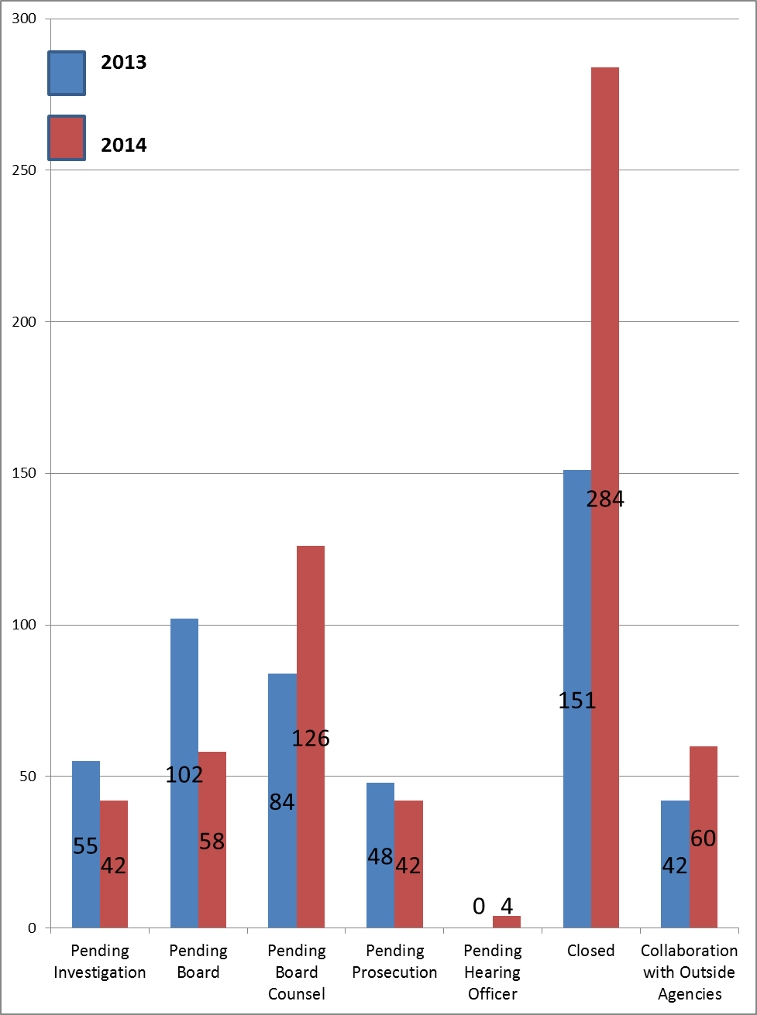

What this means: In 2014, Board staff planned extra meetings and expanded the types of cases that could be heard by the Board Delegated Review Committee to increase the amount of cases processed by the Board. The files that were processed by the Board in 2014 have been closed or have moved on for processing by Board Counsel. Overall, the data depicts that significantly more cases were closed in 2014 and cases are moving through all stages of the complaint process at a quicker rate than in 2013.

Closed Complaint Dispositions
What this means: As described above, the Board processed more complaints in 2014 than in 2013, resulting in a general increase in all complaint dispositions. Additionally, the implementation of a Just Culture is attributable to an increase in non-disciplinary dispositions (i.e., stayed probation with required continuing education requirements) and dismissals.
Complaint Dockets by Type:

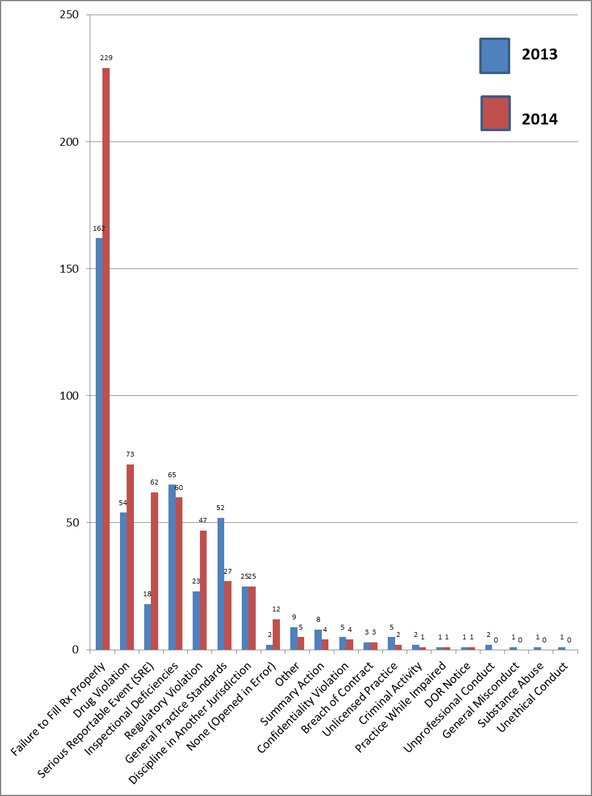

What this means: During 2013, the period of time it took to investigate a case increased because investigators spent the majority of their time in the field conducting in-depth sterile compounding inspections, and follow-up sterile compounding inspections. This staffing limitation was resolved with the addition of contract investigators in late 2013. As 2013 files were investigated in 2014, multiple companion complaints were opened in 2014, which is attributable to the rise in “Failure to Fill Rx Properly” and “Serious Reportable Event" complaints. Increased field presence in 2014, uncovered regulatory and drug violations at pharmacies, accounting for the increase in these types of complaints.
Staff Assignments/Investigations Status Totals:

What this means: Prior to 2013, staff assignment investigation files were used for purposes other than conducting pharmacy investigations. For instance, staff assignment files were used to track “Good Moral Character” (GMC) licensing inquiries and “requests” for pharmacy inspections. Separate processes have now been established for these functions, which has decreased the number of investigation openings. As noted above, in 2014, the Board prioritized the processing of files, resulting in an increased number of file closings.

Closed Staff Assignments/Investigations Dispositions:
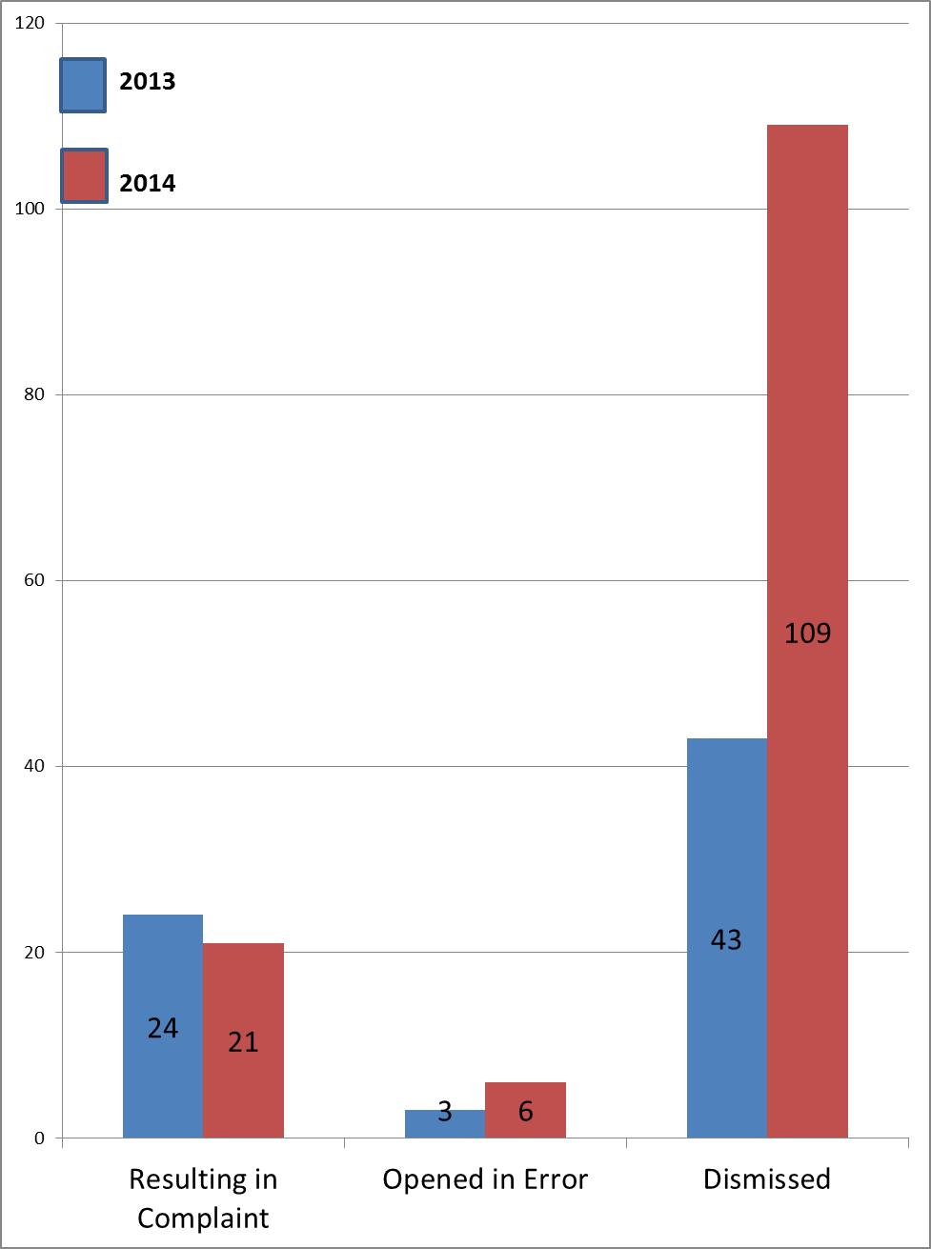

What this means: As described above, the Board processed more files in 2014, resulting in an increase in file closures. Many of the staff assignments were closed because they were not related to matters which would be violations of the Board’s regulations or applicable statutes.

Staff Assignments/Investigations by Type:

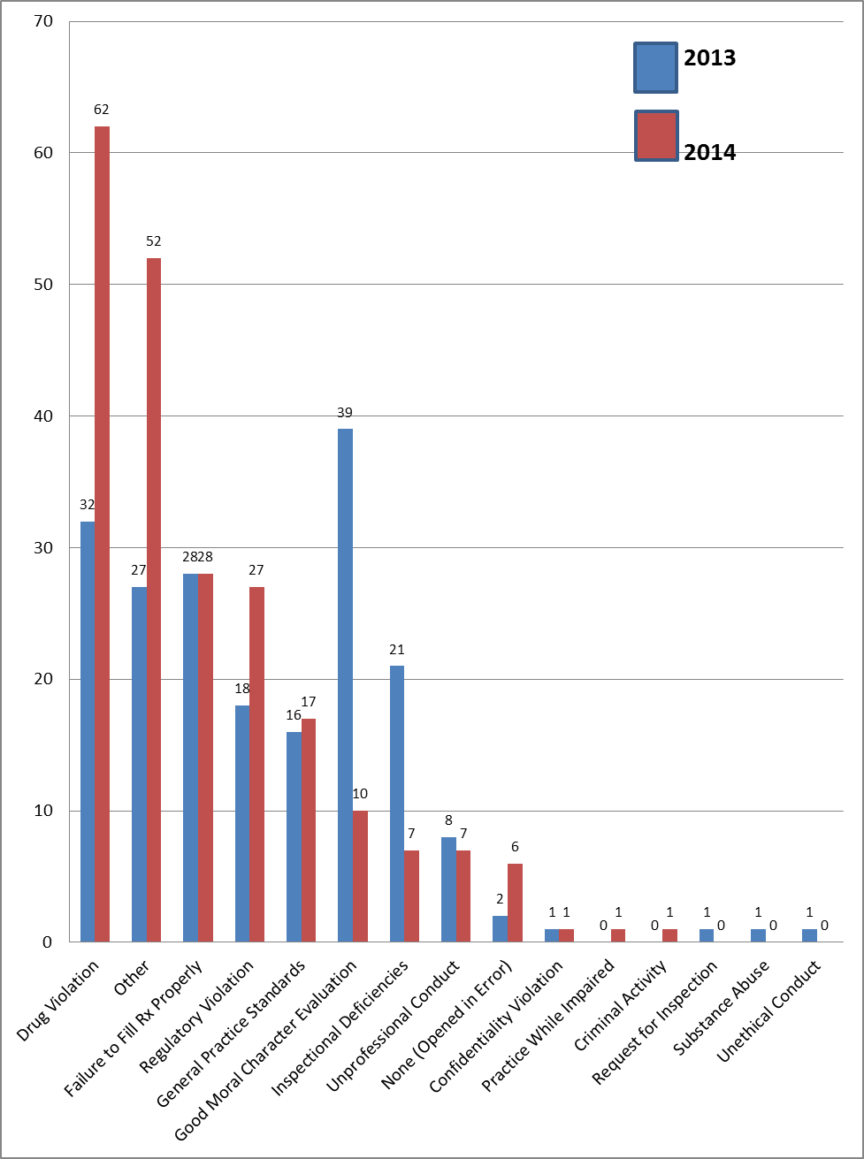

What this means: During 2014, Board staff focused on areas of pharmacy of a lesser priority than sterile compounding pharmacy inspections. Board staff developed a monitoring system for the review of controlled substance loss reports (classified as “Drug Violations”) and abnormal results related to sterile compounding (classified as “Other”), resulting in an increase in investigations related to these events. As noted above, separate processes were developed to handle inspections and GMC evaluations, resulting in the decrease of these categories.

Report Structure

The report is separated into three (3) sections:

- Complaints
- Staff Assignments/Investigations
- Preventable Medical Errors

For all files listed, the report indicates the Complaint numbers assigned to each file, the name and license number of the licensees involved, the violation alleged, and the name of any state or federal agency that collaborated in the investigation.

For each of the files handled by the Board during the above-listed time frame, a chronological account of the Board actions taken is indicated as follows:

For Complaints, the date the investigation was opened, the date it was sent to the Board for Board action, the date it went to Board Counsel, the date it was sent to Prosecution, and the date the docket was closed are included. If the docket is closed, a summary of the result is provided. If the result was formal discipline on a license, the report indicates if the discipline was reported externally (outside reporting). If a not applicable (N/A) is noted, it denotes that the Investigation or Complaint did not proceed to that particular stage, or does not yet have a final decision.

The data lists all cases that were closed in 2014 first, then the remainder of the cases are listed in their various stages, from those cases closest to closing (pending hearing officer) to those cases in the first stage (pending investigation).

For Staff Assignments/Investigations, the date the Staff Assignment/Investigation was opened, the date it was closed, and the date any complaint docket was opened as a result of the Staff Assignment/Investigation are included. A Staff Assignment/Investigation cannot result in discipline, and for that reason, no results of Staff Assignments/Investigations have been reported externally.

Preventable Medical Errors:

The report of Preventable Medical Errors details all available information for Complaints and Staff Assignments/Investigations where the alleged violation was related to a medical error. For each medical error, the report indicates a synopsis of the medical error. Redundant errors are typically companion files related to the same medical error, for all responsible licensees (pharmacy, pharmacist, pharmacy technician, manager of record, etc.)

To further assist in your review, we have also enclosed a summary of the actions taken by the Board from December 1, 2013 to December 1, 2014, on formal Complaints and Staff Assignments/ Investigations.

Thank you for reviewing this report. If you have any questions, please contact Jay Youmans, Interim Deputy Chief of Staff of External Affairs, at Jay.Youmans@MassMail.State.MA.US.

Sincerely,
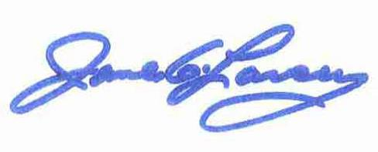
James G. Lavery
Director, Division of Health Professions Licensure

Formal Complaint Dockets:
Status | 2013 | 2014
Pending Investigation | 55 | 42
Pending Board | 102 | 58
Pending Board Counsel | 84 | 126
Pending Prosecution | 48 | 42
Pending Hearing Officer | 0 | 4
Closed | 151 | 284
Collaboration with Outside Agencies | 42 | 60

Closed Complaint Dockets:
Disposition | 2013 | 2014
Resulting in Discipline | 51 | 74
Resulting in Non-Discipline | 26 | 78
Dismissed | 69 | 120
Opened in Error | 5 | 12

Complaint Dockets by Type:
Complaint Type | 2013 | 2014
Failure to Fill Rx Properly * | 162 | 229
Drug Violation * | 54 | 73
Serious Reportable Event (SRE) * | 18 | 62
Inspectional Deficiencies | 65 | 60
Regulatory Violation * | 23 | 47
General Practice Standards | 52 | 27
Discipline in Another Jurisdiction | 25 | 25
None (Opened in Error) | 2 | 12
Other | 9 | 5
Summary Action | 8 | 4
Confidentiality Violation | 5 | 4
Breach of Contract | 3 | 3
Unlicensed Practice | 5 | 2
Criminal Activity | 2 | 1
Practice While Impaired | 1 | 1
DOR Notice | 1 | 1
Unprofessional Conduct | 2 | 0
General Misconduct | 1 | 0
Substance Abuse | 1 | 0
Unethical Conduct | 1 | 0

* During 2013, the period of time it took to investigate a case increased because investigators spent the majority of their time in the field conducting in-depth sterile compounding inspections, and follow-up sterile compounding inspections. This staffing limitation was resolved with the addition of contract investigators in late 2013. As 2013 files were investigated in 2014, multiple companion complaints were opened in 2014, which is attributable to the rise in “Failure to Fill Rx Properly” and “Serious Reportable Event" complaints. Increased field presence in 2014, uncovered regulatory and drug violations at pharmacies, accounting for the increase in these types of complaints.
Staff Assignments/Investigations:
Status | 2013 | 2014
Open | 63 | 31
Pending Board | 52 | 50
Pending Legal | 0 | 2
Closed | 76 | 136
Total | 191 | 219

Staff Assignments/Closed Investigations:
Disposition | 2013 | 2014
Resulting in Complaint | 24 | 21
Opened in Error | 3 | 6
Dismissed | 43 | 109

Investigations by Type:
Investigation Type | 2013 | 2014
Drug Violation | 32 | 62
Other | 27 | 52
Failure to Fill Rx Properly | 28 | 28
Regulatory Violation | 18 | 27
General Practice Standards | 16 | 17
Good Moral Character Evaluation | 39 | 10
Inspectional Deficiencies | 21 | 7
Unprofessional Conduct | 8 | 7
None (Opened in Error) | 2 | 6
Confidentiality Violation | 1 | 1
Practice While Impaired | 0 | 1
Criminal Activity | 0 | 1
Request for Inspection | 1 | 0
Substance Abuse | 1 | 0
Unethical Conduct | 1 | 0

The level which requires the pharmacy to take some corrective action.
Complainant: a person who makes a formal charge in an administrative proceeding or court saying that someone has done something wrong.
The BDCR consists of at least one Board member and at least the following Board staff: (1) the Executive Director or his/her designee; (2) Director of Compliance or his/her designee; and (3) Board Counsel.
A Just Culture recognizes that individual practitioners should not be held accountable for system failings over which they have no control. A Just Culture also recognizes many individual or “active” errors represent predictable interactions between human operators and the systems in which they work. However, in contrast to a culture that touts “no blame” as its governing principle, a Just Culture does not tolerate conscious disregard of clear risks to patients or gross misconduct (e.g., falsifying a record, performing professional duties while intoxicated). Excerpted from: Marx D. Patient Safety and the “Just Culture”: A Primer for Health Care Executives. New York, NY: Columbia University; 2001. Available at: http://www.safer.healthcare.ucla.edu/safer/archive/ahrq/FinalPrimerDoc.pdf
The Board requires applicants who answer “yes” to questions related to criminal or disciplinary history to provide specific documentation for GMC evaluation.
Violations marked “Other” are instances that do not fall under typical categories or are not included in our tracking database complaint type list. For example, “contaminated sterile compounds” are not currently tracked, but the Board staff created two new investigation types – “Delay in Therapy” and “Abnormal Results” in FY15. These two types of investigations comprise a large majority of the investigations classified as “Other” in 2013. Violations marked “Serious Reportable Event” pertains to a pharmacy’s requirement to report to the Board any improper dispensing of a prescription drug that results in serious injury or death.

