Massachusetts Universal Newborn Hearing Program 2015 Data
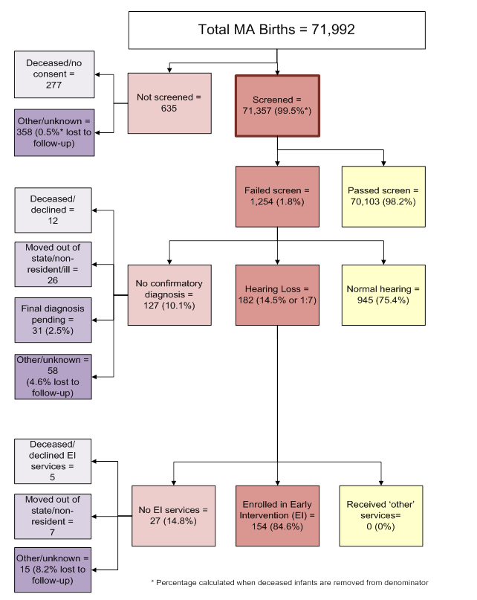

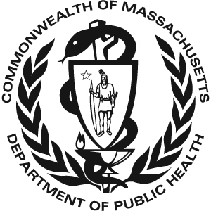 Massachusetts Universal Newborn Hearing 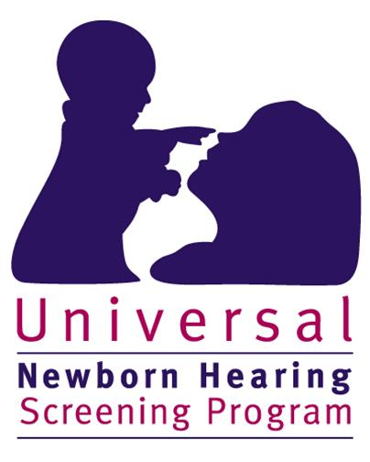
Screening Program
2015 Data

There were 71,992 total births in Massachusetts in 2015. 71,357 (99.5%*) of these infants received a hearing screen. 635 infants were not screened. Of the 635 infants that did not receive a screen:
- 277 died before a screen was performed or their parents/guardians did not provide consent to perform the screen
- 358 (0.5%*) had unknown screening status or did not receive a screen for unknown reasons (lost to screening follow-up)

Of the 71,357 infants that were screened:
- 70,103 (98.2%) passed the screen
- 1,254 (1.8%) failed the screen

Of the 1,254 infants that failed the hearing screen:
- 945 (75.4%) were diagnosed with normal hearing
- 182 (14.5%) were diagnosed with hearing loss
- 127 (10.1%) did not have a final confirmatory diagnosis when this data was reported. Of these infants without a final confirmatory diagnosis:
  - 12 were deceased or their parents/guardians declined follow-up diagnostic services
  - 26 moved out of state, did not reside in Massachusetts, or were gravely ill
  - 31 received diagnostic testing but were pending a final diagnosis
  - 58 (4.6% of the 1,254 infants that failed the screen) were lost to diagnostic follow-up

Of the 182 infants with hearing loss:
- 154 (84.6%) were enrolled in Early Intervention (EI)
- 0 (0%) received ‘other’ services such as monitoring services or non-Part C EI
- The remaining 27 infants (14.8%) were not documented to be receiving EI services for the following reasons:
  - 5 were deceased or declined EI services
  - 7 moved out of state or did not reside in Massachusetts
  - 15 were not receiving EI services for other or unknown reasons (8.2% lost to EI follow-up)

* % screened is calculated when deceased children without a screen are not included in the denominator

