Massachusetts Department of Public Health | Bureau of Environmental Health
Farm Labor Camp Housing
Requirements in Massachusetts

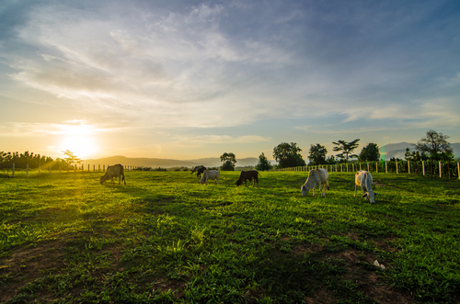
What is a Farm Labor Camp?
A Farm Labor Camp (FLC) in Massachusetts is in general a place where farming activities take place and sleeping facilities are offered in connection with employment. Farming activities include many jobs such as crops handling, livestock handling, and other jobs necessary for a farm to produce either food or materials. Farm Labor Camps must employ two or more workers with sleeping facilities as a condition of employment. This brochure is intended to provide highlights of minimum standards for Farm Labor Camp Housing in Massachusetts. For the complete definition of a Farm Labor Camp in Massachusetts, please refer to regulation 105 CMR 420.000, Housing and Sanitation Standards for Farm Labor Camps.

Why is it Important to Know your Rights?
It’s important to understand what rights you have while working at a farm labor camp. These rights come from laws that farm labor camp operators must follow.

Minimum Housing Standards
- All buildings should be clean, weatherproof, structurally sound, and free of debris and toxic waste
- All rooms should be supplied with adequate heating fixtures when necessary
- Adequate bath and toilet facilities for both genders should be provided within 200 ft. of the living quarters
- Each person is entitled to at least 50 ft² within their sleeping quarters
- Each room should have at least one (1) window, one (1) light fixture and one (1) wall outlet
- Each person shall be provided with secure personal storage space
- Living quarters should be separated according to gender except in the cases of family housing, which is separate from other

Visitation
- Visitation is allowed between 6 PM or at the end of the work day to 10:30 PM on workdays and 10 AM to 10:30 PM on non-workdays
- Visitation does not need to be approved by farm operators beforehand
- These hours of visitation do not apply to government agents, clergy members, legal services, medical personnel, or members of the press

Drinking Water Supply Requirements
- The farm operator must provide an adequate supply of potable water
- If water comes from a private well, it must be tested on a yearly basis and collected by a third-party entity not the operator
- All water testing analysis must be conducted by an EPA certified laboratory

Bedding, Linen and Laundry Requirements
- The farm operator is required to provide at least one (1) clean mattress, one (1) pillow, two (2) clean sheets, and one (1) bathing towel
- The farm operator is required to provide a means to wash and dry clothes. If there is no laundry on site, transportation and compensation for use of an off-site laundromat must be provided

Cooking and Eating Arrangements
- The farm operator must provide a clean eating space along with a kitchen
- If there is no kitchen, access to prepared food must be provided
- Adequate food storage space must be provided away from the sleeping areas

Sanitary Measures
- Trash receptacles must be covered and emptied at least twice a week
- Each building must have methods of preventing an infestation of insects and rodents
- To ensure health and safety, farm operators are prohibited from hiring laborers with pre-existing communicable diseases
- If laborers or members of their family living on the farm labor camp are not in good health, they must seek medical attention and the Department of Public Health must also be notified

Health, Fire and Safety Measures
- All buildings must comply with state and local fire and safety laws
- Each floor must have two (2) exits to the outside (adequately sized windows can act as an exit)
- Fire prevention and escape plans must be posted with instructions in both English and the workers’ native language where they can be easily seen
- A fully supplied first aid kit must be located close to the living quarters and be in the care of a responsible person

Massachusetts Laws and Regulations: Housing and Sanitation Standards
M.G.L. c. 111, § 3 , 127A and 105 CMR 420.000

Visitation Rights
M.G.L. c.111, § 3, 127A and 105 CMR 425.000

Massachusetts Department of Public Health
Whom can I contact for additional information?
Massachusetts Department of Public Health
Community Sanitation Program
1-617-624-5757
www.mass.gov/dph/dcs

Bureau of Environmental Health
250 Washington Street, 7th Floor, Boston, MA 02108
Phone: 617-624-5757 | Fax: 617-624-5777 | TTY: 617-624-5286
www.mass.gov/dph/environmental_health

2015

