**2016**

Environmental Toxicology Program

Bureau of Environmental Health

Massachusetts Department of Public Health

250 Washington Street

Boston, MA 02108

Email: dph-beach@state.ma.us

Phone: (617) 624-5757

Massachusetts Beach Testing

Results: Annual Report



**Good Harbor Beach, Gloucester, MA**

**Executive Summary**

Swimming at Massachusetts beaches is one of the most popular recreational activities in the state, with over 111 million individual trips to one of the 1,100 beaches each year (EOEEA, 2007; EOHED, 2016). As good water quality is essential to having a safe and enjoyable beach visit, it is critical to both monitor the water quality and immediately notify the public of any potential water quality concerns. Each year, the Environmental Toxicology Program in the Massachusetts Department of Public Health (MDPH), Bureau of Environmental Health collects water quality information from local health departments as well as the Massachusetts Department of Conservation and Recreation. This report provides a description of this information and is summarized immediately below.

* **Water quality:** In 2016, a total of 15,604 water samples were collected from 586 marine and 594 freshwater beach sampling locations. These locations represent 529 marine and 549 freshwater beaches. All marine beach communities and 99% of freshwater communities reported water quality information to MDPH. Approximately 3.5% and 3.0% of the samples exceeded the Massachusetts water quality standards (based on bacteria) for marine and freshwater beaches, respectively. The overall low exceedance rates indicate that Massachusetts beaches have generally high water quality. Elevated bacteria accounted for 63% of poor water quality notifications (i.e., beach postings); other reasons for notifications included harmful algae (cyanobacteria) blooms, rainfall (typically associated with elevated bacteria), and other hazards (e.g., strong currents, shark sightings).
* **Field data:** In 2016, a majority of water samples (approximately 93%) submitted to MDPH had accompanying field data. Rainfall and local pollution sources at sampling sites were identified as two important factors that contributed to elevated bacteria levels at recreational waterbodies. Generally, the number of exceedances dropped exponentially as the days since rainfall increased. Among those samples collected near potential pollution sources, the exceedance rate was higher than those without a potential pollution source.
* **Public notification:** The MDPH marine beaches website (<http://ma.healthinspections.us/public_21/>) provides near real-time information on bacteria levels at public marine beaches, as well as information on historic bacteria levels. MDPH initiated usage analyses of its beaches website in 2016 by recording the number of unique visitors. The number of website users was highest in July and August, which corresponded with the height of the beach season in Massachusetts. Individuals were also notified of unsafe conditions at beaches through the use of physical signage that is required to be posted by beach operators. All marine and 74% of freshwater beaches were in compliance with the public notification requirement. The 100% marine compliance is a first since the passage of the Massachusetts Beach Act.

**Introduction**

Swimming-associated health risks have been documented in numerous studies (Marion et al., 2010; Wade et al., 2003). Beachgoers may be exposed to pathogens through recreational activities in and around polluted waterbodies (Hlavsa et al., 2015). In the United States, most swimming-associated diseases are caused by a variety of pathogens associated with fecal contamination (Cabelli et al., 1982; USEPA, 2012). Human fecal matter can enter beach water in a variety of ways, including sewage treatment system failures, combined sewer overflows, discharge of sewage by boats, re-suspension of sediments, and rainfall and resulting surface runoff (Galfi et al., 2016; Rodrigues et al., 2016).

To address concerns over swimming-associated illness, improve public health for beachgoers, and notify the public about the quality of beach water, MDPH regulations have required regular water quality monitoring and public notification of unsafe conditions since 2001. All public and semi-public bathing beaches in Massachusetts are monitored for fecal indicator bacteria (FIB), and on occasion harmful algae during the beach season which generally begins when the school year finishes in mid-June and ends during the weekend of Labor Day.

MDPH adopted the USEPA criteria for enterococci and *E. coli* in marine and freshwater. These criteria consist of both a single sample and geometric mean (geomean) value reported as colony forming units per 100 milliliter of water (CFU/100mL) (see Table). When beach water does not meet these water quality standards, MDPH requires that the beach be posted with a notice alerting the public to the possible risk of swimming. At a majority of beaches in Massachusetts, water quality is considered to be unacceptable when two samples collected on consecutive days exceed the water quality standards. Beaches with a history of multi-day elevated bacteria levels are required to post after a single exceedance. Posting is also required when the geomean of the five most recent non-rainfall impacted samples exceeds the geomean standard.

|  |  |  |  |
| --- | --- | --- | --- |
| **Beach Type** | **Indicator** | **Single Sample** | **Geomean** |
| Marine | Enterococci | >104 | >35 |
| Freshwater | Enterococci | >61 | >33 |
| *E. coli* | >235 | >126 |

**Table. MDPH recreational water quality criteria (CFU/100 mL)**

In addition to water samples, field data such as days since rainfall and potential pollution sources are required to be collected at the time of sample collection. Field data help facilitate the interpretation of bacteria data and can improve the understanding of water quality at the local and state level.

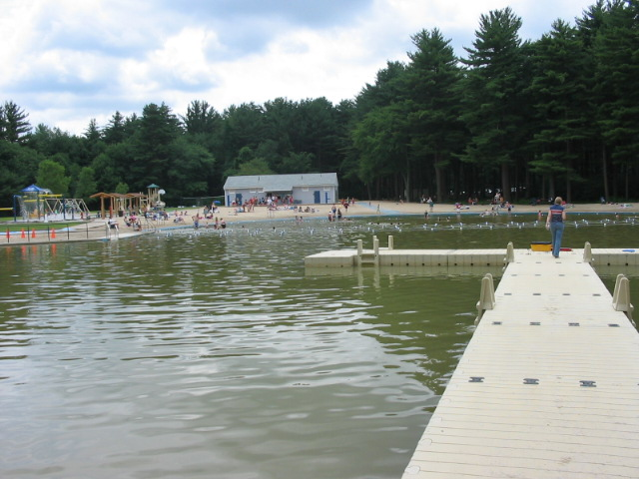

Spring Brook Park Beach, Bedford, MA

**Water Quality**

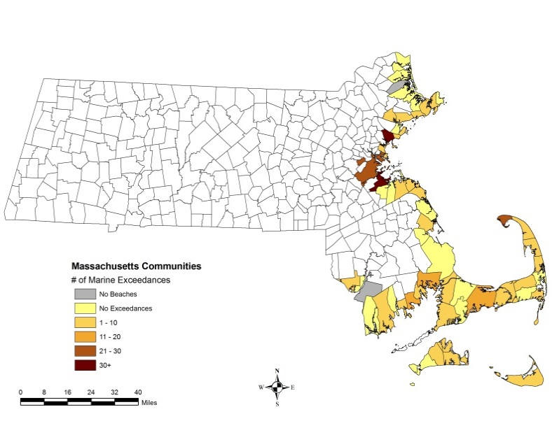***Marine beach exceedances.*** During the 2016 beach season, a total of 7,904 samples were collected and analyzed from 586 marine beaches. Of these 586 beaches, 140 (24%) in the 60 communities with beaches had at least one bacterial exceedance (see Figure 1). A total of 274 out of the 7,904 samples exceeded the 104 CFU/100 mL standard. The percentage of exceedances for marine waters in 2016 was 3.5%, which was much lower than the historical average exceedance rate of 4.9%. The number of marine beach exceedances in each community during 2016 is shown in Figure 1. The marine beaches in Boston, Lynn, and Quincy had the highest number of exceedances in 2016.

Figure 1. Marine beach water quality exceedances in 2016

***Freshwater beach exceedances.*** During the 2016 beach season, 7,700 samples from 594 freshwater beaches were collected and analyzed for the approved FIB (i.e. *E. coli* or enterococci). Most freshwater beaches (87%) used *E. coli*. Among the 594 freshwater beaches, 115 (19%) in 180 communities reporting beach data had at least one bacterial exceedance (Figure 2). A total of 232 out of the 7,904 samples exceeded the standard. The percentage of exceedances for freshwater in 2016 was 3.0%, which was much lower than the historical average exceedance rate of 3.8%. The number of freshwater beach exceedances in each community during 2016 is shown in Figure 2. The number of exceedances in freshwater beaches in 2016

varied among communities, with the highest number in Brimfield, Templeton, and West Tisbury.

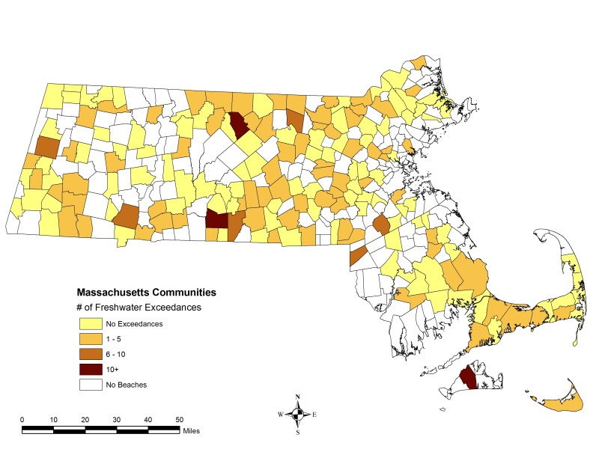***Posting beaches.*** During the 2016 beach season, poor water quality and/or unsafe conditions required the postings of beaches on 274 occasions. These postings advised individuals not to swim or bathe in the water. Figure 3 displays the causes of postings in 2016. The majority of postings were due to the exceedance or expected exceedance (i.e., rainfall) of water quality standards. For marine beaches, there were 160 postings due to elevated bacteria, rainfall, or other (e.g., rip current, shark sightings). For freshwater beaches, there were 114 postings due to elevated bacteria, rainfall, and harmful algae blooms.

Figure 2. Freshwater beach water quality exceedances in 2016

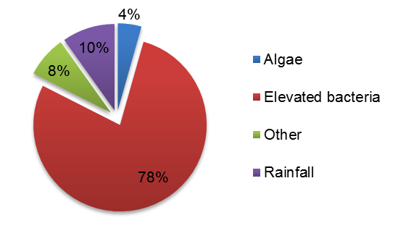

Figure 3. Posting details for marine and freshwater beaches in 2016

**Field Data**

***Potential pollution sources.*** The presence of pollution sources at beaches was associated with a higher risk of bacterial exceedances. Figure 4 shows that the exceedance rate of samples which noted the presence of specific pollution sources is higher than those without the presence of any pollution source regardless of beach type. It is worth mentioning that when pollution source information was not reported (i.e., unknown) in the field data, the exceedance rate of water samples was even higher than those with the presence of a specific pollution source. Without pollution source information, the ability to evaluate the potential impacts on water quality is diminished.

Figure 4. Exceedance rate of water samples associated with the presence, absence, or none reporting of environmental pollution sources at beaches in Massachusetts in 2016

Unknown: no information provided; yes: specific pollution source observed; no: no pollution source observed.

***Rainfall.*** Rainfall is recognized as one of the major drivers of bacterial exceedances in beach water (Harder-Lauridsen et al., 2013). An exponential drop in the number of exceedances occurs as the time between rainfall and sample collection increases (Figure 5). For marine beaches, 158 of 274 bacterial exceedances occurred within 24 hours after a rain event; for freshwater, 126 of 230 exceedances were observed within 48 hours after a rain event.

Figure 5. Relationship between the number of bacterial exceedances and days since rainfall in 2016

The historical relationship between exceedances of water quality criteria at marine and freshwater beaches and the total amount of rainfall between June and August is shown in Figure 6. The rainfall data were obtained from the National Oceanic and Atmospheric Administration (NOAA, 2016). Rainfall data sets from Boston and Chatham were used to represent monthly rainfall amounts at marine beaches; data sets from Amherst and Ashburnham, along with those from Boston and Chatham were used to represent amounts at freshwater beaches. For both marine and freshwater beaches, exceedances generally rise and fall with rainfall amounts, with some exceptions. In 2016, Massachusetts received the least amount of rain during any beach season since 2001. The low rainfall amount is likely a primary reason for the low exceedance rates in 2016.

chart of relationship between rainfall and exceedance amountsbeaches and marine life 

Figure 6. The historical relationship between rainfall amounts and exceedance rates at (A) marine and (B) freshwater beaches in Massachusetts from the 2001 to 2016 beach seasons

**Public Notification**

***Beach website.*** The MDPH beach monitoring website (<http://ma.healthinspections.us/public_21/>) provides the public with the most up-to-date marine beach testing and posting information and presents the data in an easy-to-use format. Overall, over 4,000 users visited the website during the season (this includes both new and returning users). An analysis of weekly usage data demonstrated an increase in the number of users as the beach season progressed and consistent usage during the second half of the season (Figure 6). The number of website users (n=398) peaked during week 9, which corresponds with late July. The second busiest week was that which included July 4th (week 6), when 364 people visited the site.

***Beach postings.*** When water quality standards are exceeded or other safety concerns warrant, beach operators are required to post signage at the beach advising individuals of the hazard and recommending they stay out of the water. This is an essential part of the public notification system. Marine and freshwater beaches were posted properly 100% and 75% of the time, respectively.

Figure 7. Number of MDPH marine beach website users per week during the 2016 beach season

**Conclusions**

In 2016, the exceedance rates at marine and freshwater beaches were lower than historical averages. Rainfall is a significant driver of bacteria exceedances, and the low rainfall amount received throughout the beach season across the state is likely a primary factor for the low exceedance rates. However, given the number of beaches sampled in Massachusetts, the average historical exceedance rates of less than 5% indicate that Massachusetts has beaches with generally high water quality. Public notification of marine results and postings via MDPH’s monitoring website continued to be an effective means of communicating with the public.

**Acknowledgements**

This work was partially supported by a U.S. EPA Beaches Environmental Assessment and Coastal Health (BEACH) grant and a U.S. Centers for Disease Control and Prevention’s Preventive Health and Health Services grant. MDPH received assistance from local, regional, and state partners, including Massachusetts boards of health, regional health networks, and the Massachusetts Department of Conservation and Recreation, in ensuring that bathing beaches were tested and data were submitted appropriately.

**References**

Cabelli, V.J., Dufour, A.P., McCabe, L.J., Levin, M.A. 1982. Swimming-associated gastroenteritis and water quality. American Journal of Epidemiology 115, 606-616.

Executive Office of Energy and Environmental Affairs (EOEEA). 2007. Massachusetts Outdoors 2006: Statewide Comprehensive Outdoor Recreation Plan. <http://archives.lib.state.ma.us/handle/2452/335705>

Executive Office of Housing and Economic Development (EOHED). 2016. 2015 Annual Report of the Massachusetts Office of Travel and Tourism.

<http://www.massvacation.com/wp-content/uploads/2016/09/2015-annual-report-9-27-16.pdf>

Galfi, H., Österlund, H., Marsalek, J., Viklander, M. 2016. Indicator bacteria and associated water quality constituents in stormwater and snowmelt from four urban catchments. Journal of Hydrology 539, 125-140.

Harder-Lauridsen, N.M., Kuhn, K.G., Erichsen, A.C., Mølbak, K., Ethelberg, S. 2013. Gastrointestinal Illness among Triathletes Swimming in Non-Polluted versus Polluted Seawater Affected by Heavy Rainfall, Denmark, 2010-2011. PLOS ONE 8, e78371.

Hlavsa, M., Roberts, V., Kahler, A., Hilborn, E., Mecher, T., Beach, M., Wade, T., Yoder, J. 2015. Outbreaks of Illness Associated with Recreational Water - United States, 2011–2012. Morbidity and Mortality Weekly Report, Center for Disease Control and Prevention 64, 668-672.

Marion, J.W., Lee, J., Lemeshow, S., Buckley, T.J. 2010. Association of gastrointestinal illness and recreational water exposure at an inland U.S. beach. Water Research 44, 4796-4804.

Rodrigues, V.F.V., Rivera, I.N.G., Lim, K.-Y., Jiang, S.C. 2016. Detection and risk assessment of diarrheagenic *E. coli* in recreational beaches of Brazil. Marine Pollution Bulletin 109, 163-170.

U.S. Environmental Protection Agency (US EPA), 2012. 2012 Recreational Water Quality Criteria USEPA 820-F-12-058, Office of Water.

Wade, T.J., Pai, N., Eisenberg, J.N., Colford, J.M.J. 2003. Do U.S. Environmental Protection Agency Water Quality Guidelines for Recreational Waters Prevent Gastrointestinal Illness? A Systematic Review and Meta-analysis. Environmental Health Perspectives 111.

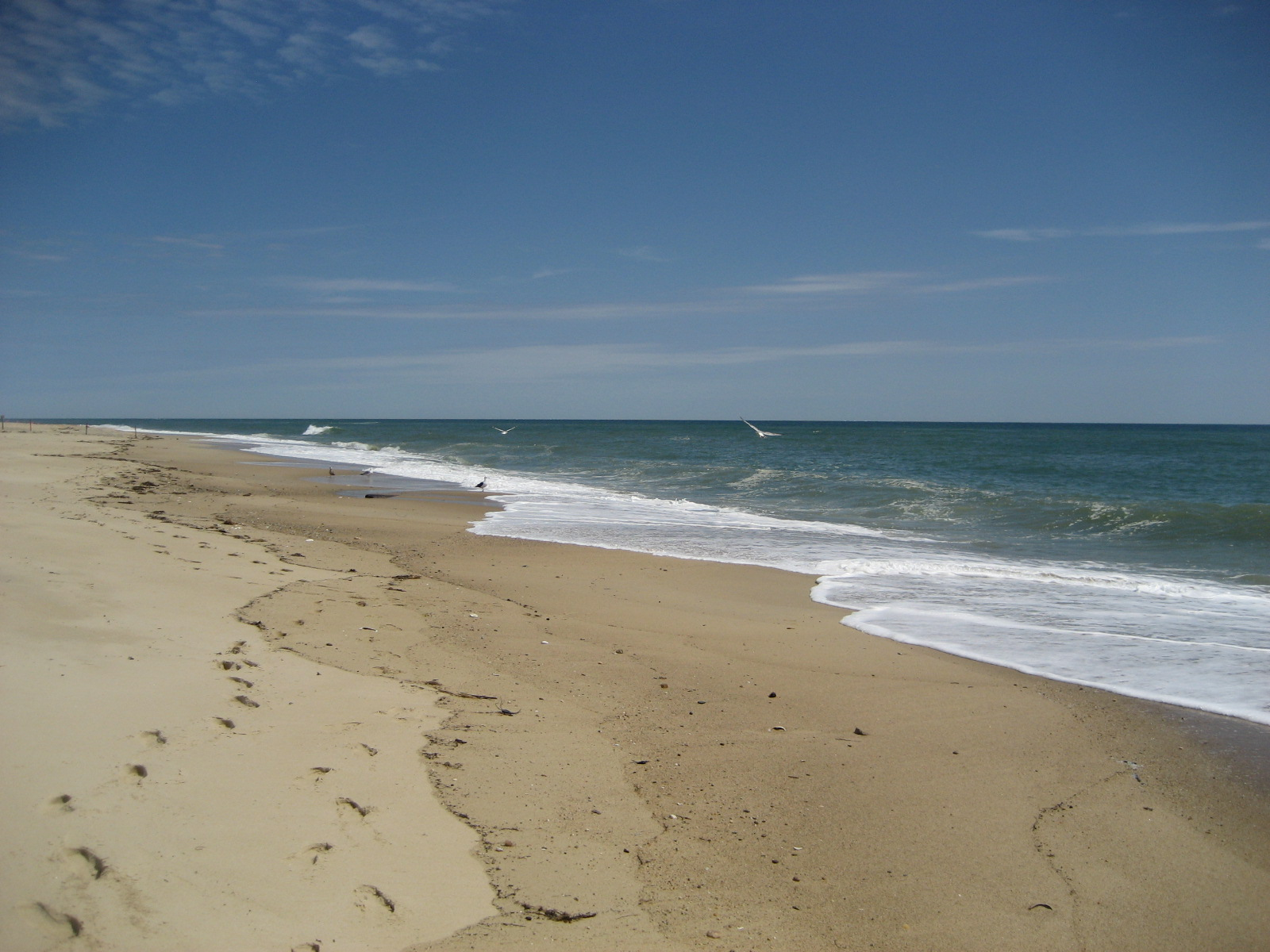

**For more information, please visit:**

MDPH Beaches and Algae website:<http://www.mass.gov/dph/beaches>

MDPH Marine Beach website: http://ma.healthinspections.us/public_21/

**Or contact:**

*Environmental Toxicology Program*

*Bureau of Environmental Health*

*Massachusetts Department of Public Health*

*250 Washington Street*

*Boston, MA 02108*

*Email: dph-beach@state.ma.us*

*Phone: (617) 624-5757*

*Fax: (617) 624-5813*

South Beach, Edgartown, MA